

Capstone Project Phase A
Project no. 21-2-R-17

Gait evaluation using Skeleton Motion Detection from Videos using YOLO

By
Saar Golan - Saar.Golan@e.braude.ac.il
Roni Nadler - Roni.Nadler@e.braude.ac.il

Mentor: Miri Weiss Cohen

Table of Contents
1 Introduction 3
2 Background of YOLO algorithm 5
3 Related work 9
4 Expected Achievements 15
5 Research Process 16
5.1 Process 18
5.2 Product: 20
5.2.1 use case diagram: 20
5.2.2 general yolov4 architecture: 20
5.2.3 Class diagram: 20
5.2.4 Login window: 21
5.2.5 Main window: 21
6 Evaluation/Verification Plan 21
7 References 22

Abstract
Gait evolution is a key factor in moving towards a better medical solutions in the healthcare system. Using deep learning methods to evaluate a patient gait can bring tremendous benefits. In our project we will use You Only Look Once (YOLO) – a real-time object detector, to build a system that will generate a skeleton figure of a patient from videos. We will train our system with the help of videos of gait. Eventually the output of our system will be used to generate a report which includes the skeleton figure and various data for the assessment of the gait.

Introduction
Gait is one of the most important functions of human beings and the most elementary form of moving. It seems a very simple task and healthy people do it without paying a lot of attention, but it is a complex interaction of joint movements, selectively controlled muscle activity, and positional perception which allows a person to move within a chosen speed and direction [1].
The complexity of the gait movement and the many factors that affect it can lead to a large variety of gait disorders. Causes of gait disorders include neurological conditions, orthopedic problems (e.g., osteoarthritis and skeletal deformities), and medical conditions (e.g., heart failure, respiratory insufficiency, peripheral arterial occlusive disease, and obesity) [2].
Most gait disorders require a rehabilitation process. The rehabilitation process is a series of sessions when each session composed of assessment of the patient condition and his progress, and Adjustment of Continued Rehabilitation Plan. To build an efficient rehabilitation plan the clinical gait analysis of the patient's needs to be as accurate as possible. Clinical gait analysis can be defined as the measurement, processing, and systematic interpretation of biomechanical parameters that characterize human locomotion and the ability to identify limitations in motion [1].
Nowadays, most of the healthcare centers are not familiar with quantitative computerized approaches for patients' gait evaluation. As of now there are not any defined methods for comparing post and pre-operative conditions of the patient. Using clinical information and the representation of the efficiency of functional recovery, in the short-term period before and after the surgical intervention or injury. [3]
Previous solutions for motion capture and gait analysis exist and have high performance but they are extremely costly. most of the times the systems are not portable and the use of markers on the body may introduce positioning errors. In addition, a wearable sensor is placed on a body part to capture the movement information. From only the body part where the device is worn, limiting the applicability across different use-cases. [3]
Another previous project was designed to help people who have had Hip surgery, by evaluating patients’ gait based on low-cost portable marker-less Mocap and CNN (a deep learning method for classification through a learning process) for the estimation of the skeleton model. This project aimed to produce patient’s gait analysis at a lower cost and efficiency than in previous solutions. Although this project solves the problem of the cost, we mentioned above it suffers from performance issue. The estimation of the skeleton model with CNN takes a long time because it estimates a skeleton model for each object in the picture and not only for the relevant object (the patient).
The aim of the present work is to produce patients’ gait analysis fast using only low-cost camera with no additional external sensors or wearable sensors for short run assessment. In addition, using a computer vision-based system to offer a reliable and faster solution which may enhance patient comfort, particularly for prolonged monitoring periods. [3]. To overcome the problem mentioned above (slow estimation of the skeleton) we will use YOLO algorithm for the object detection task and so the estimation will be faster.
Our project in collaboration with Bergamo Hospital is designed to help people in rehabilitation process due to different types of gate disorders. The system will be used for rehabilitation centers for physicians to apply proper care to patients according to the gait analysis our software provides. It will be easy to use by medical personal and will not require a computer specialist to use proficiently. Deep learning is used as a learning methodology for achieving novel accuracy and fast results.
The project aims to provide gait evaluations by creating a human motion tracking system for medical analysis, which will create a benchmark for potential clinical and home applications. The objective is to create a software that can automate the process of gait evaluations. Our solution will deal with the captured data, gait recognition, allowing motion tracking and data processing to create a report. The input to the system will be a video file provided from a simple camera. Using the camera for capturing the gait, the patient is asked to walk on a straight path marked on the floor without wearing bulky cloths. A normal RGB video is acquired simultaneously at 30 fps (Figure 1). Finally, this data is composed to a skeleton model.
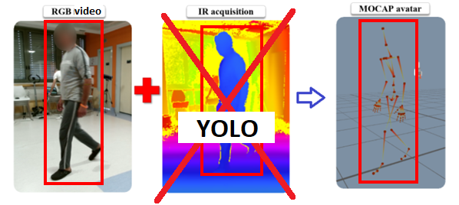
The gait evaluation process will be done in a bi-level procedure. First, detecting the person in hand from a video. Detecting an object which is in motion, incorporates two stages: object detection [7] and object classification [8]. Recently, deep neural networks have been demonstrated to achieve superior object detection performance compared to other approaches. Yolov4 is one of the state-of-the-art DNN-based object detection methods in terms of both speed and accuracy and for those reasons we chose to use it. YOLO object detection approach [YOLO] proposes formulating the object detection problem as a single regression problem, where bounding box coordinates and class probabilities are computed at the same time. Models based on the YOLOv4 network will be trained and tested on a suitable database. Second, after detecting the object, in our case the walking patient we need to analyze his\her gate performance. For the assessment to be accurate the skeleton figure should be extracted. The shape skeleton, or medial axis [5], is a structure-based object descriptor that reveals local symmetry as well as connectivity between object parts [6]. The Skeleton model can describe motion joints precisely and does not include factors that are not relevant to the assessment. The estimation of the skeleton model will be performed using a trained Convolutional Neural Network (CNN) model.
Figure 1 Gait evaluation process
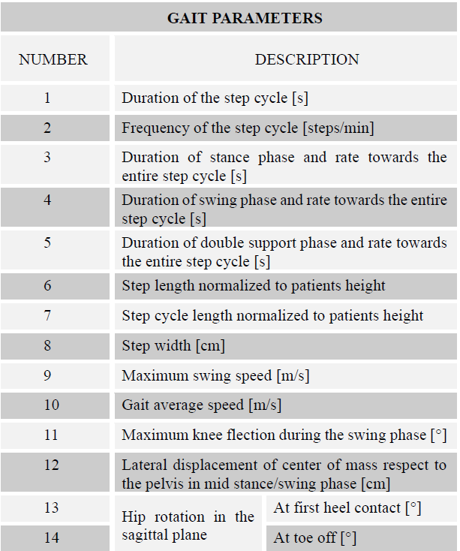
A multidisciplinary approach is needed to understand which are the right gait parameters. Table 1 describes numerous parameters that help to determine gait quality by measuring gait characteristics (e.g., step cycle, phase of a step, length of step) [3]. These parameters will be analyzed and interpreted to create results so the final users - medical personnel, can be provided exactly with the information they need.
As part of the project, we will develop an application that can take as input RGB video and automatically generate skeleton figures characterizing patients' gait performance. In this way, a complex gait evaluation is possible with a few and available means in a short time. This allows transforming the real gait of a patient after a surgical procedure or injury into a set of scores of medical relevance evaluation and significantly improve the rehabilitation process.
Table 1 Gait quality parameters

Background of YOLO algorithm
How amazing would it be if we could make a machine observe a situation and know exactly what objects are in it, what is the context of it and do it fast and accurately as humans do. Human observation is not just seeing the objects, when a person observes a situation, his brain is making many processes. First, the brain gets the picture from the eyes of the person, then it identifies and analyzes it, and finally, it needs to send action commands to the body. All this complex process takes just a fraction of a second.
YOLO algorithm is a milestone in the evolving field of computer vision. YOLO is a fast real-time multi-object detection algorithm, which was first outlined in this 2015 paper by Redmon et al. from the University of Washington. The idea behind the algorithm is to reframe object detection as a single regression problem, straight from image pixels to bounding box coordinates and class probabilities. YOLO composed of a single convolutional network simultaneously predicts multiple bounding boxes and class probabilities for those boxes.
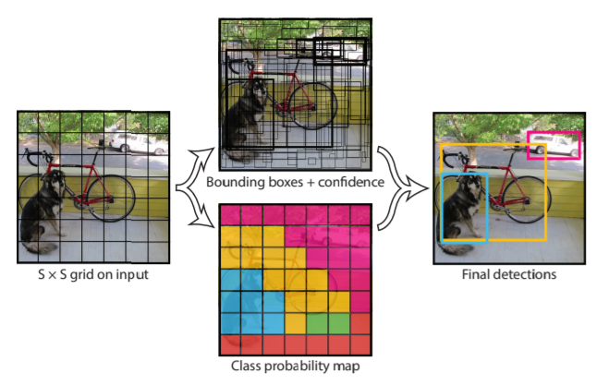
In the YOLO model the image is divided into an S x S grid and for each grid cell predicts B bounding boxes, confidence for those boxes, and C class probabilities. These predictions are encoded as an S x S x (B * 5 + C) tensor (Figure 2).
Our research aims to detect and record human gait in video taken in rehabilitation center using YOLO algorithm. To build the model, a database contains videos with gait classification in terms of health is needed. In addition, the model should be able to process the video sequence “online” to help the patient fix mistakes and walk correctly.
Figure 2 YOLO detection model [10]
Gait detection using YOLO consist of several steps. The first step is to train the model to detect objects as humans in a single frame. Then we change the network structure to achieve multi frame information so the model would be able to track the object and detect gait action. The next step is to recognize the joints in the identified posture thus creating a skeleton figure.
The skeleton figure requires tracking to follow up the movement of the person. Our goal is to keep track of the joints and so we can achieve further analysis of a person’s gait.
A research made about terrorist and illegal migration detection in difficult weather [9] found YOLO to be significantly faster than the other detector they examined and the only detector that can process a video sequence “online”.
Since 2015 when YOLO was first introduced by Joseph Redmon et al. subsequent versions were published and, in each version, improvements have been made. We will explain every version and compare them.
YOLOv1 [10] main idea was to take an entire picture as an input of the network and directly regress the position and category of the bounding boxes in the output layer. The network design (represented in Figure 3) consists of 24 convolutional layers that act as a feature extractor. They are followed by 2 fully connected layers that responsible for the classification of objects. YOLOv1 uses 1 x 1 reduction layers followed by 3 x 3 convolutional layers.
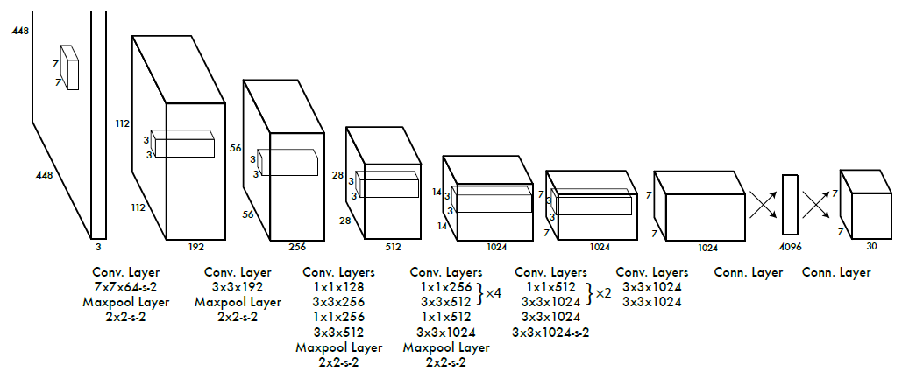
Figure 3 YOLO network design [10]
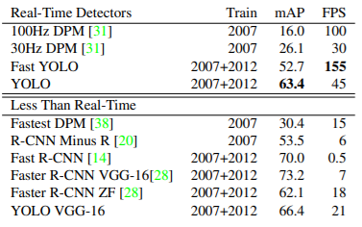
YOLOv1 results are listed in Table 2. YOLOv1 achieves 45 FPS and 63.4% mAP which are significantly higher compared to DPM (another real-time object detector). Even though Faster R-CNN VGG-16 has higher mAP, its speed much slower than YOLO's speed.
YOLOv1 has some limitations, it has difficulties in detecting small objects that appear in groups and objects having unusual aspect ratios and it makes more localization errors compared to Fast R-CNN.
Table 2 YOLOv1 results [10]
YOLOv2 [11] also called YOLO9000 because it can detect over 9000 object categories is more accurate and still fast. YOLOv2 include the mentioned below improvements:
Batch normalization was added to the architecture, so we can increase the convergence of the model that leads us for faster training. The mAP increased by more than 2% as compared to basic YOLO.
High resolution classifier: The YOLOv2 version trains on 448 * 448 resolution for 10 epochs on ImageNet data. This gives network time to adjust the filters for higher resolution. This increases the mAP by 4%.
Use anchor boxes for bounding boxes: YOLOv2 removes all fully connected layers and uses anchor boxes to predict bounding boxes and one pooling layer to increase the resolution of the output. The size of the input is changed to 416 x 416 so the number of locations in the feature map is odd and that way we get a single center cell. With anchor boxes, 69.2% mAP and recall of 88% are obtained. Though mAP is dropped a little, recall is increased by large margin.
Dimension Clusters: A k-means clustering is run on the training set Bounding Box to automatically find good priors.
Fine-Grained Features: YOLOv2 which generates 13 * 13 is sufficient for detecting large objects. To detect finer objects the architecture was modified such that the output of previous layer 26*26*512 to 13*13*2048 and concatenates with the original 13*13*1024 output layer making our output layer of size.
Multi-scale training: YOLO v2 has been trained on different input sizes from 320 * 320 to 608 * 608 using step of 32. This architecture randomly chooses image dimensions for every 10 batches. This makes sure that network can predict detentions at different resolutions.
Darknet-19 classification is used for feature extraction. This architecture has lower model complexity and therefor much faster detection speed.
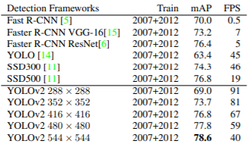
Table 3 represents the results of YOLOv2. It is faster and more accurate than prior detection methods and it can run on different resolutions for an easy tradeoff between speed and accuracy.
YOLOv3 [12] refined the design by using multi-scale prediction and bounding box prediction using logistic regression. While the accuracy increased dramatically with this version, it traded off against speed which reduced from 45 to 30 frames per second.
Table 3 YOLOv2 results [11]
YOLOv3 uses a variant of Darknet, a framework to train neural networks, which originally has 53 layers. For the detection task, another 53 layers are stacked onto it, accumulating to a total of a 106-layer fully convolutional architecture. This explains the reduction in speed in comparison with the second version, which only has 30 layers.
Improvements made in YOLOv3:
Bounding box prediction: YOLO_v3 predicts an objectness score for each bounding box using logistic regression. The width and height of the box are predicted as offsets from cluster centroids. We predict the center coordinates of the box relative to the location of filter application using a sigmoid function.
Class prediction: uses of Logistic function Classifier for class prediction instead of a softmax function as used in YOLO v2. This helps in multi-label classification.
Predictions across scales: YOLOv3 uses Feature Pyramid Networks to make predictions at varied scales. The last prediction benefit from all the prior computation.
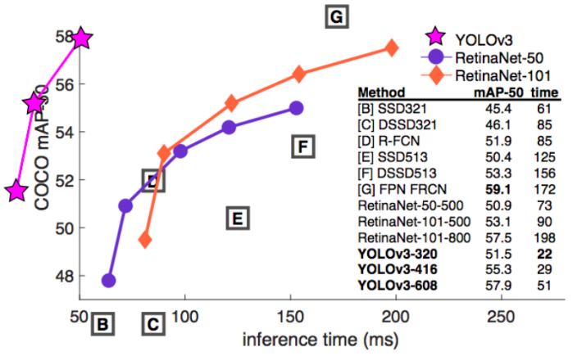
Figure 4 represent comparison between YOLOv3 and other detectors. It is relatively fast and accurate but not the most accurate.
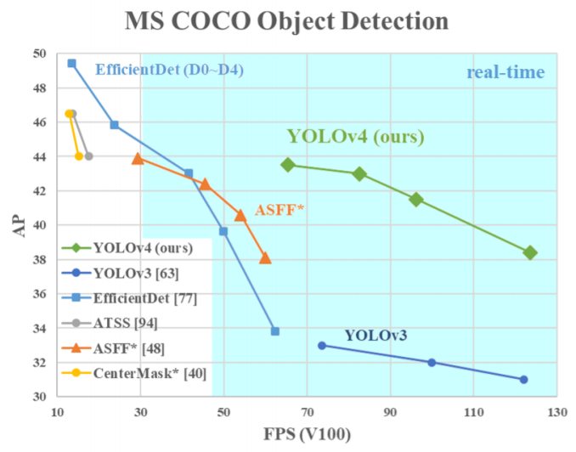
YOLOv4 [13] is an efficient and powerful object detection model that enables anyone with a 1080 Ti or 2080 Ti GPU to train a super-fast and accurate object detector. It has improved in terms of accuracy and speed.
Figure 4 YOLOv3 compared to other detectors [12]
Figure 5 represent a comparison of YOLOv4 and other object detectors. YOLOv4 runs twice faster than EfficientDet with comparable performance. In addition, AP (Average Precision) and FPS (Frames Per Second) increased by 10% and 12% compared to YOLOv3.
YOLOv4’s architecture is composed of CSPDarknet53 as a backbone, spatial pyramid pooling additional module, PANet path-aggregation neck and YOLOv3 head.
Figure 5 YOLOv4 compared to other detectors [13]
CSPDarknet53 can enhance the learning capability of CNN. The spatial pyramid pooling block is added over CSPDarknet53 to increase the receptive field and separate out the most significant context features. Instead of Feature pyramid networks (FPN) for object detection used in YOLOv3, the PANet is used as the method for parameter aggregation for different detector levels.

Related work
Human gait depends on a complex interplay of major parts of the nervous, musculoskeletal, and cardiorespiratory systems. A person’s gait pattern is strongly influenced by age, personality, and mood [14]. Walking is a sensitive indicator of overall health status, and the self-selected walking speed closely correlates with individual life expectancy in elderly persons [15].
The causes of gait disorders include neurological conditions, orthopedic problems and medical conditions. If a gait disorder has an acute onset, cerebrovascular, spinal, and neuromuscular causes should be considered, as should adversely drug effects and psychiatric disorders. Possible medical causes include cardiorespiratory or metabolic disturbances and infections [16].
To analyze gate pattern in terms of normal and pathological we need a definition and parameters that describe them. An article published in 2016 by Walter Pirker and Regina Katzenschlager [17] provides an overview on the phenotypic spectrum, work-up and treatment of gait disorders. It describes the physiological basis of gate, clinical examination of gate and gate disorders classifications.
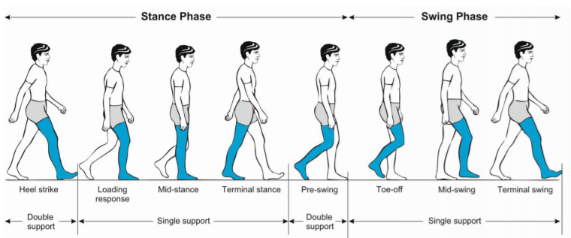
Initiating gait requires a stable upright body position, functioning postural reflexes are necessary to assume and sustain a stable body position. The gait cycle (Figure 6) is divided into the stance and swing phase [18][19]. The stance phase constitutes approximately 60 % of the gait cycle and is subdivided into:
Figure 6 Phases of normal gate cycle [17]
- initial contact (heel strike).
- loading response.
- mid-stance.
- terminal stance.
- pre-swing. Both feet are on the ground at the beginning and end of the stance phase. Each of these two double support periods lasts for approximately 10–12 % of the gait cycle.
The swing phase takes up about 40 % of the gait cycle and is subdivided into:
- initial swing (toe off).
- mid-swing (tibia vertical).
- terminal swing, terminated by the heel striking the ground.
Important measures of gait include:
- walking speed.
- cadence (number of steps per unit of time).
- walking base width (measured from midpoint to midpoint of both heels).
- step length (measured from the point of foot contact to the point of contralateral foot contact).
- stride length (linear distance covered by one gait cycle).
The preferred walking speed in healthy adults up to the age of 59 years is approximately 1.4 m/s [20]. Average stride lengths in healthy adults’ range between 150 and 170 cm. The average cadence in young adults was reported to range between 115 and 120 steps/min. Ageing is associated with a decline in gait speed and step length whereas cadence remains relatively stable. Elderly subjects prefer a 40 % wider step width than young persons (average step width in elderly women approximately 8 cm and in elderly men 10 cm) [21].
Clinical examination of gait provides an overview of the function of the structures involved in walking. In the examination process it is important to observe the entire patient, from the front and from all sides, while walking over a distance of at least several meters without obstacle and it is recommended that the patient wont were shoes. The parameters that should be clinically examined include step length, stride length, step width, rhythm, speed, posture, swinging of arms and legs and the duration and type of contact with the floor [22].
The Bruneck study, has provided valuable epidemiological data on various gait disorders in 488 persons: between the ages of 60 and 97 years one third of this population had a gait disorder, with a marked increase in prevalence with age, between the ages of 60 and 69 years, the prevalence was 10 % and in those over 80 years it was >60 % [24]. In two thirds of those affected by any gait disorder, the cause was neurological and in approximately one half, the cause was nonurological. Among the neurological causes, sensory ataxia (18 %) and parkinsonian (16 %) gait disorders were the most common, followed by frontal (8 %), cerebellar ataxic gait disorders, cautious gait and hypotonic paretic, spastic, vestibular and dyskinetic gait disorders. In approximately one third of the patients the gait disorder was due to more than one neurological cause, making a precise classification difficult [24]. It must be pointed out that these prevalence rates refer to elderly people living in the community. Substantially higher rates of gait disorders are to be expected among geriatric hospital and nursing home residents [28].
The gate disorders can be divided into the following categories:
- Musculoskeletal gait disorders: Osteoarthritis and skeletal deformities of the lower extremities are common reasons for non-neurological gait disorders in adults. The resulting orthopedic gait disturbances may be characterized by a limited range of motion, avoidance of weight-bearing and asymmetry or limping.
- Neuromuscular and myelopathic gait disorders: Peripheral paresis that is severe enough to cause a gait disorder can usually be detected on standard clinical neurological examination.
- Gait disorders associated with brain dysfunction: This category encompasses all gait disorders related to brain disease or dysfunction, i.e., the neurological gait disorders in a narrower sense. It largely overlaps with the categories of middle and higher-level gait disorders in the classification proposed by Nutt et al. [25–27]
Patients with gait disorders may benefit from multimodal rehabilitation, gait training, use of assistive devices and fall prevention measures. Commonly used exercise interventions such as muscle strength, power, and resistance training as well as coordination training can improve habitual and maximum gait speed in elderly subjects [29].
For the detection task we searched for articles that use YOLO algorithm to detect objects. Guoxu Liu, Joseph Christian Nouaze, Philippe Lyonel Touko Mbouembe and Jae Ho Kim [30] proposed an improved tomato detection model called YOLO-Tomato based on YOLOv3 to deal with automatic fruit detection in complicated environment conditions. The model overcomes environment conditions like illumination variation, branch, leaf occlusion and tomato overlap.
The suggested method was achieved through two approaches, the first incorporated the dense architecture based on YOLOv3 for feature extraction, which can make better reuse of features and help to learn more accurate models. The second replaced the traditional R-Bbox with a proposed C-Bbox, better matching the tomato shape and providing more precise IoU for the NMS process, and reducing prediction coordinates.
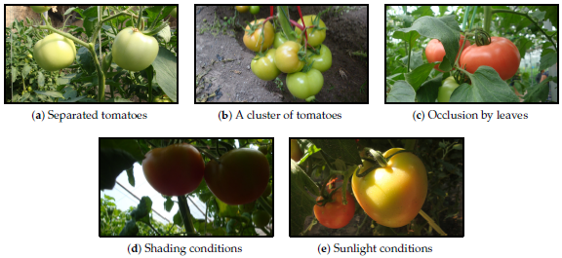
The images in the tomato dataset used in the paper were captured using a digital camera (Sony DSC-W170, Tokio, Japan) with a 3648 _ 2056-pixel resolution. All the images were taken under natural daylight conditions, including several disturbances: illumination variation, occlusion, and overlap. A total of 966 tomato images were captured and divided into a training set and a test set. The training set consisted of 725 images which contained 2553 tomatoes, and the remaining 241 images which included 912 tomatoes made up the test set. Figure 7 shows some samples from the dataset under different environments. The data augmentation technique was used in this study. While training, before input into the model, each image was randomly sampled by the entire original image or scaling and cropping.
Figure 7 Tomato samples with different growing circumstances: (a) two separated tomatoes, (b) a cluster of tomatoes, (c) occlusion case, (d) shading conditions and (e) sunlight conditions.

To better reuse the features for tomato detection, a densely connected architecture is incorporated into the YOLOv3 framework. With this modification, the extracted features can be utilized more efficiently, especially for those from low-level layers, which can be expected to improve the accuracy of detection. To make the model more compact, a transition layer was placed between any two consecutive dense layers. Owing to the direct connection between any two layers inside the dense block, the network can learn more rich features and improve the representation of tomatoes.
Different experiments were conducted to verify the performance of the proposed method. An ablation study of the dense architecture and C-Bbox showed the effectiveness of each modification. Incorporating dense architecture could contribute about 2% improvement on F1 score. Based on the dense architecture, a further adoption of C-Bbox could contribute another 0.65% improvement on the F1 score.
Experiments under different illumination and occlusion conditions were also conducted. The proposed model showed comparable results under both sunlight and shading conditions. This indicates the robustness of the model to illumination variation. The model shows a divergence under different occlusion conditions. Under slight occlusion conditions, the correct identification rate of YOLO-Tomato reaches 94.58%. This is more than 4% higher than that of severe conditions. This was mainly attributed to the loss of semantic information by severe occlusion.
Another article about object detection, named YOLO based Human Action Recognition and Localization [32] proposes a YOLO-based approach to detect, localize and recognize actions of interest in almost real-time from frames obtained by a continuous stream of video data that can be captured from a surveillance camera. The model takes input frames after a specified period and can give action label based on a single frame. Combining results over specific time allows to predict the action label for stream of video.
The dataset used in their paper is LIRIS human activities dataset [33]. The dataset contains the videos in form of RGB frames. There are 10 visual annotated actions which include human-human, human-object, and human-human-object interactions. The dataset contains 367 actions from 167 videos. These 167 videos are further divided into 109 training and 58 testing videos. Per class ratio of training to test data is kept approximately 2:1.
To train the model they converted the LIRIS dataset labels to usable label files for YOLO. YOLO requires a .txt file for each frame with a line for each action in the frame. Further YOLO requires some files to start training which are: Total number of action classes, text file with the path to all frames which we want to train, text file with names of all action classes, the path to save trained weight files, a configuration file with all layers of YOLO architecture and pre-trained convolutional weights. The value of filters in the configuration file of YOLO (.cfg file) for second last layer is not arbitrary and depends on the total number of classes [34].
For testing purpose, 30 frames in a video were selected for recognition and localization of action, from the testing video frames. After performing action detection on each frame, the action label detected in more than 5 frames and having a confidence threshold of 0.5 over 30 frames is classified as concluding action label in the video. The combined confidence score of the action label overall is calculated by averaging all confidence score obtained.
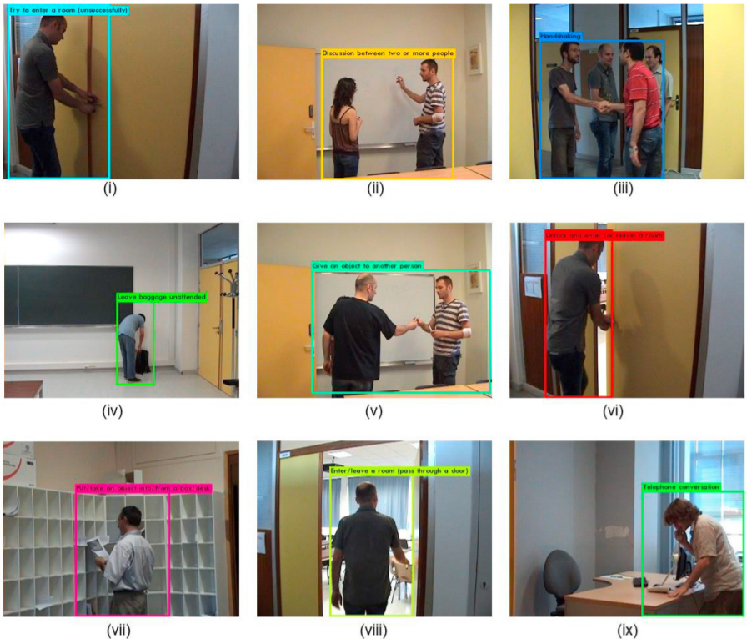
In training process, each iteration took about 5.25s. The model was trained up to 40000 iterations and average loss was found to be 0.32 for the batch size of 32 with 8 subdivisions. For testing, average recognition of action in frame takes about 61ms that is 15-16 FPS (Frame per second). Hence, Real-time recognition of action is feasible on off-the-shelf desktop PCs with a mid-level Graphics Processing Unit (GPU). The accuracy obtained on the test dataset is the primary evaluation metric for classification in the paper. The accuracy obtained by methodology proposed in this paper was found to be 88.372%.
The main finding of their study is that the proposed real-time model for human action recognition in video based on YOLO allows to recognize actions in a video even with a small number of frames. Example of action detection are shown in figure 8.
Figure 8 Recognition and Localization of actions. [32]

For the skeleton extraction task, we investigated an article that overcomes the challenge of skeleton extraction from natural images. Zavala-Mondragon, L.A., Lamichhane, B., Zhang, L. and Haan, G.D. [35], Propose a skeleton model estimation method for patient sleeping monitoring in a general clinical setting and focuses on the upper body only. This approach makes use of trained CNN that extracts movement information from posed skeleton depth images (referred to as CNN-SkelPose).
The dataset used in this research is made of videos recorded in a room setting and contained subject alternates between different poses and moves in different patterns. The ground truth of the skeleton model is obtained by manual annotation of each image in the video. Joints in the skeleton model is made to lie on the surface of the body. A simple tool was made to facilitate the annotation. The annotation tool also allows to extract patches around the selected joint locations which can be used to train models for joint detection.
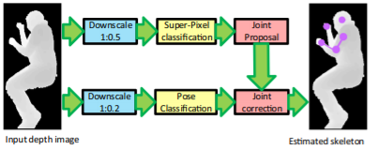
The proposed algorithm for skeleton model estimation, the CNN-SkelPose composed of super-pixel classification, clustering of the identified joints after the super-pixel classification, pose detection, and skeleton correction using the identified pose information. the processing flow for CNN-SkelPose is shown in Figure 9. The top row shows the flow for the super-pixel classification to compute a set of possible joints candidates. Simultaneously, the pose of the subject is also estimated, and this information is used to filter the detected joint locations. The downscaling of the input image is done to reduce computational cost
Figure 9 Proposed skeleton model estimation based on super-pixel classification and pose-based skeleton correction scheme. [35]
CNN-SkelPose identifies the possible joint locations based on the classification of each super-pixel. A super-pixel can be defined as a group of pixels that share common characteristics. Those super-pixels are recognized by a CNN classifier, which is trained with patches extracted from a training dataset video. The CNN Architecture consist of input layer, two stacked layers of Convolution-MaxPooling-Activation followed by a fully connected layer and a final output layer.
After super-pixel classification, a set of joint proposals are generated by clustering each predicted class. Clustering the proposed joint locations is used in a mean-shift algorithm which uses an image coordinate domain. There are multiple joint clusters for a joint type and only after the pose detection component the correct cluster is filtered.
The pose detection algorithm identifies 3 possible poses using trained CNN: Lying on the left side of the body, Lying on the right side of the body and Supine. CNN Network Architecture for pose detection: The proposed CNN network for pose detection composed of has an input layer, three stacked layers of Convolution-MaxPooling-Activation, two fully connected layer and an activation layer (the output layer).
Skeleton model correction is done using pose information of the subject inferred by our pose detector. If the subject is detected to be lying in supine position, final locations of the joints are set to the centers of the largest clusters obtained by clustering the super-pixel classification results. When the subject is detected as lying on the side of the body, it is unlikely that the shoulder and the elbow of the body side opposite to the camera are visible in image. As joints for both the left and the right hand might still be visible, first the cost to move from the detected shoulder joint to all the detected hand joint candidates is computed. Dijkstra’s shortest-path algorithm is used to determine this cost. The final hand joint is set as the candidate with the shortest path from the shoulder. The visible elbow joint is set as the center of the elbow candidate with the shortest Euclidean distance to the path connecting the joints of the shoulder and the hand. After this, the only remaining joint to be set is the hand that is opposite to the camera. This is set as the largest cluster at a higher depth value than that of the visible shoulder joint.
CNN-SkelPose gives better results compared to the Skeltrack model. When the subject is lying on one side of the body Skeltrack performs poorly while CNN-SkelPose provides good skeleton in comparison to the reference skeleton model, in this pose Skeltrack has an error of 50 cm in detection hand joint while in CNN-SkelPose the error is reduced by factor of 5. In lying on the right-side pose, the suggested model achieved a precision greater than 0.5 for all visible joints. Regarding the super-pixel component, for lying still subjects, the classifier formatting clear clusters where each joint is correctly isolated, in contrast to situations of motion subject where clear clusters are degraded especially for hand joints. Also observed, a confusion between left and right arm joints. The smallest errors are present in the detection of the head and the shoulders joints. Higher stability of the estimated skeleton is obtained when the subject is supine. By comparing the results of the skeleton model estimated using CNN-SkelPose with and without pose, information can be deduced that leveraging pose information leads to increasing precision.

Expected Achievements
The main objective of our project is to build an automated system that takes as input RGB video and transforms it into the skeleton model using YOLO algorithm and CNN and transferring the learned features from OpenPose pre-trained model to our system and so minimizing the training process. The system will serve the rehabilitation hospital with conducting research on patients before and after surgery or injury. Our expectations are to make our model as accurate and fast as possible, so the hospital will get the most beneficial report in a short time.

Expected project goals:
- A fast and accurate object detection method that does not require expensive means to perform the detection. The system will use YOLO algorithm to perform the detection on RGB video that can be recorded on any simple camera.
- We expect to build a reliable and accurate CNN, therefor we learn the appropriate unique Hyperparameters for our system to obtain the lowest possible loss in the training phase.
- Our system will serve the rehabilitation hospitals. The system will help researchers with the study on patients before and after surgery or injury. The system will help doctors decide on which procedure to preform based on the data acquired from our system and thus can save lives and prevent medical malpractice.
- A Big Data system which consumes a lot of information and provide large amounts of information compared to the low price of the system activation. The system will use recorded data from cheap and affordable camera like which is comparatively cheap as opposed to the incredibly expensive equipment typically used in hospitals for medical examinations, increase the availability of this kind of tech in places without financial means, basically it’s a low-cost solution for hospitals who spend a lot of money for expensive systems for the same objective i.e., the CT scanner.

Research Process
Today most of the interpretations of medical data are being done by medical experts. In terms of image interpretation by human expert, it is quite limited due to its subjectivity, prone to human error, may have large variations across different experts, complexity of the video, and fatigue.
The project motivation is to give rehabilitation and healthcare centers an accurate, fast, and low-cost gait evaluation system. After the success of deep learning in other real-world application, it can also provide efficiency and accuracy in the medical field. Our goal is to gain a top-level accuracy on our project, so our work can be used in rehabilitation and healthcare centers and the system will be a benchmark for potential clinical and home applications, to use deep learning techniques to automate evaluation process.
The main technology used in our project to provide best performance and accuracy is YOLO algorithm. It is a real-time object detection models that operate on a video sequence. The detector architecture is one stage which means it can detect objects without the need for a preliminary step.
In our project we first aimed to choose the best version of YOLO in terms of accuracy and speed, for human detection. After comparing performance between all it is known versions, we decided to build the project based on YOLOv4 []. This version of YOLO makes real-time detection a priority and conducts training on a single GPU.
In this project we are going to explore all the layers of YOLOv4, the specific techniques it is built on and the data augmentation strategies deployed in it. In addition, we researched how to train YOLOv4 on a custom dataset to increase accuracy.
We utilized a supervised deep learning approach. Therefore, the structuring and labeling of the dataset is a fundamental step for performing the correct training and evaluation of the model.
The YOLOv4 architecture research include the following:
- Dense Block:
A Dense Block contains multiple convolution layers with each layer Hi composed of batch normalization, ReLU, and followed by convolution. It increases the receptive field of the entire network.
Instead of using the only last layer output, hi takes the output of all previous layers as well as the original as its input. i.e., x₀, x₁, …, and xᵢ₋₁. Each Hi below outputs four feature maps. Therefore, at each layer, the number of feature maps is increased by four — the growth rate.[36]
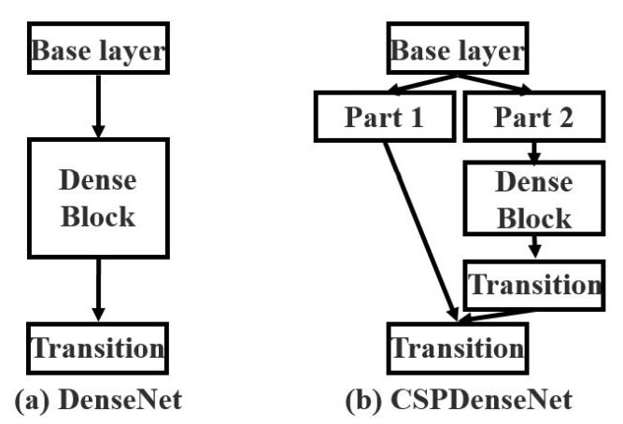
- Cross-Stage-Partial-Networks (CSP):
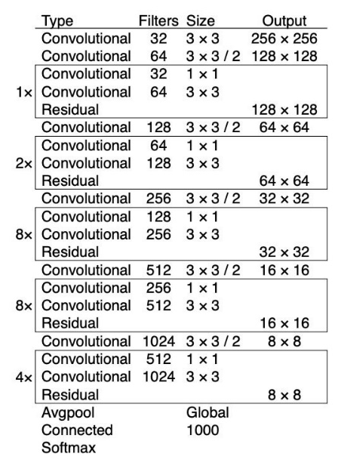
CSPNet separates the input feature maps of the DenseBlock into two parts. The first part x₀’ bypasses the DenseBlock and becomes part of the input to the next transition layer. The second part x₀’’ will go thought the Dense block as below (Figure 10). This new design reduces the computational complexity by separating the input into two parts with only one going through the Dense Block.
Figure 10 DenseNet Block and CSPDenseNet Block [37]
- CSPDarknet53 for the backbone network:
CSPDarknet53 is a convolutional neural network and backbone for object detection that uses DarkNet-53 (Figure 11). It employs a CSPNet strategy to partition the feature map of the base layer into two parts and then merges them through a cross-stage hierarchy. The use of a split and merge strategy allows for more gradient flow through the network.
- Bag of Freebies:
Set of techniques that help during training without adding much inference time. Some popular techniques include data augmentation (Figure 12), random cropping, shadowing, dropout, etc.
Figure 11 Darknet-53
Here is the list of techniques used, according to the paper [13]:
BoF for the backbone: CutMix and Mosaic data augmentation, DropBlock regularization, Class label smoothing.
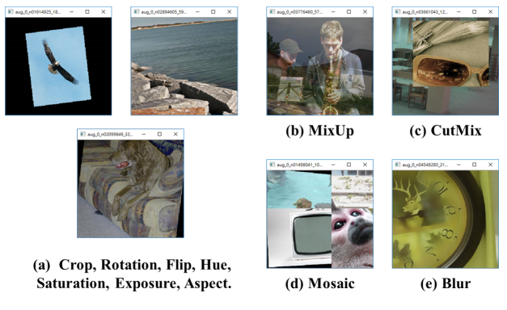
BoF for the detector: CIoU-loss, CmBN, DropBlock regularization, Mosaic data augmentation, self-adversarial training, eliminate grid sensitivity, using multiple anchors for a single ground-truth sample, cosine annealing scheduler, optimizing hyperparameters, random training shapes.
Figure 12 Various methods of Data Augmentation [13]
- Bag of Specials:
Bag-of-Specials (BoS) is another family of techniques. Unlike BoF, they change the architecture of the network and thus might augment the inference cost a bit. We already saw SAM, PAN, and SPP, which all belong to this family.
Here is the complete list, from the paper [13]:
BoS for backbone: Mish activation, cross-stage partial connections (CSP), multi-input weighted residual connections (MiWRC)
BoS for detector: Mish activation, SPP-block, SAM-block, PAN path-aggregation block, DIoU-NMS.

Process
Object detection involves the task of teaching a computer to recognize objects in an image by drawing a box around them (called a bounding box), and correctly classifying that box among a limited scope of class labels. This process called training and it is done through a suitable labeled dataset. To teach our YOLOv4 model to detect the patients we need to train it on a custom dataset.
In our project we use a custom dataset consist of 120,000 images, acquired by Bergamo hospital. Two video cameras record 3600 frames for each acquisition. Each acquisition records RGB video. The frames will be labeled according to the YOLOv4 input format with bounding boxes around objects and label.
To be able to train our custom dataset with YOLOv4, it is mandatory that our dataset follows the YOLO format:
- Each image from the dataset would associate with a .txt file having the same name, which contains the object classes and their coordinate following this syntax: <object-class> <x_center> <y_center> <width> <height>. The index of the <object-class> from label file .txt is corresponded to the index of the classes name, e.g, <object-class> of object1_name, object2_name, object3_name are 0, 1, 2 respectively.
- File classes.names contains the names of your objects following format:

Object1_name
Object2_name
.
.
.
Objectn_name
- train.txt and test.txt files contain file paths of your training images and testing images. These two files share the same format syntax as data/<image_path>.
Concerning a relatively small dataset and short developing period we intend to apply transfer learning technique to overcome overfitting and to gain high performance in the system. Thus, we are going to use OpenPose SDK which conducts motion classification in real time scenarios of multiple people. openPose pipeline according to [38] is as follows (Figure 13):
The system takes as input a color image of a fixed size and produces the 2D locations of anatomical key points for the person in the image as we see in (e).
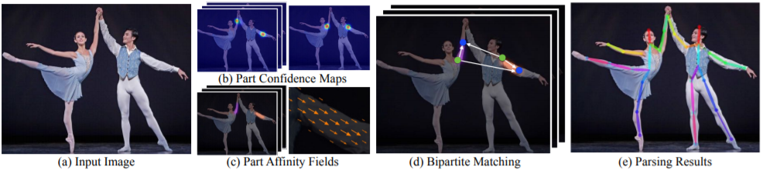
First a feedforward network predicts a set of 2D confidence maps of the body part locations (b) and a set of 2D vectors fields of part affinity fields, which encode the degree of association between parts (c). The set has N confidence maps, one per part and a vector per limb. Part pairs for taking into consideration as limbs, each image location encodes a 2D vector for then the confidence maps and the part affinity fields are parsed by greedy inference (d) to make the 2D key points output for every person in the image.
Figure 13 OpenPose pipeline [38]
To extend our knowledge about the project we have learned the following:
- Convolutional Neural Networks for Visual Recognition course from Stanford university.
- YOLO algorithm architecture and the difference between all its versions.
- Gait analysis and gait disorders.
- Deep learning concepts such as training process of CNN network, how to set hyper parameters and the effect they have on the system.
- Different architectures that can be used for our project.
- Different approaches to preprocess data before feeding it into the CNN network.

The learning process has gained us extensive knowledge about the aspects of YOLO and its fundamentals, also we achieved understanding of deep learning architectures. This process contributed to the formulation of the background and related work for our project book, and we gained meaningful conclusions to the implementation of our project.
Our challenges:
The main challenge that we have encountered is learning and understanding the deep learning topic for the first time and conduct an extensive research on the subject. It was achieved by taking a virtual course from an upscale university which was based on previous related courses which we did not participate in. We also did an extensive research Regarding deep learning in general and YOLO algorithm in particular, to gain deep understanding of how deep learning systems based on YOLO algorithm trained and detect objects of different kinds.
The learning process was mostly theoretical, so we did not gain practical understanding of the topic. furthermore, the topic of deep learning is relatively new and constantly under development, thus the evaluation process is through trial and error. There is no concrete explanation of the reasons that some hyperparameters values are superior to other values.

Product:

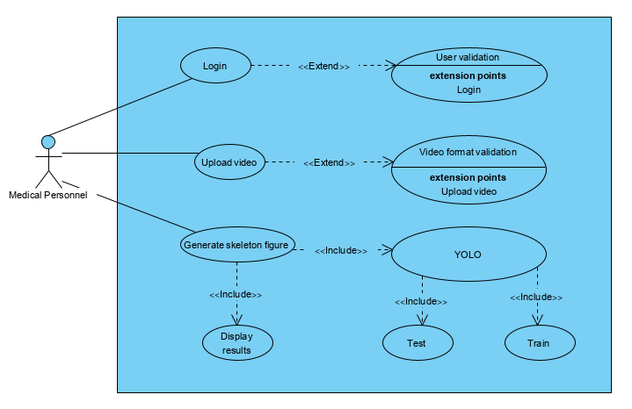
use case diagram:

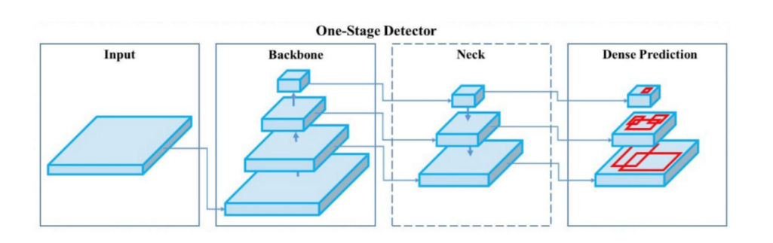
general yolov4 architecture:

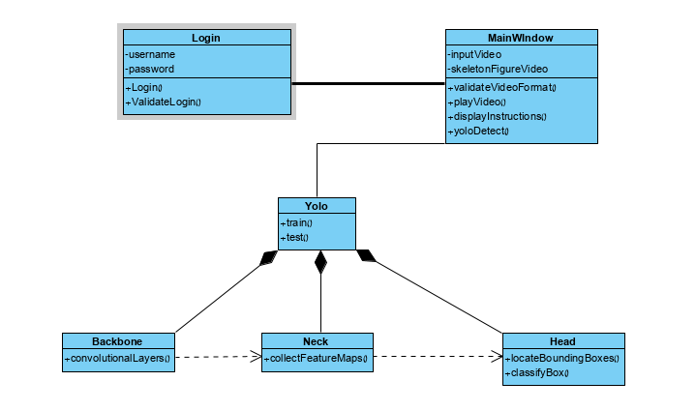
Class diagram:

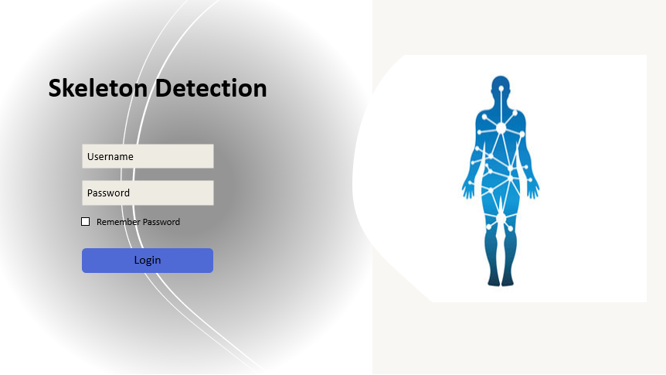
Login window:

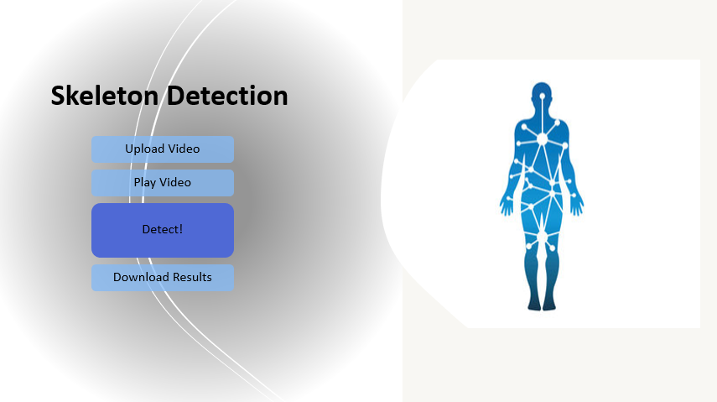
Main window:

Evaluation/Verification Plan
Case no. | Test case | Expected result
1 | Train an empty dataset | Popup Error – No dataset
2 | Login with valid user | Display main menu
3 | Login with invalid user/password | Popup Error – Invalid user or password
4 | Upload Invalid video format | Popup Error – Invalid video format
5 | Upload valid video format | The system will analyze the video
6 | Press ‘Detect!’ | The system will detect the video
7 | Press ‘Download Results’ | The user will be able to download the results from case #7

References

[1] Roy B. Davis III, Sylvia Õunpuu, Dennis Tyburski, James R. Gage, “A gait analysis data collection and reduction technique”, Human Movement Science Volume 10, Issue 5, October 1991, Pages 575-587.

[2] Walter Pirker, Regina Katzenschlager, “Gait disorders in adults and the elderly”, October 2016.

[3] Daniele Regazzoni, Andrea Vitali, Filippo Colombo Zefinetti, Caterina Rizzi, “Gait Analysis in the Assessment of Patients Undergoing a Total Hip Replacement”, In ASME International Mechanical Engineering Congress and Exposition (Vol. 83518, p. V014T14A003). American Society of Mechanical Engineers.‏

[4] Kwang Gi Kim, PhD, “Deep Learning”, Healthcare Informatics Research October 2016.

[5] Harry Blum, “Biological shape and visual science (part I)” Journal of Theoretical Biology Volume 38, Issue 2, February 1973, Pages 205-287.

[6] D. Marr, H. K. Nishihara, “Representation and recognition of the spatial organization of three-dimensional shapes”, February 1978.

[7] Irene Anindaputri Iswanto, Tan William Choa, Bin Li, “Object Tracking Based on Meanshift and Particle-Kalman Filter Algorithm with Multi Features”, Procedia Computer Science Volume 157, 2019, Pages 521-529.

[8] Omar Javed, Mubarak Shah, “Tracking and Object Classification for Automated Surveillance “, ECCV '02: Proceedings of the 7th European Conference on Computer Vision-Part IV, May 2002, Pages 343–357.

[9] MATE KRIŠTO, MARINA IVASIC-KOS, (Member, IEEE), AND MIRAN POBAR, “Thermal Object Detection in Difficult Weather Conditions Using YOLO”, July 2020.

[10] Joseph Redmon, Santosh Divvala, Ross Girshick, Ali Farhadi, “You Only Look Once: Unified, Real-Time Object Detection”, May 2016.

[11] Joseph Redmon, Ali Farhadi, “YOLO9000: Better, Faster, Stronger”, Dec 2016.

[12] Joseph Redmon, Ali Farhadi, “YOLOv3: An Incremental Improvement”, Apr 2018.

[13] Alexey Bochkovskiy, Chien-Yao Wang, Hong-Yuan Mark Liao, “YOLOv4: Optimal Speed and Accuracy of Object Detection”, Apr 2020.

[14] Ebersbach G, Sojer M, Muller J, Heijmenberg M, Poewe W. Sociocultural differences in gait. Mov Disord. 2000;15(6):1145–7.

[15] Studenski S, Perera S, Patel K, Rosano C, Faulkner K, Inzitari M, et al. Gait speed and survival in older adults. JAMA. 2011;305(1):50–8.

[16] Alexander NB, Goldberg A. Gait disorders: search for multiplecauses. CleveClin JMed. 2005;72(7):586.

[17] Pirker, W., Katzenschlager, R. Gait disorders in adults and the elderly. Wien Klin Wochenschr 129, 81–95 (2017). https://doi.org/10.1007/s00508-016-1096-4

[18] Ružicka E, Jankovic JJ. Disorders of gait. In: Jankovic ˇ JJ, Tolosa E, editors. Parkinson’s disease and movement disorders, 4th edn. Philadelphia: Lippincott, Williams and Wilkins; 2002. pp. 409–29.

[19] Lim MR, Huang RC, Wu A, Girardi FP, Cammisa FP Jr.. Evaluationof theelderlypatientwithanabnormalgait. JAm AcadOrthop Surg. 2007;15(2):107–17.

[20] Bohannon RW, Williams Andrews A. Normal walking speed: a descriptive meta-analysis. Physiotherapy. 2011;97(3):182–9.

[21] Aboutorabi A, ArazpourM, BahramizadehM,Hutchins SW, Fadayevatan R. The effect of aging on gait parameters in able-bodied older subjects: a literature review. Aging Clin ExpRes. 2015;doi:s40520-015-0420-6.

[22] Snijders AH, van de Warrenburg BP, Giladi N, Bloem BR. Neurological gait disorders in elderly people: clinical approach andclassification. LancetNeurol. 2007;6(1):63–74.

[23] Ružicka E, Jankovic JJ. Disorders of gait. In: Jankovic ˇ JJ, Tolosa E, editors. Parkinson’s disease and movement disorders, 4th edn. Philadelphia: Lippincott, Williams and Wilkins; 2002. pp. 409–29.

[24] Mahlknecht P, Kiechl S, Bloem BR, Willeit J, Scherfler C, Gasperi A, et al. Prevalence and burden of gait disorders in elderly men and women aged 60–97 years: a populationbasedstudy. PLOSONE. 2013;8(7):e69627.

[25] Nutt JG, Marsden CD, Thompson PD. Human walking and higher-level gait disorders, particularly in the elderly. Neurology. 1993;43(2):268–79.

[26] Nutt JG. Classification of gait and balance disorders. Adv Neurol. 2001;87:135–41.

[27] Nutt JG. Higher-level gait disorders: an open frontier. Mov Disord. 2013;28(11):1560–5.

[28] Sudarsky L. Gait disorders: prevalence, morbidity, and etiology. AdvNeurol. 2001;87:111–7.

[29] Hortobagyi T, Lesinski M, Gabler M, VanSwearingen JM, Malatesta D, Granacher U. Effects of three types of exercise interventions on healthy old adults’ gait speed: A systematic review and meta-analysis. Sports Med. 2015;45(12):1627–43.

[30] Sensors, EISSN 1424-8220, Published by MDPI

[31] He, K.; Zhang, X.; Ren, S.; Sun, J. Deep residual learning for image recognition. In Proceedings of the IEEE Conference on Computer Vision and Pattern Recognition, Las Vegas, NV, USA, 30 June 2016; pp. 770–778.

[32] Shinde, Shubham & Kothari, Ashwin & Gupta, Vikram. (2018). YOLO based Human Action Recognition and Localization. Procedia Computer Science. 133. 831-838. 10.1016/j.procs.2018.07.112.

[33] C Wolf, J. Mille, E. Lombardi, O. Celiktutan, M. Jiu, E. Dogan, G. Eren, M. Baccouche, E. Dellandrea, C.-E. Bichot, C. Garcia, B. Sankur, Evaluation of video activity localizations integrating quality and quantity measurements, In Computer Vision and Image Understanding (127):14-30, 2014.

[34] “Start training YOLO with our own data” [Online, Accessed on Mar 12, 2018]. Available at: http://guanghan.info/blog/en/my-works/trainyolo/

[35] Zavala-Mondragon, L.A., Lamichhane, B., Zhang, L. et al. CNN-SkelPose: a CNN-based skeleton estimation algorithm for clinical applications. J Ambient Intell Human Comput 11, 2369–2380 (2020). https://doi.org/10.1007/s12652-019-01259-5

[36] Gao Huang, Zhuang Liu, Laurens Van Der Maaten, and Kil-ian Q Weinberger. Densely connected convolutional net-works. InProceedings of the IEEE Conference on Computer Vision and Pattern Recognition (CVPR), pages 4700–4708, 2017

[37] Chien-Yao Wang, Hong-Yuan Mark Liao, Yueh-Hua Wu,Ping-Yang Chen, Jun-Wei Hsieh, and I-Hau Yeh. CSPNet:A new backbone that can enhance learning capability of cnn.Proceedings of the IEEE Conference on Computer Vision and Pattern Recognition Workshop (CVPR Workshop),2020

[38] Cao, Z., Simon, T., Wei, S.E. and Sheikh, Y., 2017. Realtime multi-person 2d pose estimation using part affinity fields. In Proceedings of the IEEE conference on computer vision and pattern recognition (pp. 7291-7299).

