Chapter 2 Word and phrase grammar

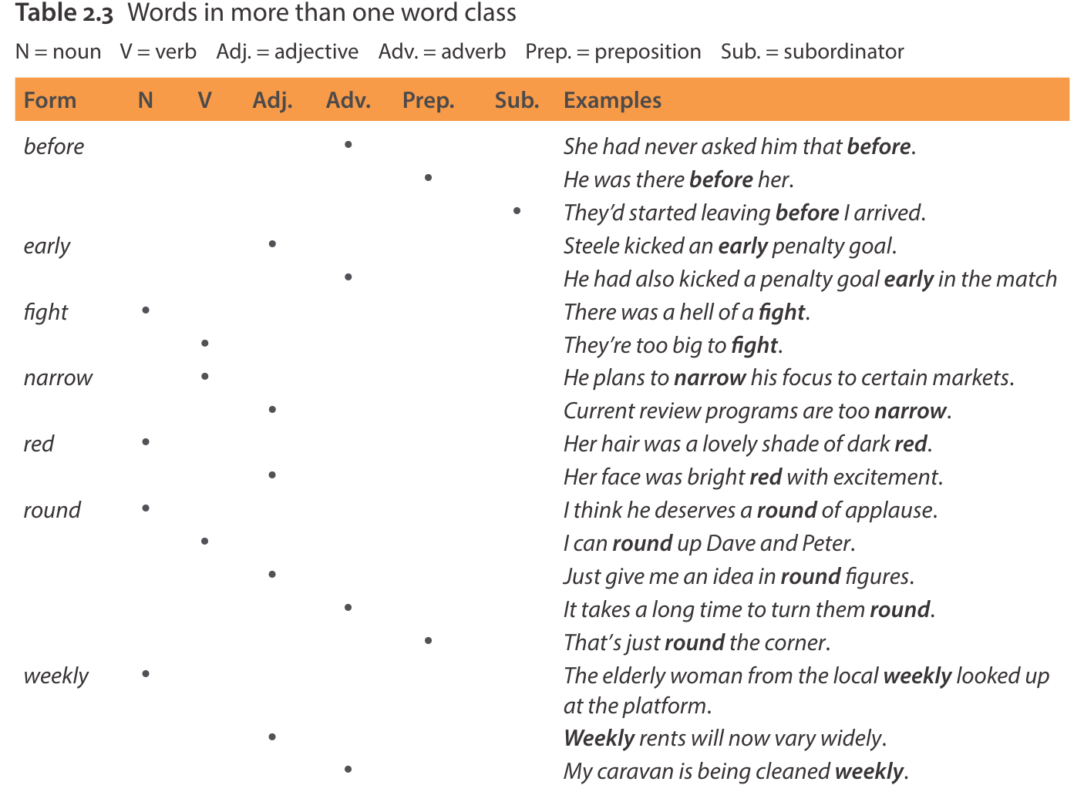

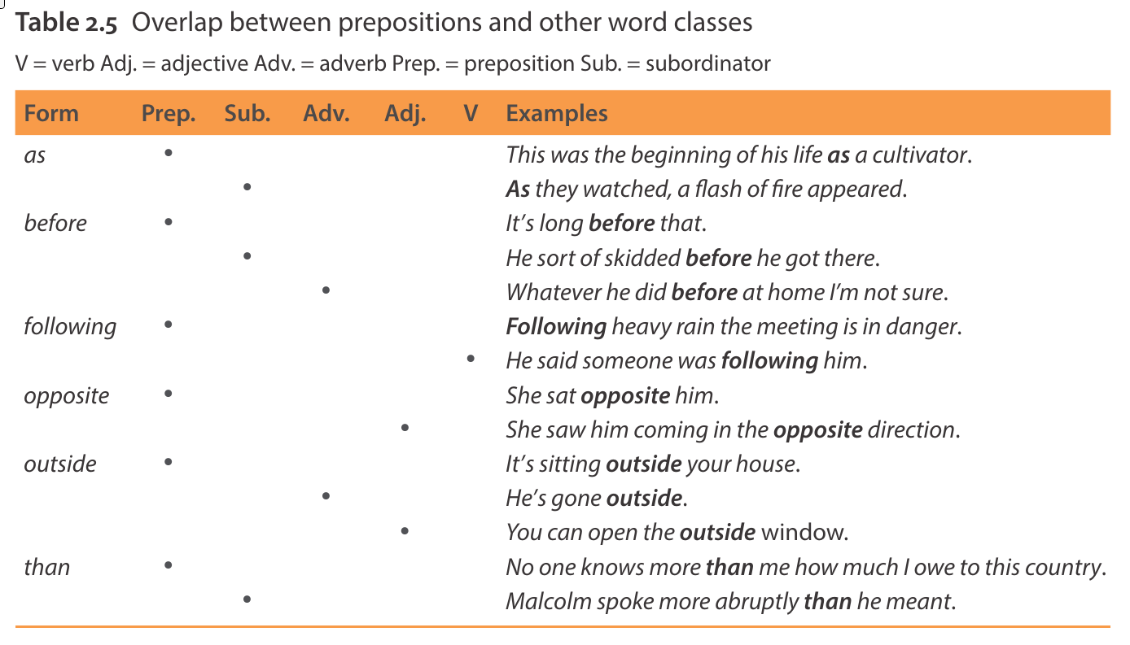

Chapter 3 Clause grammar

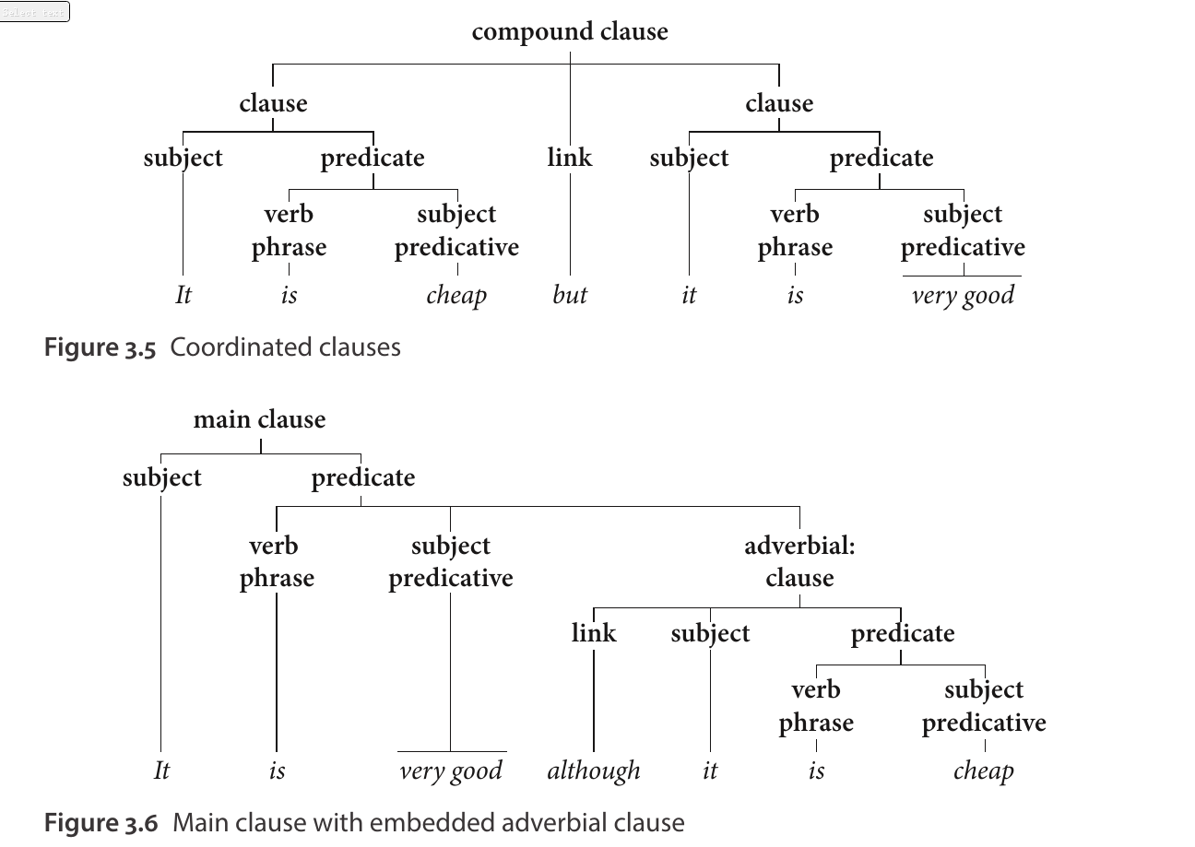

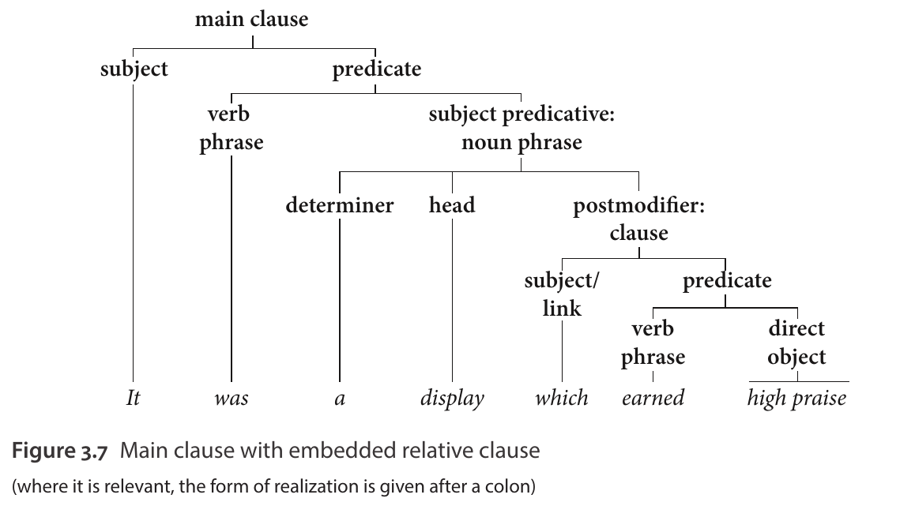

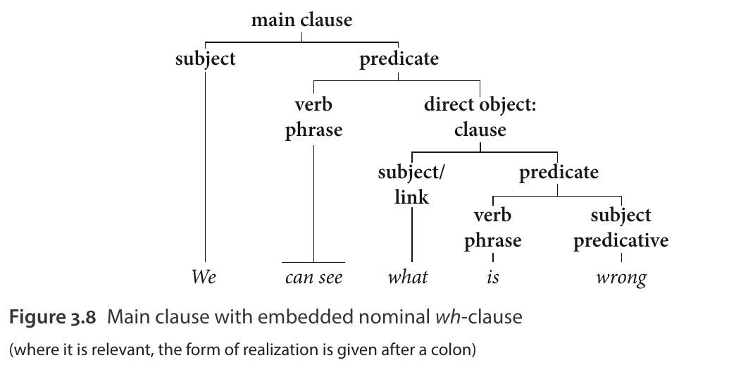

Chapter 6 Verbs

Activity verbs:

make, get, go, give, take, come, use, leave, show, try, buy, work, move, follow, put, pay, bring, meet, play, run, hold, turn, send, sit, wait, walk, carry, lose, eat, watch, reach, add, produce, provide, pick, wear, open, win, catch, pass, shake, smile, stare, sell, spend, apply, form, obtain, reduce

communication verbs:

say, tell, call, ask, write, talk, speak, thank, describe, claim, offer, suggest

mental verbs:

see, know, think, find, want, mean, need, feel, like, hear, remember, believe, read, consider, suppose, listen, love, wonder, understand, expect, hope, assume, determine

causative verbs

help, let, allow, require

verbs of simple occurrence

become, happen, change, die, grow, develop, occur

verbs of existence or relationship

seem, look, stand, stay, live, appear, include, involve, contain, exist, indicate, represent

aspectual verbs

start, keep, stop, begin, continue

题材

Conversation

Conversation中动词的常见语义域反映了该语域的典型交际目的：谈论人们做了什么（activity verbs）、他们的想法或感受（mental verbs），或他们说了什么（communication verbs）。在Conversation中，说话者通常在线进行交流，因此他们倾向于依赖这些语义域中相对较少的动词，并频繁重复相同的常用动词。以下Conversation示例展现了其中的许多特征：

A: Well I, I, I asked him what he wanted for Christmas.

B: Yeah?

A: and he said get me a padded shirt, he said, Joycie’s getting me one he said

and I want two.

B: Oh.

A: So that’s what I bought him. – And I was looking in the <unclear> yesterday – and

they sell them in You-Can’t-Go-Wrong for five ninety-nine <unclear> for Robert.

B: Mm. – Ten ninety-nine he paid for his. It’s a nice, nice thick one though.

<...>

A: Anyway, erm – we went to the Ca – Polly hadn’t seen them in the shops anywhere and

went to Caerphilly market on Saturday morning <unclear> and as we were coming

from it he said look there’s a shirt you want for Robert there. – So I thought well in

case I can’t get them anywhere else <unclear> the market and he said well we’ll have

one from here, twelve ninety-nine.

(conv)

除了主要存在动词 be 和 have 之外，本次Conversation中的所有主要动词都来自三个语义域：activity verbs：get、buy、sell、pay、go、come；communication verbs：ask、say；mental verbs：want、see、look、think、forget。这些动词通常含义动态，并且与有生命主语（通常是人称代词，例如“我”、“你”、“她/他”）一起出现。请注意，本次Conversation中最常用的动词被反复使用：get、go、say、want。

Fiction

Fiction的交际目的与Conversation类似，都报道虚构人物的肢体活动，以及他们的思想/感受和言语。然而，与Conversation相比，Fiction在动词选择上表现出广泛的词汇多样性（并且重复性较低）。Fiction作者有更多机会进行精心创作，而且Fiction文本通常具有审美价值，因此动词的选择也更加多样化

Academic。

Academic与其他两种语域截然不同。它通常使用简单的存在/关系或事件陈述来报告实体（具体和抽象）之间的关系。Academic报告的物理、心理或交流活动相对较少——即使报告了这些活动，也通常将其归因于某个无生命实体作为动词的主语

The 12 most common lexical verbs

• six are activity verbs: get, go, make, come, take, give;

• five are mental verbs: know, think, see, want, mean;

• one is a communication verb: say.

Verb derivation

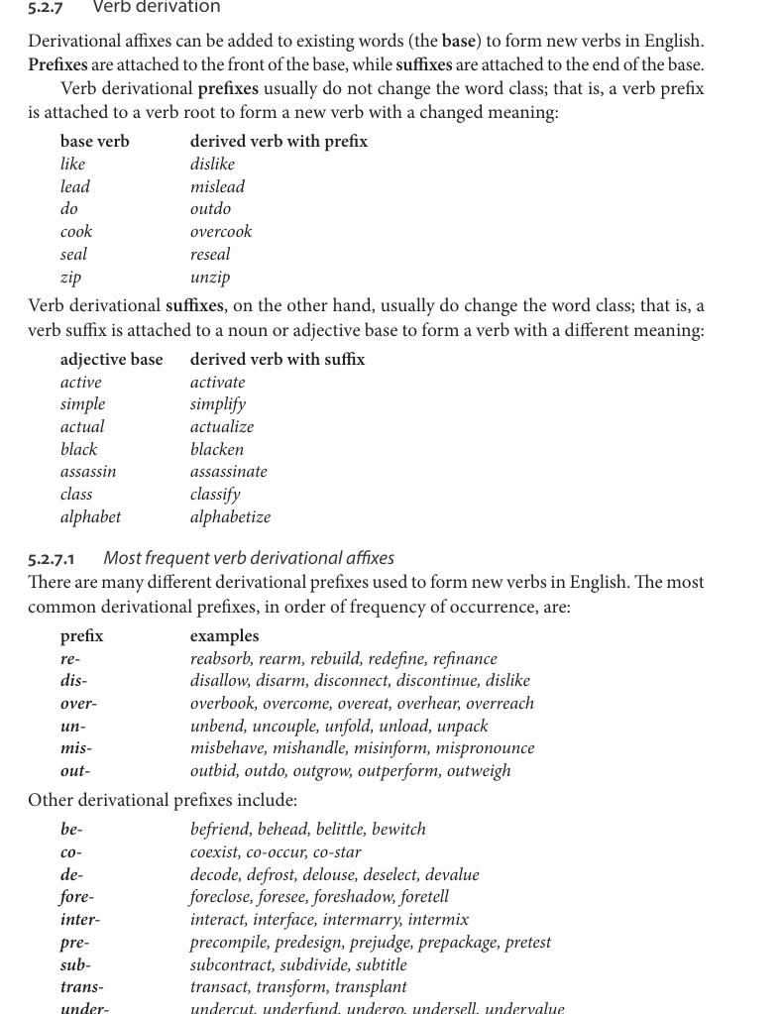

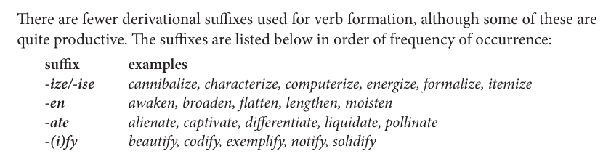

5.5 Copular verbs

– current copular verbs – be, seem, appear, keep, remain, stay

– resulting copular verbs – become, get, go, grow, prove, come, turn, turn out, end up, wind up.

Most common adjectives as subject predicative of copula “*be”：*

right, good, sure, true, different, important, difficult, possible, likely, nice, dead, necessary, afraid, available, funny, lovely, present, useful

12个：become, get, look, feel, seem, go, remain, keep, grow, sound, prove, appear

5.5.3.1

– likelihood – marked by seem and appear

– continuation of some current state – marked by remain, keep, stay

5.5.3.2 Sensory copular verbs

The sensory copular verbs – look, feel, sound, smell, taste

5.5.3.3 Resulting copular verbs

Become, get, go, grow, prove, come, turn, turn out ,end up, wind up