How to add a new control into Form Builder

*Note : Since this software uses jQuery & jQuery UI, understanding how these 2 libraries work is very helpful.*

Supposed you want to add a paragraph ( HTML element P )as a new control.

1. Index.html :
   1. Add the control into menu: Go to div with id ‘Controls’ and then add a line   
        
      <li id="Paragraph" class="ui-draggable"><img src="images/new_para.png" alt=""> Paragraph </li>  
        
      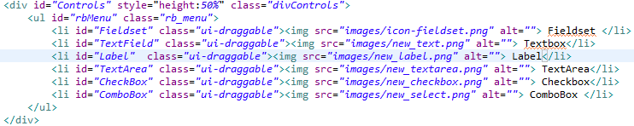
   2. Add the control tag :  
      Go to line 70 and add the following line  
      <div id="mainParagraph" class = "parentDiv"><p class="childControl clickthrough">[Paragraph]</p></div>  
      
   3. Add the properties box: Add a new div before tag </body>   
        
       <div id="ParagraphProbBox" style="display:none;margin-top:5px"> <p><label>Name:</label><input type="text" id=" ParagraphProbBox Name" style="width: 175px"/></p>  
      <p><label>Text:</label><input type="text" id=" ParagraphProbBox Text" style="width: 175px"/></p>  
       <p><label>Style:</label><textarea id="txtStyle" style=""></textarea></p> <p><input id="btn ParagraphProbBox OK" type="button" value="OK"/>  
      <input id="btn ParagraphProbBox Cancel" type="button" value="Cancel"/></p> </div>  
        
      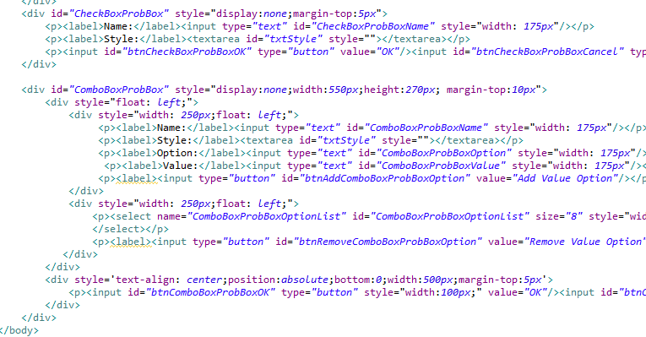
2. Add the class control :  
     
   Add a javascript name Paragraph.js into folder js and enter the following content  
     
   var Paragraph = $.buildClass({  
    className:'TextField',  
    constructor: function(){   
    this.propBoxID = "ParagraphProbBox";  
    this.el = $("#mainParagraph").clone();  
    this.uber.constructor();   
    }  
   }, mainControl);  
     
   Add a line in index.html to load this file :   
     
   <script type="text/javascript" src="js/Paragraph.js"></script>
3. Run the index.html and you see a new control