

**Tribhuvan University**

**Faculty of Humanities and Social Sciences**

**Thrift E-Commerce Web Application**

**A Proposal Report**

**Submitted to:**

**Department of Computer Application**

**Swoyambhu International College**

**In partial fulfillment of the requirements for the Bachelors in Computer Application**

**Submitted by**

**Ronish Maharjan**

**Puja Maharjan**

**Feb 2024**

**Under the Supervision of**

**Sujit Gyawali**

**Table of Contents**

**Chapter 1: Introduction…………………………………………..1**

**Chapter 2: Problem Statement :……………………………….…1**

**Chapter 3: Objective :** **…………………………………………….1**

**Chapter 4: Features:………………………………………………2**

**Chapter 5: Methodology: …………………………………………2**

**5.1 Requirement analysis………………………………………….2**

**5.1.1 Interviewing the clients………………………………………2**

**5.2 feasibility study………………………………………………….2**

**5.2.1 Technical feasibility…………………………………………...2**

**5.2.2 Operational feasibility………………………………………...2**

**5.2.3 Economical feasibility…………………………………………3**

**5.3 Methodology used………………………………………………..3**

**5.4 Use case Diagram………………………………………………...4**

**5.5 Entity Relation (ER) Diagram………………………..…………5**

**5.6 Flow chart…………………………………………………………6**

**5.7 Context Diagram (Level 0) ………………………………………7**

**Project timeline……………………………………………………….8**

**Conclusion…………………………………………………………….9**

**Table of Figures**

**Figure 1: Waterfall Methodology 3**

**Figure 2: Use case diagram 4**

**Figure 3: Entity Relation Diagram 5**

**Figure 4 : Flow Chart 6**

**Figure 5 : Context Diagram 7**

**Chapter 1:Introduction**

* Thrift will be an online version of a thrift store.
* The web based online store will have two main sections: the first section will be for selling and buying used, or refurbished items provided by customers and the second section will be for selling and buying new items belong to end-of-season or old seasons stock that have not been sold by on ground retailers of fashion brands or new items provided by small businesses with discounted prices.
* The used items must satisfy a comprehensive set of criteria before being accepted to be sold on the online store.
* The offered new items must be in a high quality and low prices.

**Chapter 2:Problem statement**

* Today’s world is all about fast fashion.
* After we buy new dress we don’t wanna repeate same dress everyday.
* So here we have a solution you can sale old clothes that you don’t want to wear and make income or we can buy different style dress you want to wear in affordable price.

**Chapter 3:Objectives**

The main objective of this project is to provide best features for both user and customers as mentioned belows:

1. To give platform to sell your old/ unwanted clothes in reasonable price
2. To acquire online medium for acquiring online clothes for customers in reasonable price.
3. To make easy to shop in less time and less price.

**Chapter 4:Features**

**•** **Browse:** Easy-to-navigate interface to browse through various categories (clothing, furniture, etc.).

• **Search:** Efficient search function with filters by category, size, price, brand & condition.

• **Product Details:** Clear and detailed descriptions and high-quality photos of each item.

• **Wishlists/Favorites:** Allow users to save items they like for later consideration.

• **Secure Shopping Cart & Checkout**: Secure platform for handling payment information.

• **Reviews & Ratings:** Enable user reviews and ratings to build trust and inform purchase decisions.

• **Communication:** Easy way for users to contact the seller with questions or concerns.

**For Sellers:**

• **Listing Creation:** Simple and user-friendly process for listing items with clear instructions.

• **Photos & Description**: Upload multiple high-quality photos and detailed descriptions.

• **Pricing & Shipping Options:** Set competitive prices and various shipping options.

• **Inventory Management:** Track inventory levels and monitor sales easily.

• **Communication Tools:** Interact with potential buyers and answer their questions.

**Chapter 5: METHODOLOGY**

Software Project Development followed the Waterfall Model as an appropriate software development model, and the following phases were implemented:

1. **Preparing Project Proposal that includes:** SW project Objectives, Importance, Main System, Expected Implementation tools, and Plane of work.

2. **Implementing Project Planning and Scheduling which includes preparing**: Project Task Table, Pert Diagram, Staff Allocation Chart (Gantt chart) using Microsoft Project.

3. **Preparing a Project Feasibility Study includes:**Estimating Software Price, Performing Break-even analysis, and Cash Flow analysis.

4. **System Analysis includes applying:** Identifying user requirements, and detailed proposed system functions that achieve system objectives by making interviews with market stakeholders, and thrifting experts..

5. **System Design includes:** System Database design using Entity Relationship Model, User Interface Design, System Modules design, and system Validation and Verification plan design using structured and OO Design Techniques.

**6. Implementation & Testing: t**PHP will be used for server-side programming. HTML, CSS, and JavaScript will be used for front-end side programming. MySQL will be used as DBMS for system database implementation. Apache HTTP Server is a free and open-source web server that delivers web content through the internet.

7. **System Production (Publishing) and Maintenance**: Publishing the web-based application on a web server and make any future required system maintenance related to new user requirements and enhancing system efficiency

**Requirement analysis**

**User Stories and Personas:** Identify different user personas (buyers, sellers, administrators).Create user stories to understand the needs and expectations of each persona.

**User Registration and Authentication**: Implement secure user registration and login functionality. Include options for social media login and password recovery.

**Product Listings:** Allow sellers to create detailed product listings with images, descriptions, and prices. Implement search and filter options for buyers to easily find specific items.

**Shopping Cart and Checkout**: Enable users to add items to a shopping cart. Implement a secure and user-friendly checkout process with various payment options.

**Payment Gateway Integration:** Integrate a secure payment gateway to facilitate transactions. Ensure compliance with relevant online payment standards and regulations.

**Inventory Management:** Provide sellers with tools to manage their inventory. Implement automated notifications for low stock levels or out-of-stock items.

**Rating and Reviews:** Allow buyers to rate and review products and sellers. Use this feedback to build a reputation system for sellers.

**User Dashboard:** Create personalized dashboards for users to track orders, manage listings, and view their account information.

**Mobile Responsiveness:** Ensure the platform is accessible and user-friendly on various devices, especially mobile phones.

**Security and Privacy:** Implement SSL encryption for secure data transmission. Comply with data protection laws and ensure user privacy.

**Shipping and Tracking:** Provide shipping options and integration with popular shipping carriers. Allow users to track their orders in real-time.

**Communication:** Implement a messaging system for buyers and sellers to communicate. Send automated notifications for order confirmations, shipping updates, and feedback requests.

**Legal Compliance:** Ensure compliance with local and international laws regarding online commerce, data protection, and intellectual property rights.

**Analytics and Reporting**: Incorporate analytics tools to track user behavior, popular products, and overall platform performance. Generate reports for administrators to make informed business decisions.

**Scalability:** Design the platform to handle a growing number of users, products, and transactions.

**Testing:** Conduct thorough testing, including usability testing, security testing, and performance testing.

**Feedback Mechanism:** Include mechanisms for users to provide feedback on the platform's functionality and suggest improvements.

**Feasibility Study**

A feasibility study for an online thrift store involves assessing various factors to determine the viability and potential success of the business. Here's a breakdown of key components to consider:

Target Market: Identify the demographic and psychographic characteristics of your target audience interested in thrift shopping.

Demand Analysis: Assess the demand for thrift clothing in your chosen market.

**Technical feasibility**

To develop the proposed system we have HyperText Markup Language(HTML), Cascading Style Sheet(CSS) and Javascript for frontend and HyperText Preprocessor(PHP) for the server side scripting which are Opensource and free to use.

**Operational Feasibility Study**

**Define Objectives and Scope:** Identify the target market, types of products to be sold, and geographical reach.

**Resource Assessment:** Identify the resources required to establish and operate.

**Technology Infrastructure:** Assess the technological infrastructure required to support the operations of the online thrift store.

**Risk Assessment:** Identify potential risks and challenges that could impact the operational feasibility of the thrift

**Cost-Benefit Analysis:** Conduct a simple cost-benefit analysis to assess the financial implications of establishing and operating the online thrift store.

**Economic Feasibility Study**

**Market Demand and Potential Revenue:** Analyze the market demand for second-hand goods by researching consumer behavior, trends, and preferences.

**Cost Analysis:** Identify and quantify the startup costs required to launch the online thrift store.

**Revenue Projection:** Forecast revenue based on the projected sales volume and pricing strategy.

**Profitability Analysis:** Calculate the gross profit margin by subtracting the cost of goods sold (COGS) from total revenue

**Cash Flow Analysis:** Prepare a cash flow projection to track the inflows and outflows of cash over a specific period

**Risk Assessment:** Identify potential risks and uncertainties that could affect the financial viability of the online thrift store, such as competition, market volatility, regulatory changes, and operational challenges.

# Methodology used

The proposed system has well defined and constant requirements and no needs to increment or add new features so best software methodology for this system is waterfall system development model.

**Flow chart:**

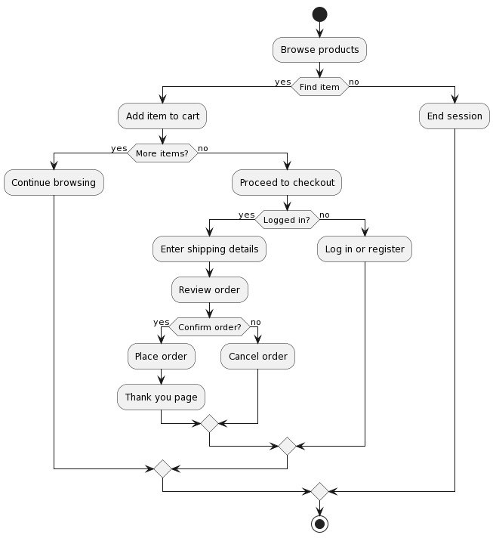

**Use case Diagram**

# ER Diagram

# Project timeline

|  |  |  |  |
| --- | --- | --- | --- |
| **Task** | **Start Date** | **End Date** |  |
| **Requirement analysis** | **02/Feb/2024** | **20/Feb/2024** |  |
| **System Design** | **21/Feb/2024** | **29/Feb/2024** |  |
| **Implementation** | **01/Mar/2024** | **15/Mar/2024** |  |
| **Testing** | **15/Mar/2024** | **20/Mar/2024** |  |
| **Deployment** | **21/Mar/2024** | **23/Mar/2024** |  |
| **Maintenance** | **24/Mar/2024** | **Till the system works** |  |

**Conclusion**

# Thrift is an ecommerce web application where one can sell or buy used clothes according to their needs .You can purchase your desirable clothes in low price. You can earn money by selling old clothes which is a good deal to person who is buying and selling. The primary goal of this project is to create a link between seller and buyer. It will fulfill the need of the clothing in low price platform in Nepal. It will offer a variety of features and functions to make it easier for both seller and buyer to do thrift. This web application will be built using HTML, CSS, PHP, and other technologies. The database will be created using MYSQL. Likewise, the project will follow water fall SDLC to design and develop different phases of development of the project. Similarly, we have already set out the milestone we need to achieve for the completion of each phase. The proposed system has been designed to include all features that will benefit both online thrift providers and customers. As a result of the entire project, a well-managed web-application will be created, which will benefit both the sellers and the customer.