Data Technician Workbook
Week 3: Databases & SQL

Name:
Course Date:
Table of contents
Day 1: Task 1 3
Day 1: Task 2 3
Day 3: Task 1 4
Day 4: Task 1: Written 6
Day 4: Task 2: PostgreSQL Practical 9
Course Notes 19
Additional Information 19

Day 1: Task 1

Place/paste your ERD image here:

Next,

Please research and complete the questions below relating to key concepts of databases.

What is a primary key? | Primary key is an unique identifier, usually a code, that is set to a record in the database. Ex: A student in a college database has an Student ID, which will identify them and to each all that student’s information on the college database will be linked to.
How does this differ from a secondary key? | A secondary key is a field used to search in the database, it helps to find information quickly. For example: In a student database, the column Name or email is a secondary key.
How are primary and foreign keys related? | They are used to link 2 or more tables. The primary key identifying a record in one table is used as foreign key in another table to create the relationship between the related records. Student ID in table ‘Student’ can be the foreign key on the table ‘Subject’
Provide a real-world example of a one-to-one relationship | A UK resident -> Insurance Number. A person only have one Insurance number, and an Insurance Number only identifies one person.
Provide a real-world example of a one-to-many relationship | A university degree module. It has many students registered to it.
Provide a real-world example of a many-to-many relationship | Gym goers can attend different classes on their gym and those classes are also attended by many other gym goers.

Day 1: Task 2

Please research and complete the questions below relating to key concepts of databases.

What is the difference between a relational and non-relational database? | A relational database (SQL) stores structured data, which is data organised in categories (columns), and records (rows). Several tables can be linked together in a relational database, making this king of database suitable for data that is well organised and when accuracy is crucial. Non-relational database is more beneficial to store semi-structured and unstructured data. It doesn’t use relational model like relational database, making it more flexible. It can handle massive amounts of data and it is easier to scale, what is beneficial with high volume of data and the speed it changes.  https://www.mongodb.com/resources/basics/databases/non-relational
What type of data would benefit off the non-relational model?  Why? | Data used in fraud prevention, as the fast-changing and high volume of data coming from numerous attempts are unstructured. Criminals may use card details, login attempts, One Time Passwords (OTPs), device information to try to steal money from a bank customer account, for example. A non-relational database can store this varied data more efficiently, helping on to identify suspicions patterns and detect fraud in real-time.

Day 3: Task 1

Please research the types of 'JOIN ' below, explain what they are and provide an example of the types of data they would be used on.

Self-join | Used to combine information from the same table to help visualisation of relevant information, making comparison between data on the same table, etc.  An example of use of self-join is when companies want to compare completion of in-house training between employees.
Right join | Matches the information between right and left tables, keeping the records from the right table as the base. If no matches from the left, populates left site with null. On the students/course example, it is helpful to visualise if there are courses that have no students registered to.  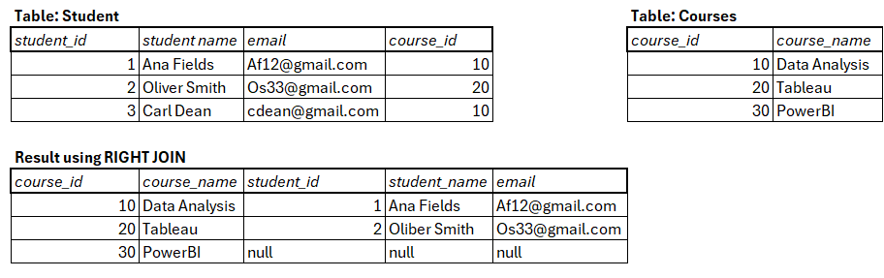
Full join | Matches everything from both tables. Useful to check for gaps or discrepancies, comparing between two databases to check if the information matches, merging information from 2 overlapping tables, etc.  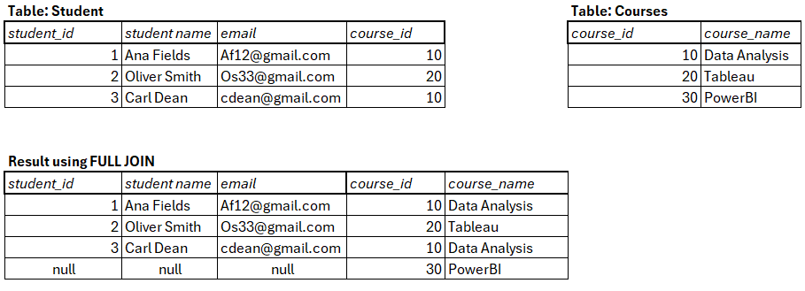
Inner join | It is used to combine related information from different tables, for example: student_id and student personal details from ‘Students’ table to the courses that have students registered from the ‘Courses’ table. It will return only matching records in both tables.  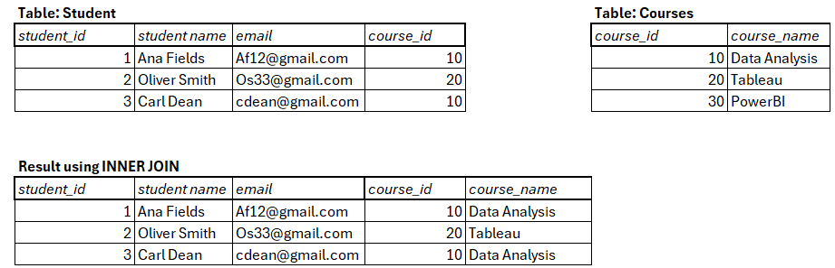
Cross join | It pairs every single row from one table to every single row from another table. It is useful when we want to create a list(or table) of every possible combination between both tables. Example: a business selling a t-shirt in 3 sizes and 3 colours. A cross joint would generate all 9 possible variations.
Left join | Similar to right join, but keeps the records from the left table and populate the right table with ‘null’ if no matches. Many analysts use left join for both situations, only keeping the table they want to compare from on the left (primary table).  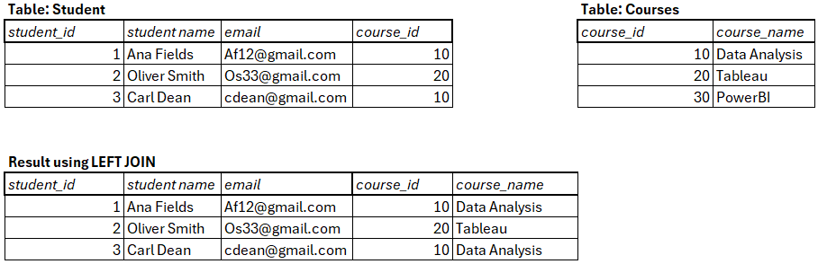

Day 4: Task 1: Written

In your groups, discuss and complete the activity below. You can either nominate one writer or split the elements between you. Everyone, however, must have the completed work below:
Imagine you have been hired by a small retail business that wants to streamline its operations by creating a new database system. This database will be used to manage inventory, sales, and customer information. The business is a small corner shop that sells a range of groceries and domestic products. It might help to picture your local convenience store and think of what they sell. They also have a loyalty program, which you will need to consider when deciding what tables to create.
Write a 500-word essay explaining the steps you would take to set up and create this database. Your essay should cover the following points:

- Understanding the Business Requirements:

- What kind of data will the database need to store? Inventory (SKU - product name, product category, price, stock count, supplier ID); SKU - sales (transaction ID, transaction date, quantity, customer ID); suppliers SKU (supplier ID, supplier name, supplier contact details), customer info SKU (customer ID, name, address, contact number, email, membership status, points total), loyalty (membership no). .

Note: SKUs, in this case, are fields in a table.

- Who will be the users of the database, and what will they need to accomplish?

- Designing the Database Schema:

- How would you structure/design the database tables to efficiently store inventory, sales, and customer information? Can you design it in Word doc.?

- What type of relationship/s between tables are necessary (and can you mention the PK and FK keys) (e.g., how sales relate to inventory and customers)?

- Implementing the Database:

- What SQL commands would you use to create the database and its tables? Top 4 or 5 queries.

- Provide examples of SQL statements for creating tables and defining relationships between them. Top 4 or 5.

- Populating the Database:

- How would you input initial data into the database tables? Can you give examples of SQL INSERT or and VALUES statements.

- Maintaining the Database:

- What measures would you take to ensure the database remains accurate and up to date?

- How would you handle backups and data security?

Your essay should include specific examples of SQL commands and explain why each step is necessary for creating a functional and efficient database for the retail business.

Your essay should include specific examples of SQL commands (a total of 3 or 4) and explain why each step is necessary for creating a functional and efficient database for the retail business. Do your research to find the commands and tell me what each command does – in one line.

Please write your 500-word essay here | I have based the business analysis on Co-op. I kept the initial concept of creating the database to a small corner shop, which I named Smart Corner.  The first step to creating a database for Smart Corner would be to understand the business requirements and identify what information needs to be stored.  The database would be required to manage inventory, suppliers, sales, customers and the loyalty programme. In addition to the requirements already provided, a Sales table and a Sale_Items table should also be created. The Sale_Items table would allow a transaction to contain more than one SKU, which is necessary because a customer can purchase several different products in one transaction. The Suppliers table would contain the supplier ID, supplier name and contact details. Customer information would include customer ID, name, address, contact number, email, membership status and loyalty points. The Sales table would record the transaction ID, transaction date and customer ID, while the Sale_Items table would record the SKUs and quantities included in each transaction.  The users of the database would mainly be the shop owner and a manager, who would be responsible for adding new products, managing suppliers, checking stock and sales levels, and viewing customer information. Front-shop employees would use the database to check stock levels and product prices and to record sales. Customer information and loyalty details would only be available to authorised users.  For the structure of the database, each table should have a primary key (PK), which uniquely identifies each record. For example, SKU could be the primary key in the Inventory/Products table, while Customer_ID could be the primary key in the Customers table. Foreign keys (FKs) can then be used to link related tables. For example, Supplier_ID in the Inventory/Products table could be a foreign key linked to the Suppliers table. Customer_ID in the Sales table could link sales to customers. Transaction_ID and SKU in the Sale_Items table could link each product purchased to the relevant transaction and product.  Sales and Products have a many-to-many relationship because one sale can contain several products, and the same product can be included in many different sales. This relationship is resolved by creating the Sale_Items table, which acts as bridge between Sales and Products.  The data base would structure could be created in a Word document using tables or relationship diagrams, similar to this:  TABLE FIELDS  Inventory SKU (PK), Product name, category, price, stockCount, supplier_ID (FK)  Suppliers Supplier_ID, Supplier name, contact details  Customers Customer_ID (PK), Customer’s name, address, contact number, email and membership details  Sales Transacion_ID (PK), transaction data, customer ID (FK) Transaction information  Sale_Items Sale_Item_ID, Transaction_ID (FK), SKU (FK), quantity  The database would be created in SQL. A few commands are:  CREATE DATABASE smart_corner;  CREATE TABLE Products (  SKU VARCHAR(20) Primary Key,  ProductName VARCHAR(100),  Category VARCHAR(50),  Price Decimal(10,2),  StockCount INT,  Supplier_ID INT  );  ALTER TABLE Products  ADD FOREIGN KEY (Supplier-ID)  REFERENCES Suppliers (Supplier_ID);  ALTER TABLE is adding a foreign key between products and suppliers.  INSERT INTO Products  (SKU, ProductName, Category, Price, StockCount, Supplier_ID)  VALUES  (‘A123’, ‘Basmati Rice’ , ‘Cupboard’ , 2.30, 18, 3);  INSERT INTO is adding product to the Products table.  To maintain accuracy and security, stock level should be updated upon sales and deliveries and regular checks should be carried on to ensure physical levels match database records.  Validation rules should be used to make sure correct entries are inserted on the database and regular backups should be implemented to protect the database against accidental deletion or issues with equipment.  To comply with data protection regulations, access to sensitive information should be restricted to top management only.

Day 4: Task 2: SQL Practical

Complete as many as you can.

Please note: The first couple of queries have no errors; practice keying them manually to understand structure and syntax.

Then the following queries all have minor errors. You will need to use your AI tool to find the error and fix it, then run the query, and explain what you fixed in simple English – only one line explanation is required. (Try to key the code manually where possible.)

Practice using PostgreSQL queries: Use the dataset you have already created in Supabase.
Called: World combined 30. Supabase | The Postgres Development Platform

Once completed, you can save as an SQL file: (Can also save as a CSV file if you want to.)

Go to table editor > Click on the file > click on 3 dots > Export data > Export table as SQL

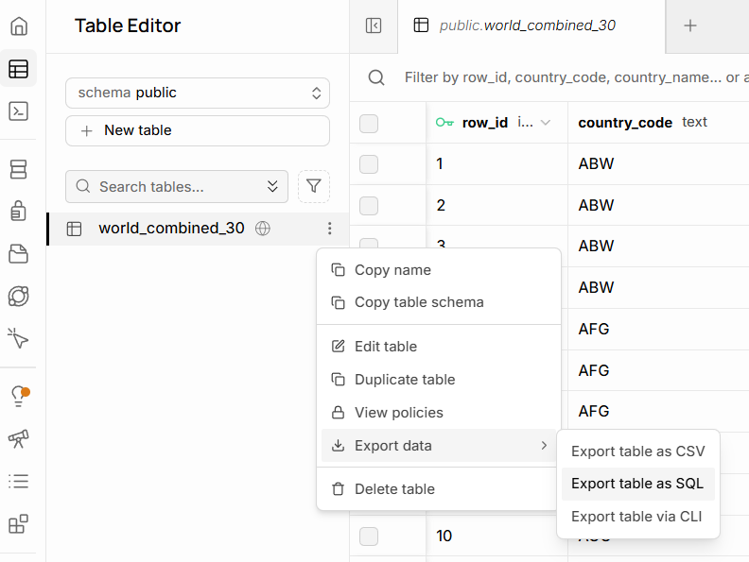

Start running these SQL queries:

I didn’t manage to work on this task as I am having issues with Supabase. It is giving me index errors from the beginning. I tried to remove the database I have inserted on the platform and even created a new account with a different email, but same issue occurred.

Basic selection and filtering
List distinct countries in the table:

SELECT DISTINCT country_name
FROM world_combined_30;

Show all languages for Angola, ordered by percentage (highest first)

SELECT language,
language_percentage
FROM world_combined_30
WHERE country_name = 'Angola'
ORDER BY language_percentage DESC

Find all countries where English appears as a language

SELECT DISTINCT country_name,
country_code
FROM
WHERE language = 'English';

Show all non-official languages for Albania

SELECT language,
language_percentage
FROM world_combined_30
WHERE country_name = 'Albania'
AND is_official = ;

List countries whose population is between 100,000 and 3,000,000

SELECT DISTINCT country_name,
country_population
FROM world_combined_30
WHERE BETWEEN 100000 AND 3000000
ORDER BY country_population;

Aggregation per country
Count how many language rows each country has in DESC order

SELECT country_name,
COUNT(*) AS language_count
FROM world_combined_30
GROUP BY country_name
ORDER BY language_count ;

Show the maximum language percentage per country

SELECT country_name,
MAX(language_percentage) AS max_language_percentage
FROM world_combined_30
GROUP BY country_name
ORDER BY DESC;

Find countries where at least one language has more than 50% share

SELECT DISTINCT country_name
FROM world_combined_30
WHERE language_percentage > 50;

For each country, show the total percentage of official languages

SELECT country_name,
SUM(language_percentage) AS total_official_percentage
FROM world_combined_30
WHERE is_official =
GROUP BY country_name
ORDER BY total_official_percentage DESC;

List countries that have more than one official language

SELECT country_name,
COUNT(*) AS official_language_count
FROM world_combined_30
WHERE is_official = TRUE
GROUP BY country_name
HAVING COUNT(*) > ?
ORDER BY official_language_count DESC;

Combining filters and aggregates
Show official languages where the percentage is under 10%

SELECT country_name,
language,
language_percentage
FROM world_combined_30
WHERE is_official = TRUE
AND language_percentage ;

Find the country where Arabic is official

SELECT country_name,
country_code,
language_percentage
FROM world_combined_30
WHERE language = ' '
AND is_official = ;

For each country, show the number of non-official languages

SELECT country_name,
COUNT(*) AS non_official_count
FROM world_combined_30
WHERE is_official =
GROUP BY country_name
ORDER BY non_official_count DESC;

List all rows where the city name contains the word ‘la’ (case-sensitive)

SELECT *
FROM world_combined_30
WHERE city_name LIKE '%%';

Show countries whose most spoken language (max %) is not official

SELECT country_name
FROM world_combined_30
WHERE language_percentage = (
SELECT MAX(w2.language_percentage)
FROM world_combined_30 AS w2
WHERE w2.country_name = world_combined_30.country_name
)
AND is_official = ;

Subqueries:

List countries with population above the overall average population

SELECT DISTINCT country_name,
country_population
FROM world_combined_30
WHERE country_population >
(
SELECT AVG()
FROM world_combined_30
);

Show languages that are official somewhere and have ≥ 40% in that country

SELECT DISTINCT language,
country_name,
language_percentage
FROM world_combined_30
WHERE is_official =
AND language_percentage >=

ORDER BY language;
Find countries whose total percentage of all languages is < 100 (data quality check)
Drag selected lines of code and then run, if need be.

SELECT country_name,
SUM(language_percentage) AS total_language_share
FROM world_combined_30
GROUP BY country_name
HAVING SUM(language_percentage) <
ORDER BY total_language_share;

Show rows where the city appears in a country with more than 5 languages
Drag selected lines of code and then run, if need be.

SELECT *
FROM world_combined_30 AS w
WHERE country_name IN (
SELECT country_name
FROM world_combined_30
GROUP BY country_name
HAVING COUNT(*) > ?
);

Course Notes

It is recommended to take notes from the course, use the space below to do so, or use the revision guide shared with the class:

Additional Information

We have included a range of additional links to further resources and information that you may find useful, these can be found within your revision guide.

END OF WORKBOOK

Please check through your work thoroughly before submitting and update the table of contents if required.

Please send your completed work booklet to your trainer.

