Lab 1: AWT Mouse Event Handling – Sum and Difference Calculator

Objective
Create an AWT Frame that implements MouseListener. On mouse press, display the sum of two numbers. On mouse release, display the difference.

File Explorer
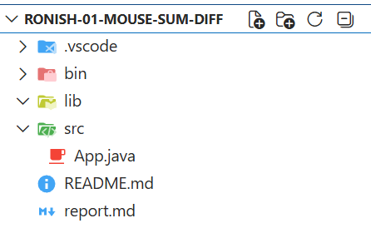

Source Code
import java.awt.*;
import java.awt.event.*;
public class Ronish32_App extends Frame implements MouseListener {
TextField t1, t2, result;
Label l;
public Ronish32_App() {
setLayout(new FlowLayout());
t1 = new TextField(10);
t2 = new TextField(10);
result = new TextField(15);
l = new Label("Result");
add(t1); add(t2); add(l); add(result);
addMouseListener(this);
setSize(300, 200);
setTitle("Mouse Sum Diff");
setVisible(true);
}
public void mousePressed(MouseEvent e) {
int a = Integer.parseInt(t1.getText());
int b = Integer.parseInt(t2.getText());
result.setText(String.valueOf(a + b));
}
public void mouseReleased(MouseEvent e) {
int a = Integer.parseInt(t1.getText());
int b = Integer.parseInt(t2.getText());
result.setText(String.valueOf(a - b));
}
public void mouseClicked(MouseEvent e) {}
public void mouseEntered(MouseEvent e) {}
public void mouseExited(MouseEvent e) {}
public static void main(String[] args) {
new Ronish32_App();
}
}

Output
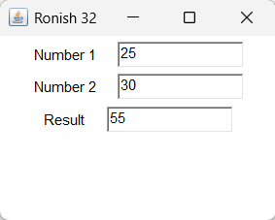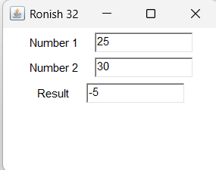

Conclusion
Learned to implement MouseListener interface and handle mouse events in AWT.

Lab 2: Swing Addition Calculator with GridLayout

Objective
Create a Swing JFrame with two input fields, a non-editable result field, and an “Add” button using GridLayout.

File Explorer
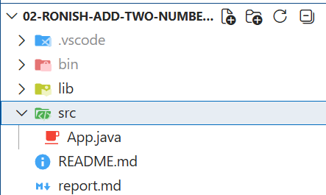

Source Code
import javax.swing.*;
import java.awt.*;
import java.awt.event.*;
public class Ronish32_App implements ActionListener {
JFrame f;
JTextField t1, t2, result;
JButton b;
public Ronish32_App() {
f = new JFrame("Add Two Numbers");
t1 = new JTextField();
t2 = new JTextField();
result = new JTextField();
b = new JButton("Add");
result.setEditable(false);
b.addActionListener(this);
f.setLayout(new GridLayout(4, 2));
f.add(new JLabel("Number 1:")); f.add(t1);
f.add(new JLabel("Number 2:")); f.add(t2);
f.add(new JLabel("Result:")); f.add(result);
f.add(new JLabel()); f.add(b);
f.setSize(300, 200);
f.setDefaultCloseOperation(JFrame.EXIT_ON_CLOSE);
f.setVisible(true);
}
public void actionPerformed(ActionEvent e) {
int a = Integer.parseInt(t1.getText());
int b = Integer.parseInt(t2.getText());
result.setText(String.valueOf(a + b));
}
public static void main(String[] args) {
new Ronish32_App();
}
}

Output
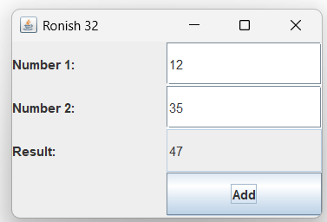

Conclusion
Learned to use Swing components, GridLayout, and ActionListener for button click events.

Lab 3: Swing Arithmetic Calculator Using JRadioButton Operations

Objective
Create a Swing calculator using JRadioButtons for selecting operations (Add, Sub, Mul, Div) with a Calculate button.
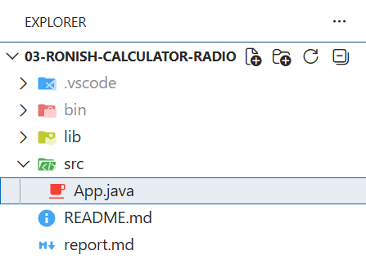

Source Code
import javax.swing.*;
import java.awt.*;
import java.awt.event.*;
public class Ronish32_App implements ActionListener {
JFrame f;
JTextField t1, t2, result;
JRadioButton add, sub, mul, div;
JButton calc;
public Ronish32_App() {
f = new JFrame("Calculator Radio");
t1 = new JTextField();
t2 = new JTextField();
result = new JTextField();
add = new JRadioButton("Add");
sub = new JRadioButton("Sub");
mul = new JRadioButton("Mul");
div = new JRadioButton("Div");
calc = new JButton("Calculate");
ButtonGroup bg = new ButtonGroup();
bg.add(add); bg.add(sub); bg.add(mul); bg.add(div);
calc.addActionListener(this);
result.setEditable(false);
f.setLayout(new GridLayout(6, 2));
f.add(new JLabel("Number 1:")); f.add(t1);
f.add(new JLabel("Number 2:")); f.add(t2);
f.add(add); f.add(sub);
f.add(mul); f.add(div);
f.add(new JLabel("Result:")); f.add(result);
f.add(new JLabel()); f.add(calc);
f.setSize(350, 250);
f.setDefaultCloseOperation(JFrame.EXIT_ON_CLOSE);
f.setVisible(true);
}
public void actionPerformed(ActionEvent e) {
double a = Double.parseDouble(t1.getText());
double b = Double.parseDouble(t2.getText());
double res = 0;
if (add.isSelected()) res = a + b;
else if (sub.isSelected()) res = a - b;
else if (mul.isSelected()) res = a * b;
else if (div.isSelected()) res = a / b;
result.setText(String.valueOf(res));
}
public static void main(String[] args) {
new Ronish32_App();
}
}

Output
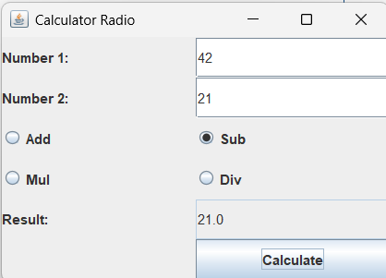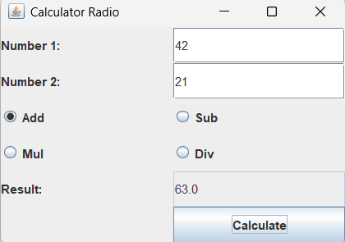

Conclusion
Learned to use JRadioButton with ButtonGroup and perform arithmetic operations based on selection.

Lab 4: AWT MouseAdapter – Sum and Difference with Anonymous Class

Objective
Create an JFrame that implements MouseAdapter. On mouse press, display the sum of two numbers. On mouse release, display the difference.
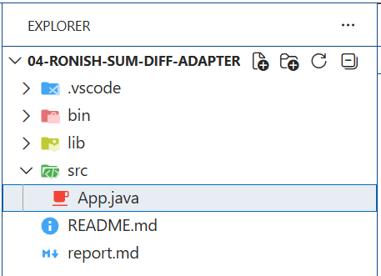

Source Code
import java.awt.*;
import java.awt.event.*;
import javax.swing.*;
public class Ronish32_App {
public static void main(String[] args) {
JFrame f = new JFrame("Sum Diff Adapter");
f.setLayout(new GridLayout(3, 2));
JTextField t1 = new JTextField();
JTextField t2 = new JTextField();
JTextField result = new JTextField();
result.setEditable(false);
f.add(new JLabel("Number 1:")); f.add(t1);
f.add(new JLabel("Number 2:")); f.add(t2);
f.add(new JLabel("Result:")); f.add(result);
f.addMouseListener(new MouseAdapter() {
public void mousePressed(MouseEvent e) {
int a = Integer.parseInt(t1.getText());
int b = Integer.parseInt(t2.getText());
result.setText(String.valueOf(a + b));
}
public void mouseReleased(MouseEvent e) {
int a = Integer.parseInt(t1.getText());
int b = Integer.parseInt(t2.getText());
result.setText(String.valueOf(a - b));
}
});
f.setSize(300, 200);
f.setDefaultCloseOperation(JFrame.EXIT_ON_CLOSE);
f.setVisible(true);
}
}

Output
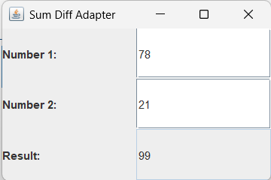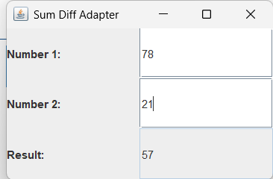

Conclusion
Learned to use MouseAdapter with anonymous class for cleaner event handling code.

Lab 5: Swing Login Form Using GridLayout

Objective
Create a Swing login form with username and password fields using GridLayout.
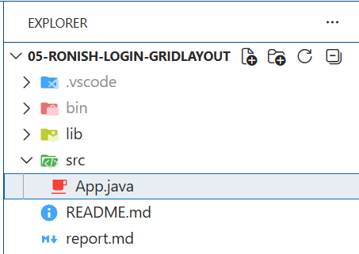

Source Code
import javax.swing.*;
import java.awt.*;
public class Ronish32_App {
public static void main(String[] args) {
JFrame f = new JFrame("Login GridLayout");
f.setLayout(new GridLayout(3, 2));
f.add(new JLabel("Username:"));
f.add(new JTextField());
f.add(new JLabel("Password:"));
f.add(new JPasswordField());
f.add(new JLabel());
f.add(new JButton("Login"));
f.setSize(300, 150);
f.setDefaultCloseOperation(JFrame.EXIT_ON_CLOSE);
f.setVisible(true);
}
}

Output
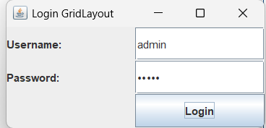

Conclusion
Learned to create a login form layout using GridLayout in Swing.

Lab 6: Swing Login Form Using GridBagLayout with Constraints

Objective
Create a Swing login form using GridBagLayout with proper spacing using GridBagConstraints.
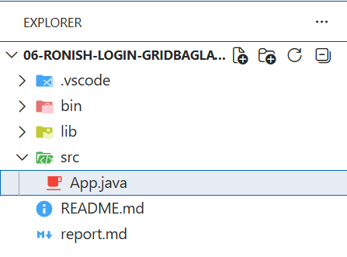

Source Code
import javax.swing.*;
import java.awt.*;
public class Ronish32_App {
public static void main(String[] args) {
JFrame f = new JFrame("Login GridBagLayout");
f.setLayout(new GridBagLayout());
GridBagConstraints gbc = new GridBagConstraints();
gbc.insets = new Insets(5, 5, 5, 5);
gbc.gridx = 0; gbc.gridy = 0;
f.add(new JLabel("Username:"), gbc);
gbc.gridx = 1;
f.add(new JTextField(15), gbc);
gbc.gridx = 0; gbc.gridy = 1;
f.add(new JLabel("Password:"), gbc);
gbc.gridx = 1;
f.add(new JPasswordField(15), gbc);
gbc.gridx = 0; gbc.gridy = 2; gbc.gridwidth = 2;
f.add(new JButton("Login"), gbc);
f.setSize(350, 200);
f.setDefaultCloseOperation(JFrame.EXIT_ON_CLOSE);
f.setVisible(true);
}
}

Output
Login form with precise component positioning using GridBagLayout and 5px insets.
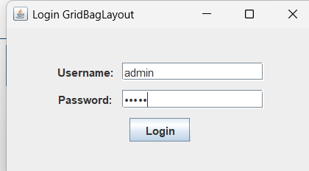

Conclusion
Learned to use GridBagLayout and GridBagConstraints for flexible component placement.

Lab 7: Swing Arithmetic Calculator Using BorderLayout and Nested Panels

Objective
Create a calculator using BorderLayout. NORTH has title, CENTER has number inputs, EAST has operation buttons.
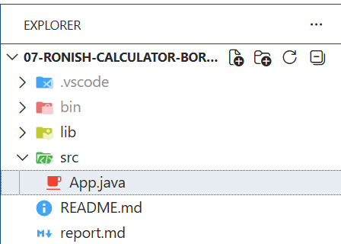

Source Code
import javax.swing.*;
import java.awt.*;
import java.awt.event.*;
public class Ronish32_App implements ActionListener {
JFrame f;
JTextField t1, t2, result;
JButton add, sub, mul, div;
public Ronish32_App() {
f = new JFrame("Calculator BorderLayout");
f.setLayout(new BorderLayout());
JLabel title = new JLabel("Calculator", SwingConstants.CENTER);
f.add(title, BorderLayout.NORTH);
JPanel center = new JPanel(new GridLayout(3, 2));
center.add(new JLabel("Number 1:")); t1 = new JTextField(); center.add(t1);
center.add(new JLabel("Number 2:")); t2 = new JTextField(); center.add(t2);
center.add(new JLabel("Result:")); result = new JTextField(); center.add(result);
result.setEditable(false);
f.add(center, BorderLayout.CENTER);
JPanel east = new JPanel(new GridLayout(4, 1));
add = new JButton("Add"); sub = new JButton("Sub");
mul = new JButton("Mul"); div = new JButton("Div");
add.addActionListener(this); sub.addActionListener(this);
mul.addActionListener(this); div.addActionListener(this);
east.add(add); east.add(sub); east.add(mul); east.add(div);
f.add(east, BorderLayout.EAST);
f.setSize(400, 250);
f.setDefaultCloseOperation(JFrame.EXIT_ON_CLOSE);
f.setVisible(true);
}
public void actionPerformed(ActionEvent e) {
double a = Double.parseDouble(t1.getText());
double b = Double.parseDouble(t2.getText());
double r = 0;
if (e.getSource() == add) r = a + b;
else if (e.getSource() == sub) r = a - b;
else if (e.getSource() == mul) r = a * b;
else if (e.getSource() == div) r = a / b;
result.setText(String.valueOf(r));
}
public static void main(String[] args) {
new Ronish32_App();
}
}

Output
BorderLayout with title at top, inputs in center, operation buttons on the right.
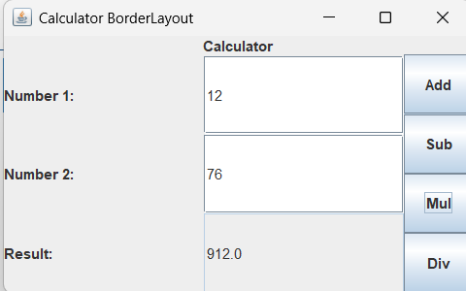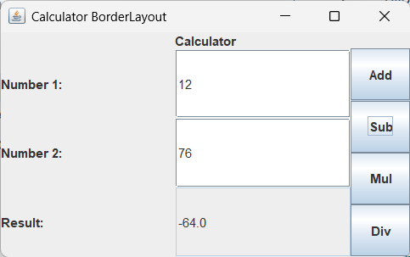

Conclusion
Learned to combine BorderLayout with nested JPanels using GridLayout for complex layouts.

Lab 8a: Dynamic Button Background Color Change on Click

Objective
Create a JFrame with three buttons. Clicking a button changes that button’s background color (RED/BLUE/GREEN).
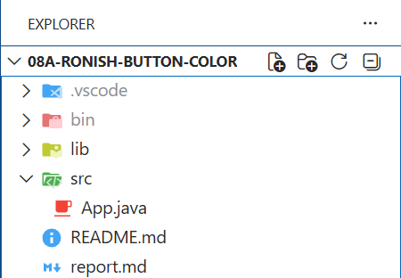

Source Code
import javax.swing.*;
import java.awt.*;
import java.awt.event.*;
public class Ronish32_App implements ActionListener {
JFrame f;
JButton red, blue, green;
public Ronish32_App() {
f = new JFrame("Button Color");
f.setLayout(new FlowLayout());
red = new JButton("RED");
blue = new JButton("BLUE");
green = new JButton("GREEN");
red.addActionListener(this);
blue.addActionListener(this);
green.addActionListener(this);
f.add(red); f.add(blue); f.add(green);
f.setSize(400, 200);
f.setDefaultCloseOperation(JFrame.EXIT_ON_CLOSE);
f.setVisible(true);
}
public void actionPerformed(ActionEvent e) {
if (e.getSource() == red) red.setBackground(Color.RED);
else if (e.getSource() == blue) blue.setBackground(Color.BLUE);
else if (e.getSource() == green) green.setBackground(Color.GREEN);
}
public static void main(String[] args) {
new Ronish32_App();
}
}

Output
Three buttons in a row. Clicking “RED” turns the red button red, and similarly for blue and green.
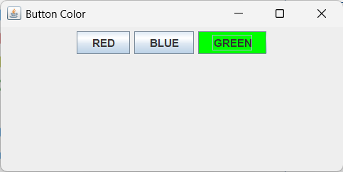

Conclusion
Learned to change component background colors dynamically on button click.

Lab 8b: Dynamic Form Background Color Change Using Content Pane

Objective
Create a JFrame with three buttons. Clicking a button changes the content pane’s background color.
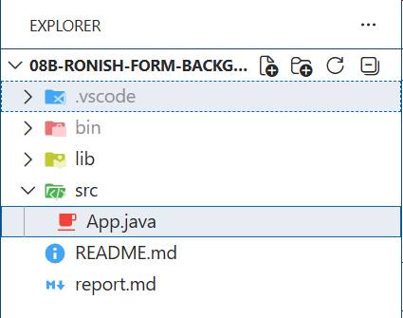

Source Code
import javax.swing.*;
import java.awt.*;
import java.awt.event.*;
public class Ronish32_App implements ActionListener {
JFrame f;
JButton red, blue, green;
public Ronish32_App() {
f = new JFrame("Form Background Color");
f.setLayout(new FlowLayout());
red = new JButton("RED");
blue = new JButton("BLUE");
green = new JButton("GREEN");
red.addActionListener(this);
blue.addActionListener(this);
green.addActionListener(this);
f.add(red); f.add(blue); f.add(green);
f.setSize(400, 200);
f.setDefaultCloseOperation(JFrame.EXIT_ON_CLOSE);
f.setVisible(true);
}
public void actionPerformed(ActionEvent e) {
if (e.getSource() == red) f.getContentPane().setBackground(Color.RED);
else if (e.getSource() == blue) f.getContentPane().setBackground(Color.BLUE);
else if (e.getSource() == green) f.getContentPane().setBackground(Color.GREEN);
}
public static void main(String[] args) {
new Ronish32_App();
}
}

Output
Three buttons. Clicking “RED” turns the entire form background red, and similarly for blue and green.
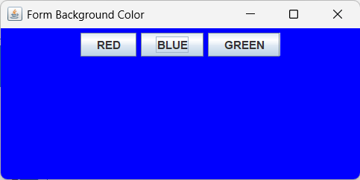

Conclusion
Learned to change the content pane background of a JFrame dynamically.

Lab 9: Combined Layout Managers – Student Info with Login Form

Objective
Create a JFrame with the use of different layout managers (FlowLayout, GridLayout, and BorderLayout).
- Divide the main frame into three panels using BorderLayout:
  - North Panel: Use FlowLayout to arrange three labels (Name, Roll No, Class) in a single row.
  - Center Panel: Use GridLayout (3x2) to create a simple login form with two text fields (Username, Password), a JCheckBox (“Remember Me”), and a JButton (“Login”).
  - South Panel: Use FlowLayout to add two buttons (Reset and Exit).
- Handle events so that:
  - When Login is pressed, display the entered username in a message dialog.
  - When Reset is pressed, clear the text fields.
  - When Exit is pressed, close the program.
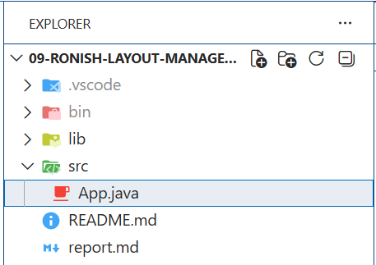

Source Code
import javax.swing.*;
import java.awt.*;
import java.awt.event.*;
public class Ronish32_App implements ActionListener {
JFrame f;
JTextField username;
JPasswordField password;
JCheckBox remember;
public Ronish32_App() {
f = new JFrame("Layout Manager Demo");
f.setLayout(new BorderLayout());
JPanel north = new JPanel(new FlowLayout());
north.add(new JLabel("Name: Ronish"));
north.add(new JLabel("Roll No: 1"));
north.add(new JLabel("Class: CSIT"));
f.add(north, BorderLayout.NORTH);
JPanel center = new JPanel(new GridLayout(3, 2));
center.add(new JLabel("Username:"));
username = new JTextField();
center.add(username);
center.add(new JLabel("Password:"));
password = new JPasswordField();
center.add(password);
remember = new JCheckBox("Remember Me");
JButton login = new JButton("Login");
login.addActionListener(this);
center.add(remember); center.add(login);
f.add(center, BorderLayout.CENTER);
JPanel south = new JPanel(new FlowLayout());
JButton reset = new JButton("Reset");
JButton exit = new JButton("Exit");
reset.addActionListener(this);
exit.addActionListener(this);
south.add(reset); south.add(exit);
f.add(south, BorderLayout.SOUTH);
f.setSize(400, 250);
f.setDefaultCloseOperation(JFrame.EXIT_ON_CLOSE);
f.setVisible(true);
}
public void actionPerformed(ActionEvent e) {
String cmd = e.getActionCommand();
if (cmd.equals("Login")) {
JOptionPane.showMessageDialog(f, "Username: " + username.getText());
} else if (cmd.equals("Reset")) {
username.setText("");
password.setText("");
remember.setSelected(false);
} else if (cmd.equals("Exit")) {
System.exit(0);
}
}
public static void main(String[] args) {
new Ronish32_App();
}
}

Output
Top panel shows student info, center has login form with Remember Me checkbox, bottom has Reset and Exit buttons. Login shows a dialog, Reset clears fields, Exit closes the app.
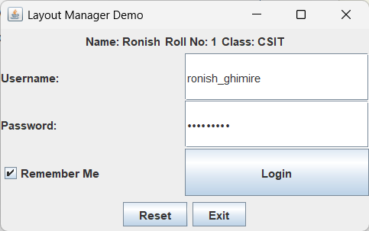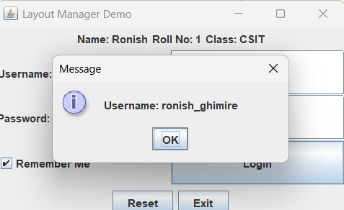

Conclusion
Learned to combine multiple layout managers (BorderLayout, FlowLayout, GridLayout) in a single application.

Lab 10: Canvas Shape Drawing – Circle, Square, and Triangle

Objective
Design a form with three buttons with captions “Circle,” “Square,” and “Triangle.”
- When the user clicks the “Circle” button, draw a red circle in the center of the frame.
- When the user clicks the “Square” button, draw a blue square in the center of the frame.
- When the user clicks the “Triangle” button, draw a green triangle in the center of the frame.
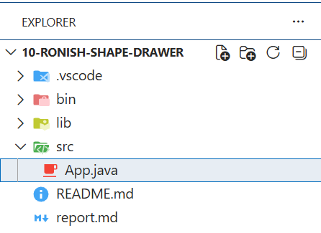

Source Code
import java.awt.*;
import java.awt.event.*;
import javax.swing.*;
public class Ronish32_App extends Canvas implements ActionListener {
String shape = "";
public Ronish32_App() {
JFrame f = new JFrame("Shape Drawer");
f.setLayout(new BorderLayout());
JPanel north = new JPanel();
JButton circle = new JButton("Circle");
JButton square = new JButton("Square");
JButton triangle = new JButton("Triangle");
circle.addActionListener(this);
square.addActionListener(this);
triangle.addActionListener(this);
north.add(circle); north.add(square); north.add(triangle);
f.add(north, BorderLayout.NORTH);
setSize(400, 400);
f.add(this, BorderLayout.CENTER);
f.setSize(500, 500);
f.setDefaultCloseOperation(JFrame.EXIT_ON_CLOSE);
f.setVisible(true);
}
public void actionPerformed(ActionEvent e) {
shape = e.getActionCommand();
repaint();
}
public void paint(Graphics g) {
if (shape.equals("Circle")) {
g.setColor(Color.RED);
g.fillOval(100, 100, 200, 200);
} else if (shape.equals("Square")) {
g.setColor(Color.BLUE);
g.fillRect(100, 100, 200, 200);
} else if (shape.equals("Triangle")) {
g.setColor(Color.GREEN);
int[] x = {200, 100, 300};
int[] y = {100, 300, 300};
g.fillPolygon(x, y, 3);
}
}
public static void main(String[] args) {
new Ronish32_App();
}
}

Output
Three buttons at top. Clicking Circle draws a red circle, Square draws a blue square, Triangle draws a green triangle on the canvas.
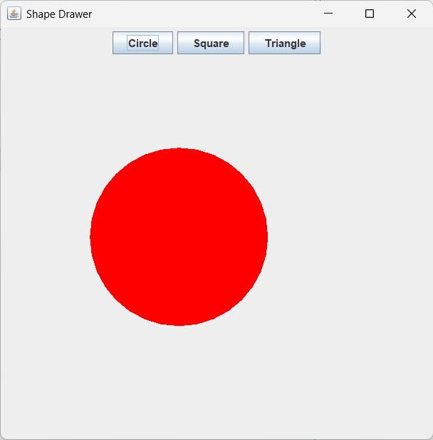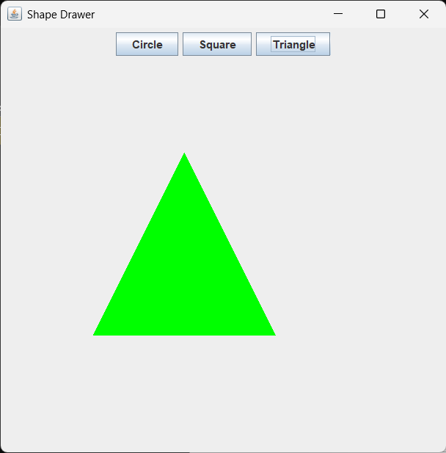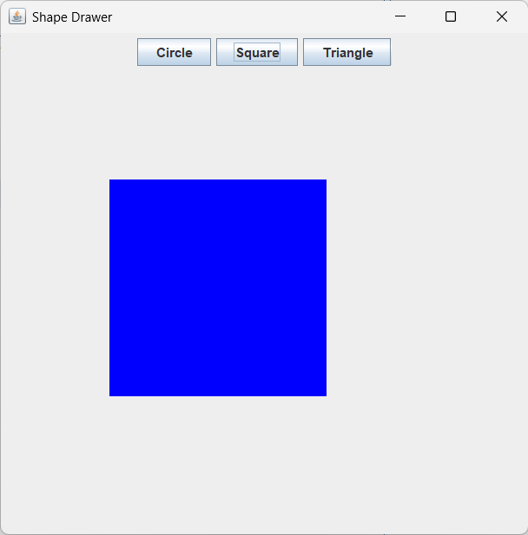

Conclusion
Learned to use Canvas, override paint(Graphics), and draw shapes using fillOval, fillRect, and fillPolygon.

Lab 11: Background Color Changer Using JRadioButton and ItemListener

Objective
Create a JFrame with three JRadioButtons (Red, Green, Blue) using ItemListener to change the content pane background.
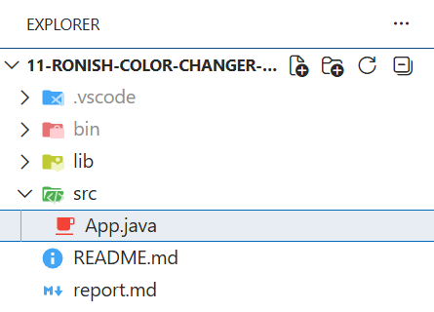

Source Code
import javax.swing.*;
import java.awt.*;
import java.awt.event.*;
public class Ronish32_App implements ItemListener {
JFrame f;
JRadioButton red, green, blue;
public Ronish32_App() {
f = new JFrame("Color Changer Radio");
f.setLayout(new FlowLayout());
red = new JRadioButton("Red");
green = new JRadioButton("Green");
blue = new JRadioButton("Blue");
ButtonGroup bg = new ButtonGroup();
bg.add(red); bg.add(green); bg.add(blue);
red.addItemListener(this);
green.addItemListener(this);
blue.addItemListener(this);
f.add(red); f.add(green); f.add(blue);
f.setSize(300, 200);
f.setDefaultCloseOperation(JFrame.EXIT_ON_CLOSE);
f.setVisible(true);
}
public void itemStateChanged(ItemEvent e) {
if (red.isSelected()) f.getContentPane().setBackground(Color.RED);
else if (green.isSelected()) f.getContentPane().setBackground(Color.GREEN);
else if (blue.isSelected()) f.getContentPane().setBackground(Color.BLUE);
}
public static void main(String[] args) {
new Ronish32_App();
}
}

Output
Three radio buttons. Selecting Red turns the background red, Green turns it green, Blue turns it blue.
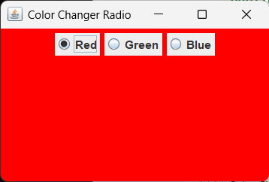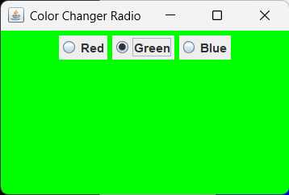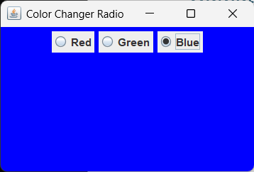

Conclusion
Learned to use JRadioButton with ButtonGroup and ItemListener for selection-based actions.

Lab 12: JToolBar with Programmatically Generated Icon Buttons

Objective
Create a JToolBar with programmatically generated colored circle icons and tooltip text.
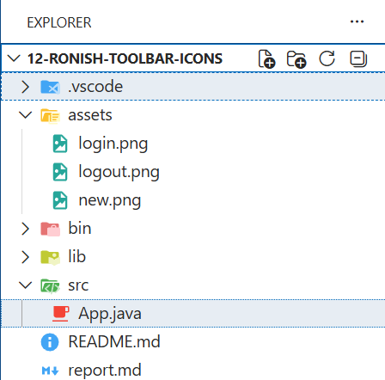

Source Code
import javax.swing.*;
import java.awt.*;
import java.awt.event.*;
import java.awt.image.BufferedImage;
public class Ronish32_App implements ActionListener {
JFrame f;
public Ronish32_App() {
f = new JFrame("Toolbar Icons");
f.setLayout(new BorderLayout());
JToolBar toolbar = new JToolBar();
JButton newBtn = new JButton(createIcon(Color.GREEN));
newBtn.setToolTipText("New");
JButton loginBtn = new JButton(createIcon(Color.BLUE));
loginBtn.setToolTipText("Login");
JButton logoutBtn = new JButton(createIcon(Color.RED));
logoutBtn.setToolTipText("Logout");
newBtn.addActionListener(this);
loginBtn.addActionListener(this);
logoutBtn.addActionListener(this);
toolbar.add(newBtn);
toolbar.add(loginBtn);
toolbar.add(logoutBtn);
f.add(toolbar, BorderLayout.NORTH);
f.setSize(300, 200);
f.setDefaultCloseOperation(JFrame.EXIT_ON_CLOSE);
f.setVisible(true);
}
private ImageIcon createIcon(Color c) {
BufferedImage img = new BufferedImage(24, 24, BufferedImage.TYPE_INT_ARGB);
Graphics g = img.getGraphics();
g.setColor(c);
g.fillOval(0, 0, 24, 24);
g.dispose();
return new ImageIcon(img);
}
public void actionPerformed(ActionEvent e) {
String cmd = ((JButton) e.getSource()).getToolTipText();
if (cmd.equals("New")) JOptionPane.showMessageDialog(f, "New File Created");
else if (cmd.equals("Login")) JOptionPane.showMessageDialog(f, "Login Successful");
else if (cmd.equals("Logout")) JOptionPane.showMessageDialog(f, "Logged Out");
}
public static void main(String[] args) {
new Ronish32_App();
}
}

Output
A toolbar with three colored circle buttons. Green shows “New File Created”, Blue shows “Login Successful”, Red shows “Logged Out”.
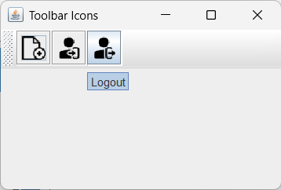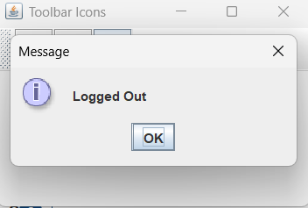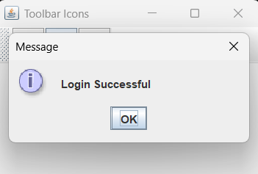

Conclusion
Learned to create icons programmatically using BufferedImage and use JToolBar with tooltips.

Lab 13: JDBC PreparedStatement – Insert and Display Student Records

Objective
Insert 5 student records using PreparedStatement and display them sorted by name.
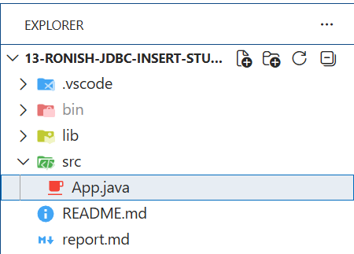

Source Code
import java.sql.*;
public class Ronish32_App {
public static void main(String[] args) throws Exception {
Class.forName("com.mysql.cj.jdbc.Driver");
Connection con = DriverManager.getConnection(
"jdbc:mysql://localhost:3306/javasamriddhi", "root", "");
String insert = "INSERT INTO tblStudent (id, name, gender,address) VALUES (?,?,?,?)";
PreparedStatement ps = con.prepareStatement(insert);
ps.setInt(1, 1); ps.setString(2, "Ram"); ps.setString(3, "Male");
ps.setString(4, "Kathmandu"); ps.executeUpdate();
ps.setInt(1, 2); ps.setString(2, "Sita"); ps.setString(3, "Female");
ps.setString(4, "Pokhara"); ps.executeUpdate();
ps.setInt(1, 3); ps.setString(2, "Hari"); ps.setString(3, "Male");
ps.setString(4, "Lalitpur"); ps.executeUpdate();
ps.setInt(1, 4); ps.setString(2, "Gita"); ps.setString(3, "Female");
ps.setString(4, "Bharatpur"); ps.executeUpdate();
ps.setInt(1, 5); ps.setString(2, "Shyam"); ps.setString(3, "Male");
ps.setString(4, "Biratnagar"); ps.executeUpdate();
Statement st = con.createStatement();
ResultSet rs = st.executeQuery("SELECT * FROM student ORDER BY name ASC");
System.out.println("ID\tName\t\tGender\t\tAddress");
System.out.println("----------------------------------------------");
while (rs.next()) {
System.out.println(rs.getInt("id") + "\t" + rs.getString("name")
+ "\t\t" + rs.getString("gender") + "\t\t" + rs.getString("address"));
}
con.close();
}
}

Output
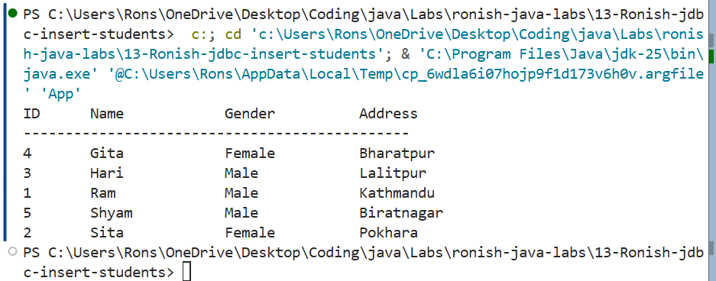

Conclusion
Learned to use PreparedStatement for parameterized queries and ResultSet for displaying data.

Lab 14: JDBC Update Query – Salary Increment by Percentage

Objective
Update salary by 15% for employees with salary less than 20000.

Source Code
import java.sql.*;
public class Ronish32_App {
public static void main(String[] args) throws Exception {
Class.forName("com.mysql.cj.jdbc.Driver");
Connection con = DriverManager.getConnection(
"jdbc:mysql://localhost:3306/javasamriddhi", "root", "");
Statement st = con.createStatement();
System.out.println("Before Update:");
ResultSet rs = st.executeQuery("SELECT * FROM student");
System.out.println("ID\tName\t\tSalary");
System.out.println("---------------------------");
while (rs.next()) {
System.out.println(rs.getInt("id") + "\t" + rs.getString("name")
+ "\t\t" + rs.getDouble("salary"));
}
int updated = st.executeUpdate(
"UPDATE student SET salary = salary + (salary * 15 / 100) WHERE salary < 20000");
System.out.println("\nRows updated: " + updated);
System.out.println("\nAfter Update:");
rs = st.executeQuery("SELECT * FROM student");
System.out.println("ID\tName\t\tSalary");
System.out.println("---------------------------");
while (rs.next()) {
System.out.println(rs.getInt("id") + "\t" + rs.getString("name")
+ "\t\t" + rs.getDouble("salary"));
}
con.close();
}
}

Output
Shows salary records before and after the 15% increment for employees with salary less than 20000.

Conclusion
Learned to execute UPDATE queries and display before/after results using JDBC.

Lab 15: JDBC Create Table and Insert Record Using PreparedStatement

Objective
Create a table tblStudent with id, name, email columns and insert a record.

Source Code
import java.sql.*;
public class Ronish32_App {
public static void main(String[] args) throws Exception {
Class.forName("com.mysql.cj.jdbc.Driver");
Connection con = DriverManager.getConnection(
"jdbc:mysql://localhost:3306/javasamriddhi", "root", "");
Statement st = con.createStatement();
st.executeUpdate("CREATE TABLE IF NOT EXISTS tblStudent ("
+ "id INT PRIMARY KEY, "
+ "name VARCHAR(50), "
+ "email VARCHAR(100))");
System.out.println("Table created successfully.");
PreparedStatement ps = con.prepareStatement(
"INSERT INTO tblStudent (id, name, email) VALUES (?, ?, ?)");
ps.setInt(1, 1);
ps.setString(2, "Ronish");
ps.setString(3, "ronish@example.com");
ps.executeUpdate();
System.out.println("Record inserted successfully.");
ResultSet rs = st.executeQuery("SELECT * FROM tblStudent");
System.out.println("\nID\tName\t\tEmail");
System.out.println("--------------------------------");
while (rs.next()) {
System.out.println(rs.getInt("id") + "\t" + rs.getString("name")
+ "\t\t" + rs.getString("email"));
}
con.close();
}
}

Output
Table created successfully.
Record inserted successfully.
ID Name Email
--------------------------------
1 Ronish ronish@example.com

Conclusion
Learned to use CREATE TABLE IF NOT EXISTS and insert records using PreparedStatement.

Lab 16: Scrollable ResultSet Navigation – first, last, previous, beforeFirst

Objective
Demonstrate scrollable ResultSet navigation (first, last, previous, beforeFirst, next) using TYPE_SCROLL_INSENSITIVE.

Source Code
import java.sql.*;
public class Ronish32_App {
public static void main(String[] args) throws Exception {
Class.forName("com.mysql.cj.jdbc.Driver");
Connection con = DriverManager.getConnection(
"jdbc:mysql://localhost:3306/javasamriddhi", "root", "");
Statement st = con.createStatement(
ResultSet.TYPE_SCROLL_INSENSITIVE, ResultSet.CONCUR_READ_ONLY);
ResultSet rs = st.executeQuery("SELECT * FROM emp");
System.out.println("--- first() ---");
rs.first();
System.out.println("ID: " + rs.getInt("id") + ", Name: " + rs.getString("name"));
System.out.println("\n--- last() ---");
rs.last();
System.out.println("ID: " + rs.getInt("id") + ", Name: " + rs.getString("name"));
System.out.println("\n--- previous() ---");
rs.previous();
System.out.println("ID: " + rs.getInt("id") + ", Name: " + rs.getString("name"));
System.out.println("\n--- beforeFirst() then next() ---");
rs.beforeFirst();
while (rs.next()) {
System.out.println("ID: " + rs.getInt("id") + ", Name: " + rs.getString("name"));
}
con.close();
}
}

Output
Demonstrates navigation through emp table records using first(), last(), previous(), beforeFirst(), and next().

Conclusion
Learned to use scrollable ResultSet with TYPE_SCROLL_INSENSITIVE for flexible cursor navigation.

Lab 17: Updatable ResultSet – In-Place Record Update via ResultSet

Objective
Use CONCUR_UPDATABLE ResultSet to update employee name and show before/after values.

Source Code
import java.sql.*;
public class Ronish32_App {
public static void main(String[] args) throws Exception {
Class.forName("com.mysql.cj.jdbc.Driver");
Connection con = DriverManager.getConnection(
"jdbc:mysql://localhost:3306/javasamriddhi", "root", "");
PreparedStatement ps = con.prepareStatement(
"SELECT * FROM emp WHERE id = ?",
ResultSet.TYPE_SCROLL_INSENSITIVE, ResultSet.CONCUR_UPDATABLE);
ps.setInt(1, 1);
ResultSet rs = ps.executeQuery();
if (rs.next()) {
System.out.println("Before Update:");
System.out.println("ID: " + rs.getInt("id") + ", Name: " + rs.getString("name"));
rs.updateString("name", "UpdatedName");
rs.updateRow();
System.out.println("\nAfter Update:");
rs.beforeFirst();
rs.next();
System.out.println("ID: " + rs.getInt("id") + ", Name: " + rs.getString("name"));
}
con.close();
}
}

Output
Before Update:
ID: 1, Name: OriginalName
After Update:
ID: 1, Name: UpdatedName

Conclusion
Learned to use CONCUR_UPDATABLE ResultSet to update records directly through the result set.

Lab 18: Servlet Lifecycle – Demonstrating init, service, and destroy Methods

Objective
Implement the Servlet interface and demonstrate init, service, and destroy lifecycle methods.

Source Code

LifeCycleServlet.java
import javax.servlet.*;
import javax.servlet.http.*;
import java.io.*;
public class LifeCycleServlet implements Servlet {
private ServletConfig config;
public void init(ServletConfig config) throws ServletException {
this.config = config;
System.out.println("in init");
}
public ServletConfig getServletConfig() {
return config;
}
public void service(ServletRequest req, ServletResponse res)
throws ServletException, IOException {
System.out.println("in service");
res.setContentType("text/html");
PrintWriter out = res.getWriter();
out.println("<h2>Hello from LifeCycleServlet</h2>");
}
public String getServletInfo() {
return "LifeCycleServlet";
}
public void destroy() {
System.out.println("in destroy");
}
}

index.html
<html>
<body>
<form action="lifecycle">
<input type="submit" value="Call LifeCycleServlet">
</form>
</body>
</html>

web.xml
<web-app>
<display-name>LifeCycleServlet</display-name>
<servlet>
<servlet-name>LifeCycle</servlet-name>
<servlet-class>LifeCycleServlet</servlet-class>
</servlet>
<servlet-mapping>
<servlet-name>LifeCycle</servlet-name>
<url-pattern>/lifecycle</url-pattern>
</servlet-mapping>
</web-app>

Output
Console shows “in init” (once), “in service” (on each request). Browser displays “Hello from LifeCycleServlet”. On undeploy, console shows “in destroy”.

Conclusion
Learned the servlet lifecycle: init(), service(), and destroy() methods.

Lab 19: HttpSession – Sharing Data Across Multiple Servlets

Objective
Demonstrate HttpSession by setting an attribute in one servlet and reading it in another.

Source Code

MyServlet1.java
import javax.servlet.*;
import javax.servlet.http.*;
import java.io.*;
public class MyServlet1 extends HttpServlet {
public void doGet(HttpServletRequest req, HttpServletResponse res)
throws ServletException, IOException {
res.setContentType("text/html");
PrintWriter out = res.getWriter();
HttpSession session = req.getSession();
session.setAttribute("college", "Samriddhi College");
out.println("<h2>Session attribute set</h2>");
out.println("<a href='view'>View Session</a>");
}
}

MyServlet2.java
import javax.servlet.*;
import javax.servlet.http.*;
import java.io.*;
public class MyServlet2 extends HttpServlet {
public void doGet(HttpServletRequest req, HttpServletResponse res)
throws ServletException, IOException {
res.setContentType("text/html");
PrintWriter out = res.getWriter();
HttpSession session = req.getSession(false);
if (session != null) {
String college = (String) session.getAttribute("college");
out.println("<h2>College: " + college + "</h2>");
} else {
out.println("<h2>No session found</h2>");
}
}
}

index.html
<html>
<body>
<a href="store">Store Session Attribute</a>
</body>
</html>

web.xml
<web-app>
<servlet>
<servlet-name>Servlet1</servlet-name>
<servlet-class>MyServlet1</servlet-class>
</servlet>
<servlet>
<servlet-name>Servlet2</servlet-name>
<servlet-class>MyServlet2</servlet-class>
</servlet>
<servlet-mapping>
<servlet-name>Servlet1</servlet-name>
<url-pattern>/store</url-pattern>
</servlet-mapping>
<servlet-mapping>
<servlet-name>Servlet2</servlet-name>
<url-pattern>/view</url-pattern>
</servlet-mapping>
</web-app>

Output
Clicking “store” sets session attribute and shows a link to “view”. Clicking “view” displays “College: Samriddhi College”.

Conclusion
Learned to use HttpSession to share data across multiple servlets for the same user session.

Lab 20: Servlet Cookie Handling – Login Form with Cookie Storage

Objective
Demonstrate cookies by storing username/password in LoginServlet and reading them in ViewCookiesServlet.

Source Code

LoginServlet.java
import javax.servlet.*;
import javax.servlet.http.*;
import java.io.*;
public class LoginServlet extends HttpServlet {
public void doPost(HttpServletRequest req, HttpServletResponse res)
throws ServletException, IOException {
res.setContentType("text/html");
PrintWriter out = res.getWriter();
String userName = req.getParameter("userName");
String userPassword = req.getParameter("userPassword");
Cookie c1 = new Cookie("userName", userName);
Cookie c2 = new Cookie("userPassword", userPassword);
res.addCookie(c1);
res.addCookie(c2);
out.println("<h2>Cookies set successfully</h2>");
out.println("<a href='view'>View Cookies</a>");
}
}

ViewCookiesServlet.java
import javax.servlet.*;
import javax.servlet.http.*;
import java.io.*;
public class ViewCookiesServlet extends HttpServlet {
public void doGet(HttpServletRequest req, HttpServletResponse res)
throws ServletException, IOException {
res.setContentType("text/html");
PrintWriter out = res.getWriter();
Cookie[] cookies = req.getCookies();
if (cookies != null) {
for (Cookie c : cookies) {
out.println("<p>" + c.getName() + ": " + c.getValue() + "</p>");
}
} else {
out.println("<p>No cookies found</p>");
}
}
}

index.html
<html>
<body>
<form action="login" method="post">
Username: <input type="text" name="userName"><br>
Password: <input type="password" name="userPassword"><br>
<input type="submit" value="Login">
</form>
</body>
</html>

web.xml
<web-app>
<servlet>
<servlet-name>Login</servlet-name>
<servlet-class>LoginServlet</servlet-class>
</servlet>
<servlet>
<servlet-name>ViewCookies</servlet-name>
<servlet-class>ViewCookiesServlet</servlet-class>
</servlet>
<servlet-mapping>
<servlet-name>Login</servlet-name>
<url-pattern>/login</url-pattern>
</servlet-mapping>
<servlet-mapping>
<servlet-name>ViewCookies</servlet-name>
<url-pattern>/view</url-pattern>
</servlet-mapping>
</web-app>

Output
Login form submits to /login, sets cookies, then clicking “View Cookies” shows userName and userPassword.

Conclusion
Learned to create and read cookies in servlets for client-side data storage.

Lab 21: JSP Cookie Management Using Scriptlets

Objective
Create cookies in JSP from form parameters and display them on another JSP page.

Source Code

index.jsp
<html>
<body>
<form action="welcome.jsp" method="post">
Username: <input type="text" name="userName"><br>
Password: <input type="password" name="userPassword"><br>
<input type="submit" value="Login">
</form>
</body>
</html>

welcome.jsp
<html>
<body>
<%
String userName = request.getParameter("userName");
String userPassword = request.getParameter("userPassword");
Cookie c1 = new Cookie("userName", userName);
Cookie c2 = new Cookie("userPassword", userPassword);
response.addCookie(c1);
response.addCookie(c2);
%>
<h2>Cookies set successfully</h2>
<a href="display.jsp">View Cookies</a>
</body>
</html>

display.jsp
<html>
<body>
<h2>All Cookies:</h2>
<%
Cookie[] cookies = request.getCookies();
if (cookies != null) {
for (Cookie c : cookies) {
out.println("<p>" + c.getName() + ": " + c.getValue() + "</p>");
}
} else {
out.println("<p>No cookies found</p>");
}
%>
</body>
</html>

Output
Form → welcome.jsp creates cookies → display.jsp shows “userName: value” and “userPassword: value”.

Conclusion
Learned to work with cookies in JSP using scriptlets and the request/response implicit objects.

Lab 22: JSP Form Submission and Table Display of Student Data

Objective
Create a student form and display the submitted data in an HTML table using JSP.

Source Code

studentForm.jsp
<html>
<body>
<h2>Student Form</h2>
<form action="displayStudent.jsp" method="post">
Name: <input type="text" name="name"><br>
Roll No: <input type="text" name="rollNo"><br>
Class: <input type="text" name="className"><br>
Address: <input type="text" name="address"><br>
<input type="submit" value="Submit">
</form>
</body>
</html>

displayStudent.jsp
<html>
<body>
<h2>Student Details</h2>
<table border="1">
<tr><th>Field</th><th>Value</th></tr>
<tr><td>Name</td><td><%= request.getParameter("name") %></td></tr>
<tr><td>Roll No</td><td><%= request.getParameter("rollNo") %></td></tr>
<tr><td>Class</td><td><%= request.getParameter("className") %></td></tr>
<tr><td>Address</td><td><%= request.getParameter("address") %></td></tr>
</table>
</body>
</html>

Output
Student form submits to displayStudent.jsp which shows a bordered HTML table with the submitted field values.

Conclusion
Learned to use JSP expressions and request.getParameter to process and display form data.

Lab 23: JSP Simple Interest Calculator with Form Input and Result Table

Objective
Calculate simple interest using JSP. Input principal, time, and rate; display inputs and result in a table.

Source Code

simpleInterestForm.jsp
<html>
<body>
<h2>Simple Interest Calculator</h2>
<form action="calculateSI.jsp" method="post">
Principal: <input type="text" name="principal"><br>
Time (years): <input type="text" name="time"><br>
Rate (%): <input type="text" name="rate"><br>
<input type="submit" value="Calculate">
</form>
</body>
</html>

calculateSI.jsp
<html>
<body>
<%
double p = Double.parseDouble(request.getParameter("principal"));
double t = Double.parseDouble(request.getParameter("time"));
double r = Double.parseDouble(request.getParameter("rate"));
double si = (p * t * r) / 100;
%>
<h2>Simple Interest Result</h2>
<table border="1">
<tr><th>Field</th><th>Value</th></tr>
<tr><td>Principal</td><td><%= p %></td></tr>
<tr><td>Time (years)</td><td><%= t %></td></tr>
<tr><td>Rate (%)</td><td><%= r %></td></tr>
<tr><td>Simple Interest</td><td><%= si %></td></tr>
</table>
</body>
</html>

Output
Form for principal, time, rate. Submitting shows a table with inputs and the calculated simple interest.

Conclusion
Learned to perform arithmetic calculations in JSP scriptlets and display results using expressions.

Lab 24: RMI Remote Method Invocation – Distributed Addition Service

Objective
Create a remote interface Adder, implement it in a server, and call it from a client.

Source Code

Adder.java
import java.rmi.*;
public interface Adder extends Remote {
public int add(int x, int y) throws RemoteException;
}

MyServer.java
import java.rmi.*;
import java.rmi.server.*;
import java.rmi.registry.*;
public class MyServer extends UnicastRemoteObject implements Adder {
public MyServer() throws RemoteException {
super();
}
public int add(int x, int y) throws RemoteException {
return x + y;
}
public static void main(String[] args) throws Exception {
Registry reg = LocateRegistry.createRegistry(5000);
reg.rebind("hiserver", new MyServer());
System.out.println("Server is ready on port 5000...");
}
}

MyClient.java
import java.rmi.*;
import java.rmi.registry.*;
public class MyClient {
public static void main(String[] args) throws Exception {
Registry reg = LocateRegistry.getRegistry("localhost", 5000);
Adder adder = (Adder) reg.lookup("hiserver");
int result = adder.add(20, 30);
System.out.println("Sum = " + result);
}
}

App.java
public class Ronish32_App {
public static void main(String[] args) {
System.out.println("Run MyServer first, then MyClient.");
}
}

Output
Server is ready on port 5000...
Run java MyServer first, then java MyClient:
Sum = 50

Conclusion
Learned RMI architecture: remote interface, server implementation with UnicastRemoteObject, and client lookup.

