Socket Programming:
- A socket is a mechanism for allowing communication between processes, be it programs running on the same machine or different computers connected on a network.
- The socket provides bidirectional FIFO Communication facility over the network.
- Each socket has a specific address. This address is composed of an IP address and a port number.
- Socket are generally employed in client server applications.
- The server creates a socket, attaches it to a network port addresses then waits for the client to contact it.
- The client creates a socket and then attempts to connect to the server socket. When the connection is established, transfer of data takes place.
A socket is a connection between two hosts. It can perform seven basic operations:
• Connect to a remote machine
• Send data
• Receive data
• Close a connection
• Bind to a port Listen for incoming data
• Accept connections from remote machines on the bound port
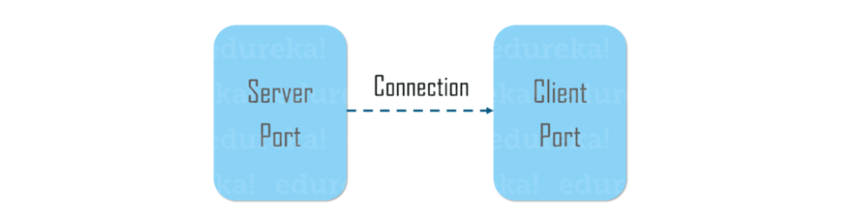

Types of Sockets : There are two types of Sockets: the datagram socket and the stream socket.
- Datagram Socket : A datagram socket uses the User Datagram Protocol (UDP) for sending messages. UDP is a much simpler protocol as it does not provide any of the delivery guarantees that TCP does.
- Stream Socket A stream socket uses the Transmission Control Protocol (TCP) for sending messages. network socket which provides a connection-oriented, sequenced, and unique flow of data without record. It is similar to phone. A connection is established between the phones (two ends) and a conversation (transfer of data) takes place.
Reading from Servers with Sockets
Basic step to read data from servers with sockets
- Open a socket.
- Open an input stream and output stream to the socket.
- Read from and write to the stream according to the server's protocol.
- Close the streams.
- Close the socket.

Reading from Server
import java.io.*;
import java.net.*;
public class App {
public static void main(String[] args) throws IOException {
Socket socket = new Socket("time.nist.gov", 13);//1.connect to remote machine
socket.setSoTimeout(15000);
InputStream in = socket.getInputStream();//2. open stream
StringBuilder time = new StringBuilder();
InputStreamReader reader = new InputStreamReader(in, "ASCII");//3. read data
int c;
while ((c = reader.read()) != -1)
{
time.append((char) c);
}
reader.close();//4. close the stream
socket.close();//5. Close the socket
System.out.println(time);

}

}

Output:
60058 23-04-24 05:04:08 50 0 0 131.2 UTC(NIST) *
Another Example:
Lab27: Write a Java program to read data from server using socket.
Reading from Server
Create MyClient.java class
import java.io.*;
import java.net.*;
public class MyClient {
public static void main(String[] args) throws IOException {
// Create a socket to connect to the server
Socket clientSocket = new Socket("localhost", 1234);
// Create input stream to read data from the server
BufferedReader in = new BufferedReader(new InputStreamReader(clientSocket.getInputStream()));//read data so InputStream
// Read data from the server
String serverResponse = in.readLine();
System.out.println("Server says: " + serverResponse);
// Close the connection
clientSocket.close();
}

}
Create MyServer.java
import java.io.*;
import java.net.*;
public class MyServer {
public static void main(String[] args) throws IOException {
// Create a server socket
ServerSocket serverSocket = new ServerSocket(1234);
// Wait for a client to connect
Socket clientSocket = serverSocket.accept();
System.out.println("Connected to Client");
// Create output stream to send data to the client
PrintWriter out = new PrintWriter(clientSocket.getOutputStream(), true); //send data so output Stream
// Send the current date and time to the client
out.println("Hello from server");
// Close the connection
clientSocket.close();
serverSocket.close();
}
}

}

}
}

Output:
Connected to localhost on port 1234
Server says: Hello from server

Writing to Server with Socket
Lab28: Write a java program to write data to server using socket.
MyClient.java
import java.io.*;
import java.net.*;
public class MyClient {
public static void main(String[] args) throws IOException {
// Create a socket to connect to the server
Socket client = new Socket("localhost", 1234);
// Create output stream to send data to the server
PrintWriter out = new PrintWriter(client.getOutputStream(), true);//send data so output stream
// Send data to the server
out.println("Hello from client");
// Close the connection
client.close();
}
}

MyServer.java
import java.io.*;
import java.net.*;
public class MyServer {
public static void main(String[] args) throws IOException {
// Create a server socket
ServerSocket serverSocket = new ServerSocket(1234);
System.out.println("Server started");
// Wait for a client to connect
Socket server = serverSocket.accept();
// Create input stream to read data from the client
BufferedReader in = new BufferedReader(new InputStreamReader(server.getInputStream()));//read data so Inputstream
// Read and print the message from the client
String clientMessage = in.readLine();
System.out.println("Client says: " + clientMessage);
// Close the connection
server.close();
serverSocket.close();

}
}
33.Lab: Write a java program to perform basic two-way operation between client and server using TCP.
34.Lab: Write a simple chat application using TCP Socket.
MyClient.java
import java.io.*;
import java.net.*;
public class MyClient {
public static void main(String[] args) throws IOException {
Socket clientSocket = new Socket("localhost", 1234);
// Set up input and output streams
PrintWriter out = new PrintWriter(clientSocket.getOutputStream(), true);
BufferedReader in = new BufferedReader(new InputStreamReader(clientSocket.getInputStream()));
int a=5;
int b=6;
out.println(a + " " + b);
String serverResponse = in.readLine();
System.out.println("Sum from server: " + serverResponse);
clientSocket.close();
}
}

MyServer.java
import java.io.*;
import java.net.*;
public class MyServer {
public static void main(String[] args) throws IOException {
ServerSocket serverSocket = new ServerSocket(1234);
Socket clientSocket = serverSocket.accept();
System.out.println("Connected to Client");
PrintWriter out = new PrintWriter(clientSocket.getOutputStream(), true);
BufferedReader in = new BufferedReader(new InputStreamReader(clientSocket.getInputStream()));
// Read the numbers from the client
String inputLine = in.readLine();
System.out.println("Received from client: " + inputLine);
String[] numbers = inputLine.split(" ");
int a = Integer.parseInt(numbers[0]);
int b = Integer.parseInt(numbers[1]);
int sum = a + b;
System.out.println("Calculated sum: " + sum);
out.println(sum);
clientSocket.close();
serverSocket.close();
}

}
UDP (User Datagram Packet) Protocol:
- Connection-less Protocol faster than TCP(connection oriented protocol)
- Using User Datagram Protocol, Applications can send data/message to the other hosts without communications or channel or path.
- Even if the destination host is not available, application can send data
- There is no guarantee that the data is received in the other side
- Good for video streaming.
Java’s Implementation of UDP
To implement UDP in Java, you can use the DatagramSocket and DatagramPacket classes.

DatagramSocket
- DatagramSocket is used to send and receive UDP packets.
- It can be created with or without a specific port number.
- send(packet) sends a packet to a specified address.
- receive(packet) waits for a packet to receive.

DatagramPacket
- DatagramPacket represents a packet of data to be sent or received.
- It contains the data, the length of the data, and the address/port of the destination.
- DatagramPacket(byte[] buf, int length) creates a packet to receive data.
- DatagramPacket(byte[] buf, int length, InetAddress address, int port) creates a packet to send data.
UDP Client and Server
UDP Client:
- The UDP client sends data to a UDP server.
- Unlike TCP, UDP does not establish a connection before sending data.
- The client creates a DatagramSocket to handle sending and receiving data packets.
- The client prepares the data, wraps it in a DatagramPacket, and sends it to the server's address and port.
- The client can use any available port for sending data, and the system assigns this port automatically.
Simple UDP Client:
- Import Required Classes: You need DatagramSocket, DatagramPacket, and InetAddress.
- Create DatagramSocket: This is UDP socket used to send data.
- Prepare the Message: Convert the message string to bytes.
- Create DatagramPacket: This packet contains the message, destination address, and port.
- Send the Packet: Use the send method of DatagramSocket.
- Close the Socket: Always close the socket to free up resources.
Simple Program:
import java.net.*;
public class App {
public static void main(String[] args) throws Exception {
// Create a DatagramSocket
DatagramSocket clientSocket = new DatagramSocket();
// Prepare the message to be sent
String message = "Hello, UDP Server!";
byte[] sbuffer = message.getBytes();
// Create a DatagramPacket with the server's address and port
InetAddress serverAddress = InetAddress.getByName("localhost");
DatagramPacket sendPacket = new DatagramPacket(sbuffer, sbuffer.length, serverAddress, 5000);
// Send the packet
clientSocket.send(sendPacket);
// Close the socket
clientSocket.close();
}
}
Step to create UDP Client Socket
- Creates a DatagramSocket.

- Converts the message to bytes.

- Creates a DatagramPacket with the message, server address, and server port.

- Send the packet using the send method.

- Wait for a response from the server if needed
- Closes the socket to free resources.

UDP Server:
- The UDP server receives data from UDP clients.
- The server needs to listen on a specific port, so clients know where to send the data.
- The server creates a DatagramSocket bound to the specific port to receive incoming packets.
- The server waits for incoming packets, processes the received data, and optionally sends a response back to the client.
- The server uses a blocking call to wait for data, meaning it will pause and wait until a packet arrives.

UDPServer.java
import java.net.*;
public class UDPServer {
public static void main(String[] args) {
try {
// Create a DatagramSocket bound to a specific port
DatagramSocket serverSocket = new DatagramSocket(5000);
// Prepare a buffer to hold incoming data
byte[] receiveBuffer = new byte[1024];
DatagramPacket receivePacket = new DatagramPacket(receiveBuffer, receiveBuffer.length);
// Wait for and receive a packet (blocking call)
System.out.println("Server is waiting for a packet...");
serverSocket.receive(receivePacket);
// Process the received data
String receivedMessage = new String(receivePacket.getData(), 0, receivePacket.getLength());
System.out.println("Received: " + receivedMessage);
// Close the socket
serverSocket.close();
} catch (Exception e) {
e.printStackTrace();
}
}
}
- 39Lab: write a simple UDP java program to send data from client to server.
- 40Lab: Write a UDP client and server socket program in which server identifies the number sent by client either even or odd and replies the client accordingly.(2024)
- 41Lab:Write a UDP client-server socket program where the client sends a number to the server. The server checks whether the number is prime or not.
- 42Lab:Write a UDP client-server program where the client requests the current time, and the server responds with the system's current time.
- 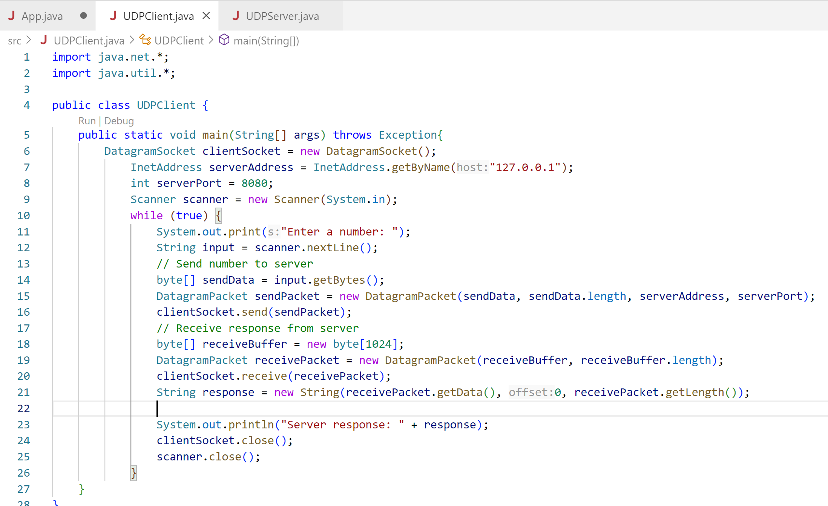

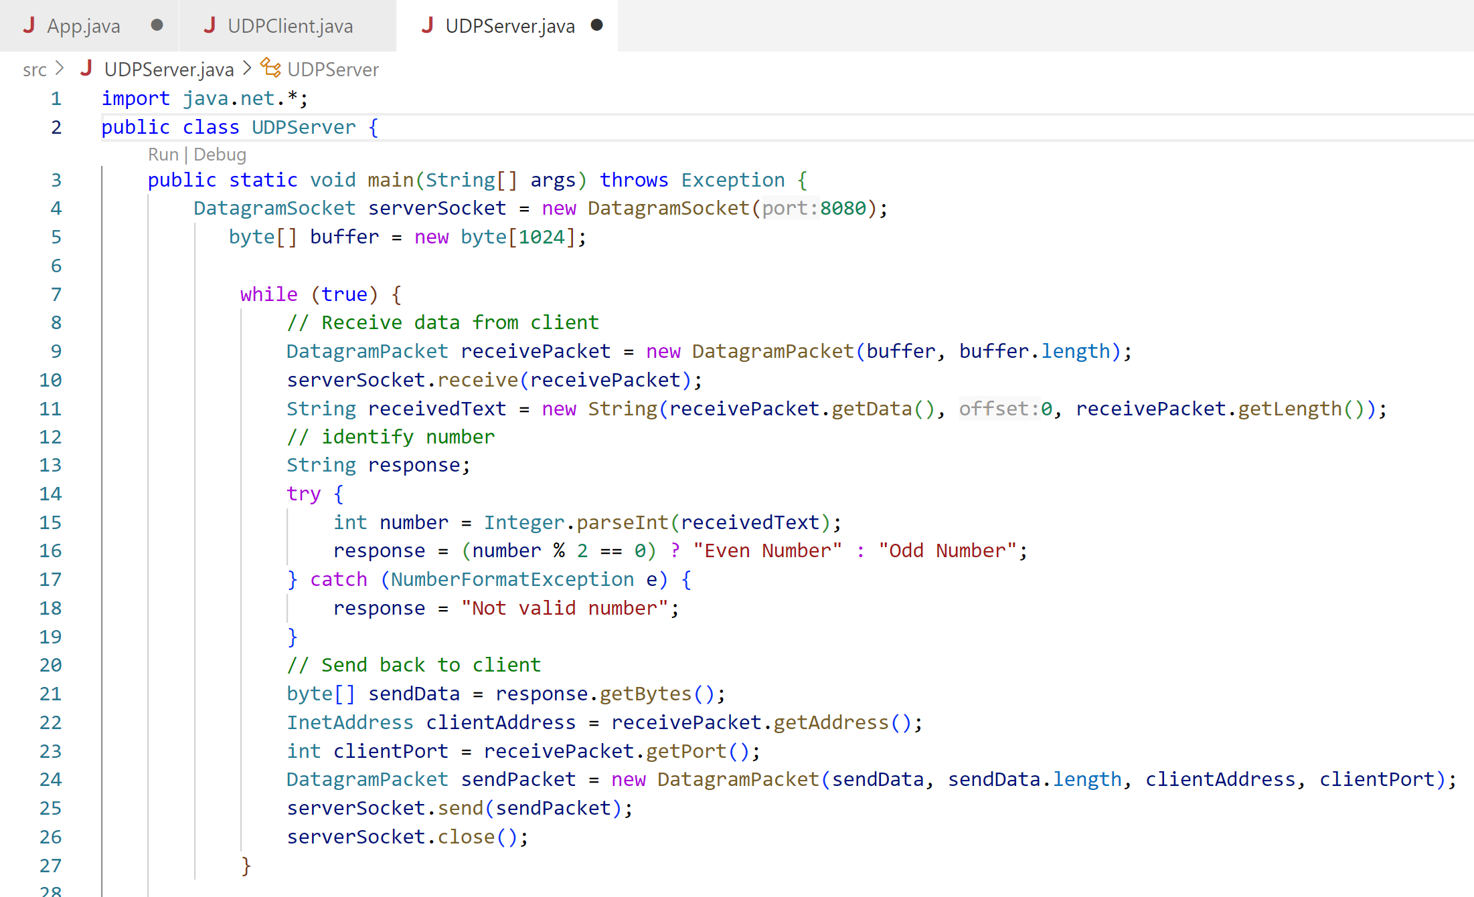

URL(Uniform Resource Locator)
It is string of characters refers to just the address.
It is the most used way to locate resources on the web.
E.g. Address:
House No., Ward No,
Kathmandu, Nepal.

The URL Class is the simplest way for a java program to locate and retrieve information form the network.
It consists of multiple parts including protocols, IP address, path and port to locate the information and the mechanism for retrieving it.
URL uses protocol such as http:// and ftp:// to identify the resource
The syntax of a URL is:
protocol://userInfo@host:port/path?query#fragment

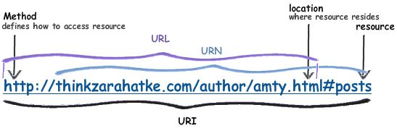
URL- Accessing resources
URN- Identifying resources
URN (Uniform Resource Name)
A URN identifies a resource by name, not by where it’s located.
A URN is like a person’s name — it identifies who they are, not where they live.

Component of URL
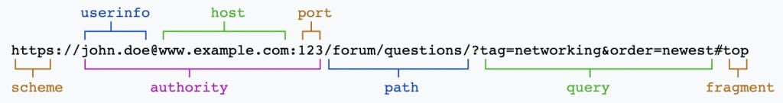
- The Scheme, which is the protocol that you’re using to interact.
- The Authority, which is the target you’re accessing. This breaks down into userinfo, host, and port.
- The Path, which is the resource you’re requesting on the host.
- The Query, which are the parameters being used within the web application.
- The Fragment, which is the target to jump to within a given page.

Lab: write a java program to spit different component of url from given url: (https://www.example.com:8080/path/to/resource?key1=value1&key2=value2#section2)
Example:
Import java.net.*;
public static void main(String[] args) throws MalformedURLException {
URL url1 = new URL("https://www.example.com:8080/path/to/resource?key1=value1&key2=value2#section2");
System.out.println(url1.toString());
System.out.println();
System.out.println(
"Different components of the URL1-");
System.out.println("Protocol:- " + url1.getProtocol());
System.out.println("Hostname:- " + url1.getHost()); System.out.println("Default port:- "+ url1.getDefaultPort());
// Retrieving the query part of URL
System.out.println("Query:- " + url1.getQuery());
// Retrieving the path of URL
System.out.println("Path:- " + url1.getPath());
// Retrieving the file name
System.out.println("File:- " + url1.getFile());
// Retrieving the reference
System.out.println("Reference:- " + url1.getRef());
}
Output:
Different components of the URL1-
Protocol:- https
Hostname:- www.example.com
Default port:- 443
Query:- key1=value1&key2=value2
Path:- /path/to/resource
File:- /path/to/resource?key1=value1&key2=value2
Reference:- section2

InetAddress Class: (Imp)
- It is part of java.net package used representation IP address, both IPv4 and IPv6.
- It can resolve hostname to IP address and vice versa.

Creating InetAddress Object
There are no public constructors in the InetAddress class. Instead, InetAddress has Static Factory Methods that connect to a DNS (Domain Name Server) server to resolve a hostname (IP address to Name). The most common is InetAddress.getByName(). For example, this is how you look up www.google.com:
Import java.net.*;
InetAddress obj=InetAddress.getByName("www.samriddhi.com.np");
System.out.println(obj);//www.samriddhi.com.np/181.214.31.79

