UNIT-3
Event Handling
The change in the state of an object or behavior by performing actions is referred to as an Event in Java. Actions include button click, keypress, page scrolling, or cursor movement.
Java provides a package java.awt.event that contains several event classes.
We can classify the events in the following two categories:
- Foreground Events
- Background Events
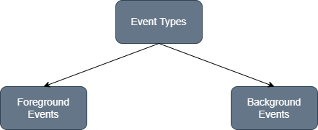

Foreground Events
Foreground events are those events that require user interaction to generate. In order to generate these foreground events, the user interacts with components in GUI. When a user clicks on a button, moves the cursor, and scrolls the scrollbar, an event will be fired.
Background Events
Background events don't require any user interaction. These events automatically generate in the background. OS failure, OS interrupts, operation completion, etc., are examples of background events.
Delegation Event Model
A mechanism that control the events and decide what should happen if an event occur. Java follows the Delegation Event Model for handling the events.
The Delegation Event Model consists of Source and Listener.

Source
Buttons, checkboxes, list, menu-item, choice, scrollbar, etc., are the sources from which events are generated.
Listeners
The events which are generated from the source are handled by the listeners. Each and every listener represents interfaces that are responsible for handling events.
Delegation Event Model in Java
The Delegation Event model is defined to handle events in GUI programming languages. The GUI stands for Graphical User Interface, where a user graphically/visually interacts with the system. The GUI programming is naturally event-driven; whenever a user initiates an activity such as a mouse activity, clicks, scrolling, etc., each is known as an event that is mapped to a code to respond to functionality to the user. This is known as event handling.
In this section, we will discuss event processing and how to implement the delegation event model in Java
. We will also discuss the different components of an Event Model.
Event Processing in Java
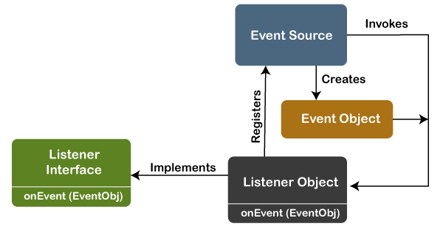

The key advantage of the Delegation Event Model is that the application logic is completely separated from the interface logic.
In this model, the listener must be connected with a source to receive the event notifications. Thus, the events will only be received by the listeners who wish to receive them
Basically, an Event Model is based on the following three components:
- Events
- Events Sources
- Events Listeners

Events
The Events are the objects that define state change in a source. An event can be generated as a reaction of a user while interacting with GUI elements. Some of the event generation activities are moving the mouse pointer, clicking on a button, pressing the keyboard key, selecting an item from the list, and so on. We can also consider many other user operations as events.
Event Sources
A source is an object that causes and generates an event. It generates an event when the internal state of the object is changed. The sources are allowed to generate several different types of events.
A source must register a listener to receive notifications for a specific event. Each event contains its registration method. Below is an example:
public void addTypeListener (TypeListener e1)
Event Listeners
An event listener is an object that is invoked when an event triggers. The listeners require two things; first, it must be registered with a source; however, it can be registered with several resources to receive notification about the events. Second, it must implement the methods to receive and process the received notifications. For example,
the MouseMotionListener interface provides two methods when the mouse is dragged and moved. Any object can receive and process these events if it implements the MouseMotionListener interface.

These are some of the most used Event classes:
Event Class | Listener Interface | Methods | Descriptions
ActionEvent | ActionListener | actionPerformed() | ActionEvent indicates that a component-defined action occurred.
FocusEvent | FocusListener | focusLost() and focusGained() | Focus events include focus, focusout, focusin, and blur.
ItemEvent | ItemListener | itemStateChanged() | Item event occurs when an item is selected.
KeyEvent | KeyListener | keyPressed(), keyReleased(), and keyTyped(). | A key event occurs when the user presses a key on the keyboard.
MouseEvent | MouseListener and MouseMotionListener | mouseClicked(), mousePressed(), mouseEntered(), mouseExited() and mouseReleased() are the mouseListener methods. mouseDragged() and mouseMoved() are the MouseMotionListener() methods. | A mouse event occurs when the user interacts with the mouse.
MouseWheelEvent | MouseWheelListener | mouseWheelMoved(). | MouseWheelEvent occurs when the mouse wheel rotates in a component.
TextEvent | TextListener | textChanged() | TextEvent occurs when an object's text change.
WindowEvent | WindowListener | windowActivated(), windowDeactivated(), windowOpened(), windowClosed(), windowClosing(), windowIconfied() and windowDeiconified(). | Window events occur when a window's status is changed.

ActionListener:
The Java ActionListener is notified whenever you click on the button or menu item. It is notified against ActionEvent. The ActionListener interface is found in java.awt.event package. It has only one method: actionPerformed().
ActionListener Example:
import java.awt.*;
import java.awt.event.*;
//1st Step Implement ActionListner
public class App implements ActionListener{
TextField tf; Button b;
App()
{
Frame f=new Frame(); tf=new TextField();
tf.setBounds(50,50, 150,20); b=new Button("Click Here");
b.setBounds(50,100,60,30);
//2nd step register
b.addActionListener(this);
f.add(b); f.add(tf);
f.setSize(400,400);
f.setLayout(null); f.setVisible(true);
}
//3rd Step listener implementation
public void actionPerformed(ActionEvent e)
{
tf.setText("Hello World");
}
public static void main(String[] args) throws Exception {

new App();

}
}
Output:
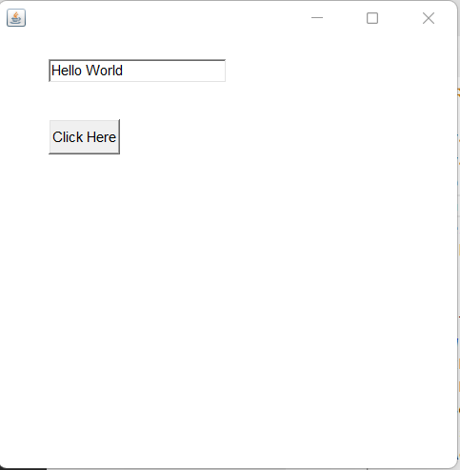

MouseListener:
The Java MouseListener is notified whenever you change the state of mouse. It is notified against MouseEvent. The MouseListener interface is found in java.awt.event package. It has five methods.
mouseClicked(), mousePressed(), mouseEntered(), mouseExited() and mouseReleased()

Mouse Listener Example:
import java.awt.*;
import java.awt.event.*;
//1st Step Implement ActionListner
public class App implements MouseListener{
Label l;
App()
{
Frame f=new Frame();
l=new Label();
l.setBounds(20,50,100,20);
f.add(l);
f.addMouseListener(this);
f.setSize(300,300);
f.setLayout(null);
f.setVisible(true);
}
public void mouseClicked(MouseEvent e) {
l.setText("Mouse Clicked");
}
public void mouseEntered(MouseEvent e) {
l.setText("Mouse Entered");
}
public void mouseExited(MouseEvent e) {
l.setText("Mouse Exited");
}
public void mousePressed(MouseEvent e) {
l.setText("Mouse Pressed");
}
public void mouseReleased(MouseEvent e) {
l.setText("Mouse Released");
}

public static void main(String[] args) throws Exception {

new App();

}
}

Output:
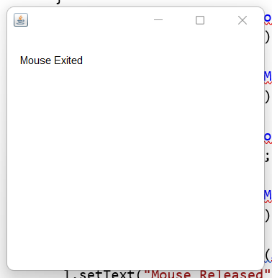
MouseMotionListener:
The Java MouseMotionListener is notified whenever you move or drag mouse. It is notified against MouseEvent. The MouseMotionListener interface is found in java.awt.event package. It has two methods.
The signature of 2 methods found in MouseMotionListener interface are given below:
- mouseDragged(MouseEvent e);
- mouseMoved(MouseEvent e);

MouseMotionListener Example:
import java.awt.*;
import java.awt.event.*;
public class App implements MouseMotionListener{
Frame f;
App()
{
f=new Frame();
f.addMouseMotionListener(this);
f.setSize(300,300);
f.setLayout(null);
f.setVisible(true);
}
public void mouseDragged(MouseEvent e) {
Graphics g=f.getGraphics();
g.setColor(Color.BLUE);
g.fillOval(e.getX(),e.getY(),20,20);
}
public void mouseMoved(MouseEvent e) {}
public static void main(String[] args) throws Exception {
new App();
}
}
Output:
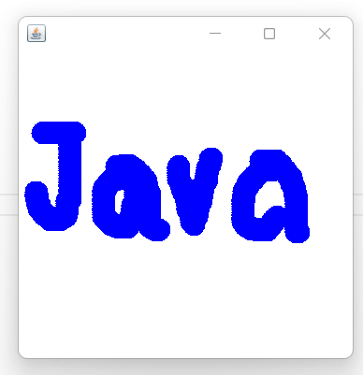

ItemListener:
The Java ItemListener is notified whenever you click on the checkbox. It is notified against ItemEvent. The ItemListener interface is found in java.awt.event package. It has only one method: itemStateChanged().
Eample:
import java.awt.*;
import java.awt.event.*;
public class App implements ItemListener{
Checkbox checkBox1,checkBox2;
Label label;
App()
{
Frame f=new Frame();label = new Label();
label.setAlignment(Label.CENTER);
label.setSize(400,100);
checkBox1 = new Checkbox("C++"); checkBox1.setBounds(100,100, 50,50);
checkBox2 = new Checkbox("Java"); checkBox2.setBounds(100,150, 50,50);
f.add(checkBox1); f.add(checkBox2); f.add(label);
checkBox1.addItemListener(this); checkBox2.addItemListener(this);
f.setSize(300,300); f.setLayout(null);f.setVisible(true);
}
public void itemStateChanged(ItemEvent e) {
if(e.getSource()==checkBox1)
label.setText("C++ Checkbox: Checked");
if(e.getSource()==checkBox2)
label.setText("Java Checkbox: Checked");
}
public static void main(String[] args) throws Exception {

new App();

}
}
Output:
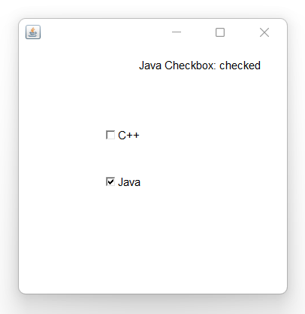
KeyListener:
The Java KeyListener is notified whenever you change the state of key. It is notified against KeyEvent. The KeyListener interface is found in java.awt.event package. It has three methods.
- keyPressed(KeyEvent e);
- keyReleased(KeyEvent e);
- keyTyped(KeyEvent e);

Example:
import java.awt.*;
import java.awt.event.*;
public class App implements KeyListener{
Label l; TextArea area;
App()
{
Frame f=new Frame();l = new Label();
l.setBounds(20,50,100,20);
area=new TextArea();
area.setBounds(20,80,300, 300);
area.addKeyListener(this);
f.add(l); f.add(area);
f.setSize(300,300); f.setLayout(null);f.setVisible(true);
}
public void keyPressed(KeyEvent e) {
l.setText("Key Pressed");
}
public void keyReleased(KeyEvent e) {
l.setText("Key Released");
}
public void keyTyped(KeyEvent e) {
l.setText("Key Typed");
}
public static void main(String[] args) throws Exception {

new App();

}
}

Output:
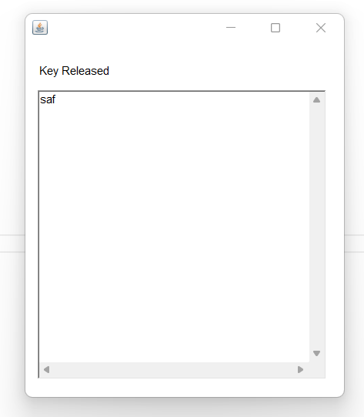

WindowListener:
The Java WindowListener is notified whenever you change the state of window. It is notified against WindowEvent. The WindowListener interface is found in java.awt.event package. It has 7 methods.
windowsActivated(), windowDeactivated(), windowOpened(), windowClosed(), windowClosing(), windowIconfied() and windowDeiconified().

import java.awt.*;
import java.awt.event.*;
public class App implements WindowListener{

Frame f;
{
f=new Frame();

f.addWindowListener(this);

f.setSize(300,300);
f.setLayout(null);
f.setVisible(true);
}

public void windowActivated(WindowEvent arg0) {
System.out.println("activated");
}
public void windowClosed(WindowEvent arg0) {
System.out.println("closed");
}
public void windowClosing(WindowEvent arg0) {
System.out.println("closing");
f.dispose();
}
public void windowDeactivated(WindowEvent arg0) {
System.out.println("deactivated");
}
public void windowDeiconified(WindowEvent arg0) {
System.out.println("deiconified");
}
public void windowIconified(WindowEvent arg0) {
System.out.println("iconified");
}
public void windowOpened(WindowEvent arg0) {
System.out.println("opened");
}
public static void main(String[] args) throws Exception {

new App();

}
}

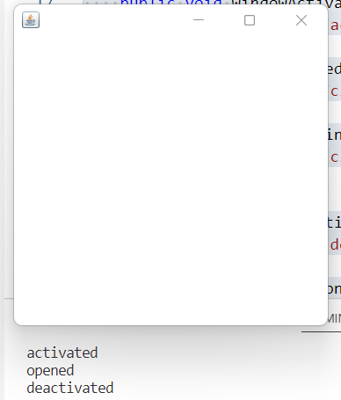

Java Adapter Classes:
Java adapter classes provide the default implementation of listener interfaces. If you inherit the adapter class, you will not be forced to provide the implementation of all the methods of listener interfaces. So it saves code.
The adapter classes are found in java.awt.event, java.awt.dnd (drag and drop) and javax.swing.event packages. The Adapter classes with their corresponding listener interfaces are given below.
java.awt.event Adapter classes
Adapter class | Listener interface
WindowAdapter | WindowListener
KeyAdapter | KeyListener
MouseAdapter | MouseListener
MouseMotionAdapter | MouseMotionListener
FocusAdapter | FocusListener
ComponentAdapter | ComponentListener
ContainerAdapter | ContainerListener
HierarchyBoundsAdapter | HierarchyBoundsListener
java.awt.dnd Adapter classes
Adapter class | Listener interface
DragSourceAdapter | DragSourceListener
DragTargetAdapter | DragTargetListener

javax.swing.event Adapter classes
Adapter class | Listener interface
MouseInputAdapter | MouseInputListener
InternalFrameAdapter | InternalFrameListener

Example:
import java.awt.*;
import java.awt.event.*;
public class App{

Frame f;
App(){
f=new Frame("Window Adapter");
f.addWindowListener(new WindowAdapter()
{
public void windowClosing(WindowEvent e)
{
f.dispose();
}
});

f.setSize(400,400);
f.setLayout(null);
f.setVisible(true);
}
public static void main(String[] args) throws Exception {

new App();

}
}

MouseAdapter Example:
import java.awt.*;
import java.awt.event.*;
public class App extends MouseAdapter{

Frame f;
App(){
f=new Frame("Mouse Adapter");
f.addMouseListener(this);

f.setSize(400,400);
f.setLayout(null);
f.setVisible(true);
}
public void mouseClicked(MouseEvent e) {
Graphics g=f.getGraphics();
g.setColor(Color.BLUE);
g.fillOval(e.getX(),e.getY(),20,20);
}
public static void main(String[] args) throws Exception {

new App();

}
}
Output:
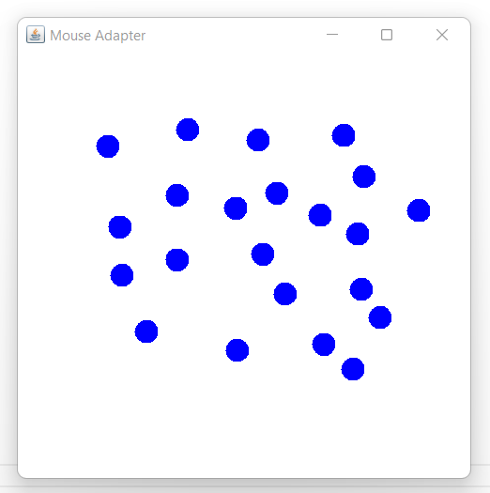

Java MouseMotionAdapter:
import java.awt.*;
import java.awt.event.*;
public class App extends MouseMotionAdapter{

Frame f;
App(){
f=new Frame("Mouse Motion Adapter");
f.addMouseMotionListener(this);

f.setSize(400,400);
f.setLayout(null);
f.setVisible(true);
}
public void mouseDragged(MouseEvent e) {
Graphics g=f.getGraphics();
g.setColor(Color.BLUE);
g.fillOval(e.getX(),e.getY(),20,20);
}
public static void main(String[] args) throws Exception {

new App();

}
}
Output:
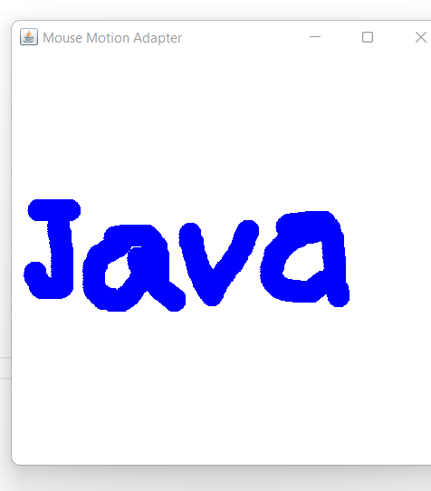

Write a program to count word and character from textarea using keyadapter class.
Java KeyAdapter Example:
import java.awt.*;
import java.awt.event.*;
public class App extends KeyAdapter{
Frame f;
Label l;
TextArea area;
App(){
f=new Frame("Key Adapter");
l=new Label();
l.setBounds(20,50,200,20);
area=new TextArea();
area.setBounds(20,80,300, 300);
area.addKeyListener(this);
f.add(l);f.add(area);
f.setSize(400,400);
f.setLayout(null); f.setVisible(true);
}
public void keyReleased(KeyEvent e) {
String text=area.getText();
String words[]=text.split("\\s");
l.setText("Words: "+words.length+" Characters:"+text.length());
}
public static void main(String[] args) throws Exception {

new App();

}
}

Output:
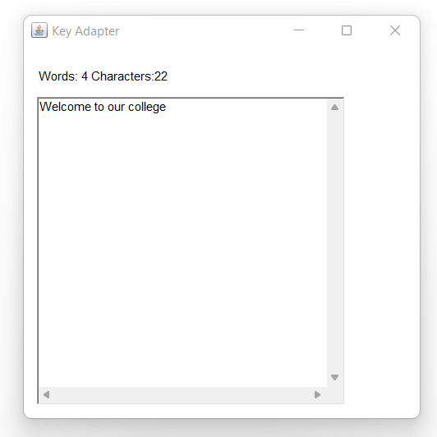

- How can you handle events using adapter classes? Discuss.
- Discuss the role of event listeners to handle events with suitable example.
- Discuss any five event classes in java.
- Discuss any three Adapter Event Classes in Java.
- Why is it important to handle events.
- What is action event? Discuss
- Define event delegation model. Why do we need adapter class in event handling?
- How can we use listener interface to handle events? Compare listener interface with adapter class.

