UNIT-8
JAVA RMI(Remote Method Invocation)
RMI stands for Remote Method Invocation. It is a mechanism that allows an object residing in one system (JVM) to access/invoke an object running on another JVM. RMI is used to build distributed applications; it provides remote communication between Java programs. It is provided in the package java.rmi.
Architecture of an RMI Application
In an RMI application, we write two programs, a server program (resides on the server) and a client program (resides on the client).
- Inside the server program, a remote object is created and reference of that object is made available for the client (using the RMI registry).
- The client program requests the remote objects on the server and tries to invoke its methods.
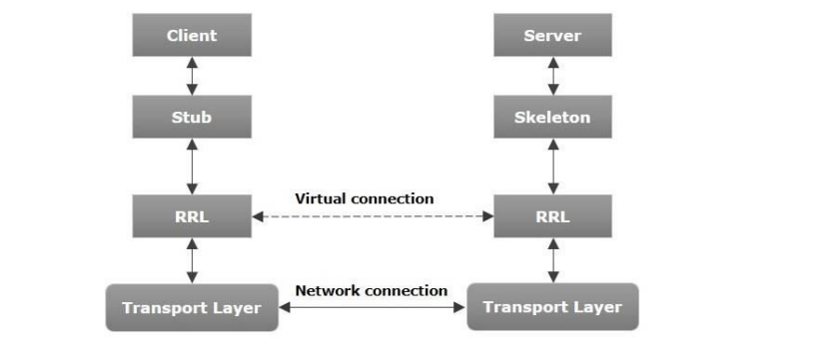
Let us now discuss the components of this architecture.
- Transport Layer − This layer connects the client and the server. It manages the existing connection and also sets up new connections.
- Stub − A stub is a representation of the remote object at client. It resides in the client system; it acts as a gateway for the client program.
- Skeleton − This is the object which resides on the server side. stub communicates with this skeleton to pass request to the remote object.
- RRL(Remote Reference Layer) − It is the layer which manages the references made by the client to the remote object.
Working of an RMI Application
- When the client makes a call to the remote object, it is received by the stub which eventually passes this request to the RRL.
- When the client-side RRL receives the request, it invokes a method called invoke() of the object remoteRef. It passes the request to the RRL on the server side.
- The RRL on the server side passes the request to the Skeleton (proxy on the server) which finally invokes the required object on the server.
- The result is passed all the way back to the client.
Marshalling and Unmarshalling
Whenever a client invokes a method that accepts parameters on a remote object, the parameters are bundled into a message before being sent over the network. These parameters may be of primitive type or objects. In case of primitive type, the parameters are put together and a header is attached to it. In case the parameters are objects, then they are serialized. This process is known as marshalling.
At the server side, the packed parameters are unbundled and then the required method is invoked. This process is known as unmarshalling.
To write an RMI Java application, you would have to follow the steps given below –
- Define the remote interface
- Develop the implementation class (remote object)
- Develop the server program
- Develop the client program
- Compile the application
- Execute the application

RMI Registry
RMI registry is a namespace on which all server objects are placed. Each time the server creates an object, it registers this object with the RMIregistry (using bind() or reBind() methods). These are registered using a unique name known as bind name. To invoke a remote object, the client needs a reference of that object.
At that time, the client fetches the object from the registry using its bind name (using lookup() method). The following illustration explains the entire process −
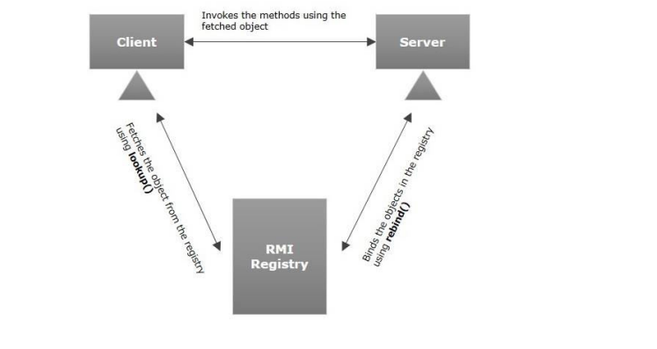
Goal of RMI
- To minimize the complexity of the application.
- To preserve type safety.
- Distributed garbage collection.
- Minimize the difference between working with local and remote objects.

Developing the Server Program
An RMI server program should implement the remote interface or extend the implementation class. Here, we should create a remote object and bind it to the RMIregistry.
To develop a server program
- Create a client class from where you want invoke the remote object.
- Create a remote object by instantiating the implementation class as shown below.
- Export the remote object using the method exportObject() of the class named UnicastRemoteObject which belongs to the package java.rmi.server.
- Get the RMI registry using the getRegistry() method of the LocateRegistry class which belongs to the package java.rmi.registry.
- Bind the remote object created to the registry using the bind() method of the class named Registry. To this method, pass a string representing the bind name and the object exported, as parameters.
https://www.youtube.com/watch?v=xNkyaMRKnnk

Write a java program to add two digit using RMI
RMI Example:
- create the remote interface
import java.rmi.*;
public interface Adder extends Remote {
public int add(int x,int y)throws RemoteException;
}
- Create and run the server application(MyServer.Java)
import java.rmi.*;
import java.rmi.registry.*;
import java.rmi.server.UnicastRemoteObject;
public class MyServer extends UnicastRemoteObject implements Adder {
public MyServer() throws RemoteException
{
super();
}
public static void main(String[] args) throws RemoteException
{
try {
Registry reg=LocateRegistry.createRegistry(5000);
reg.rebind("hi_server",new MyServer());
System.out.println("Server is Now Ready..");
}
catch(RemoteException e)
{
System.out.println(e);
}
}
@Override
public int add(int x, int y) throws RemoteException {
return x+y;
}

}

MyClient.java
import java.rmi.*;
import java.rmi.registry.*;
public class MyClient {
public static void main(String[] args) throws RemoteException
{
try{
Registry reg=LocateRegistry.getRegistry("localhost",5000);
Adder ad=(Adder)reg.lookup("hi_server");
System.out.println("Addition:"+ad.add(20, 30));

}
catch(NotBoundException|RemoteException e)
{
System.out.println(e);
}
}

}

(ServerSide) Output:
Server is Ready..
ClientSide Output:
Addition:50

CORBA:
The Common Object Request Broker Architecture (CORBA) is a standard developed by the Object Management Group (OMG) to provide interoperability among distributed objects. CORBA is the world’s leading application middleware solution enabling the exchange of information, independent of hardware platforms, programming languages, and operating systems. CORBA is essentially a design specification for an Object Request Broker (ORB), where an ORB provides the mechanism required for distributed objects to communicate with one another, whether locally or on remote devices, written in different languages, or at different locations on a network.
CORBA is a platform which support multiple programming to work together successfully
It is a mechanism in software for normalizing the method call semantic between application object residing either in the same address space or remote address space
It is a middleware neither 2 tier or 3 tier architecture.
The object request broker (ORB) enables client to invoke methods in a remote object
It is a technology to connect to objects of heterogeneous types.
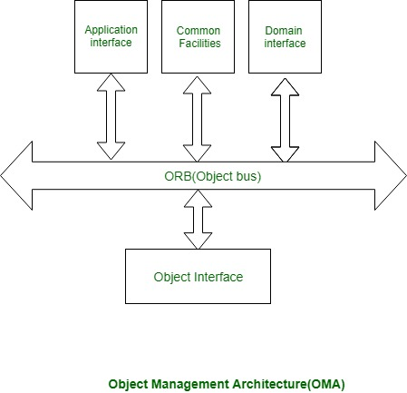

What is Middleware?
Middleware, software that functions as a translation layer, sits between an application residing on one server and any number of clients that want access to that application. In short, middleware allows users to interact with one another and with applications in a heterogeneous computing environment.
It’s important to note that the functions middleware provides are hidden, so that applications and information can be easily – and smoothly – accessed across different architectures, protocols and networks.
Interface Definition Language (IDL)
A cornerstone of the CORBA standards is the Interface Definition Language. IDL is the OMG standard for defining language-neutral APIs and provides the platform-independent delineation of the interfaces of distributed objects.
CORBA then specifies a mapping from IDL to a specific implementation language like C++ or Java. Standard mappings exist for Ada, C, C++, C++11, Lisp, Ruby, Smalltalk, Java, COBOL, PL/I and Python. There are also non-standard mappings for Perl, Visual Basic, Erlang, and Tcl implemented by object request brokers (ORBs) written for those languages.
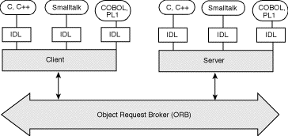

There are two types of object in corba
- Service provider object
- Client object
Service provider object: that includes functionalities that can be used by other objects
Client Object: Object that requires services of the other object
CORBA ARCHITECTURE:
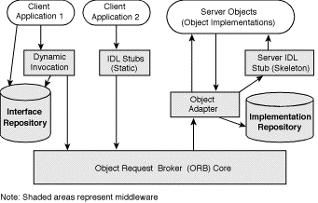

- Object -- This is a CORBA programming entity that consists of an identity, an interface, and an implementation, which is known as a Servant.
- Servant -- This is an implementation programming language entity that defines the operations that support a CORBA IDL interface. Servants can be written in a variety of languages, including C, C++, Java, Smalltalk, and Ada.
- Client -- This is the program entity that invokes an operation on an object implementation.
- Object Request Broker (ORB) -- The ORB provides a mechanism for transparently communicating client requests to target object implementations. When a client invokes an operation, the ORB is responsible for finding the object implementation.
- ORB Interface -- An ORB is a logical entity that may be implemented in various ways (such as one or more processes or a set of libraries).
- CORBA IDL stubs and skeletons -- CORBA IDL stubs and skeletons serve as the ``glue'' between the client and server applications, respectively, and the ORB.
- Dynamic Invocation Interface (DII) -- This interface allows a client to directly access the underlying request mechanisms provided by an ORB.
- Dynamic Skeleton Interface (DSI) -- This is the server side's analogue to the client side's DII. The DSI allows an ORB to deliver requests to an object implementation that does not have compile-time knowledge of the type of the object it is implementing.
RMI | CORBA
RMI is a Java-specific technology. | CORBA has implementation for many languages.
It uses Java interface for implementation. | It uses Interface Definition Language (IDL) to separate interface from implementation.
RMI objects are garbage collected automatically. | CORBA objects are not garbage collected because it is language independent and some languages like C++ does not support garbage collection.
RMI programs can download new classes from remote JVM’s. | CORBA does not support this code sharing mechanism.
RMI passes objects by remote reference or by value. | CORBA passes objects by reference.
Java RMI is a server-centric model. | CORBA is a peer-to-peer system.
RMI uses the Java Remote Method Protocol as its underlying remoting protocol. | CORBA use Internet Inter- ORB Protocol as its underlying remoting protocol.
The responsibility of locating an object implementation falls on JVM. | The responsibility of locating an object implementation falls on Object Adapter either Basic Object Adapter or Portable Object Adapter.

Simple Corba example:
https://www.youtube.com/watch?v=chsR860gbsk

