Option Dialog:
JOptionPane class is used to display four types of dialog boxes
- MessageDialog - dialog box that displays a message making it possible to add icons to alert the user.
- ConfirmDialog - dialog box that besides sending a message, enables the user to answer a question.
- InputDialog - dialog box that besides sending a message, allows entry of a text.
- OptionDialog - dialog box that covers the three previous types.
Example:
import javax.swing.*;
public class App {

public static void main(String[] args) {
JFrame frame = new JFrame("Main Window");

JOptionPane.showMessageDialog(frame, "Hello Java");
JOptionPane.showMessageDialog(frame,"Successfully Updated.","Alert",JOptionPane.WARNING_MESSAGE);
String name=JOptionPane.showInputDialog(frame,"Enter Name");
int result = JOptionPane.showConfirmDialog(null, "Do you want to remove item now?");
frame.setSize(350,350);
frame.setDefaultCloseOperation(JFrame.EXIT_ON_CLOSE);
frame.setVisible(true);
}

}

Program to create a simple JDialog

import javax.swing.*;
import java.awt.event.*;

public class App extends JFrame implements ActionListener {
static JFrame f;
public static void main(String[] args) {
// create a new frame
f = new JFrame("frame");
// create a object
App s = new App();
JButton b = new JButton("click");
b.setBounds(100,120,100,40);
// add actionlistener to button
b.addActionListener(s);
f.add(b);
// set the size of frame
f.setSize(400, 400);
f.setLayout(null);
f.setVisible(true);
}
public void actionPerformed(ActionEvent e)
{
String s = e.getActionCommand();
if (s.equals("click")) {
// create a dialog Box
JDialog d = new JDialog(f, "dialog Box");
// create a label
JLabel l = new JLabel("this is a dialog box");
d.add(l);
// setsize of dialog
d.setSize(100, 100);
// set visibility of dialog
d.setVisible(true);
}
}

}
Output:
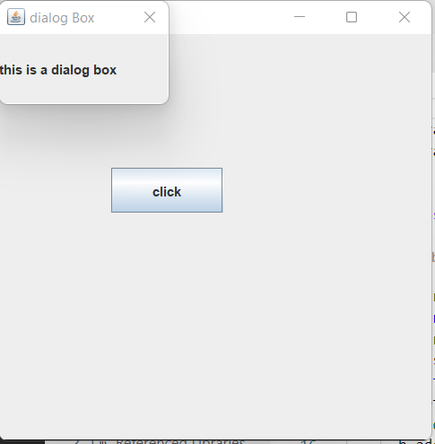

showMessageDialog
Displays a modal dialog with one button, which is labeled "OK" (or the localized equivalent). You can easily specify the message, icon, and title that the dialog displays. Here are some examples of using showMessageDialog:
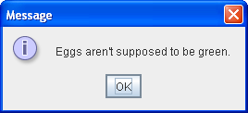 | //default title and icon  JOptionPane.showMessageDialog(frame,  "Eggs are not supposed to be green.");
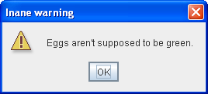 | //custom title, warning icon  JOptionPane.showMessageDialog(frame,  "Eggs are not supposed to be green.",  "Inane warning",  JOptionPane.WARNING_MESSAGE);
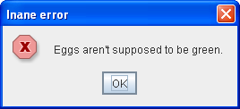 | //custom title, error icon  JOptionPane.showMessageDialog(frame,  "Eggs are not supposed to be green.",  "Inane error",  JOptionPane.ERROR_MESSAGE);
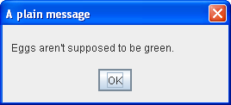 | //custom title, no icon  JOptionPane.showMessageDialog(frame,  "Eggs are not supposed to be green.",  "A plain message",  JOptionPane.PLAIN_MESSAGE);
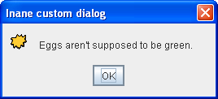 | //custom title, custom icon  JOptionPane.showMessageDialog(frame,  "Eggs are not supposed to be green.",  "Inane custom dialog",  JOptionPane.INFORMATION_MESSAGE,  icon);
showOptionDialog
Displays a modal dialog with the specified buttons, icons, message, title, and so on. With this method, you can change the text that appears on the buttons of standard dialogs. You can also perform many other kinds of customization.
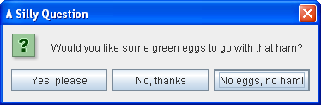
//Custom button text
Object[] options = {"Yes, please",
"No, thanks",
"No eggs, no ham!"};
int n = JOptionPane.showOptionDialog(frame,
"Would you like some green eggs to go "
+ "with that ham?",
"A Silly Question",
JOptionPane.YES_NO_CANCEL_OPTION,
JOptionPane.QUESTION_MESSAGE,
null,
options,
options[2]);

JOptionPane (constructor)
Creates a JOptionPane with the specified buttons, icons, message, title, and so on. You must then add the option pane to a JDialog, register a property-change listener on the option pane, and show the dialog. See Stopping Automatic Dialog Closing for details.
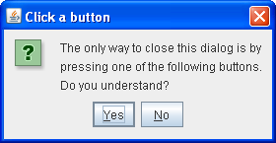
final JOptionPane optionPane = new JOptionPane(
"The only way to close this dialog is by\n"
+ "pressing one of the following buttons.\n"
+ "Do you understand?",
JOptionPane.QUESTION_MESSAGE,
JOptionPane.YES_NO_OPTION);

File Chooser:
import javax.swing.JFileChooser;

public class App {
public static void main(String[] args) throws Exception {

// Using this process to invoke the constructor,
// JFileChooser points to user's default directory
JFileChooser j = new JFileChooser();

// Open the save dialog
j.showSaveDialog(null);
}
}
Output:
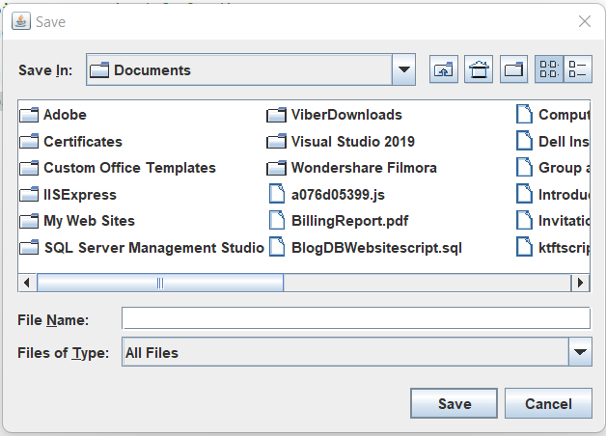

Example:
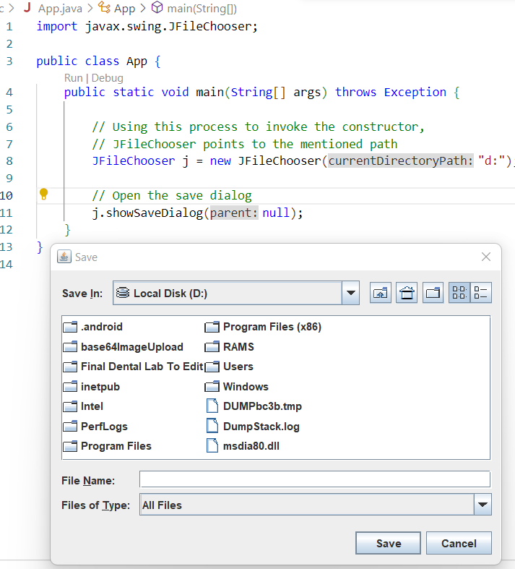

Color Chooser:
import java.awt.event.*;
import java.awt.*;
import javax.swing.*;

public class App extends JFrame implements ActionListener{
// create a button
JButton b = new JButton("color");
Container c = getContentPane();
// Constructor
App()
{
// set Layout
c.setLayout(new FlowLayout());
// add Listener
b.addActionListener(this);
// add button to the Container
c.add(b);
setSize(400, 400);
setVisible(true);
setDefaultCloseOperation(EXIT_ON_CLOSE);
}
public void actionPerformed(ActionEvent e)
{
Color initialcolor = Color.RED;
// color chooser Dialog Box
Color color = JColorChooser.showDialog(this,
"Select a color", initialcolor);
// set Background color of the Container
c.setBackground(color);
}
public static void main(String[] args) throws Exception {
App ch = new App();

}
}
Output:
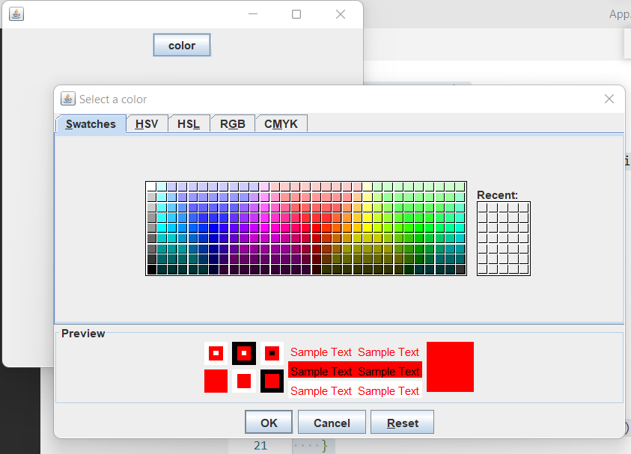
After Choosing Color Yellow Pressing Ok:
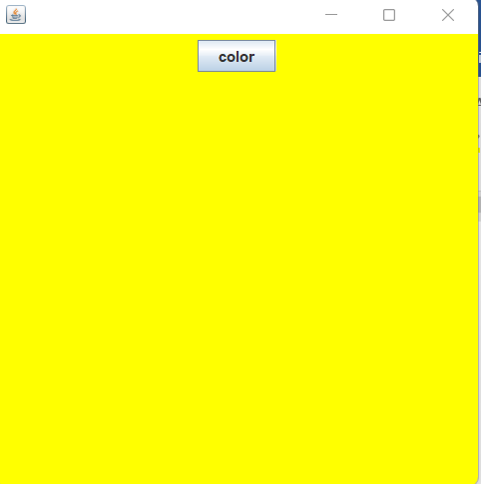

Internal Frame:
JInternalFrame is a part of Java Swing . JInternalFrame is a container that provides many features of a frame which includes displaying title, opening, closing, resizing, support for menu bar, etc.
Code:

import java.awt.*;
import javax.swing.*;

public class App extends JFrame{
// frame
static JFrame f;
// label to display text
static JLabel l, l1;
// Constructor
public static void main(String[] args) throws Exception {
// create a new frame
f = new JFrame("frame");
// set layout of frame
f.setLayout(new FlowLayout());
// create a internal frame
JInternalFrame in = new JInternalFrame("frame 1",
true, true, true, true);
// create a Button
JButton b = new JButton("button");
// create a label to display text
l = new JLabel("This is a JInternal Frame no 1 ");
// create a panel
JPanel p = new JPanel();
// add label and button to panel
p.add(l);
p.add(b);
in.setVisible(true);
in.add(p);
f.add(in);
f.setSize(300, 300);
f.setVisible(true);

}
}
Output:
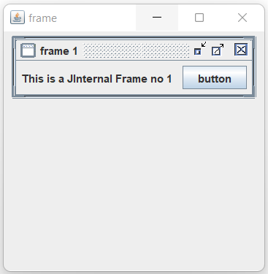
Tables:
In Java, tables are used to arrange data into columns and rows. A column is space that runs horizontally on a table, while a row is a space that runs horizontally in your table. The intersection between a column and a row is called a cell and is used to hold singular piece of data.
In Java, developers can use the JTable method to create a table in their applications. JTable is a Swing component that inherits from the JComponent class.
JTable table = new JTable (row, column);
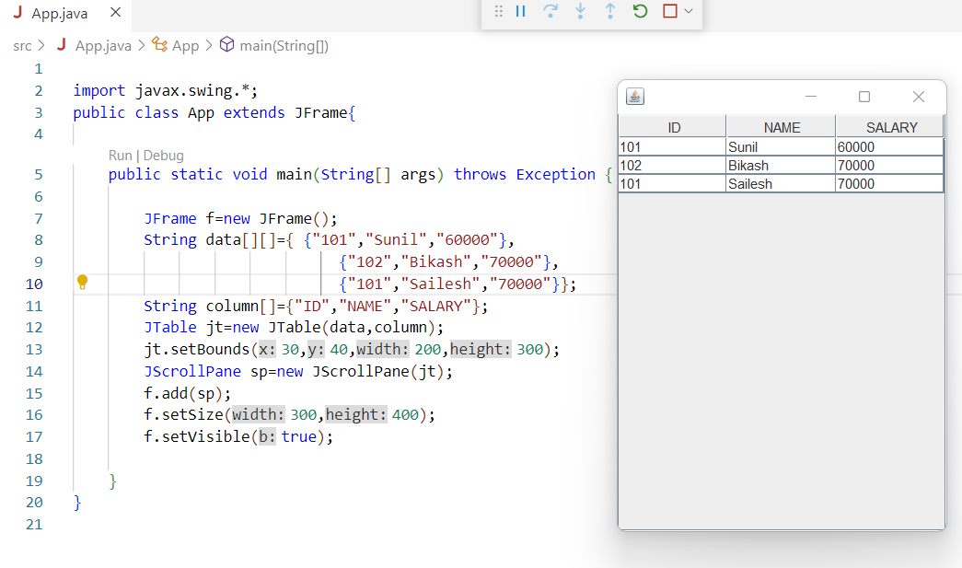
Write a program to develop a Java Swing application that contains a form with Name and Email text fields and Gender radio buttons (Male and Female). The form should include a Save button to insert the entered data into a database using JDBC when clicked, and a Reset button to clear all input fields. The application should also display all saved records in a JTable. The records must be loaded from the database when the form loads and the JTable should automatically refresh after saving a new record.
import java.sql.*;
import javax.swing.*;
import javax.swing.table.DefaultTableModel;
import java.awt.event.*;

public class App extends JFrame implements ActionListener {
JTextField txtName, txtEmail;
JRadioButton rbMale, rbFemale;
JButton btnSave, btnReset;
JTable table;
DefaultTableModel model;
Connection con;

public App() {
setTitle("User Form");
setSize(600, 500);
setLayout(null);
// Labels
JLabel lblName = new JLabel("Name:");
lblName.setBounds(50, 30, 100, 30);
add(lblName);

JLabel lblEmail = new JLabel("Email:");
lblEmail.setBounds(50, 70, 100, 30);
add(lblEmail);

JLabel lblGender = new JLabel("Gender:");
lblGender.setBounds(50, 110, 100, 30);
add(lblGender);

// TextFields
txtName = new JTextField();
txtName.setBounds(150, 30, 200, 30);
add(txtName);

txtEmail = new JTextField();
txtEmail.setBounds(150, 70, 200, 30);
add(txtEmail);

// Radio Buttons
rbMale = new JRadioButton("Male");
rbMale.setBounds(150, 110, 80, 30);

rbFemale = new JRadioButton("Female");
rbFemale.setBounds(230, 110, 100, 30);

ButtonGroup bg = new ButtonGroup();
bg.add(rbMale);
bg.add(rbFemale);

add(rbMale);
add(rbFemale);

// Buttons
btnSave = new JButton("Save");
btnSave.setBounds(150, 160, 90, 30);
add(btnSave);

btnReset = new JButton("Reset");
btnReset.setBounds(260, 160, 90, 30);
add(btnReset);

// Table
model = new DefaultTableModel();
model.addColumn("ID");
model.addColumn("Name");
model.addColumn("Email");
model.addColumn("Gender");

table = new JTable(model);
JScrollPane sp = new JScrollPane(table);
sp.setBounds(50, 220, 480, 200);
add(sp);
// Load Data
loadData();
// Save Button Action
btnSave.addActionListener(this);
// Reset Button Action
btnReset.addActionListener(this);
setVisible(true);
}
public void actionPerformed(ActionEvent e) {
if(e.getSource()==btnSave)
{
saveData();
loadData();
}
else{
clearForm();
}
}
// Save Data
public void saveData() {
try {
Class.forName("com.mysql.cj.jdbc.Driver");
con = DriverManager.getConnection(
"jdbc:mysql://localhost:3306/samdb",
"root",
"root");
String name = txtName.getText();
String email = txtEmail.getText();
String gender = rbMale.isSelected() ? "Male" : "Female";
PreparedStatement pst = con.prepareStatement(
"INSERT INTO tblstudent(name,email,gender) VALUES(?,?,?)");
pst.setString(1, name);
pst.setString(2, email);
pst.setString(3, gender);
pst.executeUpdate();
con.close();
JOptionPane.showMessageDialog(this, "Record Saved");

} catch (Exception e) {
e.printStackTrace();
}
}
// Load Data into JTable
public void loadData() {
try {
model.setRowCount(0);//clear all existing rows
Class.forName("com.mysql.cj.jdbc.Driver");
con = DriverManager.getConnection(
"jdbc:mysql://localhost:3306/samdb",
"root",
"root"); // change password
Statement st = con.createStatement();
ResultSet rs = st.executeQuery("SELECT * FROM tblstudent");
while (rs.next()) {
model.addRow(new Object[]{
rs.getInt("id"),
rs.getString("name"),
rs.getString("email"),
rs.getString("gender")
});
}
con.close();

} catch (Exception e) {
e.printStackTrace();
}
}
// Clear Form
public void clearForm() {
txtName.setText("");
txtEmail.setText("");
rbMale.setSelected(true);
rbFemale.setSelected(false);
txtName.requestFocus();
}

public static void main(String[] args) {
new App();
}
}

Write a program to develop a Java Swing application to create a Login form using GridLayout. The form should contain fields for Username and Password along with a Login button. Validate the entered username and password from a database using JDBC. If the login credentials are correct, display a message “Authorized”. If the credentials are incorrect, display a message “Invalid Username and Password”.
import java.sql.*;
import javax.swing.*;
import java.awt.*;
import java.awt.event.*;

public class LoginApp extends JFrame implements ActionListener {

JTextField txtUsername;
JPasswordField txtPassword;
JButton btnLogin, btnReset;
Connection con;

public LoginApp() {

setTitle("Login Form");
setSize(350, 200);
setLayout(new GridLayout(3, 2, 10, 10));
// Labels
JLabel lblUsername = new JLabel("Username:");
JLabel lblPassword = new JLabel("Password:");

// TextFields
txtUsername = new JTextField();
txtPassword = new JPasswordField();

// Buttons
btnLogin = new JButton("Login");
btnReset = new JButton("Reset");

// Add components
add(lblUsername);
add(txtUsername);
add(lblPassword);
add(txtPassword);
add(btnLogin);
add(btnReset);

// Button Actions
btnLogin.addActionListener(this);
btnReset.addActionListener(this);

setVisible(true);
}

// ActionPerformed
public void actionPerformed(ActionEvent e) {

if (e.getSource() == btnLogin) {
validateLogin();
} else {
clearForm();
}
}

// Validate Login
public void validateLogin() {

try {
Class.forName("com.mysql.cj.jdbc.Driver");
con = DriverManager.getConnection(
"jdbc:mysql://localhost:3306/samdb",
"root",
"root");

String username = txtUsername.getText();
String password = new String(txtPassword.getPassword());

PreparedStatement pst = con.prepareStatement(
"SELECT * FROM tbluser WHERE username=? AND password=?");

pst.setString(1, username);
pst.setString(2, password);

ResultSet rs = pst.executeQuery();

if (rs.next()) {
JOptionPane.showMessageDialog(this, "Authorized");
} else {
JOptionPane.showMessageDialog(this,
"Invalid Username and Password");
}

con.close();

} catch (Exception ex) {
ex.printStackTrace();
}
}

// Clear Form
public void clearForm() {
txtUsername.setText("");
txtPassword.setText("");
txtUsername.requestFocus();
}

public static void main(String[] args) {
new LoginApp();
}
}

Tree:
he JTree class is used to display the tree structured data or hierarchical data. JTree is a complex component. It has a 'root node' at the top most which is a parent for all nodes in the tree. It inherits JComponent class.

import javax.swing.*;
import javax.swing.tree.DefaultMutableTreeNode;
public class App{

public static void main(String[] args) throws Exception {
JFrame f=new JFrame();

DefaultMutableTreeNode style=new DefaultMutableTreeNode("Style");
DefaultMutableTreeNode color=new DefaultMutableTreeNode("color");
DefaultMutableTreeNode font=new DefaultMutableTreeNode("font");
style.add(color);
style.add(font);
DefaultMutableTreeNode red=new DefaultMutableTreeNode("red");
DefaultMutableTreeNode blue=new DefaultMutableTreeNode("blue");
DefaultMutableTreeNode black=new DefaultMutableTreeNode("black");
DefaultMutableTreeNode green=new DefaultMutableTreeNode("green");
color.add(red); color.add(blue); color.add(black); color.add(green);
JTree jt=new JTree(style);
f.add(jt);
f.setSize(200,200);
f.setVisible(true);

}
}
Output:
