UNIT-1(Threads):
Multitasking(or Multiprocessing) lets the CPU perform various tasks simultaneously (threads, process, program, task), while multithreading (with in Process) helps in the execution of various threads in a single process simultaneously.
Multithreading is faster. In multitasking, termination of a process takes more time. While in multithreading, termination of thread takes less time.
- A thread refers to the smallest unit of execution within a program.
- We use multithreading than multiprocessing because threads share a common memory area.
- They don't allocate separate memory area so saves memory, and context-switching between the threads takes less time than process.
- Java Multithreading is mostly used in games, animation etc.
- Java provides built-in support for multithreading through the java.lang.Thread class and the java.lang.Runnable interface.
Creating Thread:
We can create a new thread by either extending the Thread class or implementing the Runnable interface.
Extending java.lang.Thread:
- Extending the Thread class:
public class App {
public static void main(String[] args) throws Exception {
MyThread thread = new MyThread();
thread.start(); // Start the thread
}
}
class MyThread extends Thread {
public void run() {
// Code to be executed in the thread
System.out.println("Thread is running.");
}
}
Or,
public class App {
public static void main(String[] args) throws Exception {
Thread t1=new Thread() {
public void run() {
// Code to be executed in the thread
System.out.println("Thread is running.");
}
};
t1.start();
}
}

Implementing java.lang.Runnable:
- Implementing the Runnable interface:
public class App {
public static void main(String[] args) throws Exception {
MyRunnable runnable = new MyRunnable();
Thread thread = new Thread(runnable);
thread.start(); // Start the thread
}
}
class MyRunnable implements Runnable {
public void run() {
// Code to be executed in the thread
System.out.println("Thread is running.");
}
}
Or,
public class App {
public static void main(String[] args) throws Exception {
Runnable r1=new Runnable() {
public void run() {
// Code to be executed in the thread
System.out.println("Thread is running.");
}
};
Thread t1=new Thread(r1);
t1.start();

}
}

Life cycle of a Thread (Thread States)

A thread can be in one of the five states. The life cycle of the thread in java is controlled by JVM. The java thread states are as follows:
- New: Thread created, not yet started.
- Runnable: Started, ready for execution.
- Running: Currently executing its code.
- Non-Runnable (Blocked): Waiting for a condition to proceed.
- Terminated: Finished its execution, cannot be restarted.

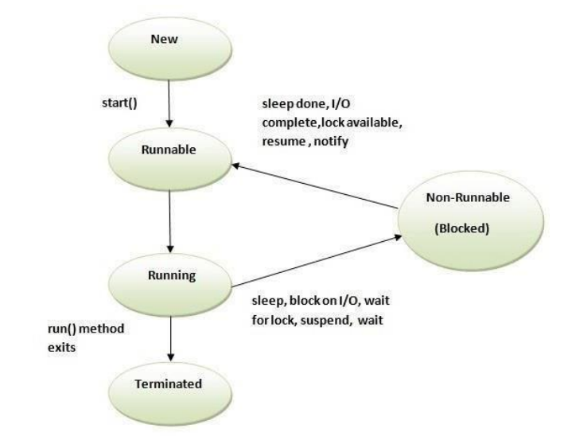

Priority of a Thread (Thread Priority):
Each thread have a priority. Priorities are represented by a number between 1 and 10. 3 constants defined in Thread class:
- public static int MIN_PRIORITY
- public static int NORM_PRIORITY
- public static int MAX_PRIORITY
Default priority of a thread is 5 (NORM_PRIORITY). The value of MIN_PRIORITY is 1 and the value of MAX_PRIORITY is 10.

Example:
public class App {
public class App {
public static void main(String[] args) throws Exception {
TestMultiPriority1 m1=new TestMultiPriority1();
TestMultiPriority1 m2=new TestMultiPriority1();
m1.setPriority(Thread.MIN_PRIORITY);
m2.setPriority(Thread.MAX_PRIORITY);
m1.start();
m2.start();
}
}
class TestMultiPriority1 extends Thread{
public void run()
{
System.out.println(Thread.currentThread().getPriority());
}
}
Output:
1
10
Synchronization
- Synchronization in Java is the capability to control the access of multiple threads to any shared resource.
- In a multithreaded environment, if multiple threads access and modify shared resources simultaneously, it can lead to problems such as data corruption, and unpredictable behavior.
- Java provides mechanisms for synchronization to help address these issues.
Thread Synchronization
There are two types of thread synchronization mutual exclusive and inter-thread communication.
- Mutual Exclusive
  - Synchronized method.
  - Synchronized block.
  - Static synchronization.
- Cooperation (Inter-thread communication in java)
Mutual Exclusive helps keep threads from interfering with one another while sharing data. It can be achieved by using the following three ways:
- By Using Synchronized Method
- By Using Synchronized Block
- By Using Static Synchronization
Java synchronized method
- It is a method that can be declared synchronized using the keyword “synchronized” before the method name.
- It is used for locking an object for any shared resources.
- The object gets the lock whenever the synchronized method is called.
- The lock does not release until the thread completes its function

public class App {
public static void main(String[] args) throws Exception {
Table obj = new Table();//only one object
MyThread1 t1=new MyThread1(obj);
MyThread2 t2=new MyThread2(obj);
t1.start();
t2.start();

}
}
class Table{
synchronized void printTable(int n){//synchronized method
for(int i=1;i<=5;i++){
System.out.println(n*i);
try{
Thread.sleep(400);
}catch(Exception e)
{System.out.println(e);}
}
}
}
class MyThread1 extends Thread{
Table t;
MyThread1(Table t){
this.t=t;
}
public void run(){
t.printTable(5);
}

}
class MyThread2 extends Thread{
Table t;
MyThread2(Table t){
this.t=t;
}
public void run(){
t.printTable(100);
}
}
Output
100
200
300
400
500
5
10
15
20
25
Synchronized Block
If a block is declared as synchronized then the code which is written inside a method is only executed instead of the whole code. It is used when sequential access to code is required.
public class App {
public static void main(String[] args) throws Exception {
Table obj = new Table();//only one object
MyThread1 t1=new MyThread1(obj);
MyThread2 t2=new MyThread2(obj);
t1.start();
t2.start();

}
}
class Table{
public void printTable(int n){//synchronized method
synchronized(this){ //This is a synchronized block
for(int i=1;i<=5;i++){
System.out.println(n*i);
try{
Thread.sleep(400);
}catch(Exception e){System.out.println(e);}
}
}
}
}

class MyThread1 extends Thread{
Table t;
MyThread1(Table t){
this.t=t;
}
public void run(){
t.printTable(5);
}

}
class MyThread2 extends Thread{
Table t;
MyThread2(Table t){
this.t=t;
}
public void run(){
t.printTable(100);
}
}

inter-thread communication or Co-operation is all about allowing synchronized threads to communicate with each other.
Inter-thread communication is the mechanism by which threads coordinate and exchange information in a multithreaded program. It allows threads to work together, share data, and synchronize their actions to achieve a specific task or goal. In Java, inter-thread communication can be accomplished using methods like wait(), notify(), and notifyAll() within synchronized blocks.
- wait()
- notify()
- notifyAll()
wait(): Causes the current thread to release the lock it holds and wait until another thread calls notify() or notifyAll() on the same object.
notify(): Wakes up one waiting thread (chosen arbitrarily) that's waiting on the same object. The awakened thread will continue once the notifying thread releases the lock.
notifyAll(): Wakes up all waiting threads that are waiting on the same object. They compete for the lock once it's released by the notifying thread
public class App {
public static void main(String[] args) throws Exception {
Customer c=new Customer();
Thread t1= new Thread()
{
public void run()
{
c.withdraw(15000);
}
};
t1.start();
Thread t2= new Thread()
{
public void run()
{
c.deposit(10000);
}
};
t2.start();
}
}
class Customer{
int amount=10000;
synchronized void withdraw(int amount)
{
System.out.println("going to withdraw...");
if(this.amount<amount)
{
System.out.println("Less balance; waiting for deposit...");
try
{
wait();
}
catch(Exception e){}
}
this.amount-=amount;
System.out.println("withdraw completed...");
}
synchronized void deposit(int amount)
{
System.out.println("going to deposit...");
this.amount+=amount;
System.out.println("deposit completed... ");
notify();
}
}

Thread Deadlock:
Deadlock in multithreading is a situation where two or more threads are unable to proceed with their execution because each is waiting for the other(s) to release a resource they need. This can lead to a situation where the program becomes unresponsive and stuck. Deadlocks are a common issue in multithreaded programming and can be challenging to identify and resolve.

public class App {
public static void main(String[] args) throws Exception {
final String resource1 = "Nepal";
final String resource2 = "China";
Thread t1=new Thread()
{
public void run()
{
synchronized(resource1)
{
System.out.println("Thread 1: Locked Resource1");
try {
Thread.sleep(100);
} catch (Exception e) {

}

synchronized(resource2)
{
System.out.println("Thread 1: Locked Resource 2");
}
}
}

};
Thread t2=new Thread()
{
public void run()
{
synchronized(resource2)
{
System.out.println("Thread 2: Locked Resource2");
try {
Thread.sleep(100);
} catch (Exception e) {

}
synchronized(resource1)
{
System.out.println("Thread 2: Locked Resource 1");
}
}
}

};
t1.start();
t2.start();
}
}
Output:
Thread 1: Locked Resource1
Thread 2: Locked Resource2

Deadlock Solution:
Let's change the order of the lock and run of the same program to see if both the threads still wait for each other.
public class App {
public static void main(String[] args) throws Exception {
final String resource1 = "Nepal";
final String resource2 = "China";
Thread t1=new Thread()
{
public void run()
{
synchronized(resource1)
{
System.out.println("Thread 1: Locked Resource1");
try {
Thread.sleep(100);
} catch (Exception e) {

}
System.out.println("Thread 1: Waiting for lock 2...");

synchronized(resource2)
{
System.out.println("Thread 1: Locked Resource 2");
}
}
}

};
Thread t2=new Thread()
{
public void run()
{
synchronized(resource1)
{
System.out.println("Thread 2: Locked Resource2");
try {
Thread.sleep(100);
} catch (Exception e) {

}
System.out.println("Thread 2: Waiting for lock 2...");
synchronized(resource2)
{
System.out.println("Thread 2: Locked Resource 1");
}
}
}

};
t1.start();
t2.start();
}
}

Output:
Thread 1: Locked Resource1
Thread 1: Waiting for lock 2...
Thread 1: Locked Resource 2
Thread 2: Locked Resource2
Thread 2: Waiting for lock 2...
Thread 2: Locked Resource 1

