Create a Simple Login Form using GridLayout in Java.
import javax.swing.*;
import java.awt.*;
import java.awt.event.*;

public class App implements ActionListener{
private JFrame f;
private JLabel userLabel;
private JTextField userText;
private JLabel passwordLabel;
private JPasswordField passwordText;
private JButton loginButton;
private JButton resetButton;
private JLabel messageLabel;
App()
{
f=new JFrame();
f.setTitle("Login Form");
f.setLayout(new GridLayout(4, 2, 10, 10));

userLabel = new JLabel("Username");
userLabel.setHorizontalAlignment(JLabel.CENTER);
f.add(userLabel);

userText = new JTextField();
f.add(userText);

passwordLabel = new JLabel("Password");
passwordLabel.setHorizontalAlignment(JLabel.CENTER);
f.add(passwordLabel);

passwordText = new JPasswordField();
f.add(passwordText);

loginButton = new JButton("Login");
loginButton.addActionListener(this);
f.add(loginButton);

resetButton = new JButton("Reset");
resetButton.addActionListener(this);
f.add(resetButton);

messageLabel = new JLabel("");
messageLabel.setHorizontalAlignment(JLabel.CENTER);
f.add(messageLabel);

// Make the frame visible
f.setSize(300,200);
f.setVisible(true);
}
public static void main(String[] args) throws Exception {
new App();
}
@Override
public void actionPerformed(ActionEvent e) {
if (e.getSource() == loginButton) {
String username = userText.getText();
String password = new String(passwordText.getPassword());

if (username.equals("admin") && password.equals("admin")) {
messageLabel.setText("Login successful");
} else {
messageLabel.setText("Invalid username or password");
}
} else if (e.getSource() == resetButton) {
userText.setText("");
passwordText.setText("");
messageLabel.setText("");
}
}
}
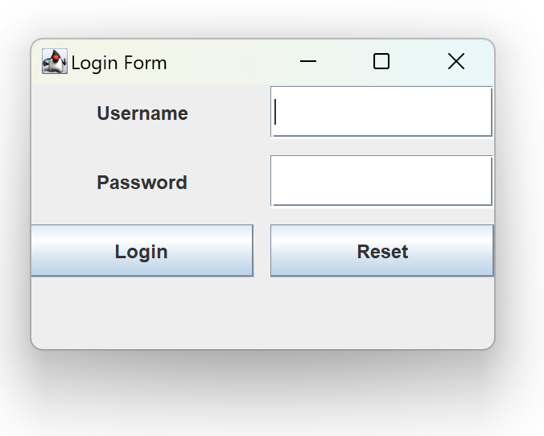

Create a Simple Login Form using GridBagLayout in Java.
import javax.swing.*;
import java.awt.*;
import java.awt.event.*;

public class App implements ActionListener{
private JFrame f;
private JLabel userLabel;
private JTextField userText;
private JLabel passwordLabel;
private JPasswordField passwordText;
private JButton loginButton;
private JButton resetButton;
private JLabel messageLabel;
App()
{
f=new JFrame();
// Set up the frame properties
f.setTitle("Login Form");
f.setLayout(new GridBagLayout());
GridBagConstraints gbc = new GridBagConstraints();
gbc.insets = new Insets(5, 5, 5, 5);
gbc.fill = GridBagConstraints.HORIZONTAL;

userLabel = new JLabel("Username");
gbc.gridx = 0;
gbc.gridy = 0;
f.add(userLabel, gbc);

userText = new JTextField();
gbc.gridx = 1;
gbc.gridy = 0;
f.add(userText, gbc);

passwordLabel = new JLabel("Password");
gbc.gridx = 0;
gbc.gridy = 1;
f.add(passwordLabel, gbc);

passwordText = new JPasswordField();
gbc.gridx = 1;
gbc.gridy = 1;
f.add(passwordText, gbc);

loginButton = new JButton("Login");
loginButton.addActionListener(this);
gbc.gridx = 0;
gbc.gridy = 2;
f.add(loginButton, gbc);

resetButton = new JButton("Reset");
resetButton.addActionListener(this);
gbc.gridx = 1;
gbc.gridy = 2;
f.add(resetButton, gbc);

messageLabel = new JLabel("");
messageLabel.setHorizontalAlignment(JLabel.CENTER);
gbc.gridwidth = 2;
gbc.gridx = 0;
gbc.gridy = 3;
f.add(messageLabel, gbc);

f.setSize(300,200);
f.setVisible(true);
}
public static void main(String[] args) throws Exception {
new App();
}
@Override
public void actionPerformed(ActionEvent e) {
if (e.getSource() == loginButton) {
String username = userText.getText();
String password = new String(passwordText.getPassword());

// Simple authentication (for demonstration purposes)
if (username.equals("admin") && password.equals("admin")) {
messageLabel.setText("Login successful");
} else {
messageLabel.setText("Invalid username or password");
}
} else if (e.getSource() == resetButton) {
userText.setText("");
passwordText.setText("");
messageLabel.setText("");
}
}
}

