**Facebook Graph API**

Data analytics has widely emerged in the last decade. Professionals analyze data to get relevant results out of it. These results can be used to increase company product statistics & help them improve it. Among the huge data, Social media’s data is most potent and game-changing for effective marketing research. Social media platforms offer a powerful opportunity to gain immediate access to the unfettered opinions of consumers. Many companies are aware of the value of using social media data to gain marketing insights. Among all the social media platforms, **Facebook** data plays a very important role in the market. Billions of people are connected with facebook. So after a product launch by a company the analysts can look out for the reactions of the people & their responses which will help them to analyze how good or bad their product is & where should they improve.

A number of excellent programs and services – some free and some commercial – have been developed for the analysis of social media data. Yet, the focus of the vast majority of these tools is to provide summary statistics of the data. But when it comes to facebook manually extracting data from such a huge sea isn’t possible. Here comes the term “**Facebook Graph API**”. Facebook Graph API is provided in order to help analysts as well as regular people to analyze their activity & get data related to it from Facebook. This API can be used as Http query or Graph API. You can also use it directly on facebook’s developer website:

**Graph API Explorer** (https://developers.facebook.com/tools/explorer/).

So getting data out & putting data into facebook becomes simple with this API. The name it holds is because it represents the information on facebook as a social graph. This graph consists of nodes, edges & fields. **Nodes** are basically "things" such as a User, a Photo, a Page, a Comment. **Edges** are the connections between those "things", such as a Page's Photos, or a Photo's Comments and the **Fields** are the info about those "things", such as a person's birthday, or the name of a Page. Since the API is http based so it works with any language that has an HTTP library, such as cURL and urllib.

The Graph API supports introspection of nodes. This enables you to see all of the edges a node has without knowing its type ahead of time.The resulting JSON will include a metadata property that lists all the supported edges for the given node:

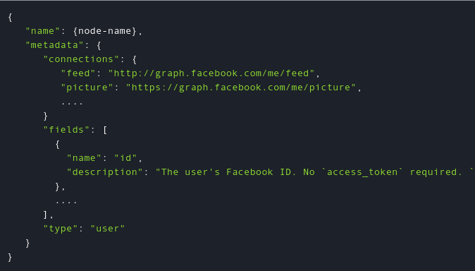

Alike other API this one also requires an access token which can be generated by facebook login. To get yours just Click on the ‘Get Token’ button in the top right of the Explorer.

Let’s look into some examples-

GET graph.facebook.com

/{node-id}/{edge-name}

POST graph.facebook.com

/{node-id}/{edge-name}

So as the words are self-explanatory they are used to pull & push the data respectively. Here when a used himself gets or puts his own data “node-id” is “me”. Here is an example query which lets you get your personal information. Simple,isn’t it?



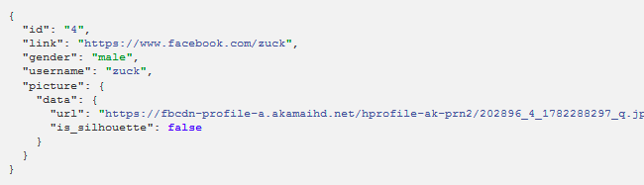

Almost all requests are passed to the API at graph.facebook.com - the single exception is video uploads which use graph-video.facebook.com. Data from graph.facebook can be fetched only using HTTP requests or Graph API explorer. You cannot view or interact with it as a website.

Even posting a status update is not at all difficult-

POST graph.faceboPOST graph.facebook.com

POST graph.facebook.com

/me/feed?

Message = “Hello, World.”

access_token = {your-access-token}

Here are some simple commands which may come handy while using this API-

* **/ {user-id} /albums** to create empty photo albums for people.
* **/ {user-id} /photos** to add individual photos for people.
* **/ {page-id} /albums** to create empty photo albums for Facebook pages.
* **/ {page-id} /photos** to add individual photos for Facebook pages.
* **/ {album-id} /photos** to add photos to an existing album for people or for Pages.
* **/ {user-id} /videos** to update an user’s videos.
* **/ {page-id} /videos** to update an page’s videos.
* **/ {event-id} /videos** to update an event’s videos.

There are some more interesting things as well which you can do using this API. So do you face the situation on your birthday where you’re tired of replying ‘thankyou’ to each & every post? Will you waste your time doing this manually? Of course not. Why would you when you can just run a script and reply thanks to each one of them! Click here to try out the script from our Mcug repository- <https://goo.gl/qReJfq> . It’s not just limited to a single script ,you can write hundreds of script . Whichever facebook task you feel can be automated, graph API will help you doing that.

Now you might be quite familier with this API. So getting to the security issues, the most important element is your access token. Facebook has taken care that it can’t be brute forced to get these tokens. The length of these access tokens is more than 128 alpha numeric characters. So definitely it can’t be remember of predicted. But as a user you need to take care that you safely note down & store this sensitive information on your machine. Hope you will try it out atleast once. Thank, you!