**Installation**

*=> npm install -g create-react-app*

g means global, this command installs create-react-app globally in system

*=> create-react-app .*

Creates a react boiler plate in the same folder

*=> create-react-app projectName*

Creates a folder called projectName, and installs boiler plate in it

*=> npm start*

starts the react application

**Using Dynamic Data**

import React from 'react';

const getYear = () => {

const d = new Date();

return d.getFullYear();

}

const user = {

name : 'Ronit',

surname : 'Chattopadhyay',

age : 16

}

const Header = () => {

return (

<div>

<div> First Name : {user.name}</div>

<div> Last Name : {user.surname}</div>

<div> Age : {user.age}</div>

<div>

Copy Right RC @ {getYear()}

</div>

</div>

)

}

export default Header;

Output:

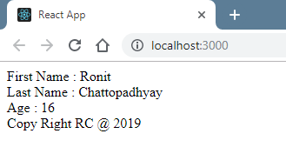

**Classes and Events**

import React, {Component} from 'react';

class Header extends Component {

inputChangeHandler(event){

console.log(event.target.value);

}

render(){

return (

<header>

<div className = "logo">Logo</div>

<input

type="text"

onChange={ (e) => this.inputChangeHandler(e)}/>

</header>

)

}

}

export default Header;

**ESX**

class Car{

constructor(){

this.wheels = 4;

this.type = 'HatchBack';

}

}

class Hyundai extends Car{

constructor(){

super();

this.windows = 4;

}

}

const car = new Car();

const hyundai = new Hyundai();

console.log(hyundai.wheels);

**State**

import React, {Component} from 'react';

class Header extends Component {

state = {

title: 'The keywords are:',

keyword: ''

}

inputChangeHandler = (event) => {

//console.log(event.target.value);

this.setState({

keyword: event.target.value

})

}

render(){

console.log(this.state.keyword)

return (

<header>

<div className = "logo">Logo</div>

<input

type="text"

onChange={ this.inputChangeHandler }/>

<div> {this.state.title} </div>

<div> {this.state.keyword} </div>

</header>

)

}

}

export default Header;

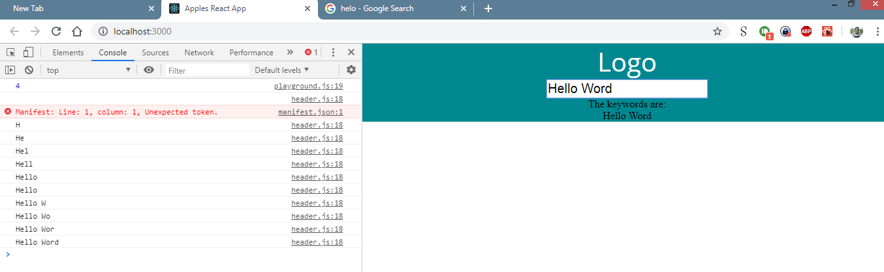

**Props and Children**

index.js

import React, {Component} from 'react';

import ReactDOM from 'react-dom';

import JSON from './db.json';

//COMPONENTS

import Header from './components/header';

import NewsList from './components/news_list';

class App extends Component {

state = {

news : JSON

}

render(){

return (

<div>

<Header/>

<NewsList news = {this.state.news}>

<h3 style={{textAlign:'center'}}>

Hello Apples

</h3>

</NewsList>

</div>

)

}

}

ReactDOM.render(<App/>, document.querySelector('#root'));

news_list.js

import React from 'react';

import NewsItem from './news_list_item';

const NewsList = (props) => {

const items = props.news.map( (item) => {

return(

<NewsItem key={item.id} item={item} />

)

} )

return(

<div>

{props.children}

{items}

</div>

)

}

export default NewsList;

news_list_item.js

import React from 'react';

const NewsItem = ({item}) => {

return(

<div key={item.id}>

<h3>{item.title}</h3>

<div>

{item.feed}

</div>

</div>

)

}

export default NewsItem;

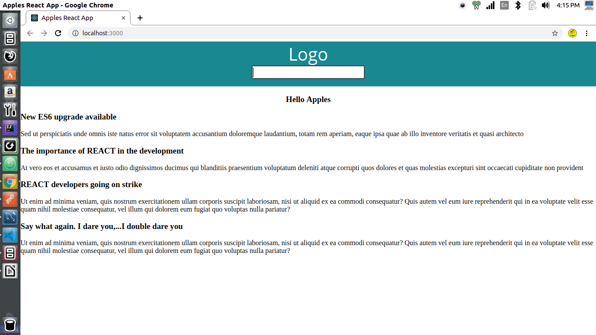

**Styles**

import React, {Component} from 'react';

class Header extends Component {

state = {

active : 'non-active',

keyword: ''

}

inputChangeHandler = (event) => {

const value = event.target.value === '' ? 'non-active' : 'active';

this.setState({

active : value,

keyword: event.target.value

})

}

render(){

/* const style = {

background: 'red'

}

if(this.state.keyword !== ''){

style.background = '#009999';

}else{

style.background = '#ff0000';

} */

return (

<header className={this.state.active}>

<div className = "logo">Logo</div>

<input

type="text"

onChange={ this.inputChangeHandler }/>

<div> {this.state.title} </div>

<br></br>

</header>

)

}

}

export default Header;

**Glamor**

Installation:  
=> npm install glamor --save

import React from 'react';

import { css } from 'glamor';

const NewsItem = ({item}) => {

let news_item = css({

padding:'10px 20px',

boxSizing: 'border-box',

borderBottom: '1px solid grey',

':hover':{

color:'#ffff00'

},

'@media(max-width:480px)':{

color:'#ffffff'

}

})

let item_grey = css({

background: 'lightgrey'

})

return(

<div className={`${news_item} ${item_grey}`}>

<h3>{item.title}</h3>

<div>

{item.feed}

</div>

</div>

)

}

export default NewsItem;

**Filtering State**

header.js

import React from 'react';

const Header = (props) => {

return (

<header>

<div className = "logo">Logo</div>

<input

type="text"

onChange={ props.keywords }/>

<br></br>

</header>

)

}

export default Header;

index.js

import React, {Component} from 'react';

import ReactDOM from 'react-dom';

import JSON from './db.json';

//COMPONENTS

import Header from './components/header';

import NewsList from './components/news_list';

class App extends Component {

state = {

news : JSON,

filtered : []

}

getKeyword = (event) => {

//console.log(event.target.value);

let keywords = event.target.value;

let filtered = this.state.news.filter((item) => {

return item.title.indexOf(keywords) > -1

});

this.setState({

filtered

})

}

render(){

//Alias

let newsFiltered = this.state.filtered;

let newsWhole = this.state.news;

return (

<div>

<Header keywords={this.getKeyword}/>

<NewsList news = {newsFiltered.length === 0 ? newsWhole : newsFiltered}>

<h3 style={{textAlign:'center'}}>

Hello Apples

</h3>

</NewsList>

</div>

)

}

}

ReactDOM.render(<App/>, document.querySelector('#root'));