PROJECT REPORT

Airport Management System

Console-Based Backend REST API

Technology Stack | Node.js · Express.js · MongoDB · Mongoose
Documentation | Swagger UI (OpenAPI 3.0)
Testing | Postman
Database | MongoDB with Mongoose ODM
Date | June 2026

1. Abstract
The Airport Management System is a backend REST API application built with Node.js and Express.js, using MongoDB as the persistent database. It provides a centralized platform for managing core airport operations including flight scheduling, passenger registration, staff rostering, seat bookings, baggage tracking, and terminal gate assignments.

The system exposes a complete set of REST API endpoints documented interactively via Swagger UI and testable through a pre-configured Postman collection. Cross-module data integrity is strictly enforced — for example, baggage can only be registered against passengers holding an active flight booking.

2. Project Objectives & Outcomes
The following objectives were defined and successfully achieved:

- Design and implement a scalable backend REST API for airport operations
- Use MongoDB to store and persist all airport data with Mongoose ODM validation
- Implement full CRUD operations across all 6 modules
- Enforce cross-module relationships and business logic (e.g., booking → baggage, gate ↔ flight sync)
- Auto-manage seat capacity on bookings and cancellations
- Document all APIs using Swagger (OpenAPI 3.0) with live Try-It-Out support
- Provide a Postman collection with auto ID chaining for end-to-end testing
- Provide a console-based database viewer (check.js) and a data seeder (seed.js)

Outcome Summary

Module | CRUD | Business Logic | Status
Flight Management | ✅ Full | Cascade delete bookings on flight delete | ✅ Complete
Passenger Management | ✅ Full | Auto-cancel bookings & restore seats on delete | ✅ Complete
Staff & Roster | ✅ Full | Filter by role, shift, status | ✅ Complete
Ticket Booking | ✅ Full | Seat availability, duplicate prevention, seat counter | ✅ Complete
Baggage Tracking | ✅ Full | Requires active booking; lifecycle status tracking | ✅ Complete
Gate Assignment | ✅ Full | Bidirectional gate ↔ flight sync | ✅ Complete

3. Tools & Technologies Used

Technology | Role | Version
Node.js | JavaScript runtime environment | v20.x LTS
Express.js | Web framework for REST API server | v4.19
MongoDB | NoSQL document database | v7.x
Mongoose | Object Data Modeling (ODM) library | v8.4
Swagger JSDoc | Generates OpenAPI 3.0 spec from JSDoc comments | v6.2
Swagger UI Express | Serves interactive API documentation UI | v5.0
Morgan | HTTP request logger for console output | v1.10
CORS | Cross-Origin Resource Sharing middleware | v2.8
Dotenv | Loads environment variables from .env file | v16.4
Nodemon | Auto-restarts server on file changes (dev tool) | v3.1
Postman | API testing client (external tool) | Latest

4. System Architecture
The project follows the MVC (Model-View-Controller) architectural pattern adapted for a REST API, with a clean separation of concerns across three layers:

Model Layer  /models/*.js  Mongoose schemas, MongoDB collection definitions, validation rules | Controller Layer  /controllers/*.js  All business logic, cross-module validation, data manipulation | Routes Layer  /routes/*.js  HTTP endpoint definitions, delegates to controllers

Client requests flow through: Express Server → Middleware (CORS, Morgan, JSON Parser) → Routes → Controllers → Models → MongoDB, and back up the same chain as a JSON response.

5. Database Design
The system uses 6 MongoDB collections. Key relationships are enforced in the controller layer:

- A Booking references a Passenger and a Flight
- Baggage can only be created if a non-cancelled Booking exists for that Passenger + Flight
- A Gate holds a reference to its currentFlight; assigning/releasing a flight updates both Gate and Flight bidirectionally
- Deleting a Flight cascades and removes all associated Bookings
- Deleting a Passenger cancels all their active Bookings and restores seat counts on the corresponding Flights

Collection | Key Fields | Notable Constraints
Flight | flightNumber, airline, origin, destination, capacity, availableSeats, price, status | Unique flightNumber; availableSeats auto-managed
Passenger | firstName, lastName, email, passportNumber | Unique email & passportNumber
Staff | employeeId, name, role, shift, status, email | 6 roles; 3 shifts; unique email
Booking | passenger, flight, seatNumber, status, pricePaid | Compound index on {flight, seatNumber}
Baggage | passenger, flight, tagNumber, weight, status | Active booking required; unique tagNumber
Gate | gateNumber, terminal, status, currentFlight, assignedStaff | Bidirectional sync with Flight

6. API Endpoints

Module | Method | Endpoint | Description
Flights | POST | /api/flights | Create flight
 | GET | /api/flights | List all (filter: origin, destination, status)
 | GET | /api/flights/:id | Get by ID
 | PUT | /api/flights/:id | Update flight details
 | DELETE | /api/flights/:id | Delete (cascades bookings)
Passengers | POST | /api/passengers | Register passenger
 | GET | /api/passengers | List all passengers
 | DELETE | /api/passengers/:id | Delete (cancels bookings, restores seats)
Staff | POST | /api/staff | Add staff member
 | GET | /api/staff | List all (filter: role, shift, status)
Bookings | POST | /api/bookings | Book a seat
 | PUT | /api/bookings/:id/checkin | Check-in passenger
 | PUT | /api/bookings/:id/cancel | Cancel booking (restores seat)
Baggage | POST | /api/baggage | Register luggage (requires active booking)
 | GET | /api/baggage/passenger/:id | Get passenger's baggage
 | GET | /api/baggage/flight/:id | Get flight cargo manifest
Gates | PUT | /api/gates/:id/assign-flight | Dock flight to gate (auto-syncs)
 | PUT | /api/gates/:id/assign-staff | Assign staff roster to gate
 | PUT | /api/gates/:id/release | Release gate (auto-syncs flight)

7. Output Screenshots & Explanations

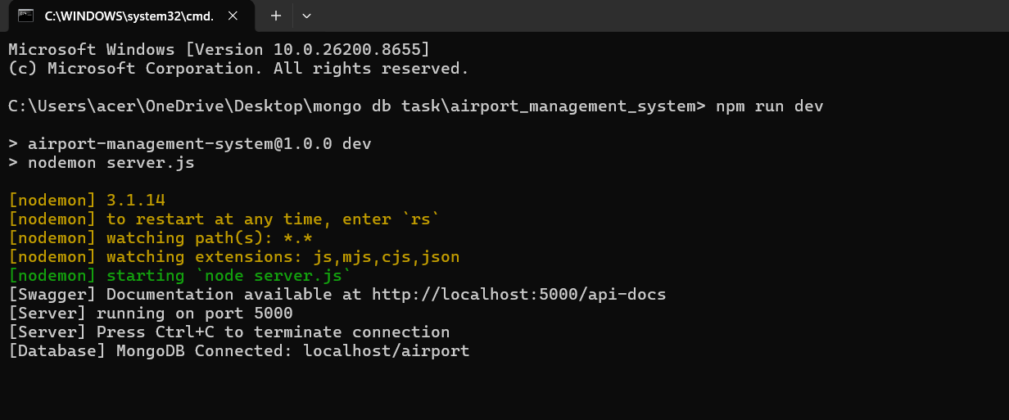
Start the Project.

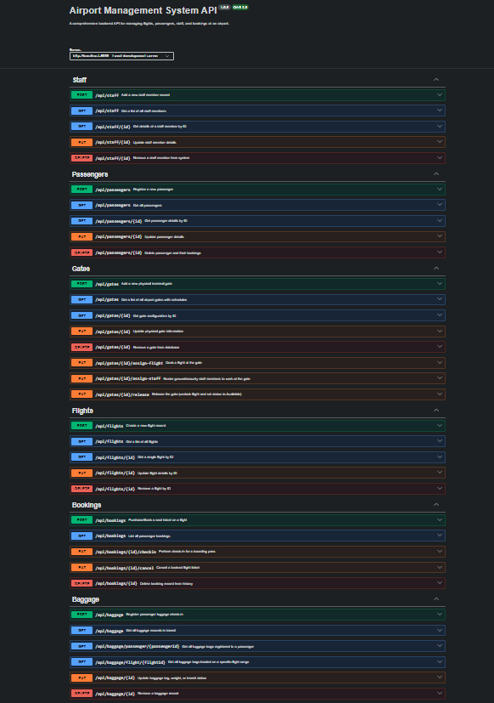
Swagger UI

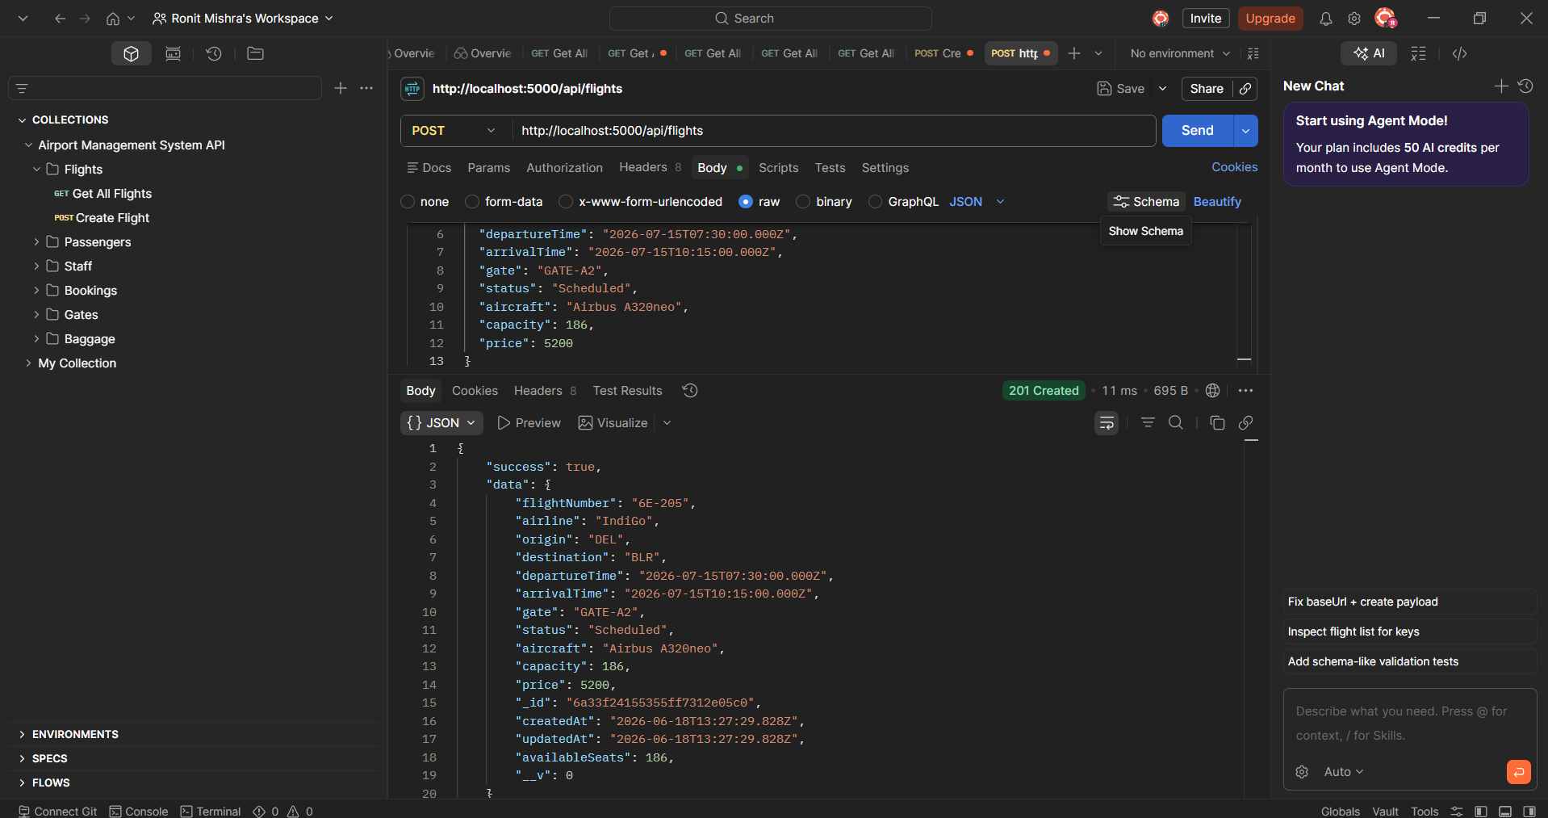
Flight POST.

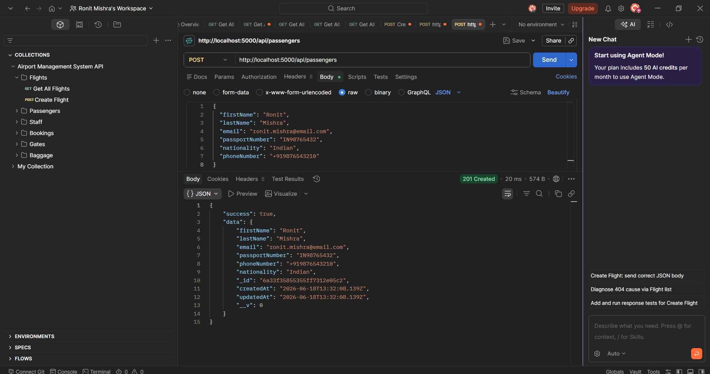
Passenger POST

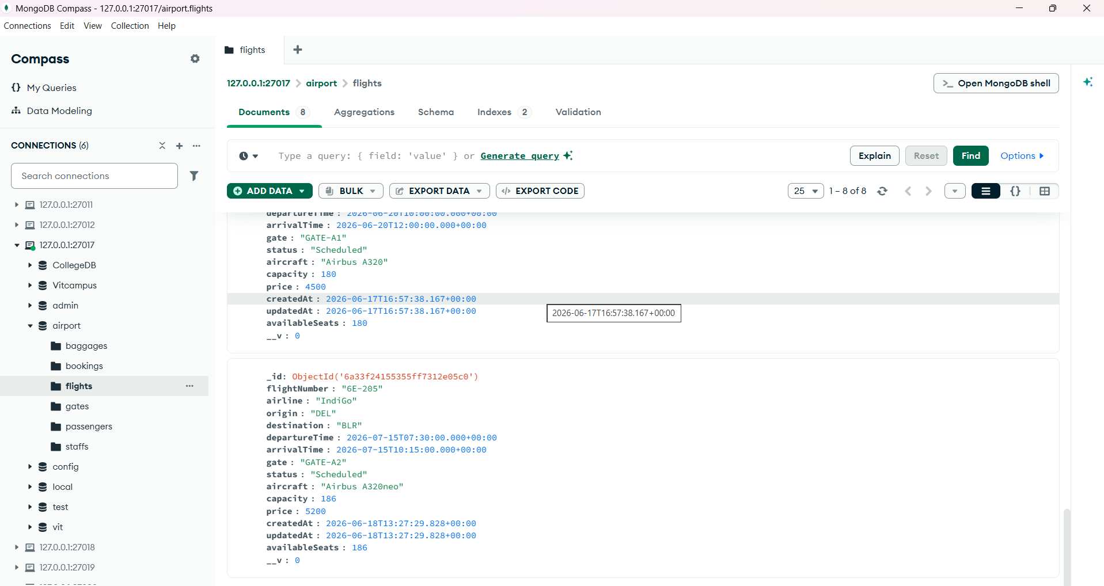
Flight Verification on MongoDB

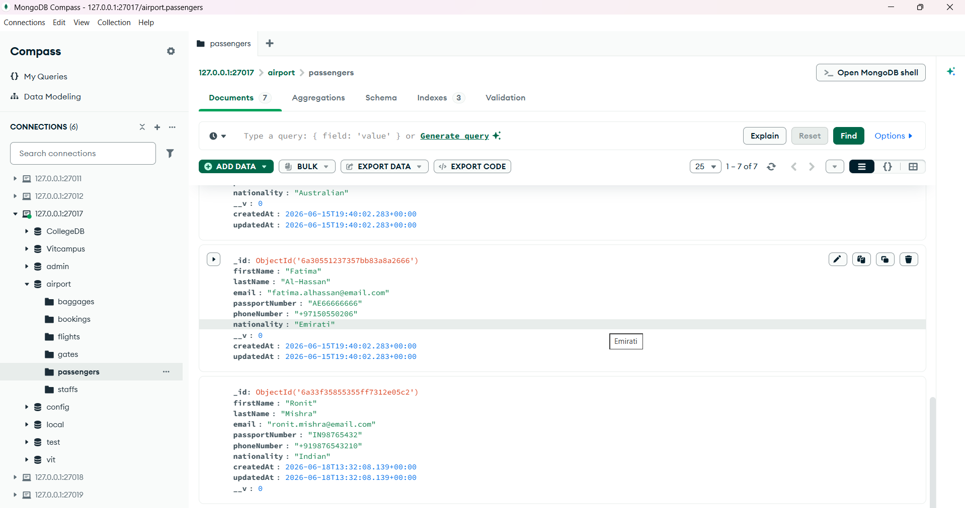
Passenger Verification on MongoDB
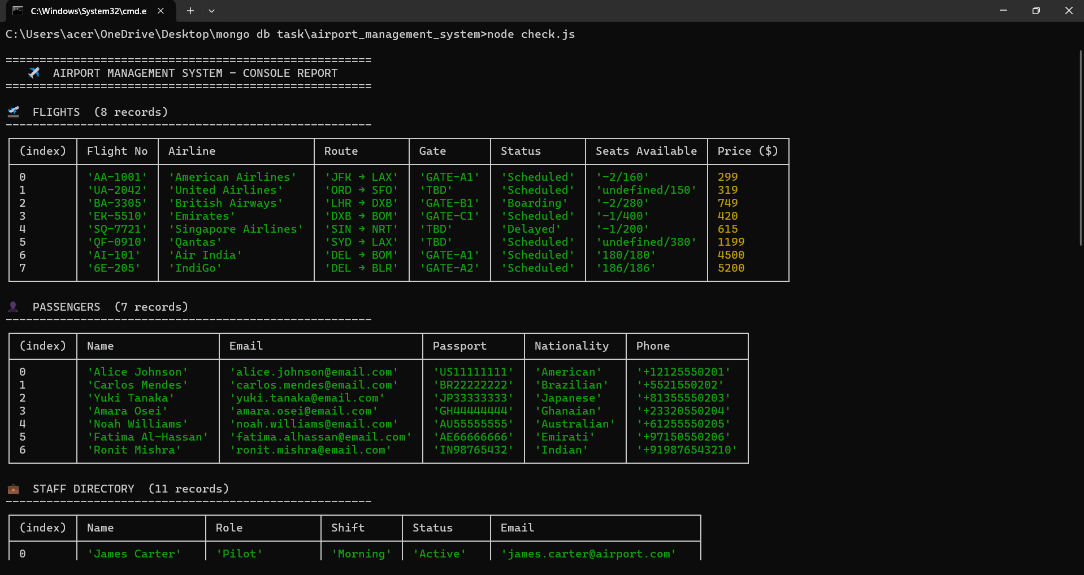
Console Verification

8. Testing & Validation
Business logic validation was tested through both Swagger UI and the Postman collection:

Test Case | Expected Result | Status
Book seat on full flight | 400 Error: No available seats | ✅ Pass
Duplicate seat on same flight | 400 Error: Seat already taken | ✅ Pass
Baggage without active booking | 400 Error: No active booking found | ✅ Pass
Cancel booking → check availableSeats | availableSeats increments by 1 | ✅ Pass
Delete passenger with active bookings | Bookings deleted, seats restored | ✅ Pass
Assign flight to gate | Gate → Occupied; Flight.gate → updated | ✅ Pass
Release gate | Gate → Available; Flight.gate → TBD | ✅ Pass
Delete flight | All associated bookings cascade-deleted | ✅ Pass

9. Summary
The Airport Management System successfully delivers a production-quality backend REST API with 6 fully functional modules, comprehensive CRUD operations, and strict cross-module data integrity enforcement.

Key architectural decisions include:
- MVC pattern with clean separation of Models, Controllers, and Routes
- Mongoose schemas with built-in validation, unique constraints, and compound indexes
- Controller-level business logic for cross-module integrity (e.g., booking → baggage, gate ↔ flight)
- Swagger JSDoc annotations embedded in routes for automatic interactive documentation
- Postman collection with embedded test scripts enabling automated ID chaining
- Utility scripts (seed.js, check.js) for rapid development and inspection

The modular folder structure (models/ · controllers/ · routes/) ensures the codebase is maintainable and easily extensible with additional modules such as cargo management, airline crew scheduling, or billing.

10. Conclusion
The Airport Management System demonstrates a well-architected, real-world backend application built on the Node.js ecosystem. It goes beyond simple CRUD by implementing relational integrity between entities, automatic seat capacity management, and bidirectional data synchronization — all of which mirror the constraints and behaviours expected in a production system.

The use of Swagger UI provides immediate, browser-accessible API documentation that doubles as a testing interface, while the Postman collection enables structured, sequential regression testing. Together, these tools make the system accessible to both developers and non-technical stakeholders.

All 10 defined objectives were met. The project establishes a strong foundation for further development and can be extended with authentication (JWT), role-based access control, real-time notifications (WebSockets), or deployment on cloud infrastructure with minimal refactoring.

Airport Management System · Node.js + MongoDB + Swagger + Postman · June 2026

