Tech Stack Used

* **Frontend**: React, HTML, CSS
* **Backend:** Node.js, JavaScript
* **Database**: MySQL

Features and Functionalities

1. **User Registration and Authentication:**
   * Create an account with your name, email, password and role(user/consultant).
   * Secure authentication to protect your account.
   * Contains a different dashboard for consultant and user.

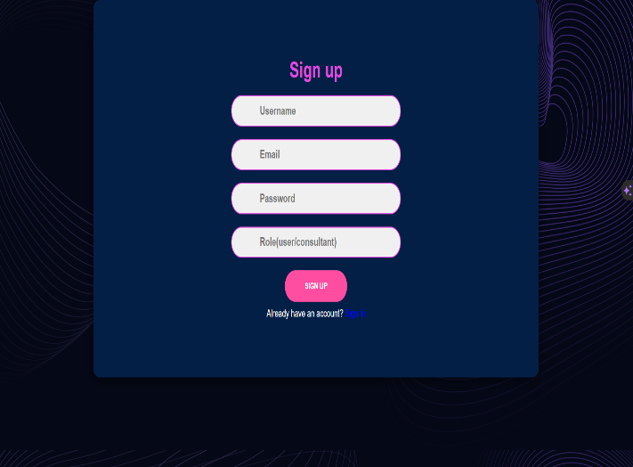 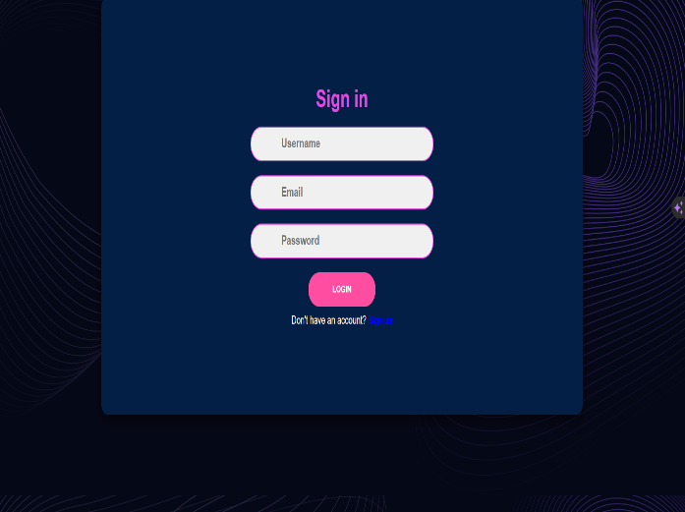

1. **Appointment Booking:**

* Users can browse available appointments from consultants.
* Select your preferred time slot and date for booking.



1. **Availability Management:**

* Consultants can manage their available time slots and dates.
* Set break times and leave dates when unavailable.

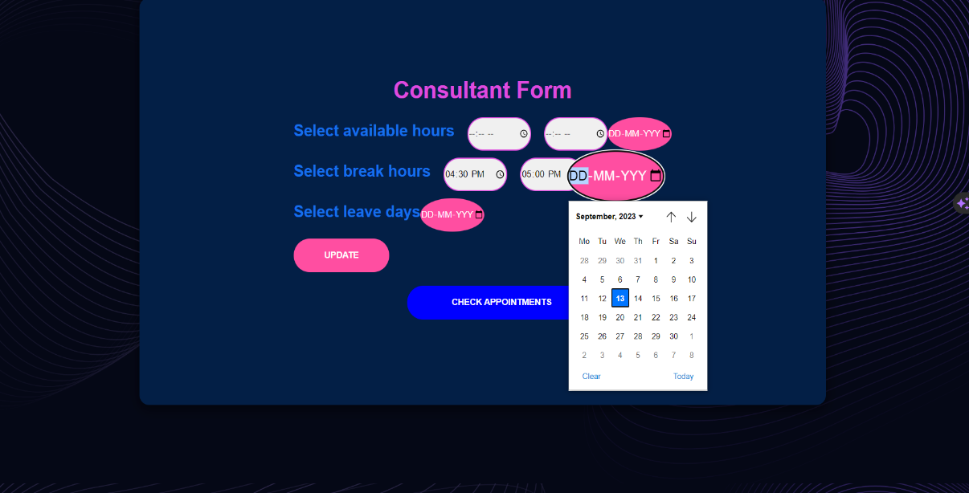

Appointments of consultant

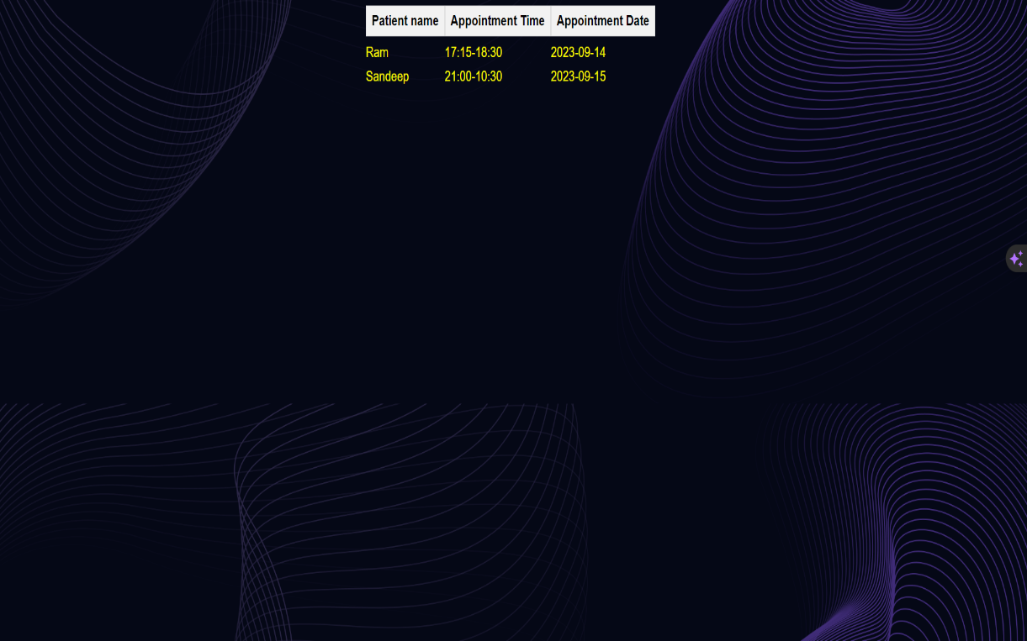

1. JWT Authentication:

* JSON Web Tokens for secure user authentication and authorization.

1. CORS Configuration:

* Cross-Origin Resource Sharing (CORS) configured for secure API access.

1. Email Notifications:

* Receive email confirmations with booking details, including time and date.

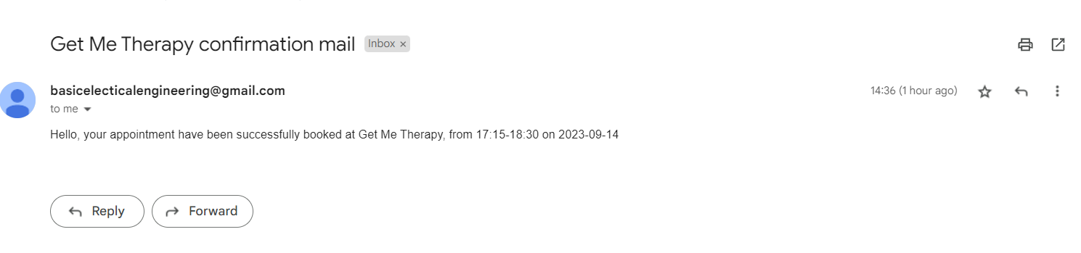

1. Beautiful UI/UX Design:

* **Calendar View**: Visualize available dates and appointments.
* **Visual Feedback**: Animations and transitions for user interactions.
* **Smooth Booking Process**: Step-by-step booking with animations.