MPCA Project Synopsis

Title: Gesture Control using Python and Arduino

Circuit Diagram:

2 Ultrasonic Sensors, Arduino UNO board, Jumper cables and temperature sensor (not shown in circuit).

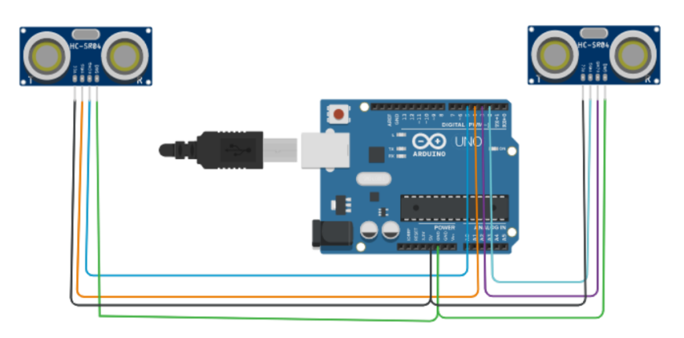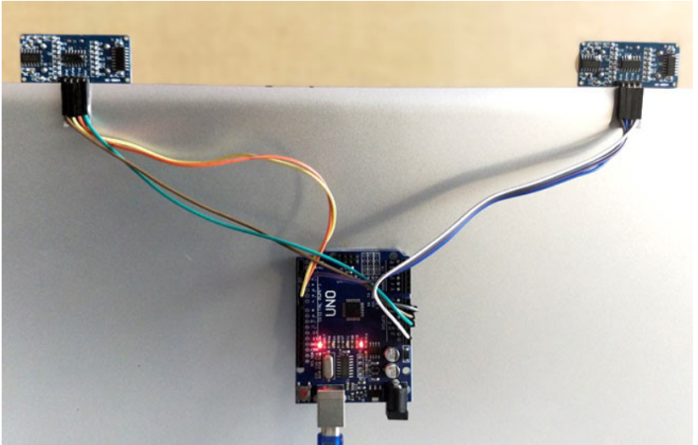

Project Description:

The concept behind the project is very simple. We will place two Ultrasonic (US) sensors on top of our monitor and will read the distance between the monitor and our hand using Arduino, based on this value of distance we will perform certain actions. To perform actions on our computer we use Python ****pyautogui**** library. The commands from Arduino are sent to the computer through serial port (USB). This data will be then read by python which is running on the computer and based on the read data an action will be performed.

Team Members:

1. Ronit Bhathija SRN: PES2UG20CS284
2. Sachin SRN: PES2UG20CS291
3. Shreyas bhat k SRN: PES2UG20CS332