**BIO-DATA**

**SAPTARSHI CHATTERJEE**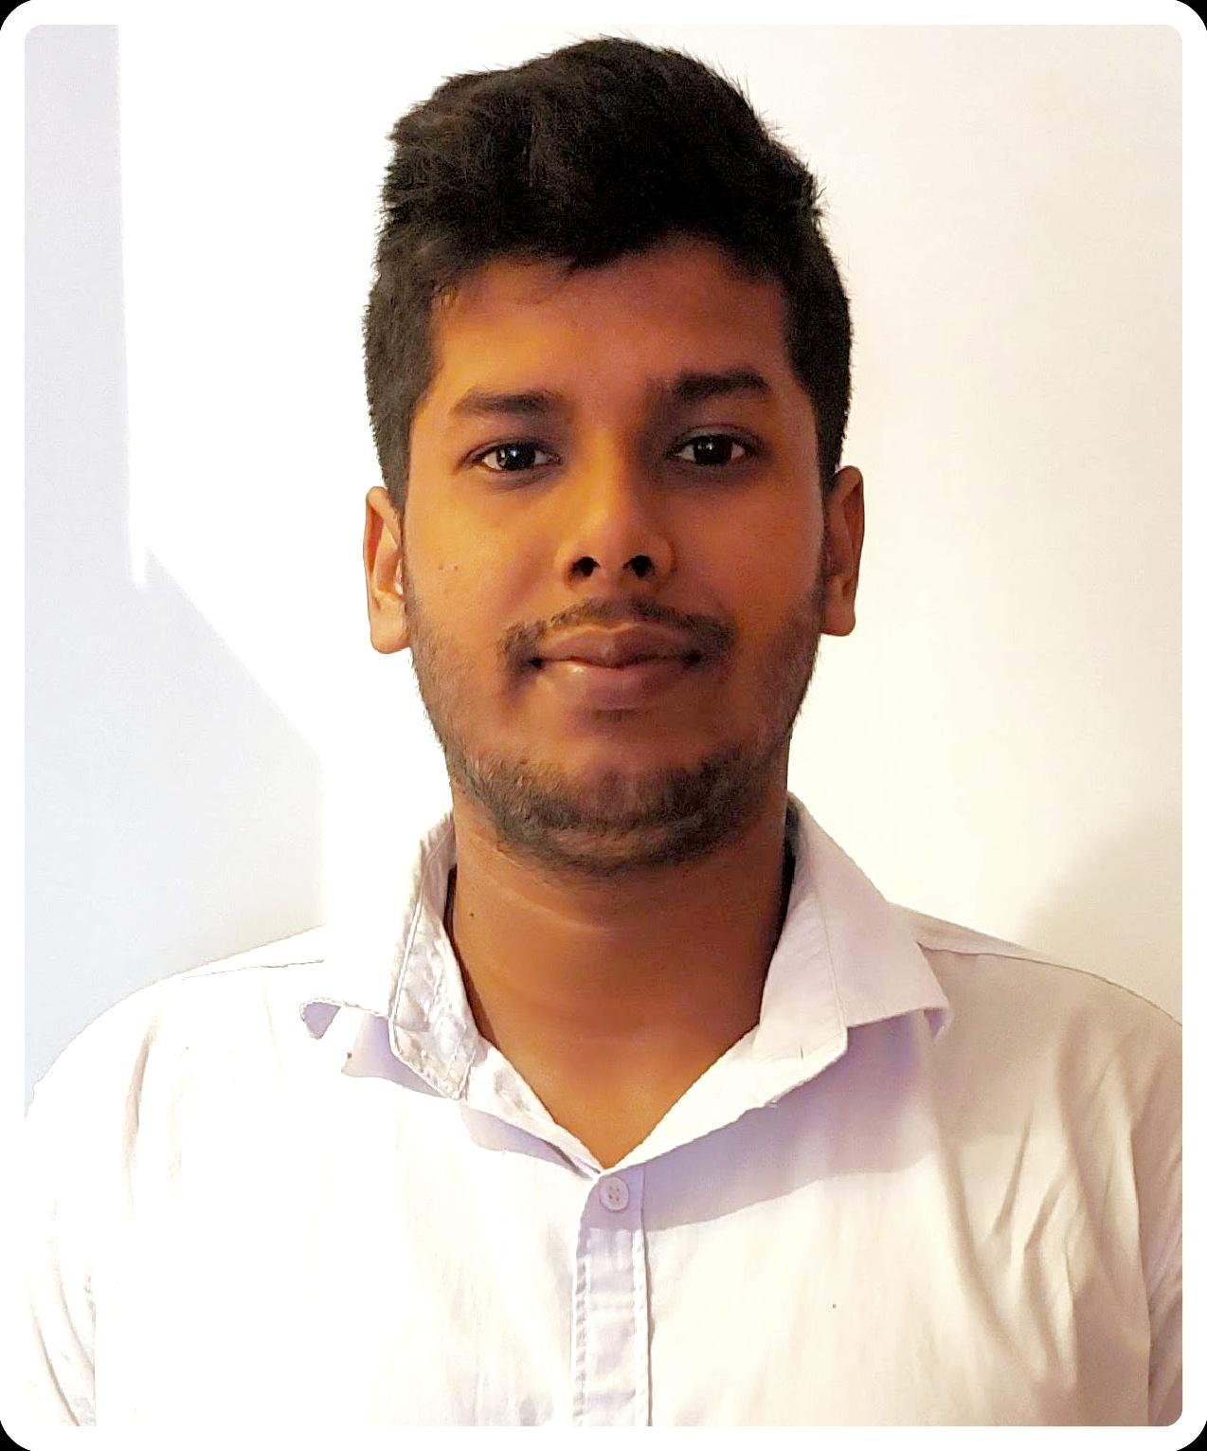

**Mobile no:** +91 8343889280/8637537436

**E-mail id:** saptarshichatterjee1234@gmail.com

**ADDRESS:** GOBINDANAGAR, BUS STAND, SRINAGAR PALLY

**POST:** KENDUADIHI

**DIST:** BANKURA

**PIN**: 722102 (WB)

**D.O.B. –** 4th of AUGUST,1996

**CARRER OBJECTIVE:**

“A self-motivated person who believes that there is no shortcut in Life & the only way to achieve success is through Sheer Hard work in Right direction with Right Dedication.”

**ACADEMIC QUALIFICATION**

| **SL. No** | **Name of**  **Examination** | **Name of board** | **Name of Institute** | **Year of Passing** | **% of marks**  **obtained** |
| --- | --- | --- | --- | --- | --- |
| 1 | M.P.(10-Grade) | W.B.B.S.E. | KENDUADIHI HIGH SCHOOL.(H.S) | 2013 | 43.14 |
| 2  3 | H.S(12-Grade)  ITI -INDUSTRIAL TRAINING INSTITUTE | W.B.C.H.S.E.  N.C.V.T | BANKURA CHRISTIAN COLLEGIATE SCHOOL. (H.S)  BANKURA TECHLAND PRIVATE ITI | 2015  2019 | 59.4  78.2 |
|  |  |  |  |  |  |

**EXTRA CURRICULAR ACTIVITIES:**

* Good Knowledge of Basic Computer Skills, Knowledge of Computer Fundamentals software, Windows OS, MS Word, MS Excel, MS PowerPoint, Etc.

**SKILLS:**

* Playing guitar and football.

**WORK EXPERIENCE :**

* Working as A CRO at Hinduja Global Solutions since 17th Jun

2017 To 29th Dec 2019.

* Working as A Tara Maa Associated Financial Agency supervisor

January 2020 To May 2021

**PERSONAL DETAILS:**

* **NAME:** SAPTARSHI CHATTERJEE
* **FATHER’S NAME: Mr.** ADITYA CHATTERJEE
* **MOTHER’S NAME:** Mrs. JYOTSNA CHATTERJEE
* **ADDRESS:** VILL. SRINAGAR PALLY,

P.O.- KENDUADIHI,

DIST.-BANKURA,

PIN-722102(WB)

* **DATE OF BIRTH:** 4TH OF AUGUST 1996
* **NATIONALITY:** INDIAN
* **RELIGION:** HINDU
* **CASTE:** GENERAL
* **PASSPORT NO:** NO
* **BLOOD GROUP:** A+
* **LANGUAGES KNOWN:**  BENGALI, HINDI AND ENGLISH.

**DECLARATION:**

I hereby declare that the above information given by me is true to the best of my knowledge.

**Place:** BANKURA

**Date**: ______________________

SAPTARSHI CHATTERJEE