**RESUME**

**Personal detail** 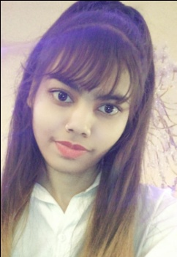

**NAME- Anuradha jaiswal**

**Address:- B22/309 DURGAKUD VARANASI**

**Mobile:- 7307908044**

**Email id:-** [**anuradha252000@gmail.com**](mailto:anuradha252000@gmail.com)

**DOB:- 02/05/2000**

**Age** :- **21**

**Marital status**:- **unmarried**

**Nationality :- Indian**

**Career objective**

**To enhance my knowledge & skill by doing best work in the organization and make the trust in organization.**

**ACADEMIC QUALIFICATION**

|  |  |  |  |
| --- | --- | --- | --- |
| **School** | **Board/University** | **year** | **Marks** |
| High school | BIHAR BOARD | 2016 | 1ST |
| intermediate | U.P BOARD | 2018 | 2ND |
| Graduation(B.com) | M.G.K.V.P | appearing | ---------- |

**EXTRA QUALIFICATION**

* **DCA**
* **TALLY**

**WORK EXPERIENCE**

* Fresher

**LANGUAGE KNOWN**

I’m well aware with Hindi & English language.

**Hobbies**

Study, art

**INTERPERSONAL SKILLS**

* Learned the importance of team player when working on projects with various teams.
* Learned real life working experience during overseas attachment.
* Learned to question listen and present during class tutorial and discussion.

**THOUGHT SKILL**

Hard Work is greater than fortune.

**Declaration**

I hereby declare that all information as given in my resume is true in my best knowledge and belief.

**Place ………………….. ANURADHA JAISWAL**

**DATE……………………**