**NIKHIL SHARMA** 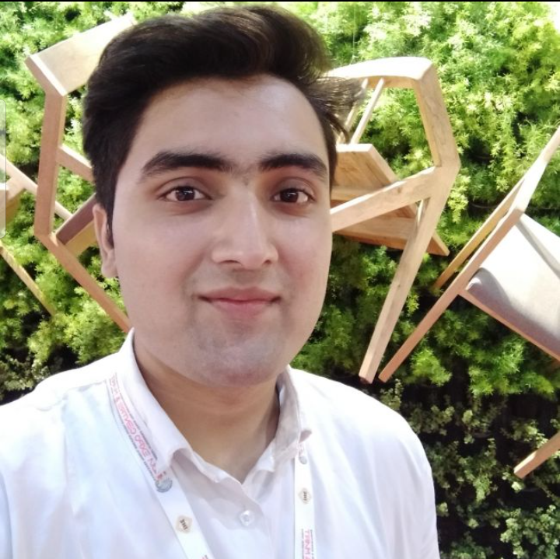

21, MALE

D.O.B - 16th.September.1999

48/ A Anand Nagar, Inderlok, New Delhi

Phone- 8076074390, 9718945065

Email- [ns2762846@gmail.com](mailto:ns2762846@gmail.com)

**Objective**

To make my career in hotel management field by using my good management skills for the mutual growth.

**Education**

Jagannath Institute of Management studies (JIMS) 2018-2021

Rohini, New Delh

Bachelor's in Hospitality, Catering, Travel Tourism & Service Industry. (HM)

Ravindra Public School (XIIth) 2018

Pitampura, New Delhi

Central Board of Secondary Education

Scored- 58.4%

Ravindra Public School (Xth) 2016

Pitampura, New Delhi

Central Board of Secondary Education

Scored- 60%

**Strength**

Patience, Good listening skills, Team management, Good leadership skills

**Linguistic proficiency**

English, Hindi

**Hobbies**

Playing cricket with friends, moreover spending ample of quality time with my family.

**Experience**

Three months Industrial Traning at TAJ PALACE,NEW DELHI.

**Personal Profile**

Father’s Name Mr. Jitender Sharma

Mother’s Name Mrs. Kamini Sharma

Nationality Indian

**Reference**

Mrs. Anshu Walia

Head of Department

Hotel Management

JIMS, Rohini, New Delhi