Assignment-1

MODULE-1:SE-OVERVIEW OF IT INDUSTRY

1) what is software ? what is software engineering?

SOFTWARE :

* Software is the language of computer.it is set of instructions,data and programs used to opreter computers and execute specific tasks.
* It is opposite of hardware, which describes the physical aspects of a computer.

SOFTWARE ENGINEERING :

* Software engineering is the branch of computer science that deals with the design,development,
* The term programmer is sometimes used as a synonym, but may emphasize software implementation over design and can also lock connotations of engineering education or skills.
* Testing and maintenance of software applications.

2) expalain types of software.

There Are 2 types of software.

1.system software

2. software

1.system software:

* Electronic devices are useless without tjis software.there are different types of system software.for example windows,macOS,android and ios.
* it is a computer program that helps the user to run compute hardware or software and manage the interactions between them.it constantly runs in the background.

2.application software:

* Anything that is not operating system or a utility is an app.types of application software.

3)what is sdlc.?explain each phase od sdlc

SDLC:

* software development life cycle
* A software development life cycle is essentially a series of steps, or phases, that provide a model for the development and life cycle management of an application or piece there are 7 phase of sdlc.

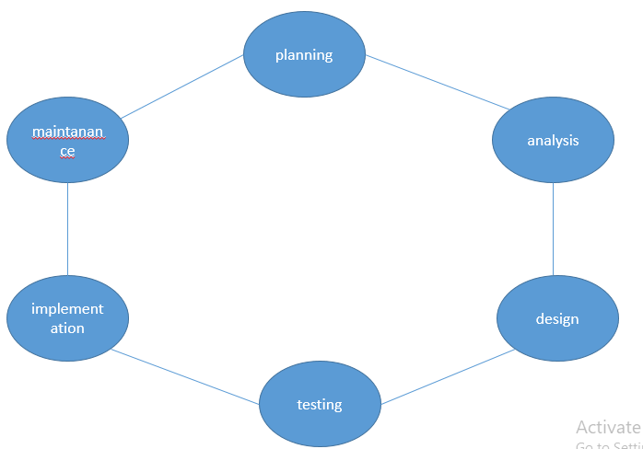

Phase of SDLC

1.planning:

* In this phase, devlopers plan the upcoming project.it helps to define the problem and scope of any systems, as well as determine the for their new system.

2.analysis:

* The analysis stage includes gathering all the specific details required for new system as well as determining the first ideas for prototypes.

3.design:

* The second of the software development life cycle phases is often done concurrently with the first.
* This phase is necessary for the developers. They will first outline the details for the overall application long side specific aspects, such as; use interface, system interface, network and network requirements and database

4.testing:

* Different types of testing occur during this phase, such as a code quality, unit testing, integration testing, performance testing and security testing.

5.implementation:

* Computer programming or coding is the composition of sequences or instructions, called programs, that computers can follow to perform tasks.

6.maintanance:

* Maintain software functionality, make upgrades to the coding, and ensure any repairs needed to the software are completed.

4)what is dfd? Create a dfd diagram on flipkart.

* A data flow diagram is a traditional way to visualize the information flows within a system.a neat and clear dfd depict.
* A good amount of the system requirements graphically. It can be manual automated or a combination of both.

**DATA FLOW DIAGRAM ON FLIPKART**

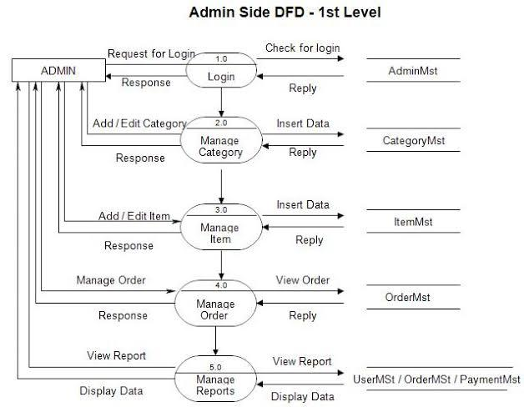

5)what is flow chart? Create a flowchart to make addition of two numbers.

* A flowchart is a graphical or symbolic representation of a process.
* Each step in the process is represented by a different symbol and contains a short description of the process step.
* Flowchart is a type of diagram that represents a workflow or process.

flowchart to make addition of two numbers

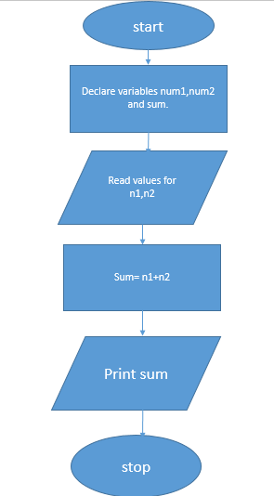

6) what is use case diagram? Create a use-case on bill payment on paytm.

* Use case diagrams describe the high-level functions and scope of a system.
* These diagrams also identify the interactions between the system and its actors.
* The use case and actors in use-case diagram describe what the system does and how the actors use it, but not how the system operates internally.

Use case on bill payment on paytm.

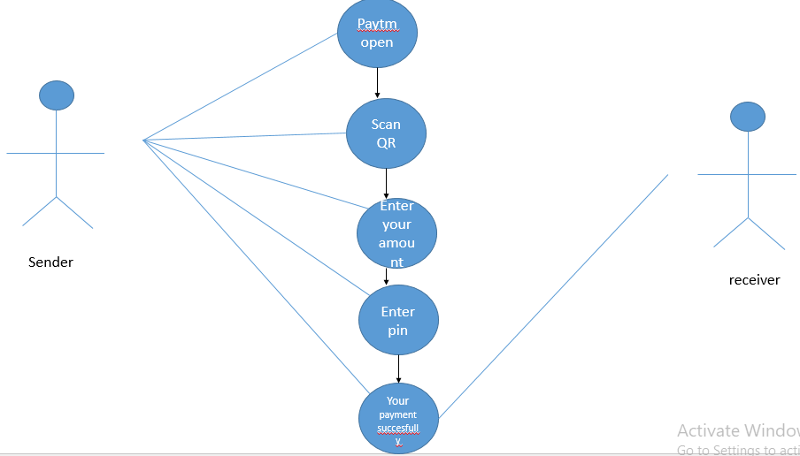

Prepared by:- ronit der