1. HHTI Flow Diagram
Start

Web/
Video

No video path
Collection of data
frames
Terminate
image processing
using PyTorch
and opencv
Generate and Train
Data classifier opencv
using Pytorch
Serlalize data
Classifier and save pt
file
Load model pt file
from disk
Load person from
video stream/video
Image preprocssing
using PyTorch and
opencv
Apply bounding box
on detector person
show result
Stop
2. Person Detection Flow Diagram

Start

Initialize
the video/
web cam
No video path

Terminate
Extract image from
the frames

Load model pt file
from disk

Load person images form
Frame

Image preprocssing
using PyTorch and
opencv

Apply bounding box
on detector person

show result

Stop

3. Class Diagram

+ setupUi (MainWindow)
+ retranslateUi (MainWindow)
Ui_MainWindow

+ «create» MainWindow ()
+ long_range ()
+ connectToCamera ()
+ disconnectCamera (index)
+ showAboutDialog ()
+ getFromDictByTabIndex (dic, tabIndex)
+ updateDictValues (dic, tabIndex)
+ setFullScreen (flag)
+ setTabCloseToolTips (tabs, tooltip)
MainWindow
+ «create» CaptureThread ()
+ run ()
+ generate_metadata_yolov4 (preds)
+ generate_metadata_yolov5 (result_class_ids)
+ stop ()
+ connectToCamera ()
+ disconnectCamera ()
+ isCameraConnected ()
+ getInputSourceWidth ()
+ getInputSourceHeight ()
+ updateFPS (timeElapsed)
updateStatisticsInGUI end

CaptureThread

+ «create» YoLov5TRT ()
+ infer (img)
+ gen_obj_dict (ids)
+ destroy ()
+ preprocess_image (image_raw)
+ transform_boxes (boxes, mask, orig_h, orig_w)
+ post_process (output, orig_h, orig_w)

YoLov5TRT

+ setupUi (ImageProcessingSettingsDialog)
+ retranslateUi (ImageProcessingSettingsDialog)
Ui_ImageProcessingSettingsDialog
+ «create» CameraView ()
+ delete ()
+ afterCaptureThreadFinshed ()
+ afterProcessingThreadFinshed ()
+ stopCaptureThread ()
+ stopProcessingThread ()
+ startThread ()
+ openLogFolder ()
+ pauseThread ()
+ updateCaptureThreadStats (statData)
+ updateProcessingThreadStats (statData)
+ updateFrame (frame)
+ clearImageBuffer ()
+ setImageProcessingSettings ()
+ updateMouseCursorPosLabel ()
+ newMouseData (mouseData)
+ handleContextMenuAction (action)

newImageProcessingFlags setROI
self.captureThread
self.processingThread self.isCameraConnected
CameraView

+ setupUi (CameraView)
+ retranslateUi (CameraView)
Ui_CameraView

+ «create» ImageProcessingSettingsDialog ()
+ updateStoredSettingsFromDialog ()
+ updateDialogSettingsFromStored ()
+ resetAllDialogToDefaults ()
+ smoothTypeChange (input)
+ validateDialog ()
+ resetSmoothDialogToDefaults ()
+ resetDilateDialogToDefaults ()
+ resetErodeDialogToDefaults ()
+ resetFlipDialogToDefaults ()
+ resetCannyDialogToDefaults ()

NewImageProcessingSettings

ImageProcessingSettingsDialog

+ «create» CameraConnectDialog ()
+ getDeviceUrl ()
+ getResolutionWidth ()
+ getResolutionHeight ()
+ getImageBufferSize ()
+ getDropFrameCheckBoxState ()
+ getApiPreference ()
+ getCaptureThreadPrio ()
+ getProcessingThreadPrio ()
+ getTabLabel ()
+ getEnableFrameProcessingCheckBoxState ()
+ setUrlMode (mode)
+ openFile ()
+ resetToDefaults ()
CameraConnectDialog
+ setupUi (CameraConnectDialog)
+ retranslateUi (CameraConnectDialog)

Ui_CameraConnectDialog

+ «create» SharedImageBuffer ()
+ getByDeviceUrl (deviceUrl)
+ removeByDeviceUrl (deviceUrl)
+ sync (deviceUrl)
+ wakeAll ()
+ setSyncEnabled (enable)
+ isSyncEnabledForDeviceUrl (deviceUrl)
+ getSyncEnabled ()
+ containsImageBufferForDeviceUrl (deviceUrl)
SharedImageBuffer
+ «create» Buffer ()
+ get ()
+ clear ()
+ size ()
+ maxSize ()
+ isFull ()
+ isEmpty ()
ret
Buffer
+ «create» FrameLabel ()
+ mouseMoveEvent (ev)
+ setMouseCursorPos (data)
+ getMouseCursorPos ()
+ mouseReleaseEvent (ev)
+ mousePressEvent (ev)
+ paintEvent (ev)
+ createContextMenu ()
newMouseData onMouseMoveEvent
FrameLabel

Step :- 1 HHTI Requirements librarys.

Package Version
------------------------------------------------------------------------------------------

PyQt5 5.15.7

pyqtgraph 0.11.1

opencv-contrib-python 4.5.4.58

opencv-python 4.5.3.56

torch 1.9.0

Pillow 8.3.2

numpy 1.19.5

tensorrt 8.0.1.6

torchvision 0.10.0

PyYAML 5.4.1

Jetson.GPIO 2.0.17

jetson-stats 3.1.3

matplotlib 2.1.1

scikit-learn 0.24.2

step 2:- How to run/use HHTI

1) First open the HHTI files and Run terminal command .

Open HHTI file => Open Terminal => Run command (Python3 main.py)

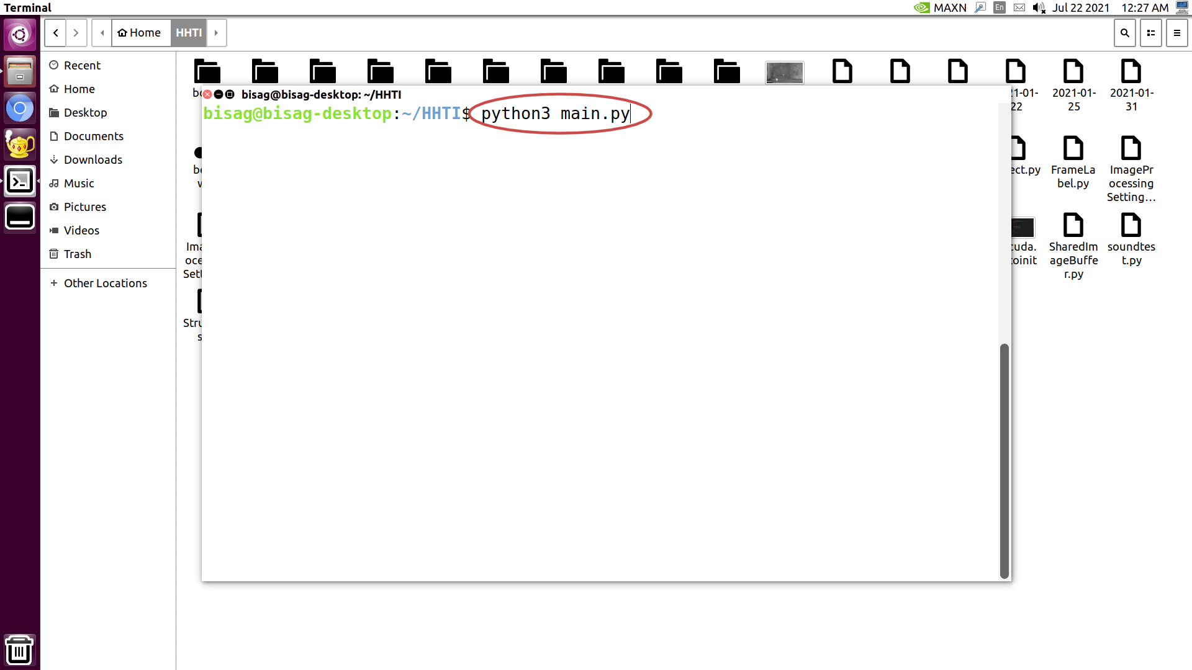
Fig.1

2) second step to click the connect to camera Button .

HHTI Main Window => Click Connect to camera Button

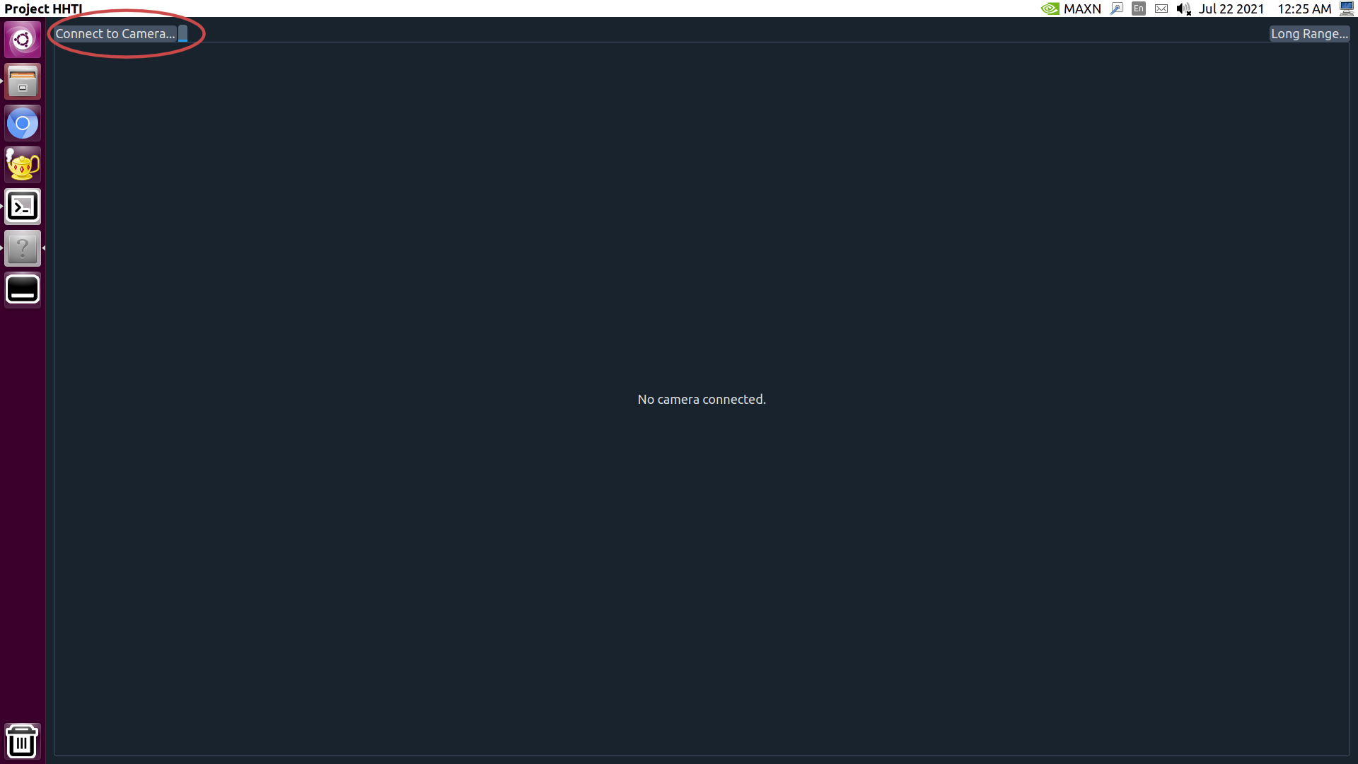

Fig.2

Fig 2:- In the figure 2 display HHTI main window the main window
contain 2 button Connect to camera and Long Range .

:- connect to camera contain detection the person and animal vehicle.

3) Third step to contain video on window display.

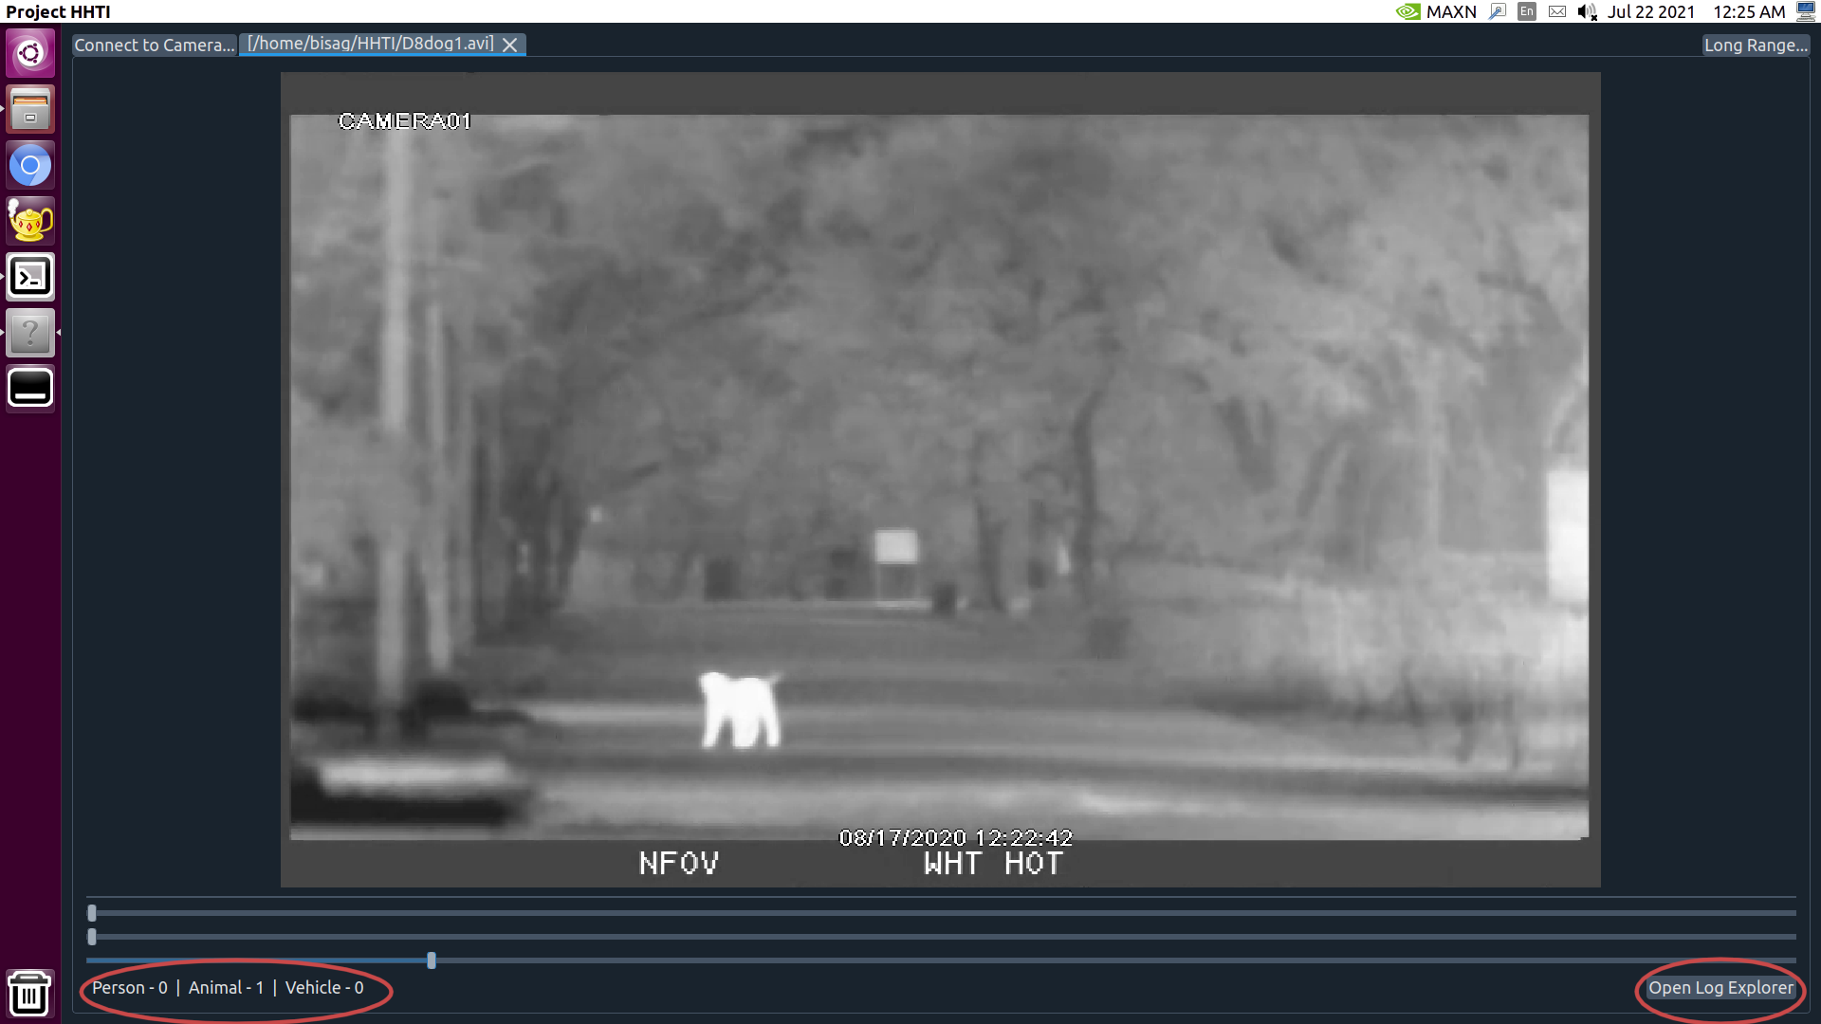

Fig.3

Fig 3:- In the figure 3 display video and it contains labels and log file
button.

:- labels count the detected person, animal and vehicle

:- open log explor button contain the log file in HHTI

4) Detect Person.

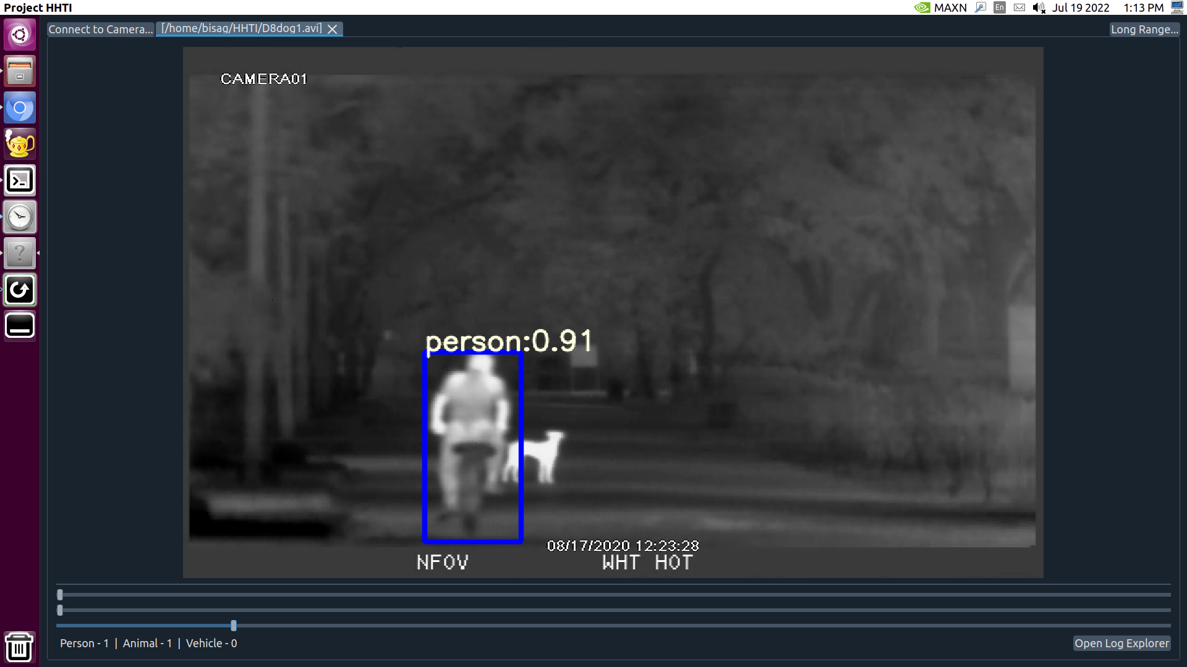

Fig.4

Fig 4:- The figure 4 detected person and draw bounding box around person.

:- The bounding box identify person and also provide accuracy.

+ setupUi (MainWindow)
+ retranslateUi (MainWindow)
Ui_MainWindow

+ «create» MainWindow ()
+ long_range ()
+ connectToCamera ()
+ disconnectCamera (index)
+ showAboutDialog ()
+ getFromDictByTabIndex (dic, tabIndex)
+ updateDictValues (dic, tabIndex)
+ setFullScreen (flag)
+ setTabCloseToolTips (tabs, tooltip)
MainWindow
+ «create» CaptureThread ()
+ run ()
+ generate_metadata_yolov4 (preds)
+ generate_metadata_yolov5 (result_class_ids)
+ stop ()
+ connectToCamera ()
+ disconnectCamera ()
+ isCameraConnected ()
+ getInputSourceWidth ()
+ getInputSourceHeight ()
+ updateFPS (timeElapsed)
updateStatisticsInGUI end

CaptureThread

+ «create» YoLov5TRT ()
+ infer (img)
+ gen_obj_dict (ids)
+ destroy ()
+ preprocess_image (image_raw)
+ transform_boxes (boxes, mask, orig_h, orig_w)
+ post_process (output, orig_h, orig_w)

YoLov5TRT

+ setupUi (ImageProcessingSettingsDialog)
+ retranslateUi (ImageProcessingSettingsDialog)
Ui_ImageProcessingSettingsDialog
+ «create» CameraView ()
+ delete ()
+ afterCaptureThreadFinshed ()
+ afterProcessingThreadFinshed ()
+ stopCaptureThread ()
+ stopProcessingThread ()
+ startThread ()
+ openLogFolder ()
+ pauseThread ()
+ updateCaptureThreadStats (statData)
+ updateProcessingThreadStats (statData)
+ updateFrame (frame)
+ clearImageBuffer ()
+ setImageProcessingSettings ()
+ updateMouseCursorPosLabel ()
+ newMouseData (mouseData)
+ handleContextMenuAction (action)

newImageProcessingFlags setROI
self.captureThread
self.processingThread self.isCameraConnected
CameraView

+ setupUi (CameraView)
+ retranslateUi (CameraView)
Ui_CameraView

+ «create» ImageProcessingSettingsDialog ()
+ updateStoredSettingsFromDialog ()
+ updateDialogSettingsFromStored ()
+ resetAllDialogToDefaults ()
+ smoothTypeChange (input)
+ validateDialog ()
+ resetSmoothDialogToDefaults ()
+ resetDilateDialogToDefaults ()
+ resetErodeDialogToDefaults ()
+ resetFlipDialogToDefaults ()
+ resetCannyDialogToDefaults ()

NewImageProcessingSettings

ImageProcessingSettingsDialog

+ «create» CameraConnectDialog ()
+ getDeviceUrl ()
+ getResolutionWidth ()
+ getResolutionHeight ()
+ getImageBufferSize ()
+ getDropFrameCheckBoxState ()
+ getApiPreference ()
+ getCaptureThreadPrio ()
+ getProcessingThreadPrio ()
+ getTabLabel ()
+ getEnableFrameProcessingCheckBoxState ()
+ setUrlMode (mode)
+ openFile ()
+ resetToDefaults ()
CameraConnectDialog
+ setupUi (CameraConnectDialog)
+ retranslateUi (CameraConnectDialog)

Ui_CameraConnectDialog

+ «create» SharedImageBuffer ()
+ getByDeviceUrl (deviceUrl)
+ removeByDeviceUrl (deviceUrl)
+ sync (deviceUrl)
+ wakeAll ()
+ setSyncEnabled (enable)
+ isSyncEnabledForDeviceUrl (deviceUrl)
+ getSyncEnabled ()
+ containsImageBufferForDeviceUrl (deviceUrl)
SharedImageBuffer
+ «create» Buffer ()
+ get ()
+ clear ()
+ size ()
+ maxSize ()
+ isFull ()
+ isEmpty ()
ret
Buffer
+ «create» FrameLabel ()
+ mouseMoveEvent (ev)
+ setMouseCursorPos (data)
+ getMouseCursorPos ()
+ mouseReleaseEvent (ev)
+ mousePressEvent (ev)
+ paintEvent (ev)
+ createContextMenu ()
newMouseData onMouseMoveEvent
FrameLabel

