USER MANUAL-SR BFSR

- The following table provides an outline of the sort of areas and details that an operator should consider. The manual provides all the information and instructions necessary to enable the operators to perform effectively.

INDEX | TOPIC
1 | Block diagram
2 | Introduction
3 | Description of Hardware used
4 | Hardware connections
5 | Operating Procedure of Application


Wireless Keyboard
VGA

Jetson Nano

SMPS
HDMI
5 V DC
AC
Power
230V
CDU
POWER
5 V DC
VGA TO HDMI
Headphone
DISPLAY
USB sound
card
BFSR_radar

1.Introduction

This is desktop based application which detects sound coming from BFSR and gives the pridiction of detected object in bfsr which is devided in three catagories (Heavy vehicle, Light vehicle, Group of men).

This application automatically fetches the value of easting, northing, speed, range, heading, azimuth from the screen and plots on the map.

- This application is divided in two parts. Left side of displays the live feed
of CDU.

- In the right side of window is devided into five parts.

- First window displays the live sound waveform form headphone.

- Second right windows contains the history of predictions, date, and time.

- Middle part contains the live pridiction and below prediction there are
refrence images are available for comparing the waveform and prediction.

- Last window contains the live spectrogram of sound.
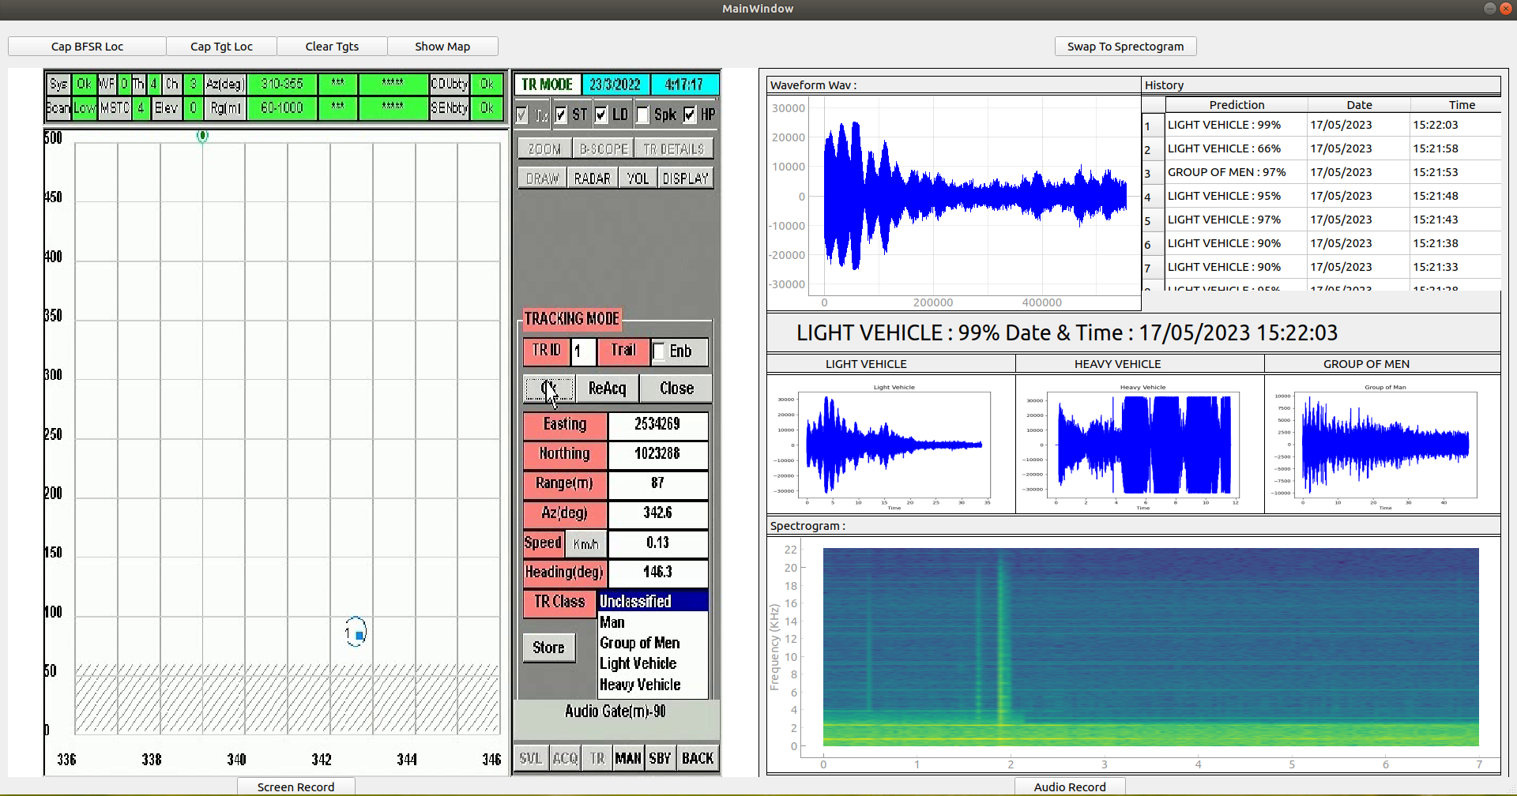
2. Description of Hardware used

- List of hardware to operate the application.

1. Intel Nuc (Next Unit of Computing): NUC 11 is a Mini Desktop Computer from Intel. Built for snappy processing power. It is used for this application for its compact design, low power consumption and smooth operation of application because it has high processing power. Though its compact design, it can easily be fitted in any ABS bag which is used in this system.

Specifications.

Supported Operating Systems: Ubuntu, windows 11 64 bit, windows 10 64 bit.

Memory type: 16 GB DDR4 SO-DIMM RAM(up to 64 GB)

Processor: 11th Gen Intel® Core™ i5-1135G7 @ 2.40GHz × 8

Graphics: Mesa Intel® Xe Graphics (TGL GT2)

Graphics Output: HDMI 2.0b; USB-C (DP1.4); MiniDP 1.4

USB Ports: 3

USB Configuration: 2x front (Type-A, Type-C) and 3x rear USB 3.2 Gen2 (2x Type-A, Type-C); USB 2.0, USB 3.1 Gen2 via internal headers

Audio (back channel + front channel): 7.1 digital (HDMI mDP); L+R mic (F)

Integrated LAN: Intel Ethernet Controller i225-V

Integrated Wireless: Intel WI-FI 6 AX201

Integrated Bluetooth: Yes

Storage: 500 GB SSD

2. HDMI cables: HDMI cables are required for display the output of Intel NUC to screen attached in the bag.

3. VGA To HDMI convertor: VGA to HDMI convertor is used for converting
the vga output of cdu into required hdmi input.

4. HDMI Video Capture: Video capture is used for capturing the video coming from hdmi to usb.

5. Usb sound card: Sound from cdu’s headphone is given into Intel nuc from usb sound card device.

6. LAN cable: LAN cable is required internet.

7. Keyboard & Mouse: wired or wireless Keyboard and mouse are used to control the system.

8. Power cable: To starting the system on AC power.

9. 12v Adapter: 12v adapter is required for DVR.

10. 19v Adapter: 19v adapter is required for Intel NUC.

3.Hardware connections:

1. Intel NUC and audio input.

Step 1: Connect 19v adpater to power supply and press power button to start the NUC.

Step 2: Connect HDMI Cable to HDMI port of NUC and other end in
the screen attached to the bag.
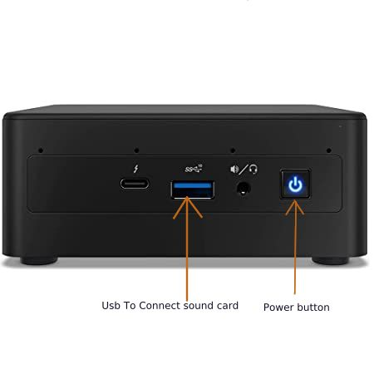

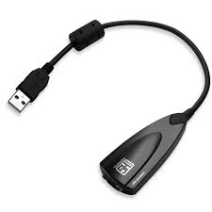

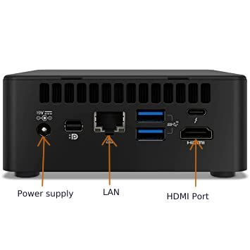

(Usb sound card)

Step 3: Connect usb sound card to the usb port of NUC as shown figure and then connect cdu’s headphone aux cable to usb sound card’s microphone port.

2. Intel NUC and cdu’s screen.

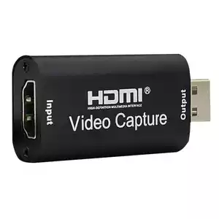
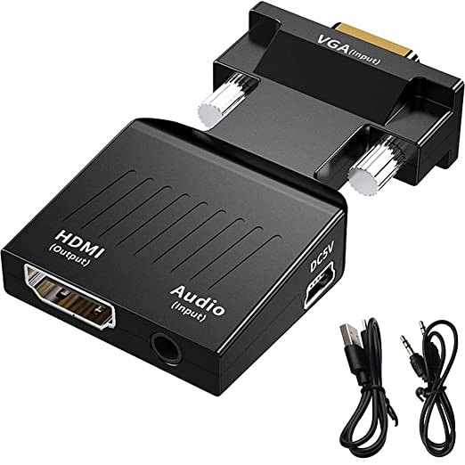

(HDMI Video Capture) (VGA to HDMI convertor)

- VGA to HDMI convertor contains the HDMI port and Type A usb port which is used for power supply.

- HDMI Video Capture contains HDMI port as input.

- Connect VGA to HDMI convertor to CDU’s VGA port with usb power cable to usb port and then connect HDMI cable to convertor and Hdmi video capture. Now connect Video capture to usb port of
NUC.

4. Operating Procedure of Application

- Step 1 : To start the application double click on the BFSR_SR icon as shown in below figure.

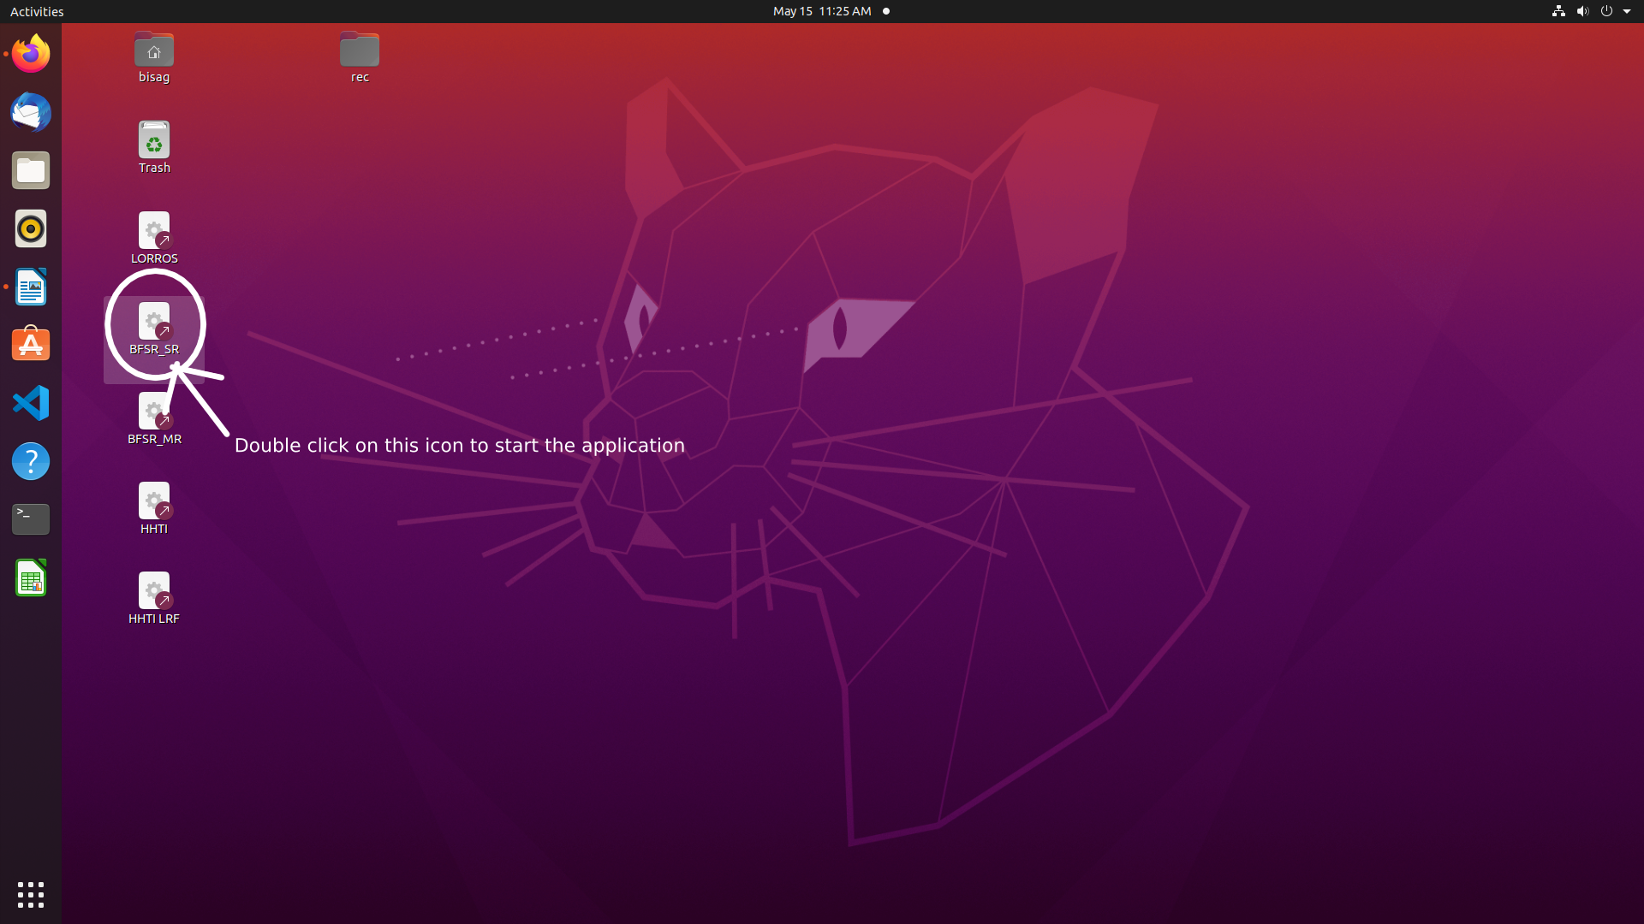

Step 2 : To capture the own location of bfsr click on the Cap Bfsr Loc
as shown in below figure.

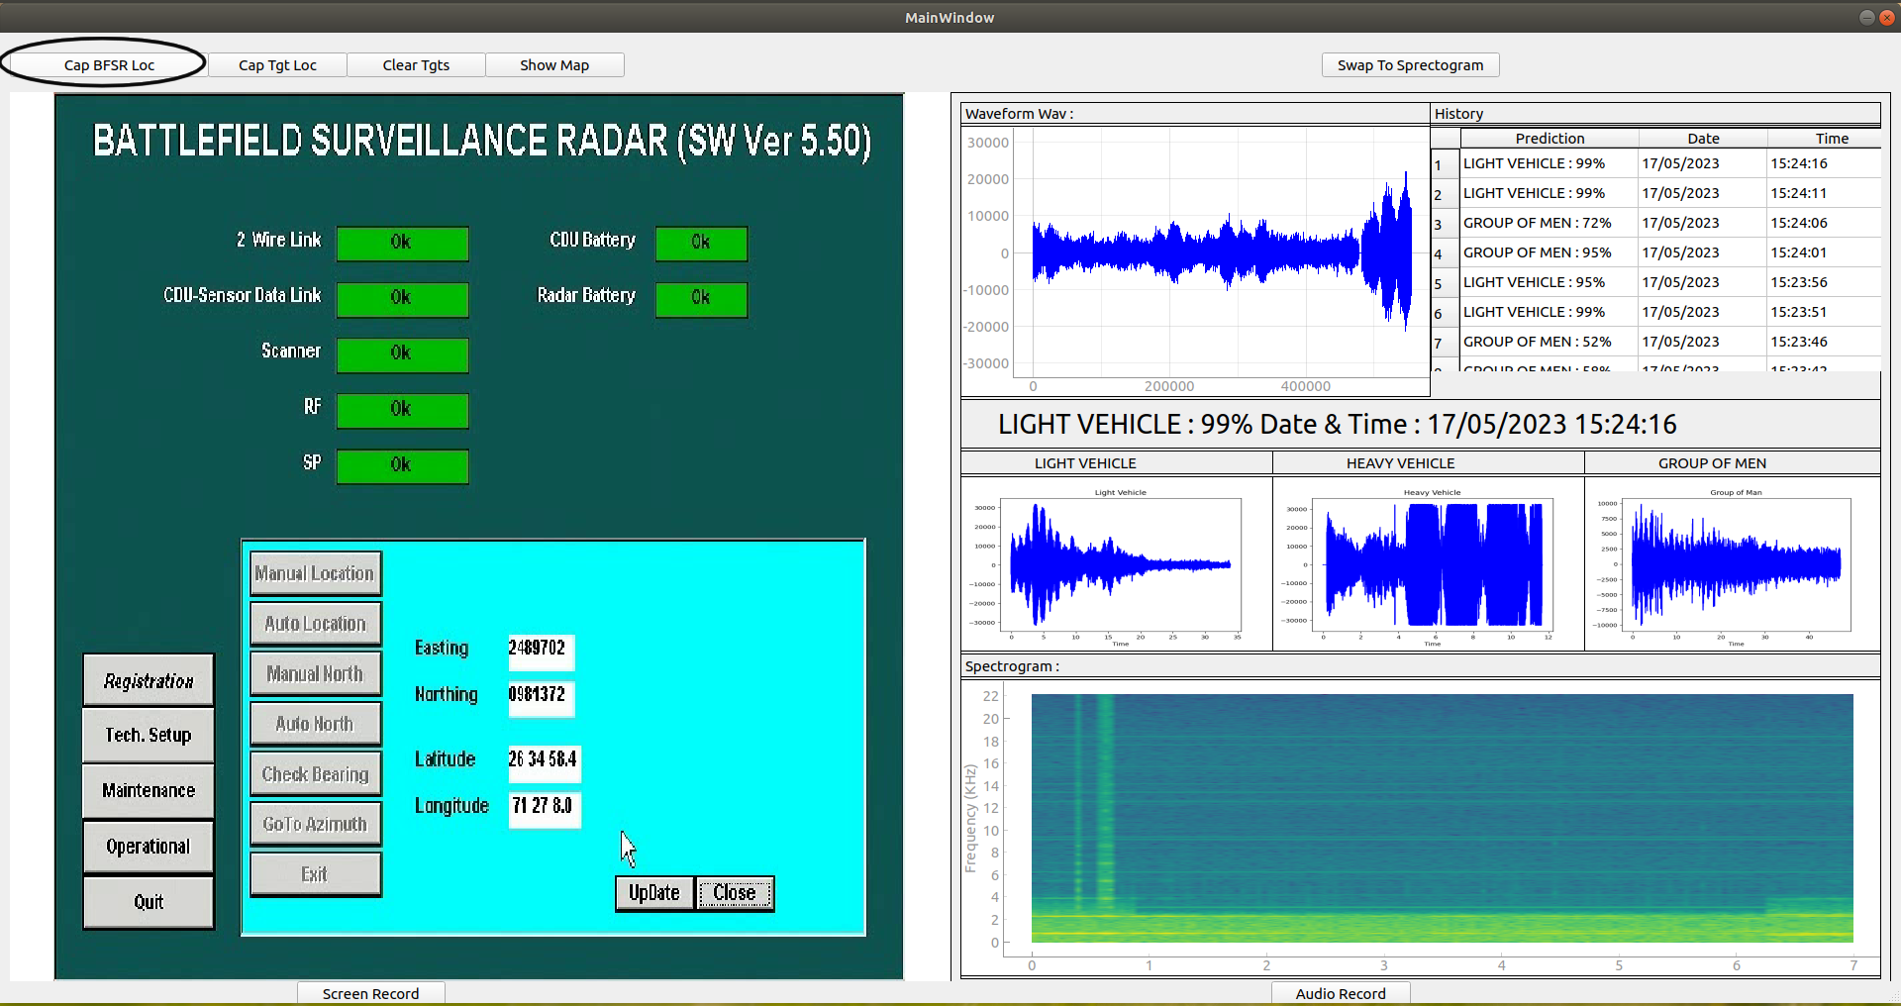

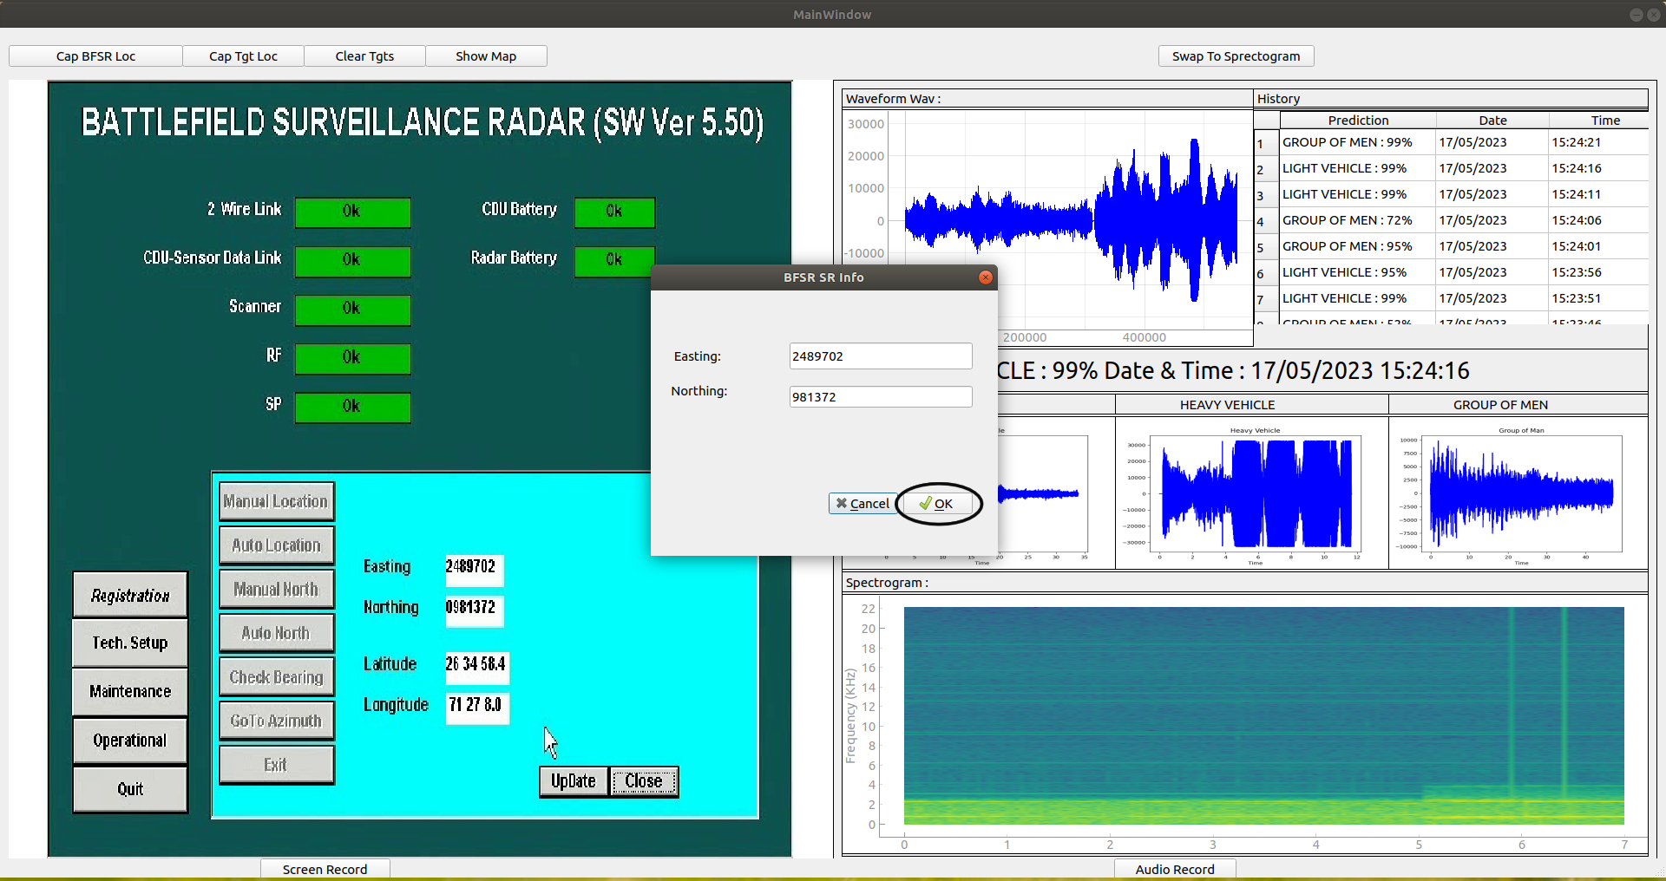
- clicking on Cap Bfsr Loc will open the popup window where you can varify the easting and northing then click on OK Button so you will be able to show BFSR location on the map.

Step 3 : To capture the Target location click on Cap Tgt Loc button.

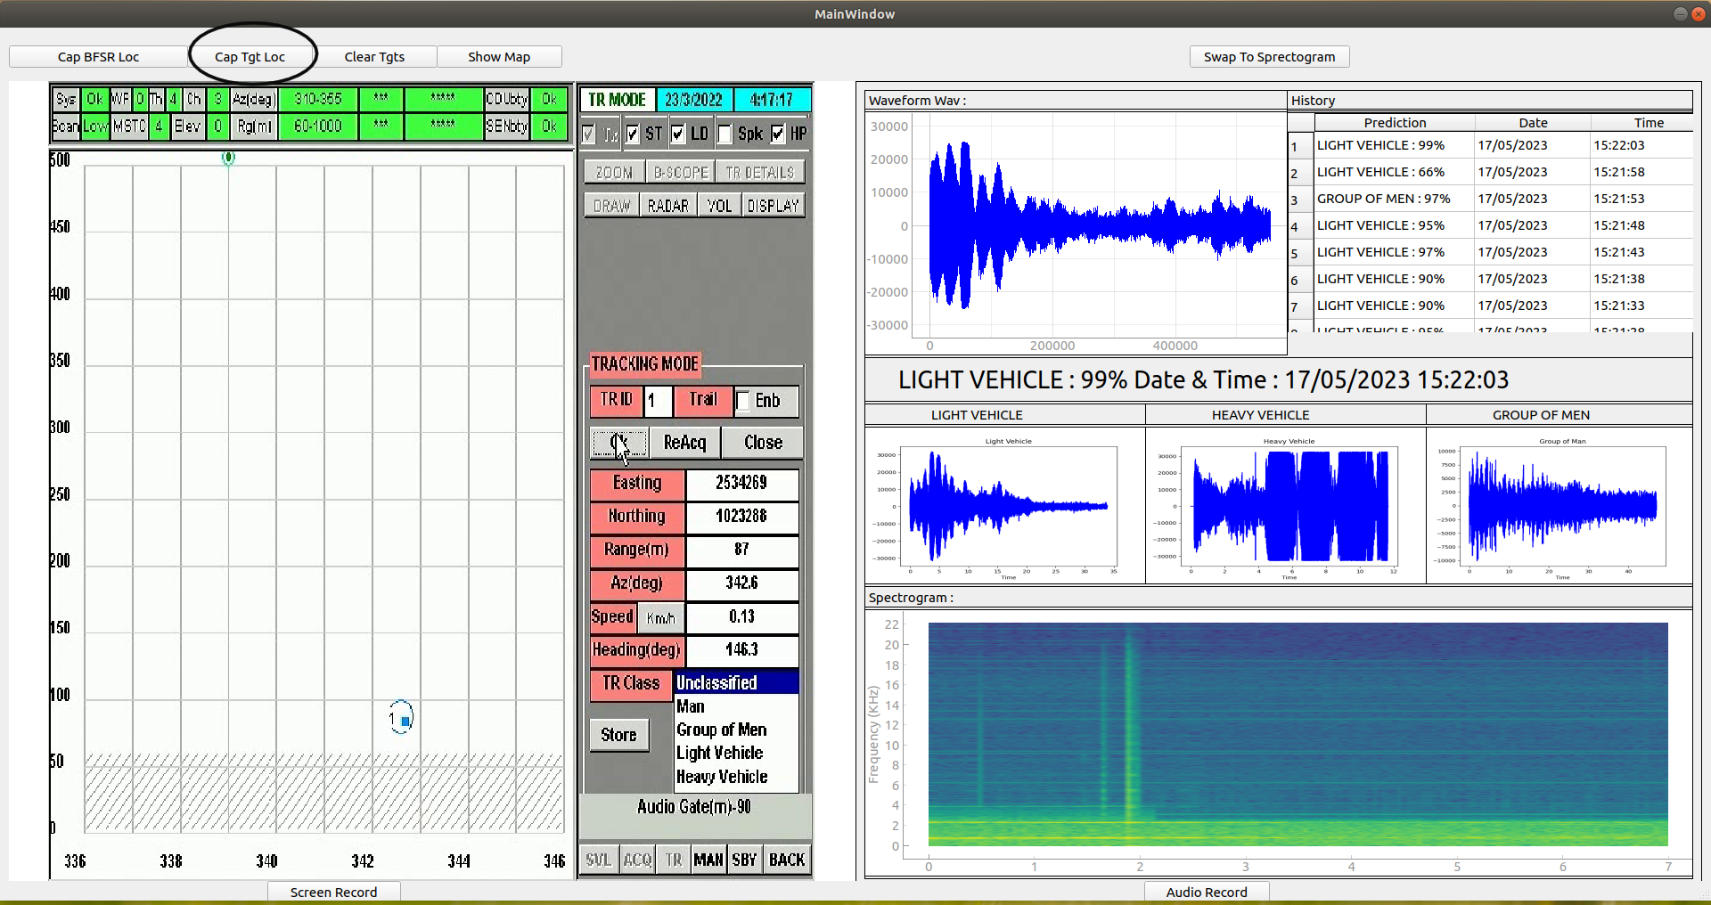

- clicking on Cap Tgt Loc button will open the popup where you
can varify all the data and click on OK button as shown in below
figure.

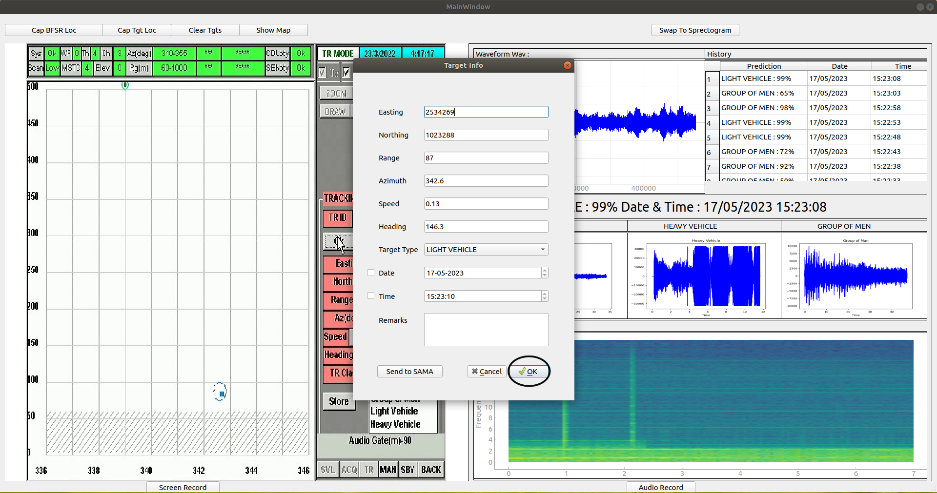
Step 4: click on Show Map button to see the map in the browser.

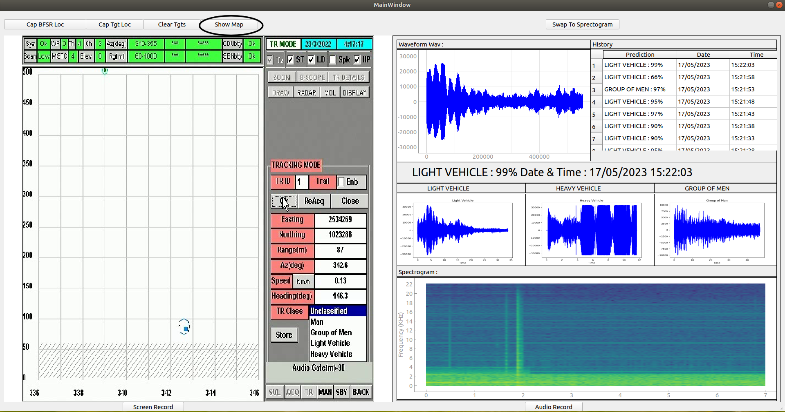
- Blue point represents the BFSR own location and red point represents the Target Location by clicking on these dots will show all the information in popup.
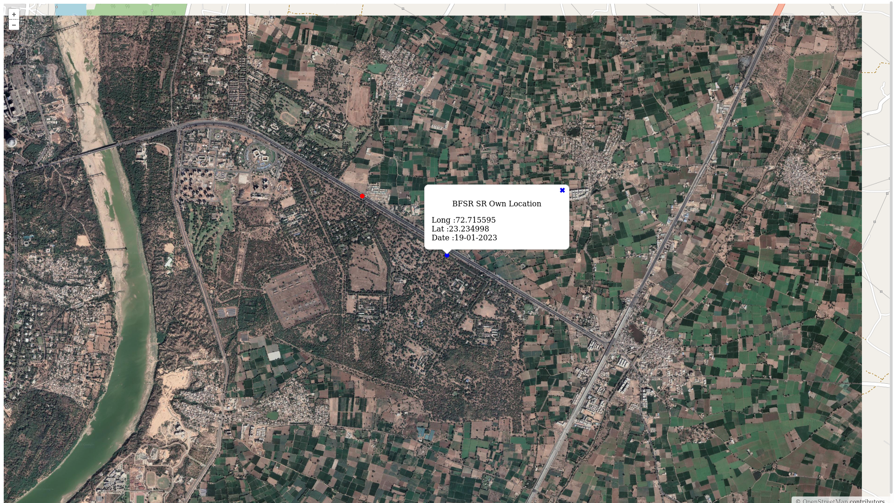

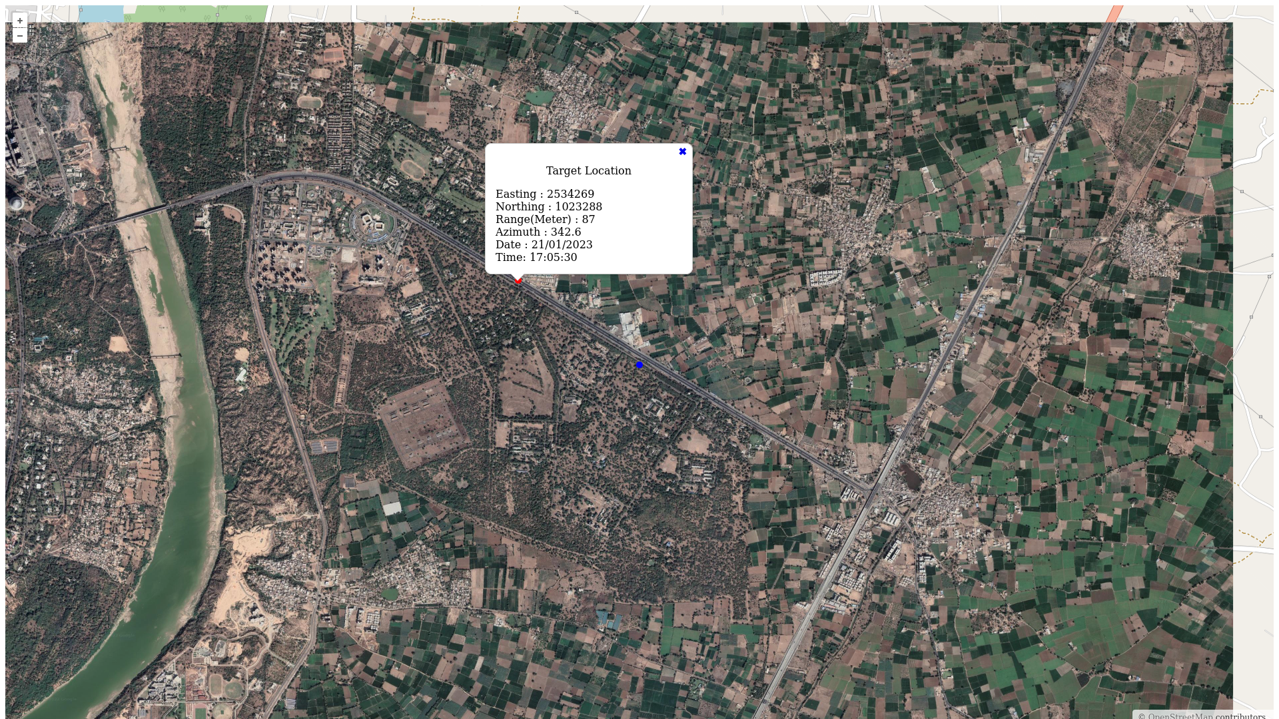

Step 5: clear Tgts Button will clear all the target points from map and keep only BFSR Own location point.
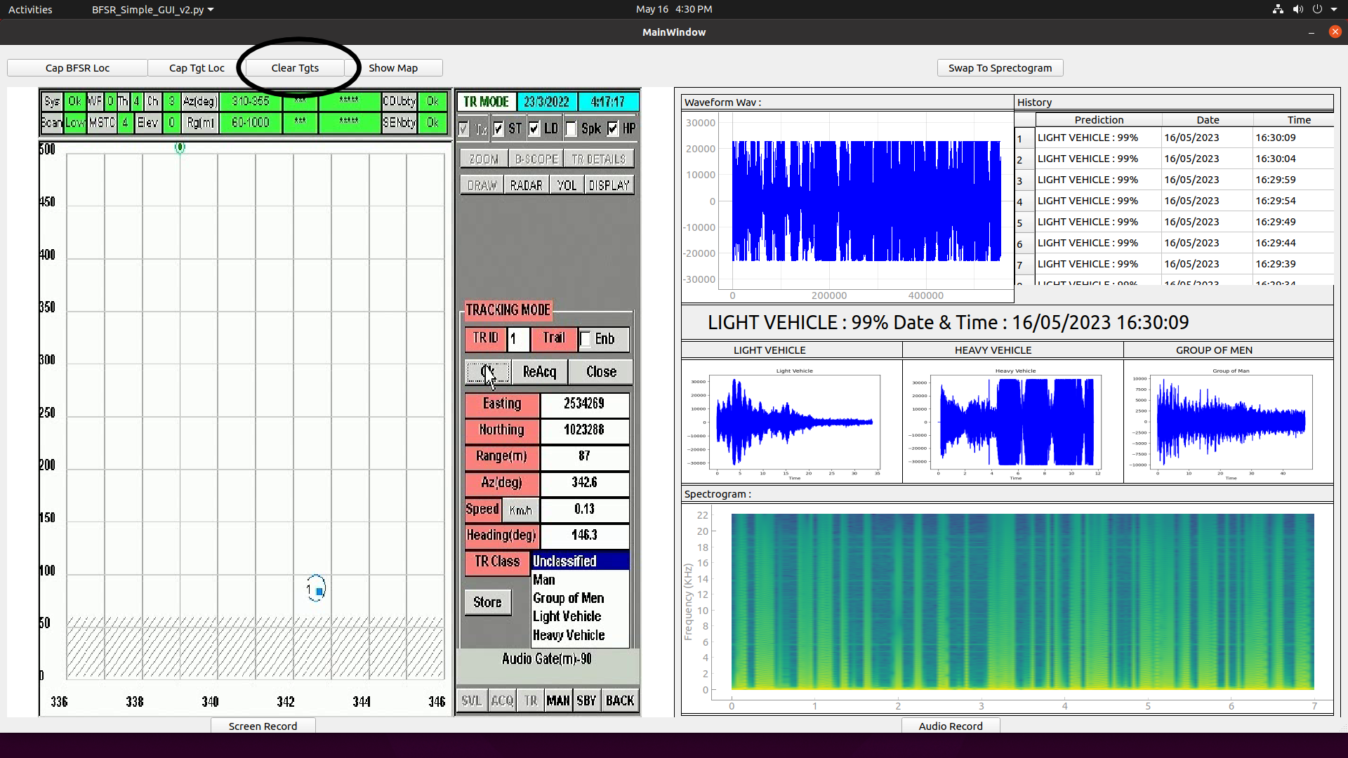

Step 6: Swap To Spectrogram button will swap the reference image as
shown in below figure.



