Experiment No. 09
DESIGN OF TEST CASES
Doctor Appointment Booking System — Aurelia Care
Student details | Information
Name | Ronit Rajput
Roll No. | E052
Program | Computer Science and Business Systems
Division / Batch | E / 2
Date of Experiment | 26 October 2026
Date of Submission | ________________
Grade | ________________

PART A

A.1 Aim
Design test cases for any two functionalities of the project: user login and appointment booking.

A.2 Prerequisites
Unit testing, black-box testing, white-box testing, and knowledge of the project requirements.

A.3 Outcome
Document and execute test cases with expected results, actual results, pass/fail status, and supporting evidence.

A.4 Theory
Software testing compares specified requirements with observed behaviour to detect defects. A test case defines preconditions, input data, execution steps, and expected results; execution supplies the actual result and verdict.
Black-box testing examines externally observable behaviour. White-box testing uses internal logic to exercise statements, decisions, and error paths. Unit tests isolate a small function; API tests using the database are integration tests.
Testing activities include setting objectives, identifying scenarios, preparing data, writing and executing cases, comparing results, reporting defects, and retesting. Key documents are the test plan, test case specification, incident report, and test summary.

A.4 Task (as numbered in the manual)
Write appropriate test cases for the project, considering any two functionalities.

PART B

B.1 Tasks Given in Part A

1. Scope and test plan
Aurelia Care supports patient authentication, doctor search, appointment booking, schedules, and administration. This experiment selects only login and appointment booking. Supporting checks inspect authentication, payment failure, time boundaries, concurrency, and transaction rollback.
Item | Configuration
Source version | b9663ffdcb771e8cf48beff67546490351794bcb
Application | React frontend; FastAPI backend; SQLite database
Execution environment | Linux cloud workspace; Python 3.12; Chromium browser
Focused tools | pytest, FastAPI TestClient, coverage.py 7.17.0, Playwright
Data isolation | Temporary SQLite fixtures for API tests; separate lab database for browser evidence
Priority / verdict | H = High; M = Medium. Pass requires all assertions in the case to succeed.

2. Test data
Field | Fictional laboratory value
Patient | Aarav Shah — patient@example.com
Second patient | Diya Patel — diya@example.com
Test password | TestingPass123! (isolated test fixtures only)
Incorrect password | WrongPass123!
Unknown email | unknown@example.com
Doctor / consultation fee | Dr. Jhatka / INR 1,200
Appointment slots | Generated future slots; actual identifiers selected from the availability API
Time-boundary fixture | 15 January 2030, 10:00 IST; clock frozen for boundary tests
Payment | Simulation: success or failure; no real payment processing

The password above is a test fixture, not an installation login credential. Browser tests use separately generated local credentials, which are not included in this report. Existing user data and the main database were not used for lab mutations.

3. Test design approach
- Equivalence partitioning: valid, incorrect, missing, malformed, and inactive login inputs.
- State transitions: logged out → authenticated → logged out; available slot → booked slot.
- Boundary analysis: appointment starts one minute before, exactly at, and one minute after a frozen current time.
- White-box analysis: login rejection and success, availability guards, payment branch, password verifier, and rollback after writes.
The next two tables retain all ten fields from the manual’s test case specification template. They use landscape pages for readability. API observations are distinguished from browser observations.

4. Test Cases: User Login
Method: black-box API integration testing. Each case has an isolated fixture; LG-02 also has browser evidence.
Test case ID | Test case | Priority | Preconditions | Input test data | Steps to be executed | Expected results | Actual results | Pass / fail | Comments
LG-01 | Valid patient login | H | Active patient; logged out | Registered email; correct password | POST login; GET account | 200; patient identity; usable session | 200; patient role; /me 200; HttpOnly cookie | Pass | API authentication
LG-02 | Incorrect password | H | Active patient; logged out | Registered email; WrongPass123! | POST login | 401; login rejected | 401 returned | Pass | Browser error also verified
LG-03 | Unknown account | H | Email not registered | unknown@example.com; test password | POST login | 401; login rejected | 401 returned | Pass | Negative partition
LG-04 | Empty required fields | M | Logged out | Empty email and password | POST login with empty strings | 422; validation fails | 422 returned | Pass | API input validation
LG-05 | Malformed email | M | Logged out | aarav.test@; test password | POST login | 422; invalid email | 422 returned | Pass | API input validation
LG-06 | Inactive account | H | Patient deactivated in fixture | Correct email and password | Deactivate fixture; POST login | 401; login rejected | 401 returned | Pass | Account-status decision
LG-07 | Account roles and access | H | Active patient, doctor, admin | Valid credentials per role | Login each role; patient requests admin users | Correct role; patient admin access 403 | All 3 roles matched; restricted request 403 | Pass | API roles; no claim of all UI routes
LG-08 | Session revoked on logout | H | Patient logged in | Session cookie | Logout; replay saved cookie to /me | Logout 200; replay 401 | 200 then 401 | Pass | Session lifecycle

5. Test Cases: Appointment Booking
Method: black-box API integration tests with database assertions where stated. Payment is simulated.
Test case ID | Test case | Priority | Preconditions | Input test data | Steps to be executed | Expected results | Actual results | Pass / fail | Comments
BK-01 | Successful booking | H | Patient authenticated; future slot free | Future slot; payment success | POST booking; inspect database | 201; one booking; paid; slot booked | 201; confirmed; simulated_paid; INR 1,200; +1 booking | Pass | API and browser confirmation
BK-02 | Unauthenticated request | H | Logged-out client; valid slot | Future slot ID | POST booking without session | 401; no database changes | 401; snapshot unchanged | Pass | Authentication
BK-03 | Occupied slot | H | First patient already booked slot | Second patient; same slot | Book slot again; compare records | 409; no duplicate changes | 409; snapshot unchanged | Pass | Availability guard
BK-04 | Past appointment | H | Logged-in patient; past slot fixture | Date 2000-01-01 | POST booking; compare records | 422; no booking | 422; snapshot unchanged | Pass | Past-time guard
BK-05 | Payment declined | H | Available future slot | payment_result=failure | POST booking; inspect records | 402; no saved booking; slot free | 402; all four table snapshots unchanged | Pass | Browser failure message verified
BK-06 | Retry failed payment | H | Future slot initially free | Failure then success; same slot | Fail payment; retry successfully | 402 then 201; exactly one new booking | 402 then 201; appointment count +1 | Pass | Browser retry verified
BK-07 | Concurrent requests | H | One available slot; valid patient session | 8 simultaneous requests | Submit with 8 workers; query records | One 201; seven 409; one confirmed booking | Exactly one 201 and seven 409; one confirmed row | Pass | Same patient session; 8 requests
BK-08 | Booking persistence | H | Successful booking exists | Saved appointment ID | Logout; reinitialize schema; login; GET booking | Saved record remains identical | 200; full response equals saved response | Pass | New authenticated client

6. White-Box and Supporting Tests
Source inspection identified the login rejection condition, password verification, slot guards, payment branch, and transaction boundaries. The following seven additional pytest cases exercise these paths. They complement the sixteen functional cases.
ID | Internal path / technique | Observed result | Verdict
WB-01a | Slot starts one minute before frozen time | 422; past slot rejected | Pass
WB-01b | Slot starts exactly at frozen time | 422; equality boundary rejected | Pass
WB-01c | Slot starts one minute after frozen time | 201; future booking accepted | Pass
WB-02 | Missing slot; doctor role calls patient booking API | 404 for missing slot; 403 for doctor | Pass
WB-03 | Slot belongs to inactive doctor | 404; slot rejected | Pass
WB-04 | Fault injected in db.notify after appointment, slot and payment writes | 500 returned; appointments, payments, slots and notifications exactly restored | Pass
WB-05 | Password verifier unit test: match, mismatch, malformed encoding | True, False, False respectively | Pass

6.1 Measured source coverage
The focused 23-case run was instrumented with coverage.py branch tracing. The figures below apply only to the named functions, not the whole application.
Function | Statements covered | Branch outcomes covered
main.login | 6 / 6 (100%) | 2 / 2 (100%)
appointments.available | 8 / 8 (100%) | 6 / 6 (100%)
appointments.book | 12 / 12 (100%) | 4 / 4 (100%)
security.verify | 6 / 6 (100%) | 0 measured branches (not applicable)

Coverage measures executed statements and branch arcs. It does not establish complete path coverage, condition/MC/DC coverage, or absence of defects. Other functions, such as cancellation and Excel import, are outside this focused coverage claim.

6.2 Test summary
Run | Result
Focused Experiment 9 suite | 23 passed; 0 failed; 0 skipped — 27.56 seconds
Existing regression suite | 21 passed; 0 failed; 0 skipped — 17.59 seconds
Fresh browser checks | 4 scenarios passed: rejected login, successful login, failed payment, successful retry / confirmation
Warnings | One upstream Starlette / AnyIO deprecation warning in each API run; no test assertions disabled

7. Browser Evidence
Screenshots were captured from the running application using a separate fictional lab database. These are observed browser states, not mockups.
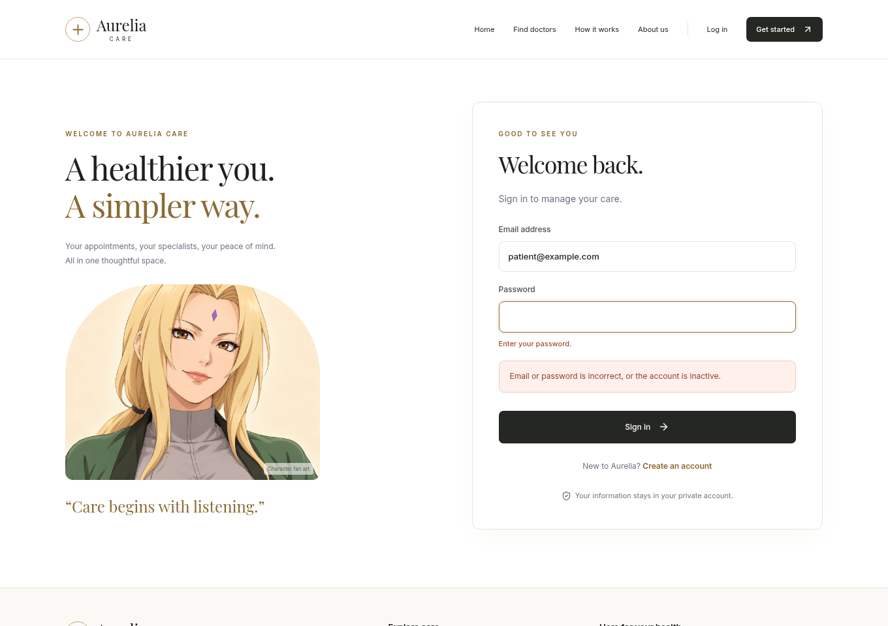
Figure 1. Incorrect credentials rejected with the application’s generic login error (LG-02).
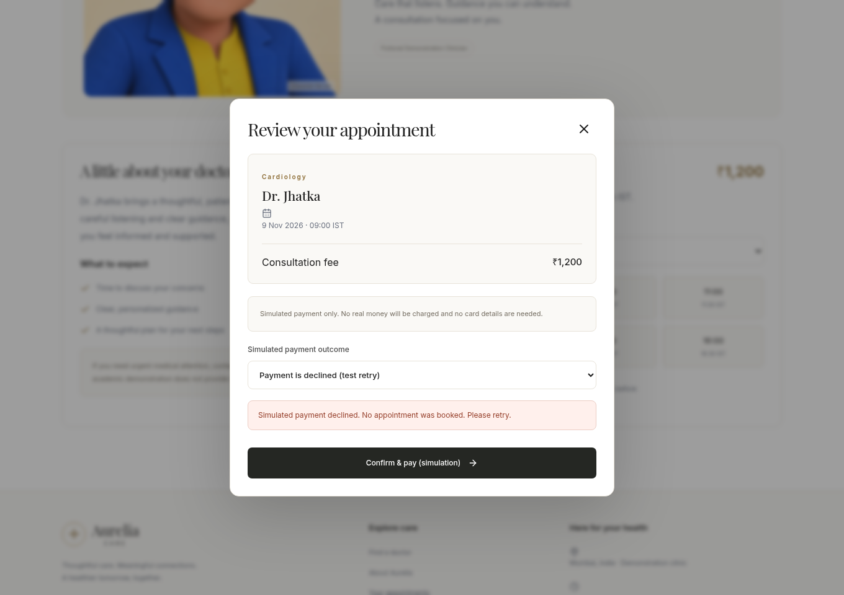
Figure 2. Simulated payment declined; the dialog reports that no appointment was booked (BK-05).

7. Browser Evidence (continued)
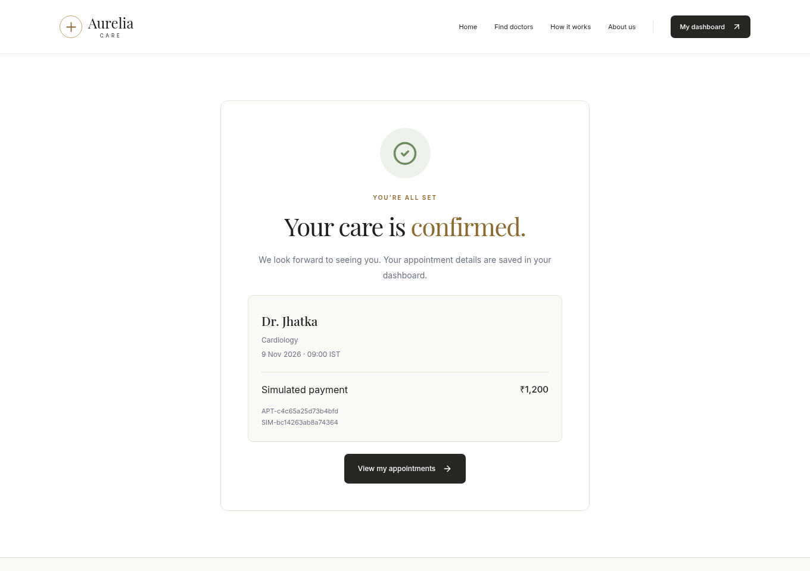
Figure 3. Successful retry creates a confirmed appointment with simulated payment (BK-01 / BK-06).

7.1 Execution evidence
Machine-readable JUnit results, the focused run log, coverage JSON, test source, and browser script are included in the accompanying evidence archive. The exact API outcomes used in the case tables are asserted by those tests.
Command / evidence | Purpose
pytest tests -q | Existing 21-test regression suite
coverage run --branch ... pytest test_experiment9.py -v | Focused 23-test run with source coverage
coverage json | Function-level statement and branch metrics
node capture.mjs | Four browser checks and three screenshots

An initial browser attempt on the lab’s alternate port was rejected by the existing Origin safeguard. The lab server was restarted with that exact local origin in ALLOWED_ORIGINS; the completed browser run then passed. Application source code was unchanged. The initial pre-permission API process was stopped and rerun with supported local networking.

B.2 Observations and Learning
- Valid credentials produced a usable HttpOnly-cookie session. Wrong, unknown, and inactive-account login requests were rejected. Empty and malformed fields returned validation errors.
- Logging out invalidated the saved session: replaying the previous cookie returned 401. Role checks denied a patient access to administrator user management.
- Successful booking saved a confirmed appointment, matching simulated payment, and a booked slot. A new authenticated client retrieved the same record.
- Eight concurrent requests for one slot produced one success and seven conflicts, with only one confirmed database row.
- A simulated payment failure returned 402 without changing appointments, payments, availability, or notifications. Retrying successfully created only one new booking.
- The frozen-clock tests demonstrated the exact time rule: a slot at or before the current time is rejected; a later slot can be booked.
- A deliberate exception after database writes caused transaction rollback. No partial booking, payment, notification, or slot-state change remained.
- Black-box observations and white-box source tracing provide complementary evidence. Complete branch coverage of selected functions does not imply complete coverage of the application.

B.3 Conclusion
The aim was achieved by designing and executing test cases for login and appointment booking in the Doctor Appointment Booking System. All sixteen functional cases and seven supporting white-box/boundary cases passed. The twenty-one existing regression tests also passed, and four fresh browser scenarios supplied visual evidence.
The results support the tested authentication, booking, failure-handling, concurrency, and persistence behaviours for the identified source version in the Linux lab environment. They do not establish production performance, native Mac compatibility, or exhaustive correctness.

B.4 Questions of Curiosity

1. What are black-box and white-box testing? Differentiate between them.
Black-box testing checks software through inputs and externally visible outputs, using requirements rather than internal code to select cases. White-box testing uses source structure and logic to select execution paths and measure structural coverage.
Basis | Black-box testing | White-box testing
Focus | External behaviour | Internal implementation
Test design basis | Requirements and specifications | Source code and control flow
Code knowledge | Not required | Required
Techniques | Equivalence partitions, boundaries, decision tables, state transitions | Statement, branch and condition coverage; path analysis
Project example | Occupied slot must be rejected | Exercise availability guards and payment branches; inspect rollback
Limitation | May miss internal paths | May miss a requirement omitted from the code

Both approaches are useful at multiple testing levels. Black-box testing is not restricted to manual tests, and white-box testing is not synonymous with unit testing.

2. What are stubs and drivers? Differentiate between them.
A stub temporarily replaces a dependency called by the component under test and returns controlled responses. A driver temporarily replaces a caller: it invokes the target component, supplies inputs, and checks outputs.
Basis | Stub | Driver
Replaces | Called dependency | Calling component
Position | Below component under test | Above component under test
Typical integration approach | Top-down | Bottom-up
Example | Fake payment dependency returning success or failure | Harness invoking the booking service with fixture inputs

Relationship: Driver → Component under test → Stub. These aids simplify testing but may not reproduce every real integration behaviour. In this experiment, the injected notification failure is a fault-injection replacement; the application’s payment-outcome selector is an existing simulation feature.

B.4 Questions of Curiosity (continued)

3. Explain the advantages and disadvantages of top-down compared with bottom-up integration.
Top-down integration begins with higher-level control modules and progressively integrates lower-level dependencies. Stubs stand in for dependencies that are not yet available. In this project, the booking API could first be tested with controlled slot, payment, and persistence dependencies.

Advantages of top-down integration
- Major workflows and orchestration can be checked early.
- An early system skeleton supports demonstrations and requirements feedback.
- Interface and control-flow problems between higher-level modules can be identified before all lower-level services are complete.

Disadvantages of top-down integration
- Many realistic stubs may be needed and must be maintained.
- Detailed database and utility behaviour is verified later.
- Simplified dependency responses may hide faults until the real components are integrated.
Bottom-up integration begins with low-level services and combines them into larger components. Drivers simulate unavailable callers. In this project, password verification, database constraints, and slot reservation could be checked before integrating the API and interface.

Advantages of bottom-up integration
- Foundational data operations and utilities are verified early.
- Failures in small components are generally easier to isolate.
- Higher-level integration can build on already-tested lower-level services.

Disadvantages of bottom-up integration
- Drivers must be written and maintained.
- Complete user workflows and demonstrations become available later.
- High-level coordination and navigation faults may remain undiscovered until later integration.
Aspect | Top-down | Bottom-up
Starting point | High-level control modules | Low-level services
Main aid | Stubs | Drivers
Early visibility | Main workflows | Foundational operations
Later integration | Detailed dependencies | Overall orchestration

A combined or sandwich approach is suitable for Aurelia Care: test authentication and database operations independently, integrate the API and its dependencies, then verify complete browser workflows.

