Business Model &
Techno-Economic Analysis
Autonomous inclined-solar-panel cleaning crawler
Group 06 · Arush Ashish Patil (E048), Ronit Rajput (E052), Harshvardhan Sahi (E058)
Business-model script and economics: Harshvardhan. Business/model support: Ronit. Robot physics, control logic and simulation: Arush. Development and report preparation were AI-assisted.

Decision summary
The proposed product combines contamination-triggered cleaning, a fixed rotary brush, a solid-object guide/catch tray and an external service dock. The business case evaluates whether one cleaner serving manually transferred panel sections can reduce operating effort and cost relative to an assumed manual baseline.
Base-case output | Calculated result
Normalised annual operating cost, κ | 0.619926 of the manual baseline
Normalised Cost Reduction Index, 1 − κ | 38.01%
Simple payback / lifetime-normalised payback | 20.52 months / 0.3420
Monthly human effort / reclaimed effort | 62.94 / 57.06 person-hours
Service capacity / assumed demand | 4.541 / 2.625 sections/hour
M/M/1 mean queue wait | 18.10 minutes under distribution assumptions

What these numbers establish
They are reproducible scenario outputs using measured simulation timing/work and explicitly assumed commercial inputs. They are not supplier quotations, customer-trial savings, measured electrical consumption or PV energy-yield recovery. Currency values are excluded in accordance with the course rubric.
The report covers the product proposition, operating workflow, assumptions, equations, worked calculations, queueing, sensitivity, uncertainty, risk and reproduction. The companion package contains the actual Python business script and its input/output files.

1 · Proposed commercial model
This is a proposed route to market; customer demand, willingness to pay and supplier costs have not been validated.
Business-model element | Proposed approach
Customer segments | Commercial rooftop-PV operators and operations/maintenance contractors with accessible, compatible panel sections.
Value proposition | Clean when dirt is detected; reduce hands-on sweeping; combine a visible digital prototype with a transparent labour/cost model.
Differentiation | RGB-gated departure, inspection feeds, targeted revisits, a fixed broad brush, rigid-body handling of a selected larger object and external servicing.
Offering / revenue hypothesis | Equipment sale or lease with maintenance support. A managed cleaning service priced per section is an alternative; no tariff or profit is calculated here.
Customer relationships | Site assessment, installation/rehearsal, operator training, periodic inspection and maintenance records.
Channels / partners | Proposed direct pilot with a PV operator or cleaning contractor; prospective fabrication, motor, camera and service partners. No partnership is claimed.
Key resources / activities | Crawler, brush/guide, cameras, containment, dock/tray, software, model validation, inspection and manual transfer between sections.
Cost structure | Capital equipment plus supervision, transfer/recovery labour, maintenance, estimated energy, spares/battery and consumables.
Adoption gate | Demonstrate real traction, panel/coating compatibility, safe mounting, reliable sensing, measured electrical power and operator workflow before commercial claims.

Operating workflow and responsibility
The operator places and checks the system on one modelled 6 × 4 m bay. Cameras monitor contamination; persistent detections trigger cleaning. The robot sweeps, revisits detected residuals, guides the selected solid to the tray, returns to the external dock and performs modelled emptying/charging service. A human transfers it to the next bay, handles recovery and performs maintenance.
The model is a cost-feasibility calculation, not a complete vendor profit-and-loss forecast. Selling price, customer acquisition, manufacturing scale, financing, tax and discounted cash flows require additional evidence.

2 · Simulation evidence and workload
Economic calibration selects all 30 proposed-controller attempts at 20° from the frozen 180-attempt evaluation (two controllers × three inclinations × 30 attempts). Failures are retained by the selector; all 30 selected attempts happened to succeed.
Simulation-derived input | Value | Interpretation
Selected sample | 30/30 completed | Observed simulation fraction p = 1; not proof of perfect field reliability.
Mean attempt time Tₐ | 612.712933 s | About 10.21 minutes; full attempt timing, not video runtime.
Positive actuator mechanical work | 3087.405795 J | Integrated simulated torque × speed; not electrical energy.
Modelled blower energy | 7081.932000 J | Computed using assumed 20 W blower power; not a power measurement.
Input provenance | summary.csv + protocol/statistics | analytics/final_validation_v1; raw 500 Hz trial logs retained separately.

Operational scenario assumptions
Input | Assumed value
Section size / workload | 24 m²; 21 sections/day; 30 days/month; 8 scheduled hours/day
Derived workload | 504 modelled m²/day; 630 sections/month; 15,120 modelled m²/month
Manual baseline H₀ | 120 person-hours/month for the specified workload
Supervision fraction f | 0.20 of active attempt time
Transfer to next section | 180 s/section, fully counted as human labour
Recovery after a failed attempt | 180 s/failure, fully counted as human labour
Maintenance | 10 person-hours/month
Retries / queue | Independent repeat attempts; one server; Poisson arrivals and exponential service assumed
The workload is a declared operating scenario, not a measured installation size or inferred 100 kWp plant. Modelled surface area is not certified cleaned area. Autonomous transfer between separate bays has not been demonstrated.

3 · Cost and energy assumptions
Let one year of manual baseline labour cost equal 1 cost unit. All costs below are dimensionless ratios or normalised coefficients, not currency amounts. Commercial inputs are assumptions; no supplier quote is represented as evidence.
Input | Assumption / units | Where used
Capital ratio k | 0.65 × one-year manual baseline cost | Simple payback; separate from annual operating κ
Equipment life L | 5 years | Lifetime-normalised payback
Battery / spares annual ratio | 0.05 | Annual operating-cost ratio
Consumables annual ratio | 0.03 | Annual operating-cost ratio
Electricity coefficient α | 0.0003 baseline cost units/kWh | Annual estimated energy × α
Electromechanical efficiency η | 0.60 | Convert positive simulated actuator work to an estimate
Robot electronics | 5 W | Attempts, recovery and transfer
Panel cameras | 2 cameras × 3 W each | 8 scheduled hours/day
Blower | 20 W during modelled blower activity | Already included in modelled blower energy
Human fractions | Transfer = 1; failure recovery = 1 | No free inter-bay transfer or recovery labour

Scope of the financial comparison
κ compares recurring annual operations against one annual manual baseline. It does not include annualised capital expenditure. Capital is evaluated separately in the simple-payback equation. This avoids counting the same capital expense twice.
The model includes an assumed efficiency and auxiliary loads, but does not resolve motor-controller losses, battery ageing, standby demand or actual charging efficiency in hardware. Electrical figures are estimates. Dock energy credit in the simulation is not evidence of a full battery recharge.

Benefits deliberately not monetised
PV electrical-yield recovery, measured water savings, coating life, quantified safety benefits and avoided downtime are not monetised. The cleaning model tracks contamination and contact, not PV power generation. No currency-based selling price, bill of materials or verified commercial profit is claimed.

4 · Calculation model and labour
Quantity | Equation / definition
Monthly completed workload | n = sections/day × operating days/month = 630
Expected recovery per success | R = (1 − p) × tᵣ / p
Time per successful service | Tₛ = Tₐ / p + R + tₜ; tₜ is transfer time
Active attempt hours/month | Hₐ = n × Tₐ / (3600p)
Supervision hours | Hsupervision = f × Hₐ
Transfer / recovery hours | Htransfer = n × (tₜ × hₜ + R × hᵣ) / 3600
Total human effort | Hrobot = Hsupervision + Htransfer + Hmaintenance
Reclaimed effort | Hreclaimed = H₀ − Hrobot
p is the selected observed success fraction; hₜ and hᵣ are the human fractions of transfer/recovery (both 1 in the base case). Repeated attempts are a business assumption; they do not create a demonstrated autonomous recovery capability.

Worked base case
Step | Calculated value
Attempt hours | 630 × 612.712933 / 3600 = 107.224763 h/month
Monitoring | 0.20 × attempt hours = 21.444953 person-h/month
Transfer / recovery | 630 × 180 / 3600 = 31.500000 person-h/month (p = 1)
Maintenance | 10.000000 person-h/month
Human effort with robot | 62.944953 person-h/month
Reclaimed effort | 120 − 62.944953 = 57.055047 person-h/month
Reclaimed time is a scenario opportunity to reallocate labour; it is not a measured reduction in headcount. The model counts all transfer labour even when the robot needs no active supervision.

5 · Energy, operating cost and payback
Attempt energy estimate: Eₐ = (Wpositive/η + Eblower + Pelectronics × Tₐ) / 3600, in Wh. Per-success robot energy adds retries and electronics during recovery/transfer: Erobot = Eₐ/p + Pelectronics × (R + tₜ)/3600.
Energy estimate | Calculated value
Robot energy / successful section | 4.497548 Wh
Robot energy / modelled m² | 0.187398 Wh/m²; excludes external cameras
Annual robot / external cameras | 34.001463 / 17.280000 kWh/year
Annual system estimate | 51.281463 kWh/year

Normalised annual operating-cost bridge
κ = Hrobot/H₀ + Eannual × α + cspares + cconsumables. Capital is evaluated separately in payback.
Cost component | Fraction of annual manual baseline
Monitoring labour | 0.17870794
Transfer / recovery labour | 0.26250000
Maintenance labour | 0.08333333
Estimated energy | 0.01538444
Battery / spares | 0.05000000
Consumables | 0.03000000
Total κ | 0.61992571
NCRI = 1 − κ = 0.38007429 (38.01%). Annual savings ratio s = NCRI. Simple payback T = 12k/s = 12 × 0.65 / 0.38007429 = 20.5223 months. Lifetime-normalised payback P = k/(L × s) = 0.342038.
If s ≤ 0, payback is undefined; the script does not report an invented finite recovery time. Financing, tax, discounting and damage-related losses are outside this simple-payback calculation.

6 · Capacity, queueing and labour graph
One server represents one robot-plus-transfer service process. λ = sections/day ÷ scheduled hours/day. μ = 3600/Tₛ. For M/M/1, ρ = λ/μ; Wq = λ/[μ(μ − λ)] and W = 1/(μ − λ), provided λ < μ.
Queue output | Base case
Service time Tₛ | 792.712933 s = 13.2119 min
λ / μ | 2.625000 / 4.541367 sections/h
Servers / utilisation | 1 / 0.578020
Mean queue wait Wq | 18.097368 min
Mean queue + service W | 31.309250 min
Service-process hours/month | 138.724763 h, including assumed transfer
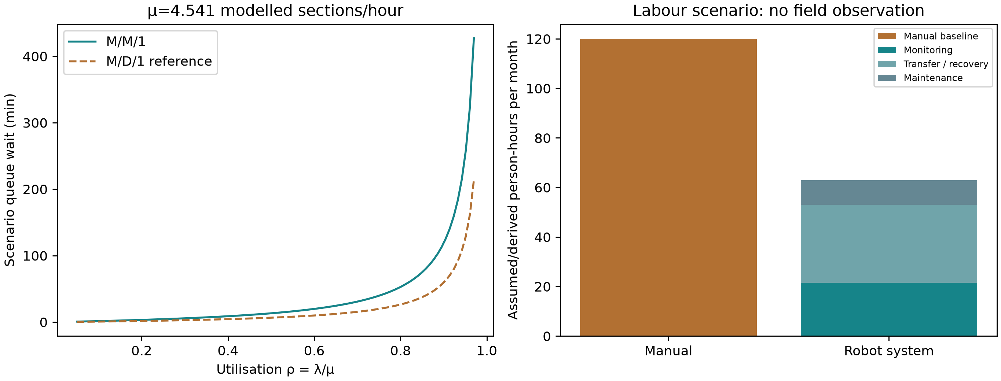
Existing final-analysis figure. Queue distributions are assumed. The M/D/1 curve is a reference, not a fitted arrival/service model. Labour includes monitoring, transfer/recovery and maintenance.
A mean queue wait can exceed one service duration because arrivals may find work already waiting. Queue delay is a stochastic scenario output, not an observed timing measurement from the robot film. If utilisation reaches 1, finite steady-state wait is not reported. Maintenance labour is costed but its detailed equipment-downtime schedule is not simulated.

7 · Sensitivity and break-even conditions
The script changes eight inputs one at a time to 70%, 100% and 130% of their base values. This is scenario sensitivity, not a financial confidence interval or a joint uncertainty model.
Input changed | NCRI at −30% / +30% | Payback months at −30% / +30%
Supervision | 43.37% / 32.65% | 17.99 / 23.89
Manual baseline hours | 15.53% / 50.11% | 50.23 / 15.57
Capital ratio | 38.01% / 38.01% | 14.37 / 26.68
Transfer seconds | 45.90% / 30.12% | 16.99 / 25.90
Recovery seconds | 38.01% / 38.01% | 20.52 / 20.52
Energy-cost coefficient | 38.47% / 37.55% | 20.28 / 20.77
Maintenance hours | 40.51% / 35.51% | 19.26 / 21.97
Drive efficiency | 37.87% / 38.08% | 20.60 / 20.48
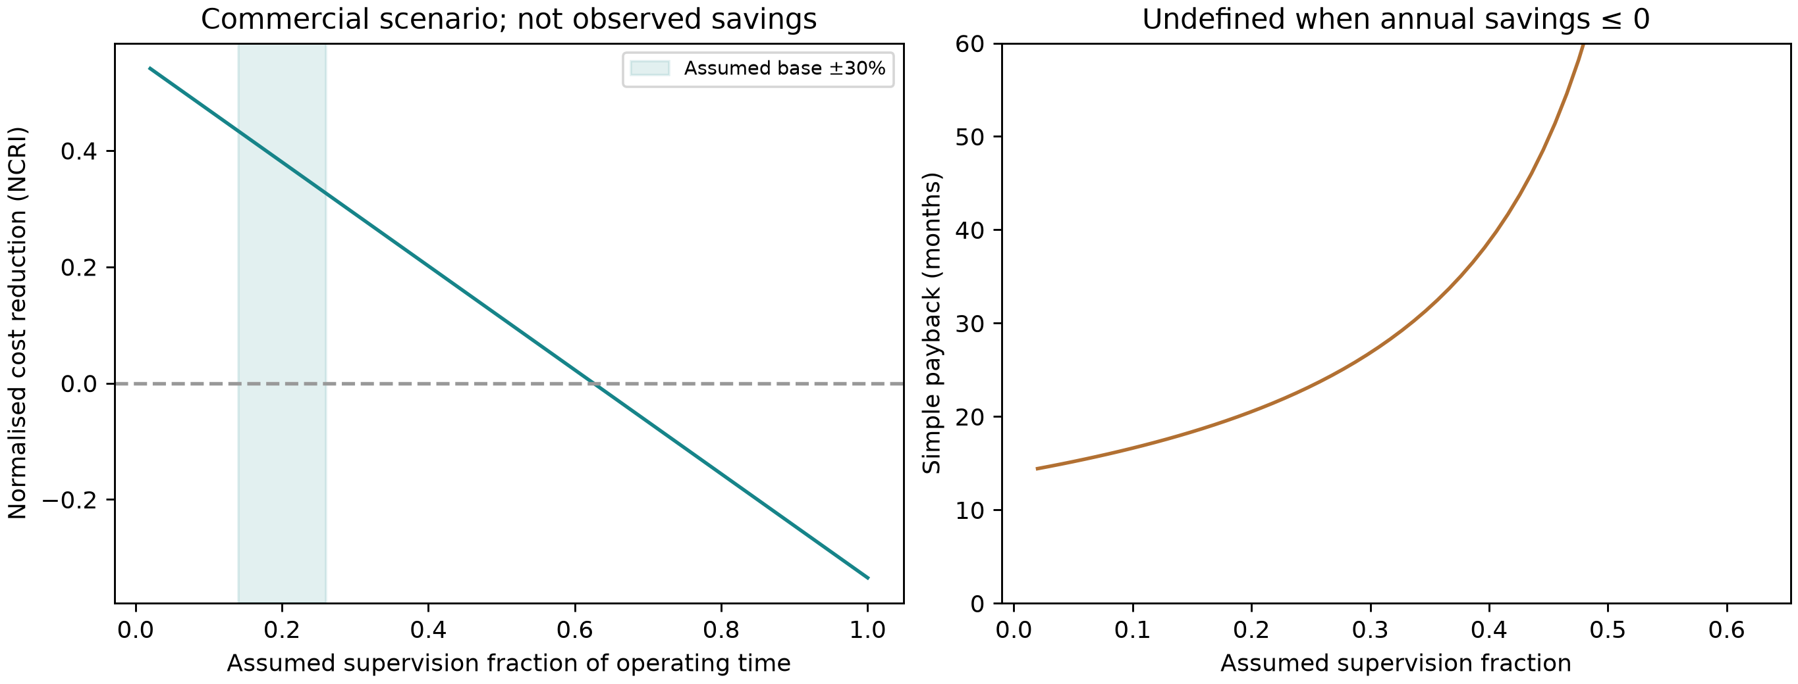
Existing final-analysis figure: supervision versus normalised operating-cost reduction and simple payback. Commercial assumptions are varied; savings are not field observations.
Base break-even supervision fraction: 0.625358 (62.54%). Above this, annual operating savings become non-positive with other assumptions fixed. Maximum capital ratio for recovery within five assumed years: 1.900371.
Recovery-time sensitivity is flat at p = 1 because no recovery is invoked in the base scenario. It matters when p < 1. Sensitivity holds other declared normalised inputs fixed; it is not a set of verified supplier-price forecasts.

8 · Reliability uncertainty and interpretation
Thirty observed successes do not establish true success probability 1. The stored lower-confidence scenario substitutes the nominal proposed controller’s 95% Wilson lower bound for p, while retaining the same measured mean attempt/work inputs. This is a stress scenario, not a prediction of field failure rates.
Output | Observed-sample base | Wilson-lower-bound scenario
Success probability used | 1.000000 | 0.886487
Service capacity (sections/h) | 4.5414 | 4.0259
Monthly human effort (person-h) | 62.9450 | 69.7245
Monthly effort reclaimed (person-h) | 57.0550 | 50.2755
κ / NCRI | 0.61993 / 38.01% | 0.67773 / 32.23%
Simple payback (months) | 20.5223 | 24.2032
Queue wait (min) | 18.0974 | 27.9272
Estimated system kWh/year | 51.2815 | 55.6353

Evidence boundary
The frozen simulation varies initial pose, dust layout and incline under its declared protocol. This does not calibrate wet-glass friction, varying dirt colours, shadows, coating wear or hardware vacuum performance. Navigation uses simulator pose; rendered RGB drives contamination detection. Fine-dirt capture is a contact-gated reduced-order mass model, while the larger solid uses rigid-body pushing in a prescribed corridor.
Physical containment guards are part of the demonstrated mechanism; their success does not prove unguarded real-world traction. The dock’s charging and emptying counters are modelled service, not tested connectors, airflow or battery recovery.

Commercial evidence still needed
Measure operator supervision/transfer time, site workload, actual electrical energy, component life, downtime and maintenance. Obtain compatible-module guidance, supplier quotations and pilot customer feedback. Keep these commercial uncertainties separate from controller Monte Carlo statistics.

9 · Risk register and FMEA
RPN = severity × occurrence × detection, each scored on an ordinal 1–10 scale. These engineering judgements are not estimated probabilities or insurance loss rates. Scores below match the current technical dossier.
Failure mode | S/O/D pre | RPN pre | RPN post | Mitigation and evidence boundary
Crawler slides down-slope on dusty glass (loss of traction) | 9/4/8 | 288 | 108 | Physical containment guard, bounded return drive, attitude/height stop and logged guard load; guards remain part of the safety model. Post D=3 credits simulation fault detection only.
Brush scratches anti-reflective coating | 8/4/9 | 288 | 288 | Rounded soft-contact brush and load logs support development. Coating wear, grit hardness and allowable local pressure are unvalidated. No reduction credited: post S/O/D unchanged.
RGB misses dirt or falsely declares clean | 6/5/8 | 240 | 90 | Persistent two-frame image trigger; actual camera feeds; independent final residual check rejects false-clean development cases. Post D=3 is offline evaluation detectability, not field camera reliability.
Large solid escapes or jams the guide | 7/4/7 | 196 | 84 | Permanent tray, fixed guide and actual solid/contact logs; success requires final retention. Applies only to the tested lower-strip corridor. Post D=3 credits final logged check.
Dock transfer/accounting fault | 5/4/7 | 140 | 60 | Settled docking, 8 s modelled service, explicit mass balance and charge-energy counters. Post D=3 credits software checks; no airflow, connector or battery hardware reliability claim.

Commercial consequence
Traction loss, jams and service failures can increase supervision, recovery, downtime and replacement costs. Those effects motivate the explicit labour terms and sensitivity cases. The current model does not assign a currency value or a probability to catastrophic panel damage.
No RPN improvement is claimed for coating scratches: hardware compatibility is untested. Other post-RPN reductions credit only the described software/simulation detection or final logged verification; they do not establish field certification.

10 · Decision, deployment plan and viva notes

Decision supported by this model
Under the base assumptions, recurring operating cost is 61.99% of the manual baseline, with simple capital recovery in about 20.5 months. The lower-confidence success scenario still produces positive operating savings, but real commercial feasibility depends on the declared labour/cost inputs and hardware performance.
Next gate | Evidence to collect before a deployment claim
Bench prototype | Measured current/power, motor and brush loads, debris collection, structural attachment and module/coating compatibility.
Controlled inclined-panel trial | Slip/stop behaviour, guarded containment, illumination challenges, edge cases and retained solid collection.
Operator pilot | Measured supervision, transfers, failures, maintenance, workload and actual downtime; replace assumptions in inputs.json.
Commercial pilot | Supplier quotes, customer acceptance, support effort and unit-economics evidence; compare against a documented manual baseline.

Short answers for the business viva
Question | Answer
Why not quote a price? | The course requires dimensionless comparisons; verified manufacturing costs and customer pricing are not available.
Where do the headline numbers come from? | calculate(inputs, measured) uses retained full-mission timing/work plus labelled assumptions. Results are not typed in as target outputs.
Does this remove human work? | No. The model charges monitoring, all inter-bay transfer/recovery and maintenance. Reclaimed hours represent reallocation potential.
Why not claim energy-yield restoration? | Dust/contact clearance is not electrical PV output. No PV electrical model or field-yield study is part of this result.
Why does queueing matter? | It tests whether scheduled workload is compatible with one system’s service capacity and exposes delay growth near saturation.

11 · Files, reproduction and submission
File / folder | Purpose
analytics/final_business_model.py | Actual executable business model, sensitivity and plots
analytics/final_business_inputs.json | Declared commercial/energy assumptions
analytics/final_validation_v1/{summary.csv, protocol.json, statistics.json} | Full 180-attempt summary, selection rules and confidence bound
analytics/final_business_v1/{inputs.json, simulation_inputs.json, results.json} | Retained input snapshot, measured calibration and final outputs
analytics/final_business_v1/sensitivity.csv | All 24 one-at-a-time cases (eight inputs × three factors)
business_sensitivity.png / queue_and_labour.png | Final-analysis figures embedded in this report
analytics/final_validation_v1/tilt_*/... | Bulk raw CSV/XZ telemetry in the full project repository, not duplicated in the business-only package

Run the business model without rerunning MuJoCo
From the group folder, use Python 3.12 with numpy, pandas and matplotlib (the existing simulation environment already includes them). The package includes requirements-business.txt for an independent business-only environment.
python analytics/final_business_model.py --validation-dir analytics/final_validation_v1 --output-dir analytics/business_recalculated
Use a new output directory: the script refuses to overwrite an existing analysis. It loads the saved final evaluation; no new robot simulation is required. Output files are results.json, inputs.json, simulation_inputs.json, sensitivity.csv and the two graphs.

What the rubric asks you to submit
MS Teams: every member individually attaches the group’s final signed dossier PDF and clicks Turn in. GitHub faculty group folder: filled dossier Word/PDF in docs/, model XML, controller code, business script, genuine trial data and reproducible outputs. LinkedIn: final team-video URL in dossier Section 5. This business report is supporting documentation; it does not replace the Python business script.
Source: GRADING_RUBRIC_AND_EVALUATION_POLICY.md in sunny-nanade/NMIMS-MPSTME-MDRIIA-2026, checked at commit d5b7da279a034fcd08b090766ef96ed31b196684. The current 20-mark rubric supersedes the older milestone/optional IEEE-paper track; no PPT is required. See ASSIGNMENT_CHECKLIST.md in the package.
Commercial-input evidence is the declared assumption file, not an external quotation. Calculation evidence is the retained simulation summary and final business outputs. The report introduces no sourced Mumbai-yield percentage, measured commercial saving or fabricated market survey.

