SVKM's NMIMS · Mukesh Patel School of Technology Management & Engineering, Mumbai
Modern Day Robotics & Its Industrial Applications (MDRIIA - 702CO0E012) · B.Tech Computer Science & Business Systems (CSBS), in partnership with TCS · AY 2026–27 Odd Semester
GROUP 06 TECHNICAL DOSSIER
Capstone ICA (20 marks): CDIO Robotics Engineering & MuJoCo Physics 10 · CSBS Techno-Economic Business Systems Analysis 5 · Studio Showcase & Viva Voce 5
Group 06 · E048 / E052 / E058
Group · project | Group 06 · Autonomous Crawler Cleaning Robot for Inclined Rooftop Solar Panels
Monorepo folder | https://github.com/sunny-nanade/NMIMS-MPSTME-MDRIIA-2026/tree/main/Group_06_Arush_Ronit_Harshvardhan
Submit (3 places) | (1) PDF on MS Teams, turned in by EVERY member · (2) this filled Word file AND its PDF committed to Group_06_Arush_Ronit_Harshvardhan/docs/MDRIIA_Group_06_Technical_Dossier.docx / .pdf · (3) LinkedIn video URL in Section 5. Due Monday, 26-Oct-2026, 23:59 IST. Studio Showcase, Expo & Viva Voce: Saturday, 31-Oct-2026.
No slides | There is no PPT for MDRIIA. At the Expo and in your video you present the live MuJoCo simulation, your business sensitivity graphs, and a webcam picture-in-picture of every member.
How to fill this file | Use Microsoft Word (desktop). Choose answers from the 'Select ▾' drop-downs and type into the 'type here' fields. Do not delete or retype them and do not edit this file in Google Docs: the fields are how your answers are read.

Student name | Roll No. | SAP ID | Capstone role(s) | Specialisation (finalised titles sheet / monorepo)
Arush Ashish Patil | E048 | 70362400013 | Lead Robotics Systems Architect | Lead Tracked Crawler Chassis & MuJoCo Adhesion Modeler
Ronit Rajput | E052 | 70362400001 | Telemetry QA Lead | Waterless Rotary Brush Actuation & Cleaning Efficiency Engineer
Harshvardhan Sahi | E058 | 70362400031 | CSBS Business & Techno-economic Systems Analyst | CSBS Photovoltaic Degradation & CapEx/OpEx Payback Analyst
Roll numbers and SAP IDs are from the official student list. Tell Dr. Nanade by Tuesday, 20-Oct-2026 if any name, ID or role is wrong. Groups with fewer than four members combine roles as shown.
SECTION 1 · Problem Bottleneck, Industry Standards & Aalborg Research Title Component 1 · CDIO Robotics (10)
Authorised Aalborg title | How can an autonomous crawler cleaning robot simulated in MuJoCo recover soiling-induced energy losses (15-18% monthly) on inclined commercial rooftop solar arrays while reducing cleaning cycle operational expenditure compared to manual labor?
Original draft topic | Solar Panel Cleaning
Why the title changed | The student submission demonstrated strong local domain awareness (commercial rooftop solar installations in Mumbai). However, it lacked specific empirical parameters for monthly dust soiling attenuation and did not identify the robotic locomotion mechanism (tracked crawler, suction/vacuum adhesion, rotating microfiber brush) or the specific physics simulator.

1.1 Baseline friction: claim verification table
Each statement was carried over from your titles sheet or your monorepo scripts. Before you use it anywhere (dossier, video, paper), find the primary source yourself and record it, or correct or delete the claim. Statistics: cite the original study, not a blog or an AI answer.
Claim (as carried over) | Faculty pre-audit note | Primary source you verified (author, year, venue, DOI/URL) | Source type | Keep / Correct / Delete
A 100 kWp commercial rooftop PV array in Mumbai generates about 140,000 kWh annually. | ≈1,400 kWh/kWp/year is plausible. Confirm with a solar-resource tool or national data for Mumbai and cite it. | No verified site-specific yield source obtained; delete numerical Mumbai claim. No electrical PV model is implemented. | No source found | Delete
A 16% monthly soiling loss forfeits 22,400 kWh/year. | Inconsistent: 22,400 kWh is 16% of the annual yield, i.e. an annual-average loss, not a monthly one. Soiling loss depends on the cleaning interval; find a primary Indian soiling study. | No verified primary monthly-loss source obtained. Monthly loss cannot be multiplied by annual generation as an annual-average loss; delete. | No source found | Delete
Daily waterless cleaning increases net energy yield by 15.2% with CapEx payback within 8.6 months. | Must come from your own script output with sourced inputs, or be deleted. | No measured PV electrical recovery or sourced commercial payback supports these numbers. Delete; replace with explicitly assumed dimensionless scenario in Section 3. | No source found | Delete

1.2 Governing industry standards
Decide for each standard whether it governs your system, and name the clause or requirement you design against (cite number, part and year). 'No' is a correct answer when you can say why. The hint is the faculty view; you may disagree with a reason.
Standard | Scope | Faculty hint for your project | Applies? | Clause / requirement you use, or why not
ISO 10218-1/-2 | Safety requirements for industrial robots (robot, and robot integration) | No | No | Scope: industrial robot/manipulator and integration. This fixed-panel cleaning mobile device is not an industrial manipulator; no conformity claim.
ISO 3691-4 | Driverless industrial trucks / AMRs and their systems: safety requirements | No | No | Scope: driverless industrial trucks. The selected fixed PV-bay cleaner is not an industrial truck; no conformity claim.
ANSI/RIA R15.06 | US national adoption of ISO 10218 (industrial robot safety) | No | No | Industrial robot-system standard associated with ISO 10218; selected system is not an industrial manipulator. No compliance claim.
IEC 60601-1 | Medical electrical equipment: basic safety and essential performance | No | No | Medical electrical equipment; the PV cleaner has no medical use. No applicable medical requirement.
Domain-specific | IEC 61215 / IEC 61730 (PV module qualification and safety) for allowable loads on the glass | Recommended: check it | Partly | IEC 61215 (PV module qualification) and IEC 61730 (module safety) are relevant to future module/cleaner compatibility. Licensed clauses and allowable local brush/wheel loads were not verified; no clause number, certified glass load or compliance is asserted.

1.3 Documented baseline friction (who struggles, with what, how it is measured today)
Baseline metric and its value today (with unit) | Measured simulation baseline: waypoint + proportional wheel control; compare at equal 0–30 s exposure. Commercial reference: 120 person-hours/month is an assumption, not a site measurement.
Source of the baseline value (author, year, DOI/URL) | Actual controller logs and frozen protocol; commercial assumptions in analytics/final_business_inputs.json. No Mumbai field survey or verified annual-yield figure.
Who carries the cost today (role / stakeholder) | Rooftop PV owner/operator and cleaning contractor; access, inspection, transfer and maintenance remain human responsibilities in the business scenario.

SECTION 2 · MuJoCo Rigid-Body Physics Modelling & Python Closed-Loop Control Component 1 · CDIO Robotics (10)
MuJoCo mechanism (titles sheet) | MuJoCo MJCF Rigid-Body Model with Autonomous Crawler Cleaning Robot for Inclined Rooftop Solar Panels Physics & Closed-Loop Control
MJCF model | Group_06_Arush_Ronit_Harshvardhan/models/collection_cleaning_crawler.xml
Controller | Group_06_Arush_Ronit_Harshvardhan/src/crawler_cleaning_controller.py
Contact & solver settings in the model today | Final model: 0.002 s, five actuators (four driven rollers approximating tracks + one rotary brush). Brush capsule contact priority 2; separate stiff solid contact; zero-friction physical containment guards. See final parameter controls below.
Core state machine (FSM) | Monitor actual RGB → persistent dirt trigger → sweep + requested bottom-edge task → image verification/revisit → return → settle → dock service. No endless loop on a clean scene.
Equations of motion & control | Rigid-body dynamics: M(q)q̈ + C(q,q̇)q̇ + g(q) = τ + Jᵀf. Ideal uphill no-slip bound: μmg cosθ ≥ mg sinθ, with Fadh=0. Wheel PI drives four roller motors; heading error creates differential wheel-speed references. Coverage is qualifying brush footprint / 24 m². Dust disappearance uses a contact-gated reduced-order removal model, not granular dust/airflow dynamics.

Audit correction: inherited 16–16.8% soiling and 15.2–16.2% restoration constants are excluded from the final analysis; there is no PV electrical model.
2.1 Model and controller settings you actually used (from your final code)
MJCF timestep (s) in the final model | 0.002 s; 500 Hz integration and logging
Main contact friction (sliding / torsional / rolling) | Rollers 1.2 / 0.005 / 0.0001; glass and brush 0.4 / 0.005 / 0.0001; brush contact priority 2. Guard friction is zero. These are model assumptions, not measured tyre/glass properties.
solref (timeconst dampratio) and why you chose it | Brush/glass 0.02 s, 1 (soft bristle approximation); guide 0.01 s, 1; model default 0.005 s, 1. Rounded capsule contact was retained after replay rejected rigid-cylinder kicks. No coating-safety inference.
Controller law used | PI / PD
Final gains (e.g. Kp, Ki, Kd or λ) with units | Wheel PI: Kp=0.8 N·m/(rad/s), Ki=0.5 N·m/rad, integral clamp ±3 rad, motor ±3 N·m. Heading 3 s⁻¹, yaw command ±1.2 rad/s. Shared incline/return regulator Kp=0.6, Ki=0.2; torque ±1 N·m, slew 4 N·m/s. Brush velocity target 15 rad/s, kv=0.1, torque ±1 N·m.
FSM states implemented in code (list) | HOME_MONITOR → SETTLE/ALIGN → SWEEP; image-requested EDGE_CLEAN_BOTTOM; verification/revisit; RETURN_HOME → DOCKING → DOCK_SERVICE → DOCKED. Safety abort/timeout remain failed outcomes.
Model loads and runs: python -c "import mujoco; mujoco.MjModel.from_xml_path(...)" | Yes

2.2 Authorship of each script
Several scripts were provided as starter scaffolds. Mark honestly what you wrote, changed, or used as given. Viva questions target the code you claim.
File | Written / Modified / Used as given | Main author (Roll) | What you changed or added (1 line)
models/collection_cleaning_crawler.xml | Modified by us | Shared (E048 / E052) | Robot model with dock, fixed brush, guide and tray. Arush led physics and logic; Ronit contributed robot/XML file work. Development was AI-assisted.
src/crawler_cleaning_controller.py | Modified by us | E048 | Camera-triggered departure, PI tracking, bounded turns/return and 500 Hz logging. Arush led AI-assisted code implementation; team members supported development.
analytics/final_business_model.py | Modified by us | E058 | Harshvardhan led final_business_model.py and the business/economic analysis, including operating costs, transfer labour, payback and sensitivity. Ronit supported business modelling. AI-assisted development.
src/vision_mission.py + panel_vision.py | Modified by us | E048 | Rendered RGB observations, persistence, targeted revisits and independent residual scoring. Arush led AI-assisted implementation; navigation uses simulator pose.
src/run_final_validation.py | Modified by us | E048 | Frozen 180 attempts over three inclinations with independent seeds, raw torque logs and source snapshots. Arush led AI-assisted implementation; team members supported the project.

2.3 Key code snippet (≤ 25 lines) implementing your FSM or control law:
src/crawler_cleaning_controller.py, lines 180–185
for i,j in enumerate(joints):
e=speeds[i]-d.qvel[j]
integral[i]=np.clip(integral[i]+e*dt,-3,3)
d.ctrl[i]=np.clip(.8*e+(.5*integral[i] if variant=="proposed" else 0),-3,3)
d.ctrl[4]=15 if state in ('SWEEP','EDGE_CLEAN_BOTTOM') else 0
mujoco.mj_forward(m,d)

2.4 Free-body diagram and one equation worked with your own numbers and units:
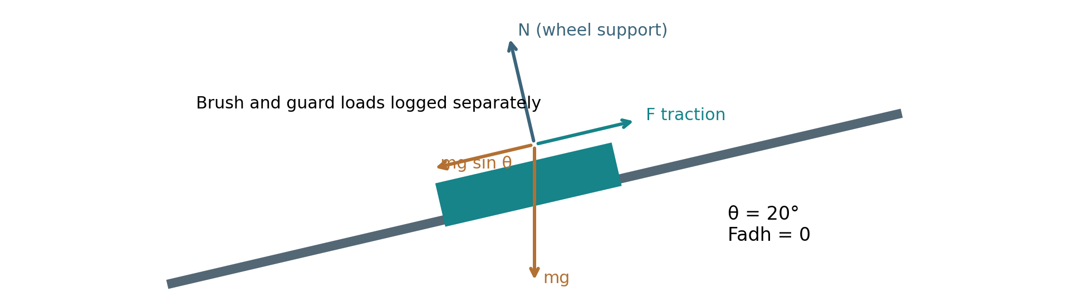
Panel-tangent free-body idealisation; guard and brush contact are distinct from wheel normal load.
m=8.5 kg, g=9.81 m/s², θ=20°: mg=83.385 N; mg sinθ=28.519 N; mg cosθ=78.355 N; ideal μmin=tan20°=0.364. No suction adhesion is simulated. These equilibrium values do not prove traction or glass safety. Actual brush normal load is brush_normal_N, guard load is guard_normal_N and panel velocities are vx/vy_panel_mps in raw CSV. Torque effort is Στ²Δt; positive mechanical work is ∫max(τq̇,0)dt. Electrical energy additionally requires declared efficiency and auxiliary-power assumptions.

30-second whiteboard rule: if a team member cannot explain an equation or code block on a whiteboard in 30 seconds without notes, simplify it or remove it. It will be asked in the viva.
SECTION 3 · CSBS Techno-Economic Business Systems Modelling Component 2 · CSBS Techno-Economic (5)
Business script | Group_06_Arush_Ronit_Harshvardhan/analytics/final_business_model.py
CSBS business case (titles sheet) | Final operational scenario: one 24 m² tilted bay is cleaned after controlled RGB detection; manual transfer between bays is explicitly charged as human labour. No site-specific PV generation, water saving, electrical-yield recovery or commercial payback is established. The three inherited numerical claims in Section 1 are deleted.
Constants hard-coded in the script today | Commercial inputs are explicitly labelled assumptions in final_business_inputs.json and varied in sensitivity.csv. Throughput/mechanical-work inputs come from the named actual simulation dataset. Modelled blower/auxiliary wattages and efficiency are assumptions; they are not electrical measurements.
Owner | CSBS Business & Techno-economic Systems Analyst: E058. Tags in this section carry that roll number.

Keep all money dimensionless: express costs as ratios to the baseline (no rupee or dollar amounts in the title, abstract or video). Every input needs a source or must be a clearly labelled assumption that you vary in the sensitivity graph.
3.1 Business model: formulas, your inputs and your results
Quantity | Formula (define every symbol in your script) | Inputs used, with source or 'assumption' | Result (with unit)
Labour reallocation H_reclaimed | Hreclaimed = H0 − [f·n·Ta/(3600p) + n·(ttransfer + (1−p)·trecovery/p)/3600 + Hmaintenance]. n=sections/month; Ta=mean attempt seconds; p=success fraction; f=supervision fraction; all transfer/recovery is human labour in the base scenario. | All 30 proposed attempts at 20°, failures retained. H0=120 h/month; 21 sections/day × 30 days; f=0.2; attempt mean 612.713 s; p=1; transfer=180 s/section fully human; recovery=180 s/failure fully human; maintenance=10 h/month. All commercial values are assumptions. | 57.055 person-h/month; robot-related human effort 62.945 h/month (monitoring + transfer/recovery + maintenance).
Payback horizon P_payback (dimensionless) | P_payback = CapEx / (T_life · ΔOpEx_annual); P < 1 ⇒ pays back within life T_life. Also report T_payback = CapEx / ΔOpEx in months. | Normalise one year of baseline labour cost to 1. CapEx ratio k=0.65; life L=5 years; annual saving ratio s=NCRI. All commercial inputs assumed. T=12k/s months; P=k/(L·s); undefined for s≤0. | T=20.522 months; P=0.34204 (dimensionless). Scenario output, not observed payback.
Normalised Cost Reduction Index NCRI | NCRI = 1 − κ; κ = annual robot-system cost / annual manual baseline cost. Costs are normalised to one baseline year. NCRI can be negative; payback is undefined when annual savings ≤ 0. | κ=human-hours/H0 + annual energy cost ratio + 0.05 spares/battery + 0.03 consumables. Electrical estimate: positive simulated work/assumed 0.60 efficiency + 20 W modelled blower + 5 W electronics; two assumed 3 W cameras. Tariff ratio=0.0003 per kWh of one-year baseline cost. | κ=0.61993; NCRI=1−κ=0.38007. Estimated system energy 51.281 kWh/year under scenario assumptions; not measured electrical energy.
Queuing delay | M/M/1: panel rows awaiting cleaning (λ per hour) served by one crawler (μ rows per hour). ρ = λ / (c·μ) < 1; M/M/1: W_q = ρ / (μ − λ); M/M/c: W_q = C(c, λ/μ) / (c·μ − λ) (Erlang C) | A section is one 24 m² bay, not a raster lane. λ=2.625 sections/h; μ=3600/[E(Tattempt)/p + (1−p)·180/p + 180]=4.54137 sections/h; c=1. Poisson arrivals/exponential service assumed. | ρ=0.57802; Wq=18.097 min if stable. Mean service 792.713 s. M/M/1 distribution assumptions are not validated by the simulator.
Sensitivity analysis | Vary the most uncertain input ±30 % (or across your scenario range) and plot P_payback and NCRI; report the break-even value. | Eight inputs swept ±30%: supervision, baseline hours, CapEx, manual transfer, failure recovery, energy price ratio, maintenance and drive efficiency. Repeated independent retries are an assumption. See sensitivity.csv; no PV yield uplift is monetised. | Break-even supervision fraction f=0.62536; maximum k for payback within assumed life=1.9004. Negative NCRI and unstable queues are retained, not converted to finite payback.

Queuing model used | M/M/1
λ, μ, c values used (with units) | λ=2.625 sections/h; μ=4.54137 sections/h; c=1; ρ=0.57802
Payback in months (T_payback) | 20.5223 months; assumed scenario
Script output reproduces every number above when re-run | Yes

3.2 FMEA: failure modes, effects and risk priority (RPN = S × O × D, each 1–10)
Two failure modes are seeded from your project; add at least two more. Score before and after your mitigation (design change, control limit, sensor, procedure). The post-mitigation RPN must be justified by something you can show in the simulation or the code.
Failure mode | Effect on mission / business | S | O | D | RPN pre | Mitigation (what you changed) | RPN post | Shown in
Crawler slides down-slope on dusty glass (loss of traction) | Fall/damage, interrupted work and human recovery. | 9 | 4 | 8 | 288 | Physical containment guard, bounded return drive, attitude/height stop and logged guard load; guards remain part of the safety model. Post D=3 credits simulation fault detection only. | 108 | Both
Brush scratches anti-reflective coating | Permanent PV damage and repair cost. | 8 | 4 | 9 | 288 | Rounded soft-contact brush and load logs support development. Coating wear, grit hardness and allowable local pressure are unvalidated. No reduction credited: post S/O/D unchanged. | 288 | Not yet
RGB misses dirt or falsely declares clean | Residual dirt or wasted cleaning cycle. | 6 | 5 | 8 | 240 | Persistent two-frame image trigger; actual camera feeds; independent final residual check rejects false-clean development cases. Post D=3 is offline evaluation detectability, not field camera reliability. | 90 | Both
Large solid escapes or jams the guide | Unsafe ejection, jam or incomplete mission. | 7 | 4 | 7 | 196 | Permanent tray, fixed guide and actual solid/contact logs; success requires final retention. Applies only to the tested lower-strip corridor. Post D=3 credits final logged check. | 84 | Both
Dock transfer/accounting fault | Dirt inventory error or missed service. | 5 | 4 | 7 | 140 | Settled docking, 8 s modelled service, explicit mass balance and charge-energy counters. Post D=3 credits software checks; no airflow, connector or battery hardware reliability claim. | 60 | Both

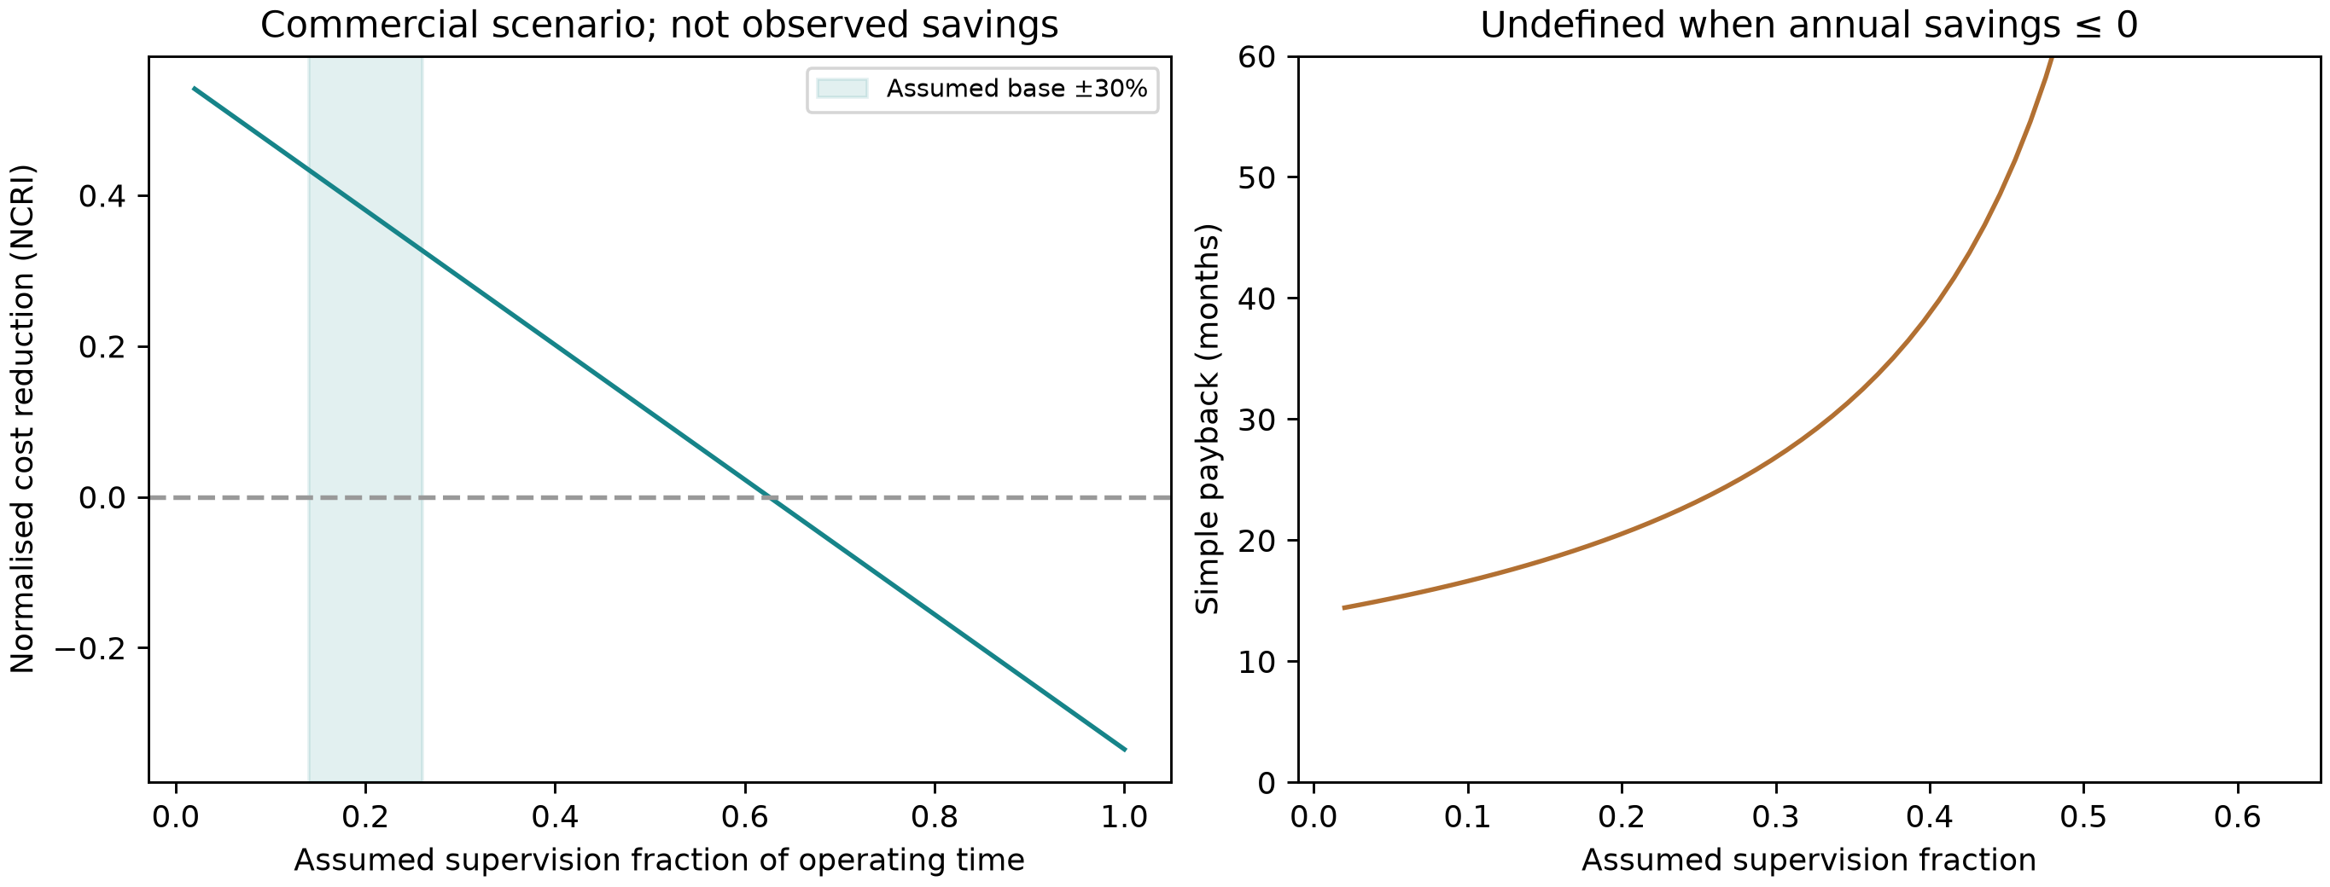  Dimensionless commercial assumptions; no observed cost-saving claim. | 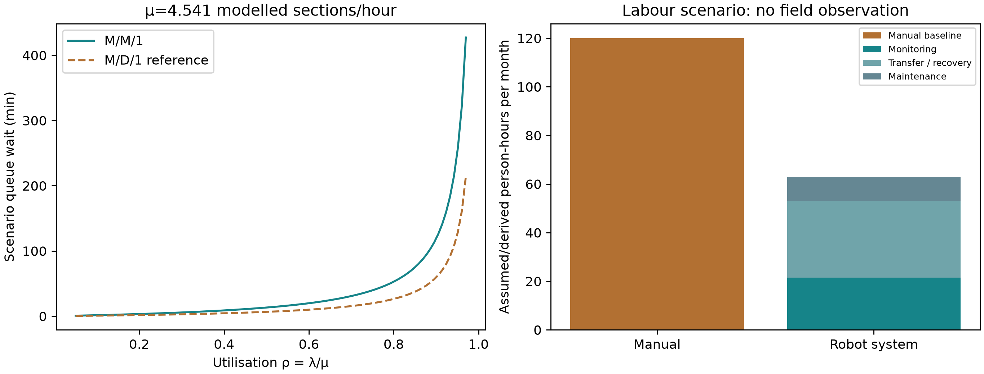  Queue distribution assumed; transfer and maintenance count as human labour.

SECTION 4 · Simulation Telemetry, Monte Carlo Testing & Empirical Validation Component 1 · CDIO Robotics (10)
Evaluation protocol (titles sheet) | Revised evaluation: N=30/controller/tilt at 10°,20°,30° (180 full attempts), initial pose/soil-layout variation, complete-cycle success, footprint, motion/load, simulated mechanical work. Primary controller comparison: common first-30-second tracking RMSE. PV electrical restoration and measured electrical Wh/m² are not available.
Telemetry standard | Log at 500 Hz (MJCF timestep 0.002 s, or every 2nd step at 0.001 s): time, state (q, q̇ or pose, velocity), reference, tracking error, actuator torques/forces, FSM state, events. One CSV per run or one CSV with a run_id column.
Monte Carlo | N ≥ 30 runs per condition (more if your protocol says so). Randomise disturbances and initial conditions from stated distributions; record every random seed.
Required measures | Tracking RMSE = √(Σ‖p − p_ref‖² / n) on the planned boustrophedon (zig-zag) sweep path vs MuJoCo crawler position; control effort E = ∫τ² dt (sum of τ²·Δt over all actuators); your primary task metric from the protocol.
Statistics | Compare the proposed controller with a baseline condition: Student's / Welch's t-test (two-sided, α = 0.05), Cohen's d = (x̄₁ − x̄₂) / s_pooled, and a 95 % confidence interval.
Where real trial data goes | Group_06_Arush_Ronit_Harshvardhan/analytics/*_real_trials.csv, produced by your controller. Files named SIMULATED_* are starter targets, never results.
Owner | Telemetry QA Lead: E052.

Baseline condition you compare against | Final collection model: waypoint reference + P wheel control versus segment lookahead + PI. Same camera pipeline, fixed brush/guide, mission route, guard, safety and shared incline/return regulator. Primary endpoint is common 0–30 s RMSE; all attempts continue through full mission/abort/1000 s.
Monte Carlo runs per condition (N) | 30 independent runs/controller/tilt; 10°,20°,30°; 180 full-mission attempts. All failures retained. Table below: prespecified nominal 20°; all conditions in Appendix A.
Randomised parameters and their distributions | Initial x/y independent U(−0.01,+0.01) m; dust shape/offset RNG independent through logged debris_seed; clusters and 120 g lower-strip corridor fixed. Dry friction fixed. Seeds/distributions frozen before execution.
Logging rate actually achieved (Hz) | 500 Hz; each 0.002 s integration sample. XZ compresses CSV; final batch serialises numbers to 9 significant digits.
Random seeds recorded for every run | Yes
Real-trials CSV path(s) in the repo | analytics/final_validation_v1/tilt_{10,20,30}/{baseline,proposed}_{seed}/telemetry.csv.xz; summary.csv, protocol.json, statistics.json and trace_audit.json. A run, not a 500 Hz sample, is the unit of inference.

Measure | N | Baseline mean ± SD | Proposed mean ± SD | Unit | Better? (direction)
Tracking RMSE | Available 30 s windows: 30 baseline / 30 proposed; 30 attempts each | 0.100061 ± 0.0012 | 0.0118225 ± 0.000166 | m; common 0–30 s | Lower is better
Control effort ∫τ² dt | Available 30 s windows: 30 baseline / 30 proposed; 30 attempts each | 30.5728 ± 0.162 | 31.1333 ± 0.201 | N²·m²·s; 0–30 s | Lower is better
Complete safe, camera-clean, solid-retained, serviced home cycle | 30 per controller at 20° | 30/30 (100.00%) | 30/30 (100.00%) | completion fraction | Higher is better

Test used | Welch's t-test
t statistic, degrees of freedom, p-value (primary metric) | 20°: t=-400.1377, df=30.11906, p=1.127902e-57; Holm-adjusted p=1.127902e-57 across 3 tilt comparisons.
Cohen's d (primary metric) | -103.3151; pooled SD; proposed minus baseline
95 % confidence interval of the difference | [-0.08868864868975783, -0.08778807408256452] m for proposed minus baseline. Run-level Welch interval; other conditions in Appendix A.

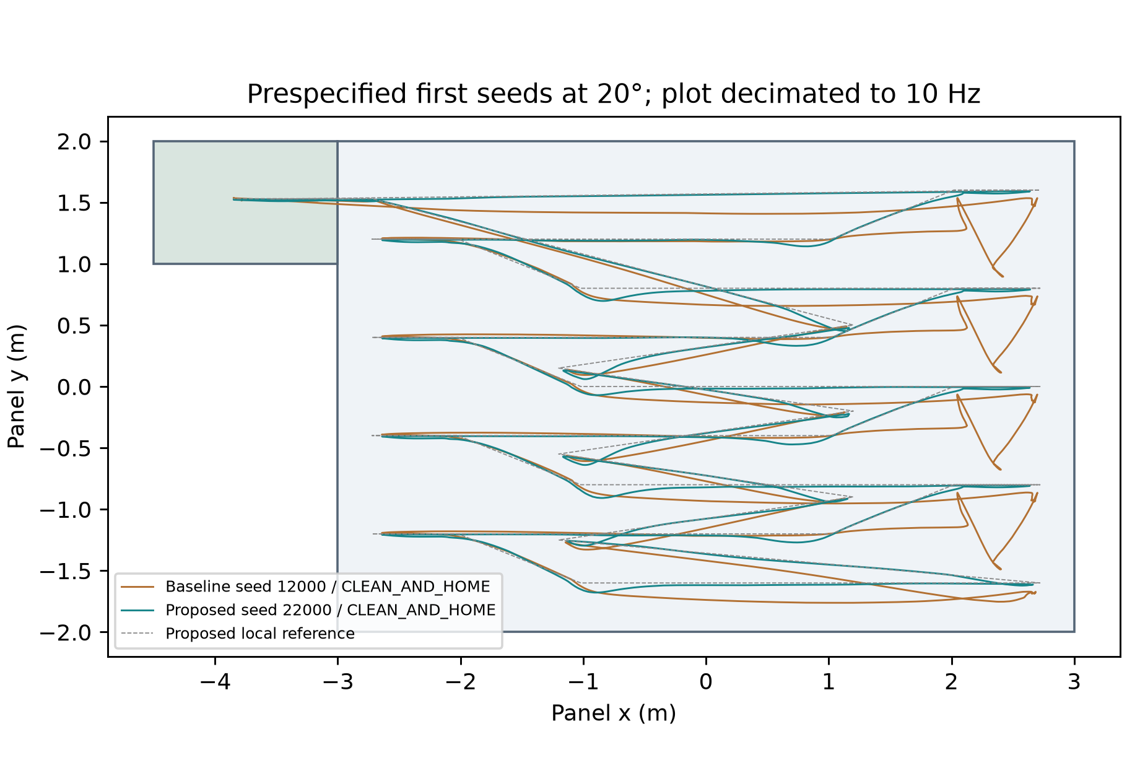  Prespecified first seeds at 20°; raw logs retained at 500 Hz. | 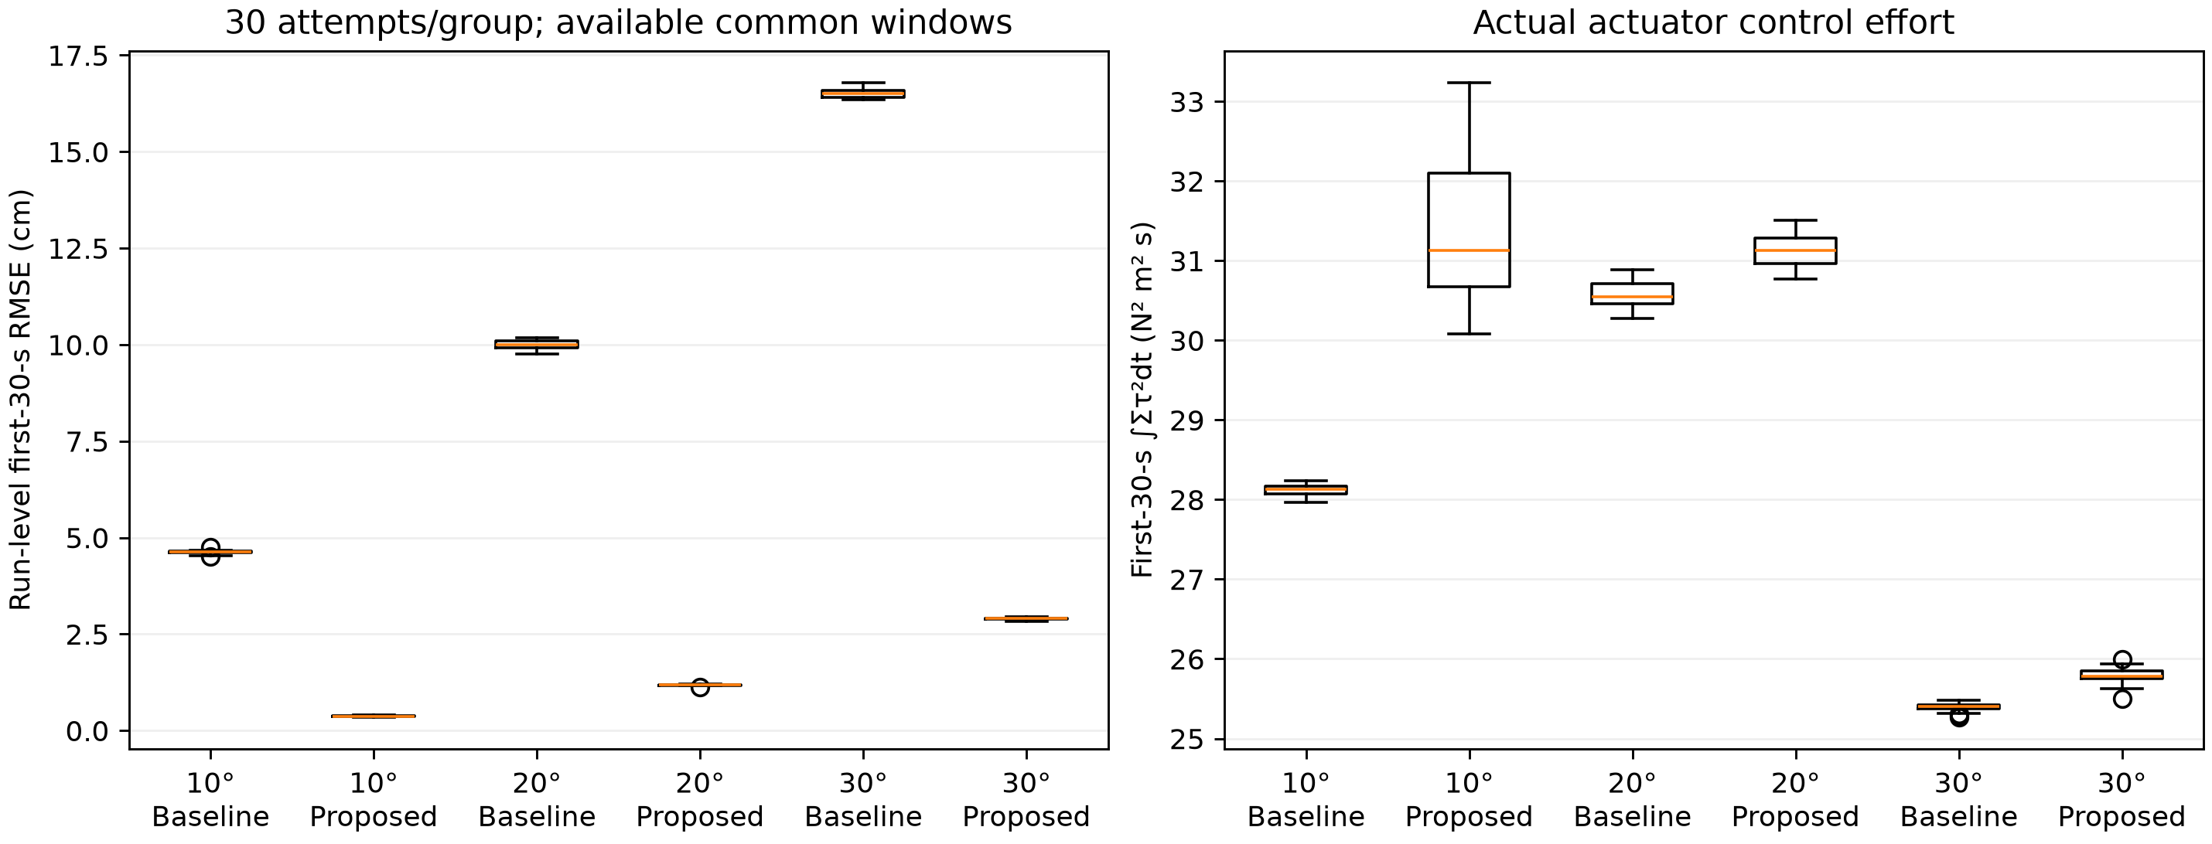  All final conditions; 30 independent attempts per controller/tilt.

DATA PROVENANCE DECLARATION (mandatory). Reporting generated target numbers as experimental results is research misconduct and scores zero for this component.
Every number in Section 4 comes from MuJoCo runs of OUR controller, logged by our code | Yes
No value comes from SIMULATED_* files, generate_paper_figures.py or any np.random 'target' data | Yes
Our plots re-generate from the *_real_trials.csv files in the repo | Yes
Every input in Section 3 has a source or is labelled as an assumption | Yes

SECTION 5 · LinkedIn Video Showcase, AI Verification Audit & Peer Review Component 3 · Showcase & Viva (5)
LinkedIn post URL | Not supplied
Video length (mm:ss) | Simulation segment: 03:21.52, including visible cameras and the business graph. Face introduction, conclusion and final edited presentation have not been supplied.
Video shows the live MuJoCo simulation (not slides) | Yes
Video shows our business sensitivity graph | Yes
Webcam picture-in-picture: every member appears and speaks | Not verified

5.1 AI Interaction Audit Log: three cases where AI gave wrong robotics or economic data
Examples: a wrong MuJoCo attribute or API call, an invented statistic, a correct paper given the wrong journal, an economic formula with the wrong units. Show how you checked each one with a textbook, the official documentation or the original paper.
# | AI tool | What we asked & what AI said | How we caught it | What was actually true (with source) | Error type | Verdict
AI-01 | ChatGPT | Conditional import mujoco.viewer inside mission was expected to work, but shadowed the module name and raised UnboundLocalError before model construction. | Ran / tested the code or simulation | Use from mujoco import viewer as mj_viewer. Actual mission/integration tests execute model construction. See docs/AI_AUDIT.md and controller import. Development audit candidate: members must review before claiming personal verification. | Wrong code / MuJoCo API | Corrected
AI-02 | ChatGPT | RMS distance to the next waypoint was initially labelled path-tracking RMSE. | Ran / tested the code or simulation | Measure distance to the active segment using projection; tests/test_geometry_economics.py checks a 0.2 m perpendicular error. Time-indexed tracking is not claimed. Development audit candidate: members must review before claiming personal verification. | Wrong number or statistic | Corrected
AI-03 | ChatGPT | Computing source hashes at run completion could label an earlier executed model with later edits. | Ran / tested the code or simulation | Capture hashes at launch and preserve immutable source snapshots. Final batch protocol records launch hashes; executed source is frozen. See docs/AI_AUDIT.md. Development audit candidate: members must review before claiming personal verification. | Wrong code / MuJoCo API | Corrected

5.2 Peer review: watch both assigned LinkedIn videos and score them (0–2 per criterion)
Group reviewed | Problem | Physics | Business | Data | Clarity | Best moment (mm:ss) | One question for the viva
Group 07: Autonomous Mobile Manipulator for Hospital Housekeeping & Patient-Room Clutter Clearing | 2 | 2 | 2 | 2 | 2 | Overall demonstration | How does the mobile manipulator detect contact with a patient or unexpected obstacle and stop safely?
Group 12: Autonomous Pipeline Surveillance UAV | 2 | 2 | 2 | 2 | 2 | Overall demonstration | How is an apparent pipeline defect distinguished from a shadow, and how is detection confidence validated?

SECTION 6 · Individual Learning Record & Research Consent unmarked · one row per member · answer honestly
These answers do not change your marks. They help improve the course and are used in anonymised research only if you consent in the sign-off below. Work share is the team’s estimated allocation (60/20/20), separate from Git commit share. Git share is the author-count percentage in the documented 55-commit repository snapshot; it includes AI-assisted commits and does not measure all project work.
Member | Hours I spent (total) | My declared role matched my actual work (1 = not at all, 5 = fully) | I learned a skill outside my role (robotics ↔ business) | Scripts I mainly wrote (file names) | Work estimate (%) /  Git commit share (%) | Share of my writing first drafted with AI | Wrong AI facts / code I personally caught
Arush Ashish Patil (E048) | ≈20 h | 5 | Yes | Physics, control and simulation logic: crawler_cleaning_controller.py, vision_mission.py, panel_vision.py and run_final_validation.py; shared model XML. AI-assisted. | Work: 60%  Git: 94.5% | 26–50 % | 6 or more
Ronit Rajput (E052) | ≈17 h | 3 | Yes | Robot-model and XML file work, including collection_cleaning_crawler.xml; supported business modelling. AI-assisted. | Work: 20%  Git: 5.5% | 26–50 % | 3–5
Harshvardhan Sahi (E058) | ≈17 h | 3 | Yes | Lead: analytics/final_business_model.py; business modelling and economic analysis. AI-assisted. | Work: 20%  Git: 0.0% | 26–50 % | 3–5

Member | Before this course I had used a physics simulator | The most valuable thing I learned (one line) | One thing I would change in this course (one line)
Arush Ashish Patil (E048) | Yes | Learning MuJoCo end-to-end: modelling robots, writing MuJoCo/Python simulation scripts and building a functioning digital prototype for business demonstrations. | No changes suggested; the teaching and guidance were effective.
Ronit Rajput (E052) | Yes | Learning MuJoCo end-to-end: modelling robots, writing MuJoCo/Python simulation scripts and building a functioning digital prototype for business demonstrations. | No changes suggested; the teaching and guidance were effective.
Harshvardhan Sahi (E058) | Yes | Learning MuJoCo end-to-end: modelling robots, writing MuJoCo/Python simulation scripts and building a functioning digital prototype for business demonstrations. | No changes suggested; the teaching and guidance were effective.

Track A: how this dossier becomes your 4-page IEEE paper
I. Introduction | Section 1: title, verified baseline friction, governing standards
II. Related work | Section 1.1: verified sources only (5+ with DOIs)
III. System model | Section 2: MJCF model, FSM, equations, control law
IV. Techno-economics & evaluation | Sections 3–4: CSBS model, FMEA, Monte Carlo results, statistics
V. Discussion & limitations | Sim-to-real gap, assumptions in the business model, AI audit lessons
Target venues (titles sheet) | A: IEEE INDICON · B: IEEE CASE

Individual Academic Sign-off every member answers and signs
Answer each statement for yourself: (1) this work is original and every source and AI use is declared; (2) our model loads and our controller and business scripts run from the repository; (3) I understand our whole project and can explain my own part in the viva voce.
Member (Roll) | (1) Original work | (2) Code runs | (3) Viva-ready | Signature | Optional research consent*
Arush Ashish Patil (E048) | Yes | Yes | Yes | 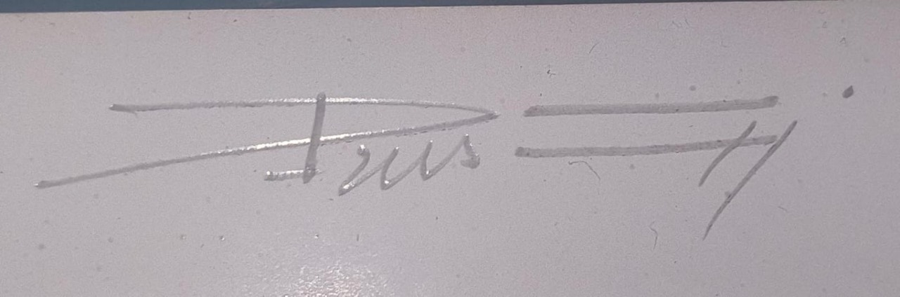
Ronit Rajput (E052) | Yes | Yes | Yes | 
Harshvardhan Sahi (E058) | Yes | Yes | Yes | 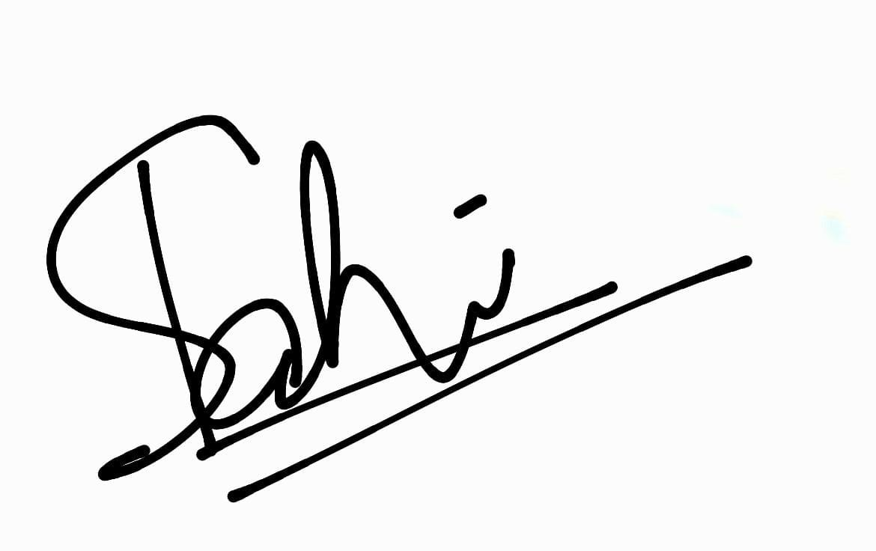
*Optional: may Dr. Nanade use anonymised data from this dossier and repository in education research publications? Your answer has no effect on your marks, and you can withdraw until results are published.

Appendix A · Evidence scope and final evaluation
Technical sections are populated from the completed frozen validation and reproducible business scenario. This copy uses ordinary editable text. Individual responses, academic declarations and peer-review scores reflect the team’s supplied answers.
Validated development movie (not independent statistical replication): CLEAN_AND_HOME at 610.858 simulated seconds; 32/32 selected irregular deposits below the residual threshold; qualifying whole-panel footprint 89.97917% (the exact-90% flag is false). Maximum rise above initial normal height 0.408684 mm; maximum tilt 0.093728°. Physical 120 g block leaves glass and is retained by the permanent tray. Initial dust inventory 4 g; final station 3.985638 g; residual glass 14.3625 mg; mass balance error 8.67e-19 kg. Final recording and headless nominal telemetry match exactly.
Tilt | Controller | Complete cycles | 0–30 s RMSE mean ± SD (m) | Coverage mean (%) | Observed duration mean (s)
10.0° | baseline | 30/30 | 0.0463282 ± 0.000453 | 88.3802 | 620.954
10.0° | proposed | 30/30 | 0.00372785 ± 0.000159 | 89.976 | 610.025
20.0° | baseline | 30/30 | 0.100061 ± 0.0012 | 86.4955 | 747.538
20.0° | proposed | 30/30 | 0.0118225 ± 0.000166 | 89.9885 | 612.713
30.0° | baseline | 30/30 | 0.165154 ± 0.00114 | 86.2146 | 937.735
30.0° | proposed | 30/30 | 0.0290058 ± 0.000328 | 90.0024 | 867.773
10.0°: proposed−baseline Δ=-0.04260033 m; 95% CI [-0.04277804142081319, -0.04242262545673142]; Welch t=-486.1776, df=35.99813, p=2.579979e-70, Holm p=7.739937e-70, Cohen d=-125.5305. Completion Fisher p=1.
20.0°: proposed−baseline Δ=-0.08823836 m; 95% CI [-0.08868864868975783, -0.08778807408256452]; Welch t=-400.1377, df=30.11906, p=1.127902e-57, Holm p=1.127902e-57, Cohen d=-103.3151. Completion Fisher p=1.
30.0°: proposed−baseline Δ=-0.1361482 m; 95% CI [-0.13658916472867358, -0.1357072431479235]; Welch t=-627.6386, df=33.74324, p=3.260053e-70, Holm p=7.739937e-70, Cohen d=-162.0556. Completion Fisher p=1.
Full-run observed RMSE, effort and duration have differing exposure when a run aborts or times out; they are secondary descriptive metrics. All attempts, statuses, independent seeds, raw data and source snapshots are retained. Completion Wilson intervals and raw-trace audits are in statistics.json/trace_audit.json. No controller is declared superior solely because its mean is smaller; use the reported test and scope.
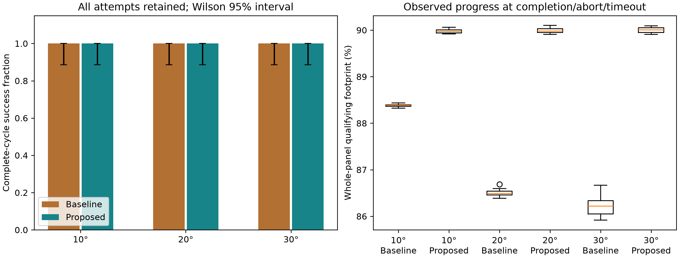

Engineering limitations and interpretation
Real RGB images drive contamination detection, persistence, targeted slowdowns/revisits and the departure decision. Navigation uses simulator ground-truth pose. Controlled colour/lighting segmentation is not a trained general debris detector. Two actual overhead sensor cameras and the onboard camera have visible equipment representations; scenery is isolated from validated sensor RGB. Clean/subthreshold development tests remain at home. General coloured/wet/shadowed dirt and arbitrary solid collection are unvalidated.
Dust removal is a contact-gated exponential layer/mass proxy, transferred to a modelled onboard bin and then station; there is no CFD vacuum or granular dust transport. The larger block has actual gravity/collision pushing, but its release corridor is prescribed. Four driven rollers approximate tracks. Zero-friction physical guards provide containment; they are not proof of real-world grip or safe operation on an unguarded panel. Soft contact permits small penetration. Scratch, wear, motor, battery, structural mounting and electrical charging safety require hardware tests. The modelled 30 W dock service credits energy over eight seconds; it is not a demonstrated full recharge.
FMEA scores are ordinal engineering judgements, not fitted failure rates. Severity and occurrence stay unchanged; any post-RPN reduction credits only the specified code/logged evaluation detection. No reduction is credited to untested coating protection. The business case assumes one cleaner repeatedly services separately transferred 24 m² bays. 504 m²/day is a workload scenario, not an inferred 100 kWp plant. Energy efficiency/auxiliary loads are assumptions; PV electrical yield is neither simulated nor monetised.

Appendix B · References and source verification
The five entries below have bibliographic metadata verified in official or author-maintained software repositories. This does not imply access to all full articles or verification of a numerical PV-loss claim. The original authorised title is preserved as a question; its 15–18% phrase is not established by this work. See submission/source_audit/source_access.json for pinned commits, hashes and access scope.
[1] E. Todorov, T. Erez and Y. Tassa, “MuJoCo: A physics engine for model-based control,” IROS, pp. 5026–5033, 2012. DOI: 10.1109/IROS.2012.6386109. MuJoCo simulator context; developer README citation metadata verified.
[2] W. F. Holmgren, C. W. Hansen and M. A. Mikofski, “pvlib python: a python package for modeling solar energy systems,” JOSS 3(29), 884, 2018. DOI: 10.21105/joss.00884. PV modelling software context; official README metadata, not a PV-yield calculation in this project.
[3] K. S. Anderson et al., “pvlib python: 2023 project update,” JOSS 8(92), 5994, 2023. DOI: 10.21105/joss.05994. PV modelling context; official README metadata verified.
[4] M. G. Deceglie, L. Micheli and M. Muller, “Quantifying Soiling Loss Directly From PV Yield,” IEEE Journal of Photovoltaics 8(2), pp. 547–551, 2018. DOI: 10.1109/JPHOTOV.2017.2784682. Yield-based soiling measurement is separate from a dust-removal proxy; author-maintained rdtools README metadata only, full article not accessed.
[5] D. C. Jordan et al., “Robust PV Degradation Methodology and Application,” IEEE Journal of Photovoltaics 8(2), pp. 525–531, 2018. DOI: 10.1109/JPHOTOV.2017.2779779. Yield/degradation analysis context; author-maintained rdtools README metadata only, full article not accessed.
MuJoCo developer documentation (official source, pinned in source_access.json): contact friction coefficients, geom priority and solref/solimp interpretation. IEC 61215/61730 licensed clauses were not accessed; no invented clause or certified glass-load limit is used. Historical literature scaffolds and SIMULATED_* starter outputs are excluded from final evidence.

Appendix C · Reproduction and remaining team actions
From the group directory, use the pinned Python environment in requirements.txt. Headless execution requires MUJOCO_GL=egl before importing MuJoCo. Commands: submission/REPRODUCE.md. Raw final CSVs use XZ. This copy uses ordinary editable text; the faculty form preserves the original controls and choices. Current revision details are in UPDATE_BASIS.json; commit-share scope and counts are in COMMIT_SHARE_RECEIPT.json.
Before submission, insert the final public team-video URL. The supplied signature images are placed in the academic sign-off table. Optional research consent is left blank at the team’s request. Faculty repository submission and individual Teams turn-in are separate actions.
Team contributions
Arush (E048) led the robot physics, control logic, coding and MuJoCo simulation. Ronit (E052) contributed robot-model/XML file work and supported business modelling. Harshvardhan (E058) led the business-model script, business modelling and economics. The team estimates its work allocation as Arush 60%, Ronit 20% and Harshvardhan 20%. The members worked together on weekends over approximately two months. Software development was AI-assisted.
Current demonstration: submission/complete_camera_video_v1/Group06_Complete_Simulation_With_Cameras.mp4 (3:21.52). The companion three-person narration script is ready, but actual face/voice footage and a published LinkedIn URL have not been supplied.

