Aws recording Session (Edyoda )---🡺

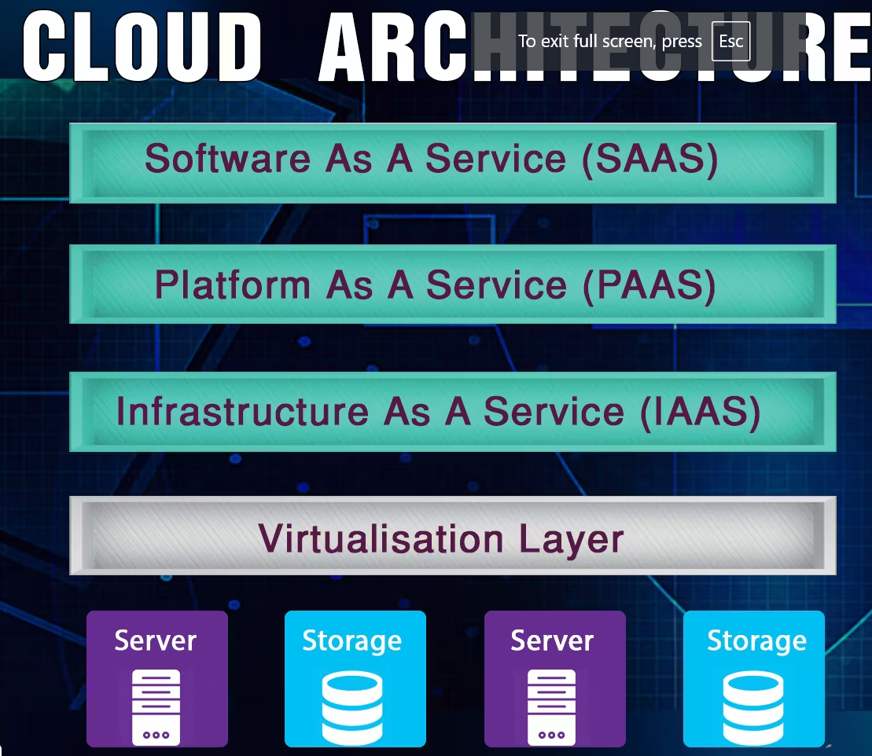

Ex.

**SAAS** 🡪 ex .Gmail, UTUBE

**PAAS** 🡪deployed database, CRM, salesforce and more

**IAAS** 🡪

**AWS cloud provider all over the Globe**🡪(pick nearest cloud service provider)

In India🡪 **Mumbai** and Hyderabad

**Virtualization layer** 🡪provide resource management, security layer

