Labsheet-6

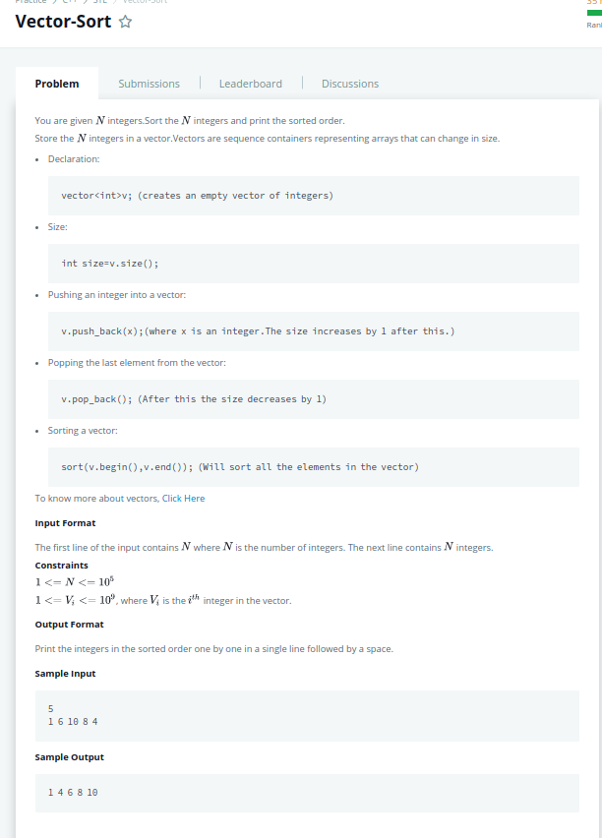
1)Answeer:
#include<bits/stdc++.h>
using namespace std;
int main(){
int n;cin>>n;
vector<int> a;
int x;
for(int i=0;i<n;i++){
cin>>x;
a.push_back(x);
}
sort(a.begin(),a.end());
for(int& i:a) cout<<i<<" ";
cout<<endl;
}

2)
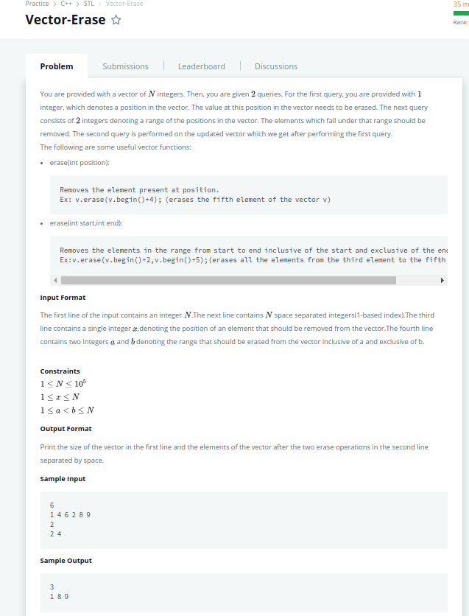

#include<bits/stdc++.h>
using namespace std;
int main(){
int n;cin>>n;
vector<int> a;
int x;
for(int i=0;i<n;i++){
cin>>x;
a.push_back(x);
}
int b;cin>>b;
a.erase(a.begin()+b-1);
int p,q;cin>>p>>q;
a.erase(a.begin()+p-1,a.begin()+q-1);
cout<<a.size()<<endl;
for(int& i:a) cout<<i<<" ";
cout<<endl;
}

3)
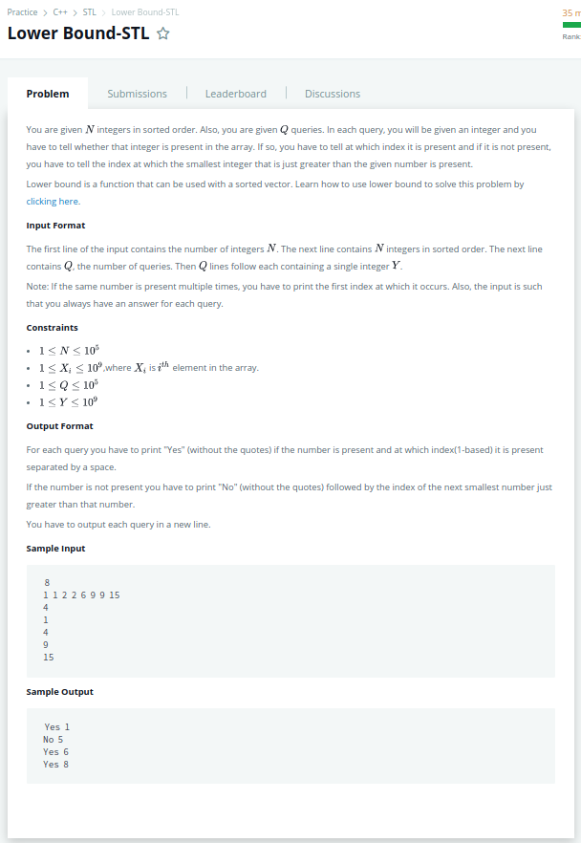

#include<bits/stdc++.h>
using namespace std;
int main(){
int n;cin>>n;
vector<int> a;
int x;
for(int i=0;i<n;i++){
cin>>x;
a.push_back(x);
}
int c;cin>>c;
int y;
while(c){
cin>>y;
auto s=lower_bound(a.begin(),a.end(),y);
if(*s==y) cout<<"Yes"<<" "<<s-a.begin()+1<<endl;
else cout<<"No"<<" "<<s-a.begin()+1<<endl;
c-=1;

4)
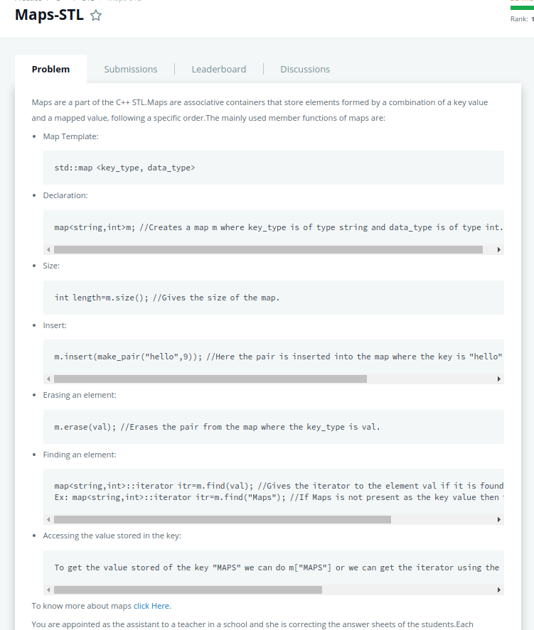

#include<bits/stdc++.h>
using namespace std;
int main(){
int t;cin>>t;
string x;int y;
map<string,int> a;
while(t){
int c;cin>>c;
cin>>x;
if(c==1){
cin>>y;
if(a.find(x)==a.end()) a.insert(make_pair(x,y));
else a[x]+=y;
}
else if(c==2) a[x]=0;
else if(c==3){
if (a.find(x)==a.end()) cout<<0<<endl;
else cout<<a.at(x)<<endl;
}
t--;
}
}

5)
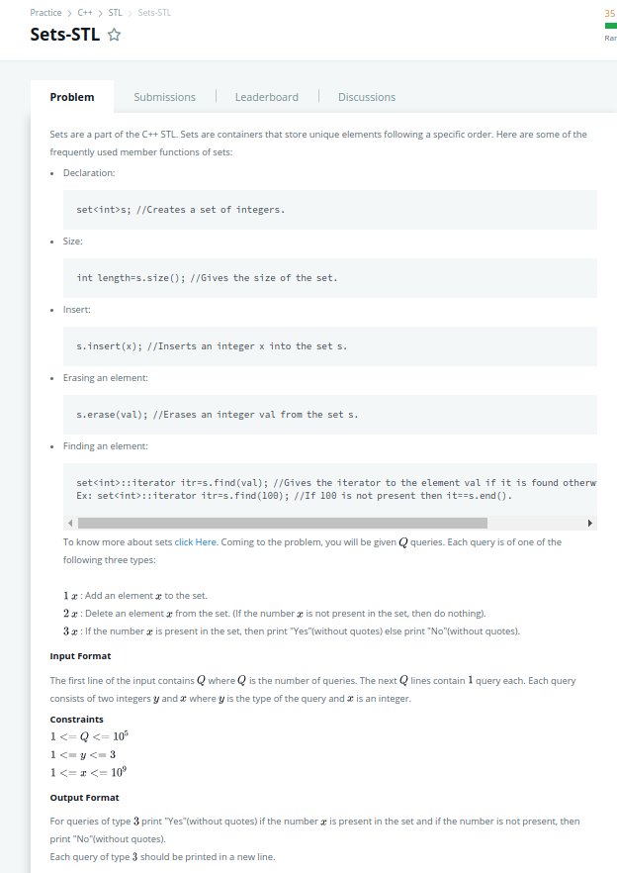
#include<bits/stdc++.h>
using namespace std;
int main(){
int n;
cin>>n;
set<int>a;
for(int i=0;i<n;i++){
int x,y;
cin>>x>>y;
switch(x){
case 1:a.insert(y);break;
case 2:a.erase(y);break;
case 3:if(a.find(y)==a.end()) cout<<"No"<<endl;else cout<<"Yes"<<endl;break;
}
}

}

7)

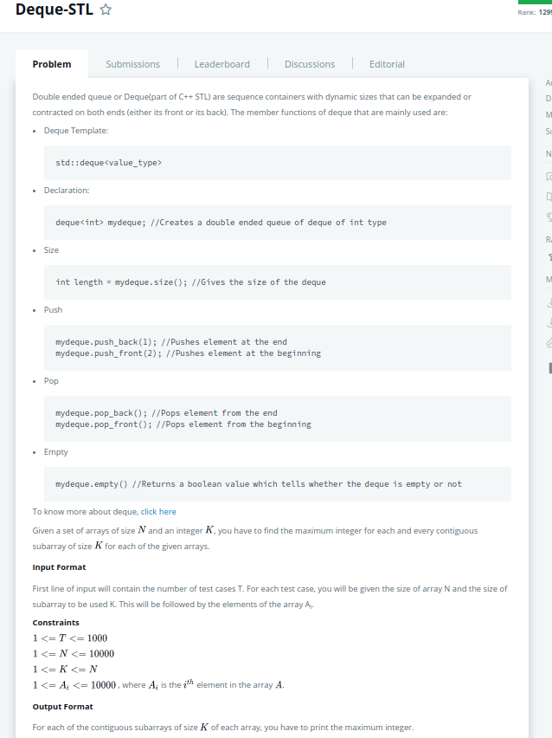
#include <iostream>
#include <deque>
#include <algorithm>
using namespace std;

void printMax(int arr[], int n, int k)
{
deque<int> d;
for (int i = 0; i < k; i++)
{
d.push_back(arr[i]);
}
int m = *max_element(d.begin(), d.begin() + k);
cout << m << " ";
for (int i = k; i < n; i++)
{
d.push_back(arr[i]);
if (d[0] == m)
{
d.pop_front();
m = *max_element(d.begin(), d.end());
cout << m << " ";
}
else
{
d.pop_front();
if (arr[i] > m)
{
m = arr[i];
}
cout << m << " ";
}
}
cout << "\n";
}
int main()
{
int t;
cin >> t;
while (t > 0)
{
int n, k;
cin >> n >> k;
int i;
int arr[n];
for (i = 0; i < n; i++)
cin >> arr[i];
printMax(arr, n, k);
t--;
}
return 0;
}

