X=nil, Y=dana

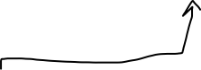

before(nil,dana)

;

in_queue(nil,_,null),

in_queue(dana,_,X),

X\=null.

in_queue(nil,_,X),

in_queue(dana,_,Y),

earlier(X,Y)

X=rami, Y=alon

X=adi, Y=tzvi

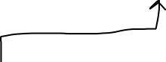

yes

in_queue(adi,_,X),

in_queue(tzvi,_,Y),

earlier(X,Y)

before(adi,tzvi)

;

in_queue(adi,_,null),

in_queue(tzvi,_,X),

X\=null.

before(rami,alon)

;

in_queue(rami,_,null),

in_queue(alon,_,X),

X\=null.

in_queue(rami,_,X),

in_queue(alon,_,Y),

earlier(X,Y)

in_queue(yael,_,X),

in_queue(vered,_,Y),

earlier(X,Y)

before(yael,vered)

;

in_queue(yael,_,null),

in_queue(vered,_,X),

X\=null.

earlier(yael,vered)