|  |
| --- |
| OOP Ex1 |
| **Wiki**  **Simon Pikalov & Ron Leib**  **320986979_313278780** |

**This Ex1 project is an java project in OOP contains Multiple classes and all the detailed information on how to use this are in the Javadoc pdf included in the git repository**

**The project is mainly about Monom’s Polynoms and ComplexFunctions and support multiple methods such as calculating the function value of x at the point, root and area for the Polynom function type, Draw a graph of a function , equal between a function and much more.**

|  |
| --- |
| OOP Ex1 |
| **Wiki**  **Simon Pikalov & Ron Leib** |

The Monom class

# **Monomial**

From Wikipedia, the free encyclopedia

In [mathematics](https://en.wikipedia.org/wiki/Mathematics), a **monomial** is, roughly speaking, a [polynomial](https://en.wikipedia.org/wiki/Polynomial) which has only one term. Two definitions of a monomial may be encountered.

In the picture you can see the Monom of x^3 drawn by the draw function of the project

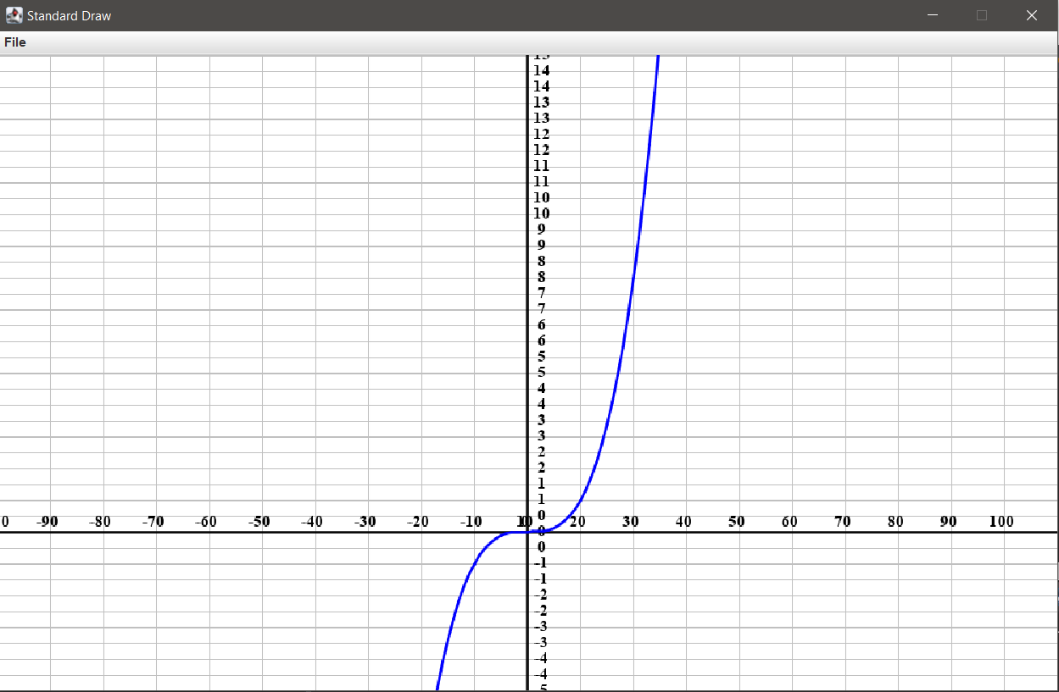

|  |
| --- |
| OOP Ex1 |
| **Wiki**  **Simon Pikalov & Ron Leib** |

The Polynom class

# **Polynomial**

From Wikipedia, the free encyclopedia

In [mathematics](https://en.wikipedia.org/wiki/Mathematics), a polynomial is an [expression](https://en.wikipedia.org/wiki/Expression_(mathematics)) consisting of [variables](https://en.wikipedia.org/wiki/Variable_(mathematics)) (also called [indeterminates](https://en.wikipedia.org/wiki/Indeterminate_(variable))) and [coefficients](https://en.wikipedia.org/wiki/Coefficient), that involves only the operations of [addition](https://en.wikipedia.org/wiki/Addition), [subtraction](https://en.wikipedia.org/wiki/Subtraction), [multiplication](https://en.wikipedia.org/wiki/Multiplication), and non-negative [integer](https://en.wikipedia.org/wiki/Integer) [exponents](https://en.wikipedia.org/wiki/Exponentiation) of variables.

In the picture you can see the Polynom of x^4+5x+1 drawn by the draw function of the project

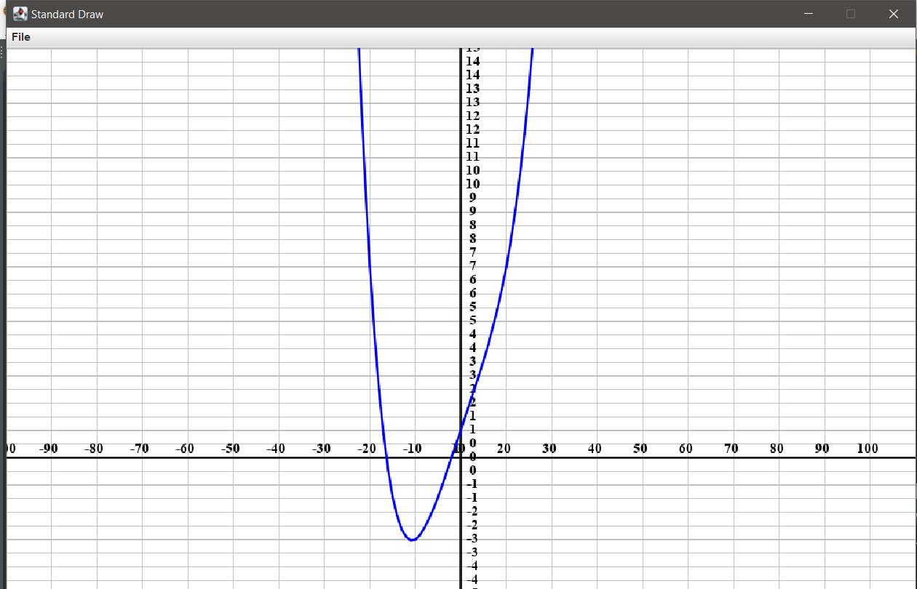

|  |  |  |
| --- | --- | --- |
| OOP Ex1   |  | | --- | | **Wiki**  **Simon Pikalov & Ron Leib** | |  | |

The ComplexFunction class

# **complexfunction**

ComplexFunction is an combination of Multiple Monoms and Polynom’s functions with and Operation in between.

