Leticia Rojas Nava

GET http://localhost:8989/api/book/

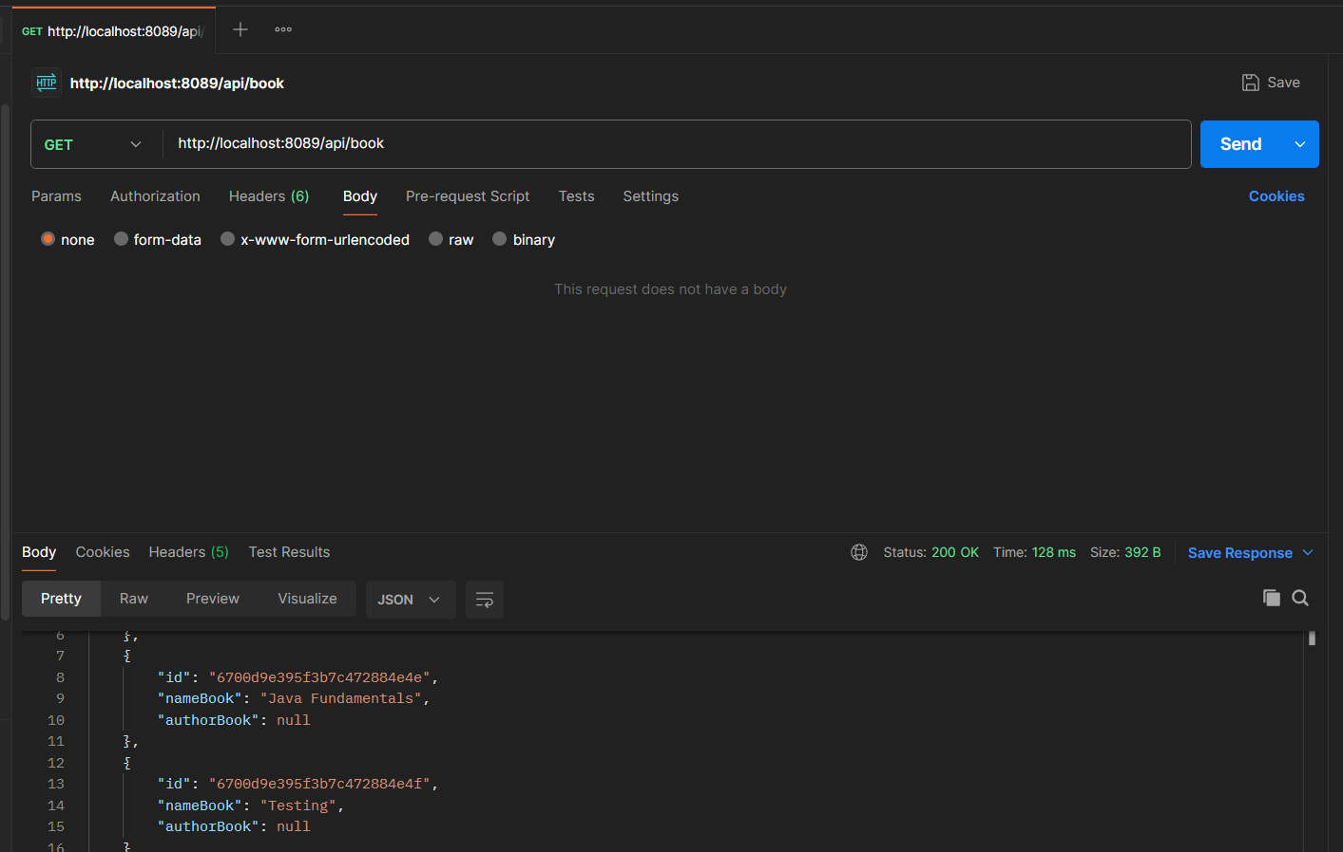

GET http://localhost:8908/api/book/6700d9e395f3b7c472884e4e

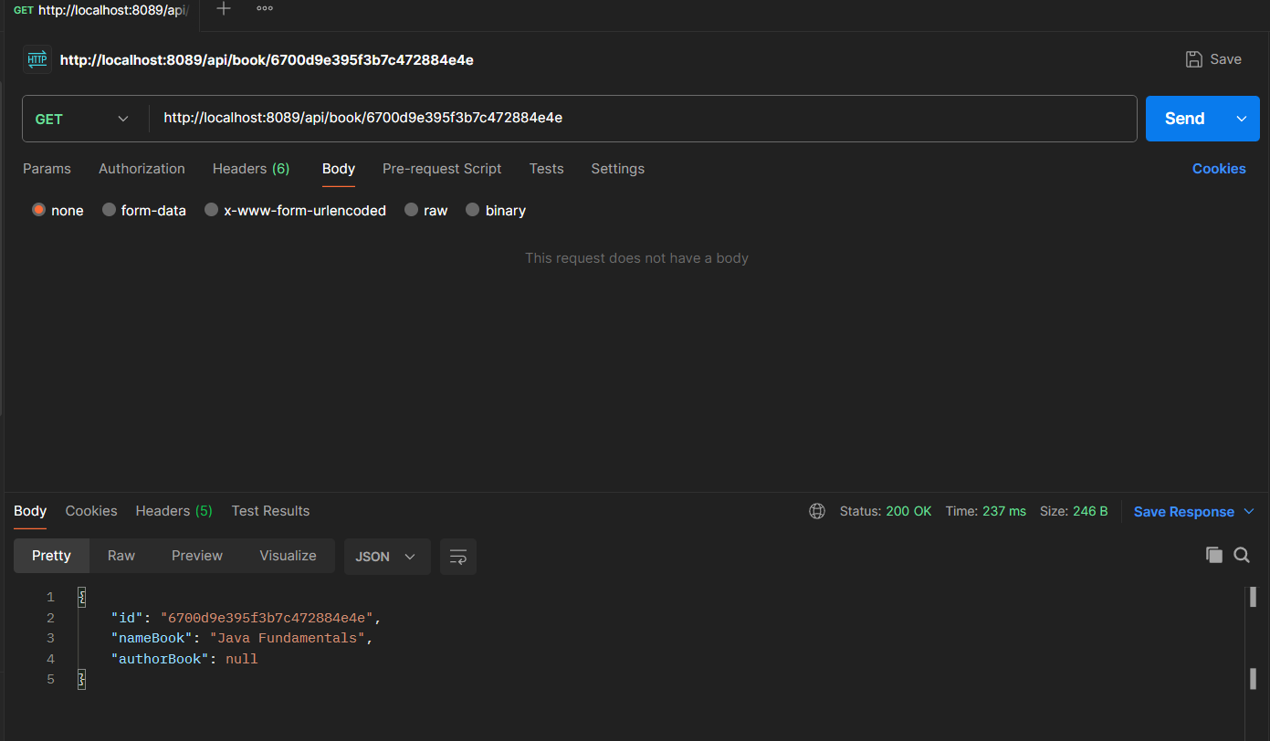

DELETE http://localhost:8989/delete/6700d9e395f3b7c472884e4e

