IT-650 3-1 Scenario Activity:

Westlake Research Hospital: Database Design

Southern New Hampshire University (IT-650)

Ronald E Miller

April 24, 2020

Table of Contents

**3-1 Scenario Activity: Chapter 4** 3

Business Rules Review 3

Entities & Attributes 4

Relationships 5

Logical Model (Crow’s Feet Notation) 6

Entity Types 7

Checklist 8

**References** 9

# **3-1 Scenario Activity: Chapter 4**

## Business Rules Review

When identifying the business rules, it is essential to understand that business rules are used to "describe the rules that govern the way data is acquired, stored, and used by the business" (Conger, 2014, p. 52). The following is a complete list of the requirements and business rules associated with the Double-Blind Study Database:

* The database must track patients’ information from their first screening through each of their visits.
* Every visit must identify the Depression State
* The database must track the patient’s appetite for each visit.
* The database must track the patents sleep habits every visit
* The database must track the patient’s activity engagement each visit.
* The database must track any physical side effects each visit.
* Every patient must have an Initial Start Date, Birth Date, Address, Phone Number, Date first diagnosed, and Email listed.
* Any current medication must be listed.
* The medication allergies field must be set to true or false.
* If the medication allergies field is true, the medications must be listed.
* The initial intake must list the symptoms of depression.
* Each visit must store any symptoms of depression experienced.
* Each Patient visit must store the patient vitals.
* Each patient visit must store the patient’s depression rating on a scale of 1-5.
* Each patient visit must store all symptoms and rate them on a scale of 1-5.
* Must be able to enter symptoms not listed on the form.
* Each visit must store the doctor's notes associated with that visit.
* Each visit must store the doctor's recommendation as one of two values. (Continue with study or Drop from the study)
* If the doctor recommends the patent be dropped from the study, they must provide an explanation.
* The doctors must be able to enter blood pressure, blood test results, depression indicators, and notes for each session.
* The database must allow patients only to view their medical profiles and doctor's notes.
* The database must restrict all full access views that include all patient information, doctor’s notes, and the drug prescribed to only the two (2) researches.
* The database must allow doctors to see only their own patient's information without showing the current drug prescribed to the patent.
* The database must be secured against external intrusion attempts, especially those perpetrated by competitors.

## Entities & Attributes

To define the entities and attributes associated with a database, we first must understand the difference between the two (2) elements. An entity is a “distinguishable real-world object that exists” (Trenten, 2019). In contrast, an attribute defines "the characteristics of the properties of an entity on the basis of which it is easily distinguishable among other entities of the real-world" (Trenten, 2019). The following list contains the entities and attributes associated with the Double-Blind Study Database:

|  |  |  |
| --- | --- | --- |
| Patients   * Patient ID * Name * Initial Start Date * Birth Date * Address * Phone Number * Email * Date first diagnosed * Family History of Depression * Test Drug Prescribed (From Lookup Table) (FK) * Doctor ID (FK)   Current Prescriptions   * Prescription ID * Patient ID (FK) * Drug Type Prescribed (From Lookup Table) * Dosage   Medication Allergies   * Allergy ID * Patient ID (FK) * Drug Type (From Lookup Table) (FK)   Visit   * Visit ID * Patient ID (FK) * Visitation Date * Depression State * Is Initial Visit * Medication Compliance * Visit Compliance * Recommendation * Recommendation Justification * Blood Pressure * Pulse * Weight   Depression History   * Depression History ID * Patient ID (FK) * Description * Is Attempt at Treatment | Doctors   * Doctor ID * Name * Degree * Phone * Email * Address   Test Supervisors   * Supervisor ID * Name * Phone * Email * Address * Is a Pharmacist   Doctor Notes   * Note ID * Visit ID (FK) * Note   Symptoms Experienced   * Symptom ID * Is Prior Symptom * Visit ID (FK) * Symptom Name * Symptom Explanation * Symptom Rating   Lookup Table   * Lookup ID * Lookup Name   Prior Depression Treatments   * Prior Depression Treatment ID * Patient ID (FK) * Date of Prior Treatment * Description of Treatment   Prior Conditions   * Prior Condition ID * Patient ID (FK) * Condition Name * Condition Description |  |
|  |  |  |

## Relationships

With relational databases, a "relationship is established between two database tables when one table uses a foreign key that references the primary key of another table" (Chapple, 2020). In the list located in the previous section titled “Entities & Attributes," there are several attributes that contain "ID" and several that contain "FK." The FK designation indicates a foreign key; this, in turn, indicates a relationship. In the list above, each attribute displayed as a subsection to the entity for which they belong. The following list details the relationships associated with the entities identified for the Double-Blind Study Database:

* Many (Mandatory) Patients - Test Drug Prescribed (FK) | To One (Mandatory) Lookup Table
* Many (Mandatory) Patients - Doctor ID (FK) | To One (Mandatory) Doctors
* Many (Mandatory) Current Prescriptions - Drug Type Prescribed (FK) | To One (Mandatory) Lookup Table
* Many (Optional) Current Prescriptions - Patient ID (FK) | To One (Mandatory) Patients
* Many (Mandatory) Medication Allergies - Drug Type (FK) | To One (Mandatory) Lookup Table
* Many (Optional) Medication Allergies - Patient ID (FK) | To One (Mandatory) Patients
* Many (Optional) Visit - Patient ID (FK) | To One (Mandatory) Patients
* Many (Optional) Depression History - Patient ID (FK) | To One (Mandatory) Patients
* One (Mandatory) Doctor Notes - Visit ID (FK) | To Many (Mandatory) Visit
* One (Mandatory) Symptoms Experienced - Visit ID (FK) | To Many (Optional) Visit
* Many (Optional) Prior Depression Treatments - Patient ID (FK) | To One (Mandatory) Patient
* Many (optional) Prior Conditions - Patient ID (FK) | To One (Mandatory) Patient

## Logical Model (Crow’s Feet Notation)

The following logical model in figure one depicts the database design for the Double-Blind Study Database. The logical design contains all the entities and their attributes outlined in previous sections. The diagram identifies the key fields for each entity using "PK" for the primary key and "FK" for the foreign keys. Finally, the diagram identifies the relationships outlined in the previous section using crow's feet notation.

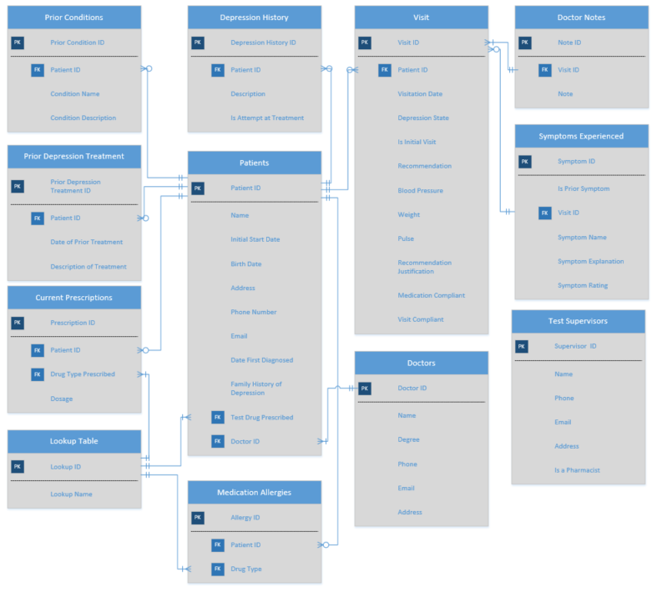

Figure 1 (Logical Model)

## Entity Types

There are four (4) types of entities, also known as roles that are used to define an entity. The four (4) types are known as Domain, Linking, Lookup, and Weak entities. A Domain entity is an entity that “relates directly to the business of the database” (Conger, 2014, p. 74). A Linking entity is an entity that is “used to resolve many-to-many relationships into two one-to-many relationships (Conger, 2014, p. 74). A Lookup entity is an entity that “stores lists of data that other tables need to look up” (Conger, 2014, p. 74). The last type of entity, a Weak entity, is an “entity that is dependent on another entity for its meaning” (Conger, 2014, p. 74).

The following list identifies the type for the entities outlined in the section titled “Entities & Attributes”:

* Domain
  + Visit
  + Test Supervisors
  + Doctors
  + Patients
* Linking
  + This database contains no many-to-many relationships.
* Lookup
  + Lookup Table
* Weak
  + Prior Conditions
  + Depression History
  + Prior Depression Treatments
  + Medication Allergies
  + Symptoms Experienced
  + Doctor Notes
  + Current Prescriptions

## Checklist

|  |  |
| --- | --- |
| Are all the major components of the clinical trial represented by domain entities? | GO |
| Does each entity contain the appropriate attributes to fully describe it and meet the business rules you have gathered so far? | GO |
| Does every entity have an appropriate primary key defined? | GO |
| Are all many-to-many relationships resolved into one-to-many relationships by linking tables? | GO |
| Are the relationships valid (no cross relationships)? | GO |
| Is the appropriate entity defined as the one side of a one-to-many relationship? | GO |
| Do the tables have appropriate foreign keys? | GO |
| Are lookup tables used for attributes that have a set list of values? | GO |

# **References**

Chapple, M. (2020, February 4). *Database Relationships*. Retrieved April 23, 2020, from Lifewire: https://www.lifewire.com/database-relationships-p2-1019758

Conger, S. (2014). *Hands-on Database* (Second ed.). Upper Saddle River, New Jersey, United States: Pearson Education, Inc. Retrieved April 08, 2020

Trenten, N. (2019, December 10). *Difference Between Entity and Attribute in Database*. Retrieved April 23, 2020, from Binary Terms: https://binaryterms.com/difference-between-entity-and-attribute-in-database.html