**Report**

First data sets were gathered from the public GitHub repository of FiveThirtyEight, under the folder titled “college-majors”. The data set “recent-grads”, a subset of the dataset “all-ages”, was then looked at to see what most recent male and female college graduates had chosen as their college major and how that effected their role in the economy. The dataset “recent-grads” was further broken down into the datasets “total”, “men”, “women”, and unemployment rate. These datasets corresponded to the total number of college graduates, the number of men graduates, the number of women graduates, and the total unemployment rate among both men and women. The majors in the datasets were chosen by the 30 most popular college majors. From this data, the hope is to hypothesize the trends of popularities of different college majors for future years.

|  |  |
| --- | --- |
| **Major Number** | **Description** |
| 0 | PETROLEUM ENGINEERING |
| 1 | MINING AND MINERAL ENGINEERING |
| 2 | METALLURGICAL ENGINEERING |
| 3 | NAVAL ARCHITECTURE AND MARINE ENGINEERING |
| 4 | CHEMICAL ENGINEERING |
| 5 | NUCLEAR ENGINEERING |
| 6 | ACTUARIAL SCIENCE |
| 7 | ASTRONOMY AND ASTROPHYSICS |
| 8 | MECHANICAL ENGINEERING |
| 9 | ELECTRICAL ENGINEERING |
| 10 | COMPUTER ENGINEERING |
| 11 | AEROSPACE ENGINEERING |
| 12 | BIOMEDICAL ENGINEERING |
| 13 | MATERIALS SCIENCE |
| 14 | ENGINEERING MECHANICS PHYSICS AND SCIENCE |
| 15 | BIOLOGICAL ENGINEERING |
| 16 | INDUSTRIAL AND MANUFACTURING ENGINEERING |
| 17 | GENERAL ENGINEERING |
| 18 | ARCHITECTURAL ENGINEERING |
| 19 | COURT REPORTING |
| 20 | COMPUTER SCIENCE |
| 21 | FOOD SCIENCE |
| 22 | ELECTRICAL ENGINEERING TECHNOLOGY |
| 23 | MATERIALS ENGINEERING AND MATERIALS SCIENCE |
| 24 | MANAGEMENT INFORMATION SYSTEMS AND STATISTICS |
| 25 | CIVIL ENGINEERING |
| 26 | CONSTRUCTION SERVICES |
| 27 | OPERATIONS LOGISTICS AND E-COMMERCE |
| 28 | MISCELLANEOUS ENGINEERING |
| 29 | PUBLIC POLICY |

Majors of Recent Graduates

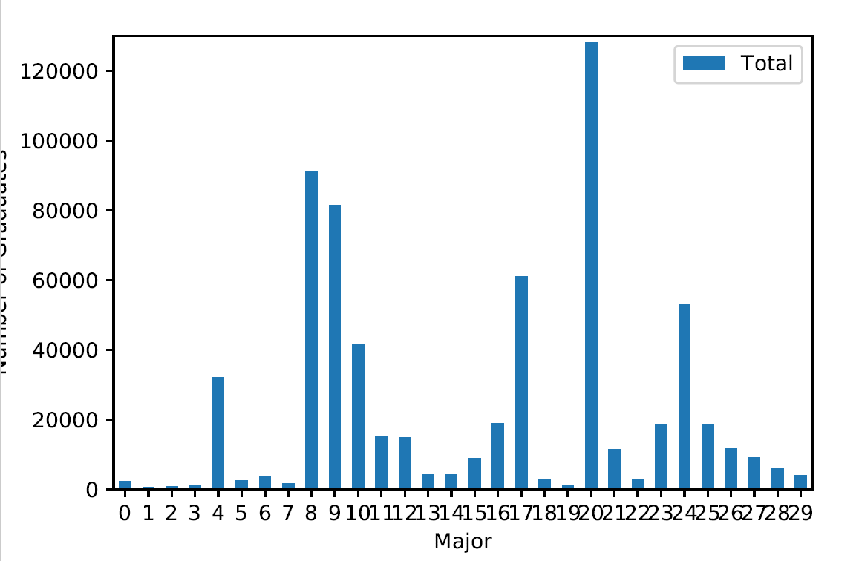

Majors of Male Graduates

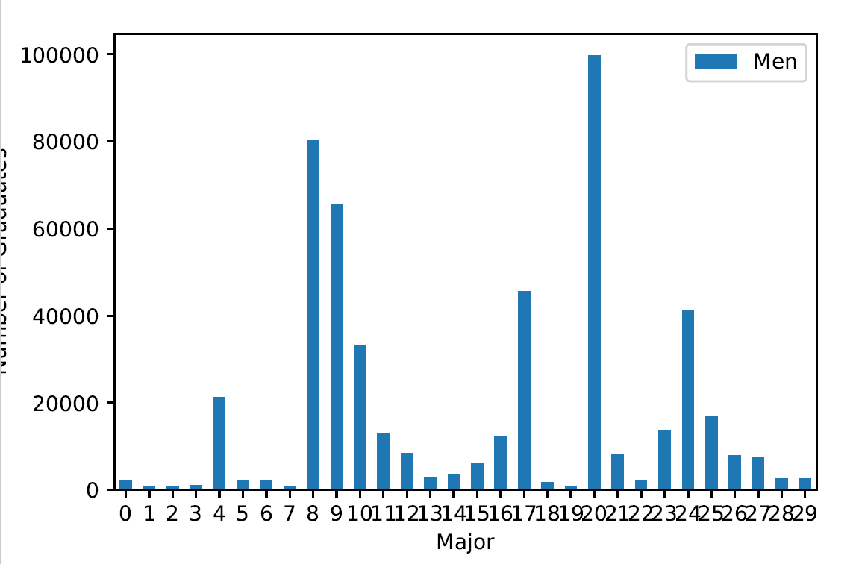

Majors of Female Graduates

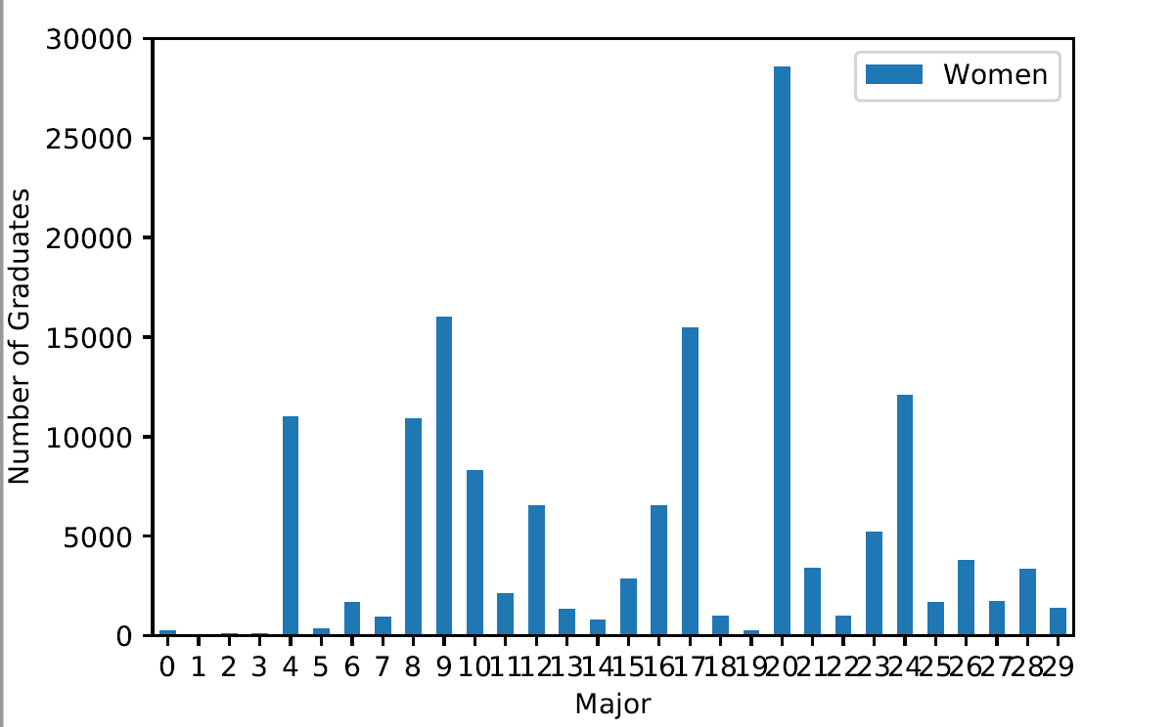

Unemployment Rate of Recent Graduates

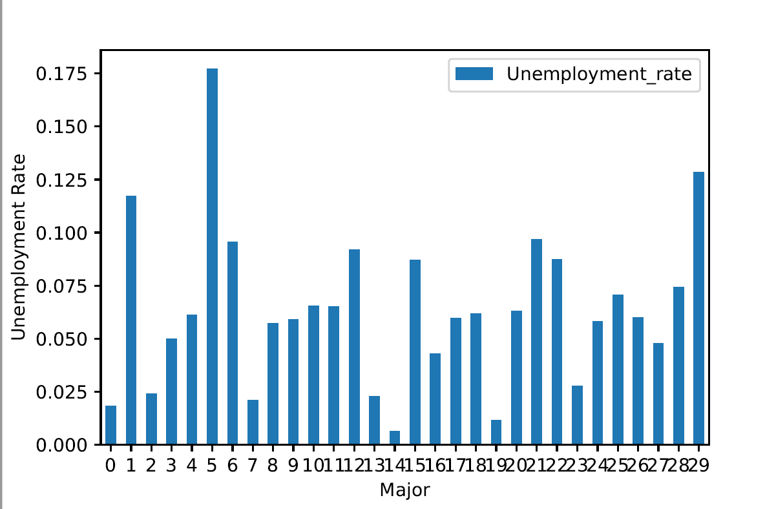

From these data results, it is seen that the unemployment rate is highest among major number 5, which corresponds to chemical engineering. This major is composed mainly of male students. However, there is only of small amount of total students in this major. This may have something to do with high unemployment rate expected after college.

The most popular major among both men and women, according to the data, seems to be without a doubt computer science. However, it holds one of the lowest total unemployment rates. As a result, a hypothesis can be made that the trend will be that the popularity of computer science will continue to grow among both male and female prospective college students. Unfortunately, I was not able to gather recent datasets of college majors.