TITLE P
Department of Information Technology
COLLEGE OF ENGINEERING
CENTRAL LUZON STATE UNIVERSITY
Science City of Muñoz, Nueva Ecija

RESTAUSIM: IMMERSIVE POS AND INVENTORY TRAINING SYSTEM FOR CLSU DHTM STUDENTS

A Capstone Project
Presented to the
Department of Information Technology

In Partial Fulfillment
of the Requirements for the Degree

BACHELOR OF SCIENCE IN INFORMATION TECHNOLOGY

By:

Baldovino, Ronnel P.
Basinga, Ejay G.
Eda, Franz Harry Daniel A.

June 2025

DISCLAIMER

“This Capstone Project is submitted to the Department of Information Technology, College of Engineering, in partial fulfillment of the requirements for the degree Bachelor of Science in Information Technology at the Central Luzon State University, Science City of Muñoz, Nueva Ecija. It is a product of our own work except where indicated in the text. The project report or any portion thereof including the source code, or any section may be freely copied and distributed provided that the source is acknowledged.”

APPROVAL SHEET

This capstone project proposal entitled “RESTAUSIM: IMMERSIVE POS AND INVENTORY TRAINING SYSTEM FOR CLSU DHTM STUDENTS” prepared and submitted by Ronnel P. Baldovino, Ejay G. Basinga, Franz Harry Daniel A. Eda in partial fulfillment of the requirements for the degree BACHELOR OF SCIENCE IN INFORMATION TECHNOLOGY, has been examined and is hereby endorsed.

ANGELIKA S. BALAGOT
Adviser

CAPSTONE 1 PROJECT ORAL PRESENTATION COMMITTEE

MARY CAMILLE D. RABANG |  | LEO CHRISTOPHER C. VIRAY
Chair |  | Member
Date Signed |  | Date Signed

Accepted and approved in partial fulfillment of the requirements for the degree BACHELOR OF SCIENCE IN INFORMATION TECHNOLOGY, school year 2024-2025.

DR. ANJELA TOLENTINO
Head, Department of Information Technology
_______________
Date Signed

DR. ROY SEARCA JOSE P. DELA CRUZ
Acting Dean, College of Engineering
_______________
Date Signed

CERTIFICATION OF MANUSCRIPT PROOFREADING

This is to certify that the undersigned has reviewed and edited the manuscript of Ronnel P. Baldovino, Ejay G. Basinga and Franz Harry Daniel A. Eda, entitled "RESTAUSIM: IMMERSIVE POS AND INVENTORY TRAINING SYSTEM FOR CLSU DHTM STUDENTS". This further certifies that the scope of editing is for proper English language, grammar, punctuation, spelling, and overall writing style.

Issued this 31st day of Month, year, at address.

FULL NAME OF CRITIC
Position/Designation
Name of institution/school

ABSTRACT

An abstract is a condensed version of a project or research report. The study's purpose, methodology, results, and significance are all succinctly explained. An overview of the entire work is provided to readers in the abstract, which serves as a brief guide for those who choose to read the full text.

TABLE OF CONTENTS
TITLE PAGE
DISCLAIMER i
APPROVAL SHEET ii
CERTIFICATION OF MANUSCRIPT PROOFREADING iii
ABSTRACT iv
TABLE OF CONTENTS v
LIST OF FIGURES vi
LIST OF TABLES xi
INTRODUCTION 1
PROBLEM STATEMENT 3
General Problem 3
Specific Problem 3
OBJECTIVES 4
General Objective 4
Specific Objectives 4
SCOPE AND LIMITATION 5
Scope 5
Limitations 8
SIGNIFICANCE OF THE STUDY 9
DEFINITIONS OF TERMS 10
REVIEW OF RELATED LITERATURE AND EXISTING ALTERNATIVES 12
Introduction 12
Conclusion 28
METHODOLOGY 30
Research Design 30
Implementation Process 30
1. Requirement Analysis 31
2. System Design 34
3. Implementation 46
4. System Testing 48
5. System Deployment 52
REFERENCES 54
APPENDICES 56

LIST OF FIGURES
Figure No. Title Page
1 Figure 1: Modified Waterfall SDLC Model 31
2 Figure 2: Use Case Diagram of the RestauSim 56
3 Figure 3: Context Diagram of the RestauSim 56
4 Figure 4: Flowchart for Account Registration 57
5 Figure 5: Flowchart for Forgot Password 57
6 Figure 6: Flowchart for Student Role: Manager Accessing PoS 58
7 Figure 7: Flowchart for Student Role: Manager Accessing Inventory 59
8 Figure 8 Flowchart for Student Role: Manager Accessing Menu 60
9 Figure 9 Flowchart for Student Role: Cashier 61
10 Figure 10: Flowchart for Student Role: Host 62
11 Figure 11: Flowchart for Student Role: Kitchen Staff 63
12 Figure 12: Flowchart for Student Role: Waiter 64
13 Figure 13: Flowchart for Instructor/Professor Creating New Sections 65
14 Figure 14: Flowchart for Instructor/Professor Viewing Sections 66
15 Figure 15: Flowchart for Instructor/Professor Viewing All Students 67
16 Figure 16: Flowchart for Student Score and Feedback 68

17 Figure 17: Flowchart for Grading and Feedback
for Student Simulation Activity 68
18 Figure 18: Flowchart for Downloading of Grades 69
19 Figure 19: Data Flow Diagram of the RestauSim 70
20 Figure 20: Exploded Data Flow Diagram Process 1 71
21 Figure 21: Exploded Data Flow Diagram Process 2 71
22 Figure 22: Exploded Data Flow Diagram Process 3 72
23 Figure 23: Exploded Data Flow Diagram Process 4 72
24 Figure 24: Exploded Data Flow Diagram Process 5 73
25 Figure 25: Exploded Data Flow Diagram Process 6 73
26 Figure 26: Exploded Data Flow Diagram Process 7 74
27 Figure 27: Exploded Data Flow Diagram Process 8 74
28 Figure 28: Exploded Data Flow Diagram Process 9 75
29 Figure 29: Exploded Data Flow Diagram Process 10 75
30 Figure 30: Exploded Data Flow Diagram Process 11 76
31 Figure 31: System Architecture of RestauSim 76
30 Figure 32: Entity-Relationship Diagram of the RestauSim 77
31 Figure 33: Relational Data Model of the RestauSim 78
32 Figure 34: Conceptual Framework of the RestauSim 79
34 Figure 35: Login Page UI 79
35 Figure 36: Registration Page UI 80
36 Figure 37: Landing Page for DHTM Students UI 80
37 Figure 38: Assigned Activities for DHTM Student UI 81
38 Figure 39: Join Activity UI 81
39 Figure 40: Profile Page UI 82
40 Figure 41: Student Activity: Cashier Role UI 82
41 Figure 42: Landing Page UI 83
42 Figure 43: PoS Access for Cashier UI 83
43 Figure 44: Orders from the Waiter UI 84
44 Figure 45: Student Activity: Manager Role 84
45 Figure 46: Manager Dashboard UI 85
46 Figure 47: Calendar for Customization of Sales Report UI 85
47 Figure 48: Inventory Page UI 86
48 Figure 49: Adding of New Item in the Inventory UI 86
49 Figure 50: Menu Management Page UI 87
50 Figure 51: Add New Menu Item UI 87
51 Figure 52: Ingredient Price per Menu Item UI 88
52 Figure 53: Student Activity: Kitchen Staff Role UI 88
53 Figure 54: Kitchen Staff Integrated Display UI 89
50 Figure 55: Completed Orders, Ongoing Process and Not Started Orders UI 89
51 Figure 56: Student Activity: Host/Waiter Role UI 90
52 Figure 57: Table Status UI 90
53 Figure 58: Order Customization UI 91
54 Figure 59: Payment UI 91
55 Figure 60: Orders when a table is clicked UI 92
56 Figure 61: Landing Page for Instructor/Professor UI 92
57 Figure 62: Section Management UI 93
58 Figure 63: Section Creation UI 93
59 Figure 64: See All Student UI 94
60 Figure 65: Add Student UI 94
61 Figure 66: See Students Per Section UI 95
62 Figure 67: Add Student to a Section UI 95
63 Figure 68: Simulation/Activity Management UI 96
64 Figure 69: Simulation/Activity Creation UI 96

LIST OF TABLES
Table No. Title Page
1 Table 1: Comparative Analysis of Prior Research and Existing Alternatives in Simulation-Based Learning for Hospitality Education 26
2 Table 2: Activities and Deliverables for Requirement Analysis Phase 34
3 Table 3: Activities and Deliverables for System Design Phase 44
4 Table 4: Activities and Deliverables for Implementation Phase 46
5 Table 5: Activities and Deliverables for System Testing Phase 47
6 Table 6: Test Cases/Scenarios and Description 48
7 Table 7: Activities and Deliverables for System Deployment Phase 51

CHAPTER I

INTRODUCTION
The integration of technology in the Hospitality and Tourism industries has significantly transformed the business operations, improving work and decision making efficiency. According to a study conducted by Baser et al., 2025 only 2% of a tourism curriculum were related to technology and innovation based on the 65-undergraduate program of 47 universities; these 47 universities are based on the top 100 in the Q.S. World Ranking for Hospitality & Leisure Management. With the hospitality and the tourism industry, education plays a significant role in meeting the industry employment needs.
Under the College of Home Science and Industry at CLSU, the Department of Hospitality and Tourism Management (DHTM) offers bachelor's degree programs in Hospitality Management and Tourism Management. These programs aim to equip student to be globally competitive in different sectors of the hospitality and tourism industries such as food and beverages, lodging, leisure etc., have skills when it comes to customer service, problem solving, having a proactive approach to the operational proficiency, intellectual curiosity and the growing awareness in promoting sustainability in the hospitality and tourism industries (Colleges | Central Luzon State University, n.d.). The department is led by Ms. Celeste D. Dele Cruz, the respected Head of DHTM, and currently serves 902 students for the Academic Year 2024–2025.
Courses such as the HM 1135 and TM 1135 (Applied Business Tools and Technologies), which aims to introduce the 1st year DHTM students to digital tools that are used in the hospitality and tourism industry such as the Point of Sale and Inventory Management. These digital tools are essential to businesses especially in the hospitality and tourism industry. However 1st year DHTM students lack hands-on experience with these tools, as traditional teaching methods often focus heavily on theoretical application and provide limited opportunities for real-world practice.
In bridging this gap, this study proposed the development of the RestauSim, which is short term for the restaurant simulation. The proposed system is an interactive point of sale and inventory training system tool for the 1st year students of CLSU DHTM. The RestauSim is a simulation based tool that is available for web and mobile view that allows the 1st year CLSU DHTM students to experience how a PoS works, with the core functionality of the PoS like order creation, order management, billing and payment processing, etc. 1st year CLSU DHTM students also experience how an inventory management works, with the core functionality like real time tracking of inventory levels, low stock alerts, reporting and analytics, etc. Using this simulation, 1st year CLSU DHTM students will help them in gaining knowledge and skills in the functionality of the point of sale and inventory management, allowing them to be ready for the hospitality and tourism industry.

PROBLEM STATEMENT

General Problem
The aim of CLSU as a university is to develop and nurture students so that they can be ready for the professional world. Teaching students theoretically allows the students to grasp how a concept works and teaching them practically allows them to apply those concepts in a controlled environment, but CLSU as a government funded university can sometimes lack the resources to provide these kinds of teaching methods.

Specific Problem
- Limited Practical Exposure: Students only learn through familiarization and identification of different tools and technologies that are being used in the hospitality and tourism industry therefore they lack the practical knowledge on how these tools and technologies are integrated and run in a real world setting.
- Lack of Role-Based Knowledge: Students lack exposure to the different roles that are usually in a restaurant setting such as manager, cashier, kitchen staff, host and waiter, that leads to the student understanding of these roles in a restaurant setting.
- Limited Opportunities for Practical Assessment: Assessments are only done through exams, quizzes, lab reports, and projects therefore instructors lack a way of assessing a students practical skills.

OBJECTIVES

General Objective
The study aims to design, develop and implement an immersive restaurant PoS and inventory training system that provides a real world experience in using the PoS and inventory management system of 1st year DHTM students by providing them a practical training system with the functionalities of a PoS and Inventory Management, allowing them for the hospitality and tourism industry.

Specific Objectives
- Design and develop an immersive restaurant PoS and inventory management training system that replicates the real world PoS operations such as order management, kitchen display, billing and payment processing, inventory management, and financial reporting, allowing the students to know the real world operation processes.
- To implement role based access within the system for the manager, cashier, kitchen staff host and waiter, allowing the students to experience different operational roles and develop their skills to the different positions in the restaurant management.
- To create a training system that enables the instructors to assess a student not only on their knowledge but also their skills.

SCOPE AND LIMITATION

Scope
The scope of the study includes the design, development and implementation of restaurant PoS and inventory management training system for educational purposes and will be used by the 1st year students of CLSU’s Department of Hospitality and Tourism Management. The study focuses on creating a functional PoS and inventory management simulation that replicates the real world operations on the PoS and Inventory Management. The system includes the following functionalities that can help the 1st year DHTM students to have the necessary skills and knowledge, especially the Point of Sale and Inventory Management that is needed in the hospitality and tourism industry:
- Order Management, allowing the waiter to display a categorized menu, create and customize orders of the customer, and modify orders before sending them to the kitchen.
- Kitchen Display System, providing real-time order tracking, displaying order details based on priority, tracking order status with color-coded, and prioritizing priority orders.
- Billing and Payment Processing, automating the bill generation, supporting multiple payment methods including credit card, split pay, and applying discounts and promotions.
- Inventory Management, ensuring real-time tracking of stock levels, providing low-stock alerts, monitoring ingredient usage for cost and waste control, and automatically deducting ingredients when orders are placed.
- Reporting and Analytics, generating sales reports, tracking inventory usage and analyzing customer insights to identify popular menu items.
- User Roles and Permissions, assigning different access levels for managers, cashiers, kitchen staff, hosts and waiters, while allowing professors to manage user roles, and enable students to switch roles for training purposes.
- Simulation Features, providing role-based learning, allowing students to experience different roles that are being used in the restaurant operations.
- HM 1135 & TM 1135 Faculty Incharge: The HM 1135 & TM 1135 Faculty Incharge will serve as the administrator of the system. They can access all of the features and functionalities of the system. They can add sections, create simulations for the students, update and archive them. They can also change and update the roles of the students.
- Status of Submission: The status of submission of an activity changes based on whether the activity is submitted by the student or not. Submitted when the activity is turned in, missing if the activity is not turned in when the due date is passed, and graded if the activity is passed and graded by the faculty in charge.
- Viewing of Grades: On the student side, the student can view the grades of each of their own activities. On the professor's side, on the other hand, they can view the grades of each student, and they can download the grades of the students per section or per semester.
- Sending Feedbacks: The faculty in charge can optionally include feedback when grading the activities of the students.
The following roles will be assigned to 1st-year students based on given simulation activity in RestauSim. All of the students can be the following roles to ensure that they gain practical, hands-on experience.
- Managers: Managers have full access to the PoS and Inventory Management, they can view the transactions made in the PoS, manage, create and update inventory stock levels, and manage, create, and update the sales and discount within the PoS. Managers can also view and generate reports from the sales and inventory. Managers can also add, edit and update the menu items and dining layouts.
- Cashiers: Cashiers can only access the PoS system, they can process the billing and payment of the customer.
- Kitchen Staff: Kitchen staff can only access the integrated kitchen display, they can update the status of the order that is sent with a color coded status indicating the stage.
- Host: Host can only access the table management, they can only see the available seat based on the table reservation and dine in customers.
- Waiter: Waiter can only access the PoS and the table management, they can send orders to the kitchen, and access, modify, update table status and combine and switch tables.

Limitations
- Restricted Environment: The system will only function as a simulation tool within the CLSU DHTM 1st year students taking the HM 1135 and TM 1135 and is not intended for real-world commercial use.
- Limited Payment Processing : The system will not also include the actual financial transactions, but the system will simulate how the payment processing will be .
- Maintenance Phase in Methodology: This project will not include system maintenance in the methodology as this capstone project's primary purpose is to complete the final requirements of the developers/researchers which will allow them to graduate.

SIGNIFICANCE OF THE STUDY
The study helps in the hospitality and tourism education by addressing the gap between theoretical knowledge and practical application through the RestauSim. The development of this project offers benefits across stakeholders:
- CLSU DHTM Students: The system will help the 1st year DHTM students by helping them to gain knowledge and skills in the restaurant PoS and inventory management and in the different roles in the restaurant.
- CLSU Department of Hospitality and Tourism Management: The system will help the Department of Hospitality and Tourism Management in enhancing the educational curriculum by providing immersive, simulation-based learning experiences. It also offers academic opportunities for both students and faculty members, allowing faculty members to integrate simulation based learning into their teaching.
- Researchers: This study serves as a valuable reference for creating simulation-based learning tools specifically tailored for hospitality and tourism education. It offers practical insights into the design, development, and implementation of restaurant PoS and inventory management simulations, which can guide future innovations and enhancements in similar educational technologies.
- Future Researchers: This study will contribute to study or research on simulation-based learning in hospitality and tourism education, providing a framework and methodology that can be adapted for similar educational tools in related study or research.

DEFINITIONS OF TERMS
- Applied Business Tools and Technologies (HM 1135/TM 1135). First-year courses designed for Hospitality Management and Tourism Management students that focus on developing technical competencies required in the modern hospitality and tourism industries.
- Billing and Payment Processing. The computerized system components responsible for calculating customer charges, applying taxes and discounts, generating receipts, and recording financial transactions within the restaurant operation simulation.
- Inventory Management. The process of ordering, storing, tracking, and controlling inventory within a restaurant or hospitality establishment.
- Modified Waterfall Software Development Life Cycle (SDLC). A systematic software development methodology consisting of sequential phases including requirement analysis, system design, implementation, testing, and deployment with maintenance.
- Point of Sale (PoS) System. A computerized network that enables businesses to track sales, cash flow, food inventory and can perform other functions like order processing, payment processing, and reporting.
- RestauSim. The proposed restaurant Point-of-Sale simulation system designed as an interactive learning tool for first-year DHTM students to gain practical experience with restaurant operations technology.
- Role-Based Access. A security approach that restricts system access based on the user's role within an organization, in this case simulating different restaurant staff positions (manager, cashier, kitchen staff, host).
- Simulation-Based Learning. Educational approach that uses interactive models to replicate real-world scenarios, allowing students to gain practical experience in a controlled environment.

CHAPTER II

REVIEW OF RELATED LITERATURE AND EXISTING ALTERNATIVES

Introduction
In the new era where digital tools like the Point of Sale (PoS) and automated inventory management system are used, it is essential that students will have knowledge and skills when they enter the hospitality and tourism industry. Somehow the Department of Hospitality and Tourism Management in the Central Luzon State University, the current teaching process of the HM and TM 1135 (Applied Business Tools and Technologies) remains more on the theoretical side, with limited exposure to the digital tools that are used in today's industry.
This literature review examines the existing study and research that is related to the current study which is the Point of Sale and Inventory management training tool. The existing study and research that will be used are focused on simulation based learning, inventory management practice and other related literature that can evaluate the impact of these existing studies and research to the current study.

Simulation-Based Learning in Hospitality Education
Simulation-based learning is the involvement of creating a real world scenario and challenges in a learning activity in order for the students to apply their knowledge and skill that mirror to their future work or profession. There are various theoretical approaches when it comes to simulation based learning,one is the Kolb’s cycle of experiential learning and problem based learning (PBL). There are various formats that are used in simulation based learning and it includes the virtual labs, role play scenario and virtual and mixed reality (Collett, 2024).
A study was conducted to know the perception of hospitality students on the simulation learning in hospitality education. The integration of simulation (SIM) labs in the education settings proves that it is a valuable tool for enhancing the student engagement and hands-on learning of the hospitality student. Simulation (SIM) labs offer interactive learning experiences of the student in applying their knowledge in the simulation (SIM) labs. Integration of third-party SIM labs with a learning management system can also further redefine the accessibility and assessment for the hospitality students making it easier to participate in the SIM labs and for faculty to track the student performance of the students. (Price-Howard & Lewis, 2022)
In a related study, (Tung, 2021) emphasized that the hospitality industry is a service-oriented field that requires students to gain hands-on experience to develop the necessary skills for real-world applications. The study emphasizes the need for integrating experiential learning methods in hospitality management courses, highlighting the importance of reducing theoretical instruction in favor of practical activities. Studies have suggested that simulation software, mobile applications, and other interactive tools such as Opera Hotel Management, enhance student engagement and improve learning outcomes while also being cost-effective for educational institutions.
The study of (Quah, Kok, & Aziz, 2021) explored the use of the Front Office Tasks Simulator (FOTS) for the Hospitality TVET Students. In the study, it was found that the student found that using the FOTS is easy to use, it is engaging to use and the student is satisfied in using the FOTS. (Quah, Kok, & Aziz, 2021) concluded that using the FOTS offers a valuable and interactive way to gain knowledge and skills that is useful for the hospitality industry such as customer service, reservation management and the overall operation decision making.
The studies that were mentioned show gaps. Though previous studies mentioned above were studied about simulation tools like the Front Office Tasks Simulator (FOTS) and Opera Hotel Management, these studies focus on the front desk tasks or an overall management for the hospitality industry. Mentioned studies created a gap for restaurant specific tools like the point of sale (PoS) and inventory management. Two studies revealed that having a simulation tool resulted in student satisfaction and involvement in the simulation tools (Quah, Kok, & Aziz, 2021; Tung, 2021). Some challenges such as initial student comprehension, cost, technical issues and the availability of “cheating” have been noted, while some of these challenges, such as cost management and system integration, have been addressed through institutional support and automation, issues like online cheating remain unresolved (Price-Howard & Lewis, 2022).
The current study addresses these gaps by developing a functional restaurant PoS and inventory system designed to simulate real-world operations, providing a more targeted and practical learning experience for hospitality and tourism students. This project aims to develop a comprehensive operational tool that integrates both point-of-sale and inventory management functionalities. The emphasis on creating a system that mirrors real-world operations directly addresses Tung's (2021) call for reducing theoretical instruction in favor of practical activities. By integrating core PoS functionalities such as order management, billing, and reporting, this system offers hands-on training that aligns with industry standards, potentially improving students' long-term preparedness for the hospitality and tourism industry.

Inventory Management Practices in Hospitality Education
Inventory management is essential for optimizing the restaurant operation, managing waste and seamless service delivery in the hospitality industry. Proper inventory management can enhance efficiency, prevents overstocking or understocking of ingredients, and contributes to the overall restaurant operations. In the study conducted by (Danso et al., 2021) conducted a study on inventory management practices at the Hospitality Management Department of Takoradi Technical University., it indicates that the Department of Takoradi Technical University has successfully implemented an inventory management process, allowing hospitality students to handle the inventory properly and ensuring a strong relationship between staff and students as recommended by Dury & Tayley, (1994). According to Drury and Tayles, the inventory management process refers to the approach a company uses to hold a supply of products in expectation of possible demand for goods that is held by a company in anticipation of some potential demand as cited in the paper of (Danso et. al., 2021) (p.37).
In a similar study to (Danso et. al., 2021), (Ayivi et al., 2022), researched the effect of inventory management practices to the education service delivery at the Sunyani Technical University. (Ayivi et al., 2022) concluded that having inventory management practices show a significant positive correlation to the inventory management practice and in the institutional management. According to them also that STU uses basic practices on the cycle stock, in transit inventories and material requirement planning, the STU didn't use advanced techniques such as FIFO, ABC analysis, JIT and EOQ models, which can hinder to the inventory management practice to address some issues like the dead stock or the supply chain interruptions.
The studies conducted by (Danso et al., 2021) and (Ayivi et al., 2022) reveal perspectives on inventory management practices in educational points, especially in the hospitality programs, though some gaps still show in these two papers. (Danso et al., 2021) emphasized that the adoption of computerized inventory management systems are still a challenge and these challenges include such as manual record-keeping and potential inefficiencies persist like overstocking or understocking. Implementing automated systems can enhance efficiency, reduce labor costs, and improve inventory tracking. (Ayivi et al., 2022) noted that in their study they didn’t use advanced strategies such as FIFO, ABC analysis, JIT, and EOQ models, which hindered addressing issues like dead stock or supply chain interruption. Both of the studies did not explore technological tools such as Point of Sale (PoS).
This project bridges these gaps by creating a functional restaurant PoS and inventory training system that can replicate actual operational processes. The incorporation of technology in the educational setting via the PoS system fills the gap left by previous research. This project aims to develop a comprehensive operational tool that integrates both point-of-sale and inventory management functionalities. This study enhances earlier research by overcoming its gaps and offering a more comprehensive, technology-focused, and practical education for hospitality and tourism students.

Bridging Academic-Industry Gap in Hospitality Education
The study of (Ahlawat & Rawal, 2022) emphasized the importance of having the alignment of hospitality programs with hospitality industry demands to ensure that the graduates have the necessary skills and knowledge. Their research highlighted that hospitality programs globally face challenges in staying relevant with hospitality industry practices, as employers frequently indicate that the new graduates lack skills, particularly in practical operational skills, communication abilities, and technological expertise.
The study by (Anselmo et al., 2024), focuses on the technical and management competencies of the BSHM graduates in the Philippines. (Anselmo et al., 2024) noted that, although graduate student of BSHM is assured about their technical skills in the housekeeping, still they are ensure to the other needed skills in the hospitality sector like the food and beverages services, their billing precision and their management skills such as the report analysis, there are various factors that they feel these challenges to their skills, restricted laboratory experiences, their self-confidence, and the limitation of the online classes were some of the challenges that they face that contribute to these uncertainty in their skills.
The studies that conducted by (Ahlawat & Rawal, 2022) and (Anselmo et al., 2024) highlights some significant gaps in the hospitality education, especially on the practical skill of the hospitality students such as the operational skills, their technical knowledge in using tools in the hospitality industry and their management skills. (Ahlawat & Rawal, 2022) emphasized that the hospitality curriculum shall connect to the hospitality industry needs because based on their study hospitality graduate students usually lack some real world skills that are needed for the hospitality sectors like the communication and the technical skills that are usually needed in the hospitality industry. (Anselmo et al., 2024) also emphasized some shortcoming in the hospitality curriculum in the Philippines, it includes the challenges in the food and beverage services, their billing precision and their management skills such as the report analysis, due to the challenges in the restricted laboratory experiences, their self-confidence, and the limitation of the online classes. These are some of the challenges and problems that the student faced when they graduated in the hospitality management program.
The study addresses these gaps in the practical skills of the hospitality management graduates by developing a functional point of sale (PoS) and inventory management training system that replicates the actual restaurant scenario in the point of sale and inventory management. By adding core features and functionalities in the PoS such as the order creation, order management, billing and payment processing, etc. and how an inventory management works, with the core functionality like real time tracking of inventory levels, low stock alerts, reporting and analytics, etc., this study directly addresses the the lack of skills that the hospitality management graduate that was said in the study of (Ahlawat & Rawal, 2022; Ahlawat & Rawal, 2022). Also the system availability in the form of web and mobile can be a valuable tool for a face to face education or online classes. This study highlights the gaps in the study of (Ahlawat & Rawal, 2022) and (Ahlawat & Rawal, 2022) by presenting a practical tool that simulates the actual restaurant scenario also it is an innovative approach to the improvement of hospitality education to have a simulation tool that can replicate actual restaurant scenario in the point of sale and inventory management.

Hospitality and Tourism Education in an Emerging Digital Economy
The study of Adeyinka-Ojo et al., 2020 emphasized the need of shifting of the hospitality and tourism curriculum to integrate the digital tools and technologies that are being used in the hospitality and tourism industry such as the artificial intelligence, mobile apps, robotics, big data, and the Internet of Things (IoT) are increasingly used in industry operations nowadays. The study of Adeyinka-Ojo et al., 2020 suggested that adding digital tools and technologies into the curriculum outcomes and also in the teaching methods, highlighting the importance of the simulation based learning, flipped classrooms and industry collaborations will greatly help students to gain valuable knowledge and skill that is much needed in the today's industry.
While the study identified the tools and technologies needed, a gap still remains in the hospitality and tourism curriculum as the teaching method remains theoretical and in the study it fails to offer specific example digital tools or some training platforms that can help students to build their knowledge in these digital tools that are being used in today's industry.
The current study addresses the gap identified in the study of Adeyinka-Ojo et al., 2020 by creating an immersive, simulation based learning tool that replicates a restaurant PoS and inventory management system. The system will act as a training tool that addresses the digital skill gaps that are highlighted in the study. With the current study, engaging in the simulation that mimics the PoS and inventory management system that is used in the industry, students get hands-on experience on how to use these systems.

Educators’ Use and Views of Simulations as Teaching Tools within a Discipline: The Example of Hospitality and Tourism
The study of Deale et al. (2021) focuses on the perception of the faculty members in the field of hospitality and tourism education regarding the use of simulations in their teaching practices. A survey was conducted from the 167 faculty members, 122 from the completed the survey. According to the study, 64.8% of the faculty did use simulation in their teaching process, food and beverage operations (F&B Restaurant Basics) and hotel operations (Front Office) were the two most commonly used simulations. In the study, faculty members suggested that using simulation in their teaching process enhances the students' knowledge and skills. According to the faculty members, they say that using simulations can benefit students such as improving students' decision-making, problem-solving, and teamwork skills, as well as linking theory to practice.
The study provides valuable insights into the benefits and challenges of using simulations in hospitality and tourism education; however, there are several gaps emerging from the study. First is the cost and accessibility, in the study it is one of the primary concern because of the high cost of the simulation, many of the faculty members concerned about the price of simulation, especially for students and educational institutions Another gap is the flexibility and customization wherein some simulations are too rigid, limiting how can the simulations can be used in the classroom. Last is realism and engagement wherein some faculty members said that simulations were recognized for their role in linking theory to practice, some of them felt that the simulations lacked realism.
To address these gaps that identified in the study of Deale et al. (2021), the current study addresses these gaps. First and the primary issue when it comes to the simulation tools is the cost and accessibility, the current study addresses this, the only cost for the current study is the monthly or annual hosting payment in order to upload and access the system. Another gap identified is the lack of flexibility and customization in existing simulations, with these the current study offers a role based access control, so that students can only access what roles are given to them. Also in the current study, the instructor/professor can also create a simulation so that students learn different roles. Lastly is realism and engagement, the current study addresses this gap by developing a system that mimics the real world PoS system and inventory management system.
Evaluation of Existing Technological Alternatives
There are various tools and technological platforms that are currently available for restaurant management, some may not be implemented to the academic setting for various reasons such as complexity, cost, etc. In this evaluation of existing technological alternatives there are tools that can be used such as the commercial Point of Sale systems, open source platforms, gamification tools and virtual restaurant simulators.
Commercial Point of Sale (PoS) platforms such as Toast and Upserve are both cloud-based restaurant management platforms widely used in commercial settings. Toast Point of Sale (PoS) offers different products like point of sale, payout suite, payment processing, online ordering, etc. Toast is effective and reliable in processing transactions efficiently. Upserve also offers PoS, inventory management, online ordering and reports and analytics. Upserve is known for its strong analytics in the restaurant operations, there is an intuitive interface and the addition of third party applications. Both Toast PoS and Upserve are not free and one needs to have a subscription in order to use these features and functionalities.. This is one of the problem why some educational institution don’t have a PoS for their curriculum because of the cost of it, and also Toast Point of Sale(PoS) and Upserve has many comprehensive feature that is useful especially for the student in order for them to learn the real world usage of these features but it might be harder to for them to learn.
Open-source tools like Odoo offer modular features for POS, inventory, and accounting, making it adaptable for various businesses, including restaurants. It offers cost-effective and customizable solutions, with integration across business processes and support from a large developer community. However, its generic design, steep learning curve, and technical setup requirements can make it challenging for educational use. While Odoo provides a strong technical foundation, it lacks industry-specific workflows and requires significant customization to create realistic restaurant management experiences, making it less practical for hospitality education without extensive technical expertise.
Gamification platforms such as Mambo.IO allows businesses and educational institutions to integrate game mechanics into their systems to enhance engagement, learning, and productivity. It provides tools for adding features like points, badges, leaderboards, challenges, and rewards to various applications, making them more interactive and motivating for users. Mambo.io can enhance student engagement by incorporating leaderboards, rewards, and scenario-based challenges. While Mambo.IO motivates its learning into gamification which is becoming a trend nowaday when it comes to education, the Mambo.IO may not provide an immersive PoS and inventory training tool that can help the student in their decision making.
Finally, while the Virtual Restaurant Simulators, are interactive software applications like games that are designed to replicate the real world restaurant operation such as order processing, order creation and billing and payment. Users who use these may gain a hands-on learning experience as it is replicating the real world restaurant operation. These virtual simulators may offer an immersive and interactive learning to the training to allow the student to practice restaurant operation and management in their own way. Virtual restaurant simulators also help students to improve their decision making and problem solving skills through these simulators. There are various benefits when it comes to using it as a practice tool, virtual restaurant simulators may not replicate all of the real - life restaurant operation. Though the proposed system is also for simulation and may not replicate some of the restaurant operation, the proposed system allows for customization for educational settings which virtual restaurant simulators don't have.
Synthesis of the Literature Review and Existing Technological Alternatives
The current study is important because there is a sizeable dearth on studies of simulation-based learning especially on the Restaurant PoS and Inventory Management, research by Price-Howard and Lewis (2022) highlights the benefits of simulation labs in enhancing student engagement and learning outcomes, while studies by Tung (2021) and Quah et al. (2021) emphasize the effectiveness of simulation tools like Opera Hotel Management and the Front Office Tasks Simulator (FOTS). However, gaps remain in restaurant-specific systems such as Point of Sale (PoS) and inventory control. Issues like cheating, technical difficulties, and integration challenges persist in the Simulation Lab Price-Howard & Lewis (2022).
Studies by Danso et al., (2021) and Ayivi et al., (2022), shows that while implementing an inventory management in hospitality education, gaps still persist like the lack of advanced techniques in the inventory management practices and implementation of computerized inventory management systems. Studies in the hospitality management graduates also reveal some challenges such as the lack of connection in the hospitality curriculum and the hospitality industry needs.
Due to these challenges some graduates’ are found lacking in billing precision and management skills (e.g. report analysis), thus need improvement (Ahlawat & Rawal, 2022; Ahlawat & Rawal, 2022) .
With the current existing technological alternatives including the commercial Point of Sale (i.e. Toast PoS & Upserve), open-source platform (i.e. Odoo), gamification tools (i.e. Mambo.IO), and virtual restaurant simulators, they offer valuable features that are helpful for the student. Commercial PoS systems such as the Toast and Upserve are robust but expensive and complex for students. Open-source solutions like Odoo are customizable and affordable but require technical skills and lack restaurant-specific workflows. Gamification platforms boost engagement but lack immersive PoS functionalities. Virtual restaurant simulators provide hands-on learning and skill development but may not fully replicate real operations or offer educational customization.
To address these gaps in these studies, this study is about a development and implementation of a point of sale and inventory training system that can replicate real world scenario in the point of sale and inventory management, integrating core features and functionalities in the PoS such as the order creation, order management, billing and payment processing, etc. and how an inventory management works, with the core functionality like real time tracking of inventory levels, low stock alerts, reporting and analytics, etc., this study aims to enhance the skills and knowledge that is needed for the hospitality and tourism industry

Gaps in Existing Research
Table 1: Comparative Analysis of Prior Research and Existing Alternatives in Simulation-Based Learning for Hospitality Education
Research Title | Key Findings | Gaps/Limitation | Current Project Solution to these Gaps
Simulation - Based Learning in Hospitality Education | Price-Howard & Lewis (2022) found that simulation labs enhance student engagement and hands-on learning. Tung (2021) emphasized the need for practical activities over theoretical instruction. Quah, Kok, & Aziz (2021) study shows using FOTS offers valuable and interactive way to gain knowledge and skills | Studies focus primarily on front-office tasks and overall restaurant management, leaving gaps in things like PoS and inventory management. Research emphasizes short-term engagement rather than long-term career impact. Issues like online cheating, technical difficulties, and student comprehension persist. Sustainability aspects in operational training are limited. | The current project develops a functional restaurant PoS and inventory system tailored for hospitality students. It integrates order management, billing, and reporting functionalities, bridging the gap between theoretical and practical learning. It also provides data for long-term career impact assessment and incorporates sustainability-focused training.
Inventory Management Practices in Hospitality Education | Danso et al. (2021) implemented basic inventory management processes in a hospitality program. Ayivi et al. (2022) found a positive correlation between inventory management practices and educational service delivery. | Studies did not explore advanced inventory techniques like FIFO, ABC analysis, JIT, or EOQ models. Lack of real-world simulation in educational settings. No technological solutions like PoS integration were considered. | The project introduces a restaurant PoS and inventory system, incorporating advanced inventory strategies and providing hands-on learning experiences. This ensures students gain both practical and theoretical knowledge in inventory management.
Bridging Academic-Industry Gap in Hospitality Education | Ahlawat & Rawal (2022) highlighted a skills gap in hospitality graduates, particularly in operational and technological competencies. Anselmo et al. (2024) found that BSHM graduates struggle with food and beverage services, billing accuracy, and management tasks due to limited hands-on training. | Existing research identifies skill gaps but does not provide scalable solutions to address them. Studies do not integrate modern technological tools to enhance student preparedness. | The project provides a functional PoS and inventory system that replicates real-world restaurant operations, giving students hands-on training in billing, reporting, and management tasks, directly addressing industry needs.
Digital Tool Integration in Hospitality Education | Adeyinka-Ojo et al. (2020) emphasized integrating digital tools such as AI, robotics, big data, IoT and mobile application into the hospitality curriculum via the simulation based learning, flipped classroom and industry collaboration will help to equip hospitality students with the skills and knowledge that is needed in the industry. | The hospitality curriculum remains theoretical, lacking training platforms for digital tools and there is no guidance for the educators on how to implement these technologies effectively in the hospitality curriculum. | The current study bridges this gap by developing an immersive, simulation-based PoS and inventory management training tool. Students gain hands-on experience with realistic systems mirroring industry standards, directly addressing the digital skill gaps highlighted by Adeyinka-Ojo et al. (2020).
Educators’ Use and Views of Simulations as Teaching Tools within a Discipline: The Example of Hospitality and Tourism | Deale et al. (2021) found in their study that 64.8% of hospitality educators use simulations to enhance decision-making, problem-solving, and teamwork. | Gaps includes the cost and accessibility, flexibility and customization, and the realism and engagement | The current study addresses these gaps by reducing the cost to hosting fees, the system offers role based access control and creation of simulation for flexible teaching and learning and a PoS and inventory system that mimics the PoS and inventory system that is being used in the real world.
Existing Technological Alternatives | Key Findings | Gaps/Limitation | Current Solution to these Gaps
Toast PoS | Cloud-based restaurant management with PoS, online ordering, reporting, and employee management | High costs, complex learning curve, limited backend access, and minimal customization for educational use. | Develops a customizable, industry-specific simulation system for educational use.
Virtual Restaurant Simulators | Interactive software mimicking restaurant operations, improving decision-making and problem-solving. | May not fully replicate real-world complexities or offer curriculum - specific customization | Provides an industry-specific PoS and inventory system that mirrors real-world workflows
UpServe | Comprehensive restaurant management platform with analytics and third-party integrations. | High subscription costs, complexity, and focus on operational efficiency rather than education. | Offers a simplified PoS system designed for training hospitality and tourism students.
Odoo | Open-source ERP with modular PoS and inventory features, supporting multiple business function | Generic design, steep learning curve, and technical setup requirements make it challenging for education. | Offers a PoS system designed for training hospitality and tourism students.
Mambo.IO | Open-source gamification platform enhancing engagement through points, badges, and challenges. | Lacks immersive restaurant simulation and operational decision-making components. | The project integrates interactive components while providing real-world simulation.

Conclusion
This study is significant as it fills various gaps in the current literature regarding simulation-based learning within hospitality education. Although previous research has examined simulation tools for training in the hospitality sector, it has mainly concentrated on front-office management or an overall restaurant management, with minimal attention given to restaurant-specific tasks like Point of Sale (PoS) systems and inventory management. This initiative addresses these constraints by creating an immersive PoS and inventory system designed for hospitality and tourism students, providing real-world educational opportunities. In addition, earlier studies have emphasized the difficulties of online cheating, technical issues, and early student understanding in SBL, challenges that this research seeks to address through organized implementation and improvements in usability. This study bridges the divide between academic preparation and industry needs by offering a specialized, educationally enhanced PoS simulation, thereby better preparing students with the skills required for their careers. In conclusion, this research improves experiential learning experiences in hospitality education by tackling the shortcomings of current options, providing a more effective and industry-related training resource.

CHAPTER III

METHODOLOGY
This chapter outlines the step by step process for designing, developing. deploying and evaluating the proposed system “RestauSim: Immersive PoS and Inventory Training System for CLSU DHTM Students”.

Research Design
This study adopts a development research design to develop the web and mobile-based training system for the 1st year CLSU DHTM students. The Modified Waterfall Software Development Life Cycle (SDLC) methodology will be used in performing this proposed project. This methodology allows the researchers to iterate with each phase based on the given feedback.

Implementation Process
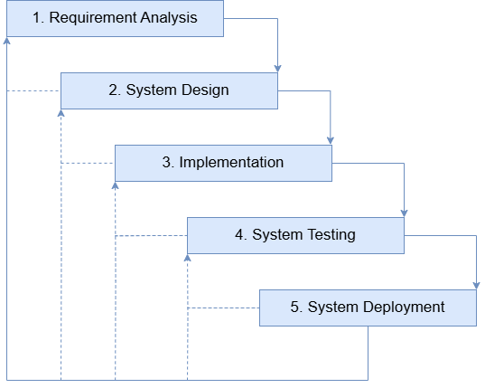
Figure 1: Modified Waterfall SDLC Model (Adopted and modified from the paper of Chunming Gao & Hembroff, 2012)
The project follows a Modified Waterfall Software Development Life Cycle (SDLC) with the following phases: Requirement Analysis, System Design, Implementation, System Testing and System Deployment.

Requirement Analysis
In this phase, the researchers will gather and define all of the needed requirements for the development of the RestauSim: Immersive PoS and Inventory Training System for CLSU DHTM Students. With this step it ensures that the proposed system will help the needs of the 1st year DHTM students.
To create the system, the researchers will conduct an interview with the lecturers handling the subjects to know what are the current process of teaching, challenges and the limitations of the current teaching process. The interview will guide the researcher on what features and functionalities are needed.
The following key activities will be conducted during this phase:

a. User Assessment and Review of the Current Process
The researchers will conduct an interview with the DHTM faculty to gather relevant information about the current process of how the HM 1135 and TM 1135 is taught. The lecturers will be able to provide further suggestions for features and functionalities.

b. Requirement Analysis
Based on the findings from the user assessment, a detailed requirement analysis was conducted to define the necessary features and functionalities of RestauSim. This comprehensive analysis ensures that RestauSim aligns with industry standards while addressing the specific learning needs of DHTM students.

c. Feasibility Study
According to Oregon State University, (2015) feasibility studies are preliminary research done before the main study is being conducted. In the feasibility study it should answer the question “Can this study be done?” before the main study is being conducted. In this case the proposed system will be determined in three aspects which is the technical, operational, and economics. With the help of the feasibility study, it helps the researchers if the proposed system is feasible.
c.1 Technical Feasibility
This will determine if the proposed system is feasible with the current technology or machine. The proposed system will be a web and a mobile application. The researchers conducted an interview with the professors handling the HM and TM 1135 to gain insights into the technical capabilities and potential challenges that users might face when using the system. The findings from the interview will help to align the necessary features and functionality that is needed for the system.

c.2 Operational Feasibility

This feasibility, it assesses if the system can be deployed, implemented, and function properly within the Department of Hospitality and Tourism Management (DHTM) at Central Luzon State University. This feasibility will help to evaluate the practicality of the implementation of the system, its impact on the skills and knowledge of the 1st year CLSU DHTM student.
c.3 Economic Feasibility
This feasibility assesses if the system is financially viable for deploying and implementing the system in the Department of Hospitality and Tourism Management (DHTM) at Central Luzon State University. This feasibility will examine the cost when it comes to the development, deployment and implementation of the system.
The table two (2) shows the activities and deliverables for the Requirement Analysis phase of the Modified Waterfall Software Development Life Cycle.
Table 2: Activities and Deliverables for Requirement Analysis Phase.
 | Activities | Description | Deliverables
1 | User Assessment and Review of the Current Process | Conduct an interview to know the current teaching process of the HM and TM 1135. | Interview findings, list of required system functionalities.
2 | Requirement Analysis | Analyze the interview to create the right features and functionalities aligned to the needs of the 1st year DHTM students | Documented system requirements and specifications.
3 | Technical Feasibility Study | To evaluate whether the system is feasible with the current technology. | Technical Feasibility  Analysis
4 | Operational Feasibility Study | To evaluate whether the system is feasible to deploy and implement to the Department of Hospitality and Tourism Management. | Operational Feasibility Analysis
5 | Economic Feasibility Study | To evaluate whether the system is financially feasible to deploy and implement to the Department of Hospitality and Tourism Management. | Economic Feasibility Analysis

System Design
In this phase, the researchers will create the following diagrams, namely: like Use Case Diagram, Context Diagram, Flowcharts, Data Flow Diagram, Entity - Relationship Diagram, Relational Data Model, Conceptual Framework, and User Interface Design to help visualize the overall proposed system. The following are the diagrams that will be used in designing the system:
- Use Case Diagram
The Use Case Diagram of RestauSim shows how instructors and DHTM students interact with the system. Instructors create and manage simulations and sections, while students join sections, simulates assigned restaurant roles, and run the simulations. The diagram highlights role-based access and user responsibilities within the system.

- Context Diagram
The Context Diagram of RestauSim shows the system’s interaction with external entities, namely DHTM students and instructors. RestauSim acts as the central platform where students join sections and run simulations, while instructors manage students, sections, and simulations. Admin manages faculty accounts. The diagram defines the system boundaries and shows how users exchange data with the system.
- Flowcharts
The flowcharts of RestauSim illustrate the system’s process flows, including user registration, forgotten password, and role-specific activities. Student roles such as manager, cashier, host, kitchen staff, and waiter follow defined workflows for handling orders, payments, inventory, and table management, while instructors manage sections and students. The flowcharts also highlight key decision points, such as login validation and payment verification.
- Data Flow Diagram (DFD)
The Data Flow Diagram of RestauSim illustrates how DHTM students and instructors interact with the system and its data stores. Students create accounts, access assigned simulations, and use the PoS and inventory tools based on their roles, while instructors, roles, sections, and simulation activities. The diagram presents core processes including account management, user and role management, simulation setup and execution, inventory and order management, billing and payment, kitchen and table management, reporting and analytics, and grading. It defines how data flows between users, system processes, and data stores to support the complete restaurant simulation and training workflow.
- Entity - Relationship Model
The Entity–Relationship Diagram (ERD) of RestauSim presents 19 entities that define the system’s database structure, including students, professors, sections, activities, roles, orders, menu and inventory components, payments, grades, and feedback. Each entity contains clearly defined attributes with primary keys to support relationships across simulations, restaurant operations, and academic evaluation. The ERD provides a structured view of how data is organized and interconnected to manage RestauSim’s core functionalities.
- Relational Data Model
The Relational Data Model of RestauSim illustrates how entities are linked through primary and foreign keys. It defines relationships among students, professors, sections, activities, orders, menu items, recipes, inventory, and payments. This model shows data dependencies and ensures consistency across restaurant operations and simulation management within the system.
- Conceptual Framework
The conceptual framework of RestauSim follows the Input–Process–Output (IPO) model. Inputs include users, required hardware and software, and simulation data. The process covers core system functions such as order processing, inventory management, reporting, and simulation, while the output is a functional PoS and inventory training system for DHTM students.
- System Architecture
The system architecture of RestauSim illustrates the interaction between users, the frontend, the web server, the file system, and the database. User actions are processed by the web server, which accesses the file system or database as needed to support system functions.
- User Interface Design
The User Interface Design of RestauSim presents the system prototype that users interact with, including the login screen, student simulation dashboard, instructor dashboard, Point of Sale, and Inventory Management interfaces. The design demonstrates how users navigate and use the system’s core features.
The table three (3) shows the activities and deliverables for the System Design phase of the Modified Waterfall Software Development Life Cycle.
Table 3: Activities and Deliverables for System Design Phase.
# | Activities | Description | Deliverables
1 | Conceptual Framework | Showing the needed input data, how the system will process and what is the output of the system. | Conceptual Framework Diagram
2 | Context Diagram | Creating a high-level diagram to illustrate system boundaries, external entities, and their interactions with the system. | Context Diagram
3 | Data Flow Diagram (DFD) | Visualizing how data moves within the system, including input, output, and processing steps. | Data Flow Diagram
4 | Entity Relationship Diagram | Defining system entities, their attributes, and relationships for database design. | Entity Relationship Diagram
5 | Relational Data Model | Structuring database tables and defining relationships for data storage. | Relational Data Model
6 | Use Case Diagram | Mapping user interactions with the system to define different functionalities and user roles. | Use Case Diagram
7 | Flowchart | Representing the step-by-step process of how the system functions. | Flowchart
8 | User Interface Design | Designing system interfaces to illustrate user navigation and system functionality. | Prototype and Wireframe

Implementation
In this phase, the researchers will now begin to code and develop the system. The visual studio code will be used mainly for building the entire web application.
For the setting up of the development environment the Visual Studio Code will be used for the coding for the web development and the XAMPP will be used to create a local server for testing the components of the system. The backend code of the system will be coded using Laravel which is a PHP framework. For storing important details such as student and professor login credentials, inventory management, PoS content, the MySQL will be used.
The frontend code of the web application will be built using HTML for structuring the web application, TailwindCSS for designing and responsiveness of the web application in various screens and Javascript/Livewire for dynamically updating the details such as restocking of ingredients, adding new stocks etc.
After developing the web, the researchers will now check if the system functions well such as account registration, creating of section and simulation, joining section and simulation, and running simulation, etc. For mobile development, a responsive design will be utilized for the mobile development.
The table four (4) shows the activities and deliverables for the Implementation phase of the Modified Waterfall Software Development Life Cycle.
Table 4: Activities and Deliverables for Implementation Phase.
# | Activities | Description | Deliverables
1 | Setting Up of Development Environment | Set up development environment with Visual Code Studio and XAMPP | Development environment configuration
2 | Backend Development | Writing the backend logic using Laravel. Setting up models, controllers, and routes. Connecting to the MySQL database. | Functional backend with database integration
3 | Frontend Development and Responsiveness | Developing the user interface for the web application. Implementing responsive design and interactive elements. | Web application UI components with a responsive design to mobile, tablets and Laptop/PCs.
4 | Checking of Fully Developed Web-Based System | Verifying that all web functionalities work as expected. Ensuring smooth UI/UX, database connectivity, and feature completeness. | Fully developed and tested web-based system.

System Testing
In this phase, after the development of the web and mobile application a system testing is held. The system testing is done before the system deployment so that it ensures that all of the features and functionalities are working properly for various screen sizes, web browsers, and devices. The system testing also ensures that the system does not have any bugs or errors before the system deployment
The table five (5) shows the activities and deliverables for the System Testing phase of the Modified Waterfall Software Development Life Cycle.
Table 5: Activities and Deliverables for System Testing Phase.
 | Activities | Description | Deliverables
1 | Creation of Test Case | Creating detailed test cases based on system requirements, covering functional, security, and performance aspects. | Documented test cases and testing plan.
2 | Functional Testing | Checking if all features work as expected, including authentication, data processing, and system interactions. | Functional test results and bug reports.
3 | Compatibility Testing | Ensuring that the system works properly on different devices, browsers, and operating systems. | Compatibility test results and necessary adjustments.
4 | Bug Fixing and System Optimization | Addressing issues found during testing and optimizing the system for better performance and stability. | Updated, stable, and optimized system version.
The table 6 shows a table of all the test cases/scenarios together with its test descriptions. The table indicates the list of the scenarios on the system that will be tested and measure if each scenario will pass or fail.
Table 6: Test Cases/Scenarios and Description
# | Test Cases/Scenarios | Test Description
1 | Public Browsing of Content | The system will be tested to ensure the public could view the landing page of the RestauSim
2 | Login using Valid Credentials | The system will be tested to verify that admin, faculty and students can log in using correct email/passwords.
3 | Login using Invalid Email | The system will be tested to ensure users cannot log in with incorrect email
4 | Login using Invalid Email | The system will be tested to ensure users cannot log in with incorrect password
5 | Forgot Password Functionality | The system will be tested to verify that users can successfully request a forgotten password using a valid email address and receive the necessary instructions.
6 | Login/Registration with Third Party Application (Gmail) | The system will be tested to ensure that users can log in using their Gmail credentials successfully.
7 | Registration of Student Account | The system will be tested to verify that users or students can create an account with their details.
8 | User Login (Faculty) | The system will be tested to verify that users can log in successfully and access all features based on their user-role.
9 | Faculty Creates a New Section | The system will be tested to verify that faculty can create a new section.
10 | Faculty Invites Students via Email | The system will be tested to verify that faculty can invite students via email.
11 | Faculty Copies Section Invite Link | The system will be tested to verify that faculty can archive a section.
12 | Faculty Archives Section | The system will be tested to verify that faculty can archive a section.
13 | Faculty Creates new Activity | The system will be tested to verify that faculty can create a new activity.
14 | Faculty Creates Announcements | The system will be tested to verify that faculty can create new announcements.
15 | Faculty Grades a Simulation Activity | The system will be tested to verify that faculty can grade a submitted simulation activity.
16 | User Login (Student) | The system will be tested to verify that users can log in successfully and access all features based on their user-role.
17 | Student Joins via Code | The system will be tested to verify that students can join the section via code provided by the faculty.
18 | Student Joins via Email Invitation | The system will be tested to verify that student can join section via email invitation by the faculty
19 | Student Access the Simulation | The system will be tested to verify that students can access the simulation based on the role given by the faculty.
20 | Student Access their Score/Grades | The system will be tested to verify that students can access the scores/grades on their submitted simulations.
21 | User Login (Admin) | The system will be tested to verify that users can log in successfully and access all features based on their user-role.
22 - A | Create Faculty Account  (via Dashboard) | The system will be tested to verify that the admin can create new faculty account
22 - B | Create Faculty Account  (via Faculty Page) | The system will be tested to verify that the admin can create new faculty account
23 | Manager Can Add New Inventory Items | The system will be tested to verify that the manager can add new inventory items to the system.
24 | Manager can Restock Inventory | The system will be tested to verify that manager can restock inventory into the system
25 | Manager can Create New Menu Item | The system will be tested to verify that the manager can add new menu items to the system
26 | Manager can Upload/Update Dining Layout | The system will be tested to verify that manager can upload or update the dining layout
27 | Manager can Access Reports and Analytics | The system will be tested to verify that managers can access the reports and analytics.
28 | Waiter can Access the Dining Layout | The system will be tested to verify that the waiter can access the dining layout.
29 | Waiter can Create Orders | The system will be tested to verify that waiters can create new orders
30 | Waiter can Modify Table Status | The system will be tested to verify that waiter can modify table status (e.g. Dirty, Available, Occupied)
31 | Waiter can Transfer Customer Between Tables | The system will be tested to verify that waiter can transfer to different tables
32 | Waiter can Combine Tables | The system will be tested to verify that waiters can combine two or more tables
33 | Waiter can Send Orders to the Kitchen | The system will be tested to verify that waiter can send orders to the kitchen
34 | Cashier can Process Customer Payments | The system will be tested to verify that cashier can process customer payment
35 | Cashier can Generate Receipt | The system will be tested to verify that cashier can generate receipts based on the customers order
36 | Kitchen Staff can Access Orders | The system will be tested to verify that kitchen staff can access the orders
37 | Kitchen Staff can Update Order Status | The system will be tested to verify that kitchen staff can update order status
38 | Manager can Download Sales Reports | The system will be tested to verify that the manager can download sales reports based on the active filter.
39 | Manager can Download Inventory Reports | The system will be tested to verify that the manager can download sales reports based on the active filter.
40 | User Accessing Profile Settings | The system will be tested to verify users can access and update their profile
41 | User can Change Password | The system will be tested to verify users can change their password
42 | User can Delete their Account | The system will be tested to verify users can delete their existing account
43 | Role Based Access Control | The system will be tested to verify that each role can only access its allowed modules.

System Deployment
In this phase, the system is deployed in the Department of Hospitality and Tourism Management for real-world use. It will be tested to gather feedback and make any necessary refinements that the DHTM Student sees when they try the system. Security measures, such as user authentication, encryption, and data backups, will also be enforced to protect system integrity and user data. Also in this the researchers will gather insights from the IT Experts, DHTM Faculty and DHTM Students from the deployed system.
The table seven (7) shows the activities and deliverables for the System Deployment phase of the Modified Waterfall Software Development Life Cycle.
Table 7: Activities and Deliverables for System Deployment Phase.
# | Activities | Description | Deliverables
1 | System Deployment on Live Server | Upload the system files to the hosting server and configure the necessary deployment settings. Ensure that both the web and mobile applications are accessible. | Fully operational web and mobile applications
2 | Configure hosting, domain, and database connections | Set up the domain, hosting server, and database environment to ensure smooth connectivity and data flow. Update environment variables for production | Properly configured server and database
3 | Test system accessibility and responsiveness on different devices | Verify that the system functions correctly across various devices, including desktops, tablets, and smartphones, ensuring a seamless user experience. | System compatibility report
4 | Ensure backup and recovery mechanisms are in place | Implement data backup strategies and test recovery procedures to minimize data loss in case of system failure. | Backup and recovery documentation
5 | Provide system documentation for administrators and users | Create detailed technical and user documentation, including installation guides, troubleshooting steps, and feature explanations. | User manual and technical documentation
6 | Evaluation of the Deployed System | Create a different evaluation for the IT Experts, DHTM Faculty and DHTM Students | Evaluation Report for IT Experts, DHTM Faculty and

CHAPTER IV

RESULT AND DISCUSSION
This chapter presents the results obtained during the development, deployment, and evaluation of the system. It discusses the outcomes of each phase of the methodology using the Modified Waterfall Software Development Life Cycle (SDLC) Model, the Requirements Analysis, System Design, Implementation, System Testing and System Deployment phases. How each phase of the study contributed to solving the organizational problems identified in the earlier chapters, and it interprets these results in light of related studies and industry standards. Tables and figures are included to visualize the system outputs, while the discussion highlights their significance to the study’s objectives and related research.

Requirement Analysis
The requirements were conducted through interviews. The primary issues identified include the lack of a simulation system for PoS and Inventory Management System.
- User Assessment and Review of the Current Process
The researchers conducted interviews to the faculty of the Department of Hospitality and Tourism Management. Their feedback was reviewed and evaluated by the researchers to finalize the features of the system. From these discussions, several problems were identified and these findings guided the researchers for their system’s objective
Table 8. Client Interview Answers
Interview Questions | Answers
What is the current process of teaching for the Lecture part of the HM & TM 1135? | The lecture part of HM & TM 1135 focuses on familiarizing students with the relevant tools and technologies through explanations, demonstrations, and practical examples to enhance their understanding and application.
What is the current process of teaching for the Laboratory part of the HM & TM 1135? | The laboratory part of HM & TM 1135 involves hands-on activities where students identify and compare traditional and technological tools, practice tasks such as creating email signatures, and perform secretarial and IoT-related activities like faxing, photocopying, and other administrative functions.
Are there any tools or technologies that are used for the Lecture/Laboratory of HM & TM 1135? | Yes
If there are tools or technologies used, can you list them? | The tools and technologies used for the lecture and laboratory of HM & TM 1135 include Virtual Reality (VR) technology, which allows students to engage in immersive and interactive learning experiences.
How do the teachers/professors assess the student skills and understanding of the lessons for the HM & TM 1135? | Teachers and professors assess students’ skills and understanding in HM & TM 1135 through a combination of exams, quizzes, projects, and laboratory reports, which evaluate both their theoretical knowledge and practical application of the lessons.
What challenges are experienced in the current teaching process? | Limited access to physical tools, time constraints during laboratory sessions, and difficulty in monitoring individual student performance.
How do teachers assess students’ skills and understanding? | A more structured, immersive, and measurable training platform that enhances student engagement and skill development.
What features do you suggest to be included? | Order Management, Inventory Management, Point of Sale, Kitchen Display System, Billing and Payment Processing and Reporting and Analytics.
How do instructors currently monitor individual student performance during laboratory activities? | Monitoring is mostly manual. Instructors observe students during activities and review outputs such as lab reports and projects, which can be time-consuming and sometimes difficult with large classes.
What type of feedback system would be helpful for students? | Immediate feedback after completing tasks or simulations would help students identify mistakes and improve their skills before formal assessments.

Current Process Flowchart
The Current Process Flowchart illustrates the existing teaching process for HM & TM 1135 before the implementation of the proposed system of the RestauSim System. It provides a visual representation of how instructional activities laboratory exercises, and student assessments are currently conducted within the course. This diagram helps to identify the manual steps and how lessons are delivered in the current process. This serves as the foundation for designing a more efficient system that minimizes manual processes, reduces human errors, and lessens the delays in monitoring and evaluating student performance by providing a more organized and interactive system.
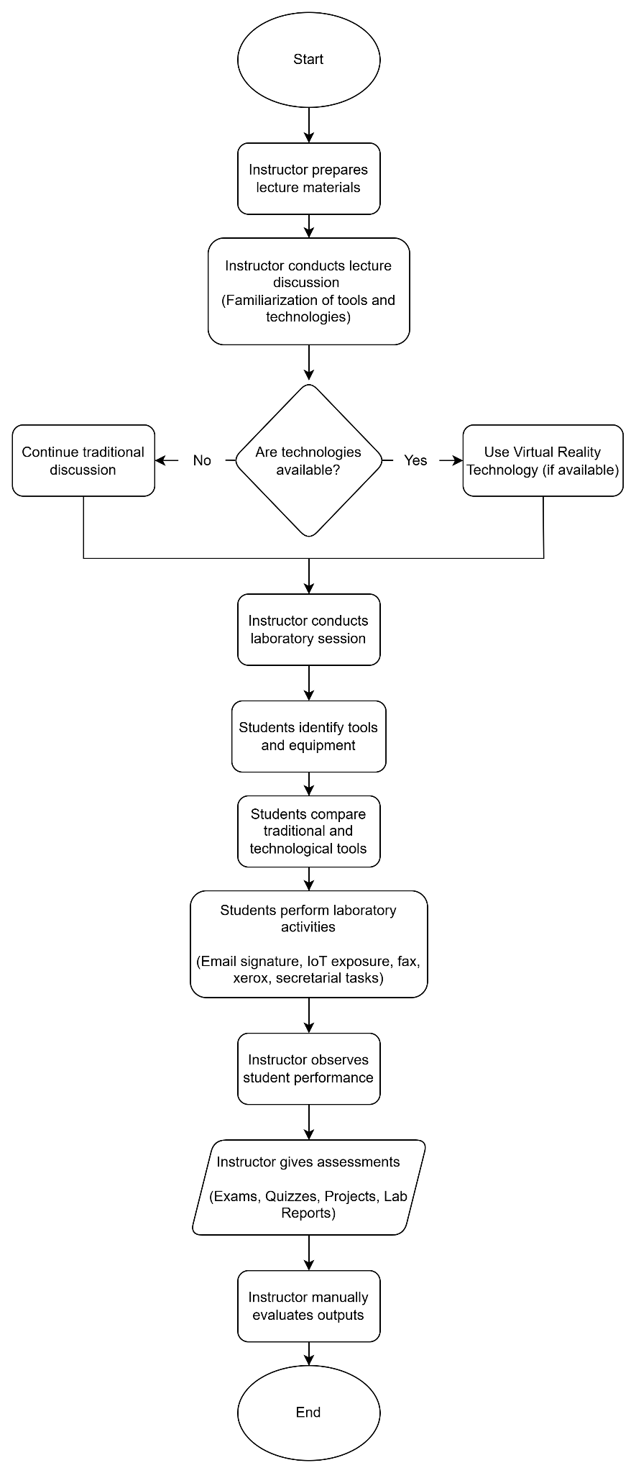
Figure 2. Current Process Flowchart of RestauSim
The Current Process Flowchart of RestauSim shown in Figure 2 shows how the teaching process for HM & TM 1135 is currently done before the implementation of the RestauSim system. It illustrates a visual representation of how instructional activities, laboratory exercises, and student assessments are currently conducted within the course.
The diagram helps to show that the current teaching method mostly relies on discussions and manual activities. It also shows that there is no complete system that allows students to fully visualize and simulate real restaurant operations. As a result, students may struggle to fully understand real restaurant operations, leading to limited engagement and practical experience.

Feasibility Study
This evaluates viability of the proposed RestauSim system in terms of technical, operational, and economical feasibility. It ensures that the system is practical, manageable, and sustainable for long-term use in improving the learning experience and enhancing student’s understanding of restaurant operations.
- Technical Feasibility
The proposed system is technically feasible, as it was checked to make sure that the necessary technologies and skills are available and manageable. The system was developed using open-source and widely supported tools, which makes it cost-effective and sustainable. It can run smoothly on standard computers and only need a stable internet connection and a web browser for students and instructors to access it. The following table shows the minimum and recommended hardware and software requirements, as well as the current system setup used during the development and testing of the system

Table 9.1. Open-source Software Tools
Software Name | Purpose | Version | Usage in the System
XAMPP | Local Server Development | v.3.3.0 | To host and test the  system locally with  Apache, PHP, and  MySQL support.
Visual Studio Code | Source Code Editor | v.1.109.5 | It is the preferred  IDE for coding
Github | Version Control | Web-based | To manage source  code, track  changes, and  support  collaboration
Figma | UI/UX Design and Prototyping Tool | Web-based | To create and  collaborate on  system interface  designs,  wireframes, and  interactive  prototypes for  frontend  development.

Table 9.1 shows the software tools that were needed in the development of the system. These tools provided the necessary environment and support for coding, testing, and collaboration. XAMPP was used to create a local server environment, allowing the developers to run and test the system with integrated Apache, PHP and MySQL support. Visual Studio Code was the choice of the developers as the primary code editor, offering features for efficient coding, debugging and managing of the system files. Github was used as a central repository, mainly used for version control for the code and efficient collaboration of the developers. Figma was used for designing the user interface and creating the prototype of the system.
Table 9.2. Back-End Technologies Used
Software Name | Purpose | Version | Usage in the System
Laravel | PHP web application framework | Laravel 12.0 | Handles backend logic, authentication, routing, and database management.
MySQL | Relational database management system | MySQL 8.3.0 | To store, manage,  and retrieve, student, faculty and simulation data
Livewire | Dynamic Laravel interface framework | Livewire 3.6.4 | Powers interactive POS, dashboards, and real-time components.
Konva | Interactive HTML5 canvas library | Konva 10.2.0 | Manages tables and interactive floor plan layouts.
ChartJS | JavaScript data visualization library | Chart,js 4.5.1 | Displays sales analytics, reports, and dashboard visualizations.

Table 9.2 shows the backend technologies used in the development of the system. Laravel was used as the core backend framework of the system. It manages the routing, authentication, middleware and business logic. It also handles the database operations through the Eloquent ORM ensuring a secure and structured data processing for different modules such as PoS transaction, inventory management, floor plan control and report generations. MySQL served as the database management system for storing and retrieving student, faculty and simulation records. Livewire utilizes the creation of interactive components with minimal JavaScript by allowing real-time UI updates for various modules like POS interfaces, kitchen dashboards, floor plans, and inventory monitoring. Konva is used to manage the interactive floor plan, enabling users to manipulate table arrangements visually. Chart.js provides data visualization through graphical reports on sales trends, revenue summaries, inventory movement, and performance analytics, allowing an effective data analysis.
Table 9.3. Front-End Technologies
Software Name | Purpose | Version | Usage in the System
HTML | Web Content Structure | HTML5 | To create the  structure and layout  of the system’s  interface.
TailwindCSS | Styling and Design | Tailwind 4.1.12 | To style the  interface and  improve user  experience.
JavaScript | Client-side Scripting | ES2025 | To make the system  interactive and  handle client-side  logic.
JSON | Data Format |  | used to structure, transfer, and process report and analytics data for dashboard visualizations.

Table 9.3 shows the frontend technologies used in the development of the system. These technologies ensured that the system was responsive, interactive, and accessible across devices. HTML and TailwindCSS were used to build the structure and styling of the system’s interface, while JavaScript handled interactivity and client-side logic. JSON was used to structure, transfer, and process report and analytics data for dashboard visualizations.
Table 9.4. Minimum System Requirements
Category | Component | Minimum  Specification | Recommended  Specification | Current  Specification  Used
Hardware | Processor  (CPU) | Intel Core i3  (2.4 GHz) or  equivalent | Intel Core i5  (3.0 GHz) or  higher | Intel Core i5 -  1135G7 @ 2.40  GHz
 | Memory  (RAM) | 4 GB | 8 GB or higher | 8 GB DDR4
 | Storage | 250 GB HDD | 500 GB SSD | 512 GB SSD
 | Display | 1280 × 720  resolution | 1920 × 1080  resolution | 1920 × 1080  resolution
 | Network | 5 Mbps internet  connection | 10 Mbps or  higher  broadband | 25 Mbps  broadband
 | Peripherals | Keyboard,  Mouse | Keyboard,  Mouse,  External  Storage  (optional) | Keyboard,  Mouse
Software | Operating  System | Windows 10 /  Linux Ubuntu  20.04 | Windows 11 /  Linux Ubuntu  22.04 | Windows 11  Pro 64 -b it
 | Web Server | Apache / Nginx | Apache 2.4+  with PHP 8.x | Apache 2.4  with PHP 8.1
 | Database  Server | MySQL 5.7 | MySQL 8.0 or  higher | MySQL 8.0
 | Programming  Language | PHP 7.4 | PHP 8.1 or  higher | PHP 8.1
 | Framework | Laravel 8 | Laravel 10 | Laravel 10
 | Development  Tools | Visual Studio  Code | Visual Studio  Code /  PhpStorm | Visual Studio  Code
 | Web Browser | GoogleChrome  / Mozilla  Firefox | Latest versions  of Chrome,  Edge, or  Firefox | GoogleChrome  (latest)

The hardware and software needed for the system are easy to find and can be used without difficulty, making sure everything runs smoothly and works well with the available equipment. The setup that is used during the development also meets and even exceeds the recommended requirements, which shows that the system is technically feasible, manageable, and ready to improve or upgrade in the future.
- Operational Feasibility
The RestauSim: Immersive PoS and Inventory Training System for CLSU DHTM Students was designed to be user-friendly, intuitive, and aligned with the learning needs of Hospitality and Tourism Management students. The system interface was structured to simulate a real-world restaurant Point-of-Sale (PoS) and inventory environment while maintaining simplicity for academic use. The researchers also provided a user manual and conducted basic training for faculty and students to help them operate and navigate the system. Since the users already had basic knowledge with smartphones and web applications, they were able to operate the system with little supervision. With these supports, the system was proven to be operationally feasible and ready for adoption.
- Economical Feasibility
This evaluates whether the project is financially practical by analyzing estimated cost against project benefits.
- Estimated Cost - The RestauSim was developed using free and open-source resources, eliminating cost normally for implementation. Tools such as IDEs, framework and collaboration platforms were all free, while hardware and internet services were already provided by the development team.
Table 10. Estimated Cost of the RestauSim Implementation
Expense Item | Estimated Cost (PHP) | Frequency | Notes
Hosting | 491.68 (including tax) | Monthly | For system deployment and storage
Domain Name | 570.08 (including tax) | Annually | For registering the domain name
Development Laptops/PCs | 0 | Free | Already available from the development team
Internet Connection | 0 | Free | Already available from the development team
IDEs / Code Editors,  Frameworks &  Languages (Laravel,  PHP, MySQL,  HTML, TailwindCSS,  JavaScript) | 0 | Free | Open source tools
Collaboration Tools  (GitHub) | 0 | Continuous | Free versions used for  project management  and version control.
SSL Certificate | 0 | Annual | Included in hosting;  no additional  expense.

The chosen web-based hosting platform supports all required technologies, ensuring smooth deployment and consistent system performance. The system was hosted through Hostinger for a duration of one month. This temporary hosting setup was primarily used for testing, evaluation, and demonstration purposes to assess the system’s performance and functionality in a live environment.
Upon completion of the testing and evaluation phase, the system was formally turned over to the Department of Hospitality and Tourism Management (DHTM) of Central Luzon State University (CLSU). The turnover process included the transfer of complete system files, source code, database backups, deployment documentation, and user manuals. Administrative credentials and access details were securely handed over to the designated faculty to ensure full control and future system management. An orientation and system presentation were conducted to familiarize the department with the system’s functionality, ensuring a smooth and sustainable transition.

System Design
The system was designed using a role-based access model, ensuring that administrator, faculty and students had defined responsibilities. A layered architecture supported scalability, while the database schema facilitated efficient handling of member, volunteer, and content data. Flowcharts, ERD, and DFDs were produced to visualize system logic.
- Use Case Diagram
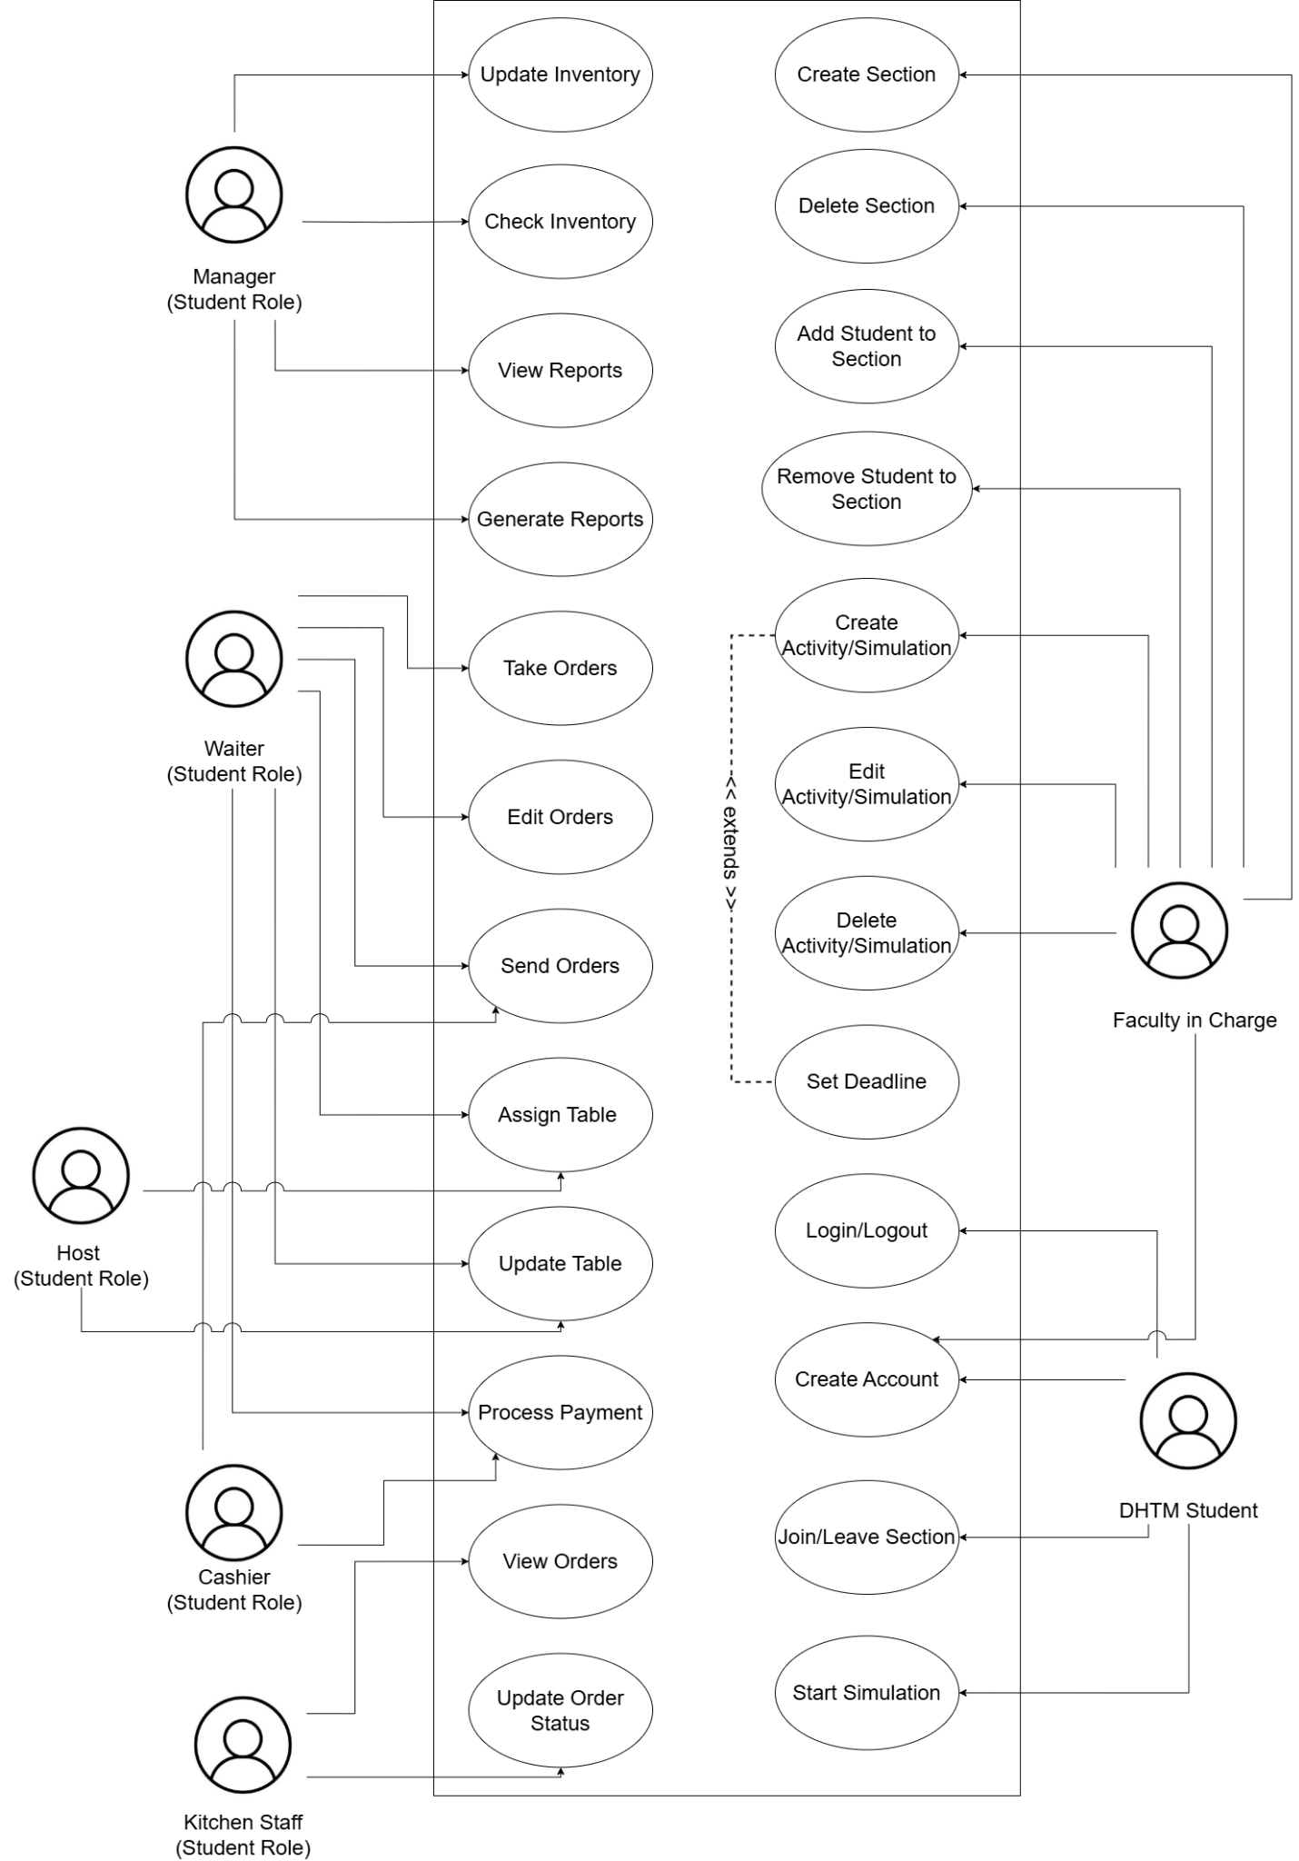
Figure 3. Use Case Diagram
The Use Case Diagram for RestauSim showed how DHTM students and instructors interacted with the system. RestauSim simulated a restaurant setting where students were given roles such as manager, waiter, kitchen staff, host, and cashier. These roles were assigned during a simulation activity created by the instructor or professor. Each role had specific access, allowing students to experience real restaurant operations. Instructors handled the management of simulations and sections, while DHTM students joined sections and participated in the simulations. Overall, the diagram helped explain what each user could do within the system.
- Context Diagram
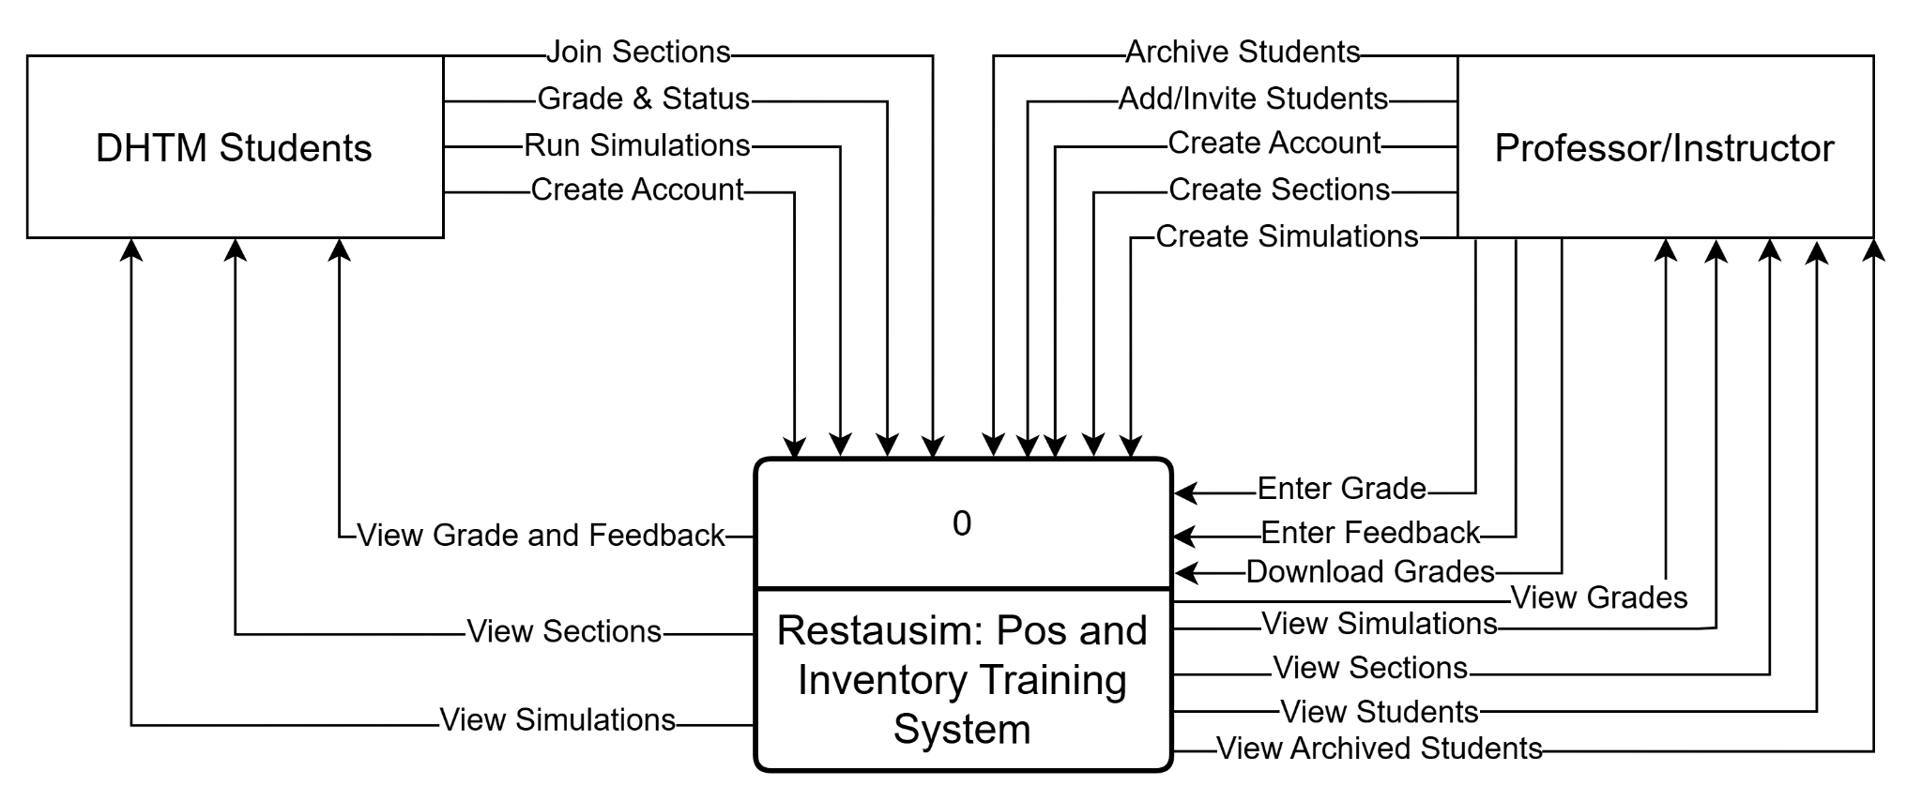
Figure 4. Context Diagram
The Context Diagram of RestauSim showed the interaction between the system and the external entities, which were the DHTM students and the instructors or professors. RestauSim served as the central platform where DHTM students were able to create an account, join assigned sections, run simulations, and view their sections and simulations. Instructors or professors interacted with the system by archiving students, adding or inviting DHTM students, creating accounts, and creating sections and simulations. They also viewed created sections and simulations, as well as active and archived students. This diagram defined the system boundaries and highlighted the exchange of data between the users and the RestauSim platform, providing a clear view of how users interacted with the system’s training functions.
- Flowcharts
The flowcharts for RestauSim showed the specific process flow within the system, including user registration and the forgotten password process. They also illustrated the five student roles and their functions in the simulation. The manager handled access to the point-of-sale (PoS), inventory, menu and reports and analytics. The cashier processed payments and generated receipts. The host managed table access and table status. The kitchen staff received orders from the waiter and updated the order status. The waiter took customer orders, handled payments, and updated the table status. The flowcharts also covered the instructor or professor role, which included creating sections, viewing created sections, and viewing all students. In addition, the flowcharts showed decision points such as verifying correct login credentials and checking payment status.

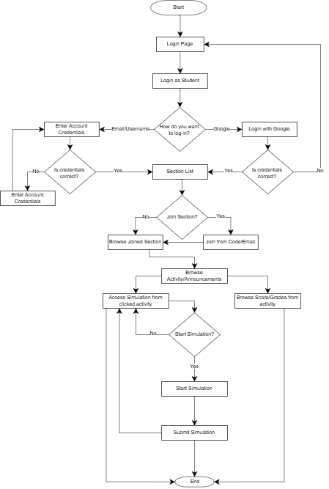
- Student Flowchart
Figure 5: Flowchart for Student
The Figure 5 flowchart represents how a student interacts with the system. It outlines the steps from accessing the system and entering their login details to viewing their assigned sections. Once inside a section, students can check announcements, explore posted activities, review their scores, and participate in simulation tasks. The diagram shows a clear and organized flow that supports students in accessing course materials, completing tasks, and keeping their track of progress.
- Faculty Flowchart
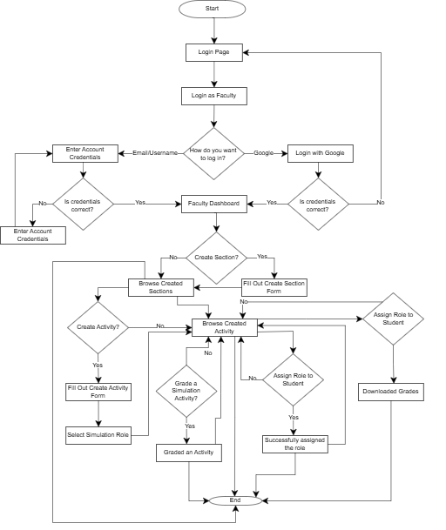
Figure 6: Flowchart for Faculty
The Figure 6 flowchart outlines how instructors manage their classes and activities within the system. It highlights the steps on how the instructors are given access to tools that allow them to organize sections, create simulation activities, assign student roles, and monitor performance. This process shows how the system helps instructors manage teaching tasks in a more organized and efficient way.
- Simulation Role: Manager Flowchart
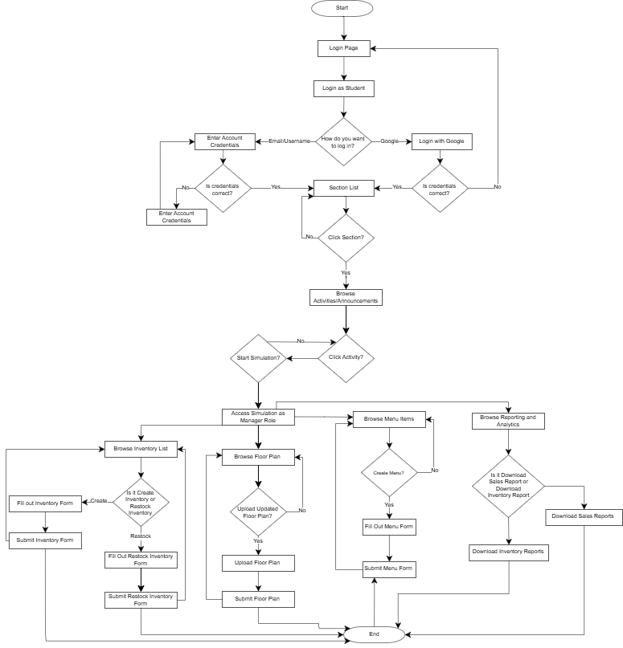
Figure 7: Manager Flowchart
- Data Flow Diagram (Level 1)
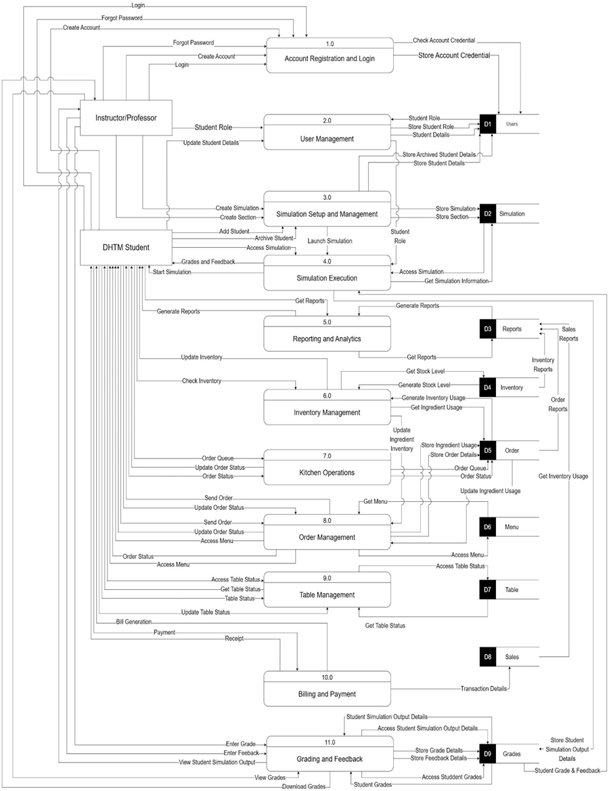
Figure 19: Data Flow Diagram of the RestauSim
The data flow diagram of the RestauSim wherein the DHTM Students can create an account, access the activities that are uploaded by the instructor in the simulation, access the PoS and Inventory Management tool based on their role given by the instructor/professor. The instructor/professor can also create an account, upload and manage activities to the simulation and change or update roles of the DHTM students.
- Data Flow Diagram (Level 2)
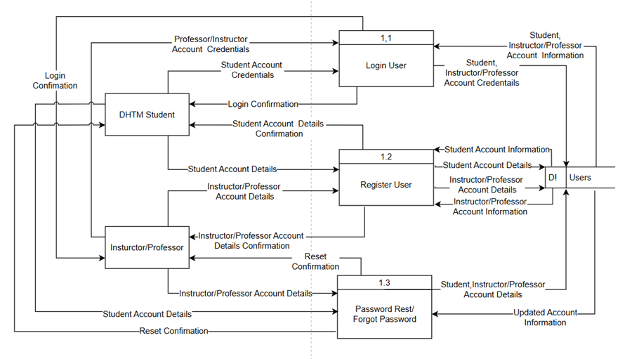
Figure 20: Exploded Data Flow Diagram Process 1
Figure 20, Process one (1) is for account registration and login. Here DHTM students and instructor/professor can create an account, then it will store in the user data store. DHTM students and instructor/professor can login with the account credentials that they used in the account creation, if the account credentials match in the user data store, the DHTM students and instructor/professor will now log into the system. DHTM students and Instructor/Professor can also forget their password.
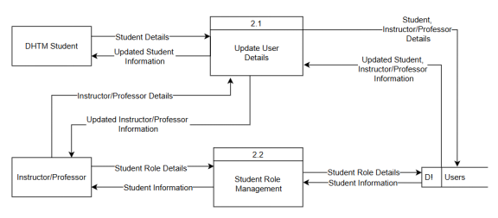Figure 21: Exploded Data Flow Diagram Process 2
Figure 21, Process two (2), user management, it manages all of the roles of the DHTM students by the instructor/professor. The instructor/professor can give and change roles of the DHTM students, it is stored in the users data store. DHTM Students can also update their details.

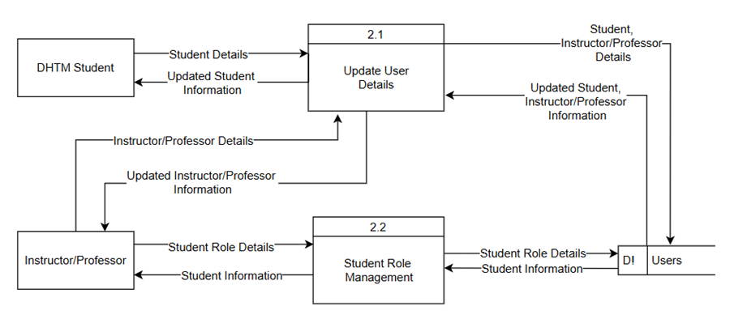
Figure 22: Exploded Data Flow Diagram Process 3
Figure 22, Process three (3), Simulation Setup and Management, manages the simulation and the sections, the instructor/professor can create and assign simulation activities to the sections that they created, after creating and assigning it to the section it will store in the simulation data store. Instructors/Professors can add or archive students.
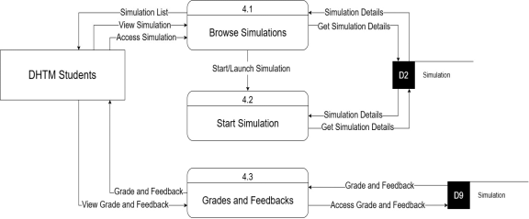
Figure 23: Exploded Data Flow Diagram Process 4
Figure 23, Process four (4), Simulation Execution, acts as a central point to access/view the simulation or to start or launch a simulation assigned to the student.
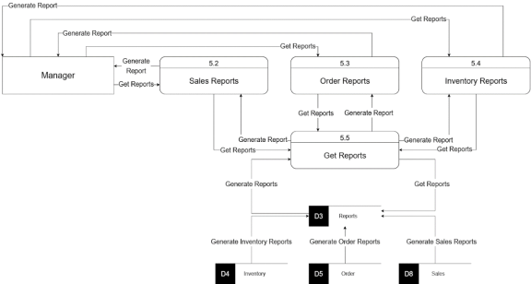
Figure 24: Exploded Data Flow Diagram Process 5
Figure 24, Process five (5), Reporting and Analytics, handles all of the reports from the inventory, sales, and order reports. The inventory reports come from the inventory data store, sales reports come from the transaction data stores and the order reports come from the order data store. The manager can create and access reports from these data stores, then the generated reports are stored in the reports data store.
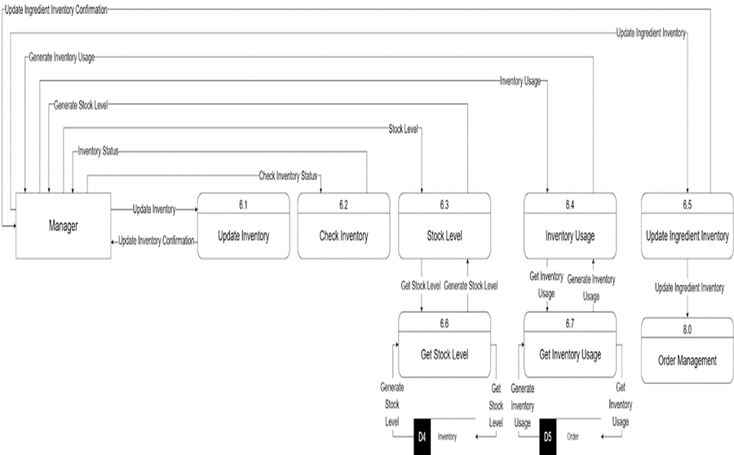
Figure 25: Exploded Data Flow Diagram Process 6
Figure 25, Process six (6), Inventory Management, handles all of the inventory practices from getting inventory usage to creating an inventory report. To get and generate a stock level it will get from the inventory data store. To get an inventory usage it will get from the order data store. The manager can check and update the inventory stock levels and generate an inventory report from the inventory data store.
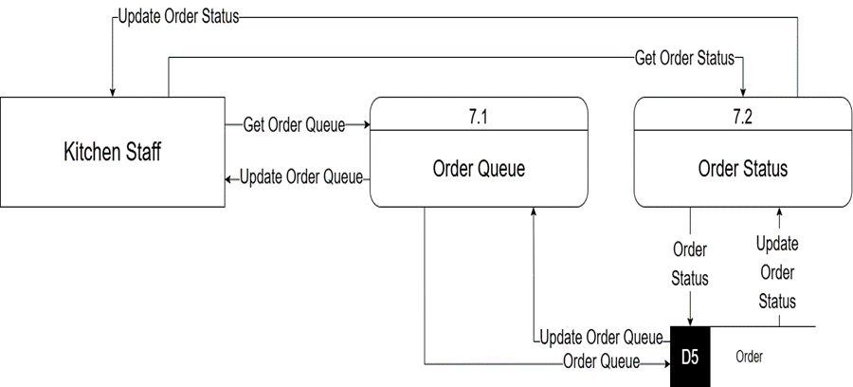
Figure 26: Exploded Data Flow Diagram Process 7
Figure 26, Process seven (7), presents the kitchen. It manages all of the orders of the customers, kitchen staff receive orders, updates order status, checks order queue, and sends completed orders, the order queue stores and gets from the order data store.
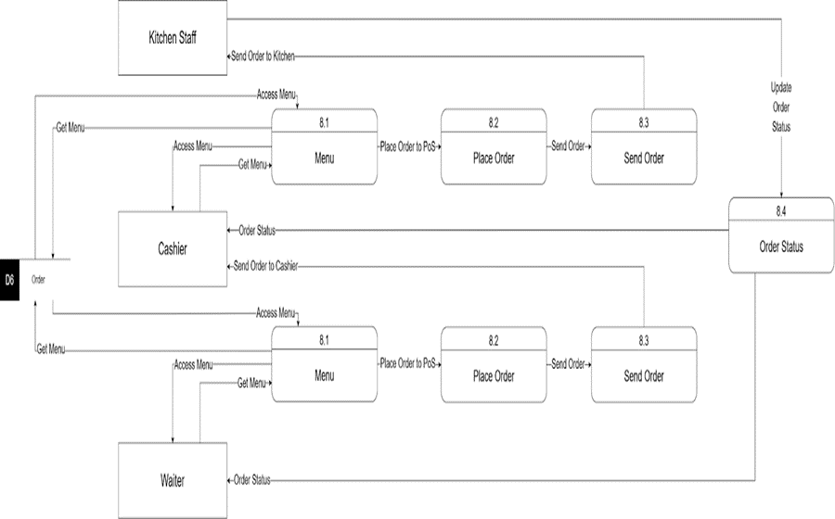
Figure 27: Exploded Data Flow Diagram Process 8
Figure 27, Process eight (8), Order Management, manages all of the order processing from the order entry to sending of orders to the customer. The order entry gets and accesses the menu from the menu data store. The order details of the customer is also sent in the kitchen. The order details and ingredient usage is stored in the order data store. The completed orders are sent to the billing and payment process. From the order data store, the order management gets an updated ingredient usage and sends an inventory usage to the inventory management process. The table occupied by the customer is updated also in the table data store.
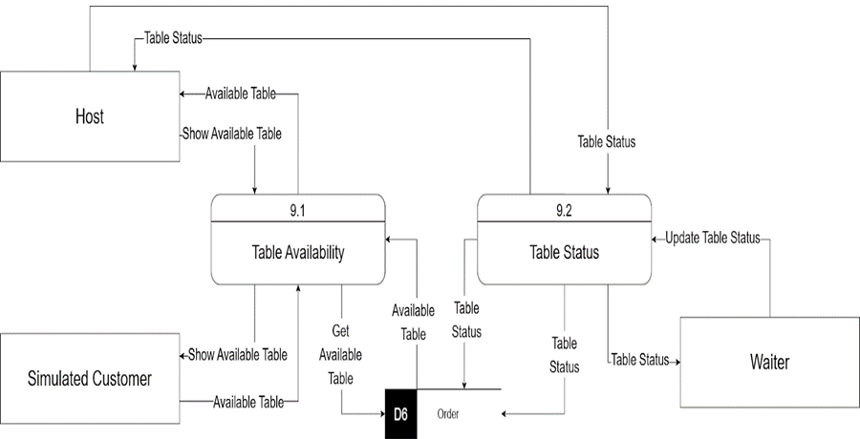
Figure 28: Exploded Data Flow Diagram Process 9
Figure 28, Process nine (9), Table Management, manages all of the table management for the table reservation and dine in. The host is responsible for the table management, he/she can access the table status from the table data store, and show it to the customer based on the reservation and availability.

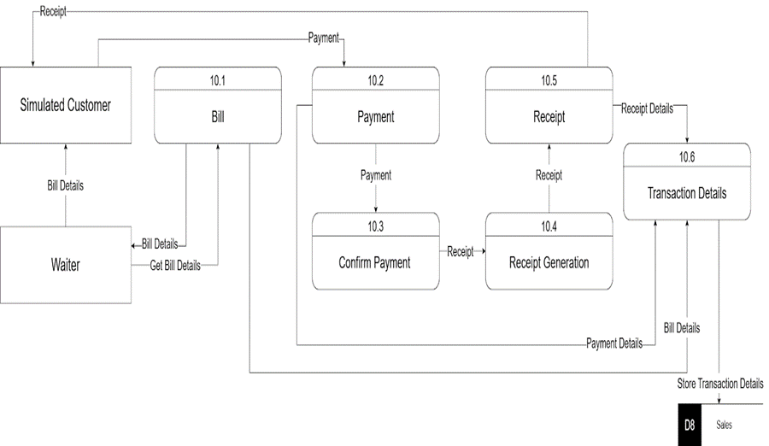
Figure 29: Exploded Data Flow Diagram Process 10
Figure 29, Process ten (10), Billing And Payment, it handles all of the billing and the payment of the customer. The customer receives their bills and gives the payment, then the billing and payment sends the payment to the order management process it stores in the sales data store.
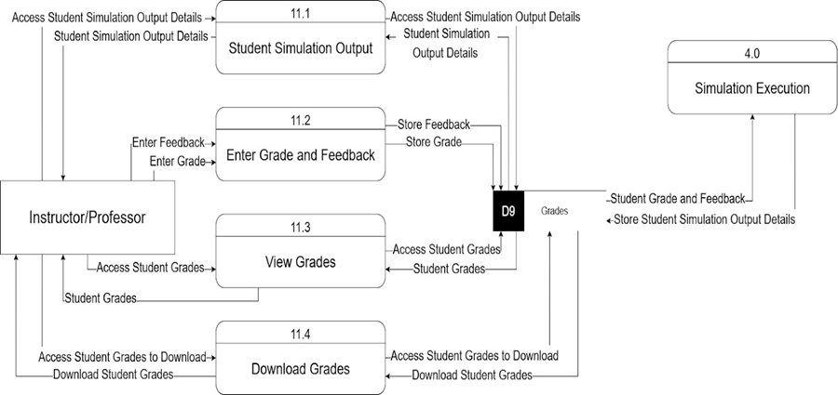
Figure 30: Exploded Data Flow Diagram Process 11
Figure 30, Process eleven (11), Grading And Reporting; this handles all of the grading and feedback of the faculty in charge. The student simulation output details are stored in the grades data store. Faculty in charge can grade and create feedback on the student simulation output and store it in the grades data store. Faculty in charge can also download the grades depending on their preference if per section or per semester.
- Entity-Relationship Model
.
Figure 31: Entity-Relationship Model
- Relational Data Model
.
Figure 32: Relational Data Model
- Conceptual Framework
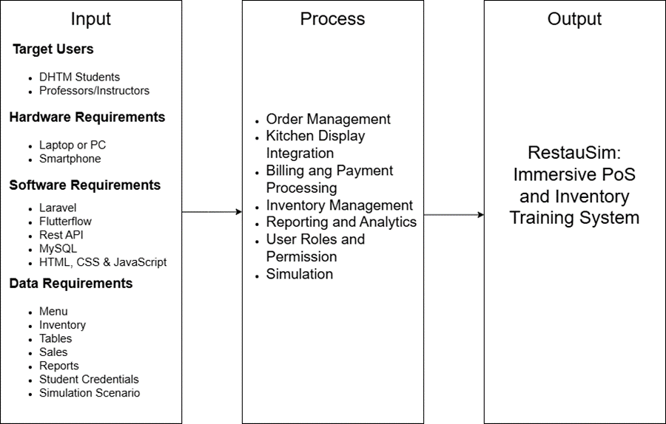
Figure 34: Conceptual Framework of the RestauSim
The conceptual framework for RestauSim outlines the overall structure of the system using the IPO (Input-Process-Output) model. Inputs include DHTM students and instructors as users, supported by required hardware (PCs, smartphones) and software tools (Laravel, FlutterFlow, MySQL, etc.), along with key data such as menus, inventory, and simulation scenarios. The process component includes functions like order management, kitchen display integration, payment processing, inventory tracking, reporting, and simulation. The output is a fully functional PoS and inventory training tool where DHTM students can practice their skills and knowledge.
- System Architecture
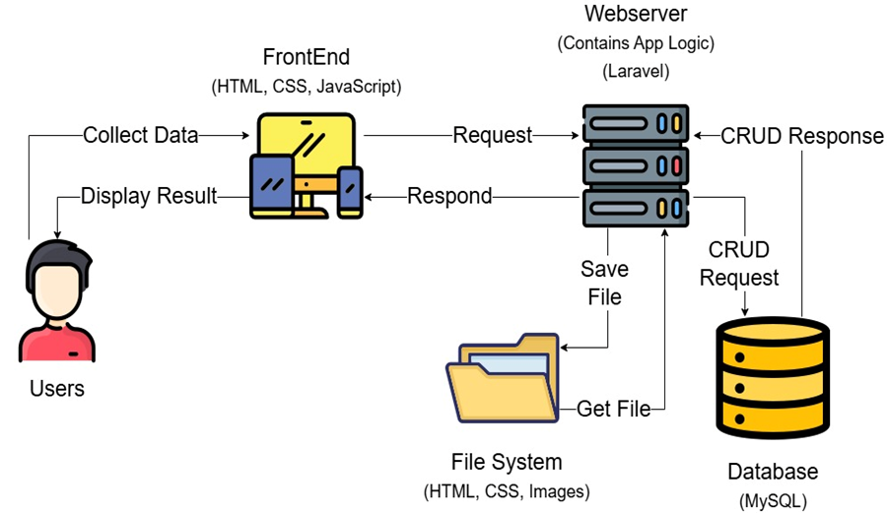
Figure 35: System Architecture of RestauSim
The system architecture for RestauSim outlines the overall structure of the system with the users, frontend, web server, file system and the database. Users can access the system through the frontend, if they do something in the system, such as login, start simulation, it will now request in the web server then depending on the action, it will access the file system or the database.

Implementation
The development of the RestauSim:Immersive PoS and Inventory Training System for CLSU DHTM Students began in August 2025 right after completing the requirement analysis and the system design including the prototype which helps the development team to visualize the overall workflow and design of the system
The development team converted the prototype into a functional web application for the CLSU DHTM. It was developed using the Traditional Waterfall Software Development Life Cycle (SDLC) Model approach. Using the requirement analysis that was done, the system was now coded, integrated and tested in the local development server.
Coding Environment, Technologies, Framework, Software Used
The core backend of the system was developed using the Laravel PHP framework, supported by MySQL for database management. The frontend was built using HTML, TailwindCSS, and JavaScript to ensure a responsive, user-friendly, and modern interface. Version control and collaborative development were efficiently managed through GitHub, which provided centralized repository access, structured branching, and systematic tracking of code changes throughout the development lifecycle.
The system architecture was organized into two primary modules: the Classroom Module and the Simulation Module. To improve scalability, maintainability, and feature tracking, each primary module was further divided into smaller submodules. This modular approach allowed for incremental development, systematic testing, and efficient monitoring of completed functionalities.
Both modules were primarily developed using PHP, HTML, and TailwindCSS. However, additional technologies were strategically integrated based on functional requirements. In the Classroom Module, JavaScript was utilized to enhance interactivity, dynamic content rendering, and user experience. In the Simulation Module, Livewire was implemented to enable reactive, real-time components without extensive JavaScript complexity. Furthermore, Konva was used to manage interactive floor plan layouts and table positioning, while Chart.js was integrated to generate sales analytics, reports, and dashboard visualizations for performance monitoring and decision-making support.
Throughout the development process, the primary focus was on implementing the system’s core functionalities, including user authentication and role management, classroom activity management, order processing, payment handling, inventory tracking, sales recording, report generation, and simulation logging. By the end of the development phase, the system evolved into a fully functional training platform that enables students to realistically simulate real-world Point-of-Sale (PoS) and Inventory Management operations. This immersive approach supports experiential learning by allowing students to practice transactional workflows, inventory monitoring, and operational decision-making within a controlled digital environment.

Table 11: Technology Used in the Implementation Phase
Component | Technology/Tool Used | Version (if applicable)
Programming Language | HTML  PHP  JavaScript | HTML5  PHP 8.2  ES2025
Framework | Laravel  TailwindCSS  Livewire | Laravel 12.0  Tailwind 4.1.12  Livewire 3.6.4
JavaScript Library | ChartJS  Konva | Chart,js 4.5.1  Konva 10.2.0
Database | MySQL | MySQL 8.3.0
Integrated Development  Environment (IDE) | Visual Studio Code | v.1.109.5
Version Control | Github | v. 2.53.0
Implementation of System Features
- Section Management: Designed to provide a centralized platform for faculty to create activities, manage student submissions, and grade assignments, while giving students access to all simulation activities.
- Role-Based Access Control: Implemented to assign specific access levels for managers, cashiers, kitchen staff, hosts, and waiters, while enabling instructors to manage sections and students, and allowing students to access simulation activities according to role assigned.
- Order Management: Developed to allow the students to experience creating and customizing orders of the customer, and modify orders before sending them to the kitchen.
- Kitchen Display Integration: Integrated to allow students to track orders in real time, display order details based on priority, monitor order status using color-coded indicators.
- Billing and Payment Processing: Developed to allow the students to experience bill generation, supporting multiple payment methods including credit card, split pay, and applying discounts and promotions as applicable.
- Inventory Management: Developed to allow the students to experience real-time tracking of stock levels, providing low-stock alerts, monitoring ingredient usage for cost and automatically deducting ingredients when orders are placed.
- Reports and Analytics: Developed to allow the students to experience generating sales reports, tracking inventory usage and analyzing customer insights to identify popular menu items.
- Simulation Features: Developed to allow the students to experience different roles that are being used in the restaurant operations.
Table 12: Activities and Deliverables in the Implementation Phase
 | Activities | Description | Deliverables
1 | Development of the System | Developers wrote the program that made up the system using Laravel (PHP framework), HTML/CSS, JavaScript, and  MySQL. This included backend logic, database design, and frontend user interfaces. | - System Source Code  - Database Schema  - Functional Backend and Frontend components
2 | Functionality  and Module  Integration | Integrated the core modules of the system such as Section Management, Simulation Features, Role-Based Access Control, Order Management, Kitchen Display Integration, Billing and Payment Processing, Inventory Management and Reports and Analytics | Integrated System Modules  - Section Management  - Simulation Features  - Order Management  - Kitchen Display Integration  - Billing and Payment Processing  - Inventory Management  - Reports and Analytics
3 | Initial Testing | Conducted unit and integration testing on each module to ensure correct functionality, role-based access, and data accuracy. Bug reports were generated and  issues were resolved before proceeding to full system testing. | - Test Case Result  - System Bug Reports  - Fixed and Updated Modules

System Testing
This phase presents the result of the testing phase conducted on the RestauSim: Immersive PoS and Inventory Training System for CLSU DHTM Students. This testing is beneficial to assess whether the modules were working and met its functional requirements and that the classroom module and simulation were working properly. Testing was done in three levels: Developer Testing (Test Case) for both functional and non-functional, IT Expert Testing and the User Acceptance Testing.
- Developer Testing
Developer Testing was done to ensure that the system's functionality was working properly. The testing process includes functional tests such as user login, role-based access, activity creation, section creation and accessing created simulations. Each test case was done to confirm that the modules were working as expected and can handle both valid and invalid inputs from the users. This stage was done to ensure that the system operated smoothly, reducing error prior to the users and experts evaluation.
Table 13: Activities and Deliverables in the System Testing Phase
 | Activities | Description | Deliverables
1 | Unit Testing | The development team tested each module component such as activity, created, order creation, combine tables and generate receipts | Test Case Result
2 | Usability Testing | The development team assessed the overall user experience, checking the workflow, UI design, responsiveness and the role-based access (Faculty, Student, etc.) | Usability Test Feedback form  - User Experience Results  - Recommendation for Improvements
Table 13 shows the activities and deliverables during the System Testing Phase. In this stage, unit testing was done to ensure that each module component were working properly. Usability Testing was done to assess the overall user experience, workflow and, responsiveness, role-based access, and the ease of use with the feedback gathered from the users to improve the overall interface and features of the system.
Functional Testing
Table 14: Test Case Summary
# | Test Cases/Scenarios | Status (Passed/Failed)
1 | Public Browsing of Content | Passed
2 | Login using Valid Credentials | Passed
3 | Login using Invalid Email | Passed
4 | Login using Invalid Email | Passed
5 | Forgot Password Functionality | Passed
6 | Login/Registration with Third Party Application (Gmail) | Passed
7 | Registration of Student Account | Passed
8 | User Login (Faculty) | Passed
9 | Faculty Creates a New Section | Passed
10 | Faculty Invites Students via Email | Passed
11 | Faculty Copies Section Invite Link | Passed
12 | Faculty Archives Section | Passed
13 | Faculty Creates new Activity | Passed
14 | Faculty Creates Announcements | Passed
15 | Faculty Grades a Simulation Activity | Passed
16 | User Login (Student) | Passed
17 | Student Joins via Code | Passed
18 | Student Joins via Email Invitation | Passed
19 | Student Access the Simulation | Passed
20 | Student Access their Score/Grades | Passed
21 | User Login (Admin) | Passed
22 - A | Create Faculty Account  (via Dashboard) | Passed
22 - B | Create Faculty Account  (via Faculty Page) | Passed
23 | Manager Can Add New Inventory Items | Passed
24 | Manager can Restock Inventory | Passed
25 | Manager can Create New Menu Item | Passed
26 | Manager can Upload/Update Dining Layout | Passed
27 | Manager can Access Reports and Analytics | Passed
28 | Waiter can Access the Dining Layout | Passed
29 | Waiter can Create Orders | Passed
30 | Waiter can Modify Table Status | Passed
31 | Waiter can Transfer Customer Between Tables | Passed
32 | Waiter can Combine Tables | Passed
33 | Waiter can Send Orders to the Kitchen | Passed
34 | Cashier can Process Customer Payments | Passed
35 | Cashier can Generate Receipt | Passed
36 | Kitchen Staff can Access Orders | Passed
37 | Kitchen Staff can Update Order Status | Passed
38 | Manager can Download Sales Reports | Passed
39 | Manager can Download Inventory Reports | Passed
40 | User Accessing Profile Settings | Passed
41 | User can Change Password | Passed
42 | User can Delete their Account | Passed
43 | Role Based Access Control | Passed

The table above presents the comprehensive system testing conducted for RestauSim: Immersive PoS and Inventory Training System for CLSU DHTM Students. It covers major functional components including public browsing, user authentication (valid/invalid login attempts, password recovery, and third-party login via Gmail), account registration, and profile management.
The testing also includes academic management features, such as faculty account creation, section management (creation, invitation via email or link, archiving), activity creation, announcements, grading of simulation activities, and student access to simulations and grades. Administrative functions, including faculty account creation through different modules and role-based access control, were likewise validated.
In addition, the table evaluates the operational PoS simulation components, covering inventory management (adding items, restocking, report downloads), menu creation, dining layout upload and updates, order processing workflows, and analytics access. Role-specific operational tasks were tested for managers, waiters, cashiers, and kitchen staff, including order creation, table management (transfer and combination), payment processing, receipt generation, kitchen order status updates, and report generation.
Each test case was executed systematically to ensure alignment with the defined system requirements and expected outputs. The “Passed” status across all forty-three (43) test scenarios confirms that the system functions correctly, reliably, and securely across different user roles and operational workflows. The results demonstrate system stability in handling academic management processes, restaurant simulation transactions, inventory operations, and report generation.
For detailed step-by-step procedures of each executed test case, please refer to the Appendix A: Test Cases.
IT Expert Evaluation Result (ISO 25010)
As part of the system testing phase, an IT Expert Evaluation was conducted following the ISO 25010 standards. This evaluation aimed to assess the system’s performance, functionality, reliability, usability, security, and maintainability from the perspective of professionals in the field. By involving IT experts, the study ensured that the system meets industry standards and user expectations, while identifying areas for improvement before the actual deployment.
This evaluation, based on ISO 25010 standards, indicates that the system is technically robust across multiple quality attributes. Experts largely agreed or strongly agreed that the system meets functional requirements, performs efficiently, and is compatible with different environments. Attributes such as security, maintainability, and flexibility received particularly high ratings, demonstrating confidence in the system’s technical design and reliability. Minor disagreements were noted in interaction capability and reliability, but overall, the evaluation shows that the system is well-structured, secure, and maintainable from a professional standpoint.
Table here for IT Expert Evaluation with explanation
Graph for mean and explanation

System Deployment
The RestauSim: Immersive PoS and Inventory Training System for CLSU DHTM Students was deployed to a production server to make it accessible to faculty members and students of the Department of Hospitality and Tourism Management (DHTM). The deployment was conducted using a Hostinger Premium Hosting Plan, which provided sufficient server resources to ensure stable online access, responsive performance, and secure data handling.
The hosting service was subscribed to on a monthly cost of ₱491 with an additional ₱570 for the domain name, for a total subscription of one month and was utilized primarily for system testing, evaluation, demonstration, and validation in a live environment. This setup allowed actual end-users, which are instructors and students, to access the system remotely and assess its real-world functionality, including academic management features and the immersive PoS and inventory simulation components.
To ensure proper system adoption and usability, the researchers prepared separate user manuals tailored for each role, including instructors, students and the five simulation roles. These manuals provided step-by-step guidance on navigating the system, managing sections and activities, performing simulation tasks, processing orders, handling inventory, and generating reports. Orientation and basic walkthrough sessions were also conducted to familiarize users with the platform’s features and workflows.
Following the official project turnover to the CLSU DHTM, responsibility for hosting renewal, domain management, system maintenance, data management, and future enhancements will rest with the department. This ensures the sustainability and continuous improvement of RestauSim as an instructional tool integrated into the DHTM curriculum.
Evaluation
End-User Evaluation Result (ISO 25010)
Table and explanation ng mean
graph and explanation
comparison ng it expert and end user

CHAPTER V

CONCLUSIONS AND RECOMMENDATIONS

REFERENCES
Başer, M. Y., Kozak, M., & Büyükbeşe, T. (2025). Integration of emerging technologies in tourism and hospitality curriculum: An international perspective. Journal of Hospitality, Leisure, Sport and Tourism Education, 36. https://doi.org/10.1016/j.jhlste.2025.100546
Colleges | Central Luzon State University. (n.d.). Clsu.edu.ph. https://clsu.edu.ph/academic-affairs/colleges
Collett, D. (2024). Simulation-based learning. Learning Environments. https://le.unimelb.edu.au/news/articles/simulation-based-learning
Price-Howard, L. K., & Lewis, H. (2022). Perceived usefulness of simulation learning in hospitality education. International Hospitality Review, 37(2), 384–39 https://doi.org/10.1108/ihr-05-2022-0028
Tung, T. M. (2021). Developing quality hospitality students through simulation and experiential learning as a guide for hospitality education. GATR Global Journal of Business Social Sciences Review, 9(4), 283–292. https://doi.org/10.35609/gjbssr.2021.9.4(5)
Boon, Q. W., Kok, R. A., & Aziz, A. (2021). Integrating pedagogical model for simulation-based learning in hospitality TVET students: Attitudes and satisfaction. International Journal of Academic Research in Business and Social Sciences, 11(6). https://doi.org/10.6007/ijarbss/v11-i6/10195
Danso, B., Whyte, T. N. M., O.-A., P. O., Fenteng, R. A., & Akyaa, L. A. (2021). An assessment of inventory management practices at the hospitality management department of Takoradi Technical University. Journal of Humanities and Social Sciences Studies, 3(11), 29–39. https://doi.org/10.32996/jhsss.2021.11.3
Ayivi, B. E., Anane, A., & Awuah, G. (2022). The effects of inventory management practices on educational service delivery: A case study of Sunyani Technical University, Ghana. Asian Journal of Economics, Business and Accounting, 55–68. https://doi.org/10.9734/ajeba/2022/v22i2030675
Ahlawat, S., & Rawal, Y. S. (2022). A review on bridging the gap between hospitality education and hospitality industry with special reference to hotels of India. In AIJR Publisher EBooks (pp. 35–44). https://doi.org/10.21467/books.134.5
Anselmo, C. T., Matulin, M. V., & Maramag, K. J. C. (2024). Bridging the gap: Technical and management competencies of BSHM graduates in the Philippine context. EIKI Journal of Effective Teaching Methods, 2(4). https://doi.org/10.59652/jetm.v2i4.318
Adeyinka-Ojo, S., Lee, S., Abdullah, S. K., & Teo, J. (2020). Hospitality and Tourism Education in an Emerging Digital Economy. Worldwide Hospitality and Tourism Themes, 12(2), 113–125.
Deale, C. S., Bae, S., & Lee, S.-H. (2021). Educators’ Use and Views of Simulations as Teaching Tools within a Discipline: The Example of Hospitality and Tourism. International Journal for the Scholarship of Teaching and Learning, 15(2). https://doi.org/10.20429/ijsotl.2021.150210
Chunming Gao, & Hembroff, G. (2012). Implications of modified waterfall model to the roles and education of health IT professionals. 2012 IEEE Network Operations and Management Symposium. https://doi.org/10.1109/noms.2012.6212076
Division of Research and Innovation. (2015). What is the difference between feasibility studies and pilot testing? Oregon State University. https://research.oregonstate.edu/ori/irb/what-difference-between-feasibility-studies-and-pilot-testing

APPENDICES
Appendix A - Test Cases
Table
Test Title |  |  | Public Browsing of Content
Test Case No. |  |  | 1
Test Executed by: |  |  | Ronnel P. Baldovino
Test Priority (Low/Medium/High) |  |  | High
Module Name |  |  | Website
Test Evaluation Date |  |  | March 2026
Description |  |  | Make sure the public can view the landing page of the RestauSim
Pre-Condition |  |  | Browser is open and has internet connection
Step | Test Steps | Test Data |  | Expected Result | Status (Passed/Failed)
1 | Navigate or search for the  domain name. | restausim.com |  | The website is displayed | Passed
2 | Browse the landing page |  |  | All of the section of the landing page shows | Passed

Test Title |  |  | Login with Valid Credentials
Test Case No. |  |  | 2
Test Executed by: |  |  | Ronnel P. Baldovino
Test Priority (Low/Medium/High) |  |  | High
Module Name |  |  | Login
Test Evaluation Date |  |  | March 2026
Description |  |  | Verify that users or admin, faculty and students can log in successfully with the correct email and password.
Pre-Condition |  |  | The user account must exist in the system.
Step | Test Steps | Test Data |  | Expected Result | Status (Passed/Failed)
1 | Navigate to Sign In page |  |  | The sign in page is displayed. | Passed
2 | Enter a valid email and password. | User email and password |  | Fields are filled correctly | Passed
3 | Click the ‘Login’ button. |  |  | The user is logged in and redirected to the homepage. | Passed

Test Title |  |  | Login with Invalid Email/Username
Test Case No. |  |  | 3
Test Executed by: |  |  | Ronnel P. Baldovino
Test Priority (Low/Medium/High) |  |  | High
Module Name |  |  | Login
Test Evaluation Date |  |  | March 2026
Description |  |  | Verify that users cannot log in with an invalid email.
Pre-Condition |  |  | The user email must be valid and registered in the system.
Step | Test Steps | Test Data |  | Expected Result | Status (Passed/Failed)
1 | Navigate to Sign In page |  |  | The sign in page is displayed. | Passed
2 | Enter an invalid email/username | Invalid email/username |  | Fields are filled correctly. | Passed
3 | Enter password | User password |  | Fields are filled correctly | Passed
4 | Click the ‘Login’ Button |  |  | The error message is  displayed and ask the user to enter a valid email/username. | Passed

Test Title |  |  | Login with Invalid Password
Test Case No. |  |  | 4
Test Executed by: |  |  | Ronnel P. Baldovino
Test Priority (Low/Medium/High) |  |  | High
Module Name |  |  | Login
Test Evaluation Date |  |  | March 2026
Description |  |  | Verify that users cannot log in with an incorrect password.
Pre-Condition |  |  | The user has an account and is registered in the system.
Step | Test Steps | Test Data |  | Expected Result | Status (Passed/Failed)
1 | Navigate to Sign In page |  |  | The sign in page is displayed. | Passed
2 | Enter registered email | User email |  | Fields are filled correctly. | Passed
3 | Enter an invalid password | Invalid password |  | Fields are filled correctly | Passed
4 | Click the ‘Login’ Button |  |  | The error message is  displayed and ask the user to enter a valid password. | Passed

Test Title |  |  | Forgot Password Functionality
Test Case No. |  |  | 5
Test Executed by: |  |  | Ronnel P. Baldovino
Test Priority (Low/Medium/High) |  |  | High
Module Name |  |  | Login
Test Evaluation Date |  |  | March 2026
Description |  |  | Verify that users can successfully request a forgotten password using a valid email address and receive the necessary instructions.
Pre-Condition |  |  | The user has registered a valid email.
Step | Test Steps | Test Data |  | Expected Result | Status (Passed/Failed)
1 | Navigate the login  page. |  |  | The login page is  displayed. | Passed
2 | Enter a valid email | User email |  | Fields are filled  correctly. | Passed
3 | Click the ‘Forgot your password?’ link |  |  | The user is directed to forgot password page. | Passed
4 | Enter the email to receive the password reset link. | User email |  | Fields are filled  correctly | Passed
5 | Open the gmail  sent by laravel  click ’Reset  Password’ |  |  | The user is directed to a new password page. | Passed
6 | Enter new  password | New User Password |  | Fields are filled  correctly. | Passed
7 | Click the ‘Reset Password’ button |  |  | The user is directed to the login page | Passed

Test Title |  |  | Login/Registration with Third Party Application (Gmail)
Test Case No. |  |  | 6
Test Executed by: |  |  | Ronnel P. Baldovino
Test Priority (Low/Medium/High) |  |  | High
Module Name |  |  | Login
Test Evaluation Date |  |  | March 2026
Description |  |  | Verify that users can log in using their Gmail credentials successfully.
Pre-Condition |  |  | The user has an active Gmail account.
Step | Test Steps | Test Data |  | Expected Result | Status (Passed/Failed)
1 | Click ‘Login with Google’  button |  |  | The user will choose  what Gmail will the  user wants to use | Passed
2 | Select existing Google account | Google Account |  | OAuth token generated | Passed
3 | Approve Google permission |  |  | System receives student info from Google | Passed
4 | Email is new: creates new student account |  |  | Account is created and redirected to section page | Passed
5 | Email is existing: logged the student into the system |  |  | Student redirected to section page | Passed

Test Title |  |  | Registration of Student Account
Test Case No. |  |  | 7
Test Executed by: |  |  | Ronnel P. Baldovino
Test Priority (Low/Medium/High) |  |  | High
Module Name |  |  | Login
Test Evaluation Date |  |  | March 2026
Description |  |  | Verify that users or students can create an account with their details
Pre-Condition |  |  | None
Step | Test Steps | Test Data |  | Expected Result | Status (Passed/Failed)
1 | Click ‘Don’t Have an Account? Register Here’ |  |  | Student will be redirected to Sign Up form | Passed
2 | Input all provided fields. |  |  | Student information will be filled up | Passed
3 | Click the ‘Register’ button. |  |  | Students will be successfully registered. | Passed

Test Title |  |  | User Login (Faculty)
Test Case No. |  |  | 8
Test Executed by: |  |  | Ronnel P. Baldovino
Test Priority (Low/Medium/High) |  |  | High
Module Name |  |  | Login
Test Evaluation Date
Description |  |  | Verify that users can log in successfully and access all features based on their user-role.
Pre-Condition |  |  | The user account must exist.
Step | Test Steps | Test Data |  | Expected Result | Status (Passed/Failed)
1 | Navigate to Sign In page |  |  | The sign in page is displayed. | Passed
2 | Enter user email and password. | Faculty Username and Password |  | Fields are filled correctly. | Passed
3 | Click the ‘Login’ button |  |  | The faculty is logged and redirected to the faculty dashboard. | Passed

Test Title |  |  | Faculty Creates a New Section
Test Case No. |  |  | 9
Test Executed by: |  |  | Ronnel P. Baldovino
Test Priority (Low/Medium/High) |  |  | High
Module Name |  |  | Section
Test Evaluation Date |  |  | March 2026
Description |  |  | Verify that faculty can create a new section
Pre-Condition |  |  | The user must be logged in as a faculty.
Step | Test Steps | Test Data |  | Expected Result | Status (Passed/Failed)
1 | Click ‘Create Section’ button |  |  | Shows the Create Section modal | Passed
2 | Input all provided fields. |  |  | Fields are filled correctly. | Passed
3 | Click ‘Create Section’ button |  |  | Redirected to the Activity page | Passed

Test Title |  |  | Faculty Invites Students via Email
Test Case No. |  |  | 10
Test Executed by: |  |  | Ronnel P. Baldovino
Test Priority (Low/Medium/High) |  |  | High
Module Name |  |  | Section
Test Evaluation Date |  |  | March 2026
Description |  |  | Verify that faculty can invite students via email.
Pre-Condition |  |  | The faculty must have a section created.
Step | Test Steps | Test Data |  | Expected Result | Status (Passed/Failed)
1 | Click ‘Manage’ button |  |  | Shows the Manage modal and shows the Section Detail tab. | Passed
2 | Click the Settings tab |  |  | Shows the section settings with | Passed
3 | Click ‘Invite’ button |  |  | Shows the Invite student modal | Passed
4 | Enter the email or paste emails | Student emails |  | Fields are filled correctly. | Passed
5 | Click ‘Send Invite’ button |  |  | Emails should send to the emails that are entered or pasted. | Passed

Test Title |  |  | Faculty Copies Section Invite Link
Test Case No. |  |  | 11
Test Executed by: |  |  | Ronnel P. Baldovino
Test Priority (Low/Medium/High) |  |  | High
Module Name |  |  | Section
Test Evaluation Date |  |  | March 2026
Description |  |  | Verify that faculty can copy the section link.
Pre-Condition |  |  | The faculty must have a section created.
Step | Test Steps | Test Data |  | Expected Result | Status (Passed/Failed)
1 | Click ‘Manage’ button |  |  | Shows the Manage modal and shows the Section Detail tab. | Passed
2 | Click the Settings tab |  |  | Shows the section settings with | Passed
3 | Click ‘Copy Invite Link’ button |  |  | Copies the Invite Link and shows the success message. | Passed

Test Title |  |  | Faculty Archives Section
Test Case No. |  |  | 12
Test Executed by: |  |  | Ronnel P. Baldovino
Test Priority (Low/Medium/High) |  |  | High
Module Name |  |  | Section
Test Evaluation Date |  |  | March 2026
Description |  |  | Verify that faculty can archive a section.
Pre-Condition |  |  | The faculty must have a section created.
Step | Test Steps | Test Data |  | Expected Result | Status (Passed/Failed)
1 | Click ‘Manage’ button |  |  | Shows the Manage modal and shows the Section Detail tab. | Passed
2 | Click the Settings tab |  |  | Shows the section settings with | Passed
3 | Click ‘Archive’ button |  |  | Archives the section and shows the success message. | Passed

Test Title |  |  | Faculty Creates new Activity
Test Case No. |  |  | 13
Test Executed by: |  |  | Ronnel P. Baldovino
Test Priority (Low/Medium/High) |  |  | High
Module Name |  |  | Activity
Test Evaluation Date |  |  | March 2026
Description |  |  | Verify that faculty can create a new activity.
Pre-Condition |  |  | The faculty must have a section created.
Step | Test Steps | Test Data |  | Expected Result | Status (Passed/Failed)
1 | Click ‘Create Activity’ button |  |  | Shows the Create Activity Modal | Passed
2 | Input all provided fields. |  |  | Fields are filled correctly. | Passed
3 | Click ‘Select Due Date’ button |  |  | Shows the Select Date & Time Modal. | Passed
4.1 | Click No Due Date checkbox |  |  | Marks the No Due Date and disables the Select Due Date Button | Passed
4.2 | Click the Due Date input |  |  | Shows the calendar modal. | Passed
5 | Click the Select Role dropdown |  |  | Shows the five roles within the system | Passed
6 | Click ‘Create Activity’ button |  |  | Successfully creates the activity | Passed

Test Title |  |  | Faculty Creates Announcements
Test Case No. |  |  | 14
Test Executed by: |  |  | Ronnel P. Baldovino
Test Priority (Low/Medium/High) |  |  | High
Module Name |  |  | Section
Test Evaluation Date |  |  | March 2026
Description |  |  | Verify that faculty can create new announcements.
Pre-Condition |  |  | The faculty must have a section created.
Step | Test Steps | Test Data |  | Expected Result | Status (Passed/Failed)
1 | Navigate and click the announcement tab. |  |  | Faculty should navigate to the announcement page. | Passed
2 | Click the ‘Post Announcement’ button. |  |  | Shows the Announcement modal. | Passed
3 | Input all provided fields. |  |  | Fields are filled correctly. | Passed
4 | Click the ‘Post’ button. |  |  | Creates the Announcement and refresh the page | Passed

Test Title |  |  | Faculty Grades a Simulation Activity
Test Case No. |  |  | 15
Test Executed by: |  |  | Ronnel P. Baldovino
Test Priority (Low/Medium/High) |  |  | High
Module Name |  |  | Section
Test Evaluation Date
Description |  |  | Verify that faculty can grade a submitted simulation activity
Pre-Condition |  |  | The faculty must have a section and activity created.
Step | Test Steps | Test Data |  | Expected Result | Status (Passed/Failed)
1 | Navigate and click the activities tab. |  |  | Faculty should navigate to the activity page. | Passed
2 | Click a specific activity created. |  |  | Shows Activity Details page. | Passed
3 | Navigate and click the student works tab |  |  | Shows the Simulation submission page. | Passed
4 | Click a submitted simulation activity |  |  | Shows the Simulation Submission Details page | Passed
5 | Input all provided fields. |  |  | Fields are filled correctly. | Passed
6 | Click the ‘Return Grade’ button. |  |  | Returns the grade to the student and emails them. | Passed

Test Title |  |  | User Login (Student)
Test Case No. |  |  | 16
Test Executed by: |  |  | Ronnel P. Baldovino
Test Priority (Low/Medium/High) |  |  | High
Module Name |  |  | Login
Test Evaluation Date |  |  | March 2026
Description |  |  | Verify that users can log in successfully and access all features based on their user-role.
Pre-Condition |  |  | The user account must exist.
Step | Test Steps | Test Data |  | Expected Result | Status (Passed/Failed)
1 | Click ‘Continue with Email/Username’ button |  |  | The login page is displayed. | Passed
2 | Enter user email and password. | Student email and password |  | Fields are filled correctly. | Passed
3 | Click the ‘Login’ button |  |  | The student is logged and redirected to the section page | Passed

Test Title |  |  | Student Joins via Code
Test Case No. |  |  | 17
Test Executed by: |  |  | Ronnel P. Baldovino
Test Priority (Low/Medium/High) |  |  | High
Module Name |  |  | Section Enrollment
Test Evaluation Date |  |  | March 2026
Description |  |  | Verify that student can join section via code provided by the faculty
Pre-Condition |  |  | The student must be logged in the RestauSim
Step | Test Steps | Test Data |  | Expected Result | Status (Passed/Failed)
1 | Click ‘Join Section’ button |  |  | Shows the Join Section Modal. | Passed
2 | Enter the code provided by the faculty | Code generated from the system |  | Fields are filled correctly. | Passed
3 | Click ‘Join’ button |  |  | Students are redirected to the Join Section page. | Passed
4.1 | Students is not yet a member of the section |  |  | The system shows the Join Section page with the ‘Join Section’ button. | Passed
4.2 | Students is already a member of the section |  |  | The system displays a 'You're already a member’ message. | Passed
5.1 | Click ‘Join Section’ button |  |  | Students are redirected to the Activities and Announcement page | Passed
5.2 | Click the ‘Activities’ button. |  |  | Students are redirected to the Activities and Announcement page | Passed

Test Title |  |  | Student Joins via Email Invitation
Test Case No. |  |  | 18
Test Executed by: |  |  | Ronnel P. Baldovino
Test Priority (Low/Medium/High) |  |  | High
Module Name |  |  | Section Enrollment
Test Evaluation Date |  |  | March 2026
Description |  |  | Verify that student can join section via email invitation by the faculty
Pre-Condition |  |  | The student must be logged in the RestauSim
Step | Test Steps | Test Data |  | Expected Result | Status (Passed/Failed)
1 | Click the Email Invitation by the Faculty |  |  | Shows the email invitation by the faculty. | Passed
2 | Click ‘Click Here to Join the Section ’ button |  |  | Students are redirected to the Join Section page. | Passed
3.1 | Students is not yet a member of the section |  |  | The system shows the Join Section page with the ‘Join Section’ button. | Passed
3.2 | Students is already a member of the section |  |  | The system displays a 'You're already a member’ message. | Passed
4.1 | Click ‘Join Section’ button |  |  | Students are redirected to the Activities and Announcement page | Passed
4.2 | Click the ‘Activities’ button. |  |  | Students are redirected to the Activities and Announcement page | Passed

Test Title |  |  | Student Access the Simulation
Test Case No. |  |  | 19
Test Executed by: |  |  | Ronnel P. Baldovino
Test Priority (Low/Medium/High) |  |  | High
Module Name |  |  | Activity
Test Evaluation Date |  |  | March 2026
Description |  |  | Verify that students can access the simulation based on the role given by the faculty.
Pre-Condition |  |  | The student must be logged in the RestauSim and has a role given
Step | Test Steps | Test Data |  | Expected Result | Status (Passed/Failed)
1 | Click an activity |  |  | Shows the activity details page | Passed
2 | Click the simulation details card |  |  | Shows the simulation details modal | Passed
3 | Click the ‘Start Simulation’ button |  |  | Redirects to the simulation based on the given role | Passed

Test Title |  |  | Student Access their Score/Grades
Test Case No. |  |  | 20
Test Executed by: |  |  | Ronnel P. Baldovino
Test Priority (Low/Medium/High) |  |  | High
Module Name |  |  | Activity
Test Evaluation Date |  |  | March 2026
Description |  |  | Verify that students can access the scores/grades on their submitted simulations.
Pre-Condition |  |  | The student must be logged in to the RestauSim.
Step | Test Steps | Test Data |  | Expected Result | Status (Passed/Failed)
1 | Navigate and click the file icon in the sidebar |  |  | Shows the Grades/Score page | Passed
2 | Browse the activities. |  |  | Shows the activities and their status. | Passed

Test Title |  |  | User Login (Admin)
Test Case No. |  |  | 21
Test Executed by: |  |  | Ronnel P. Baldovino
Test Priority (Low/Medium/High) |  |  | High
Module Name |  |  | Login
Test Evaluation Date |  |  | March 2026
Description |  |  | Verify that users can log in successfully and access all features based on their user-role.
Pre-Condition |  |  | The user account must exist.
Step | Test Steps | Test Data |  | Expected Result | Status (Passed/Failed)
1 | Click ‘Continue with Email/Username’ button |  |  | The login page is displayed. | Passed
2 | Enter user email and password. | Admin email and password |  | Fields are filled correctly. | Passed
3 | Click the ‘Login’ button |  |  | The admin is logged and redirected to the admin dashboard page | Passed

Test Title |  |  | Create Faculty Account  (via Dashboard)
Test Case No. |  |  | 22 - A
Test Executed by: |  |  | Ronnel P. Baldovino
Test Priority (Low/Medium/High) |  |  | High
Module Name |  |  | Admin
Test Evaluation Date |  |  | March 2026
Description |  |  | Verify that admin can create new faculty account
Pre-Condition |  |  | The admin must be logged in.
Step | Test Steps | Test Data |  | Expected Result | Status (Passed/Failed)
1.1 | Click ‘Add Faculty’ button |  |  | Shows the Add Faculty Account Modal. | Passed
2 | Input all provided fields. |  |  | Fields are filled correctly. | Passed
3 | Click ‘Add’ button |  |  | The faculty account is successfully created. | Passed

Test Title |  |  | Create Faculty Account  (via Faculty Page)
Test Case No. |  |  | 22 - B
Test Executed by: |  |  | Ronnel P. Baldovino
Test Priority (Low/Medium/High) |  |  | High
Module Name |  |  | Admin
Test Evaluation Date |  |  | March 2026
Description |  |  | Verify that admin can create new faculty account
Pre-Condition |  |  | The admin must be logged in.
Step | Test Steps | Test Data |  | Expected Result | Status (Passed/Failed)
1 | Navigate and click the faculty with board icon |  |  | Shows faculty page with the faculty list. | Passed
2 | Click ‘Add Faculty’ button |  |  | Shows the Add Faculty Account Modal. | Passed
3 | Input all provided fields. |  |  | Fields are filled correctly. | Passed
4 | Click ‘Add’ button |  |  | The faculty account is successfully created. | Passed

Test Title |  |  | Manager can Add New Inventory Items
Test Case No. |  |  | 23
Test Executed by: |  |  | Ronnel P. Baldovino
Test Priority (Low/Medium/High) |  |  | High
Module Name |  |  | Manager/Inventory/Simulation
Test Evaluation Date |  |  | March 2026
Description |  |  | Verify that the manager can add new inventory items to the system
Pre-Condition |  |  | Users must be in the manager role.
Step | Test Steps | Test Data |  | Expected Result | Status (Passed/Failed)
1 | Click ‘Add Item’ button |  |  | Shows the Add New Inventory Page | Passed
2 | Input all provided fields. |  |  | Fields are filled correctly. | Passed
3 | Click ‘Submit’ button |  |  | Create new inventory items. | Passed

Test Title |  |  | Manager can Restock Inventory
Test Case No. |  |  | 24
Test Executed by: |  |  | Ronnel P. Baldovino
Test Priority (Low/Medium/High) |  |  | High
Module Name |  |  | Manager/Inventory/Simulation
Test Evaluation Date |  |  | March 2026
Description |  |  | Verify that manager can restock inventory into the system
Pre-Condition |  |  | Users must be in the manager role.
Step | Test Steps | Test Data |  | Expected Result | Status (Passed/Failed)
1 | Click ‘Restock’ button |  |  | Shows the Restock Inventory page. | Passed
2 | Click ‘Select Inventory’ button |  |  | Shows the list of all of the available inventory. | Passed
3 | Click an inventory item |  |  | Clicking add to the restock list and click done. | Passed
4 | Input all provided fields. |  |  | Fields are filled correctly. | Passed
5 | Click the unit of measurement dropdown |  |  | Shows the list of the unit of measurement | Passed
6 | Click ‘Submit Restock’ button |  |  | Updates the inventory stock. | Passed

Test Title |  |  | Manager can Create New Menu
Test Case No. |  |  | 25
Test Executed by: |  |  | Ronnel P. Baldovino
Test Priority (Low/Medium/High) |  |  | High
Module Name |  |  | Manager/Menu/Simulation
Test Evaluation Date |  |  | March 2026
Description |  |  | Verify that manager can add new menu items to the system
Pre-Condition |  |  | Users must be in the manager role.
Step | Test Steps | Test Data |  | Expected Result | Status (Passed/Failed)
1 | Navigate and click the menu in the sidebar |  |  | Shows the Menu List page. | Passed
2 | Click the ‘Add New Menu Item’ button |  |  | Shows the Create Menu Item page. | Passed
3 | Input all provided fields. |  |  | Fields are filled correctly. | Passed
4 | Click ‘Add Ingredient’ button |  |  | Shows the Inventory List Modal | Passed
5 | Click ingredients on the Inventory List. |  |  | Adds to the Ingredients List | Passed
6 | Click toggle switch |  |  | Ingredient is marked as removable or non-removable | Passed
7 | Enter ingredient quantity |  |  | Quantity is successfully added | Passed
8 | Click the unit of measurement dropdown |  |  | Shows the list of the unit of measurement | Passed
9 | Click ‘Add Alternative’ button |  |  | Shows the Inventory List Modal | Passed
10 | Click ingredients on the Inventory List. |  |  | Adds to the Ingredients List | Passed
11 | Enter ingredient quantity |  |  | Quantity is successfully added | Passed
12 | Click the unit of measurement dropdown |  |  | Shows the list of the unit of measurement | Passed
13 | Click ‘Add Ingredient’ button under Additional Ingredients |  |  | Shows the Inventory List Modal | Passed
14 | Click ingredients on the Inventory List. |  |  | Adds to the Ingredients List | Passed
15 | Enter ingredient quantity |  |  | Quantity is successfully added | Passed
16 | Click the unit of measurement dropdown |  |  | Shows the list of the unit of measurement | Passed
17 | Click ‘Submit’ button |  |  | Creates new menu | Passed

Test Title |  |  | Manager can Create Dining Layout
Test Case No. |  |  | 26
Test Executed by: |  |  | Ronnel P. Baldovino
Test Priority (Low/Medium/High) |  |  | High
Module Name |  |  | Manager/Dining/Simulation
Test Evaluation Date |  |  | March 2026
Description |  |  | Verify that manager can upload or update the dining layout
Pre-Condition |  |  | Users must be in the manager role.
Step | Test Steps | Test Data |  | Expected Result | Status (Passed/Failed)
1 | Navigate and click orders in the sidebar |  |  | Shows the current layout of the restaurant floor plan | Passed
2 | Input all provided fields. | Valid table details |  | Fields are filled correctly. | Passed
3 | Click ‘Submit’ button |  |  | Add the table to the dining layout | Passed
4 | The newly created table appears at the upper-left corner of the layout by default. |  |  | The newly created table appears at the upper-left corner of the layout by default. | Passed
5 | Drag the newly created table to the desired position within the dining layout. |  |  | The table can be repositioned successfully and remains in the selected location.

Test Title |  |  | Manager can Access Reports and Analytics
Test Case No. |  |  | 27
Test Executed by: |  |  | Ronnel P. Baldovino
Test Priority (Low/Medium/High) |  |  | High
Module Name |  |  | Manager/Reports&Analytics/Simulation
Test Evaluation Date |  |  | March 2026
Description |  |  | Verify that manager can access the reports and analytics
Pre-Condition |  |  | Users must be in the manager role.
Step | Test Steps | Test Data |  | Expected Result | Status (Passed/Failed)
1 | Navigate and click Reports and Analytics in the sidebar |  |  | Shows the Reports and Analytics dashboard | Passed
2 | Browse the different parts of the Reports and Analytics. |  |  | Shows the information about the usage and sales. | Passed

Test Title |  |  | Waiter can Access the Dining Layout
Test Case No. |  |  | 28
Test Executed by: |  |  | Ronnel P. Baldovino
Test Priority (Low/Medium/High) |  |  | High
Module Name |  |  | Waiter/Dining/Simulation
Test Evaluation Date |  |  | March 2026
Description |  |  | Verify that the waiter can access the dining layout.
Pre-Condition |  |  | Users must be in the waiter role.
Step | Test Steps | Test Data |  | Expected Result | Status (Passed/Failed)
1 | Click activity with a waiter role |  |  | Shows the Activity Description Modal | Passed
2 | Click ‘Start Simulation’ button |  |  | Redirects to the Dining page. | Passed
3 | Browse the dining layout |  |  | Shows the dining layout. | Passed

Test Title |  |  | Waiter can Create Orders
Test Case No. |  |  | 29
Test Executed by: |  |  | Ronnel P. Baldovino
Test Priority (Low/Medium/High) |  |  | High
Module Name |  |  | Waiter/Orders/Simulation
Test Evaluation Date |  |  | March 2026
Description |  |  | Verify that waiters can create new orders.
Pre-Condition |  |  | Users must be in the waiter role.
Step | Test Steps | Test Data |  | Expected Result | Status (Passed/Failed)
1 | Click a table in the dining layout. |  |  | Shows the table with the reservation tab | Passed
2 | Click the ‘Order’ tab and click ‘Add Order’ button |  |  | Shows the order tabs and redirects to the Menu. | Passed
3 | Click the Menu Item |  |  | Shows the Customization modal. | Passed
4 | Input/select values in all required fields |  |  | All fields accept valid input and display the entered/selected values correctly. | Passed
5 | Click ‘Save’ button |  |  | Close the customization modal and add the order. | Passed
6 | Click ‘Send to Kitchen’ |  |  | Sends the Order to the Kitchen | Passed

Test Title |  |  | Waiter can Modify Table Status
Test Case No. |  |  | 30
Test Executed by: |  |  | Ronnel P. Baldovino
Test Priority (Low/Medium/High) |  |  | High
Module Name |  |  | Waiter/Dining/Simulation
Test Evaluation Date |  |  | March 2026
Description |  |  | Verify that waiter can modify table status (e.g. Dirty, Available, Occupied)
Pre-Condition |  |  | Users must be in the waiter role.
Step | Test Steps | Test Data |  | Expected Result | Status (Passed/Failed)
1 | Click a table |  |  | Shows the table with the reservation tab | Passed
2.1 | Click the ‘Order’ tab and click ‘Add Order’ button |  |  | Automatically updates the table status to occupied | Passed
2.2 | Click the ‘Checkout’ button and process payment |  |  | Automatically updates the table status to dirty | Passed
3 | Click again the table |  |  | Shows the table with the reservation tab with the ‘clean table’ button | Passed
4 | Click the ‘Clean Table’ button |  |  | Updated the table status to available | Passed

Test Title |  |  | Waiter can Transfer Customer Between Tables
Test Case No. |  |  | 31
Test Executed by: |  |  | Ronnel P. Baldovino
Test Priority (Low/Medium/High) |  |  | High
Module Name |  |  | Waiter/Dining/Simulations
Test Evaluation Date |  |  | March 2026
Description |  |  | Verify that waiter can transfer to different tables
Pre-Condition |  |  | The user must be in the waiter role.
Step | Test Steps | Test Data |  | Expected Result | Status (Passed/Failed)
1 | Click the table where customer is currently seated |  |  | Shows the table with the reservation tab | Passed
2 | Click ‘Switch’ button |  |  | Shows the transfer modal with the dropdown | Passed
3 | Click the table number |  |  | Automatically updates the table based on the switch table. | Passed

Test Title |  |  | Waiter can Combine Tables
Test Case No. |  |  | 32
Test Executed by: |  |  | Ronnel P. Baldovino
Test Priority (Low/Medium/High) |  |  | High
Module Name |  |  | Waiter/Dining/Simulation
Test Evaluation Date |  |  | March 2026
Description |  |  | Verify that waiters can combine two or more tables
Pre-Condition |  |  | The user must be in the waiter role.
Step | Test Steps | Test Data |  | Expected Result | Status (Passed/Failed)
1 | Click the ‘Combine Table’ button |  |  | Enters into the combine table mode | Passed
2 | Click tables to combine them | T1, T2, T3 |  | Shows a orange border indicating tables will be combined | Passed
3 | Click ‘Combine Selected’ button |  |  | A confirmation modal will appear | Passed
4 | Click ‘Confirm’ button |  |  | Modal closes and shows the combined table
5 | Click ‘Exit Combine Mode’ |  |  | Exits to the combine mode and returns to dining mode.

Test Title |  |  | Waiter can Send Orders to the Kitchen
Test Case No. |  |  | 33
Test Executed by: |  |  | Ronnel P. Baldovino
Test Priority (Low/Medium/High) |  |  | High
Module Name |  |  | Waiter/Order/Simulation
Test Evaluation Date |  |  | March 2026
Description |  |  | Verify that waiter can send orders to the kitchen
Pre-Condition |  |  | The user must be in the waiter role.
Step | Test Steps | Test Data |  | Expected Result | Status (Passed/Failed)
1 | Click the table |  |  | Shows the table with the reservation tab | Passed
2 | Click the ‘Order’ tab and click the ‘Add Order’ |  |  | Redirects to the order tab and redirects to the Point of Sale page | Passed
3 | Click the order item |  |  | Shows the order information | Passed
4 | Input/select values in all required fields |  |  | All fields accept valid input and display the entered/selected values correctly. | Passed
5 | Click ‘Save’ button |  |  | Saves the order and closes the modal | Passed
6 | Click ‘Send to Kitchen’ button |  |  | Successfully sends it to the kitchen dashboard. | Passed

Test Title |  |  | Cashier can Process Customer Payments
Test Case No. |  |  | 34
Test Executed by: |  |  | Ronnel P. Baldovino
Test Priority (Low/Medium/High) |  |  | High
Module Name |  |  | Cashier/Payments/Simulation
Test Evaluation Date |  |  | March 2026
Description |  |  | Verify that cashier can process customer payment
Pre-Condition |  |  | The user must be in the cashier role
Step | Test Steps | Test Data |  | Expected Result | Status (Passed/Failed)
1 | Click ‘Bill Out’ button | Existing order |  | Shows the Payments page | Passed
2.1 | Click ‘Select Discount’ dropdown |  |  | Shows all available discount | Passed
2.2 | Click ‘Discount’ icon |  |  | Shows the Discount information modal | Passed
3 | Input all provided fields/dropdown |  |  | All fields accept valid input and display the entered/selected values correctly. | Passed
4 | Click ‘Save’ button |  |  | Closes the discount modal and saves the discount per item
5 | Click ‘Proceed to Payment ’ |  |  | Redirects to the | Passed
6.1 | If Cash Payment: Select Cash | Payment Type: Cash |  | Cash payment UI is displayed
6.2 | Enter Cash Amount |  |  | System calculates the change automatically | Passed
6.3 | Click ‘Confirm Payment’ button |  |  | Automatically shows the receipt.
6.4 | Click ‘Close ’ button |  |  | Redirects to the dining layouts
7.1 | If Cash Payment: Select Cash | Payment Type: Cash |  | Card payment UI is displayed
7.2 | Enter required card details |  |  | System accepts valid card details
7.3 | Click ‘Confirm Payment’ button |  |  | Automatically shows the receipt.
7.4 | Click ‘Close ’ button |  |  | Redirects to the dining layouts
8.1 | If Split Payment: Select Split | Payment Type: Cash + Card |  | Split payment UI is displayed
8.2 | Enter Cash Amount for the first payment method |  |  | System deducts the entered amount from the total balance
8.3 | Enter Card Details for the remaining balance |  |  | System validates the card details and calculates the remaining balance correctly
8.4 | Click ‘Confirm Payment’ button |  |  | Automatically shows the receipt.
8.5 | Click ‘Close ’ button |  |  | Redirects to the dining layouts

Test Title |  |  | Cashier can Generate Receipt
Test Case No. |  |  | 35
Test Executed by: |  |  | Ronnel P. Baldovino
Test Priority (Low/Medium/High) |  |  | High
Module Name |  |  | Cashier/Payments/Simulation
Test Evaluation Date |  |  | March 2026
Description |  |  | Verify that cashier can generate receipts based on the customers order
Pre-Condition |  |  | The user must be in the cashier role
Step | Test Steps | Test Data |  | Expected Result | Status (Passed/Failed)
1 | Complete a customer order and click ‘Bill Out’ |  |  | Redirects to the Payments page | Passed
2 | Select a Payment Type (Cash / Card / Split) |  |  | Selected payment interface is displayed | Passed
3 | Enter required payment details |  |  | System accepts valid payment information | Passed
4 | Click ‘Confirm Payment’ button |  |  | System processes the payment successfully | Passed
5 | System automatically generates the receipt |  |  | Receipt modal/page is displayed containing order information | Passed
6 | Click ‘Close’ button |  |  | Redirects to the Dining Layout page. | Passed

Test Title |  |  | Kitchen Staff can Access Orders
Test Case No. |  |  | 36
Test Executed by: |  |  | Ronnel P. Baldovino
Test Priority (Low/Medium/High) |  |  | High
Module Name |  |  | Kitchen/Orders/Simulation
Test Evaluation Date |  |  | March 2026
Description |  |  | Verify that kitchen staff can access the orders
Pre-Condition |  |  | The user must be in the kitchen staff role.
Step | Test Steps | Test Data |  | Expected Result | Status (Passed/Failed)
1 | Click activity with a kitchen staff role |  |  | Shows the Activity Description page | Passed
2 | Click the simulation details card |  |  | Shows the simulation details modal | Passed
3 | Click ‘Start Simulation’ button |  |  | Redirects to the Kitchen Dashboard page. | Passed
4 | Browse the kitchen dashboard |  |  | Shows the tables with the orders | Passed

Test Title |  |  | Kitchen Staff can Update Order Status
Test Case No. |  |  | 37
Test Executed by: |  |  | Ronnel P. Baldovino
Test Priority (Low/Medium/High) |  |  | High
Module Name |  |  | Waiter/Kitchen/Simulation
Test Evaluation Date |  |  | March 2026
Description |  |  | Verify that kitchen staff can update order status
Pre-Condition |  |  | The user must be in the kitchen staff role.
Step | Test Steps | Test Data |  | Expected Result | Status (Passed/Failed)
1 | Click activity with a kitchen staff role |  |  | Shows the Activity Description page | Passed
2 | Click the simulation details card |  |  | Shows the simulation details modal | Passed
3 | Click ‘Start Simulation’ button |  |  | Redirects to the Kitchen Dashboard page. | Passed
4 | Browse the kitchen dashboard |  |  | Shows the tables with the orders | Passed
5 | Click ‘Start’ button |  |  | Order status changes to “In Progress” and timer starts | Passed
6 | Click ‘Finish’ button |  |  | Timer stops and order status changes to “Completed” | Passed

Test Title |  |  | Manager can Download Sales Reports
Test Case No. |  |  | 38
Test Executed by: |  |  | Ronnel P. Baldovino
Test Priority (Low/Medium/High) |  |  | High
Module Name |  |  | Manager/Reports/Simulations
Test Evaluation Date |  |  | March 2026
Description |  |  | Verify that the manager can download sales reports based on the active filter.
Pre-Condition |  |  | The user must be in the manager role
Step | Test Steps | Test Data |  | Expected Result | Status (Passed/Failed)
1 | Navigate and click Reports and Analytics |  |  | Redirects to the Reports and Analytics dashboard | Passed
2 | Click ‘Download Sales’ button | Active filter applied (e.g. today, this week) |  | Automatically downloads the sales based on the active filter | Passed
3 | Browse the Downloaded Sales Report | Generated sales report file |  | The downloaded report displays accurate sales data | Passed

Test Title |  |  | Manager can Download Inventory Reports
Test Case No. |  |  | 39
Test Executed by: |  |  | Ronnel P. Baldovino
Test Priority (Low/Medium/High) |  |  | High
Module Name |  |  | Manager/Reports/Simulations
Test Evaluation Date |  |  | March 2026
Description |  |  | Verify that the manager can download sales reports based on the active filter.
Pre-Condition |  |  | The user must be in the manager role
Step | Test Steps | Test Data |  | Expected Result | Status (Passed/Failed)
1 | Navigate and click Reports and Analytics |  |  | Redirects to the Reports and Analytics dashboard | Passed
2 | Click ‘Download Inventory’ button | Active filter applied (e.g. today, this week) |  | Automatically downloads the sales based on the active filter | Passed
3 | Browse the Downloaded Inventory Report | Generated inventory report file |  | The downloaded report displays accurate sales data | Passed

Test Title |  |  | User Accessing Profile Settings
Test Case No. |  |  | 40
Test Executed by: |  |  | Ronnel P. Baldovino
Test Priority (Low/Medium/High) |  |  | Medium
Module Name |  |  | User Profile
Test Evaluation Date |  |  | March 2026
Description |  |  | Verify that users can access and update their profile
Pre-Condition |  |  | The user account must exist in the system
Step | Test Steps | Test Data |  | Expected Result | Status (Passed/Failed)
1 | Login as student | Student email/username and password |  | Section page is displayed | Passed
2 | Navigate and click user full name |  |  | Student information is displayed | Passed
3 | Click ‘Edit’ button |  |  | Shows Update Information form | Passed
4 | Input all provided fields. |  |  | User information will be filled up | Passed
5 | Click ‘Change Photo’ | Profile Image |  | New image is displayed | Passed
6 | Click ‘Save button’ |  |  | Updated the student information | Passed

Test Title |  |  | User can Change Password
Test Case No. |  |  | 41
Test Executed by: |  |  | Ronnel P. Baldovino
Test Priority (Low/Medium/High) |  |  | Medium
Module Name |  |  | User Profile
Test Evaluation Date |  |  | March 2026
Description |  |  | Verify that users can change their password
Pre-Condition |  |  | The user must have their current password
Step | Test Steps | Test Data |  | Expected Result | Status (Passed/Failed)
1 | Click ‘Change Password’ |  |  | Shows the Change Password modal | Passed
2 | Input current password | Current user password |  | System accepts the input | Passed
3 | Input new password | New user password |  | System accepts the input | Passed
4 | Click ‘Update Password’ button |  |  | Successfully updates the password | Passed

Test Title |  |  | User can Delete their Account
Test Case No. |  |  | 42
Test Executed by: |  |  | Ronnel P. Baldovino
Test Priority (Low/Medium/High) |  |  | Medium
Module Name |  |  | User Profile
Test Evaluation Date |  |  | March 2026
Description |  |  | Verify that users can delete their existing account
Pre-Condition |  |  | The user account must exist in the system
Step | Test Steps | Test Data |  | Expected Result | Status (Passed/Failed)
1 | Click ‘Delete’ button |  |  | Shows the Delete Account modal | Passed
2 | Input user password | User password |  | System accepts the input | Passed
3 | ‘Click Delete’ button |  |  | Successfully deleted the account in the system, | Passed

Test Title |  |  | Role Based Access Control
Test Case No. |  |  | 43
Test Executed by: |  |  | Ronnel P. Baldovino
Test Priority (Low/Medium/High) |  |  | High
Module Name |  |  | User Role
Test Evaluation Date |  |  | March 2026
Description |  |  | Verify that each role can only access its allowed modules.
Pre-Condition
Step | Test Steps | Test Data |  | Expected Result | Status (Passed/Failed)
1 | Login as Faculty | Faculty email and password |  | Faculty modules are displayed and accessible | Passed
2 | Login as Student | Student email and password |  | Student modules are displayed and accessible | Passed
3 | Login as Admin | Admin email and password |  | Admin modules are displayed and accessible | Passed
4 | Simulation Role: Manager |  |  | Manager modules are displayed and accessible | Passed
5 | Simulation Role: Cashier |  |  | Cashier modules are displayed and accessible | Passed
6 | Simulation Role: Kitchen Staff |  |  | Kitchen Staff modules are displayed and accessible | Passed
7 | Simulation Role: Waiter |  |  | Waiter modules are displayed and accessible | Passed
8 | Simulation Role: Front Desk/Host |  |  | Front Desk/Host modules are displayed and accessible | Passed

Test Title |  |  | Cashier Can Split the Bill for a Customer Order
Test Case No. |  |  | 44
Test Executed by: |  |  | Ronnel P. Baldovino
Test Priority (Low/Medium/High) |  |  | High
Module Name |  |  | Cashier/Payment/Simulation
Test Evaluation Date |  |  | March 2026
Description |  |  | Verify that the cashier can generate a receipt after the payment is processed.
Pre-Condition |  |  | The user must be under the cashier role.
Step | Test Steps | Test Data |  | Expected Result | Status (Passed/Failed)
1 | Complete a customer order and click ‘Bill Out’ |  |  | Redirects to the Payments page | Passed
2 | Click the Split button on the left sidebar and toggle the Split Bill switch to ON. |  |  | The split payment UI becomes active with Cash+ and Card+ options. | Passed
3 | Click the Cash + button to add a cash payment section. |  |  | A cash payment form appears with Amount, Received Amount, and Change fields | Passed
4 | Click the Select Items button within the Cash section. |  |  | "Item Select" modal opens showing available items from the order. | Passed
5 | Select specific items for the Cash portion and click Save. |  |  | The cost of selected items is automatically calculated in the Cash Amount field. | Passed
6 | Click the Card + button to add a card payment section and enter details. |  |  | Card payment fields (Auth Code, Ref No.) appear and are filled correctly. | Passed
7 | Enter the Received Amount for the Cash portion and verify the Total Payment matches Amount Due. |  |  | 240.00 Total Payment updates; "Confirm Payment" button becomes enabled. | Passed
8 | Click ‘Confirm Payment’ button |  |  | Automatically shows the receipt. | Passed
9 | Click ‘Close ’ button |  |  | Redirects to the dining layouts | Passed

Test Title |  |  | Front Desk/Host can Access the Dining Layout
Test Case No. |  |  | 45
Test Executed by: |  |  | Ronnel P. Baldovino
Test Priority (Low/Medium/High) |  |  | High
Module Name |  |  | Waiter/Dining/Simulation
Test Evaluation Date |  |  | March 2026
Description |  |  | Verify that the frontdesk/host can access the dining layout.
Pre-Condition |  |  | Users must be in the frontdesk/host role.
Step | Test Steps | Test Data |  | Expected Result | Status (Passed/Failed)
1 | Click activity with a frontdesk/host role |  |  | Shows the Activity Description Modal | Passed
2 | Click ‘Start Simulation’ button |  |  | Redirects to the Dining page. | Passed
3 | Browse the dining layout |  |  | Shows the dining layout. | Passed

Test Title |  |  | Front Desk/Host can Reserve a Table
Test Case No. |  |  | 46
Test Executed by: |  |  | Ronnel P. Baldovino
Test Priority (Low/Medium/High) |  |  | High
Module Name |  |  | Waiter/Dining/Simulation
Test Evaluation Date |  |  | March 2026
Description |  |  | Verify that the frontdesk/host can access reserve a table in the dining layout
Pre-Condition |  |  | Users must be in the frontdesk/host role.
Step | Test Steps | Test Data |  | Expected Result | Status (Passed/Failed)
1 | Click activity with a frontdesk/host role |  |  | Shows the Activity Description Modal | Passed
2 | Click ‘Start Simulation’ button |  |  | Redirects to the Dining page. | Passed
3 | Click an available table |  |  | Shows the reservation tab with the Add Reservation button | Passed
4 | Click the ‘Add Reservation’ button |  |  | Shows the Reservation Modal | Passed
5 | Input all provided fields and add date and time |  |  |  | Passed
6 | Click ‘Save’ button |  |  | The system saves the reservation, and the reservation details are displayed when the table is clicked. | Passed

Appendix B - Implementation of System Features
Appendix C - System Consultation with Client
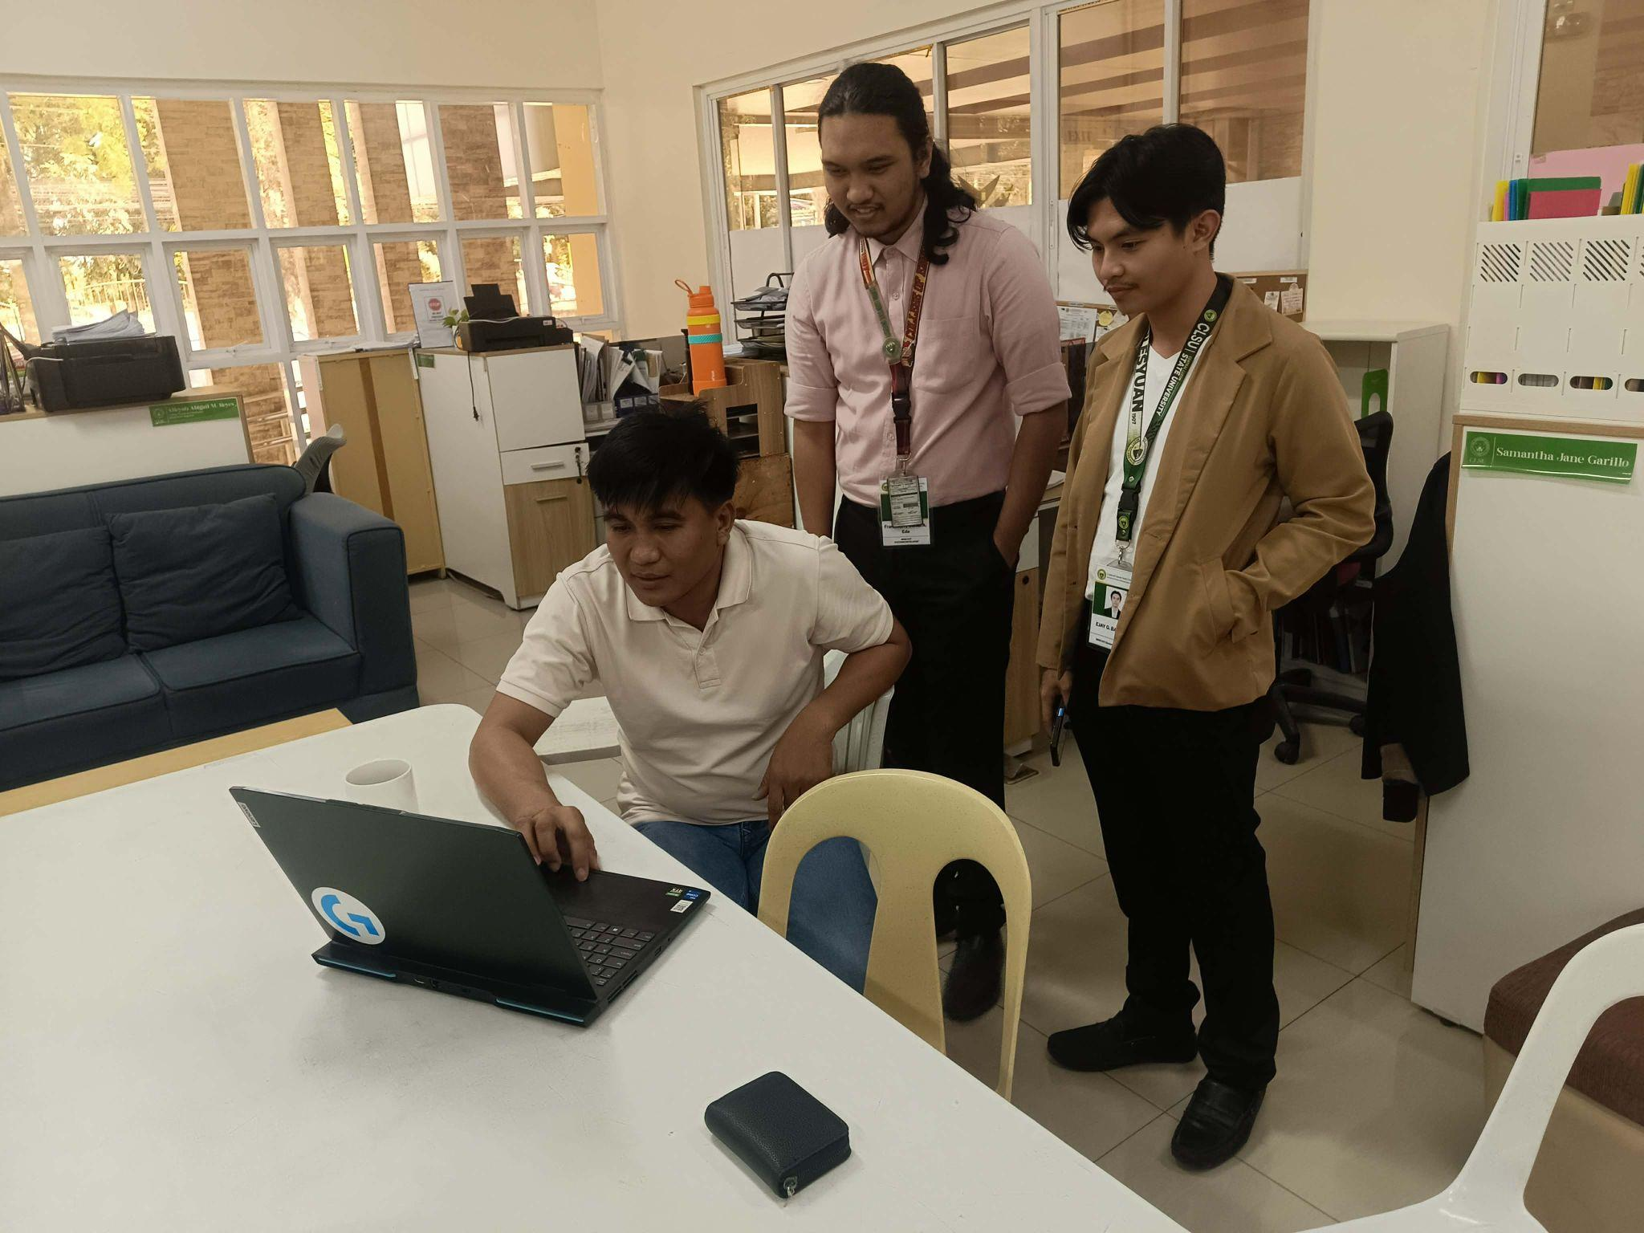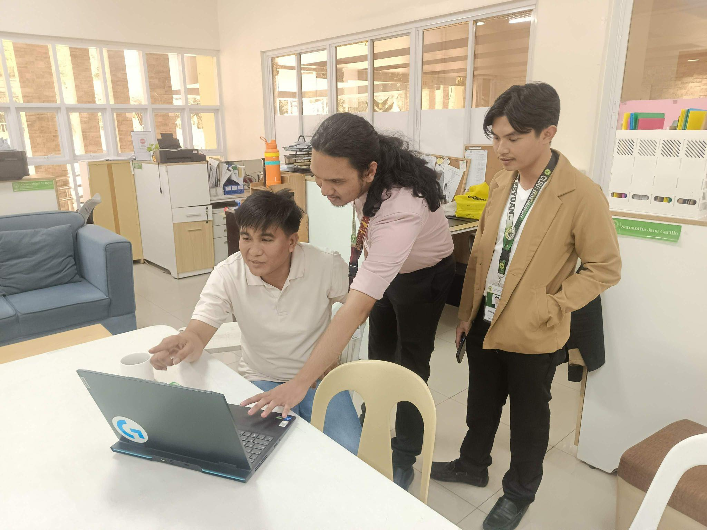

Appendix D - Evaluation Tool for IT Expert (Adopted from ISO 25010)

Appendix E - Evaluation Tool for End-User - Student (Adopted from ISO 25010)
Appendix F - Evaluation Tool for End-User - Faculty (Adopted from ISO 25010)
Appendix G - Evaluation Response Data from IT Experts
Appendix H - Evaluation Response Data from Students
Appendix I - Evaluation Response Data from Faculty
Appendix J - System Testing Documentation
Appendix K - User Manual

