|  |  |
| --- | --- |
| system integration and architecture II  ERPNext Documentation | ERPNext is an open source web-based system aimed at small and medium sized businesses. It assists companies with accounting, human resource management, sales, purchase, inventory, CRM, administration, project and task management, manufacturing, and even website.  Canillo’s Group  SIA 102 |

# **Implementation Strategy**

Before you start managing your Operations in ERPNext, you must first become familiar with the system and the terms used. For this, we recommend implementation should happen in two phases.

* A **Test Phase**, where you enter dummy records representing your day-to-day transactions, and a **Live Phase**, where we start entering live data.

The first thing to do is download all the tools that you need.

Virtual Machine

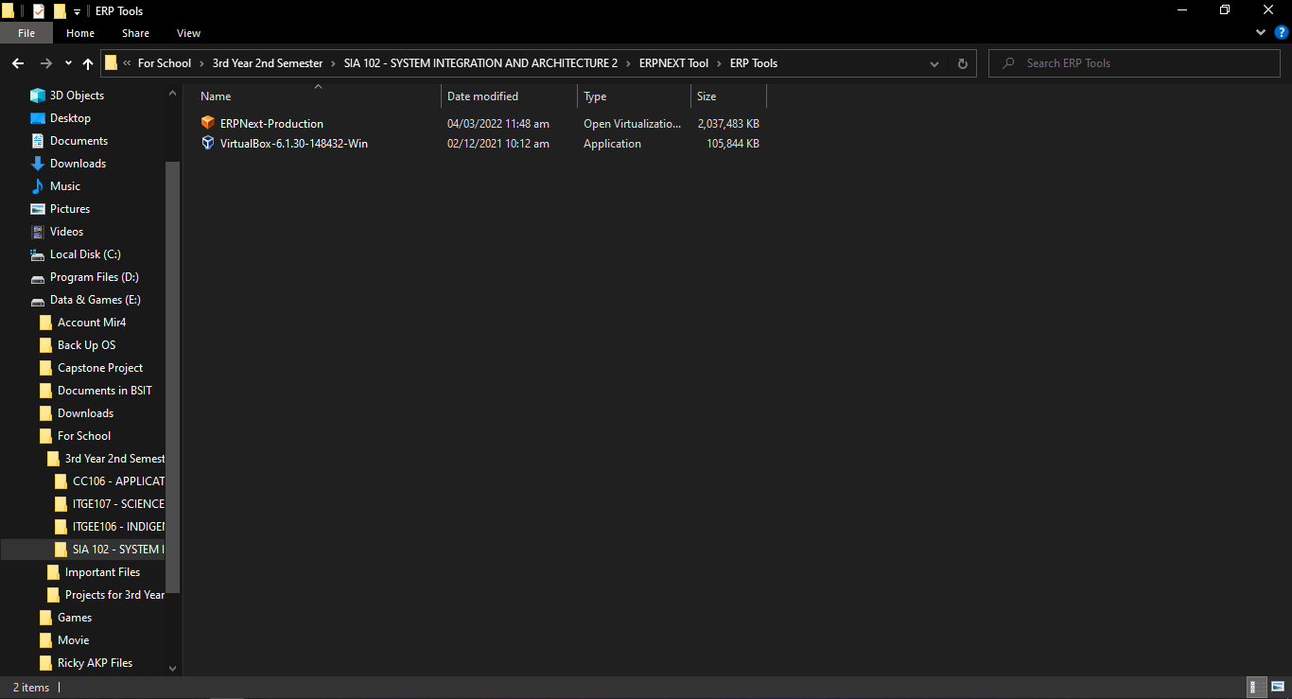ERPNEXT Software (Production Image)

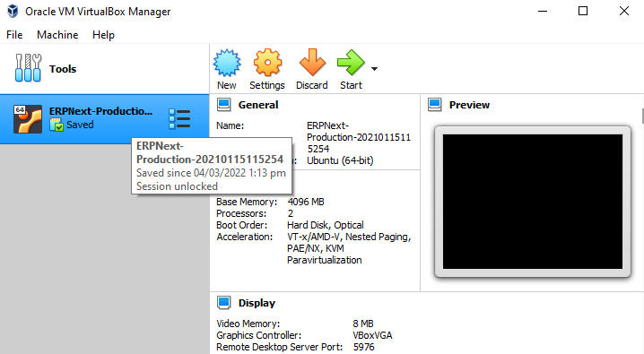After downloading the tools Install Virtual Machine on your computer. Run Virtual Machine as Administrator. Just leave all the settings by default.

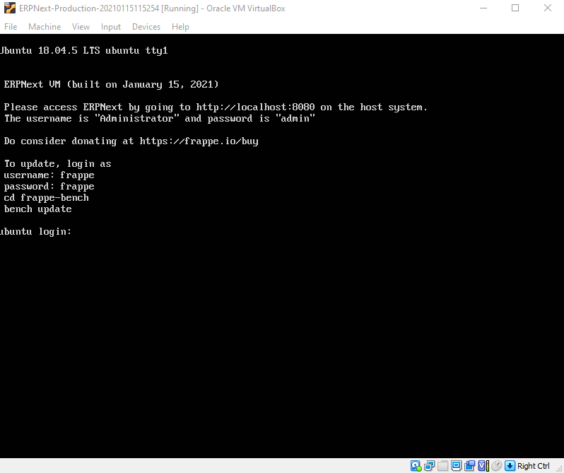Run the ERPNext Image in your Virtual Machine. Fill up log in using username frappe and password frappe.

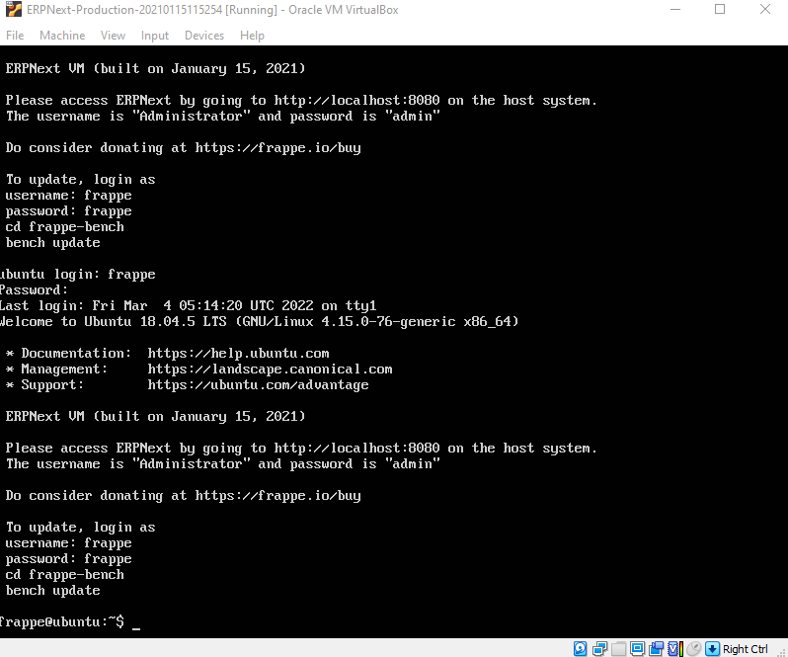After you input the username and the password just leave the virtual machine open so that you can start to browse the ERPNext using localhost:8080.

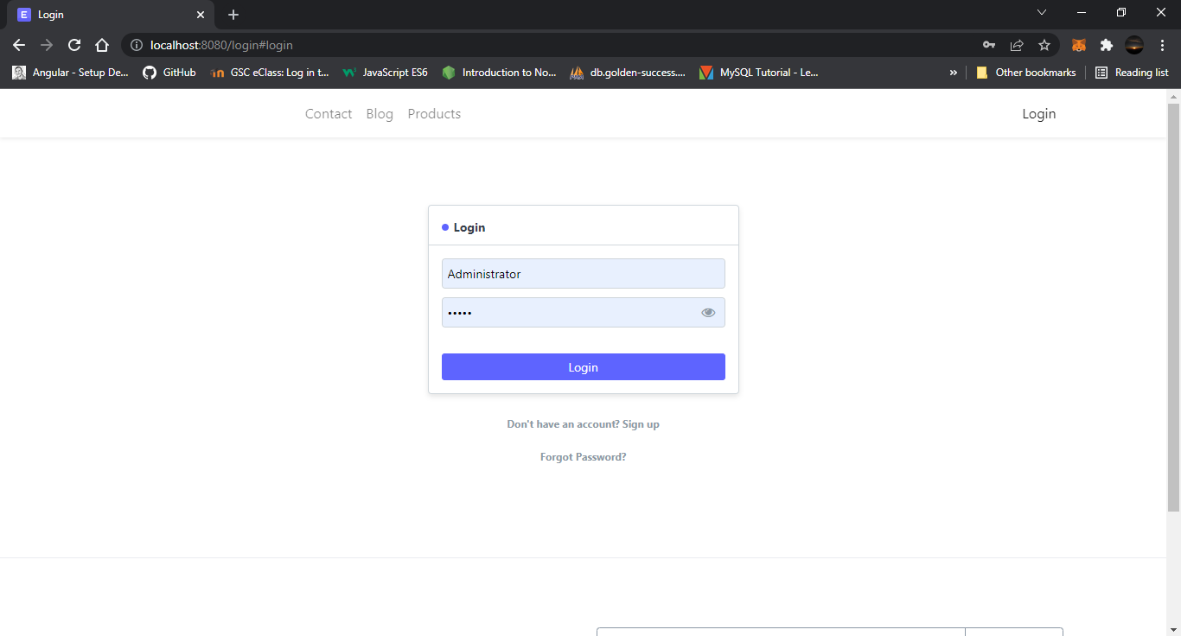After connecting it in your local now you can log in to ERPNEXT using Administrator as username and admin as password. You can change it later after.

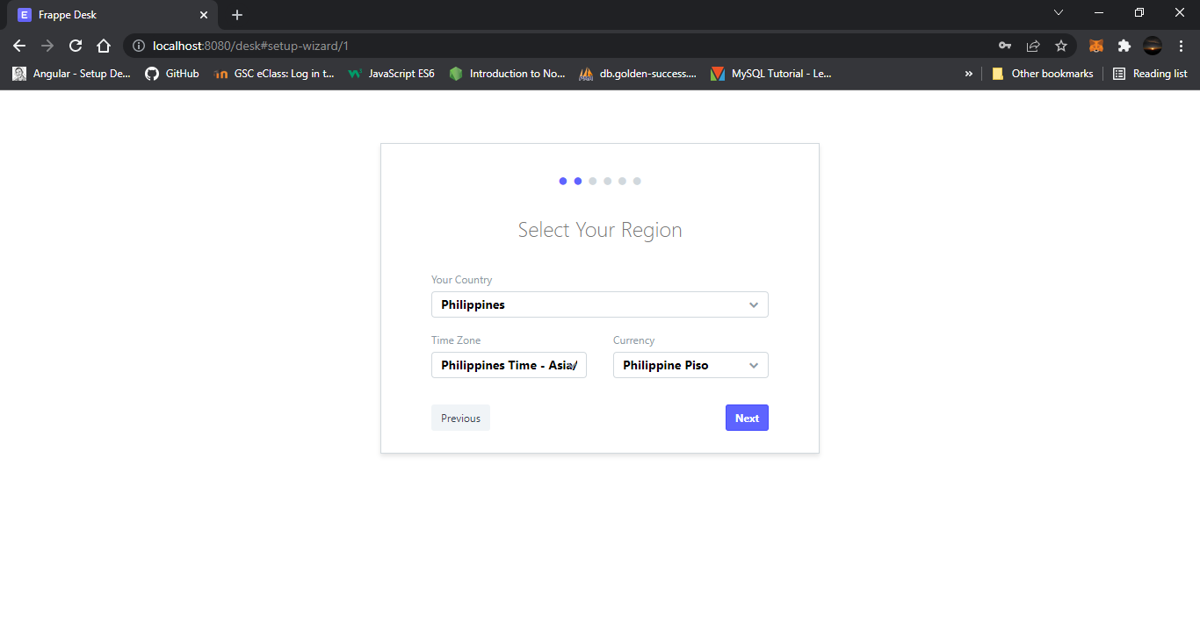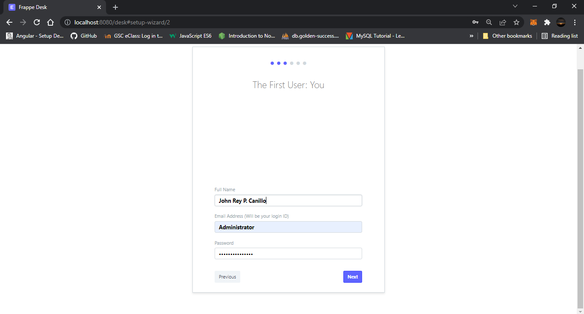The Next Step is to select your Region and Time zone where you live.

As a First User, you should fill up your Full Name, Email Address for ID, and password. I just leave it by default.

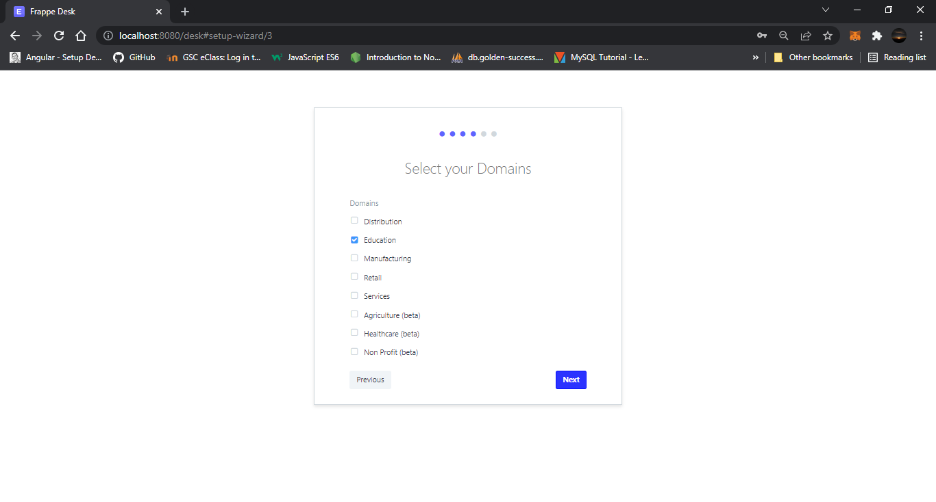Select Domain, for me I choose Education because I want to build a tool that will be used in our School shortly. Then click NEXT.

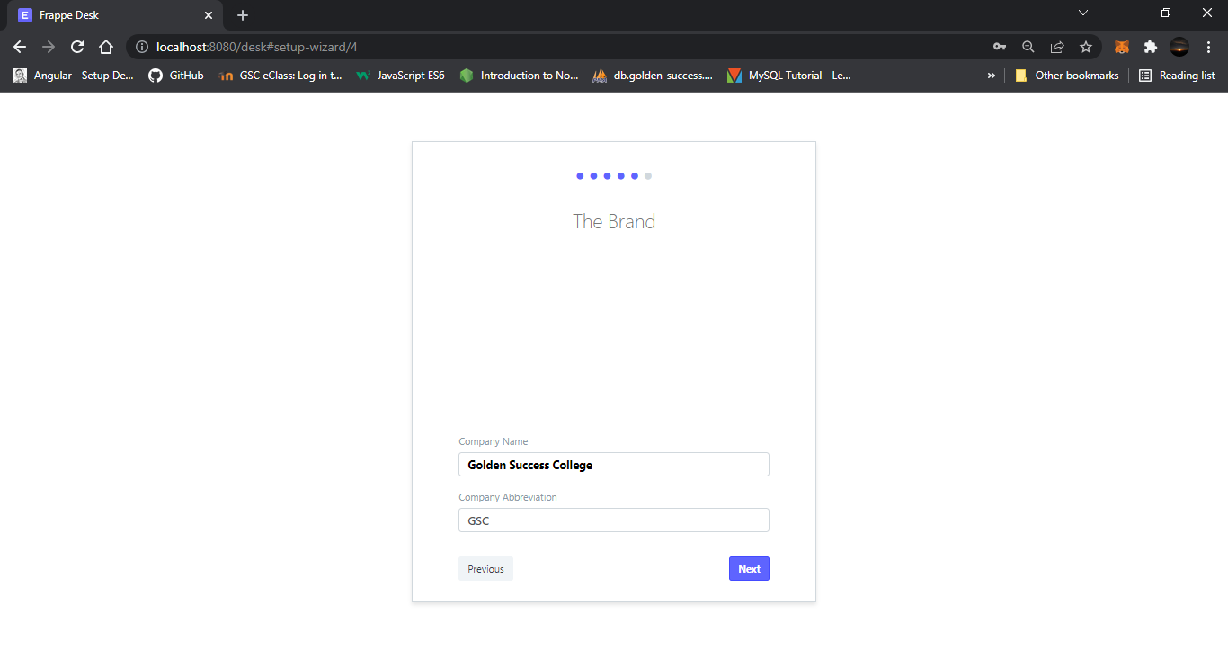Brand Name, I choose to name it Golden Success College because I will use it in the school.

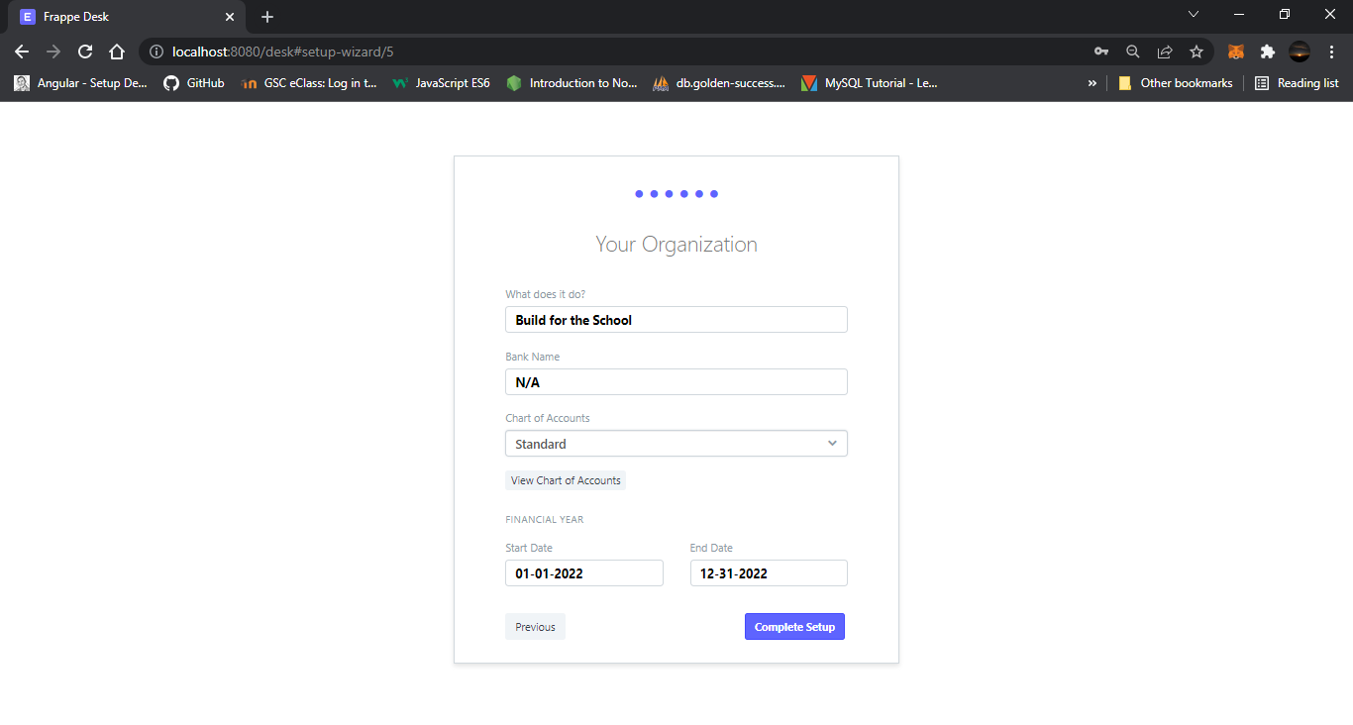Fill up the blank, and state the purpose of your Organization.

Then Click Complete Set-Up.

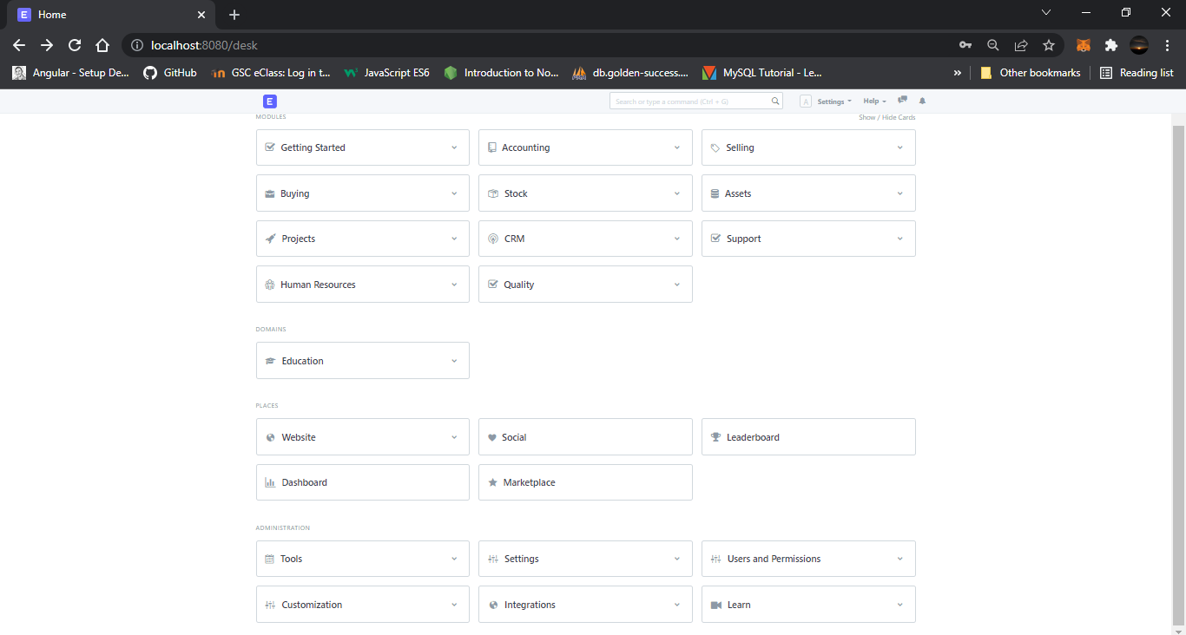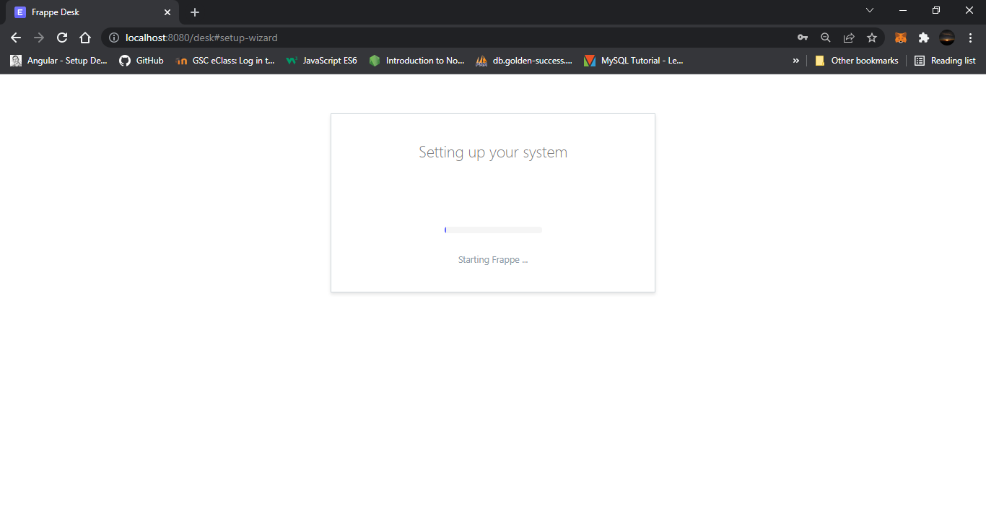After it’s done set up on your system. Try to explore what is inside in ERPNext.