|  |  |
| --- | --- |
| SYSTEM INTEGRATION AND ARCHITECTURE II | ERPNext is an open source web-based system aimed at small and medium sized businesses. It assists companies with accounting, human resource management, sales, purchase, inventory, CRM, administration, project and task management, manufacturing, and even website.  BS-IT 3rd Year College |

**Introduction of ERPNEXT Education**

The Education domain in ERPNext is designed to meet requirements of any organization which imparts knowledge and believe in doing so in an organized fashion. It has already been used at schools, colleges and even in private firms.

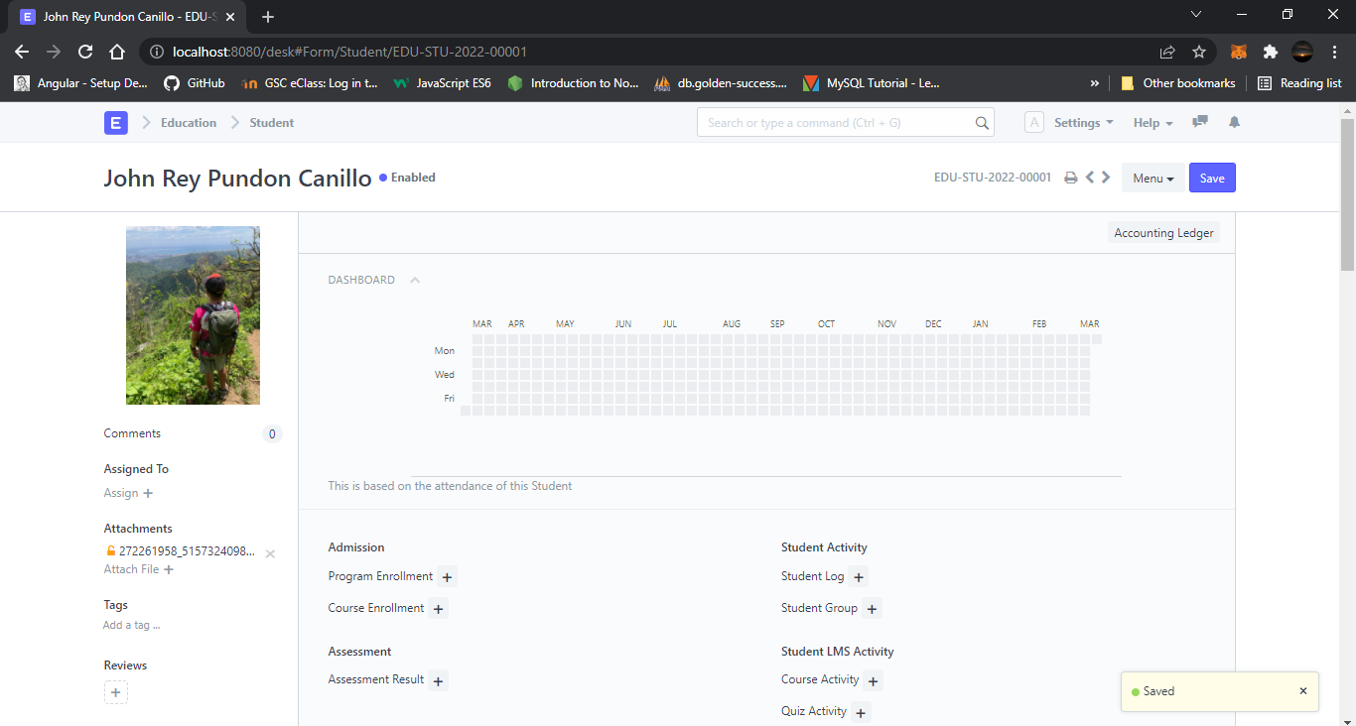It helps you to effectively manage administration and allows you to focus on what is most important for your institute, **to educate!**

## Contents of ERPNext Education Domain

Using Education module of ERPNext, you can effectively manage operations like:

* Managing Student
* Program and Courses
* Publishing Programs on the portal
* Online Admissions
* Student Attendance
* Course Scheduling
* Portal for Publishing Programs
* Assessment Planning and Assessment Result
* Fee Structure and Fee Receipt

# Education Domain

Whether you are running a B-School, an Academy or even a Primary School, the ERPNext Education Module helps you in organizing your entire set-up. You can have your entire Student Database, Fee Structure, Staffing Information, Courses, Curriculum, all defined in ERPNext.

We also understand that an Educational Institute needs a lot more than a simple 'Education Module', and ERPNext has all of it available built-in. You can:

* Track your books of accounts using [Accounts module](https://docs.erpnext.com/docs/v13/user/manual/en/accounts).
* Manage payroll, leaves, and claims of your admin and teaching staff in the [HR module](https://docs.erpnext.com/docs/v13/user/manual/en/human-resources).
* Organize your [purchases](https://docs.erpnext.com/docs/v13/user/manual/en/buying) and place an approval system.

Here are the functionalities available under the ERPNext Education domain to go through after this [**introduction**](https://docs.erpnext.com/docs/v13/user/manual/en/education/introduction)

## Topics

### 1. Setup

1. [Program](https://docs.erpnext.com/docs/v13/user/manual/en/education/program)
2. [Course](https://docs.erpnext.com/docs/v13/user/manual/en/education/course)
3. [Topic](https://docs.erpnext.com/docs/v13/user/manual/en/education/topic)
4. [Instructor](https://docs.erpnext.com/docs/v13/user/manual/en/education/instructor)
5. [Room](https://docs.erpnext.com/docs/v13/user/manual/en/education/room)
6. [Student Category](https://docs.erpnext.com/docs/v13/user/manual/en/education/student-category)
7. [Academic Term](https://docs.erpnext.com/docs/v13/user/manual/en/education/academic-term)
8. [Academic Year](https://docs.erpnext.com/docs/v13/user/manual/en/education/academic-year)
9. [Education Settings](https://docs.erpnext.com/docs/v13/user/manual/en/education/education-settings)

### 2. Student

1. [Student](https://docs.erpnext.com/docs/v13/user/manual/en/education/student)
2. [Guardian](https://docs.erpnext.com/docs/v13/user/manual/en/education/guardian)
3. [Student Log](https://docs.erpnext.com/docs/v13/user/manual/en/education/student-log)
4. [Student Batch Name](https://docs.erpnext.com/docs/v13/user/manual/en/education/student-batch-name)
5. [Student Group](https://docs.erpnext.com/docs/v13/user/manual/en/education/student-group)
6. [Student Group Creation Tool](https://docs.erpnext.com/docs/v13/user/manual/en/education/student-group-creation-tool)

### 3. Admission

1. [Student Applicant](https://docs.erpnext.com/docs/v13/user/manual/en/education/student-applicant)
2. [Program Enrollment](https://docs.erpnext.com/docs/v13/user/manual/en/education/program-enrollment)
3. [Program Enrollment Tool](https://docs.erpnext.com/docs/v13/user/manual/en/education/program-enrollment-tool)
4. [Student Admission](https://docs.erpnext.com/docs/v13/user/manual/en/education/student_admission)

### 4. Fees

1. [Fees](https://docs.erpnext.com/docs/v13/user/manual/en/education/fees)
2. [Fee Structure](https://docs.erpnext.com/docs/v13/user/manual/en/education/fee-structure)
3. [Fee Category](https://docs.erpnext.com/docs/v13/user/manual/en/education/fee-category)
4. [Fee Schedule](https://docs.erpnext.com/docs/v13/user/manual/en/education/fee-schedule)

### 5. Schedule

1. [Course Schedule](https://docs.erpnext.com/docs/v13/user/manual/en/education/course-schedule)
2. [Scheduling Tool](https://docs.erpnext.com/docs/v13/user/manual/en/education/scheduling-tool)

### 6. Learning Management System

1. [Setting Up LMS](https://docs.erpnext.com/docs/v13/user/manual/en/education/setting-up-lms)
2. [LMS Masters](https://docs.erpnext.com/docs/v13/user/manual/en/education/lms-masters)
3. [Navigating the Portal](https://docs.erpnext.com/docs/v13/user/manual/en/education/navigating-the-portal)

### 7. Attendance

1. [Student Attendance](https://docs.erpnext.com/docs/v13/user/manual/en/education/student-attendance)
2. [Student Attendance Tool](https://docs.erpnext.com/docs/v13/user/manual/en/education/student-attendance-tool)
3. [Student Leave Application](https://docs.erpnext.com/docs/v13/user/manual/en/education/student-leave-application)

### 8. Assessment

1. [Introduction](https://docs.erpnext.com/docs/v13/user/manual/en/education/assessment-introduction)
2. [Assessment Criteria](https://docs.erpnext.com/docs/v13/user/manual/en/education/assessment_criteria)
3. [Assessment Group](https://docs.erpnext.com/docs/v13/user/manual/en/education/assessment_group)
4. [Assessment Plan](https://docs.erpnext.com/docs/v13/user/manual/en/education/assessment_plan)
5. [Assessment Result](https://docs.erpnext.com/docs/v13/user/manual/en/education/assessment_result)
6. [Assessment Result Tool](https://docs.erpnext.com/docs/v13/user/manual/en/education/assessment_result_tool)
7. [Grading Scale](https://docs.erpnext.com/docs/v13/user/manual/en/education/grading_scale)

### 9. Tools

1. [Student Attendance Tool](https://docs.erpnext.com/docs/v13/user/manual/en/education/student-attendance-tool)
2. [Assessment Result Tool](https://docs.erpnext.com/docs/v13/user/manual/en/education/assessment_result_tool)
3. [Student Group Creation Tool](https://docs.erpnext.com/docs/v13/user/manual/en/education/student-group-creation-tool)
4. [Program Enrollment Tool](https://docs.erpnext.com/docs/v13/user/manual/en/education/program-enrollment-tool)
5. [Course Scheduling Tool](https://docs.erpnext.com/docs/v13/user/manual/en/education/course-scheduling-tool)

Program

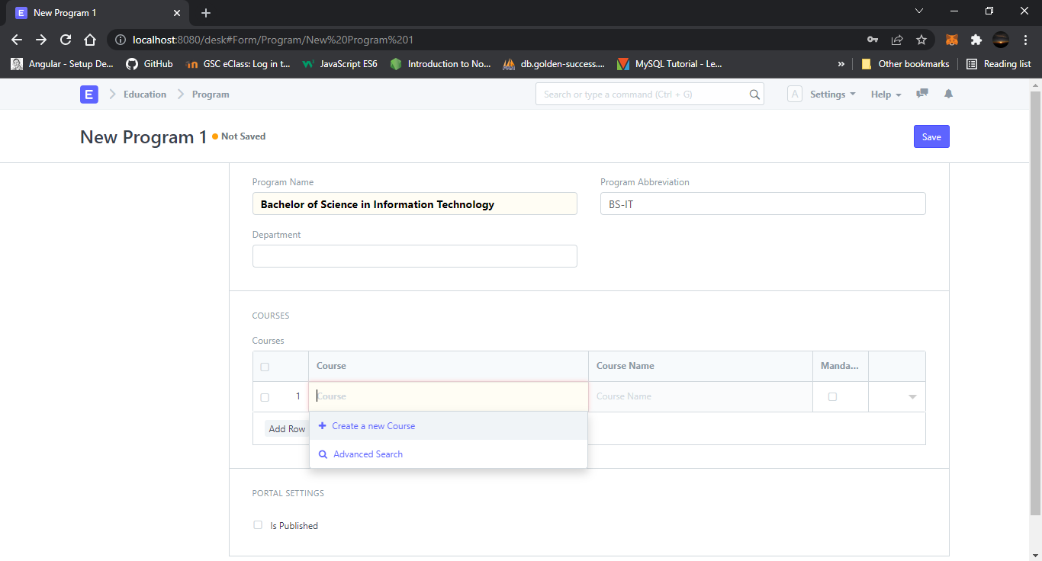A Program will have an educational curriculum defined by your institute to streamline the learning process and goals in each subject or course.

1. Prerequisites

To create a New Program, it is advised to create the following first:

1. Department
2. Course

Creating a New Program

1. Go to the Program list and click on New.
2. Enter the Program Name and the Program Abbreviation.
3. Select the Department for the Program.
4. Select and add the courses within the Program.
5. Save.

Course

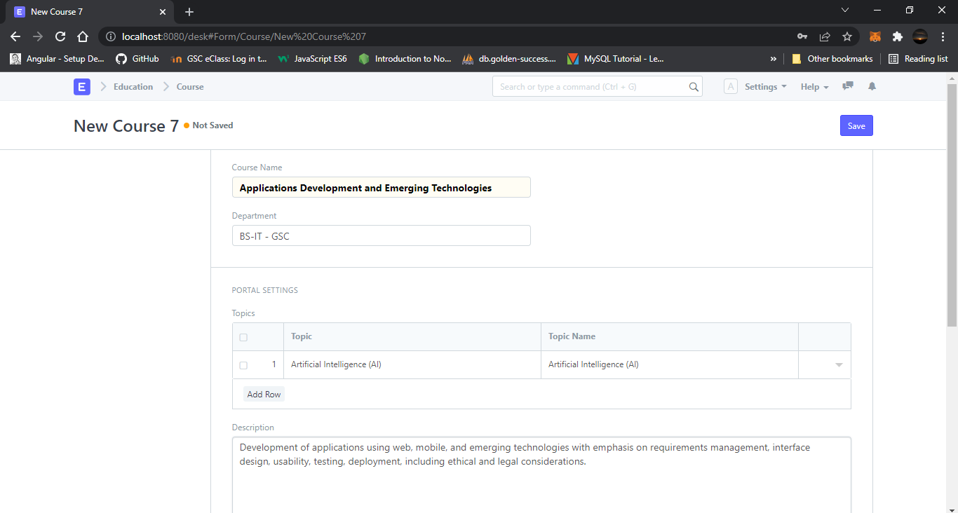A course can be considered as a subject or a part of an educational program which is to be taught for a term.

1. Prerequisites

Before creating a course, it is advised to create:

1. Department
2. Topics

How to create a course

1. Go to Course List and click on New.
2. Enter the Course Name.
3. Select the Department under which this course is being made.
4. Add the Topics. You can also create the topics from here itself.
5. Add the Description for the course.
6. Save.

Topic

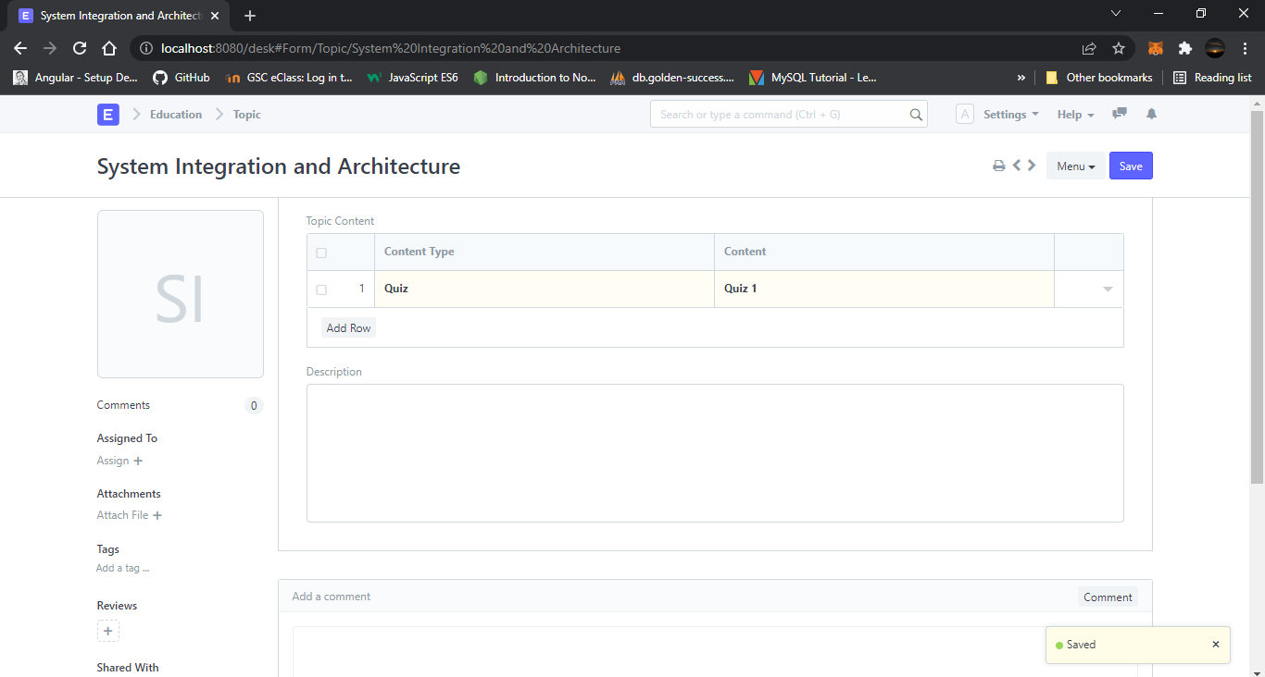A Topic is a subunit of a Course and will contain all the contents related to the topic.

1. Prerequisites

Before creating a New Topic, it is advisable that you create the following first:

1. Article
2. Video
3. Quiz

How to create a Topic

1. Click on New Topic and add the title of the Topic.
2. Add the related course (optionally).
3. Select the Content Type for the topic. It could be an Article, a Video or a Quiz.
4. Select the Content for the Topic. You can create a New Article, Video or a Quiz from here itself.
5. Optionally add a description and Save.

Instructor

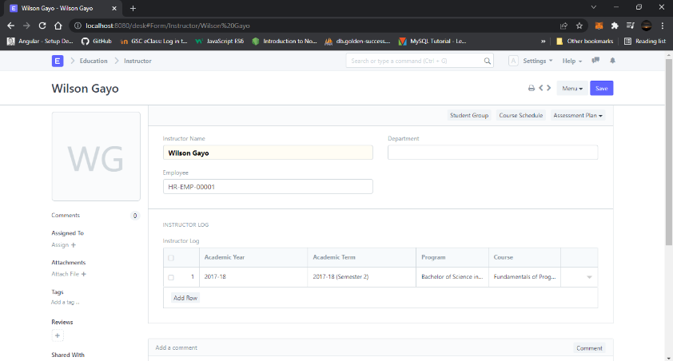An instructor is a teacher, tutor, or a professor that will be responsible for teaching a particular topic or course to the students.

## 1. Prerequisites

Before creating an instructor, it is advisable to first create the following:

1. Employee
2. Department
3. Academic Year
4. Academic Term
5. Program
6. Course
7. Student Group

## 2. How to create an Instructor

1. Click on New Instructor.
2. Select the Employee ID/Employee Name for the Instructor.
3. Select the Department for which you are creating an Instructor.
4. Save.

### Instructor Log

* **Academic Year**: The Academic Year for which the Instructor is created.
* **Academic Term**: The Academic Term for which the Instructor is created.
* **Department**: The department to which the Instructor belongs to.
* **Program**: The Program for which the Instructor Log is being made.
* **Course**: The course for which the Instructor Log is being made.
* **Student Group**: The Student Group for which the user is making the Instructor Log.

### After Submitting

Once the Instructor and Instructor Log is saved, you can create the following from there:

1. [Student Group](https://docs.erpnext.com/docs/v13/user/manual/en/education/student-group)
2. [Course Schedule](https://docs.erpnext.com/docs/v13/user/manual/en/education/course-schedule)
3. 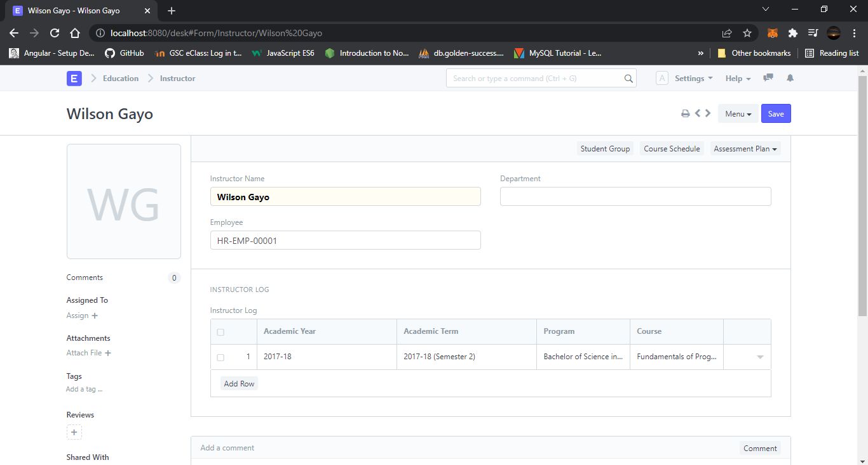[Assessment Plan](https://docs.erpnext.com/docs/v13/user/manual/en/education/assessment_plan)

# Room

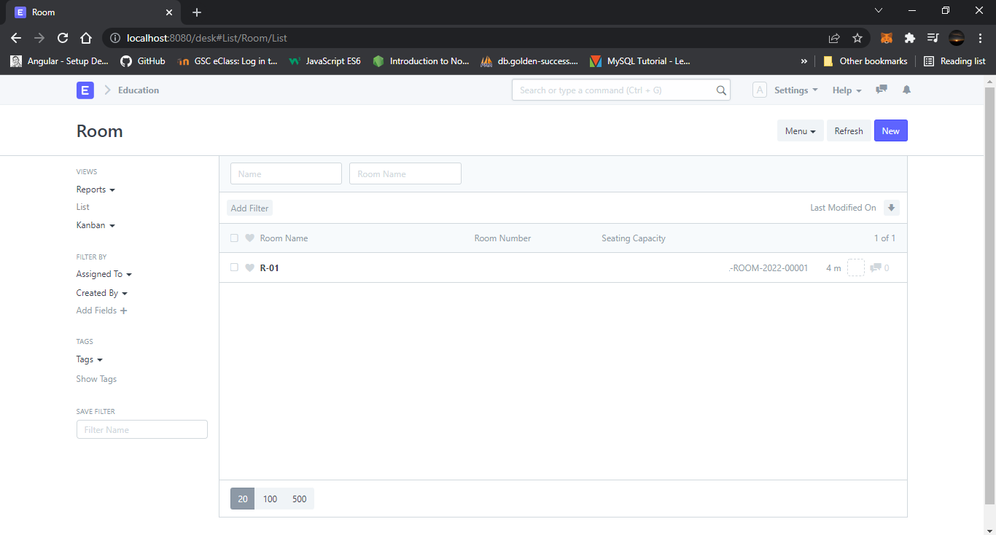**Room refers to a tutoring space which can be set as the venue for courses or examinations.**

## 1. How to create a Room

1. Go to the Room list and click on New.
2. Add the name of the room.
3. Add the Room Number for the selected room.
4. Enter the Seating capacity for the room.

# Student Category

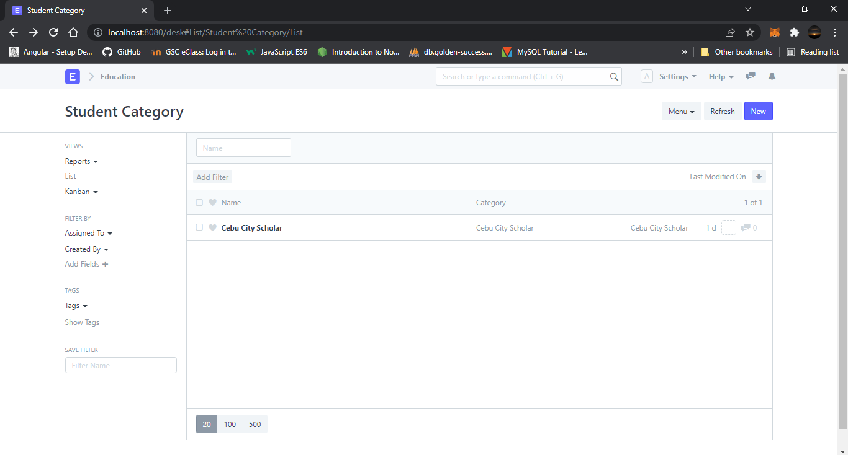**Student Category allows you to classify the students based on various categories.**

## 1. How to create a Student Category

To create a new student category, click on New Student Category and add the name of the Student Category.

You can select the Student Category while making the Fee Structure and accordingly the student from the selected groups can be filtered out while making the Fee Schedule.

# Academic Term

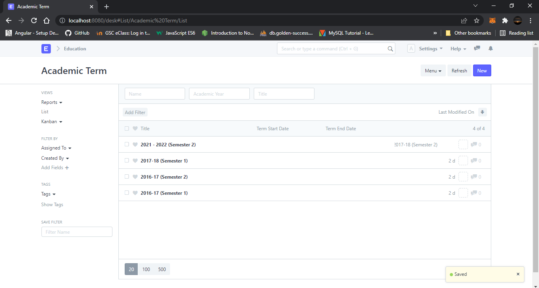**An Academic Term would become a part of the Academic Year, during which the Institute will assess its Students on the curriculum defined for that term. It could be a Quarter, Trimester or a Semester.**

If the Academic Term has been specified in the [Education Settings](https://docs.erpnext.com/docs/v13/user/manual/en/education/education-settings) then it will become the default Academic Term in all the forms and will be editable if required.

The following are the various forms where Academic Term is a relevant field:

1. Student Log
2. Student Group
3. Student Applicant
4. Student Admission
5. Program Enrollment
6. Assessment Plan
7. Assessment Result
8. Assessment Criteria
9. Fees
10. Fee Schedule
11. Fee Structure
12. Fee Category
13. Course Schedule

# Academic Year

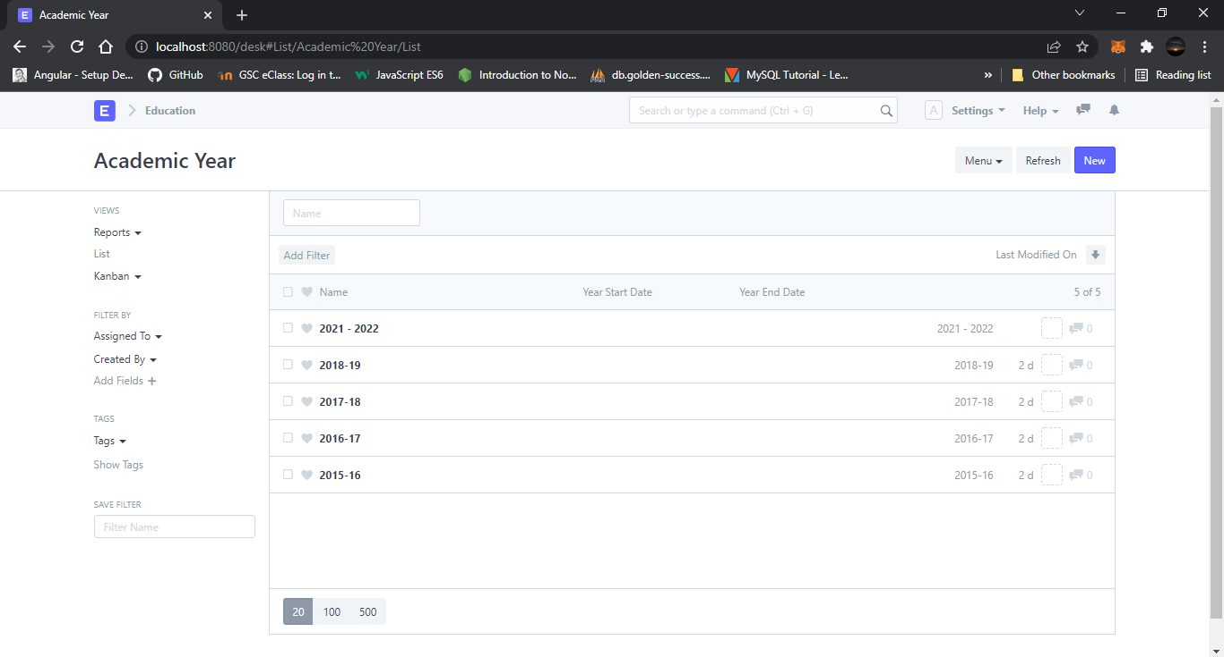**An academic year is a period which the Educational Institutes, Schools and Universities use to measure a quantity of study.**

If the Academic Year has been specified in the [Education Settings](https://docs.erpnext.com/docs/v13/user/manual/en/education/education-settings) then it will become the default Academic Term in all the forms and will be editable if required.

The following are the various forms where Academic Year is a relevant field:

1. Student Log
2. Student Group
3. Student Applicant
4. Student Admission
5. Program Enrollment
6. Assessment Plan
7. Assessment Result
8. Assessment Criteria
9. Fees
10. Fee Schedule
11. Fee Structure
12. Fee Category
13. Course Schedule

# Student

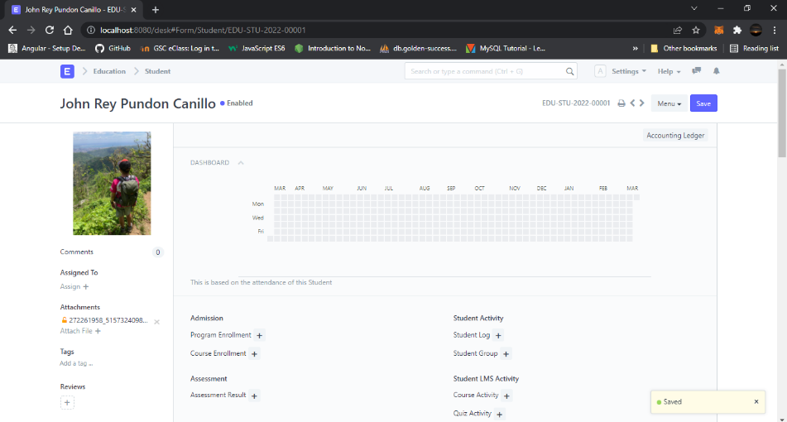**The Student document will hold all the data of any Student in your Academy like their Personal Information, Photo, Date of Birth, Address, etc.**

**The student is enrolled in a Program when the application is approved. Once the enrollment is done the Student Applicant status is update to Admitted.**

## 1. Prerequisites

Before creating a student, it is advised to create the following first:

* User(If Applicable)

## 2. How to create a New Student

1. Go to the student list and click on New.
2. Enter the First Name, Middle Name and Last Name of the student.
3. Enter other details like Student Email Address, User ID (If Applicable) and Joining Date.
4. Save.

# Student Batch

**A Student batch is a collection of students from within Student Groups.**

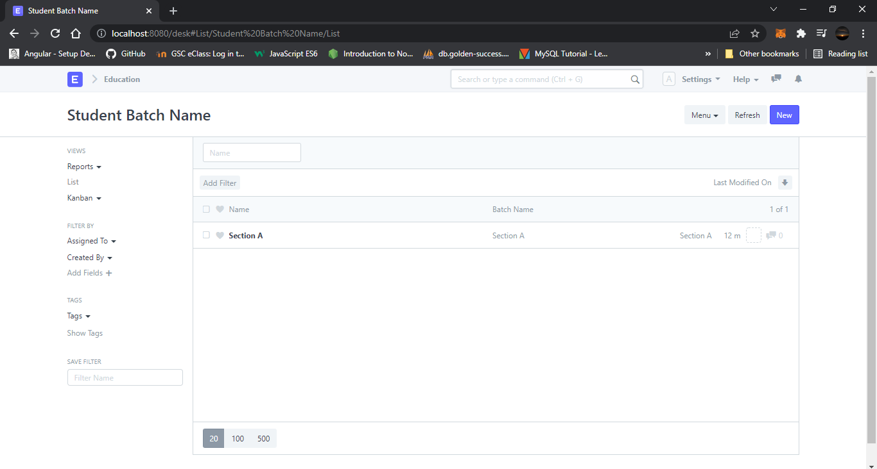For example, a group of students studying the same Program together will be called a Student Batch.

When a student is enrolled for a [Program](https://docs.erpnext.com/docs/v13/user/manual/en/education/program), the batch can be selected for the student, and they shall be a part of that batch.

You can also get a Student Batch-Wise Attendance report to view the number of students present from the Batch.

# Student Group

**A student group is a collection of students from the same batch or taking the same course.**

## 1. Prerequisites

Before creating a Student group, it is advisable that you first create the following:

1. [Student](https://docs.erpnext.com/docs/v13/user/manual/en/education/student)
2. [Program Enrollment](https://docs.erpnext.com/docs/v13/user/manual/en/education/program-enrollment)
3. [Student Batch name](https://docs.erpnext.com/docs/v13/user/manual/en/education/student-batch-name)
4. [Student Category](https://docs.erpnext.com/docs/v13/user/manual/en/education/student-category)
5. [Instructor](https://docs.erpnext.com/docs/v13/user/manual/en/education/instructor)

## 2. Creating a Student Group

1. Go to Student Group List and click on New.
2. **Group Based On**: Select the basis on which you would like to create the student group. The three options available are:
   * Batch: List of all the students from within a specific batch will be fetched in this case.
   * Course: List of all the students who have enrolled for a specific course will be fetched in this case.
   * Activity: You can select this option when you want to create a group of students for certain activities happening in the school.
3. **Student Group Name**: Enter the name of the student group.
4. 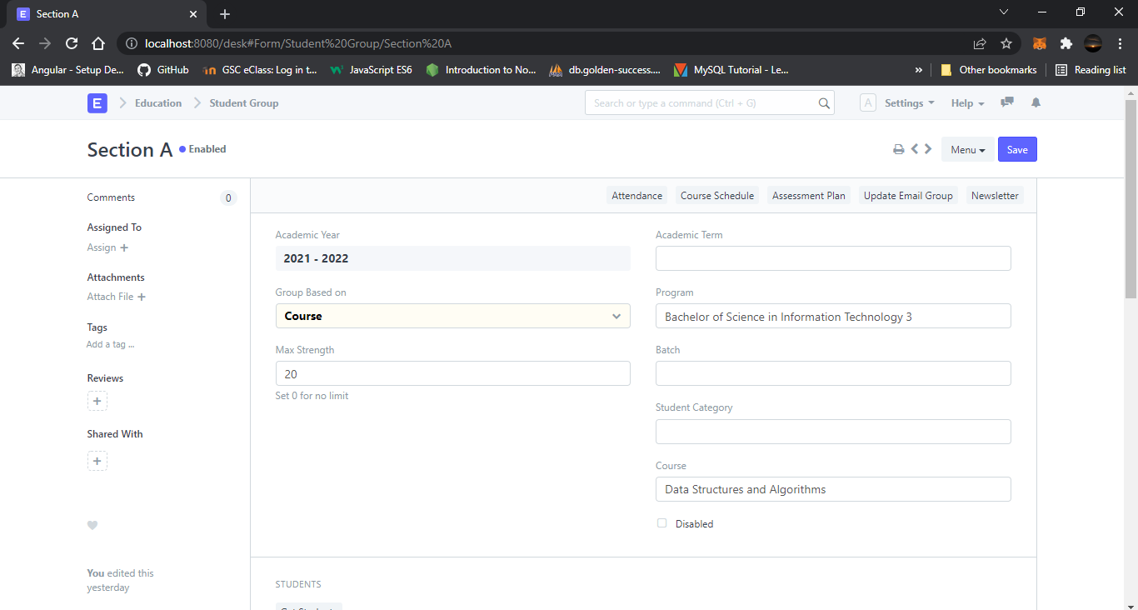Save.

# Student Group Creation Tool

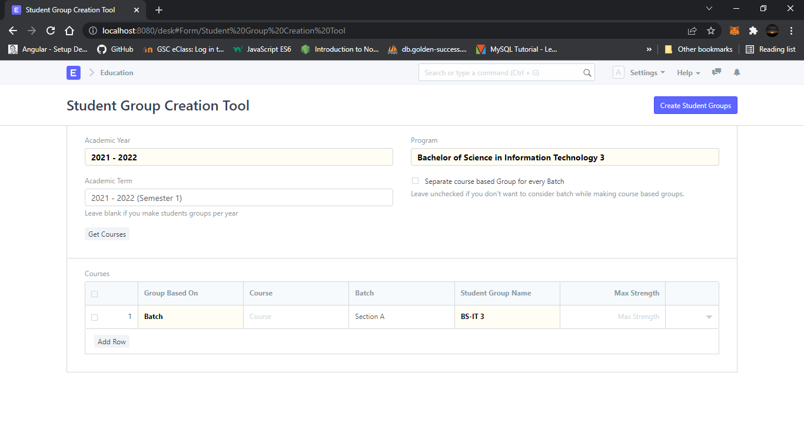**The Student group creation tool allows you to create student groups in bulk.**

## 1. How to use the Student Group Creation Tool

1. Select the **Academic Term** and the **Program** for which a student group is to be created.
2. Select the **Program** under which you are creating the student group.
3. By default, the student group is created based on the courses only. The check-box for **Separate course based Group for every Batch** allows you to create different batch-wise Student groups for each course.
4. Click on get **Get Courses**: All the courses within the selected Program will be enlisted here. You can choose and delete courses from the list already added in the list. You can also select and add courses from other programs on this list.
5. Click on **Create Students Groups**. Multiple Student groups for each course and batch will be created.

# Student Log

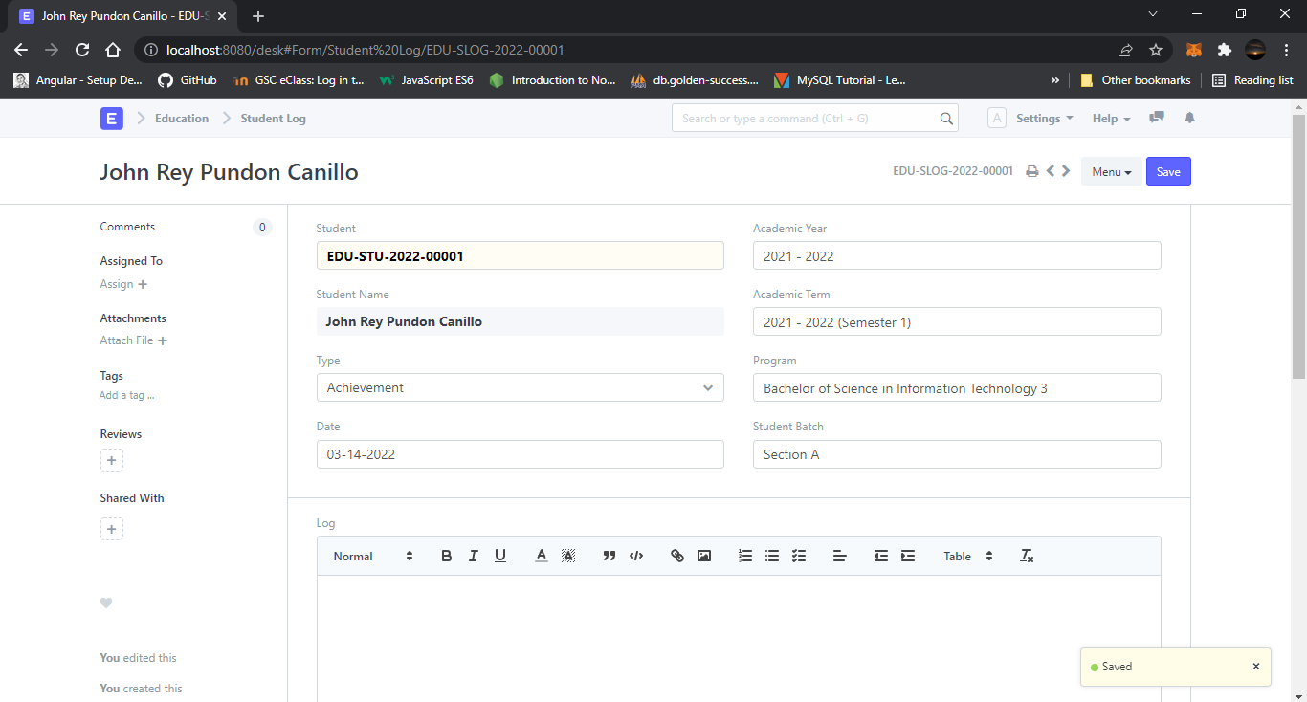**The student Log will act as a Student Diary, wherein, all their logs and other notes can be recorded.**

## 1. Prerequisites

* Student
* Academic Year
* Academic Term
* Program
* Student Batch

## 2. How to create a Student Log

1. Go to Student Log List and click on New.
2. Enter the Student ID. The moment you do this, the name of the student will automatically be fetched.
3. Save.

# Student Applicant

**A Student Applicant record gets created when a student applies to your institute for admission.**

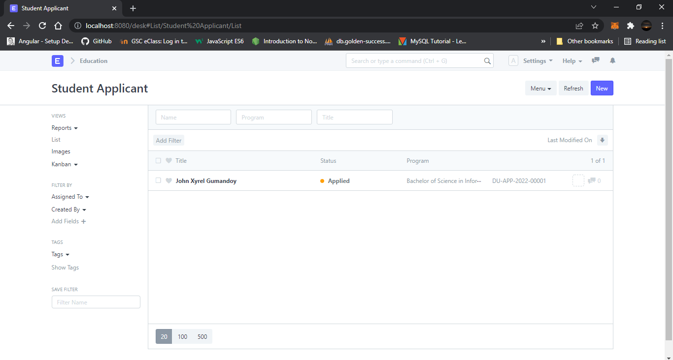You can Approve or Reject a student applicant. By accepting a student applicant you can add them to the student master.

## 1. Prerequisites

Before creating a Student Applicant, it is advisable to first create the following:

1. [Academic Term](https://docs.erpnext.com/docs/v13/user/manual/en/education/academic-term)
2. [Academic Year](https://docs.erpnext.com/docs/v13/user/manual/en/education/academic-year)
3. [Program](https://docs.erpnext.com/docs/v13/user/manual/en/education/program)

## 2. How to create a Student Applicant

1. Go to the student Applicant and click on New.
2. Enter the **First Name** of the student Applicant.
3. Enter the **Program** for which the student has applied.
4. Enter the **Student Email Address**.
5. Save.

### Online Application via a Web Form

A Student Applicant gets automatically created when a student applies online. This can be made possible through the Student Applicant Web Form which is created by default in the system. Search for "[Web Form List](https://docs.erpnext.com/docs/v13/user/manual/en/website/web-form)" in the awesome bar to access the list of all the web forms in the system.

Once the student applies, the status of the application by default is "Applied". You can either "Approve" or "Reject" the form.

Once the application is approved, you can "Enroll" the student to a program. When you click the **Enroll** button, the system shall create a student against that applicant and redirect you to the [Program Enrollment form](https://docs.erpnext.com/docs/v13/user/manual/en/education/program-enrollment).

Note: Once a student is created against the student applicant, the system will set the application status to 'Admitted' and will not allow you to change the application status unless the student record is deleted.

# Program Enrollment

**Program Enrollment is the record of enrollment of a student in a given program and chosen courses for a particular Academic Term.**

To ensure that students are associated with a particular program in the system, their Program Enrollment must be created. The mandatory course in that program is automatically filled in the Enrolled Courses table while the elective or optional courses can be selected manually.

If the student has applied online for the admission in a particular **Program** and the application is approved, then the Program Enrollment can be created from within the Student Applicant record via clicking on the **Enroll** button.

## 1. Prerequisites

Before creating a Program Enrollment, it is advisable that you create the following first:

1. [Student](https://docs.erpnext.com/docs/v13/user/manual/en/education/student)
2. [Program](https://docs.erpnext.com/docs/v13/user/manual/en/education/program)
3. [Student Category](https://docs.erpnext.com/docs/v13/user/manual/en/education/student-category)
4. [Student Batch](https://docs.erpnext.com/docs/v13/user/manual/en/education/student-batch-name)
5. [Academic Year](https://docs.erpnext.com/docs/v13/user/manual/en/education/academic-year)
6. [Academic Term](https://docs.erpnext.com/docs/v13/user/manual/en/education/academic-term)
7. [Course](https://docs.erpnext.com/docs/v13/user/manual/en/education/course)
8. [Fee Structure](https://docs.erpnext.com/docs/v13/user/manual/en/education/fee-structure)

## 2. How to create a Program Enrollment

1. Go to Program Enrollment List and click on new.
2. Select the Student whom you are getting enrolled in the program.
3. Select the Program under which you are getting the student enrolled.
4. Enter the Academic Year for which the student is getting enrolled.
5. The Enrollment Date for the form would by default be set on the current date, the same, however, can be changed if needed.
6. 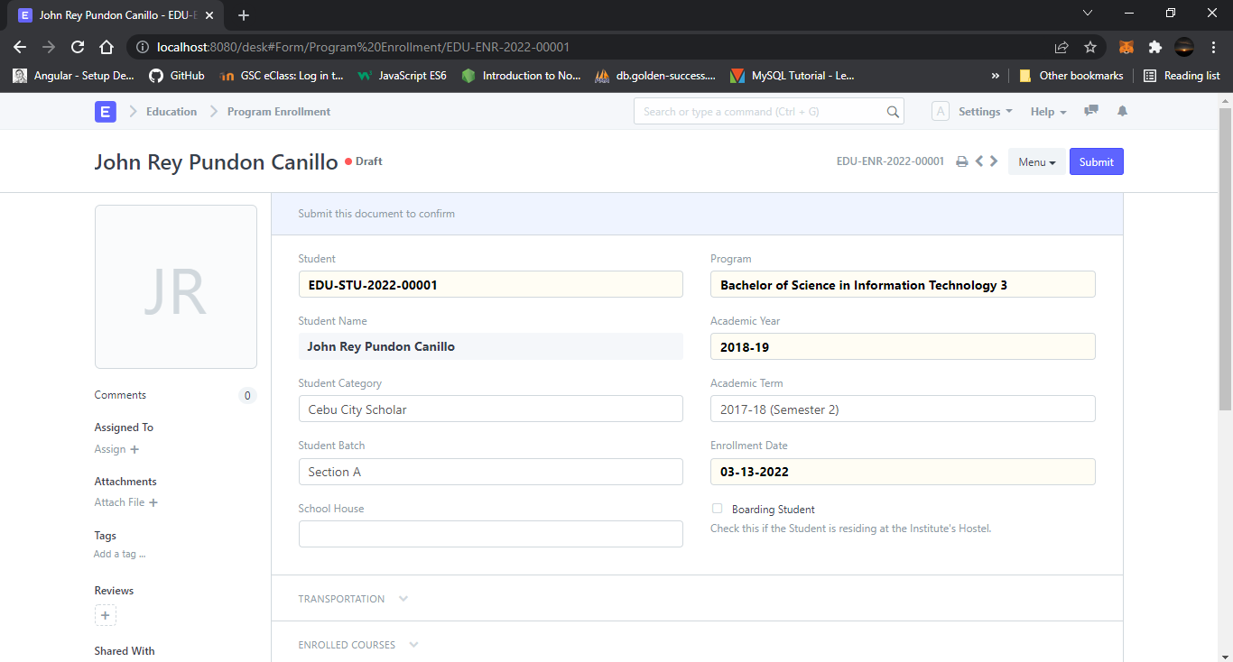Save and submit.

### Additional Options while creating a Program Enrollment

1. **Student Category**: Select the category if the student belongs to a particular student category.
2. **Academic Term**: Select the Academic Term.
3. **Student Batch**: Select the batch if the student belongs to a particular student batch.
4. **Student House**: Select the House if the student belongs to a particular student house.
5. **Boarding Student**: Check this if the Student is residing at the Institute hostel. In this case, the fee structure would accordingly be updated.

# Program Enrollment Tool

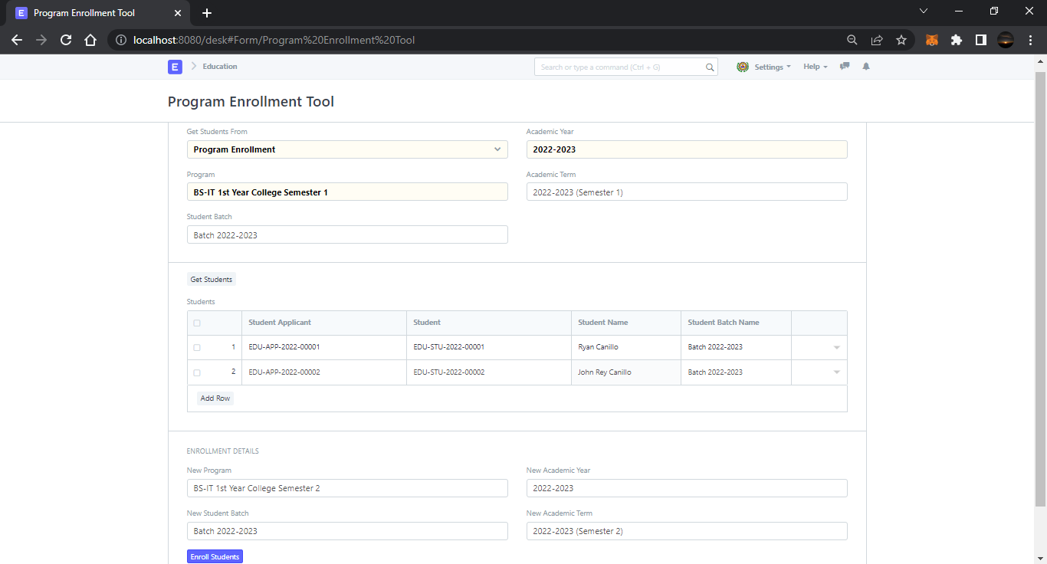**The Program Enrollment Tool can be used in cases when you want to bulk Enroll new students to a Program, or when old or existing students, who are already enrolled to a program are needed to be enrolled to a new program.**

## 1. How to create Student Enrollment using the Student Enrollment Tool

1. **Get Students From**: If you are enrolling a new student, you can fetch the students from the **Student Applicant** or if you are promoting the older students you can fetch them from the **Program Enrollment** itself.
2. **Academic Year**: Enter the Academic Year for which the new students had applied or under which the existing students were enrolled.
3. **Academic Term**: Enter the Academic Term for which the new students had applied or under which the existing students were enrolled.
4. **Program**: Enter the Program for which the new students had applied or under which the existing students were enrolled.

# Student Admission

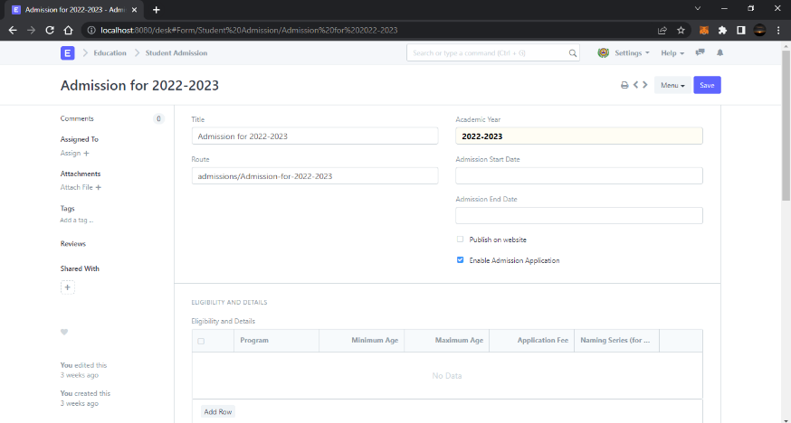**Student Admission is a document which can be configured to initiate an Admission Process for your institution by publishing it on the ERPNext generated website.**

## 1. Prerequisites

Before creating a Student Admission, it is advisable that you first create the following:

1. [Academic Year](https://docs.erpnext.com/docs/v13/user/manual/en/education/academic-year)
2. [Program](https://docs.erpnext.com/docs/v13/user/manual/en/education/program)

## 2. How to create a Student Admission

1. Go to Student Admission list and click on New.
2. Select the **Academic Year** for the Student Admission.
3. Enter the **Application Form Route**. This is the navigation URL for the Online Admission portal.
4. Save.

# Fees

**In this document we can maintain the Fee Records of the students.**

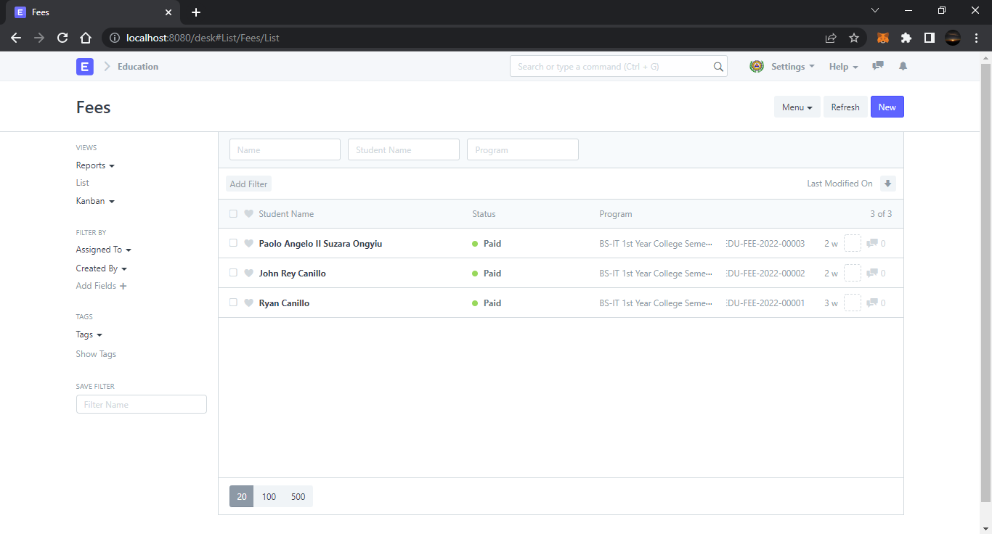At the time of submission of Fees by each student, a new Fees Record will be created wherein all the details of the student, Program they are enrolled in, Accounting information, etc. would be maintained.

## 1. Prerequisites

Before you create Fees record, it is advisable that you create the following first:

1. [Student](https://docs.erpnext.com/docs/v13/user/manual/en/education/student)
2. [Fee Category](https://docs.erpnext.com/docs/v13/user/manual/en/education/fee-category)
3. [Fee Structure](https://docs.erpnext.com/docs/v13/user/manual/en/education/fee-structure)

## 2. How to Create Fees

1. Go to the Fees list and click on New.
2. The **Institution** will be selected by default, which is editable, if required.
3. Select and add the **Student** for whom the Fees record is being made. The name of the student will be fetched simultaneously.
4. Add the **Due Date** of the payment of the Fees.
5. Save.

# Fee Structure

**A Fee Structure is a template that can be used while making Fees records or generating them via the Fee Schedule.**

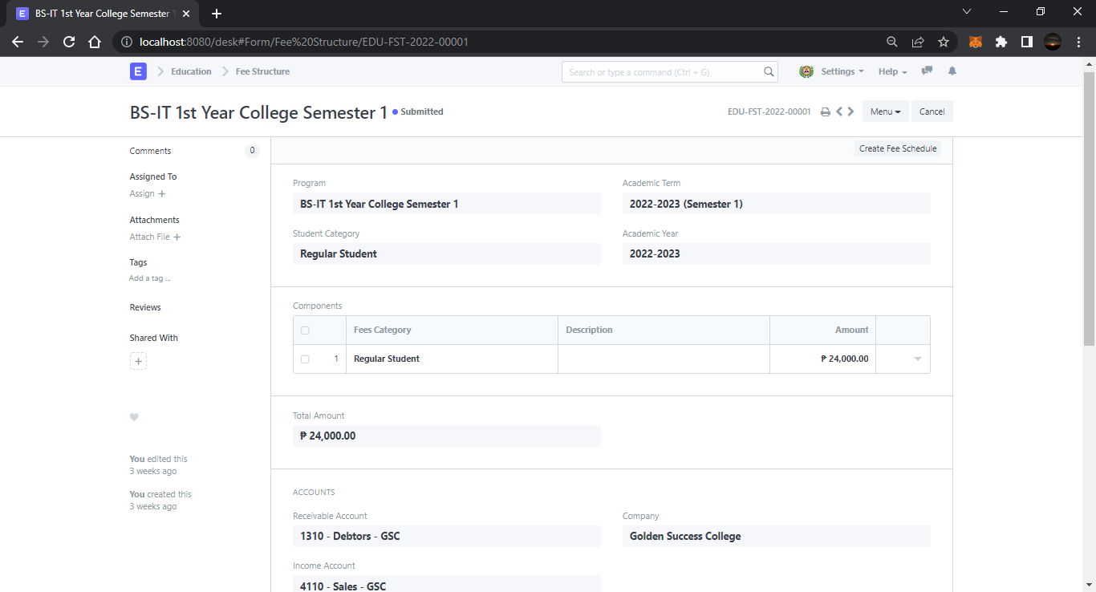The Fee structure can be fetched while creating the [Fees](https://docs.erpnext.com/docs/v13/user/manual/en/education/fees) for each student.

## 1. Prerequisites

Before creating a Fee Structure, it is advisable to create the following first:

1. [Academic Term](https://docs.erpnext.com/docs/v13/user/manual/en/education/academic-term)
2. [Academic Year](https://docs.erpnext.com/docs/v13/user/manual/en/education/academic-year)
3. [Program](https://docs.erpnext.com/docs/v13/user/manual/en/education/program)
4. [Student Category](https://docs.erpnext.com/docs/v13/user/manual/en/education/student-category)

## 2. How to create a Fee Structure

1. Go to the fee structure list and click on New.
2. Select and add the **Program** and other details for the fee structure.
3. In the Components Table, enter the **Fees Category** and **Amount**.
4. Save and Submit.

# Fee Category

**Fee Category would form all the components for calculation of Fees or creation of Fee Structure.**

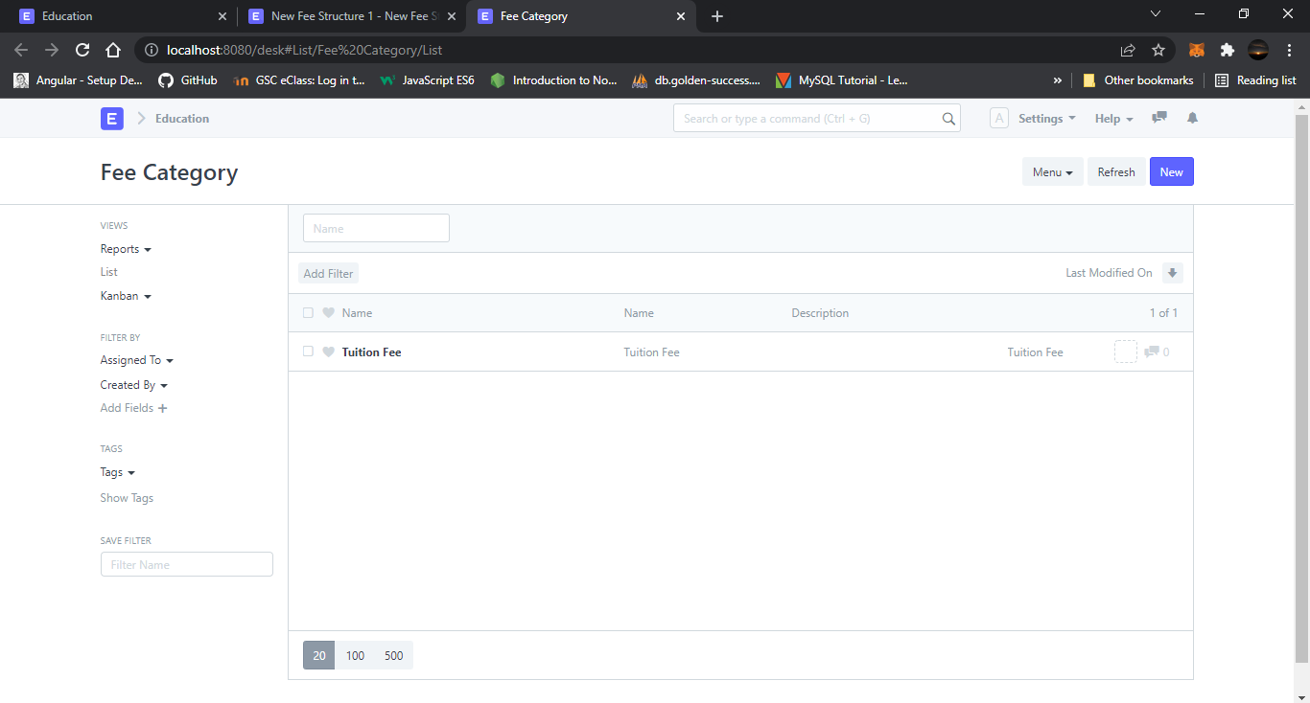For example, Tuition Fees and Hostel fees would make the different categories of fees.

# Fee Schedule

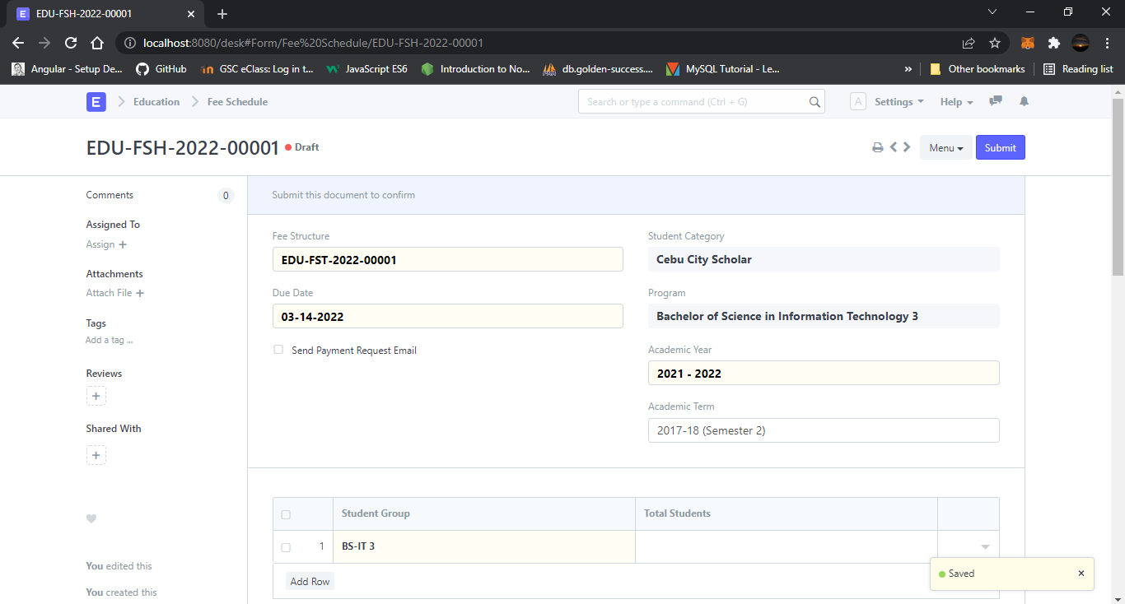**Fee Schedule would help you in defining a time-line for the Fee payment of the students, based on the Student Group.**

## 1. Prerequisites

1. [Fee Structure](https://docs.erpnext.com/docs/v13/user/manual/en/education/fee-structure)
2. [Student group](https://docs.erpnext.com/docs/v13/user/manual/en/education/student-group)

## 1. How to create a new Fee Schedule

1. Go to the Fee Schedule list and click on New.
2. Select and add the **Fee Structure**. The moment you add the Fee Structure, the **Fee Break Up for Each Student** will be auto-populated.
3. Select and add the **Academic Year** and the **Academic Term**.
4. Add the **Due Date** for the fees.
5. Select and add the **Student Group**.
6. Save and Submit.

# Course Schedule

**Course Schedule can be used for scheduling a particular course by an Instructor.**

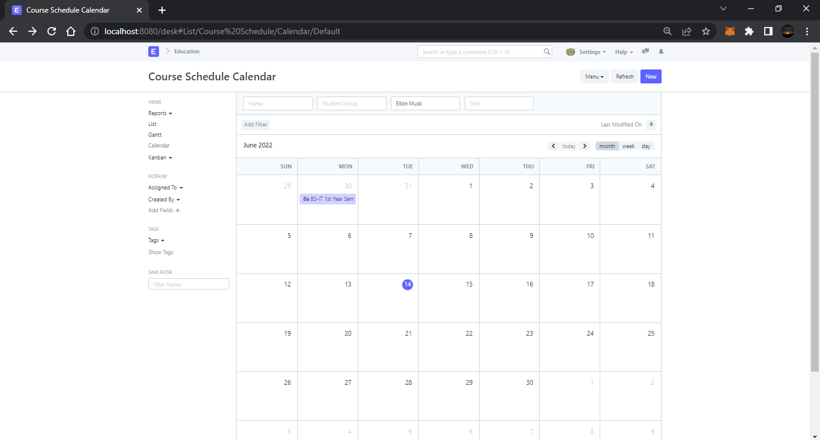Using this feature, a time table or an itinerary can be created in the Institute, wherein each slot will be scheduled via Course schedule.

## 1. Prerequisites

Before creating a Course Schedule, it is advised that you create the following first:

1. [Student Group](https://docs.erpnext.com/docs/v13/user/manual/en/education/student-group)
2. [Instructor](https://docs.erpnext.com/docs/v13/user/manual/en/education/instructor)
3. [Course](https://docs.erpnext.com/docs/v13/user/manual/en/education/course)
4. [Program](https://docs.erpnext.com/docs/v13/user/manual/en/education/program)
5. [Room](https://docs.erpnext.com/docs/v13/user/manual/en/education/room)

## 2. How to create a Course Schedule

1. Create a new Course Schedule from the Schedule Calendar.
2. Select the **Student Group** for which you want to create the Course Schedule.
3. Select the **Instructor** who will be tutoring the students for the course.
4. Select the **Course** for which the schedule is being prepared.
5. Add the **From Time** and **To Time** for the Course Schedule.
6. Select and add the **Room** wherein the Lecture would be conducted.

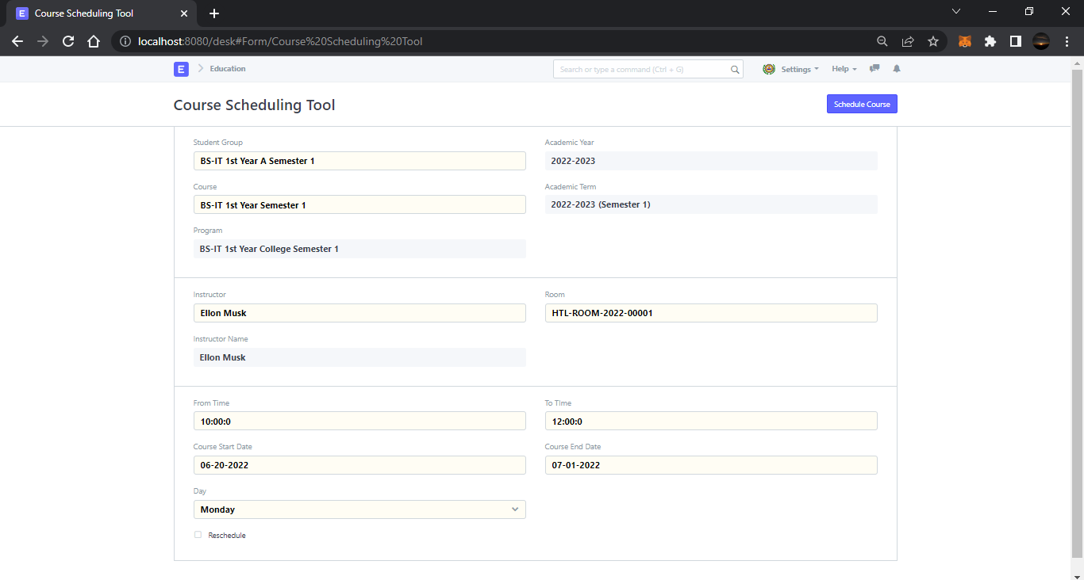

## 1. Creating Course Schedules

* Select Student Group for which you need to create Course Schedules.
* Select Course, Room and Instructor for Course Schedules.
* Enter From Time and To Time for Course Schedule.
* Enter Start Date and End Date of the Course (Course Schedules will be created within this date range)
* Enter Day of the week on which you want to schedule the Course.
* Click on the 'Schedule Course' button
* The system will create Course Schedules if the Room and Instructor are available and there is no conflict for the selected Student Group with other Course Schedules.

# Student Attendance

**Student Attendance allows you to track and manage the attendance of a student for a day. The Attendance module is designed to help teachers easily mark student attendance during class.**

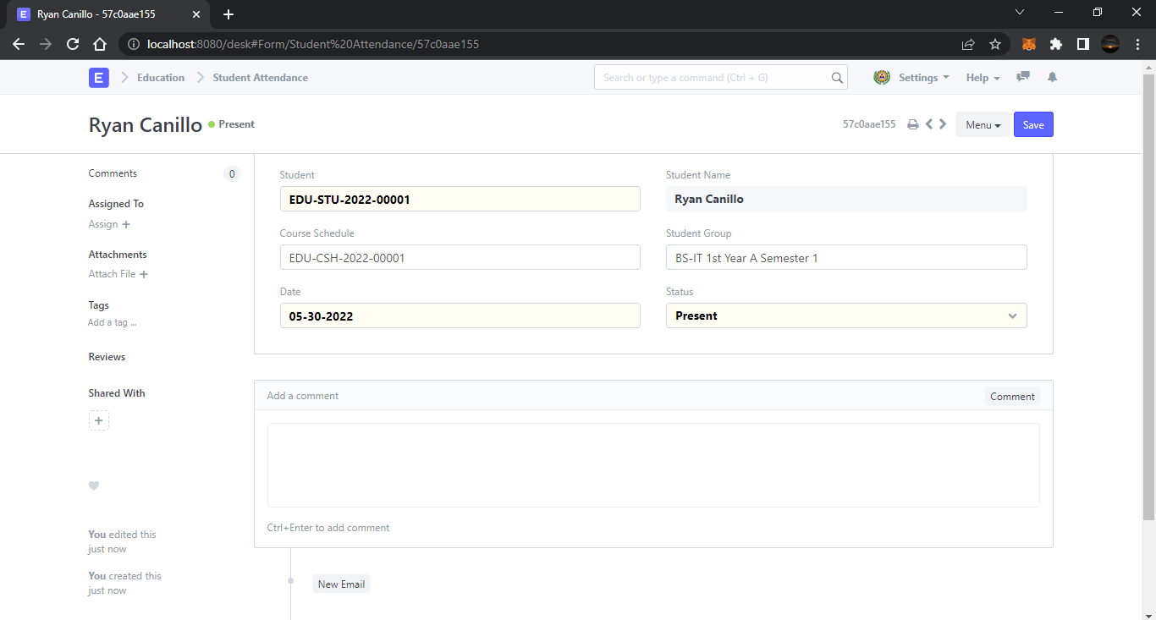Attendance Records can be created against Students on a daily basis.

# Student Leave Application

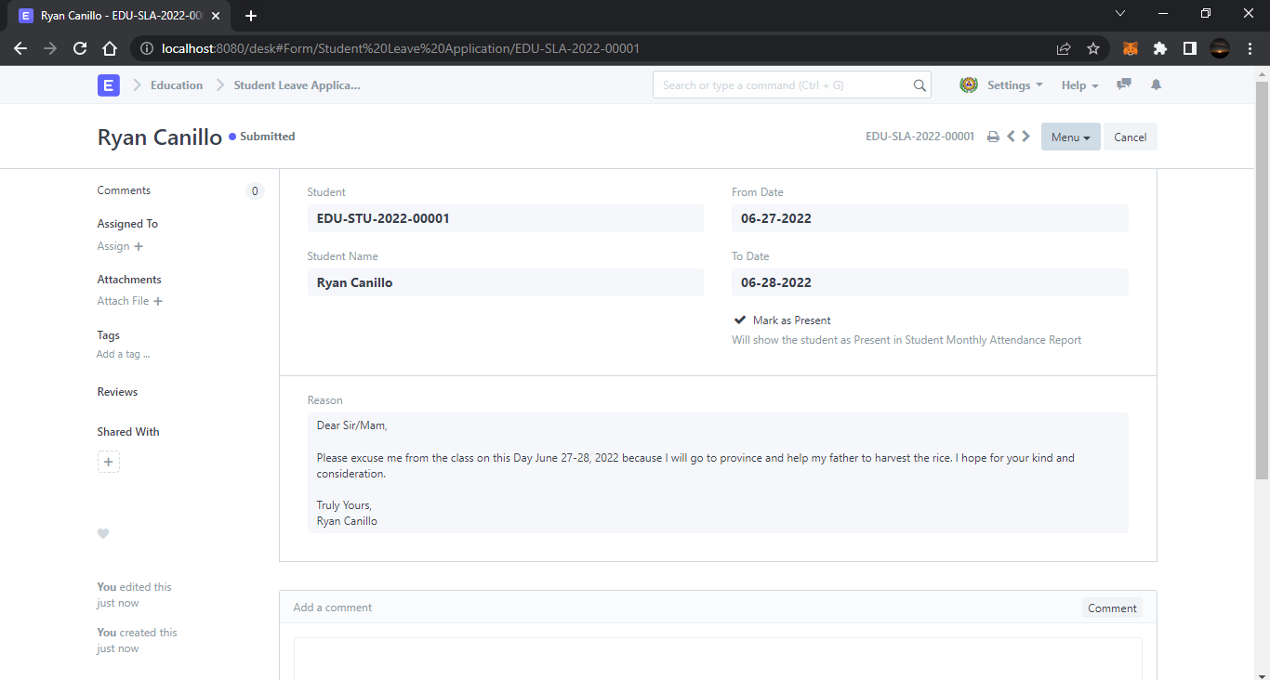**Student Leave Application is a formal document to keep a track of leaves for a student.**