# Order

# Animations

* AnimateTransitionShader
* Wipe
* AnimateProperty
* Effect
* Glow – for a selected image
* Move
* Parallel – for the online \ offline effect
* Sequence

# TBD

* Success

# Promotion

## Integration Points

* <http://developers.facebook.com/docs/guides/canvas/>
* [Stream publishing](http://developers.facebook.com/docs/guides/canvas/#stream)
* [Requests](http://developers.facebook.com/docs/guides/canvas/#requests)
* [Bookmarks and Counters](http://developers.facebook.com/docs/guides/canvas/#bookmarks)
* [Application and Games dashboards](http://developers.facebook.com/docs/guides/canvas/#dashboards)
* [Profile tabs](http://developers.facebook.com/docs/guides/canvas/#tabs)

# Framework

* Tip of the day

# Register

* Disclose My Facebook details to Facebook Friends
* Disclose Facebook Friends details

# Mailer

## Email template

|  |  |  |
| --- | --- | --- |
| **iFacedate - Hello getter name** | | |
|  | | |
| http://photos-a.ak.fbcdn.net/hphotos-ak-snc4/hs224.snc4/38516_418350777907_689887907_4552069_6278404_t.jpg | Message for the user | **Actions**  sender's Profile  action  iFacedate |
| sender name |

## Email types

|  |  |  |  |  |
| --- | --- | --- | --- | --- |
| Type | Sender | Getter | Message | Actions |
| Viewed | Noam | Carmit | Noam has viewed your profile | * View Noam's profile * Expose Noam |
| Exposing | Noam | Carmit | Noam has requested to expose you  Noam wrote:"$user text$" | * View Noam's profile * Approve sender |
| Rejected | Carmit | Noam | Carmit has rejected your request for exposure | * View Carmit's profile |
| Approved | Carmit | Noam | Carmit has approved your request for exposure  You can log-into Carmit profile and start communicating with her Noam wrote:"$user text$" | * Communicate with Carmit * View Carmit's profile |
| Genius | iFacedate | Noam | Genius has found a match the fit for your profile | * View match profile * Expose Noam |
| Invitation Email | iFacedate on behave Noam | Carmit | Noam is using iFacedate – Facebook app for Dating and he think you might be interested in joining Noam wrote:"$user text$" | * Register |
| Flirt | Noam | Carmit | Noam has sent you a flirt.  Noam flirt:" $Flirt Text$" | * Flirt with Noam * View Noam's profile * Expose Noam |
| Holiday | iFacedate | Noam | Carmit turns 38 on August 10  You have viewed Carmit's profile in iFacedate | * View Carmit profile * Expose Noam |
| Update | iFacedate on behave Carmit | Noam | Carmit has updated her profile in iFacedate | * View Carmit's profile * Expose Noam |
| Confirm Registration | iFacedate | Carmit | To complete registration click here | * Complete registration |

# Top Bar

## Left

* Home
* Requests – of new users that saw your profile and request to expose
* Notifications – of comm from all users (existing, exposed etz…)

## Middle

* Search
* By name
* By Gender?

## Right

* Credit: fd$152
* Balance
* Invitation Status (Get Credit only after invitee registers)
* Invited
* Rejected
* Exists
* By Me
* By else
* Registered
* Invite friends to get Free Credit
* Purchase Credit
* PayPal
* Google Checkout
* …
* Settings
* ronniek
* My Account
* Details
* Change Password
* Change Email
* Balance
* Balance
* Invitation Status
* Invite friends to get Free Credit
* Purchase Credit
* Privacy
* Edit My Profile
* Invite friends to get Free Credit
* Logout

# Bottom Bar

* Facedate © 2010
* Legal – application modal pop up with 3 tabs
* [Terms and Conditions of Service](http://www.jdate.com/Applications/Article/ArticleView.aspx?CategoryID=1948&ArticleID=6498&HideNav=True#service)
* [Privacy Statement](http://www.jdate.com/Applications/Article/ArticleView.aspx?CategoryID=1948&ArticleID=6498&HideNav=True#privacy)
* [Terms and Conditions of Purchase](http://www.jdate.com/Applications/Article/ArticleView.aspx?CategoryID=1948&ArticleID=6498&HideNav=True#purchase)
* Safety – application modal pop up
* Help
* Help
* FAQ – like neo games interview
* Support
* Contact info – probably redirect to support system
* About – application modal pop up

# Navigator

## Search

* Simple / Quick
* Name
* Email
* Keyword
* Advanced
* Map – like WinWin
* Zip Code
* City
* Proximity
* Online
* Seen You
* Exposed you
* You Exposed
* With Picture
* Facebook Friends
* Deleted

## Saved Searches

Defined by user

## My Lists

## Actions

* New List

# Results

* Name of Result
* Combination of the search Criteria
* Custom name by User
* View
* List
* Proximity
* Thumbs
* Image Size
* Filmstrip (like windows explorer)
* Carousel
* On a Map
* Actions
* Selection
* Check all
* Check one
* Uncheck all
* On Item
* Flirts
* Expose
* Save to List
* Drag & Drop to List

# Profile

* Details – Tabs… - Toggle Bar Buttons
* Common
* Image
* Photos
* Hobbies
* Comm
* Notifications
* Chat
* Blog
* History / Log
* Me – with all
* Other – with me
* My Comments
* Actions
* Flirts
* Fixed
* Expose
* Mail
* Contact
* Track
* On Me
* Other
* Save to List
* Drag & Drop to List
* Report of Misbehave
* Web
* Online
* Offline
* Status
* Exists
* Viewed
* Exposing / Deleted
* Approved / Rejected

Exists

Viewed

Exposing / Deleted

Approved / Rejected

|  |  |
| --- | --- |
| **1** | **View** |
| **2** | **Exposing** |
| **3** | **Rejected** |
| **4** | **Approved** |
| **5** | **Genius** |
| **6** | **Flirt** |
| **7** | **Holiday** |
| **8** | **Update** |

1. **Register**
2. **Send and Receive mail**
3. **Details**
   1. **Flirt**
   2. **Delete**
   3. **Exposing**
4. **Search**
   1. **Result**
      1. **List**
5. **CP$**
   1. **Get**
   2. **Buy**
   3. **Balance**
   4. **Use**
6. **Translation**
7. **Misc** 
   1. **Legal**
   2. **FAQ**
   3. **Help**
   4. **Support**
   5. **About**
8. **Design**
9. **Buzz**
   1. **Blog**
   2. **Talkback**
   3. **JDates**
   4. **Facebook Groups**

# Colors

## css

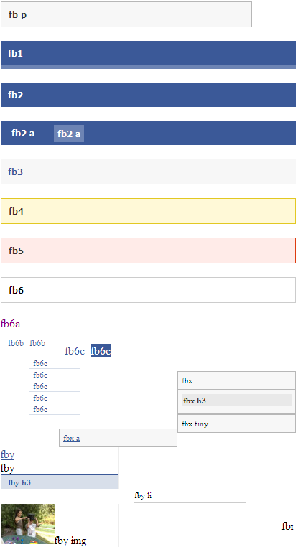

## What are the colors Facebook uses?

|  |  |
| --- | --- |
| Hex | Usage |
| #0e1f5b |  |
| #3b5998 | Header, Links |
| #7f93bc | Line between "Facebook" and "Search" |
| #95a5c6 |  |
| #bdc7d8 |  |
| #c3cddf |  |
| #d8dfea |  |
| #eceff5 | Comments and likes background |
| #cccccc | Misc. borders/lines around facebook |
| #f7f7f7 | Background of left nav, inactive tabs, canvas backgrounds on eg. Photos app |
| #dd3c10 | Error box border |
| #ffebe8 | Error box background |
| #e2c822 | Attention box border |
| #fff9d7 | Attention box background |

## How do I make my buttons look like Facebook buttons?

Set the class name of an input button to that of a facebook style. ie.

<input type="button" value="Make me look like Facebook!!!!" class="**inputsubmit**" />

## What are the widths of the canvas and the profile application box, and is there a limit to height?

The canvas is 760 pixels wide (646 pixels wide on the old profile). You need to edit your application's settings in order for your canvas page to expand to the full 760 pixels - a nice consideration for backwards compatibility.

The narrow profile box is 190 pixels wide, not including margins. The left margin is 10 pixels, but there is no right margin. For balanced margins, make your content 180 pixels wide.

The wide profile box is 388 pixels wide, not including margins. The left margin is 8 pixels, but there is no right margin. For balanced margins, make your content 380 pixels wide.

Narrow profile boxes on the main profile (the Wall and Info tabs) can be up to 250 pixels in height. There is no known pixel height limit for Facebook profile box contents on the Boxes tab. (Verified up to 100,000px on May 06, 2008)

