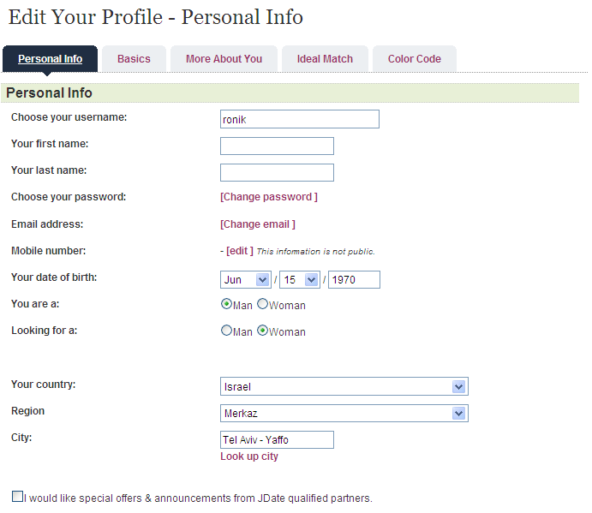

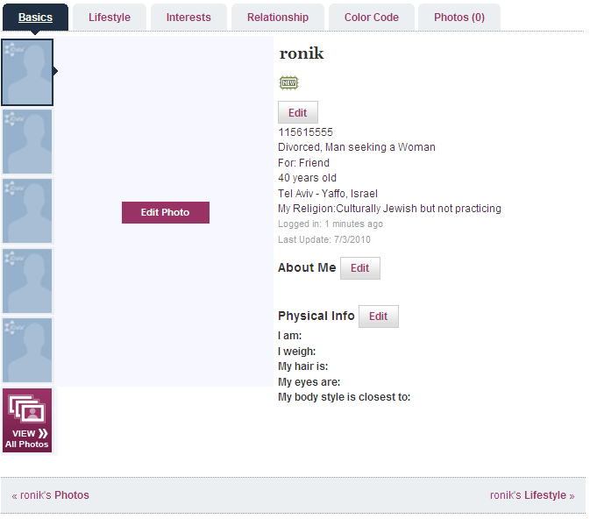

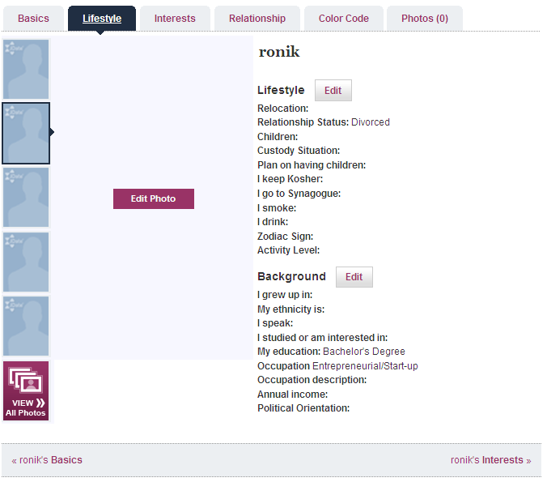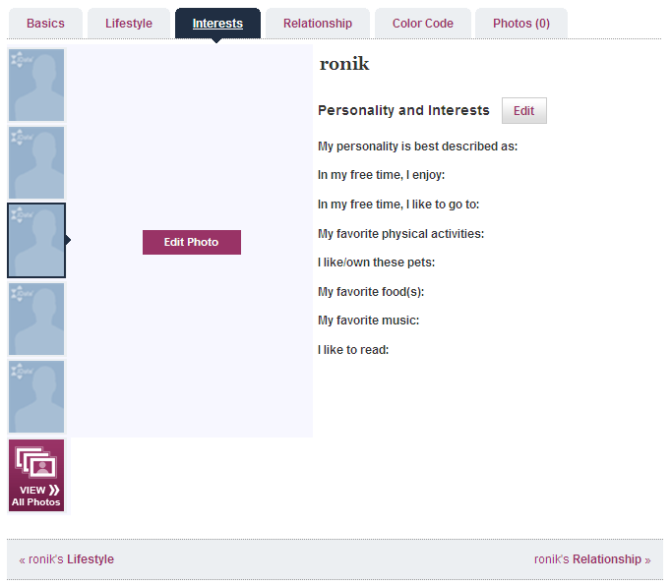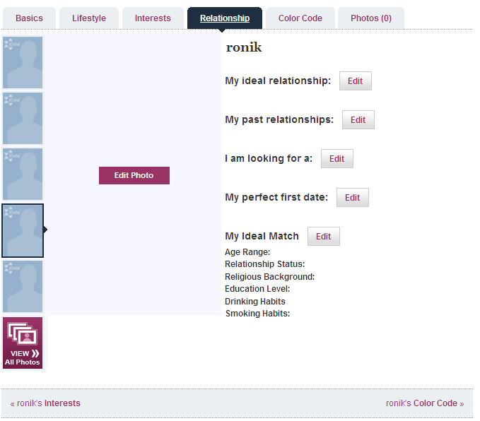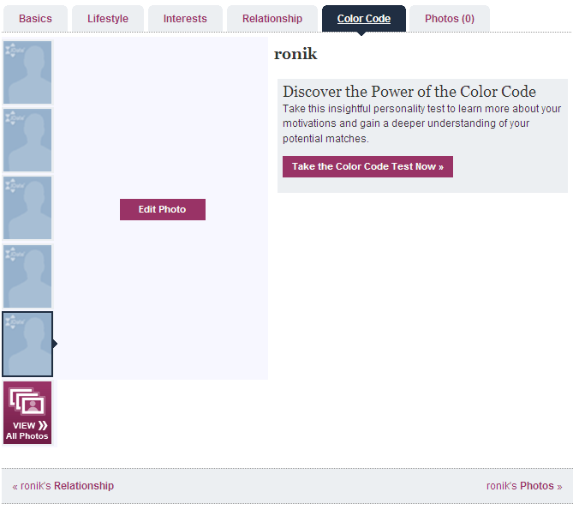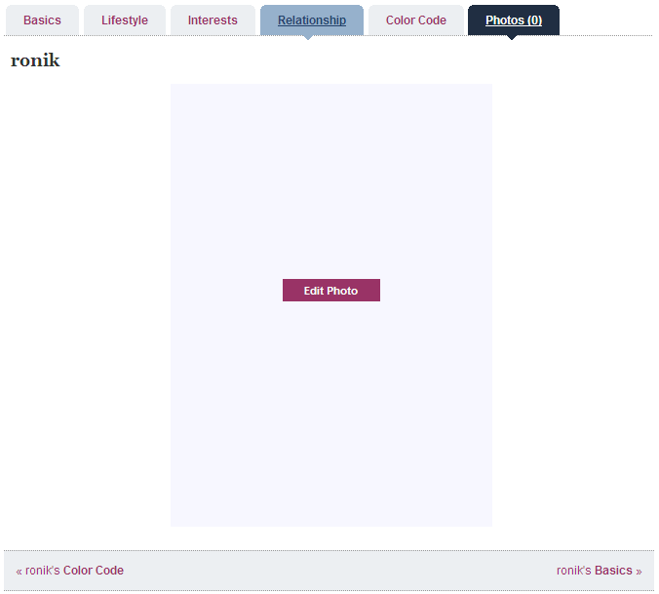

Site Map

1. **Articles and Content**

[**About JDate**](http://www.jdate.com/Applications/Article/ArticleView.aspx?CategoryID=1998&HideNav=True)

Discover all there is to know about JDate.com

[**Frequently Asked Questions**](http://www.jdate.com/Applications/Article/FAQMain.aspx)

Uncover the answers to frequently asked questions

[**Make It Happen**](http://www.jdate.com/Applications/Article/ArticleDefault.aspx?CategoryID=2010)

Help us help you find a date with useful dating articles and advice

[**Dating Talk**](http://www.jdate.com/Applications/Article/ArticleDefault.aspx?CategoryID=2308)

Featured articles about dating

[**Success Stories**](http://www.JDate.com/jmag/category/successstories/)

Read real success stories of members who met through JDate

[**Safety**](http://www.jdate.com/Applications/Article/ArticleView.aspx?CategoryID=114&HideNav=true)

Learn guidelines for smart and safe dating

1. **Login and Registration**

[**Login**](http://www.jdate.com/Applications/Logon/Logon.aspx)

Login and meet other singles

[**Register Today**](http://www.jdate.com/Applications/MemberProfile/RegistrationStep1.aspx)

Join and post a free profile

1. **Subscription**

[**Subscribe**](http://www.jdate.com/Applications/Subscription/Subscribe.aspx?prtid=81)

Get connected! Subscribe today to use our Chat Rooms, Instant Message and Email

1. **My Profile**

[**Account Information**](http://www.jdate.com/Applications/Subscription/History.aspx)

View and manage the details of your JDate account

[**Edit Your Profile**](http://www.jdate.com/Applications/MemberProfile/ViewProfile.aspx)

Get noticed by keeping your profile looking fresh

[**Change Your Email Address or Password**](http://www.jdate.com/Applications/MemberProfile/ChangeEmail.aspx)

Update your email address or password

[**Edit Your Photos**](http://www.jdate.com/Applications/MemberProfile/MemberPhotoUpload.aspx)

Get noticed — profiles with photos get more responses. Add or update your photos

[**Show/Hide Settings**](http://www.jdate.com/Applications/MemberServices/DisplaySettings.aspx)

Show or hide your profile settings

1. **Connect**

[**Members Online**](http://www.jdate.com/Applications/MembersOnline/MembersOnline.aspx)

See other members that are online now

[**Chat Rooms**](http://www.jdate.com/Applications/Chat/Default.aspx)

Chat real-time with other members

[**Message Boards**](http://connect.JDate.com/boards/)

Share your thoughts and opinions and learn what other members have to say

[**E-cards**](http://connect.JDate.com/cards/categories.html)

E-cards are another fun way to communicate and connect with people

1. **Search**

[**Your Matches**](http://www.jdate.com/Applications/Search/SearchResults.aspx)

Check out the members that you are looking for

[**Look Up Member**](http://www.jdate.com/Applications/LookupProfile/LookupProfile.aspx)

Quickly find other members — search by username or ID

[**Search Preferences**](http://www.jdate.com/Applications/Search/SearchPreferences.aspx)

Choose the criteria for members you want to view

1. **My Lists**

[**Hot Lists**](http://www.jdate.com/Applications/HotList/View.aspx?CategoryID=0)

Save or view your favorite members and see who's "Hot Listed" you too

[**Members You Click With**](http://www.jdate.com/Applications/HotList/View.aspx?CategoryID=-15)

Meet the members who said they'd *Click!* with you

1. **Email and Messages**

[**Your Email**](http://www.jdate.com/Applications/Email/MailBox.aspx)

Manage your anonymous email correspondence

[**Email Folder Settings**](http://www.jdate.com/Applications/Email/FolderSettings.aspx)

Add/Edit/Delete on-site email folders

[**On-Site and Off-Site Message Settings**](http://www.jdate.com/Applications/Email/MessageSettings.aspx)

Manage your on-site and off-site message settings

[**Never Miss An Email**](http://www.jdate.com/Applications/Article/ArticleView.aspx?CategoryID=1938&ArticleID=6312&RowNumber=1)

Make sure you receive all your email from JDate

[**JDate Mobile™**](http://www.jdate.com/Applications/Mobile/MobileSettings.aspx)

Find out what's new in your inbox by signing up for FREE notifications.

1. **Contact Us**

[**Contact Us**](http://www.jdate.com/Applications/ContactUs/ContactUs.aspx)

Do you have a question or comment? Feel free to contact us

1. **Legal**

[**Terms and Conditions of Service**](http://www.jdate.com/Applications/Article/ArticleView.aspx?CategoryID=1948&ArticleID=6498&HideNav=True#service)

Learn the Terms and Conditions of Service

[**Privacy Statement**](http://www.jdate.com/Applications/Article/ArticleView.aspx?CategoryID=1948&ArticleID=6498&HideNav=True#privacy)

Review our Privacy Statement

[**Terms and Conditions of Purchase**](http://www.jdate.com/Applications/Article/ArticleView.aspx?CategoryID=1948&ArticleID=6498&HideNav=True#purchase)

Read the Terms and Conditions of Purchase

1. **About Spark Networks**

[**About Spark Networks**](http://www.spark.net/about.htm)

Who operates JDate? Learn more about Spark Networks

[**Investor Relations**](http://www.spark.net/investor.htm)

SEC filings, stock quotes and other financial information

[**Careers at Spark Networks**](http://www.spark.net/careers.htm)

Join the team

[**News**](http://www.spark.net/news.htm)

Read our latest press releases

[**Affiliates Program**](https://affiliates.spark-networks.com/)

Generate revenue by linking to our websites

[**Spark Networks Sites**](http://static.JDate.com/spark_networks_sites/generic.htm)

Review a list of the online communities operated by Spark Networks

* Home
* Inbox
  + Messages
  + Mail Settings
  + Custom Folders
* Matches
  + Your Matches
  + Who's Searching for You?
  + Preferences
* Search
  + Quick Search
  + Keyword Search
  + Photo Gallery
  + Look Up Member
* Hot Lists
  + Who's Checking You Out?
  + You'r e Checking Out…
  + Do We Click@?
  + Custom Lists
  + Matches by Mail
* Community
  + Members Online
  + Chat Room
  + Message Boards
  + E-cards
  + Travel & Events
* Your Profile
  + Edit You Profile
  + Manage Your Photos
  + Settings
  + Color Code
  + Member Services
  + JDate Mobile Settings
* JDateTV
  + JDate Season 1
  + Other Videos
* Subscribe
  + Subscribe