Zach Wolsborn and Ronnie Mohapatra

Ronnie and Zach’s Music Player

­­

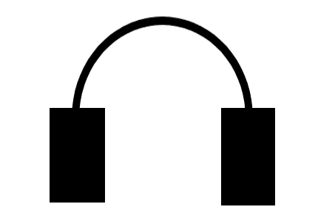

Zach Wolsborn

Final Project Reflection

During this project we created a music player app that allows the user to create playlists, add and remove songs from the playlist, and add songs or playlists to a queue that holds the next songs to be played. We learned a lot about the File class in Java as well as the ins and outs of GUI. To aid us in our project we used YouTube to get .wav files for the songs, GitHub to collaborate on the project, SWT plugin to make the GUI, the Stack overflow and Oracle websites for help with errors and bugs within our project, and Spotify, which we modeled our app after. We were able to complete our whole project with all our intended functions and features.

One thing I learned during this project was how to use GitHub. While I’ve used GitHub on a project before this one, I had never used it as often as this project. Before I just copied the code shown in GitHub but during this project I learned how to use Git within the command prompt and push and pull changes to different branches. I also learned that you can go back to previous versions of your project after you’ve committed those versions.

The second thing I learned during this project was how to use eclipse plugin. For example, we used the SWT plugin from GitHub to make the GUI for our music player. Rather than copy the same code repeatedly and typing out each GUI object we downloaded a plugin from eclipse that allowed us to click and drag GUI objects into a window which then generated code. This taught me a lot about how to use plugins with Java and made me more familiar with the eclipse environment.

One thing I struggled on was using GUI. Even with the generated code from the SWT

Plugin, I had to relearn aspects of GUI that I had forgotten from AP Computer Science A. To resolve this, Ronnie helped me remember the different methods used in GUI and looking at resources online helped me relearn the material. This came in handy when it came to reading over Ronnie’s code as well since I then understood GUI much better and allowed me to look at each method and review the work he had done.

Given more time we would have added more songs to our song folder as we only had

slightly less than 50 songs. This would allow the user a broader range of music to select for their playlists. Also, we would’ve made the app look more professional. When we merged our code towards the end we realized that the GUIs did not look the same since Ronnie has a Mac computer while I have a Windows computer. To fix this we changed the look and feel of our app to Nimbus. While this made the app appear more uniform for the two computers, it caused the app to look slightly outdated from 2019 technology.

I enjoyed the independent learning idea as it allowed us to teach ourselves the stuff we

don’t know and skip over information we do know. Also, West Point uses the Thayer teaching method where cadets must teach themselves the lessons for the next class and the purpose of in class time is to ask questions. This independent learning opportunity allowed me to practice the type of learning I will be doing for the next four years.

After completing this project, I feel like I really understand how to use GUI now and how most music player apps work. We took a lot of influence from the app Spotify when making our game and deconstructed how we thought those developers made the app when coding our own. I also now feel comfortable with the data structures we used, which included: ArrayLists, arrays, Maps, and enums as we used those structures extensively.