Online Food Ordering System – Object Oriented Analysis and Design

1. Introduction
This project is based on an Online Food Ordering System. The system is designed to allow customers to browse restaurants, view menus, place orders, make payments, and track deliveries. It also allows restaurant administrators to manage their menu items and handle customer orders. The main objective is to make the food ordering process simple and convenient for both customers and restaurants.

2. Problem Statement
Many customers face challenges when ordering food manually. They have to call or visit restaurants physically to place orders, which is time-consuming. Restaurants also find it hard to keep track of customer orders and payments efficiently. This system automates the process of ordering, payment, and delivery tracking.

3. Objectives
• To allow customers to place food orders online from anywhere.
• To enable restaurants to manage their menu and orders digitally.
• To simplify payment and order tracking processes.
• To improve customer satisfaction and efficiency.

4. Scope
The system covers customer registration, restaurant management, menu display, order creation, payment processing, and delivery tracking. It does not include real online payment integration or GPS tracking for delivery.

5. UML Diagrams

5.1 Use Case Diagram
The Use Case Diagram shows the interaction between different users (Customer, RestaurantAdmin, DeliveryDriver, PaymentGateway) and the main system functions such as browsing restaurants, placing orders, making payments, and tracking orders.

5.2 Class Diagram
The Class Diagram shows the structure of the system using classes and relationships. The main classes include User, Customer, Restaurant, MenuItem, Order, OrderItem, Payment, and Delivery. It defines how these classes interact and depend on each other.

5.3 Sequence Diagram
The Sequence Diagram explains the flow of activities when a customer places an order. It shows how the system components like the web interface, order service, payment gateway, and delivery service communicate step-by-step.

5.4 Activity Diagram
The Activity Diagram shows the workflow of placing an order, from browsing the menu to payment processing, delivery assignment, and final order completion.

6. System Implementation
The system can be implemented using an Object-Oriented Programming language like Java or Python. Below is a simple Java version showing how the classes interact.
class Customer {
void placeOrder(Order order) {
System.out.println('Order placed successfully');
}
}
class Order {
String orderId;
double total;
void calculateTotal() {}
)
activity diagram
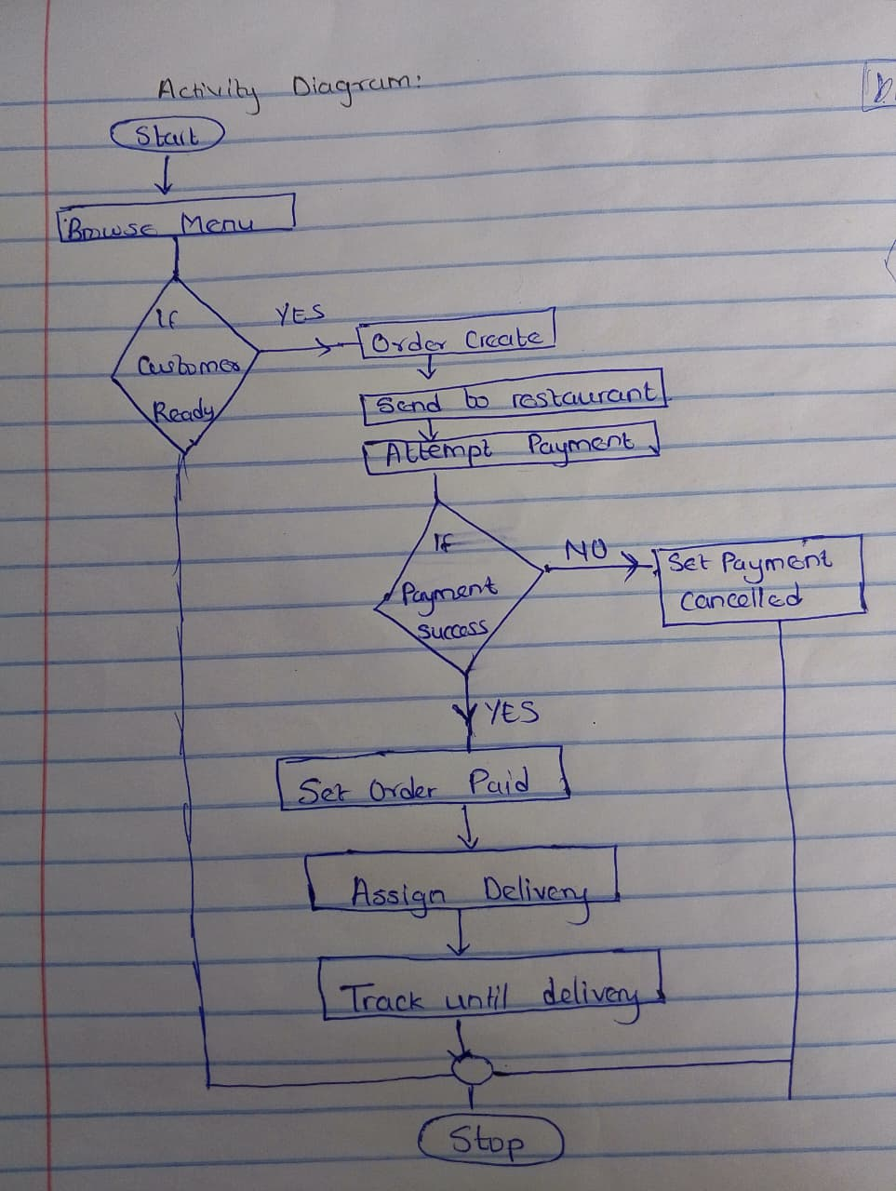
database design
use case diagram
c
7 java implementation
enum OrderStatus { CREATED, PAID, PREPARING, OUT_FOR_DELIVERY, DELIVERED, CANCELLED }

class User {
String id, name, email;
public User(String id, String name, String email){ this.id=id; this.name=name; this.email=email; }
public boolean login(){ return true; }
}

class Customer extends User {
String address, phone;
public Customer(String id,String name,String email,String address,String phone){ super(id,name,email); this.address=address; this.phone=phone; }
List<Order> orders = new ArrayList<>();
public void placeOrder(Order o){ orders.add(o); System.out.println(name+" placed order "+o.id); }
}

class Restaurant {
String id,name;
List<MenuItem> menu = new ArrayList<>();
public Restaurant(String id,String name){ this.id=id; this.name=name; }
public void addMenuItem(MenuItem mi){ menu.add(mi); }
}

class MenuItem {
String id,name; double price;
public MenuItem(String id,String name,double price){ this.id=id; this.name=name; this.price=price; }
}

class OrderItem {
MenuItem menuItem; int quantity;
public OrderItem(MenuItem m,int q){ this.menuItem=m; this.quantity=q; }
public double getSubTotal(){ return menuItem.price*quantity; }
}

class Order {
String id; Customer customer; List<OrderItem> items = new ArrayList<>();
OrderStatus status = OrderStatus.CREATED; double total;
public Order(String id, Customer c){ this.id=id; this.customer=c; }
public void addItem(OrderItem oi){ items.add(oi); }
public double calculateTotal(){ total = items.stream().mapToDouble(OrderItem::getSubTotal).sum(); return total; }
}

class Payment {
String id; Order order; double amount; String status="PENDING";
public Payment(String id, Order order){ this.id=id; this.order=order; this.amount=order.calculateTotal(); }
public boolean process(){ status="SUCCESS"; return true; }
}

class DeliveryDriver { String id,name; public DeliveryDriver(String id,String name){ this.id=id; this.name=name; } }

class Delivery { DeliveryDriver driver; Order order; int etaMinutes; String status="ASSIGNED"; public Delivery(DeliveryDriver d, Order o, int eta){ this.driver=d; this.order=o; this.etaMinutes=eta; } }

public class OnlineFoodDemo {
public static void main(String[] args){
Customer c = new Customer("C1","Ronnie","ron@example.com","Nairobi","0711000000");
Restaurant r = new Restaurant("R1","FastFood");
r.addMenuItem(new MenuItem("M1","Burger",300));
r.addMenuItem(new MenuItem("M2","Fries",100));

Order order = new Order("O1",c);
order.addItem(new OrderItem(r.menu.get(0),2));
order.addItem(new OrderItem(r.menu.get(1),1));
c.placeOrder(order);

Payment p = new Payment("P1",order);
if(p.process()){ order.status=OrderStatus.PAID; System.out.println("Payment successful"); }

DeliveryDriver d = new DeliveryDriver("D1","James");
Delivery del = new Delivery(d,order,25);
System.out.println("Delivery assigned to "+d.name+", ETA "+del.etaMinutes+" mins");
}
}

Future Improvements
- Real Online Payment Integration
  - Integrate with payment gateways like MPesa, PayPal, Stripe, or Visa/Mastercard for real-time transactions.
  - Implement features like refunds, receipts, and multi-currency support.
- Real-Time Delivery Tracking
  - Integrate GPS tracking for delivery drivers.
  - Show live location updates to customers and estimated delivery time.
- Restaurant Analytics & Reporting
  - Provide dashboards for restaurants to track sales, popular menu items, and peak hours.
  - Predict inventory needs based on historical orders.
- AI-Powered Recommendations
  - Suggest menu items based on customer preferences, order history, and ratings.
  - Personalize offers or discounts.

Security Measures
- User Authentication & Authorization
  - Use hashed and salted passwords (e.g., bcrypt) instead of storing plain text.
  - Implement role-based access control (RBAC) to differentiate customer, admin, and delivery driver permissions.
- Data Encryption
  - Encrypt sensitive customer data (like payment info) using TLS/SSL for network security.
  - Store sensitive database fields encrypted (e.g., credit card numbers, passwords).

Conclusion
The Online Food Ordering System helps make the ordering process easier and more efficient. It combines different users and processes into one organized system using Object-Oriented principles and UML design. This makes it scalable and easy to maintain.

