|  |
| --- |
|  |
| DWAI |
| Created By: Ronnie Vu and Kalebh Ryals |
|  |
|  |
|  |

|  |
| --- |
|  |

Summary:

This is a game where a player can take a maze that can be controlled and maneuver his/her way through it. With the ability to control the walls, the goal will be to create a path that will take the main character to the goal which will allow the player to proceed to the next level

Table of Contents

I. Story/Theme Information..........................................................................................................................2

II. General Look and Feel..............................................................................................................................3

III. Summary of Game Play ...........................................................................................................................4

IV. Information Architecture and Mock-ups ................................................................................................4

V. Specifications of Specific Features ...........................................................................................................5

VI. Timeline to Complete .............................................................................................................................6

VII. Concept Art .........................................................................................................................................7-8

Game Summary:

DWAI is a maze-based puzzle game where the player must try to get the character to the goal somewhere within the room. Sounds easy, but there's a twist. There are two sets of controls, one that controls the character and another that controls the maze! Different type of blocks can only move in certain directions. This means that in DWAI the path is not laid out for the player, rather the player must lay out their own path. Throughout the game different types of blocks will be introduced. For example, there will be blocks that do not move at all and there will also be blocks that move in every direction! Sometimes there will be an object that can either power up or limit the player.

Goal:

The ultimate goal in this game is to create scenarios that will make the player think outside the box when completing a level. The player should be able to control the maze where they can produce a clear path that would lead to the exit of the game. Overall, this game is intended to be a simple yet fun casual game.

Target Audience:

The target audience would be anyone with critical thinking skills. It would be mostly aimed at people above the age of 9, but anyone can play the game.

General Look and Feel

Art Style:

The main art style off the game is going to based off of the flat user interface type of design. This type of design is prevalent in modern graphic design, and its simplicity is both pleasing to the eye and simple. DWAI's color scheme will be based off of three or four different colors that will be present throughout the entire game. For the different types of blocks and characters, different icons that compliment the design style will be used. The overall theme of the objects will be Japanese. For example, the power up could be sprites with are swords or onigiri while one the other hand, the crab or sake could limit the characters movement of completing the maze. The background will be a Japanese themed background to really make the player feel like he/she is playing something that strongly revolves around Japanese culture.

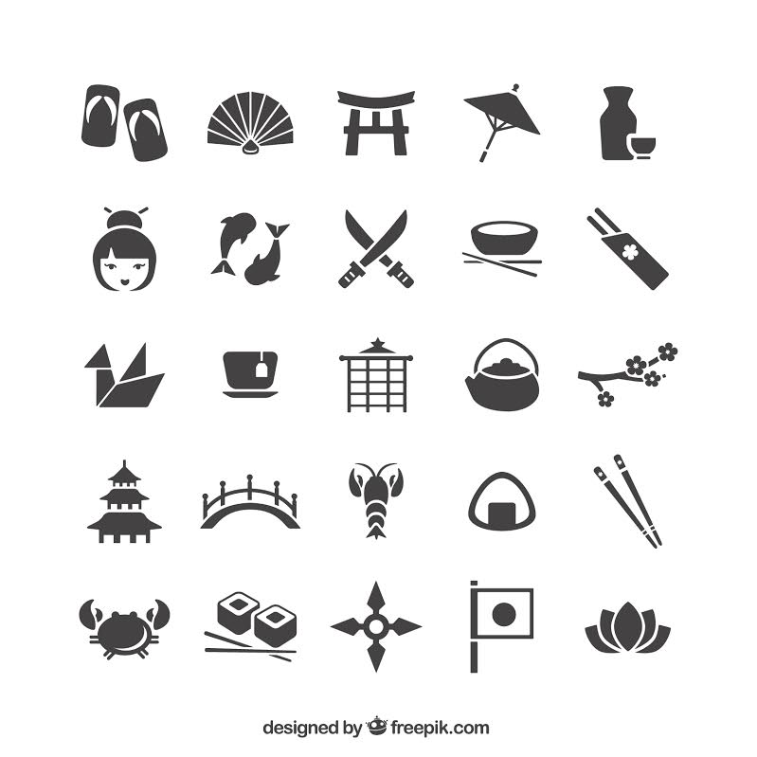

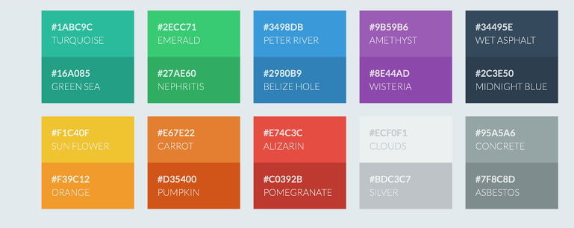

Game Play:

Starting the Game-

At the start of the game, there will be a menu and on that menu it will have a start button and a load button. The main screen will maintain a simple UI. When trying to load a level, the game will use Game Makers save function. After clicking on the start button, the player will see the first level on the screen.

Playing the Game-

During the actual game play of the levels, the player will have the option to move the walls of the maze using the w, a, s, d keys while controlling the character using the right, down, up, and left keys. Using these two functions, the player will be able to move the character through the maze with the goal of making it to the goal which will bring the player to the next level. Also, there will be a restart button where the player will be able to reset the entire level if he/she is to get stuck. There may be a possible undo button as well. As new blocks are introduced throughout the game, there will be short messages or demo levels to explain the use of the new block types.

During Game Play & Ending-

As the play progresses through each level, the levels will progressively get more challenging. Due to the fact that the first level will be easiest level, the player will be able to get use to the game and progressively get better as he or she moves on with each level. Upon finishing the last level, the player will come to the congratulations screen where they will be notified that they have completed all the levels.

Main objects in the Game

Horizontal Moving Squares - Will use bridge icon

Vertical Moving Squares - Will use tower icon

Non Moving Blocks - Will use gate icon

Katana upgrade - When player has a Katana upgrade, they can break a single block of their choice. It will most likely be implemented using the space bar.

Bonus Point Objects: Sushi, Teapot, Paper Crane, Chopsticks, etc.

Enemy Objects: Sake will cause the player's controls to be inverted. Crabs will cause the player to lose point. There will most likely be other enemy objects added to the game as well.

Player Object- Not determined what the player will be represented as yet. Possibly Hamtaro.