[SUBJECT: Physics]
CHAPTER: Electrostatic Potential and Capacitance
TOPIC: Electric Potential

[DIFFICULTY: Easy]
[Q] A conducting sphere of radius $R$ is given a charge $Q$. The electric potential and the electric field at the centre of the sphere respectively are:
[A] 0 and $\frac{Q}{4πε_{0}R^{2}}$
[B] $\frac{Q}{4πε_{0}R}$ and 0
[C] $\frac{Q}{4πε_{0}R}$ and $\frac{Q}{4πε_{0}R^{2}}$
[D] Both are 0
[Ans] B
[Sol] Due to conducting sphere at centre, electric field $E=0$
And electric potential $V=\frac{Q}{4πε_{0}R}$

[DIFFICULTY: Easy]
[Q] The expression $E=−\frac{dv}{dr}$ implies, that electric field is in that direction in which
[A] increase in potential is steepest.
[B] decrease in potential is steepest.
[C] change in potential is minimum.
[D] None of these
[Ans] B
[Sol] Since $E=−\frac{dV}{dr}$, the electric field points in the direction in which the potential decreases, and its magnitude equals the rate of decrease of potential with distance.
Hence the electric field is along the direction in which the decrease in potential is steepest.

[DIFFICULTY: Easy]
[Q] In a hollow spherical shell, potential (V) changes with respect to distance (s) from centre as
[A] 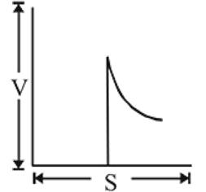
[B] 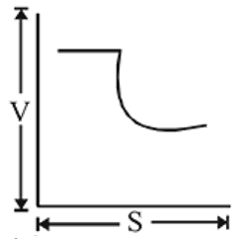
[C] 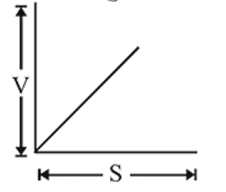
[D] 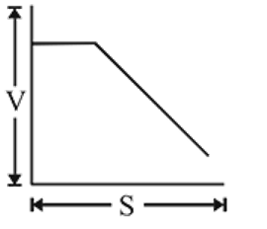
[Ans] B
[Sol] Inside a hollow charged spherical shell, $E=0$, so the potential is constant and equal to its value at the surface, $V=\frac{kQ}{R}$.
Outside the shell $\left(s>R\right)$, $V=\frac{kQ}{s}$, i.e. the potential decreases as $\frac{1}{s}$.
So $V$ remains constant up to $s=R$ and then falls off as $\frac{1}{s}$, which is shown by graph (B).

[DIFFICULTY: Medium]
[Q] The 1000 small droplets of water each of radius $r$ and charge $Q$, make a big drop of spherical shape. The potential of big drop is how many times the potential of one small droplet?
[A] 1
[B] 10
[C] 100
[D] 1000
[Ans] C
[Sol] Volume of big drop $=1000×$ volume of each small drop: $\frac{4}{3}πR^{3}=1000×\frac{4}{3}πr^{3}⇒R=10r$
$∵ V=\frac{kq}{r}$ and $V′=\frac{kq}{R}×1000$
Total charge on one small droplet is q and on the big drop is $1000q$. $⇒ \frac{V′}{V}=\frac{1000r}{R}=\frac{1000}{10}=100$
$∴ V′=100 V$

[DIFFICULTY: Medium]
[Q] The electric potential at a point $\left(x,y\right)$ in the $x−y$ plane is given by $V=−kxy$. The field intensity at a distance $r$ from the origin varies as
[A] $r^{2}$
[B] $\frac{1}{r^{2}}$
[C] $1/r$
[D] $r$
[Ans] D
[Sol] Let the $x−y$ coordinates of the point at distance $r$ from the origin be given as $x=rcosθ, y=rsinθ$
Potential is given as $V=−Kxy$
Now, electric field intensity is $\vec{E}=\left(−dV/dx\right) \vec{i}+\left(−dV/dy\right) \vec{j}=K\left(y\vec{i}+x\vec{j}\right)=K\left(rsinθ \vec{i}+rcosθ \vec{j}\right)=Kr\left(sinθ \vec{i}+cosθ \vec{j}\right)∝r$
So electric field intensity is proportional to $r$.

[DIFFICULTY: Easy]
[Q] Four charges $q_{1}=2×{10}^{−8} C$, $q_{2}=−2×{10}^{−8} C$, $q_{3}=−3×{10}^{−8} C$, and $q_{4}=6×{10}^{−8} C$ are placed at four corners of a square of side $\sqrt{2} m$. What is the potential at the centre of the square?
[A] $270 V$
[B] $300 V$
[C] Zero
[D] $100 V$
[Ans] A
[Sol] Potential at the centre $O, V=k\frac{q}{r}$
$V=k\left[\frac{2×{10}^{−8}}{1}+\frac{−2×{10}^{−8}}{1}+\frac{−3×{10}^{−8}}{1}+\frac{6×{10}^{−8}}{1}\right]$
$V=k×3×{10}^{−8}=9×{10}^{9}×3×{10}^{−8} volt$
$=27×10=270 V$

[DIFFICULTY: Medium]
[Q] A charge $Q$ is distributed over two concentric hollow spheres of radii $r$ and $R \left(R>r\right)$ such that the surface densities are equal. The potential at the common centre is $\frac{1}{4πε_{0}}$ times-
[A] $Q\left[\frac{r+R}{r^{2}+R^{2}}\right]$
[B] $\frac{Q}{2}\left(\frac{r+R}{r^{2}+R^{2}}\right)$
[C] $2Q\left(\frac{r+R}{r^{2}+R^{2}}\right)$
[D] zero
[Ans] A
[Sol] $q_{r}+q_{R}=Q$ …(1)
$\frac{q_{r}}{q_{R}}=\frac{4πr^{2}σ}{4πR^{2}σ}=\frac{r^{2}}{R^{2}}⇒\frac{q_{r}}{q_{R}}=\frac{r^{2}}{R^{2}} …\left(2\right)$
From (1) and (2) $q_{r}=\frac{Qr^{2}}{R^{2}+r^{2}}$ and $q_{R}=\frac{QR^{2}}{R^{2}+r^{2}}$
So, $V=\frac{q_{r}}{4πε_{0}r}+\frac{q_{R}}{4πε_{0}R}$
$⇒V=\frac{Q}{4πε_{0}}\left(\frac{r+R}{r^{2}+R^{2}}\right)$

[DIFFICULTY: Hard]
[Q] Three concentric charged metallic spherical shells $A$, $B$ and $C$ have radii $a$, $b$ and $c$; charge densities $σ$, $−σ$ and $σ$ and potentials $V_{A}$, $V_{B}$ and $V_{C}$ respectively. Then which of the following relations is correct?
[A] $V_{A}=\left(a+b+c\right)\frac{σ}{ε_{0}}$
[B] $V_{B}=\left(\frac{a^{2}}{b}−b+c\right)\frac{σ}{ε_{0}}$
[C] $V_{C}=\left(\frac{a^{2}+b^{2}}{b}+c\right)\frac{σ}{ε_{0}}$
[D] $V_{A}=V_{B}=V_{C}=\left(a+b+c\right)\frac{σ}{ε_{0}}$
[Ans] B
[Sol] The three shells are shown in figure.
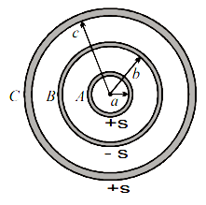
Let $K=\frac{1}{4πε_{0}}$. Charges on the shells are $q_{A}=4πa^{2}σ$, $q_{B}=−4πb^{2}σ$ and $q_{C}=4πc^{2}σ$.
Point $A$ lies inside shells $B$ and $C$:
$V_{A}=K\left[\frac{4πa^{2}σ}{a}−\frac{4πb^{2}σ}{b}+\frac{4πc^{2}σ}{c}\right]=\frac{σ}{ε_{0}}\left(a−b+c\right)$
Shell $B$ lies outside $A$ and inside $C$:
$V_{B}=K\left[\frac{4πa^{2}σ}{b}−\frac{4πb^{2}σ}{b}+\frac{4πc^{2}σ}{c}\right]=\frac{σ}{ε_{0}}\left(\frac{a^{2}}{b}−b+c\right)$
Shell $C$ lies outside $A$ and $B$:
$V_{C}=K\left[\frac{4πa^{2}σ}{c}−\frac{4πb^{2}σ}{c}+\frac{4πc^{2}σ}{c}\right]=\frac{σ}{ε_{0}}\left(\frac{a^{2}−b^{2}+c^{2}}{c}\right)$
Hence only the relation for $V_{B}$ is correct.

[DIFFICULTY: Easy]
[Q] An electron having charge $e$ and mass $m$ starts from the lower plate of two metallic plates separated by a distance $d$. If the potential difference between the plates is $V$, the time taken by the electron to reach the upper plate is given by
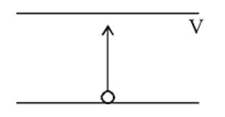
[A] $\sqrt{\frac{2md^{2}}{eV}}$
[B] $\sqrt{\frac{md^{2}}{eV}}$
[C] $\sqrt{\frac{md^{2}}{2eV}}$
[D] $\frac{2md^{2}}{eV}$
[Ans] A
[Sol] $E=\frac{V}{d}, F=eE=eV/d$
$a=\frac{F}{m}=\frac{eV}{md}$
$d=\frac{1}{2}at^{2}$ or $t=\sqrt{\frac{2d}{a}}$
or $t=\sqrt{\frac{2d⋅md}{eV}}=\sqrt{\frac{2md^{2}}{eV}}$

[DIFFICULTY: Medium]
[Q] There is a uniform electrostatic field in a region. The potential at various points on a small sphere centred at $P$, in the region, is found to vary between in the limits $589.0 V$ to $589.8 V$. What is the potential at a point on the sphere whose radius vector makes an angle of ${60}^{∘}$ with the direction of the field?
[A] $589.5 V$
[B] $589.2 V$
[C] $589.4 V$
[D] $589.6 V$
[Ans] B
[Sol] Potential at the centre of the sphere is the mean of the extreme values: $V_{P}=\frac{589.0+589.8}{2}=589.4 V$
Across a diameter, $ΔV_{max}=E\left(2R\right)=589.8−589.0=0.8 V⇒ER=0.4 V$
For a point whose radius vector makes ${60}^{∘}$ with the field (potential decreases along the field):
$V=V_{P}−ERcos{60}^{∘}=589.4−0.4×\frac{1}{2}=589.2 V$

[DIFFICULTY: Easy]
[Q] A charge of 3 coulomb moving in a uniform electric field experiences a force of 3000 newton. The potential difference between the two points situated in a field at a distance of $1 cm$ from each other will be:
[A] 100
[B] 5000
[C] 10
[D] 50
[Ans] C
[Sol] Force on a charge in an electric field is $F=qE$
But $E=\frac{V}{d} ∴ F=\frac{qV}{d}$
or $V=\frac{Fd}{q}=\frac{3000 N×1×{10}^{−2} m}{3 C}=10$ volt

[DIFFICULTY: Medium]
[Q] Three charges $−q$, $+q$ and $+q$ are situated in $X−Y$ plane at points $\left(0,−a\right)$, $\left(0,0\right)$ and $\left(0,a\right)$ respectively. The potential at a point distant $r \left(r>a\right)$ in a direction making an angle $θ$ from $Y$-axis will be
[A] $\frac{Kq}{r}\left(1−\frac{2acosθ}{r}\right)$
[B] $\frac{2kqcosθ}{r^{2}}$
[C] $\frac{Kq}{r}$
[D] $\frac{Kq}{r}\left(1+\frac{2acosθ}{r}\right)$
[Ans] D
[Sol] $V=\frac{Kq⋅2acosθ}{r^{2}}+\frac{Kq}{r}=\frac{Kq}{r}\left[\frac{2acosθ}{r}+1\right]$

[DIFFICULTY: Medium]
[Q] In a region, the potential is represented by $V\left(x,y,z\right)=6x−8xy−8y+6yz$, where $V$ is in volts and $x,y,z$ are in metres. The electric force experienced by a charge of 2 coulomb situated at point $\left(1,1,1\right)$ is:
[A] $6\sqrt{5} N$
[B] $30 N$
[C] $24 N$
[D] $4\sqrt{35} N$
[Ans] D
[Sol] $V_{\left(x,y,z\right)}=6x−8xy−8y+6yz$
$E_{x}=−\frac{∂V}{∂x}=−6+8y$
$E_{y}=−\frac{∂V}{∂y}=8x+8−6z$
$E_{z}=−\frac{∂V}{∂z}=−6y$
$\vec{E}=\left(−6+8y\right) \hat{i}+\left(8x+8−6z\right) \hat{j}−6y \hat{k}$
${\vec{E}}_{\left(1,1,1\right)}=2\hat{i}+10\hat{j}−6\hat{k}$
$\left|\vec{E}\right|=2\sqrt{35} N C^{−1}$
$F=qE=2×2\sqrt{35}=4\sqrt{35} N$

[DIFFICULTY: Hard]
[Q] Figure shows a system of three concentric metal shells $A$, $B$ and $C$ with radii $a$, $2a$ and $3a$ respectively. Shell $B$ is earthed and shell $C$ is given a charge $Q$. Now if shell $C$ is connected to shell $A$, then the final charge on the shell $B$, is equal to
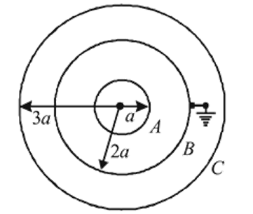
[A] $−4Q/13$
[B] $−8Q/11$
[C] $−5Q/3$
[D] $−3Q/7$
[Ans] B
[Sol] From given conditions, $V_{A}=V_{C}$ and $V_{B}=0⇒V_{B}=\frac{k\left(Q−q_{1}\right)}{3a}+\frac{kq_{2}}{2a}+\frac{kq_{1}}{2a}=0$
$⇒2Q+q_{1}+3q_{2}=0 ………$ (i)
Using $V_{A}=V_{C}$
$\frac{k\left(Q−q_{1}\right)}{3a}+\frac{kq_{2}}{3a}+\frac{kq_{1}}{3a}=\frac{kq_{1}}{a}+\frac{k\left(Q−q_{1}\right)}{3a}+\frac{kq_{2}}{2a}$
$⇒q_{1}=−\frac{q_{2}}{4} ………$ (ii)
Using it in $\left(1\right), q_{2}=−\frac{8}{11}Q$
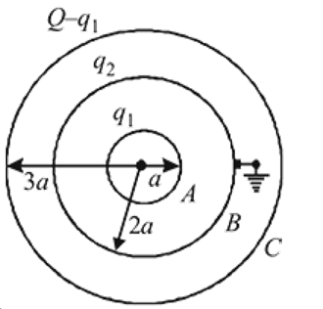

[DIFFICULTY: Medium]
[Q] A charge $+q$ fixed at each of the points $x=x_{0}, x=3x_{0}, x=5x_{0},…$ upto $∞$ on $X$-axis and charge $−q$ is fixed on each of the points $x=2x_{0}, x=4x_{0},…$ upto $∞$. Here $x_{0}$ is a positive constant. Take the potential at a point due to a charge $Q$ at a distance $r$ from it to be $\frac{Q}{4πε_{0}r}$, then the potential at the origin due to above system of charges will be:
[A] zero
[B] infinite
[C] $\frac{q}{8πε_{0}x_{0}\log_{e}2}$
[D] $\frac{q\log_{e}2}{4πε_{0}x_{0}}$
[Ans] D
[Sol] $V=\frac{1}{4πε_{0}}\left[\frac{q}{x_{0}}+\frac{q}{3x_{0}}+\frac{q}{5x_{0}}+…\right]+\frac{1}{4πε_{0}}\left[\frac{\left(−q\right)}{2x_{0}}+\frac{\left(−q\right)}{4x_{0}}+\frac{\left(−q\right)}{6x_{0}}+…\right]$
$=\frac{1}{4πε_{0}} \frac{q}{x_{0}}\left[1−\frac{1}{2}+\frac{1}{3}−\frac{1}{4}+\frac{1}{5}−\frac{1}{6}+…\right]$
$=\frac{1}{4πε_{0}} \frac{q}{x_{0}}\log_{e}\left(1+1\right)=\frac{q\log_{e}2}{4πε_{0}x_{0}}$

[DIFFICULTY: Medium]
[Q] A sphere of radius $R$ has a uniform charge density $ρ$. The difference in the electric potential at $r=R$ and $r=0$ from the centre is
[A] $\frac{−ρR^{2}}{ε_{0}}$
[B] $\frac{−2ρR^{2}}{ε_{0}}$
[C] $\frac{ρR^{2}}{3ε_{0}}$
[D] $\frac{−ρR^{2}}{6ε_{0}}$
[Ans] D
[Sol] 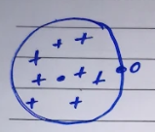
$V_{c}=\frac{3}{2} \frac{KQ}{R}$
$V_{0}=\frac{kQ}{R}$
Difference
$ΔV=−\frac{kQ}{2R}$
$=\frac{−1}{4πε_{0}}×\frac{1}{2R}\left(ρ×\frac{4}{3}πR^{3}\right)$
$=\frac{−ρR^{2}}{6ε_{0}}$

[DIFFICULTY: Medium]
[Q] The electric field intensity at all points in space is given by $\vec{E}=\sqrt{3} \hat{i}−\hat{j}$ volt/metre. The nature of equipotential lines in $xy$-plane is given by
[A] 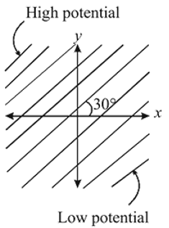
[B] 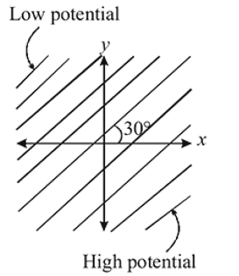
[C] 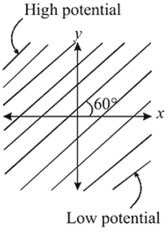
[D] 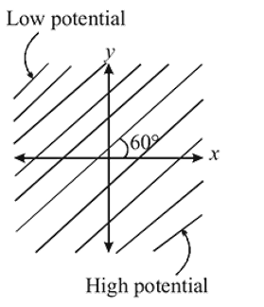
[Ans] C
[Sol] $\vec{E}=\sqrt{3} \hat{i}−\hat{j}$ makes an angle of ${30}^{∘}$ below the $+x$-axis $\left(tanα=−\frac{1}{\sqrt{3}}\right)$.
Equipotential lines are perpendicular to $\vec{E}$, so they are inclined at ${60}^{∘}$ to the $x$-axis.
The electric field points from high to low potential, so the potential is high towards the upper-left and low towards the lower-right. This matches graph (C).

[DIFFICULTY: Easy]
[Q] The electric potential at a point $\left(x,y,z\right)$ is given by $V=−x^{2}y−xz^{3}+4$. The electric field $\vec{E}$ at that point is
[A] $\vec{E}=\hat{i} 2xy+\hat{j}\left(x^{2}+y^{2}\right)+\hat{k}\left(3xz−y^{2}\right)$
[B] $\vec{E}=\hat{i} z^{3}+\hat{j} xyz+\hat{k} z^{2}$
[C] $\vec{E}=\hat{i}\left(2xy−z^{3}\right)+\hat{j} xy^{2}+\hat{k} 3z^{2}x$
[D] $\vec{E}=\hat{i}\left(2xy+z^{3}\right)+\hat{j} x^{2}+\hat{k} 3xz^{2}$
[Ans] D
[Sol] The electric field at a point is equal to negative of potential gradient at that point. $\vec{E}=−\frac{∂V}{∂r}=\left[−\frac{∂V}{∂x}\hat{i}−\frac{∂V}{∂y}\hat{j}−\frac{∂V}{∂z}\hat{k}\right]$
$=\left[\left(2xy+z^{3}\right)\hat{i}+\hat{j} x^{2}+\hat{k} 3xz^{2}\right]$

[DIFFICULTY: Medium]
[Q] Electric field at a far away distance $r$ on the axis of dipole is ${\vec{E}}_{0}$. What is the electric field at a distance $2r$ on perpendicular bisector?
[A] $\frac{{\vec{E}}_{0}}{16}$
[B] $−\frac{{\vec{E}}_{0}}{16}$
[C] $\frac{{\vec{E}}_{0}}{8}$
[D] $−\frac{{\vec{E}}_{0}}{8}$
[Ans] B
[Sol] ${\vec{E}}_{0}=\frac{2kp}{r^{3}} \hat{p} …\left(1\right)$
$\vec{E}=\frac{kp}{{\left(2r\right)}^{3}}\left(−\hat{p}\right)$
$\vec{E}=−\frac{1}{8} \frac{kp}{r^{3}} \hat{p}⇒\vec{E}=−\frac{{\vec{E}}_{0}}{16}$ from (1)

--------------------------------------------------

TOPIC: Capacitance

[DIFFICULTY: Medium]
[Q] Voltage rating of a parallel plate capacitor is $500 V$. Its dielectric can withstand a maximum electric field of ${10}^{6} V m^{−1}$. The plate area is ${10}^{−4} m^{2}$. What is the dielectric constant if the capacitance is $15 pF$? (given $ε_{0}=8.86×{10}^{−12} C^{2} N^{−1} m^{−2}$)
[A] $3.8$
[B] $8.5$
[C] $6.2$
[D] $4.5$
[Ans] B
[Sol] $C=Kε_{0}A/d$ and $V=Ed$
Or $K=CV/ε_{0}AE_{max}$
$K=\left(15×{10}^{−12}×500\right)/\left(8.86×{10}^{−12}×{10}^{−4}×{10}^{6}\right)=8.5$

