

SCHOOL/INSTITUTIONAL DATA MANAGING SYSTEM

[A DBMS Project]

SONKOJU ROHIT ADITHYA

202157 [Roll no.]

Electrical and Electronics Engineering

[2020-2024]

**TOPIC:**

INSTITUTIONAL DATA MANAGING SYSTEM

**PROBLEM STATEMENT:**

Institutional Data Managing System design is basically aimed to provide complete information of the Institution and its schedule to the students and teachers according to which they can easily manage their time and resources. The database administrator can insert, modify and delete data corresponding to both students and teachers.

One can obtain dedicated experience by just looking at the modified data from their corresponding modules which saves their time and reduces physical storage space and effort also making it efficient. The details of the students, teachers, courses, payments etc. are stored and modified in real time. Parents can supervise their kids’ academic performance at their choice of time.

**DATASETS:**

As the data of an institute includes personal data of both students and teachers such as their phone numbers etc., it can neither be obtained as an open dataset, nor can be shared as a private data set.

*Therefore, it has been synthetically made with AI with randomized information of the students and teachers for their personal/sensitive fields.*

**ASSUMPTIONS:**

A student is involved all 6 or 7 courses of the respective standard.

A teacher can be involved in utmost 1 course for a respective class and overall in 2 courses.

A Course can be taught by more than one teacher. [If applicable]

Only one seat in one class can be allocated for a single student.

Every class is comprised of exactly 1 section with same tuition fee for all class students.

Multiple students can have same second names but no two students can have same names & father’s names [including second names].

Multiple teachers can have same second names but no two teachers can have same names & father’s names [including second names].

One student can make many payments off for the same tuition fees.

One teacher can be paid off in flexible monthly payments for the same salary.

Any number of students can be allotted under a single parent.

Every subject should be taught in all the classes.

Utmost 2 classes of a subject can be taught in a class in a single day.

There can only be one principal and shall not teach any course.

The time for teaching each subject is same [1 hour] for one period/class.

*This database is applicable to single/no branch Institute/School.*

**TABLES:**

Student Details:

|  |  |  |
| --- | --- | --- |
| Attributes | Datatypes | Constraints |
| Student_Id | Int | PRIMARY KEY |
| First_Name | Varchar (10) | NOT NULL |
| Last_Name | Varchar (10) | NOT NULL |
| Father_First_Name | Varchar (10) | NOT NULL |
| Father_Second_Name | Varchar (10) | NOT NULL |
| Gender | Varchar (1) | NOT NULL |
| Mobile-1 | Varchar (15) | NOT NULL |
| Mobile-2 | Varchar (15) | NOT NULL |
| Age | Int | NOT NULL |
| Date_of_Birth | Date | NOT NULL |
| Admission_Date | Date | NOT NULL |
| Class | Int | FOREIGN KEY,  NOT NULL |
| House_No | Varchar (15) | NOT NULL |
| Street_Name | Varchar (15) | NOT NULL |
| Area | Varchar (15) | NOT NULL |
| Pincode | Int | NOT NULL |

Teachers Details:

|  |  |  |
| --- | --- | --- |
| Attributes | Datatype | Constraints |
| Teacher_Id | Int | PRIMARY KEY |
| Teacher_First_Name | Varchar (10) | NOT NULL |
| Teacher_Second_Name | Varchar (10) | NOT NULL |
| Subject | Varchar (10) | FOREIGN KEY,  NOT NULL |
| Position | Varchar (20) | NOT NULL |
| Age | Int | NOT NULL |
| Gender | Varchar (1) | NOT NULL |
| Date_Of_Birth | Date | NOT NULL |
| Qualifications | Varchar (25) | NOT NULL |
| Joining_Date | Date | NOT NULL |
| Salary_Annual | Int | NOT NULL |
| Account_Details | Varchar (35) | UNIQUE, NOT NULL |
| House_No | Varchar (15) | NOT NULL |
| Street_Name | Varchar (20) | NOT NULL |
| Area | Varchar (20) | NOT NULL |
| Pincode | Int | NOT NULL |

Student Payments:

|  |  |  |
| --- | --- | --- |
| Attributes | Datatype | Constraints |
| Student_Id | Int | Primary key |
| Fee_Deposited | Int | NOT NULL |
| Payment_Mode | Varchar (20) | NOT NULL |
| Payment_Date | Date | NOT NULL |
| Payment_Status | Varchar (7) | NOT NULL |

Teacher Payments:

|  |  |  |
| --- | --- | --- |
| Attributes | Datatype | Constraints |
| Teacher_Id | Int | PRIMARY KEY |
| Salary_Credited | Int | NOT NULL |
| Payment_Mode | Varchar (20) | NOT NULL |
| Payment_Date | Date | NOT NULL |
| Payment_Status | Varchar (7) | NOT NULL |

Class Fees:

|  |  |  |
| --- | --- | --- |
| Attributes | Datatypes | Constraints |
| Class | Int | PRIMARY KEY |
| Total_Fees | Int | UNIQUE, NOT NULL |

Course Syllabus:

|  |  |  |
| --- | --- | --- |
| Attributes | Datatype | Constraints |
| Class | Int | PRIMARY KEY (1) |
| Subject | Varchar (10) | PRIMARY KEY (2) |
| Syllabus | Varchar (100) | UNIQUE, NOT NULL |
| Completion_Status | Int | NOT NULL |

Marks:

|  |  |  |
| --- | --- | --- |
| Attributes | Datatype | Constraints |
| Student_id | Int | PRIMARY KEY (1) |
| Class | Int | PRIMARY KEY (2) |
| Examination | Varchar (15) | PRIMARY KEY (3) |
| Subject | Varchar (10) | PRIMARY KEY (4) |
| Marks | Int | NOT NULL |

Class Time Tables:

|  |  |  |
| --- | --- | --- |
| Attributes | Datatype | Constraints |
| Class | Int | PRIMARY KEY |
| Time_Table | Varchar (600) | NOT NULL |

Teacher Time Tables:

|  |  |  |
| --- | --- | --- |
| Attributes | Datatype | Constraints |
| Teacher_Id | Int | PRIMARY KEY |
| Time_Table | Varchar (100) | UNIQUE, NOT NULL |

**FUNTIONAL DEPENCENCIES AND PRIMARY KEY:**

***Student Details:***

*Student_id {Student_Id, First_Name, Last_Name, Father_First_Name, Father_Second_Name, Age, Gender, Mobile-1, Mobile-2, Date_Of_Birth, Admission_Date, Class, House_No, Street_Name, Area, Pincode}*

Since all the fields depend on (Student_id),

(Student_id) R

Hence, (Student_id) is a PRIMARY KEY.

***Teachers Details:***

*Teacher_Id {Teacher_Id, Teacher_First_Name, Teacher_Second_Name, Subject, Position, Age, Gender, Date_Of_Birth, Qualifications, Joining_Date, Salary_Annual, Account_Details, House_No, Street_Name, Area, Pincode}*

Since all the fields depend on (Teacher_id),

(Teacher_id) R

Hence, (Teacher_Id) is a PRIMARY KEY.

***Class Time Tables:***

*Class {Class, Monday, Tuesday, Wednesday, Thursday, Friday, Saturday}*

Since all the fields depend on (Class),

(Class) R

Hence, (Class) is a PRIMARY KEY.

***Teacher Time Table:***

*Teacher_Id {Teacher_Id, Monday, Tuesday, Wednesday, Thursday, Friday, Saturday}*

Since all the fields depend on (Teacher_id),

(Teacher_id) R.

Hence, (Teacher_id) is a PRIMARY KEY.

***Student Payments:***

*Student_id {Student_Id, Fee_Deposited, Payment_mode, Payment_date, Payment_Status}*

Since all the fields depend on (Student_id),

(Student_id) R.

Hence, (Student_id) is a PRIMARY KEY.

***Teacher Payments:***

*Teacher_id {Teacher_Id, Salary_Credited, Payment_mode, Payment_date, Payment_Status}*

Since all the fields depend on (Teacher_id),

(Teacher_id) R

Hence, (Teacher_id) is a PRIMARY KEY.

***Class Fees:***

*Class {Class, Total_Fees}*

Since all fields depends on (Class),

(Class) R

Hence, (Class) is a PRIMARY KEY.

***Course Syllabus:***

*Class (Class, Subject, Completion_Percentage)*

Since all fields depends on (Class),

(Class) R

Hence, (Class) is a PRIMARY KEY.

***Marks:***

*{Student_id, Class, Examination, Subject} (Student_id, Class, Examination, Subject, Marks)*

Since all the fields depend on *{Student_id, Class, Examination, Subject}*,

{Student_id, Class, Examination, Subject} R

Hence, {Student_id, Class, Examination, Subject}combined becomes a COMPOSITE PRIMARY KEY.

**NORMALISATION:**

***Student Details:***

PRIMARY KEY: *Student_id*

All attributes depend on the *Student_id*, hence the table is in 2NF.

All attributes depend directly on *Student_id,* hence the table is in 3NF.

All determinants (*Student_id*) form a Super key, hence the table is in BCNF.

***Teachers Details:***

PRIMARY KEY: *Teacher_Id*

All attributes depend on the *Teacher_Id*, hence the table is in 2NF.

All attributes depend directly on *Teacher_Id*, hence the table is in 3NF.

All determinants (*Teacher_Id*) forms a Super key, hence the table is in BCNF.

***Class Time Tables:***

PRIMARY KEY: *Class*

All attributes depend on the *Class*, hence the table is in 2NF.

All attributes depend directly on *Class,* hence the table is in 3NF.

All determinants (*Class*) form a Super key, hence the table is in BCNF.

***Teacher Time Table:***

PRIMARY KEY: *Teacher_Id*

All attributes depend on the *Teacher_Id*, hence the table is in 2NF.

All attributes depend directly on *Teacher_Id*, hence the table is in 3NF.

All determinants (*Teacher_Id*) form a Super key, hence the table is in BCNF.

***Student Payments:***

PRIMARY KEY: *Student_id*

All attributes depend on the *Student_id*, hence the table is in 2NF.

All attributes depend directly on *Student_id*, hence the table is in 3NF.

All determinants (*Student_id*) form a Super key, hence the table is in BCNF.

***Teacher Payments:***

PRIMARY KEY: *Teacher_id*

All attributes depend on the *Teacher_id*, hence the table is in 2NF.

All attributes depend directly on *Teacher_id*, hence the table is in 3NF.

All determinants (*Teacher_id*) form a Super key, hence the table is in BCNF.

***Class Fees:***

PRIMARY KEY: *Class*

All attributes depend on the *Class*, hence the table is in 2NF.

All attributes depend directly on *Class*, hence the table is in 3NF.

All determinants (*Class*) form a Super key, hence the table is in BCNF.

***Course Syllabus:***

PRIMARY KEY: *Class*

All attributes depend on the *Class*, hence the table is in 2NF.

All attributes depend directly on *Class*, hence the table is in 3NF.

All determinants (*Class*) form a Super key, hence the table is in BCNF.

***Marks:***

PRIMARY KEY: *{Student_id, Class, Examination, Subject}*

All attributes depend on the *{Student_id, Class, Examination, Subject}*, hence the table is in 2NF.

All attributes depend directly on *{Student_id, Class, Examination, Subject}*, hence the table is in 3NF.

All determinants *{Student_id, Class, Examination, Subject}* together form a Super key, hence the table is in BCNF.

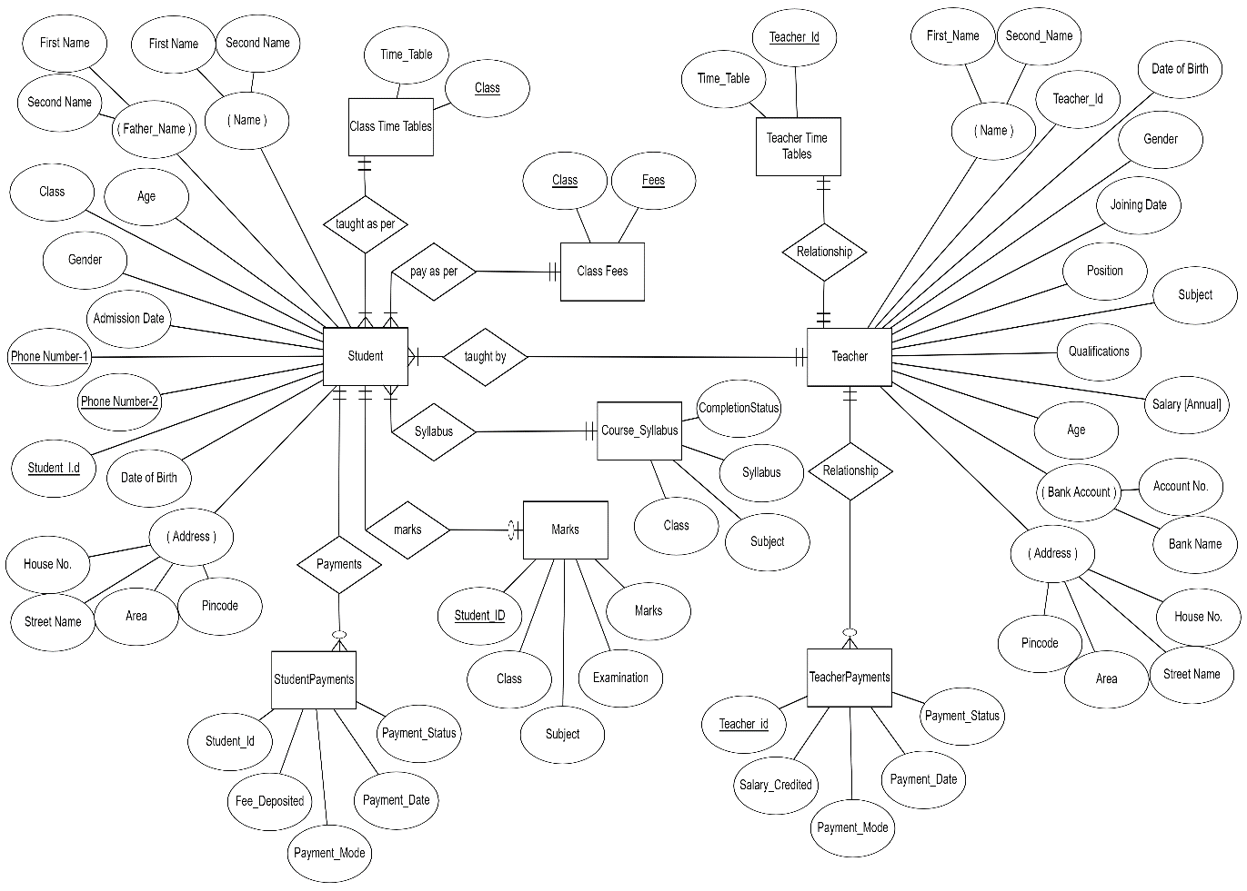**ER DIAGRAM:**

For more detailed view, visit <https://github.com/ronnyADIT>

**RELATIONAL SCHEMA:**

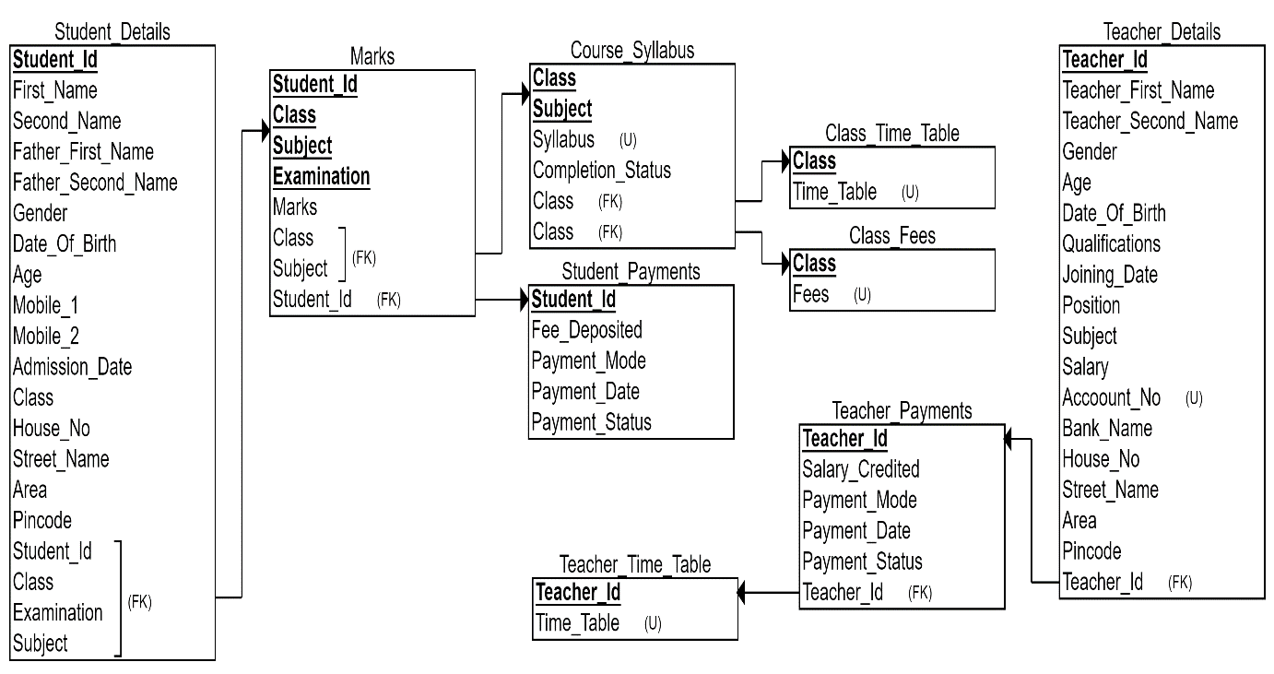

For more detailed view, visit <https://github.com/ronnyADIT>

**MYSQL CODE:**

Creating Database:



Creating Tables:

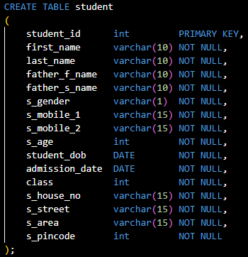

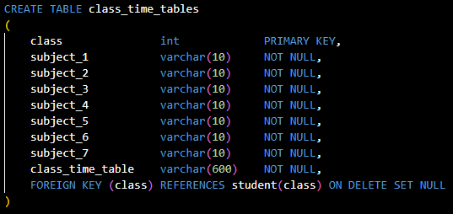

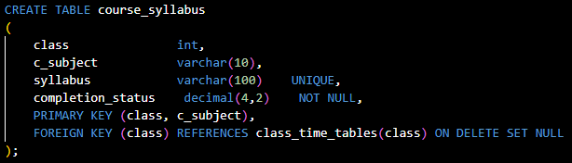

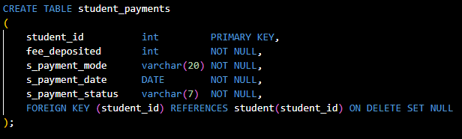

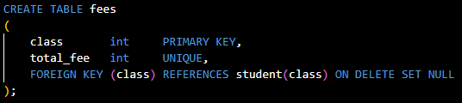

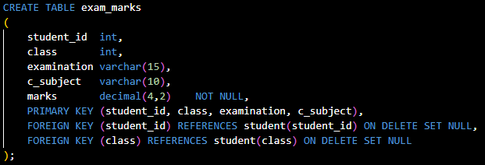

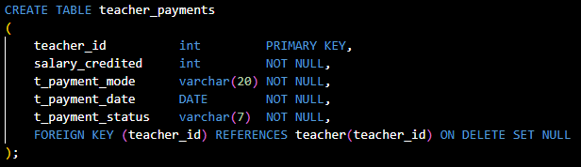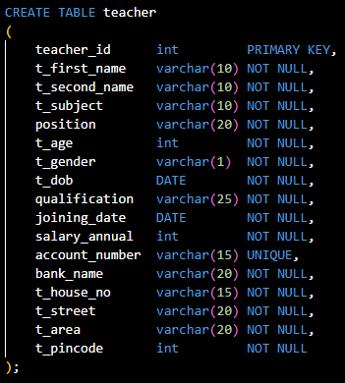

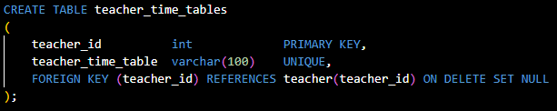

Inserting Data:

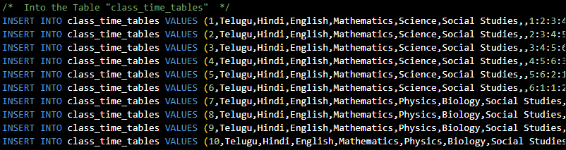

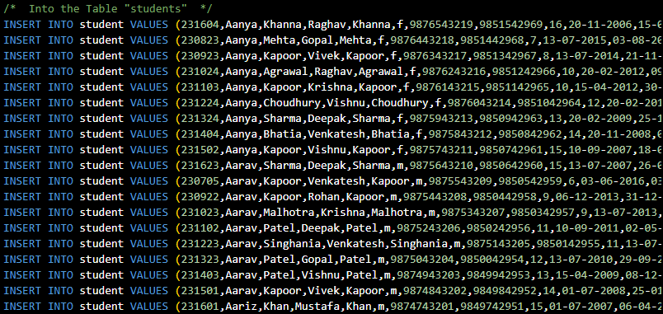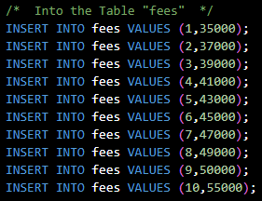

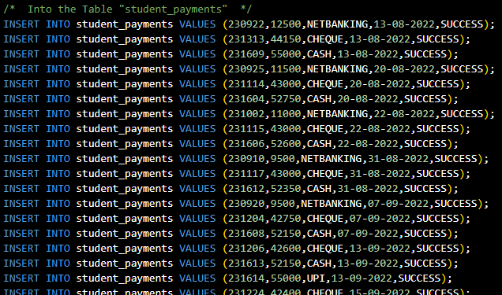

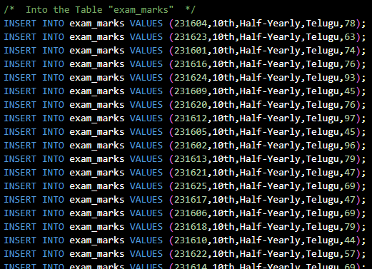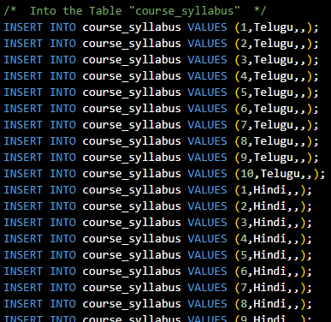

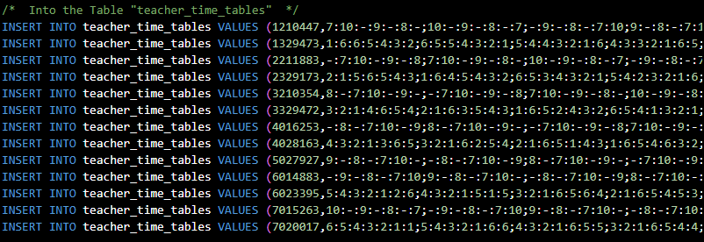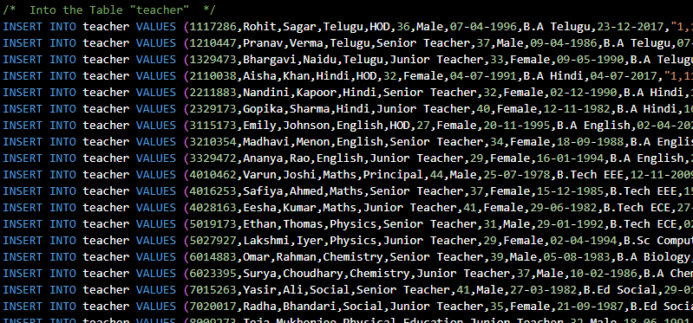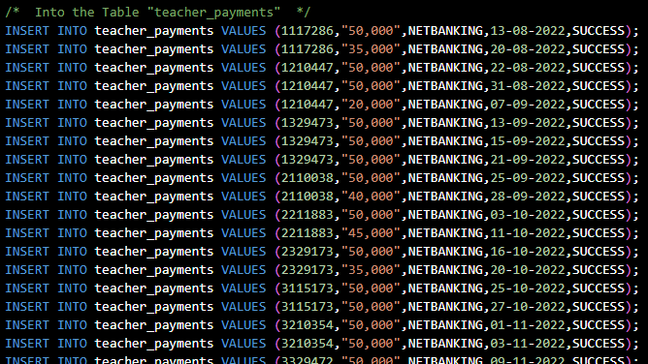

For detailed Queries visit,

<https://github.com/ronnyADIT>

**TABLES CREATED:**

Student:

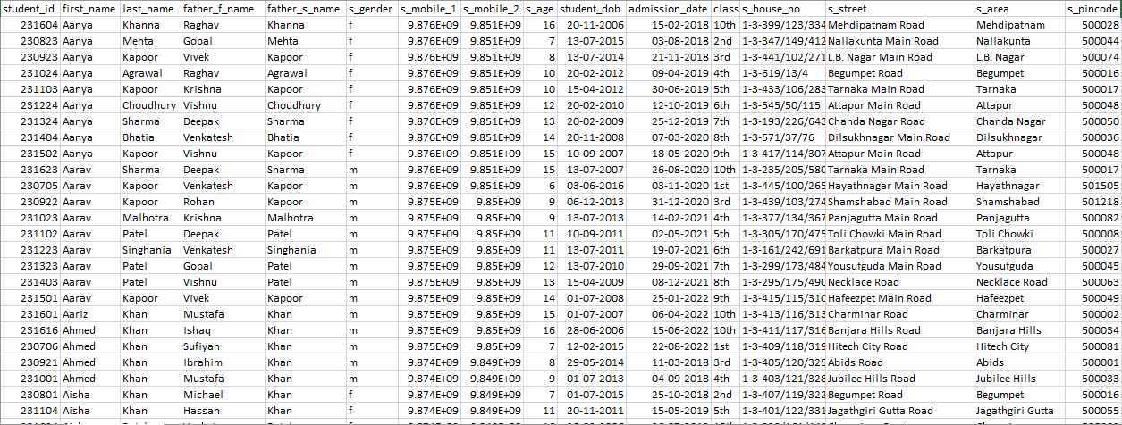

Class_Time_Tables:

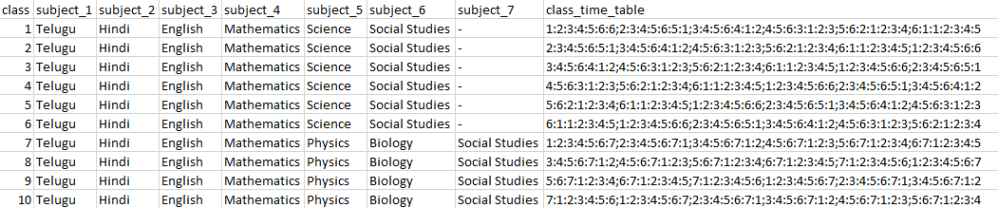

Course_Syllabus:

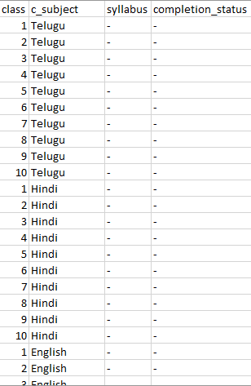

Student_Payments:

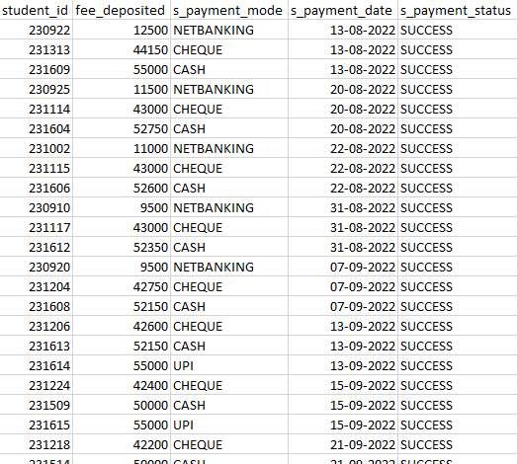

Fees:

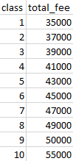

Exam_Marks:

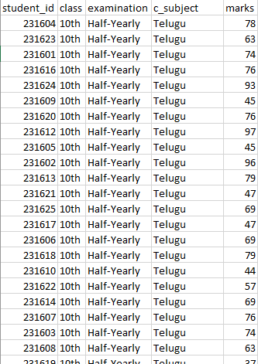

Teacher_Payments:

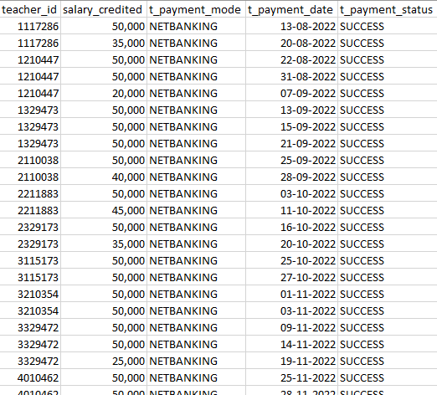

Teacher

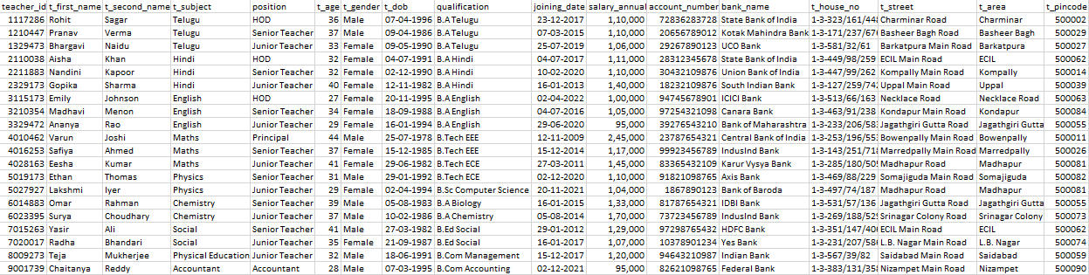

Teacher_Time_Tables:

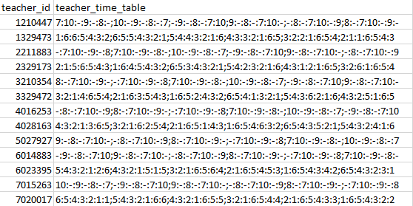

**QUERIES:**

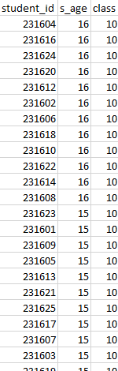Display all student_id’s with age and class greater than 13 and 7 respectively and sorted by their class (in decreasing order)

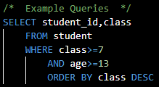

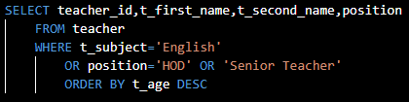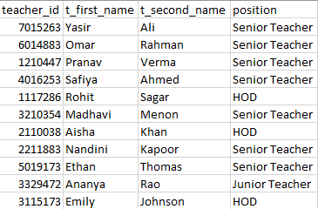Display all teacher id, teacher names and positions of teachers teaching English or are either Senior Teacher or HOD in decreasing order of their age.

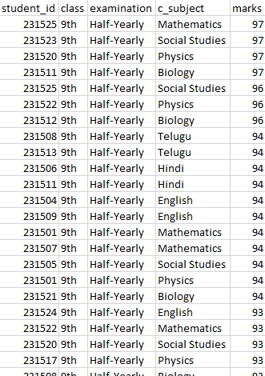

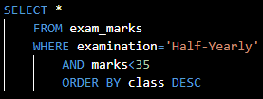Display all the columns of half-yearly examination of the students with less than passing marks (35) ordered by class

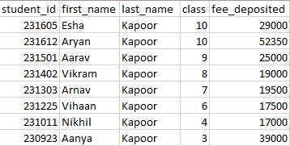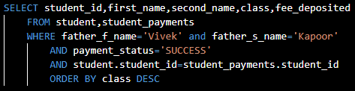Display student id, name, class and fee they deposited under the father name, Vivek Kapoor

**THANK YOU**

I extend my heartfelt appreciation to you for taking the time and effort to read the entire project on Institute Database Management System. Your dedication and interest in understanding the intricacies of the system are truly commendable. Your support and engagement have motivated me throughout this journey, and I am grateful for the opportunity to share my work with someone as enthusiastic and attentive as you. It is readers like you who make the pursuit of knowledge and sharing of ideas worthwhile. Thank you once again for being a part of this endeavor and for your invaluable contribution to the world of learning.

With sincere gratitude,

ROHIT ADITHYA SONKOJU