33kV Incoming Feeder Daily Analysis Report

Scope
This report summarizes the analysis built in 33kv_incoming_feeder_daily_long_transform.ipynb.
Primary analysis window:
- 2025-04-01 to 2026-03-31
Primary datasets used:
- feeder daily energy data reshaped from 20260407_33kVIncomingFeederDailyDataWide.xlsx
- recharge data summarized from 20260407_RechargeToDate.csv
Primary processed outputs:
- data/processed/33kv_incoming_feeder_daily_long.parquet
- data/processed/vend_amounts_daily.parquet
Important note:
- the combined daily summary file includes earlier recharge dates outside the feeder period because the energy and recharge series were outer-joined
- the notebook analysis itself correctly filters to 2025-04-01 through 2026-03-31 for the weekday and special-day sections

Headline Findings
- Average daily feeder energy is very stable across weekdays, staying in a narrow band of roughly 11.59M to 11.78M kWh.
- Average daily vend amount is much more uneven than energy, with a strong Monday effect and a clear weekend drop.
- Average Rs/kWh is highest on Monday at about 2.66 and falls steadily toward the weekend, reaching about 0.71 on Sunday.
- Variability is materially lower for energy than for the money-based measures. Overall CV is about 0.22 for kWh, versus about 0.63 for Rs and 0.62 for Rs/kWh.
- In the special-day comparison, Mon Excluding Weekday After Public Holiday has the highest average vend amount and the highest average Rs/kWh.
- Weekends have the lowest average vend amount and among the lowest average Rs/kWh.
- Weekday After Public Holiday has the highest CV for Rs/kWh, suggesting post-holiday recharge intensity is less predictable than normal weekday behavior.

Weekday Summary
Overall weekday-level averages and variability from the saved summary workbook:
Day | Avg kWh | StdDev kWh | Avg vend_amount | StdDev vend_amount | Avg Rs/kWh | StdDev Rs/kWh | CV kWh | CV Rs | CV Rs/kWh
Monday | 11,681,703 | 2,540,128 | 30,780,013 | 15,665,479 | 2.656 | 1.281 | 0.217 | 0.509 | 0.482
Tuesday | 11,781,846 | 2,573,307 | 23,514,814 | 12,490,391 | 2.073 | 1.161 | 0.218 | 0.531 | 0.560
Wednesday | 11,645,852 | 2,453,609 | 19,897,364 | 8,525,622 | 1.746 | 0.751 | 0.211 | 0.428 | 0.430
Thursday | 11,590,076 | 2,613,811 | 18,539,450 | 7,982,094 | 1.618 | 0.633 | 0.226 | 0.431 | 0.391
Friday | 11,781,144 | 2,610,837 | 19,517,346 | 8,327,925 | 1.691 | 0.683 | 0.222 | 0.427 | 0.404
Saturday | 11,698,460 | 2,743,752 | 10,617,199 | 5,005,672 | 0.914 | 0.381 | 0.235 | 0.471 | 0.417
Sunday | 11,608,262 | 2,444,689 | 8,299,721 | 3,821,874 | 0.713 | 0.282 | 0.211 | 0.460 | 0.396
Overall | 11,684,174 | 2,550,095 | 18,751,074 | 11,847,590 | 1.631 | 1.015 | 0.218 | 0.632 | 0.622
Interpretation:
- Energy is operationally steady across the week.
- Recharge value is behaviorally front-loaded, with Monday materially above all other days.
- Weekend recharge softness is large enough that it pulls down both vend_amount and Rs/kWh, even though energy stays broadly flat.

Special-Day Summary
Special-day group summary from the revised grouping, where the post-holiday bucket is restricted to weekdays only:
Group | Days | Avg kWh | StdDev kWh | Avg vend_amount | StdDev vend_amount | Avg Rs/kWh | StdDev Rs/kWh | CV kWh | CV Rs | CV Rs/kWh
Overall | 365 | 11,684,174 | 2,550,095 | 18,751,074 | 11,847,590 | 1.631 | 1.015 | 0.218 | 0.632 | 0.622
Weekends | 104 | 11,653,361 | 2,586,279 | 9,458,460 | 4,582,020 | 0.813 | 0.348 | 0.222 | 0.484 | 0.428
Weekday After Public Holiday | 14 | 10,719,746 | 1,716,537 | 24,046,202 | 14,342,328 | 2.268 | 1.428 | 0.160 | 0.596 | 0.630
Mon Excluding Weekday After Public Holiday | 48 | 11,725,874 | 2,529,814 | 31,324,385 | 15,980,766 | 2.688 | 1.299 | 0.216 | 0.510 | 0.483
Tue-Thu Excluding Weekday After Public Holiday | 150 | 11,738,406 | 2,562,232 | 20,659,214 | 9,687,979 | 1.803 | 0.843 | 0.218 | 0.469 | 0.467
Fri Excluding Weekday After Public Holiday | 49 | 11,818,262 | 2,686,068 | 18,803,322 | 7,584,098 | 1.624 | 0.600 | 0.227 | 0.403 | 0.369
Interpretation:
- Mon Excluding Weekday After Public Holiday is the strongest recharge bucket in both absolute vend_amount and Rs/kWh.
- Weekends remain the weakest recharge bucket while energy usage stays close to the overall level.
- Weekday After Public Holiday is not the highest average recharge bucket, but it remains the most unstable in price-per-energy terms, with the highest CV of Rs/kWh among the comparison groups.
- Fri Excluding Weekday After Public Holiday has the lowest financial CVs among the special weekday groups, which may make it the cleanest baseline comparison bucket.

Charts

Weekday Profile
This chart is the clearest summary of average weekday behavior and dispersion:
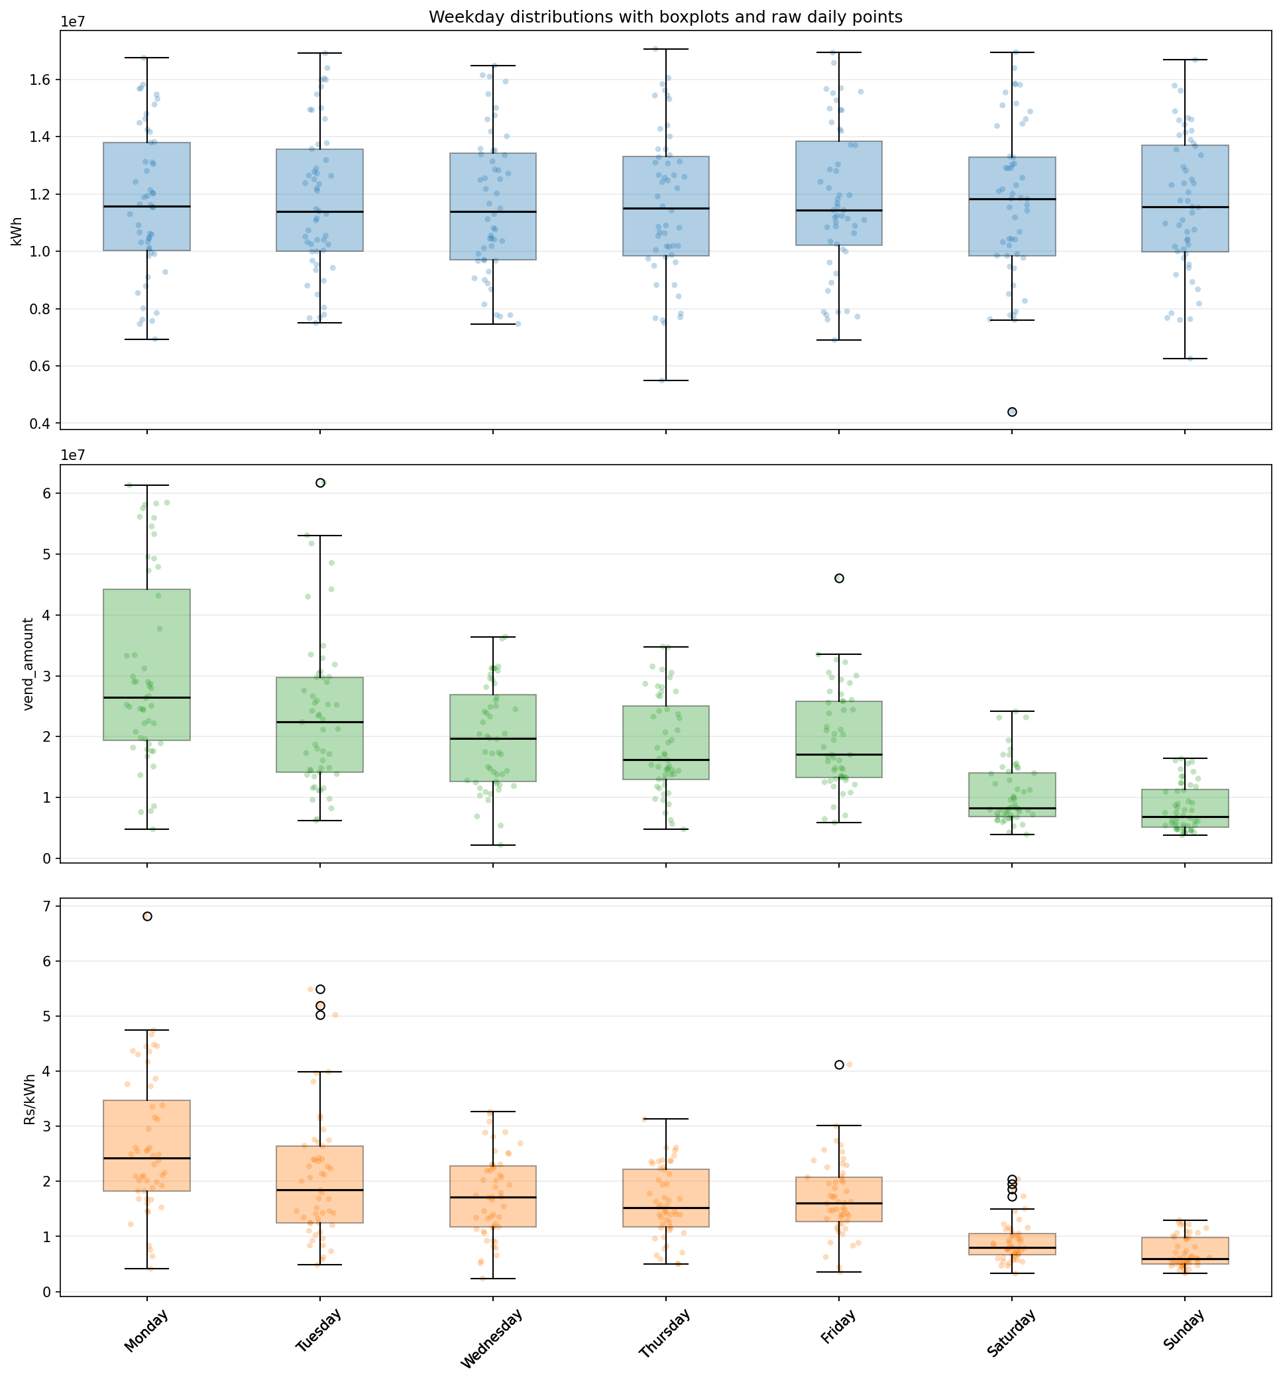
Weekday profile

Weekday CV Comparison
This chart makes the difference in relative volatility easy to see:
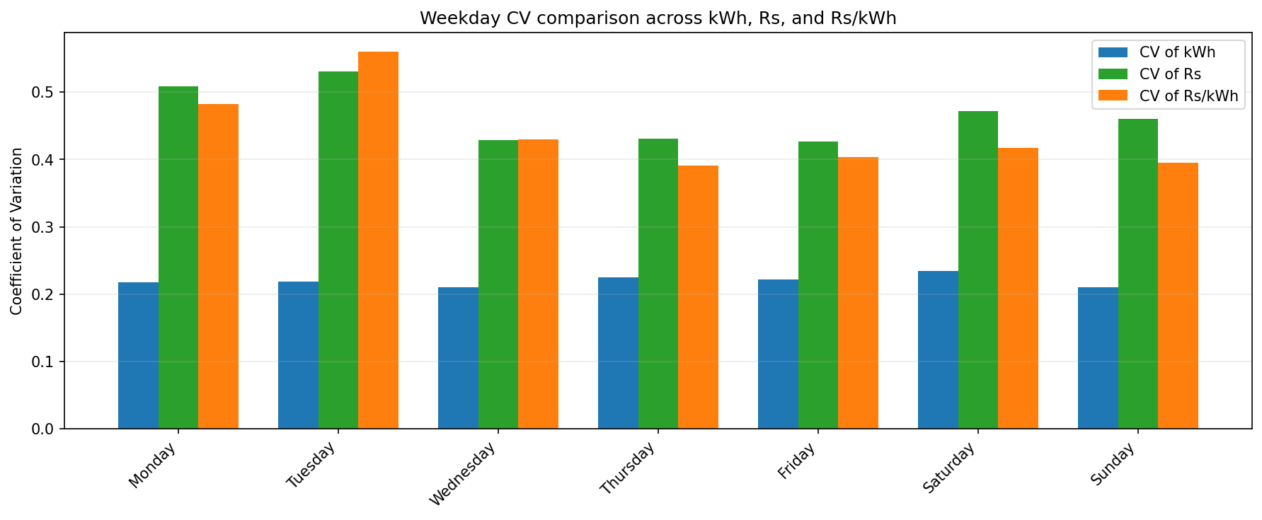
Weekday CV comparison

Daily Trend
This is the best overall view for seasonality and co-movement:
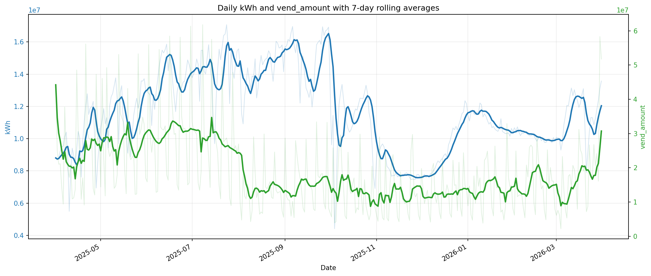
Daily kWh and vend trend

Special-Day Boxplots
These keep the full distributional information for the grouped comparisons:
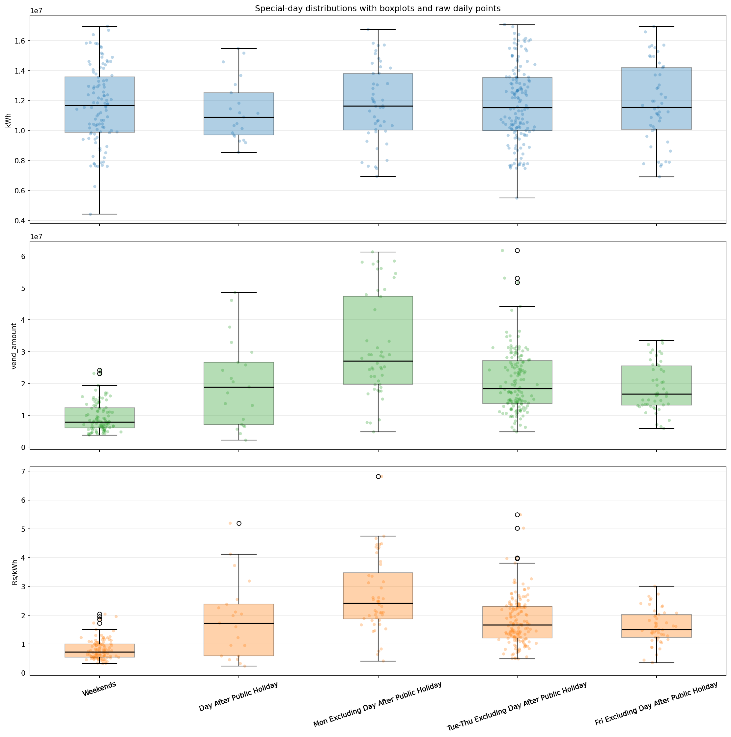
Special-day boxplots

Special-Day CV Comparison
This is the quickest view for comparing predictability across the special-day buckets:
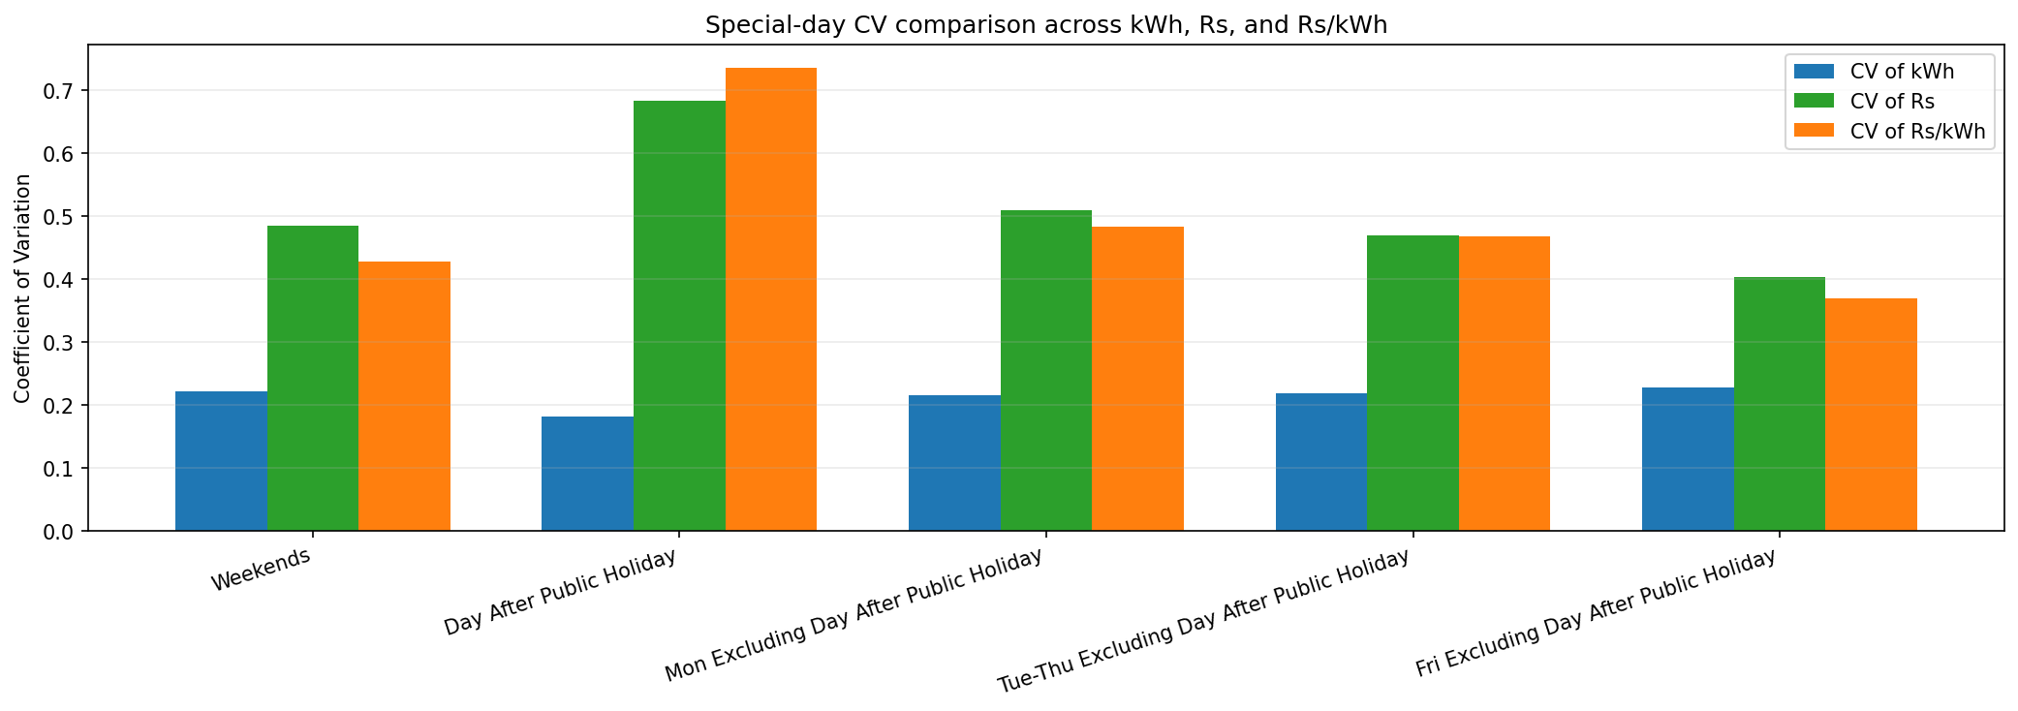
Special-day CV comparison

Practical Conclusions
- The feeder energy series is operationally steady; the stronger movement is in recharge behavior rather than underlying energy volume.
- Monday is the most commercially intense day in the week, while weekends are materially softer.
- Relative volatility is consistently higher for Rs and Rs/kWh than for kWh, so commercial behavior is noisier than physical load.
- Weekday After Public Holiday should be treated as a distinct operating condition because its Rs/kWh behavior is less stable than ordinary weekdays.
- For baseline weekday comparisons, Fri Excluding Weekday After Public Holiday and Tue-Thu Excluding Weekday After Public Holiday look cleaner than using all weekdays together.

Caveats
- Bihar holiday dates in the notebook are suitable for analysis grouping, but some festival observances can shift slightly in practice.
- Recharge history extends earlier than the feeder energy history, so any cross-series comparison should stay inside the notebook’s filtered analysis window.
- Rs/kWh here is an observed daily ratio of summarized vend amount to summarized feeder energy; it is useful analytically, but it should not be treated as a tariff.

Appendix: Alternative Visuals
These figures are useful supporting views for deeper review.

Monthly Profile
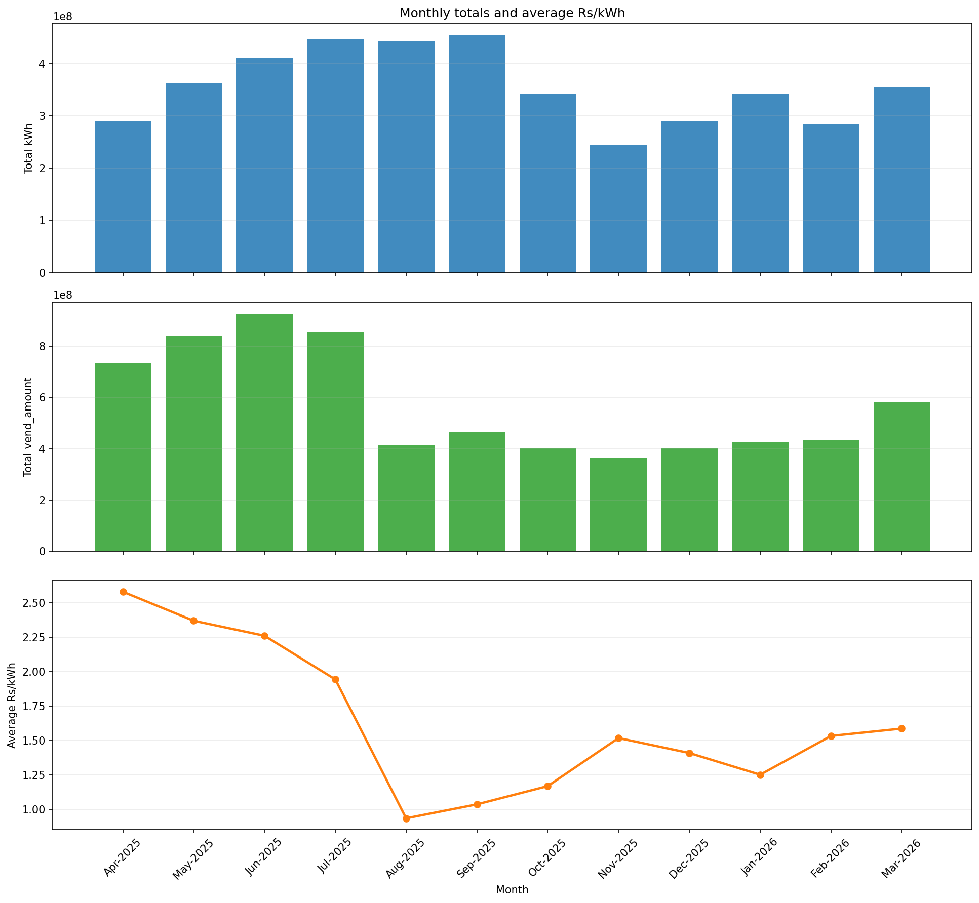
Monthly profile

Indexed Trend
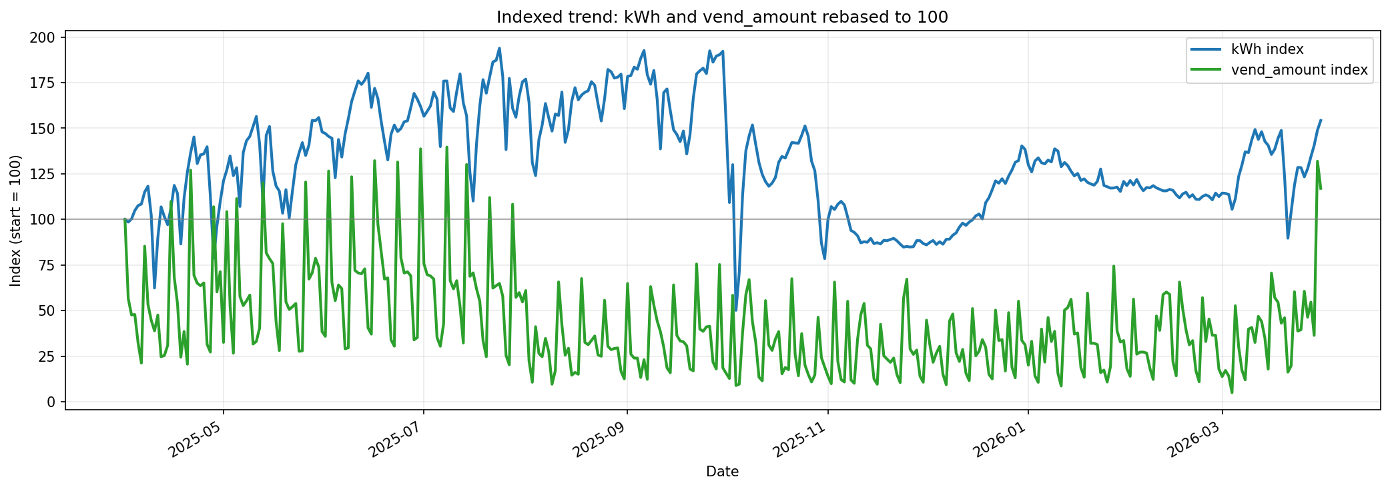
Indexed trend

Weekday-Month Heatmap
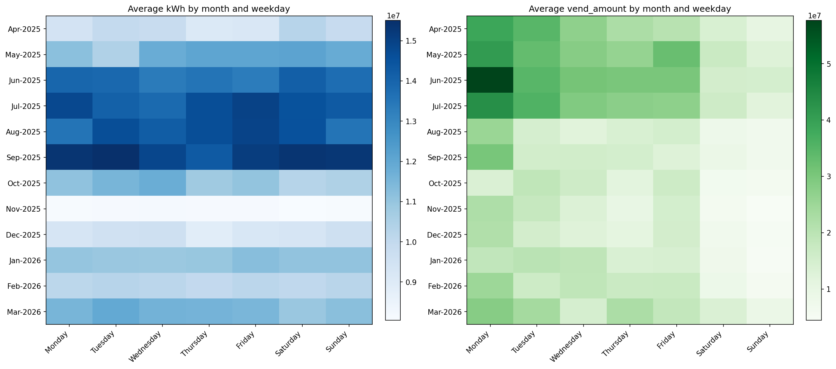
Weekday-month heatmap

kWh vs Vend Scatter
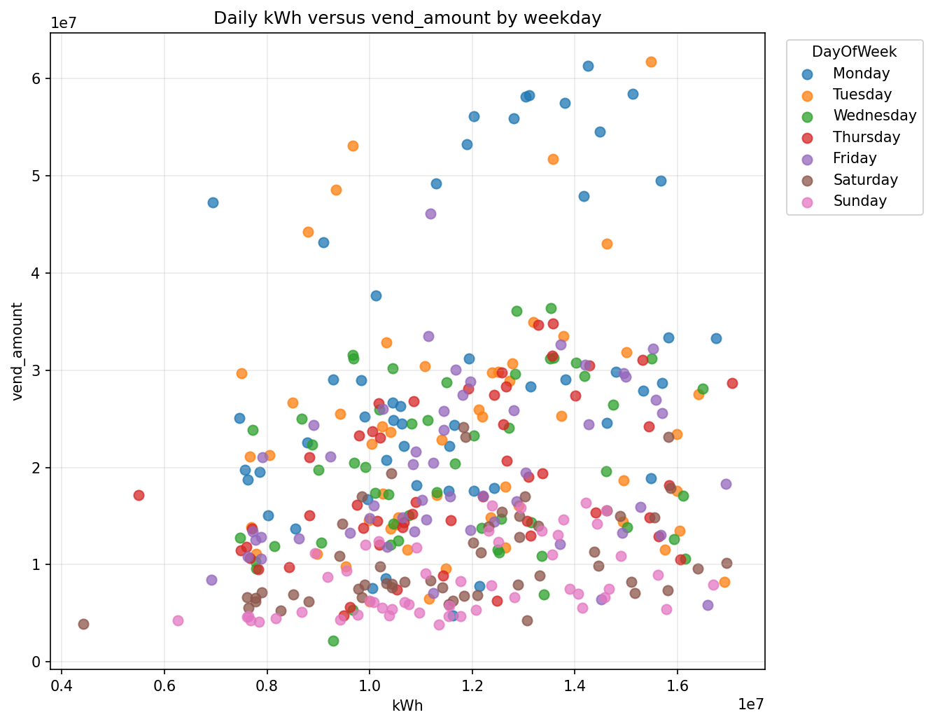
kWh vs vend scatter

