Table of Contents

1.1 2

1.2 5

1.3 5

2.1 6

2.2 8

3.1 9

3.2 13

3.3 17

# 1.1

Screenshot of output of JavaScript array in a table format (Matthus, 2019).

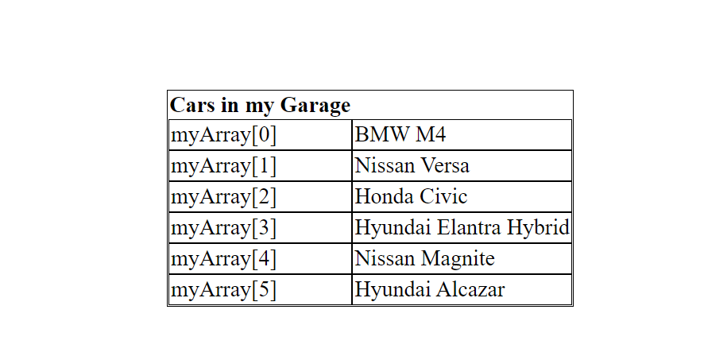

Code:

<!DOCTYPE html>

<html lang="en">

<head>

<meta charset="UTF-8">

<meta http-equiv="X-UA-Compatible" content="IE=edge">

<meta name="viewport" content="width=device-width, initial-scale=1.0">

<title>Neighbor’s Cars</title>

<!-- css styling within html -->

<style>

table{

border: 1px solid black;

}

tbody tr td {

border: 1px solid black;

}

</style>

</head>

<body>

<table style="border-spacing: 0px; margin-left: auto; margin-right: auto; margin-top: 150px; margin-bottom: auto;">

<tr class=" ">

<th>Cars in my Garage</th>

</tr>

<tbody id=" tableView ">

</tbody>

</table>

<script>

let myCars = [

{'position':'myArray[0]', 'carType':'BMW M4'},

{'position':'myArray[1]', 'carType':'Nissan Versa'},

{'position':'myArray[2]', 'carType':'Honda Civic'},

{'position':'myArray[3]', 'carType':'Hyundai Elantra Hybrid'},

{'position':'myArray[4]', 'carType':'Nissan Magnite'},

{'position':'myArray[5]', 'carType':'Hyundai Alcazar'},

]

tableFunction(myCars)

function tableFunction (data){

var table = document.getElementById('tableView')

for (var i = 0; i < data.length; i++){

var row = `<tr>

<td>${data[i].position}</td>

<td>${data[i].carType}</td>

</tr>`

table.innerHTML += row

}

}

</script>

</body>

</html>

# 1.2

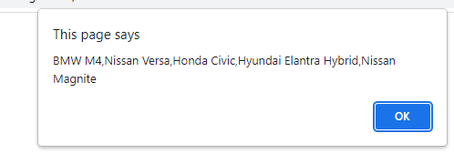

Code

let myCarsToDelete = ["BMW M4", "Nissan Versa", "Honda Civic", "Hyundai Elantra Hybrid", "Nissan Magnite", "Hyundai Alcazar"];

        myCarsToDelete.pop();

        window.alert(myCarsToDelete);

# 1.3

The zeroth index element index[0] is the first element in an array (Pearson, 2019).

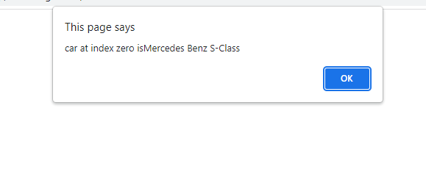

Code

let carsToUnshift = ["BMW M4", "Nissan Versa", "Honda Civic", "Hyundai Elantra Hybrid", "Nissan Magnite", "Hyundai Alcazar"];

        carsToUnshift.unshift("Mercedes Benz S-Class")

        window.alert("car at index zero is"+carsToUnshift[0]);

The unshift() method is used to add elements to the beginning of an array (Tutorialspoint, 2020).

# 2.1

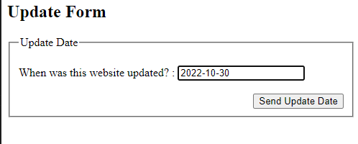

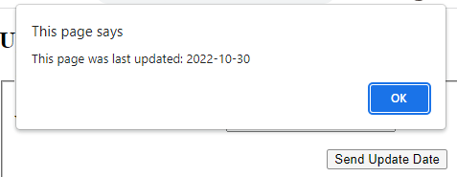

Code:

<!DOCTYPE html>

<html lang="en">

<head>

    <meta charset="UTF-8">

    <meta http-equiv="X-UA-Compatible" content="IE=edge">

    <meta name="viewport" content="width=device-width, initial-scale=1.0">

    <title>Date</title>

</head>

<body>

    <h2>Update Form</h2>

    <div >

    <form>

     <fieldset>

        <legend>Update Date</legend>

                <br>

        When was this website updated? : <input id="date" name="date" placeholder="YYYY-MM-DD" value="2022-10-29" min="2022-01-01" max="2022-12-12" type="year">

        <br>

        <br>

        <div style="text-align: right ;">

           <button type="submit"  style="margin-left: auto;" onclick="submitDate()">Send Update Date</button>

        </div>

    </fieldset>

    </form>

</div>

    <script>

        function submitDate(){

            let dateInput = document.getElementById("date");

            window.alert("This page was last updated: "+dateInput.value);

        }

    </script>

</body>

</html>

# 2.2

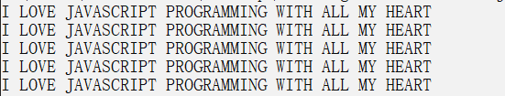

Code:

let iLoveJs = "i love javascript programming with all my heart";

for (var i =0; i<5; i++){

    console.log(iLoveJs.toUpperCase());

}

# 3.1

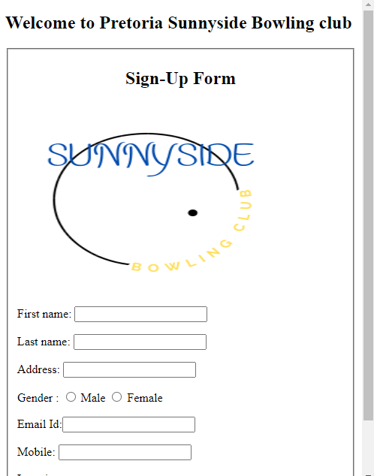

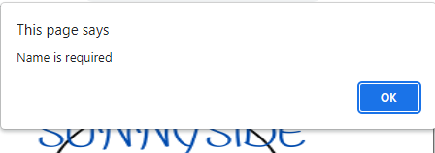

Code:

<!DOCTYPE html>

<html lang="en">

<head>

<meta charset="UTF-8">

<meta http-equiv="X-UA-Compatible" content="IE=edge">

<meta name="viewport" content="width=device-width, initial-scale=1.0">

<title>Sunny Bowside Club</title>

<style>

    btns{

        display: inline; margin-right: 20px;

        margin: 0 auto;

    }

</style>

</head>

<body>

    <h2>Welcome to Pretoria Sunnyside Bowling club</h2>

<form name="myForm" action="" onsubmit="confirmSubmittedData()">

    <h2 style="text-align: center ;">Sign-Up Form</h2>

    <img src="sunnyside.png" height="250px" width="350px" style="margin-left: auto; margin-right: auto;">

        <label>First name: <input name="firstName" /></label>

        <label>Last name: <input name="lastName" /></label>

        <label>Address: <input name="address" /></label>

        Gender :

        <label><input type="radio" name="gender" value="male" /> Male</label>

        <label><input type="radio" name="gender" value="female" /> Female</label>

        <label>Email Id:<input type="email" name="email" /></label>

        <label>Mobile: <input name="mobile" /></label>

        <label> Location

        <br />

        <select name="location">

            <option>select option</option>

            <option>Boardwalk</option>

            <option>Brooklyn</option>

            <option>Lynnwood</option>

            <option>Sunnyside</option>

        </select>

        </label>

    </p>

        <button style="display: inline; margin-right: 20px; margin: 0 auto;" class="btns"  type="submit">Sign-Up</button>

        <button style="display: inline; margin-right: 20px; margin: 0 auto;" class="btns" >Reset</button>

</form>

<script>

    function confirmSubmittedData (){

        var fName = document.forms['myForm']['firstName'].value;

        var lName = document.forms['myForm']['lastName'].value;

        var address = document.forms['myForm']['address'].value;

        var gender = document.forms['myForm']['gender'].value;

        var email = document.forms['myForm']['email'].value;

        var mobile = document.forms['myForm']['mobile'].value;

        var location = document.forms['myForm']['location'].value;

        if(fName == ""){

            window.alert("first Name is required");

        }

        if(lName == ""){

            window.alert("last Name is required");

        }

        if(address == ""){

            window.alert("address is required");

        }

        if(gender == ""){

            window.alert("gender is required");

        }

        if(email == ""){

            window.alert("email is required");

        }

        if(mobile == ""){

            window.alert("mobile is required");

        }

        if(location == ""){

            window.alert("location is required");

        }

    }

</script>

</body>

</html>

# 3.2

Try catch expressions are used for error handling within functions.

try {

}

is used to execute a function while

catch(error){

}

allows handling of errors that might occur during execution (Tutorialspoint, 2019).

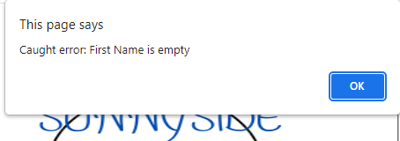

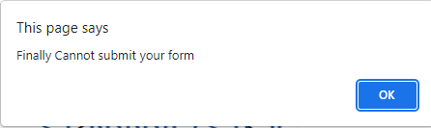

finally{

}

Executes code irregardless of an error

Code:

<!DOCTYPE html>

<html lang="en">

<head>

<meta charset="UTF-8">

<meta http-equiv="X-UA-Compatible" content="IE=edge">

<meta name="viewport" content="width=device-width, initial-scale=1.0">

<title>Sunny Bowside Club</title>

<style>

    btns{

        display: inline; margin-right: 20px;

        margin: 0 auto;

    }

</style>

</head>

<body>

    <h2>Welcome to Pretoria Sunnyside Bowling club</h2>

<form name="myForm" action="" onsubmit=" confirmSubmittedData ()">

    <h2 style="text-align: center ;">Sign-Up Form</h2>

    <img src="sunnyside.png" height="250px" width="350px" style="margin-left: auto; margin-right: auto;">

        <label>First name: <input name="firstName" /></label>

        <label>Last name: <input name="lastName" /></label>

           <label>Address: <input name="address" /></label>

        Gender :

        <label><input type="radio" name="gender" value="male" /> Male</label>

        <label><input type="radio" name="gender" value="female" /> Female</label>

           <label>Email Id:<input type="email" name="email" /></label>

        <label>Mobile: <input name="mobile" /></label>

        <label> Location

        <br />

        <select name="location">

            <option>select option</option>

            <option>Boardwalk</option>

            <option>Brooklyn</option>

            <option>Lynnwood</option>

            <option>Sunnyside</option>

        </select>

        </label>

        <button style="display: inline; margin-right: 20px; margin: 0 auto;" class="btns"  type="submit">Sign-Up</button>

        <button style="display: inline; margin-right: 20px; margin: 0 auto;" class="btns" >Reset</button>

</form>

<script>

    function confirmSubmittedData (){

        var fName = document.forms['myForm']['firstName'].value;

        var lName = document.forms['myForm']['lastName'].value;

        var address = document.forms['myForm']['address'].value;

        var gender = document.forms['myForm']['gender'].value;

        var email = document.forms['myForm']['email'].value;

        var mobile = document.forms['myForm']['mobile'].value;

        var location = document.forms['myForm']['location'].value;

        try{

            if(fName == "") throw "First Name is empty";

            if(lName == "") throw "Last Name is empty";

            if(address == "") throw "Address is empty";

            if(gender == "") throw "Gender is empty";

            if(email == "") throw "Email is empty";

            if(mobile == "") throw "Mobile number is empty";

            if(location == "") throw "Location is empty";

        }

        catch(error){

            window.alert("Caught error: "+ error);

        }

        finally{

            window.alert("Finally Cannot submit your form");

        }

    }

</script>

</body>

</html>

# 3.3

Cookies in JavaScript are set using document.cookie (Programming, 2020).

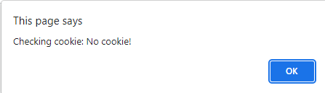

Code:

function cookieFunction(){

        var fName = document.forms['myForm']['firstName'].value;

        var email = document.forms['myForm']['email'].value;

        var mobile = document.forms['myForm']['mobile'].value;

        document.cookie=RegCookie;

        RegCookie = "username"+"="+fName+ ";"+ "email"+"="+email+";"+"mobile"+"="+mobile+";"+"expires"+"="+"30*24*60*60*1000";

       if (RegCookie == ""){

        window.alert('Cookie not set');

       }else{

        window.alert('Cookie set');

       }

    }

    function checkCookie(){

        if(document.cookie.length != 0){

            alert("There are cookies");

        }else{

            window.alert("Checking cookie: No cookie!");

        }

    }

References

Matthus, F. (2019). *Insert Array Into Table Javascript*.

Pearson, E. (2019). *JavaScript : Arrays Arrays ▪ Data structures consisting of related data items JavaScript arrays ▪ “ dynamic ” entities that can change size after they*. 1–39.

Programming, I. (2020). *JavaScript : Using Cookies Why cookies ?* 1–8.

Tutorialspoint. (2019). *JavaScript - Errors & Exceptions Handling - Tutorialspoint*. https://www.tutorialspoint.com/javascript/javascript_error_handling.htm

Tutorialspoint. (2020). *JAVASCRIPT - ARRAY UNSHIFT METHOD*. 5.