The source code has been compiled in the platform MacOS 12.6 and Ubuntu 20.

1. Compiling

A. Please open the project file ledgame.pro by Qt Creator

B. Please ignore or delete folder _MACOSX

C. Please update the path of gtest_dependency.pri

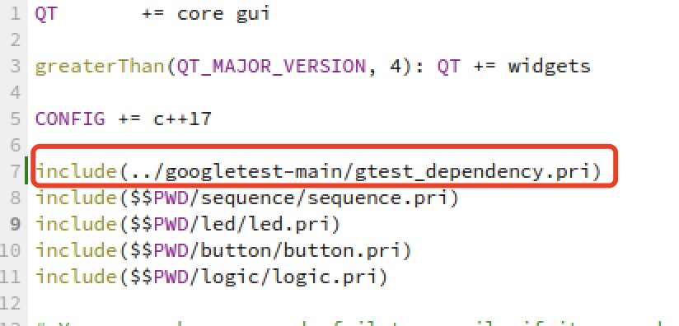

2. Structure

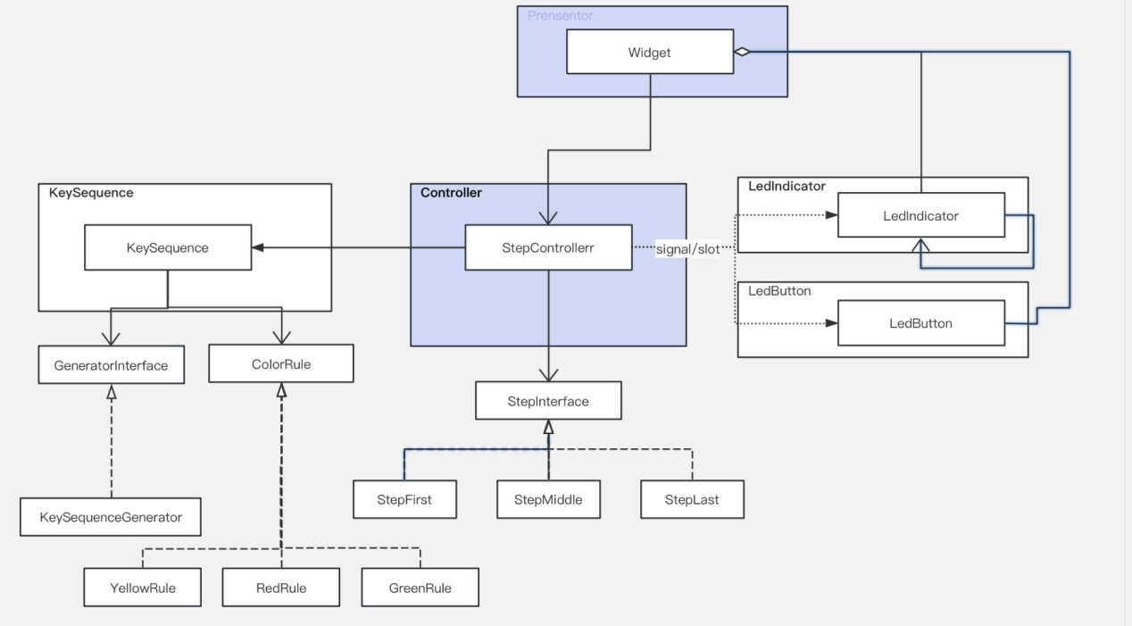

3. TODO:

A. UI Test

B. Refactory StepController and Widget

C. Clarification requirement, about “The button sequence is randomly generated on system start-up. After a 3-green result, another random sequence is generated.”