TASK; A PHOTOGRAPHIC ESSASY ON ANY IMPORTANT ISSUE THE STUDENT MAY IDENTIFY IN THE AFRICAN COMMUNITY.
THE IMPACT OF DIGITAL DIVIDE IN AN AFRICAN COMMUNITY
Introduction
In today’s rapidly advancing technological landscape, the digital divide presents a significant challenge for many communities across Africa. This issue encompasses the gap between those who have easy access to digital technologies, such as the internet and computers, and those who do not. This divide not only affects individual access to information but also has far-reaching implications for economic development, education, and social inclusion within African communities.
- Economic implications
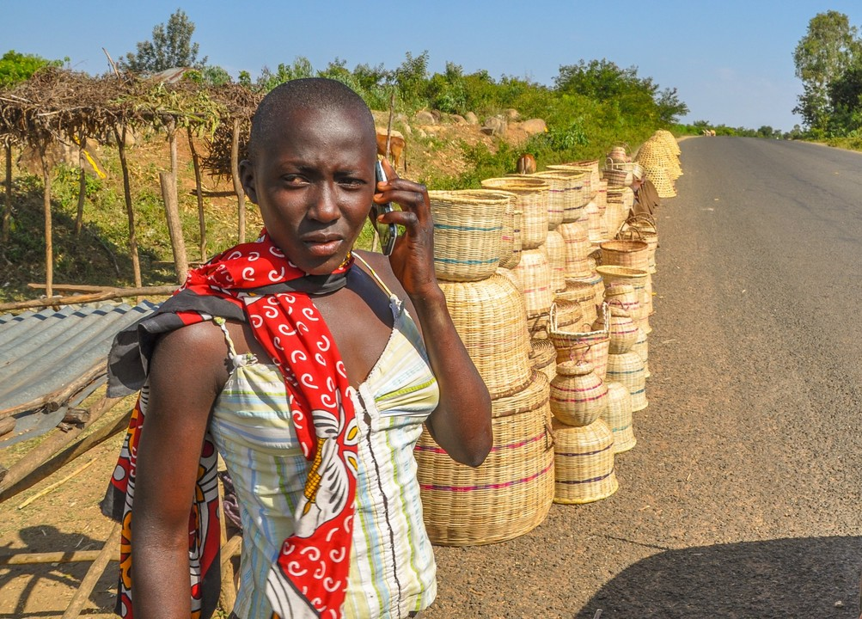
(atelier55design.com)
The digital divide significantly impacts economic opportunities in African communities. Many businesses rely on digital platforms for marketing, sales, and communication. In areas with limited internet access, local entrepreneurs struggle to compete in the broader market. This lack of digital presence can hinder job creation and economic growth. Furthermore, the ability to access online resources, training programs, and global markets is crucial for small and medium enterprises (SMEs), which are vital for economic stability in many African nations. Bridging the digital divide can empower these businesses, foster innovation and enabling them to thrive. Additionally, the growth of the digital economy presents opportunities for remote work and freelancing. By expanding internet access, communities can tap into a global workforce, allowing individuals to earn income from clients worldwide. This can significantly enhance local economies and provide financial stability for families.
2.Educational Challenges

(ghanaweb. live)
Education is another area deeply affected by the digital divide. Access to the internet and digital learning tools is essential for students to succeed in an increasingly competitive world. However, in many African communities, especially in rural areas, schools lack the necessary infrastructure and resources to provide students with digital learning opportunities. This disparity exacerbates existing inequalities and limits the potential of young people. Moreover, the COVID-19 pandemic highlighted the importance of digital access in education. With many schools shifting to online learning, students in areas without reliable internet access faced significant challenges, leading to learning gaps that may take years to bridge. Ensuring equitable access to technology is crucial for preventing further educational disparities. Incorporating technology into teacher training can also enhance the quality of education. Educators equipped with digital skills can create engaging learning environments and utilize online resources effectively, thereby improving student outcomes
3.Social Inclusion and Connectivity
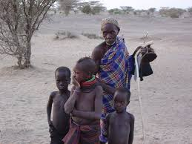
(turanadiary.com)
The digital divide also affects social inclusion. In communities where access to technology is limited, individuals may feel isolated and disconnected from the global community. This lack of connectivity can hinder social cohesion and limit access to vital information, such as health services, government programs, and community initiatives. Enhancing digital literacy and access can empower marginalized groups, including women and youth, allowing them to participate actively in their communities and engage with societal issues. Furthermore, digital platforms can facilitate civic engagement, enabling citizens to communicate with their governments and participate in democratic processes. This increased engagement can lead to greater accountability and responsiveness from local authorities, fostering a culture of transparency.
4.Health Access and Information
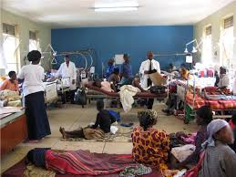
(missio.org)
Access to digital technology is crucial for healthcare in African communities. Telemedicine and online health resources can significantly improve healthcare delivery, especially in rural areas where medical facilities are scarce. The digital divide limits access to health information and services, exacerbating health disparities. By enhancing internet access, communities can benefit from telehealth services, health education, and timely information about disease outbreaks. Additionally, public health campaigns can leverage digital platforms to disseminate crucial information about preventive measures, vaccination drives, and health services, ensuring that communities are informed and engaged in their health outcomes.

5.Environmental Awareness and Action

(globaltimes.com)
The digital divide can also influence environmental awareness and sustainability efforts in African communities. Access to information about climate change, conservation practices, and sustainable agriculture can empower communities to adopt eco-friendly practices. Digital platforms can facilitate the sharing of knowledge and resources related to environmental protection, enabling communities to engage in climate resilience initiatives. By promoting awareness and education on environmental issues, communities can work together to address challenges such as deforestation, pollution, and resource depletion, ultimately leading to more sustainable development.
Strategies for Bridging the Divide

To address the digital divide, a multi-faceted approach is necessary. Governments must invest in infrastructure development, ensuring that internet access is available in rural and underserved areas. Public-private partnerships can play a crucial role in expanding connectivity and reducing costs. Additionally, initiatives focused on digital literacy are essential to equip individuals with the skills needed to navigate the digital world effectively. Educational institutions should also integrate technology into their curricula, preparing students for future job markets. Collaboration with tech companies can provide resources and training for both educators and students, fostering an environment where digital skills are prioritized. Community-driven initiatives, such as tech hubs and digital literacy workshops, can empower local residents to take charge of their technological education. By fostering a culture of innovation and collaboration, communities can collectively work towards closing the digital gap.

Advocacy and Policy Development
Advocacy for policy changes is vital in addressing the digital divide. Stakeholders, including non-governmental organizations (NGOs) and community leaders, must work together to influence government policies that prioritize technology access and digital literacy. Effective policies can create an enabling environment for investment in digital infrastructure and education. Additionally, public awareness campaigns can highlight the importance of bridging the digital divide, garnering support from various sectors of society and mobilizing resources for targeted interventions.
Conclusion
The digital divide is a pressing issue for many African communities, affecting economic development, education, social inclusion, health access, and environmental sustainability. By recognizing and addressing this challenge, stakeholders can work towards creating a more equitable society where all individuals have the opportunity to thrive in the digital age. Bridging this divide is not just about access to technology; it is about empowering communities to unlock their full potential and participate fully in the global economy. With concerted efforts, Africa can transform the digital landscape, leading to sustainable development and improved quality of life for all its citizens.

