**Experiment No: 04**

**Name of the Experiment:** Study of Newton-Raphson(NR) Iterative Method to Obtain the Root(s) of a Nonlinear Equation.

**Objectives:** The objective of this experiment is to apply NR iterative method to find out the very precise value of the root of an equation, using MATLAB.

**Theory:** The **Newton-Raphson method** (also known as Newton's method) is a way to quickly find a good approximation for the root of a real-valued function *f*(*x*)=0. It uses the idea that a continuous and differentiable function can be approximated by a straight line tangent to it[1].

Suppose you need to find the root of a continuous, differentiable function *f*(*x*), and you know the root you are looking for is near the point *x*=*x*0​. Then Newton's method tells us that a better approximation for the root is *x*1​=*x*0​−*f*′(*x*0​)/*f*(*x*0​)​.

This process may be repeated as many times as necessary to get the desired accuracy. In general, for any x*x*-value *xn*​, the next value is given by

*xn*+1​=*xn*​−*f*′(*xn*​)/*f*(*xn*​)​

**Tool:** MATLAB Software

**Methodology:**

**(I) Algorithm:**

1. Start
2. Read x, e, n, d ,*x is the initial guess, e is the absolute error i.e the desired degree of accuracy,n is for operating loop,d is for checking slope*
3. Do for i =1 to n in step of 2
4. f = f(x)
5. f1 = f'(x)
6. If ( [f1] < d), then display too small slope and goto 11.  
   *[ ] is used as modulus sign*
7. x1 = x – f/f1
8. If ( [(x1 – x)/x1] < e ), the display the root as x1 and goto 11.  
   *[ ] is used as modulus sign*
9. x = x1 and end loop
10. Display method does not converge due to oscillation.
11. Stop

**(II)Flowchart:**

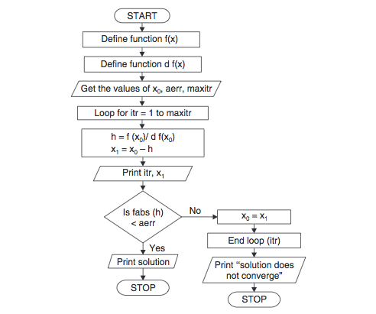

**Figure 2.1 Flowchart of Newton-Raphson method procedure [2]**

**(III) MATLAB Code:** The given function is f(x) =2x^2-15x+3

clear all

clc

syms x;

fun=input('Enter the fun:');

f=inline(fun);

z=diff(f(x));

f1=inline(z);

x0=input('Enter initial value:');

x=x0;

display(' No. y f(a) f1(a) x')

display('---- ----- ----- ----- -----')

for i=0:1:15

y=x;

x=y-(f(x)/f1(x));

if x==y

break

else fprintf(' %d %f %f %f %f \n',i,y,f(x),f1(x),x);

end

end

**Output:**

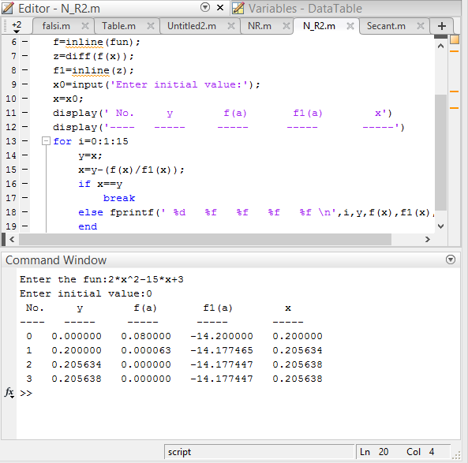

**Result& Discussion:** The roots of the given function is 0.205638.Which is equal to the original value (0.205638) directly calculated by calculator.

**Conclusion:** So from the above test we saw that nearly 3rd iteration we get the resultant value of two roots which is very close to the original roots.

**References:**

[1]C. Chapra and P. Canale Raymond , “*Numerical Methods for Engineers”,* 7th ed. McGraw-Hill Education, 2 Penn Plaza, New York, NY 10121, 2015

[2] *Newton-Raphson Method Algorithm and Flowchart,*CODEWITHC, April 21, 2014.Accessed on: Jan. 23,2020[online].

Available: <https://www.codewithc.com/newton-raphson-method-algorithm-flowchart/>