**Experiment No: 06**

**Name of the Experiment:** Study of Successive Approximations (SA) Method to Obtain the Root(s) of a Nonlinear Equation.

**Objectives:** The objective of this experiment is to apply SA method to find out the very precise value of the root of an equation, using MATLAB.

**Theory:** This open method employs a formula to predict the root. Such a formula can be developed for simple fixed-point iteration (or, as it is also called, one-point iteration or successive substitution) by rearranging the function f(x) =0 so that x is on the left-hand side of the equation: x= g(x)….(1)

This transformation can be accomplished either by algebraic manipulation or by simply adding x to both sides of the original equation. For example,

x2-2x+3=0 can be simply manipulated to yield x=(x2+3)/2

The utility of the equation 1 is that it provides a formula to predict a new value of x as a function of an old value of x. Thus, given an initial guess at the root xi, equation 1 can be used to compute a new estimate xi+1 as expressed by the iterative formula  
xi+1 = g(xi) …….(2)

**Tool:** MATLAB Software

**Methodology:**

**(I) Algorithm:**

1. Start
2. Read values of x0 and e.  
   *Here x0 is the initial approximation  
   e is the absolute error or the desired degree of accuracy, also the stopping criteria*
3. Calculate x1 = g(x0)
4. If [x1 – x0] <= e, goto step 6.  
   *Here [ ] refers to the modulus sign*
5. Else, assign x0 = x1 and goto step 3.
6. Display x1 as the root.
7. Stop

**(II)Flowchart:**

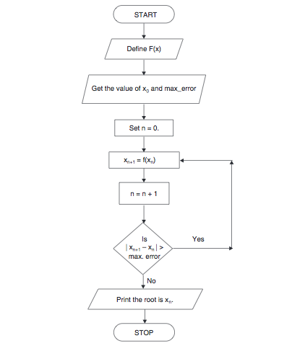

**Figure 2.1 Flowchart of iteration method procedure [2]**

**(III) MATLAB Code:** The given function is f(x) =(x^3+3)/5

clear all

clc

syms x;

fun=input('Enter the fun:');

f=inline(fun);

a=input('Enter the value of initial assumption:');

if f(a)==0

fprintf('Root')

return

end

display(' No. a xn ')

display(' -- ----- ----- ')

for i=1:1:20

xn=f(a);

if abs(xn-a)<0.001

break;

else fprintf(' %d %f %f\n',i,a,xn);

a=xn;

end

end

**Output:**

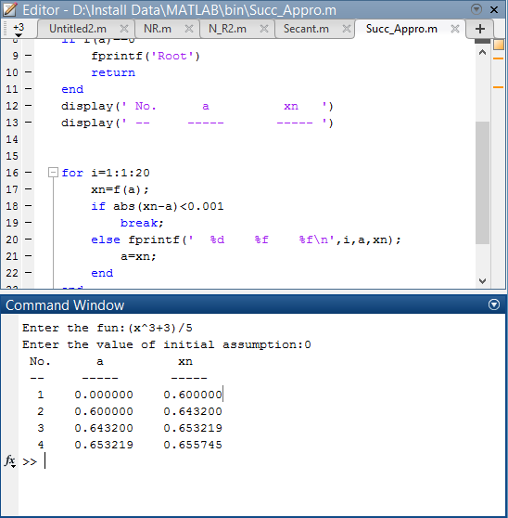

**Result& Discussion:** The roots of the given function is 0.655745.Which is nearly close to the original value (0.65634) direct calculated by calculator.

**Conclusion:** So from the above test we saw that nearly 4th iteration we get the resultant value of two roots which is very close to the original roots.

**References:**

[1]C. Chapra and P. Canale Raymond , “*Numerical Methods for Engineers”,* 7th ed. McGraw-Hill Education, 2 Penn Plaza, New York, NY 10121, 2015

[2]*Iteration Method Algorithm and Flowchart,*CODEWITHC, April 21, 2014.Accessed on: Jan. 23,2020[online].

Available: <https://www.codewithc.com/iteration-method-algorithm-flowchart/>