**Experiment No: 07**

**Name of the Experiment:** Study Of Gauss Elimination(GE) Method To Find The Solution Of Simultaneous Equations.

**Objectives:** The objective of this experiment is to apply GE method to find out the very precise values of the equations, using MATLAB.

**Theory:** Solving of a system of linear algebraic equations appears frequently in many engineering problems. Most of numerical techniques which deals with partial differential equations, represent the governing equations of physical phenomena in the form of a system of linear algebraic equations. Gauss elimination technique is a well-known numerical method which is employed in many scientific problems.

Consider an arbitrary system of linear algebraic equations as follows:

*a11x1 + a12x2 + … + a1nxn = c1*

*a21x1 + a22x2 + … + a2nxn = c2*

……………….

*an1x1 + an2x2 + … + annxn = cn*

where *xi* are unknowns and *aij* are coefficients of unknowns and *ci* are equations’ constants. This system of algebraic equation can be written in the matrix form as follows:

[A]{x}={C}

Where [A] is the matrix of coefficient and {x} is the vector of unknowns and {C} is the vector of constants. Gauss elimination method eliminate unknowns’ coefficients of the equations one by one. Therefore the matrix of coefficients of the system of linear equations is transformed to an upper triangular matrix. The last transformed equation has only one unknown which can be determined easily. This evaluated unknown can be used in the upper equation for determining the next unknown and so on. Finally the system of linear equations can be solved by back substitution of evaluated unknowns[1].

**Tool:** MATLAB Software

**Methodology:**

## (I)Algorithm:

1. Start
2. Declare the variables and read the order of the matrix n.
3. Take the coefficients of the linear equation as:  
   pivot matrix 1 1 value then calculate .
4. Pivot matrix value 2 2 and make zero 3 2.
5. Stop

**(II) MATLAB Code:**

A=[1 1 1; 2 1 3; 3 4 -2];

B=[4;7;9];

% Augmented matrix

AB=[A,B];

%% pivot 1 1

alpha = AB(2,1)/AB(1,1);

AB(2,:)=AB(2,:)-alpha*AB(1,:);

alpha=AB(3,1)/AB(1,1);

AB(3,:)=AB(3,:)-alpha*AB(1,:);

%% pivot 2 2

alpha=AB(3,2)/AB(2,2);

AB(3,:)=AB(3,:)-alpha*AB(2,:);

%% Back Subs

x=zeros(3,1);

x(3) = AB(3,end)/AB(3,3);

x(2) = (AB(2,end)-AB(2,3)*x(3))/AB(2,2);

x(1) = (AB(1,end)-(AB(1,3)*x(3)+AB(1,2)*x(2)))/AB(1,1);

**Output:**

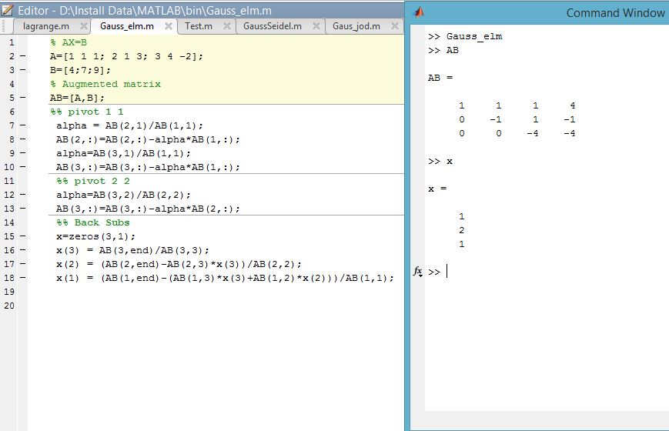

**Result& Discussion:** From the output the value of x matrix is 1, 2, 1.Means x=1, y=2, z=1.

**Conclusion:** The output is exactly the same as we learnt from the theory and it is an upper triangle.

**References:**

[1]C. Chapra and P. Canale Raymond , “*Numerical Methods for Engineers”,* 7th ed. McGraw-Hill Education, 2 Penn Plaza, New York, NY 10121, 2015